Professional Career Development

STUDENT NAME: Nikolay Stoyanov
STUDENT NUMBER: 1920479
LECTURE’S NAME: Lloyd Beharry

MODULE CODE: BMSW4005
MODULE NAME: Professional Career Development
LEVEL: 4
GROUP NUMBER: T3G3

Table of Content:

- Introduction

- Interview Role play

- Analysis and reflection of the role play

- Gibbs Reflective Cycle

- SWOT Analysis

- SMART Objectives Matrix

- Johari Window

- Conclusion

- Reference List

- Introduction
My overall career aspiration has always been related to technologies and the changes they make in the world. From a young age I always been interested in programming and computing. I was often keen to learn something new related to coding and programming.
I enrolled to the business program from University of Wales: Trinity Saint Davis because I knew that my computing skills are my strong side, however my personal development skills needed improving. By studding in the university, I had the opportunity to learn how to enhance my basic set of work skills which will help me find a job in the field I want to progress my career into.
My employment history started when I moved to the UK as a Security Officer and it was a job that will help me with my cost of living as well as saving to pay my computing degree, I am planning to enrol to next year. My job was related with people interaction, which showed me how much I needed to improve my personal and professional development skills. I needed the workplace skills on top of my computing and programming knowledge.
My study allowed me to learn the practical side of professional development on one hand, and dive into self-reflection of my strong qualities and be able to see where I have opportunities for improvement on another hand.
The purpose of this report will be mainly concentrated on the practical professional development exercise- role play and various techniques used for self-reflection on the role play.
I was paired with another student and we had to play both the role of the interviewee and the interviewer.
I was interviewed for the role of a Security Officer.
In addition to the role play in the report I will include and review the self-reflection techniques I have applied, and I have tailored based on my goals and objectives for professional career development.

- Role Play- Interview
From previous experience I am aware that the interview is the time to show the person behind the CV, as I have passed the pile of CV’s that employers have to go through every day. Many people think that the interview is the place to shine and show a bit more for the person from the CV.
The day before my role play exercise in class, I practice a bit with my roommate. He asked me the standard interview questions and I was able to practice my answers and receive a feedback from him. This gave me a second opinion and helped me evaluate my answers.
In class I acted both as an interviewer and interviewee. In this report I will focus on the interviewee scenario.
As I mentioned earlier, I was on a job interview for Security Officer.
The first question I was asked was: What experience do I have?
This question gave me the opportunity to highlight my strong qualities developed on my current workplace as well as stating that I already have experience in the field.
I have lots of experience as security officer including escort, money transport and close protection.
Afterwards I was asked what skills do I have that will help me in the job? I answered that I am trustworthy, calm and I work well under high pressure. I am also very responsible and highly motivated. I have also stated that perfectionism and multitasking combined with high performance are just a few of my strongest features.
My partner asked me am I self-motivated? I stated that self-motivation is a strength of me. I believe self-motivation is part of everyone’s life in general.
I was asked next can I work in a team- I explained that working in a team is easy for me as I am very outgoing person.
Lastly, I was asked where do I see myself in 5 years? This question was related to my future goals and professional development. I started with my objectives that were related to computing career and I stated that the experience I will build in this job will help me develop the personal and professional skills needed to be a successful candidate in any future role. I stated that this position will help me gain more experience in the field and it will help me develop my people skills as well as my personal skills. This will help me procced with career in the computing.

Overall, the role play was very useful for me in both roles as it helped me gain some confidence in talking about myself with others. It also helped me practice my interview skills. I was appropriately dressed for the task, there were no technical problems nor any external noise. I would say that as a lesson from the role play, I can take is that I have to work more on my body language and engage more in a conversation as I did not give many details on the questions asked and I was too serious in my roles.

- Gibbs reflective cycle
I have used this technique for reflection on the role play as I strongly believe that people learn best form experience.
The reflection cycle was published in 1988 by Professor G, Gibbs. The cycle is very useful for people struggling to adjust to changes in behaviour. The cycle is a framework that helps people learn from experience especially when the experience was negative.

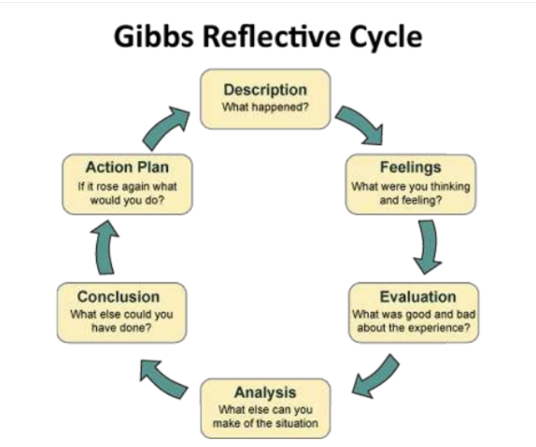

Description of the situation- the role play was conducted in class in a timeframe of 20 minutes and me and my partner had to be in the role of interviewee and interviewer. Me and my partner kept a professional attitude, and, in my opinion, we managed to delve into the roles.
Feelings- I was left with positive feelings from the role play as there were not many issues. I found it easy to be in both roles and I think I performed well. My partner was also calm. We were both missing body language.
Evaluation- I think I was lucky with my partner. The role play went well and better that I thought, and I think my partner’s calmness helped a lot.
Analysis- the role play helped me personally realise that interviews are not that scary and having the right attitude set before the interview is something I need to improve as I often end up going to an interview with the perception of failure.
Conclusion- overall the role play went well, however improvement in my body language and self-development are some aspects both me and my partner have to consider.
Action Plan- this exercise helped me with understanding the key points I need to look for when analysing my weaknesses, as well as looking for opportunities for improvement.

- SWOT Analysis
This is widely used technique for evaluation of the strength and weaknesses of business organisations as well as individuals.
I have chosen SWOT analysis as this will help me not only flag my strengths and weaknesses but also discover opportunities for improvement and if I am facing any threats.
Strengths- as I have already mentioned I believe some of my strengths are trustworthiness, calmness and I work well under pressure. I am also very proactive and highly motivated to reach out to high standards. I have also stated that perfectionism and multitasking are strengths of mine.
Weaknesses- I consider my seriousness as a weakness as sometimes I don’t smile, and this makes people that don’t know me nervous.
Opportunities- my main opportunity is my study. My degree will give me better chance to stand out on the recruitment market and it will enable me to get a desired job.
Threats- the enormous competition in the programming industry is a threat for me as this type of career is desired amongst the youngsters nowadays.

- SMART Objectives
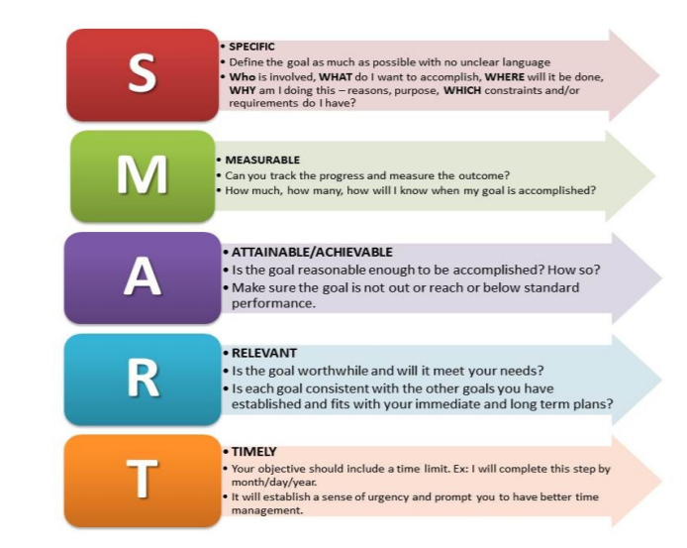

I choose the SMART Objectives model as it is commonly used and easy to apply. The technique helped me develop my goals and objectives as well as be able to measure them in time.
Specific- I am very clear in my goal as I imagine my future career being related to computing and programming. My objective is to finish my study and build a strong qualification to help me find my dream job.
Measurable- my objective can be measured with my grades. I am aiming for A and B.
Attainable- my goal is achievable as I have experience in the coding and programming as well as I have a certificate for SQL language skills.
Relevant- my goal is relevant as with the pandemic more industries are moving online, and the need of computing specialists will increase.
Timely- my timeframe is 4 years as after I finish in University of Trinity, I will enrol to a 3 year programming course.

- Johari Window
This technique is very popular as helps individuals to raise self-awareness. I used the technique because it helped me better express my feeling and to be easily understood by others.

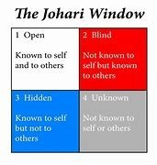

Open- I am very easy person. I believe I am easy to talk to as well as very friendly. Everyone that knows me, knows that I am very determent and focused. I also pay much attention to the small details that surround me.

Blind- I sometimes put other’s priorities before mine. I am constantly trying to make everyone around me happy without even realising it.

Hidden- I am very sensitive person, bit I am trying not to show it too much as I fear it will be used against me in the future. I have a passion for mechanics, but I would rather not share it with my circle as I think what keep us together is the common passion for computing.

Unknown- this is related to things I do not know about myself or others do not know about me. One of my features is that I take everything for granted. I often do not realise what I have until I do not lose it or someone else does not take it away from me.

- Conclusion
Being able to talk about myself openly and in class made more confident and help me realise that I am not the only one fearing to open up in front of others.
My self- reflection proved me that hard work indeed will pay off eventually. Moreover, it is nothing wrong with wanting to be successful and to want to constantly improve yourself.
In this report, I used various techniques for self- reflection in order to get to know myself better. I realised that my dreams are nothing if they are not supported with goals and objectives. In order to achieve my goals, I need to improve my self-development and keep developing through my whole life. The learning path is not just for a certain period of time.
The role play conducted in class made me realise that I have a lot more potential that I thought. It also helped me open up a but more and overcome my fear of talking about my self in front of others.

- Reference list:
- Finlay, L. (2008). Reflecting on reflective practice. PBPL paper, 52, 1-27.
- Gibbs, G. (1988). Learning by Doing: A Guide to Teaching and Learning Methods. Oxford: Oxford Further Education Unit
- Gibbs, G. (1998). Reviewing and improving your teaching. Practice Guide, 7, H851.
- J and Page, L (2013) Reflective Practice Hoboken: Wiley Jasper,
- Jack Mezirow (2017) Fostering Critical Reflection in Adulthood: How critical reflection triggers transformative learning [online]. Available from:
https://my.liberatedleaders.com.au/wp-content/uploads/2017/02/How-Critical-
Reflection-triggers-Transformative-Learning-Mezirow.pdf (Accessed: 20 04 2021).
- The University of Edinburgh (2019) Gibbs' reflective cycle [online]. Available from: https://www.ed.ac.uk/reflection/reflectors-toolkit/reflecting-on-experience/ gibbs-reflective-cycle (Accessed: 20 04 2021).
- Joe Luft, Harry Ingham (1961) JOHARI WINDOW [online]. Available from: http://www.richerexperiences.com/wp-content/uploads/2014/02/JohariWindow.pdf (Accessed: 20 04 2021

Appendix 1

Private & Confidential
Application for Employment

To ensure that you are able to complete the application form in full, please refer to the short-listing criteria on the job description.
Position Applied For | SECURITY OFFICER
How did you learn about this vacancy? | MITIE SECURITY LIMITED MANAGER

1. Personal Details
Title | Mr.
Surname | Stoyanov
Previous Name
Forenames | Nikolay
Address | Palmers Green  London
Post Code | N13
Telephone number |  |  | Mobile No |  |  | 0000-1920479
E-mail address | 1920479@student.uwtsd.ac.uk
National Insurance
Number

1a. Additional Information
Do you hold a full, clean driving license valid in the UK? |  |  |  |  | Yes |  |  |  | No
Do you have the right to work in the UK without restriction?  (Proof of right to work in the UK ID will be required) |  |  |  |  | Yes |  |  |  | No

2. Employment History
The last 5 years employment should be detailed, including any gaps in employment.
Please continue on a separate sheet if required.

Current or Most Recent Employment
Employers Name | MITIE LIMITED
Address | Level 12 The Shard, 32 London Bridge Street, London, England
Postcode | SE1 9SG
Job Title | Technician
Dates of Employment | From |  | 04/2017 | To |  | Present
Reason for leaving | WORK UNDER HI PRESURE |  |  | Salary
Brief outline of main responsibilities and key duties | Supporting all electrical equipments  Changing faulty parts  Checking all Electrical equipments meet Safety and Security criteria

2. Employment History
The last 5 years employment should be detailed, including any gaps in employment.
Please continue on a separate sheet if required.

Current or Most Recent Employment
Employers Name
Address

Postcode
Job Title
Dates of Employment | From |  |  | To
Reason for leaving |  |  |  | Salary
Brief outline of main responsibilities and key achievements

Please continue on a separate sheet if required.
3. Formal Qualifications and Training & Development
Continue on a separate piece of paper if required. You will be required to provide original qualification certificates if successful.

Secondary Education Qualifications
Name of Qualification | Date Gained |  |  |  | Level | Grade |  | Awarding Body
NON QUALIFICATION

Further/Higher Education Qualifications
Name of Qualification | Date Gained |  |  | Level |  | Grade |  | Awarding Body
CERTHE  SKILLS FOR THE WORKPLACE | JUNE 2021 |  |  | 4 |  |  |  | UWTSD

Professional Qualifications
Name of Qualification | Date Gained |  |  | Level | Grade |  | Awarding Body
SIA License Door Supervisor  NVQ-Door Supervision  NVQ-Security Systems  Cisco Academy:  CCNA  CCNP  CompTIA A+ | 11/2017  10/2017  10/2017  06/2008  07/2008  04/2007 |  |  | 2  1  4  4  - | A+ |  | SIA  SIA  SIA  Cisco  Cisco  CompTIA

CPD / Training and Development
Brief description / course title |  | Date Taken

4. Interests and hobbies

Please provide details of your hobbies / leisure activities / voluntary work
I have few hobbies like travelling exploring different cultures and traditions also my favourite is technologies. I love to read and test new technologies.

5. Referencing

Referencing required for 2 full years (with a minimum of 2 references). At least 1 reference should be your current of most recent employer. Please confirm any existing personal / family relationship with existing PRC employees

References (Current or most recent employer)
Name of Referee | Alex Sakasvili
Job Title | Security Manager
Employers Name | Trinity Security Limited
Address | 166 College Road, Harrow, England
Postcode | HA1 1BH
Telephone Number | 02082924817 |  | Ext. Number
E-Mail Address | manager@trinitysecurity.co.uk
Are you willing for this referee to be approached prior to interview? | Yes No

 | References
 | Name of Referee
 | Job Title
 | Employers Name
 | Address
 | Postcode
 | Telephone Number |  | Ext. Number
 | E-Mail Address
Are you willing for this referee to be approached prior to interview? |  | Yes No

6. Reason for applying

Please detail below reasons for applying for the position including your skills, experience and attributes.
I`m a good team player.
Very responsible and motivated person.
I have lots of experience as security officer including escort, money transport and close protection.
Can work with computer, alarm, access control and CCTV systems.
Also I have experience as a Dog Handler in K9 department and I love dogs.
Have a valid SIA License.

Please specify how you meet the criteria for this role.
Ability to work in team.
More than 10 years Experian’s in security industry.
Very good technical knowledge of alarm systems, access control and CCTV.
Very good computer systems knowledge.
Qualifications and License in security industry area.

7. Declaration
Please complete the following declaration and sign it in the appropriate place below.
I certify that:
- All the information given to me on this form is correct to the best of my knowledge
- All questions relating to me have been accurately and fully answered
- I possess all the qualifications which I claim to hold
Signed: Date:

Print Name : Nikolay Stoyanov

