

Statistical Programming
ACCB5021
Osvaldas Stanelis
1802408

Documentation of pell.r

Starting with simple flow chart to mirror the script.
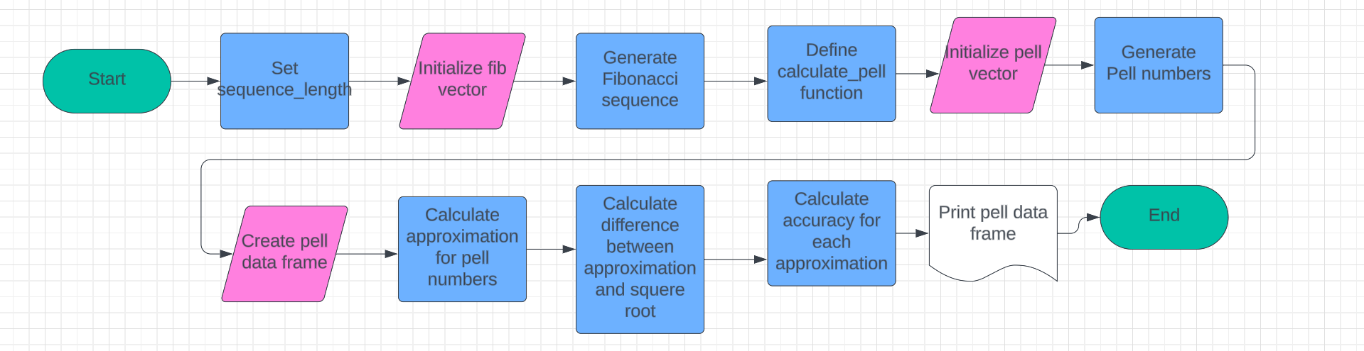
To explain how pell.r script works, first of all we need closer look how code works, so let’s break it down:
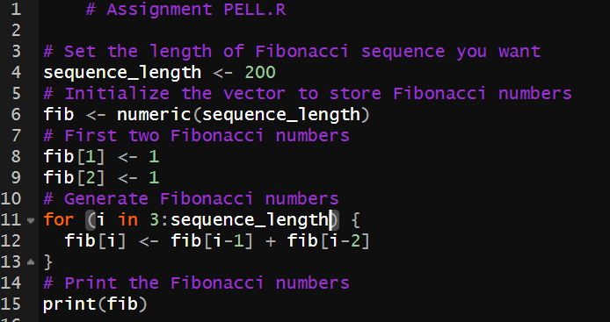
Fibonacci sequence generation:
- Sequence_length – this variable sets the wanted length of the Fibonacci swquence.
- Initialization – as numeric vector “fib” of length “sequence_length” is initialized to store Fibonacci numbers.
- Initial values – the first two Fibonacci numbers (1 and 1) are assigned to “fib[1]” and “fib[2]”
- Fibonacci calculation - using for loop starting from the third index up to “sequence_length”, Fibonacci numbers are generated by summing the previous two numbers.
- Printing – the Fibonacci sequence is displayed.
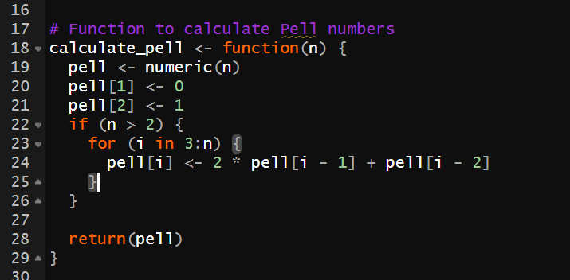
Pell numbers calculation:
- Calculate_pell function – this functon takes an integer “n” as input and returns the first “n” Pell numbers.
- Initialization – a numeric vector “pell” of length “n” is initialized to store Pell numbers.
- Initial values – the first two Pell numbers (0 and 1) are assigned to “pell[1]” and “pell[2]”.
- Pell numbers calculation – using a loop stating from the third index up to “n”, Pell numbers are generated using the formula “2 * pell[i-1] + pell[i-2]”
- Return – returning calculated values as (pell).
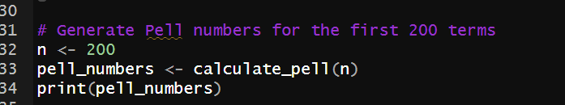
Generate Pell numbers:
- Variable initialization – n <- 200 assigns the value 200 to the variable “n”, indicating the number of Pell numbers to generate.
- Function call – “pell_numbers <- calculate_pell(n)” calls the “calculate_pell” function with the argument “n”, which generates the first “n” Pell numbers and assigns them to the variable “pell_numbers”.
- Printing – displaying the generated Pell numbers stored in the variable “pell_numbers”.
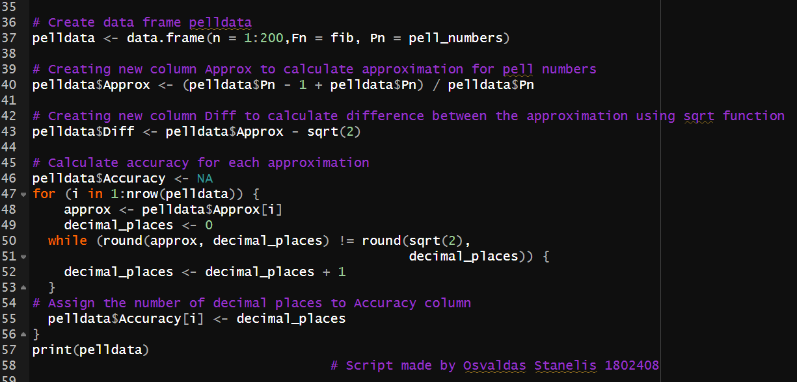
Data frame creation and analysis
- Data frame creation – data frame named “pelldata” is created with columns “n”, “Fn” (Fibonacci numbers), “Pn” (Pell numbers).
- Approximation calculation – an approximation formula “(Pn – 1 + Pn) / Pn” is applied to each Pell number to calculate approximation and stored in pelldata as new column called “Approx”.
- Accuracy calculation – for each approximation, the code iterates over each row and calculates the number of decimal places required for the approximation to match “sqrt(2)”.
- Printing – displaying the final data frame “pelldata” with all calculated values.
Testing
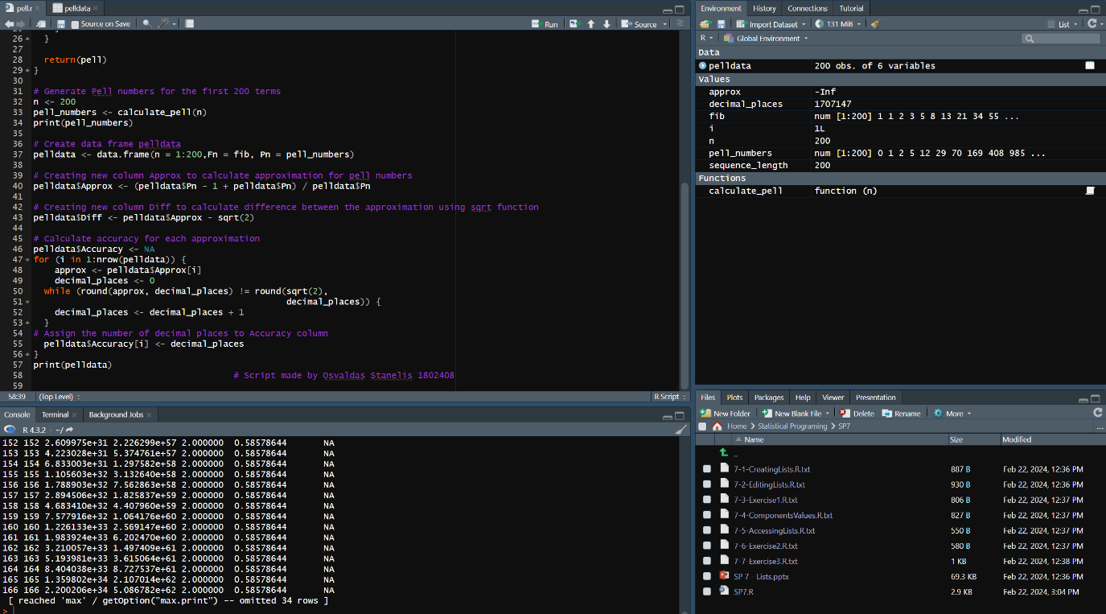
To test the code can run it with different sequence lengths for Fibonacci and Pell numbers.
Will generate and print the first 10 Fibonacci and Pell numbers along with their approximations and accuracy values. Compare the results with known Fibonacci and Pell sequences to verify correctness. Additionally, we can try different sequence lengths to ensure the code scales appropriately.
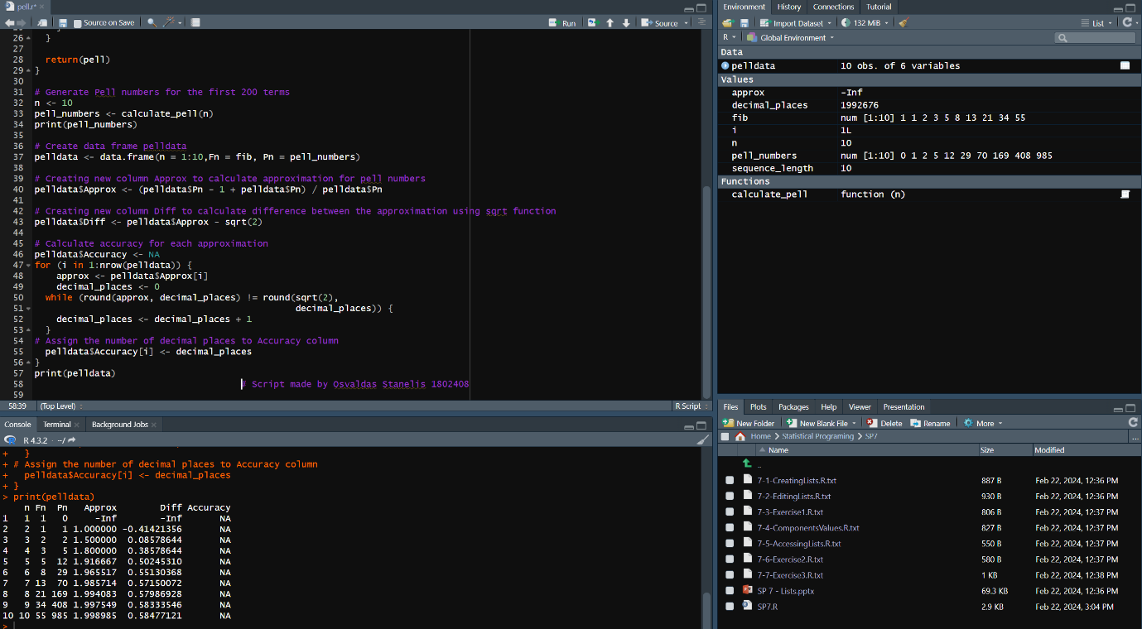
Additionally adding whole code:
# Assignment PELL.R

# Set the length of Fibonacci sequence you want
sequence_length <- 200
# Initialize the vector to store Fibonacci numbers
fib <- numeric(sequence_length)
# First two Fibonacci numbers
fib[1] <- 1
fib[2] <- 1
# Generate Fibonacci numbers
for (i in 3:sequence_length) {
fib[i] <- fib[i-1] + fib[i-2]
}
# Print the Fibonacci numbers
print(fib)

# Function to calculate Pell numbers
calculate_pell <- function(n) {
pell <- numeric(n)
pell[1] <- 0
pell[2] <- 1
if (n > 2) {
for (i in 3:n) {
pell[i] <- 2 * pell[i - 1] + pell[i - 2]
}
}

return(pell)
}

# Generate Pell numbers for the first 200 terms
n <- 200
pell_numbers <- calculate_pell(n)
print(pell_numbers)

# Create data frame pelldata
pelldata <- data.frame(n = 1:200,Fn = fib, Pn = pell_numbers)

# Creating new column Approx to calculate approximation for pell numbers
pelldata$Approx <- (pelldata$Pn - 1 + pelldata$Pn) / pelldata$Pn

# Creating new column Diff to calculate difference between the approximation using sqrt function
pelldata$Diff <- pelldata$Approx - sqrt(2)

# Calculate accuracy for each approximation
pelldata$Accuracy <- NA
for (i in 1:nrow(pelldata)) {
approx <- pelldata$Approx[i]
decimal_places <- 0
while (round(approx, decimal_places) != round(sqrt(2),
decimal_places)) {
decimal_places <- decimal_places + 1
}
# Assign the number of decimal places to Accuracy column
pelldata$Accuracy[i] <- decimal_places
}
print(pelldata)
# Script made by Osvaldas Stanelis 1802408

Reflection
Challenges:
Calculating the accuracy of the approximation required a careful approach, especially when dealing with floating-point arithmetic and rounding errors.
Ensuring the code is efficient, especially for larger sequence lengths, required attention to algorithmic complexity and optimization.
Debugging issues related to indexing errors or off-by-one errors can sometimes be challenging, especially in longer scripts.
Learnings:
Developing a deeper understanding of Fibonacci and Pell number generation algorithms was valuable.
Practicing data frame manipulation techniques, such as creating, indexing, and updating data frames, improved my proficiency in working with tabular data in R.
Organizing code into functions and modular components enhances readability, maintainability, and reusability.
Next time, I would include more comprehensive test cases to ensure the code handles edge cases and unexpected inputs robustly. Providing more detailed comments and documentation within the code would enhance clarity for others reviewing or collaborating on the code. Exploring ways to optimize the code further, such as vectorization or alternative algorithms, could improve efficiency, especially for larger sequence lengths.
Regarding generative AI support, I utilized it to clarify concepts, validate the accuracy of the explanation, and refine the flowchart and testing suggestions. It helped ensure the explanations were accurate, comprehensive, and accessible, enhancing the overall quality of the response.
Conclusion
Even with the help of the AI I was not able to fully complete the 4th task, because I run into error, and I have lost myself in that code. I had to devote more of my time to this assignment to completing it. I thought I had enough knowledge to complete those tasks quickly, but I was wrong. I will be more prepared and willing to give more time to do it for upcoming assignments.

