DS 1 Template

My Screenshots/Photos – Alexandru Iordachi

Screenshot/Photo 1
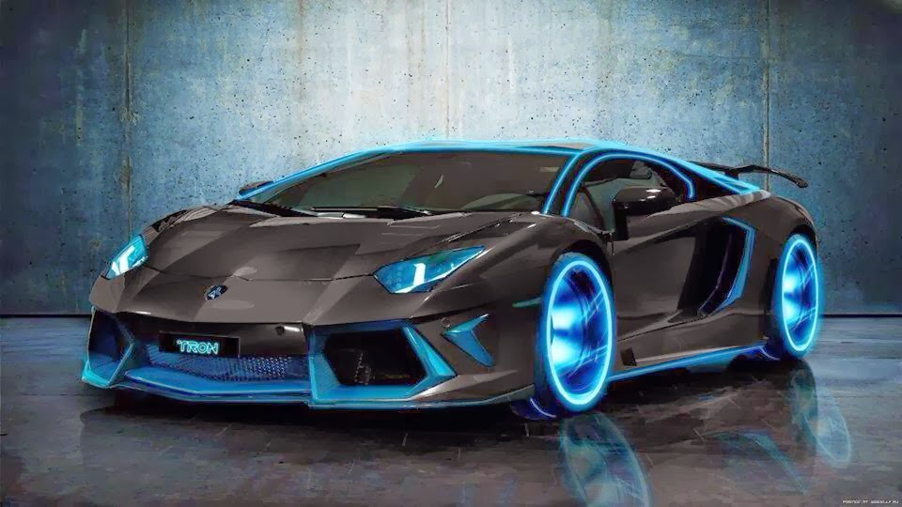
This photo shows one of my interests. I like looking at cars online and learning about different models and designs and I log in to website to download my pictures

Screenshot/Photo 2
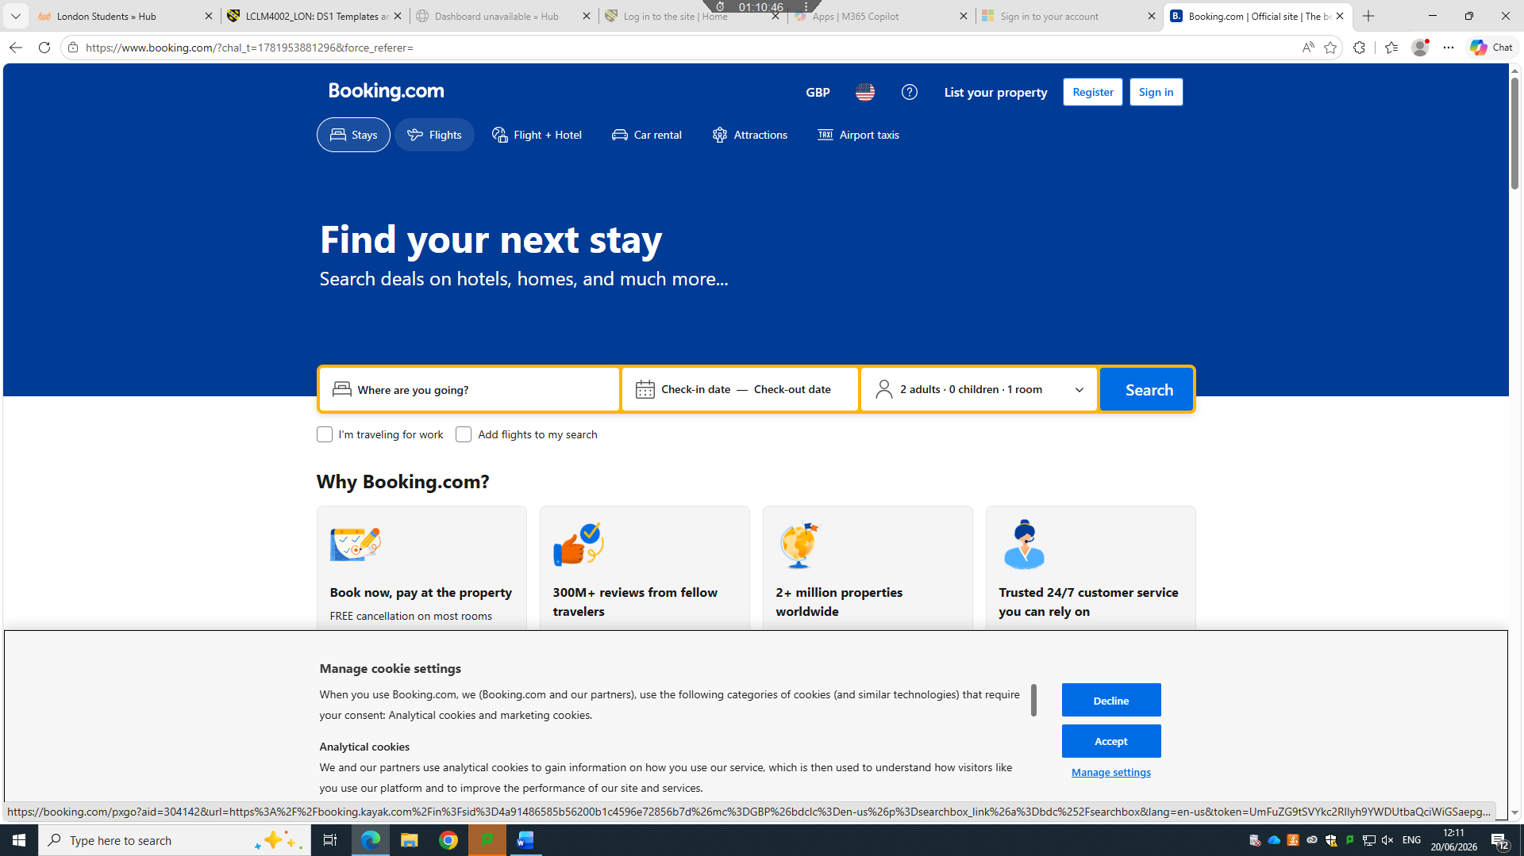
To book my holidays to go to Romania , I use booking.com website

Screenshot/Photo 3
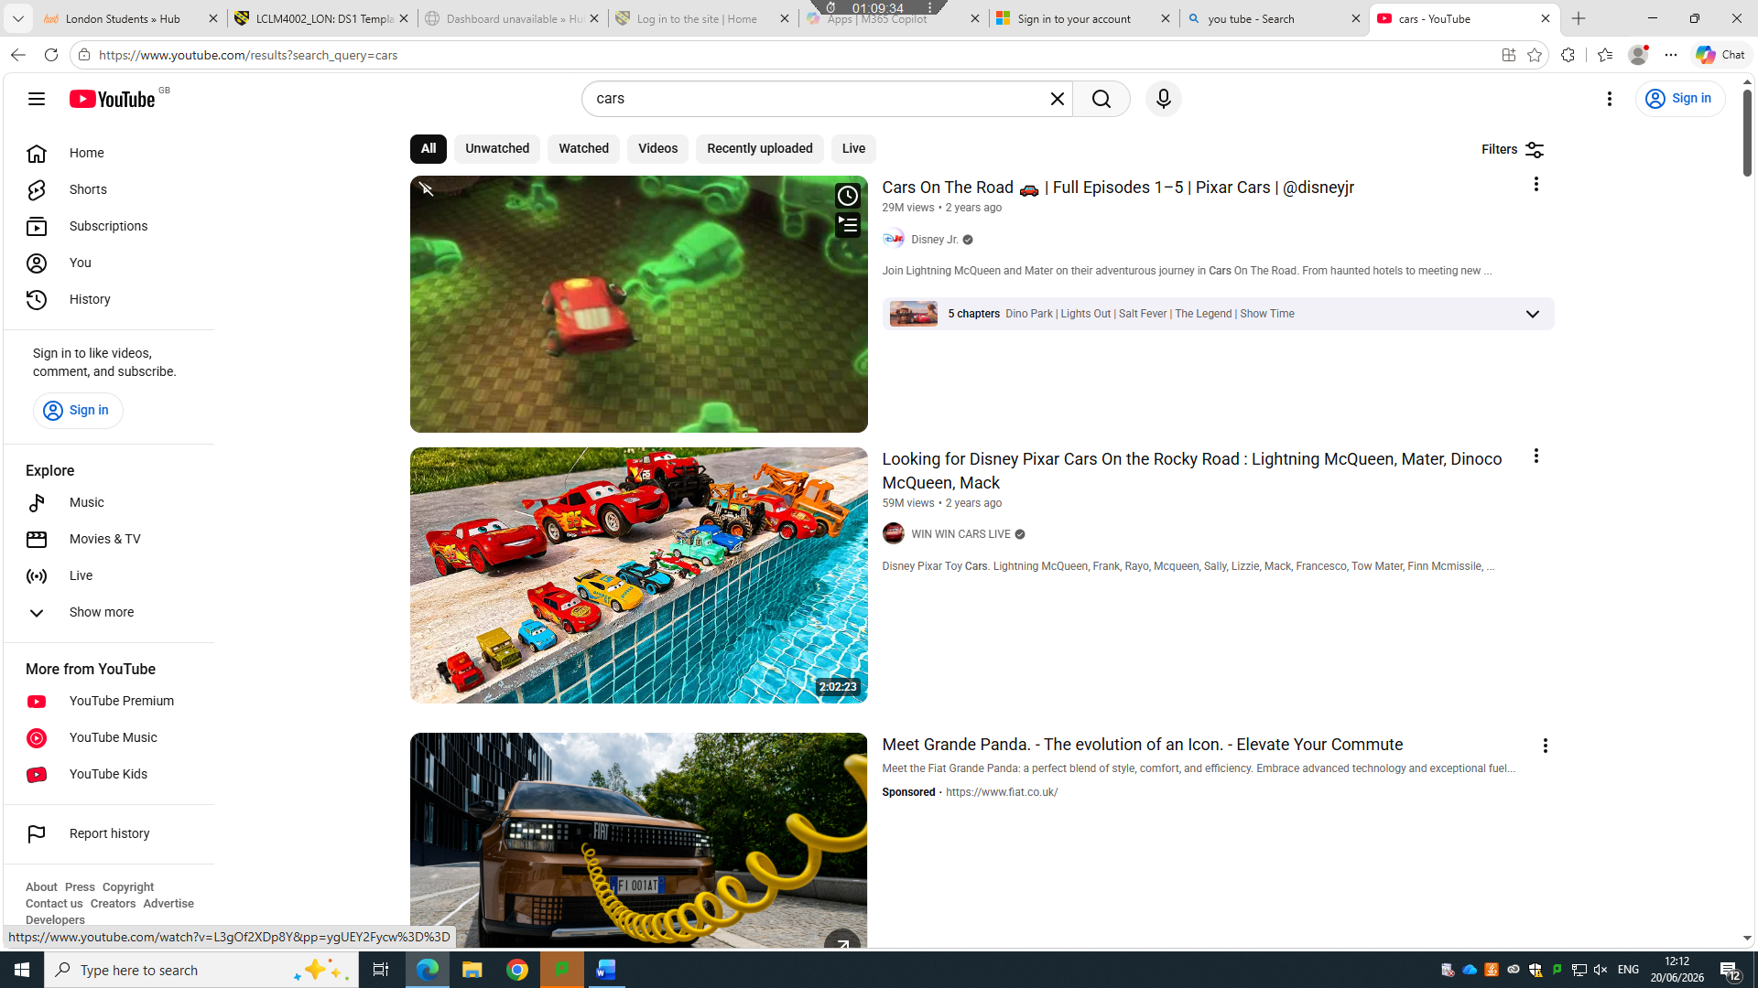
This photo shows interest in cars, as you know I am passionate about cars and I use YOUTUBE to watch Formule

Screenshot/Photo 4
[Insert Photo/Screenshot below]

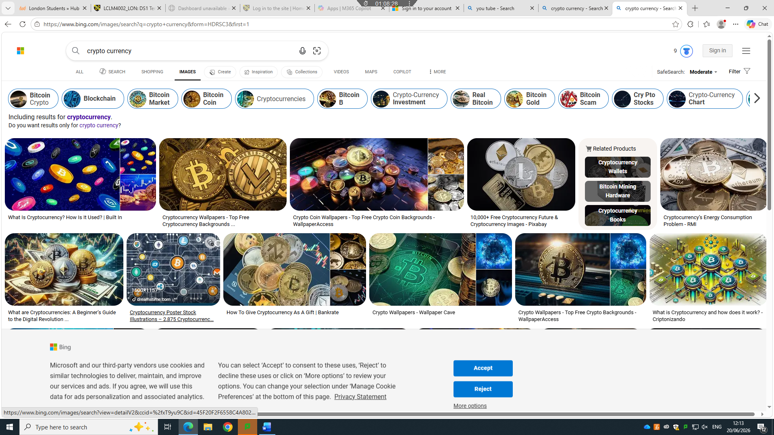This photo show my interest finance and business and the transformation of physical money to digital money such as crypto

Screenshot/Photo 5
[Insert Photo/Screenshot below]
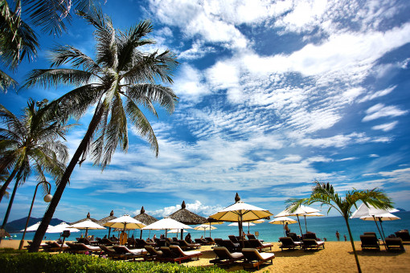
This photo show my interest in travel and holidays.

Digital skills are important for me because I use technology every day for university, communication and learning.

Submission Checklist
Before you submit, please check:
​​​ ☒ I added 4–6 screenshots
☒ I wrote short sentences for each screenshot
☒ I wrote my short reflection
☒ My work is my own
☒ My file opens correctly
​​☒ My file opens correctly

