
Program: CertHE Skills for the Workplace
Module Name: Effective Team Work and Communication
Module Code: BMSW4002

Assignment Title: Effective Team Work and Communication Assessment

Student Name: Mohmed Aarif Idris Patel
Student Number: 2120428
Lecturer Name: Lloyd Beharry

Contents
1. Introduction 3
2. Models of Communication 4
2.1 Shannon and Weaver’s Model 4
2.2 Schramm’s Model 5
2.3 Berlo’s Model 6
3. Communication Skills 7
3.1 Verbal Communication Skill 7
3.2 Non-Verbal Communication Skill 7
3.3 Listening Skill 7
4. Advantages and Disadvantages of Communication Technology 9
4.1 Advantages of Communication Technologies 9
4.2 Disadvantages of Communication Technology 10
Conclusion 11
References 12

1. Introduction
This report intends to exhibit the importance of communication in the current world setting. Communication is a term that can be defined as sensitive and important for each person, group, or organization. In daily life, people communicate with different entities for specific purposes, and communication will be effective if it is able to meet those purposes exactly as expected by the communicator. So, the study will assist in learning how to identify effective communication. This approach will discuss four popular models of communication and analyze which types of communication those models are applicable to. Besides, it will also cover how communication skills facilitate the development of effective communication. Thus, understanding the models and the importance of communication skills will aid someone to perform communication skills fruitfully. Finally, from the last section, users will be able to judge their communication approach, as that section includes an analysis of the advantages and disadvantages of communication technologies.

2. Models of Communication

2.1 Shannon and Weaver’s Model
It’s a mathematical theory mainly focused on the issues that arise within the channel of communication that connects both the sender and the receiver. This model is developed, including the sender, communication channel, and receiver. The main point highlighted in this model is the noise that may interrupt the sense of messages that the sender originally means to the receiver. The other two special terms within this model are the encoding and the decoding of messages. Encoding works like a transmitter of the sender’s message, while decoding refers to the retrieval of the original message (Al-Fedaghi, 2012). This model is mainly applicable for person-to-person communication, telephone conversation, radio broadcasting, etc., and the physical noise can occur due to technical issues, semantic issues, or effectiveness issues. This model suggests that by keeping attention to these issues, misunderstanding can be avoided. For example, kind of similar to Pedro and Maria’s case, in our workplace the HR manager telephoned one of our colleagues for a "redesign paper" for a project, but due to noise he heard it as a "resignation paper" (Baecker, 2013).
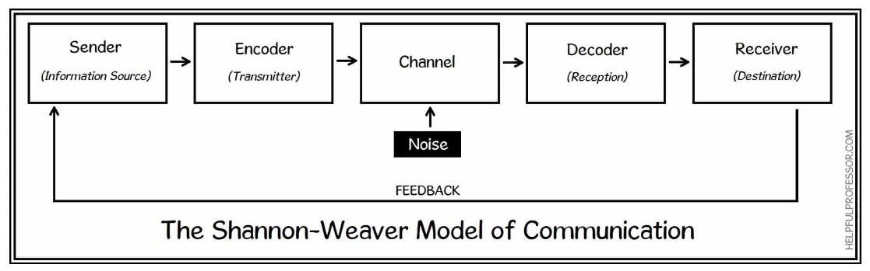
Figure: Shannon-Weaver Model of Communication
Sourcce: (Baecker, 2013)
Though, Shannon originally developed the model where feedback was not included later it was introduced by Weaver.

2.2 Schramm’s Model
It is a circular model of communication that avoids those issues of the traditional or linear model. Thus, it is a dynamic model where the sender and receiver communicate in a practical way. Using this model, the sender first encodes the message and forwards it to the receiver, who then decodes and interprets the message according to the original meaning. Noise or interruptions can also arise in the communication channel (Lin and Lin., 2020), but within this model, the interpreter plays a major role in retrieving the actual sense of the message that the sender wanted to convey. The receiver and interpreter here are mostly the same people. Another key characteristic of this model is the feedback, or receiver’s approach to contact with the sender to understand the meaning (Elleström, 2018). That’s why it’s known as the circular or dynamic model of communication. For example, through Schramm’s model, a colleague in the previous example may then ask the boss whether he meant "resignation" paper or something else. So, approaching through interpretation and feedback can help the receiver avoid interference in the communication.
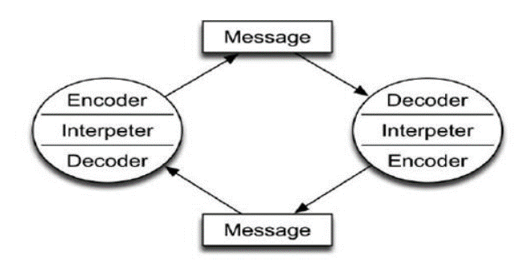
Figure: Schramm’s Communication Model
Source: (Lin and Lin., 2020)

2.3 Berlo’s Model
This model is identified as the simplest form of communication that only includes the exchange of messages from the sender to the receiver. Distinct from the previous models discussed, this model doesn’t include any feedback. And, noise or interference is also deemed as an integral part of the model, but unlike the earlier models in which noise can arise only in the communication channel, this model considers noise may arise even after the message is sent. Noise is classified here into two categories, i.e., internal and external. Internal noises arise within the communication channel. For example, due to the noise of the building construction, Pedro heard from Maria's’ Chicken 'as' Kitchen ’, which indicates an external noise mainly created by the background noise of the channel (Narula, 2006). However, internal noises arise due to the difference between the sender and the receiver in terms of their communication skills, attitudes, and knowledge of communication, culture, and social systems. Suppose, an invitation to drink wine may be considered a friendly message in European culture, while the same message may contain a negative vibe for a receiver from Arabian culture (difference in the social system). This model, unlike other models, considers a few aspects of each component of the model that are reflected in the picture below.
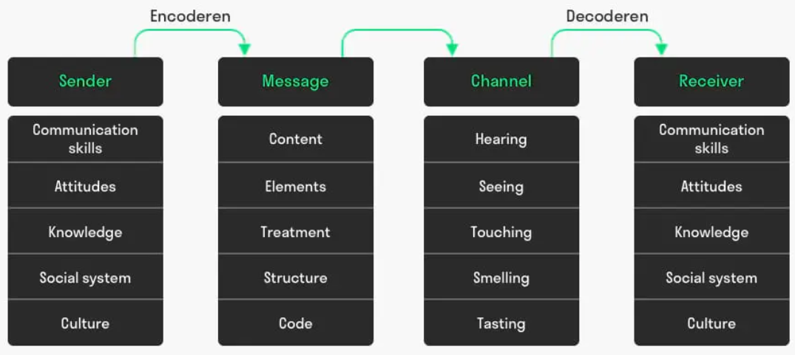
Figure: Berlo’s Communication Model
Source: (Narula, 2006)

3. Communication Skills
Communication is considered an important soft skill for working in an organization, thus communication skills include expertise in various modes of communication such as verbal communication, non-verbal communication, listening to others, etc. (McGunagle, and Zizka, 2020). So, this section includes an overview of these mentioned skills with appropriate references from the case studies discussed.

3.1 Verbal Communication Skill
Verbal communication refers to establishing communication with explicit sentences or languages in spoken or written form to express some ideas, opinions, or messages in the conversation. Thus, verbal communication is classified into two forms, i.e., spoken and written (Wahyuni et al., 2018). And because explicit messages are communicated here, the choice of words while writing or speaking plays a major factor in conveying the appropriate meaning properly (Vogel et al., 2018). Besides, the tone and pitch of the messages also have an impact on the other person. The case study ‘A Day with the Chief' demonstrates how verbal communication can have separate effects on the employees (McGunagle, and Zizka, 2020). Here, the chief’s tone of conversation while speaking provides a positive or negative vibe in appropriate cases in the organization. Besides, the chief exhibited his verbal presence in speaking mostly for informal tasks and appreciated written communication for official or formal communications.

3.2 Non-Verbal Communication Skill
Another significant part of effective communication skills is the expertise in non-verbal techniques for giving a message. That’s why a communicator’s expression, gestures, and body language mean a lot in communication (Vogel et al., 2018). For instance, within the above case study discussed, the chief’s body language while conversing with employees had a significant impact on them, reflecting the chief’s leadership quality (Coffelt et al., 2019). Besides, when the Chief appeared in the seminars or meetings, his body language was much more impressive to the audience, which facilitated him with proper attention from the audience for expressing his messages.

3.3 Listening Skill
Listening skills refer to how well the person communicating can understand or feel the meaning of the messages from the opposite person. Two types of listening skills are considered, i.e., active listening and empathetic listening. According to the case study, "Max the Multi-Tasker," active listening refers to paying attention to the messages of the opposite person and avoiding multi-tasking at the same time while listening (Vasanthakumari, 2019). For example, Max often exposed his attention to different tasks while communicating with someone, which, on reflection, hit the opposite person with ignorance, and communication thereby would result in ineffectiveness. Thus, active listening to others is important, besides empathetic listening, in this case, for additional success in communication (McGunagle, and Zizka, 2020). That actively seeks to make the communicator feel the actual scenario encountered by the person speaking. As a result, an appreciating situation develops within the communication, and both parties feel sympathetic for successfully establishing the communication.

4. Advantages and Disadvantages of Communication Technology
With the help of technology, communication systems have expanded their range into a broader field. The technological aspects that facilitate communication between people or groups are known as "communication technology. The recent pace of the scientific revolution has gifted the world with a lot of technologies to communicate (Okundaye et al., 2019). For instance, social media, emails, mobile devices, computers, network websites, and so on. That is why communicating with someone at a great distance is now simple, but the setups or complexities within technological systems include significant communication disadvantages. Thus, the current section intends to analyze these related advantages and disadvantages.

4.1 Advantages of Communication Technologies
Communication gets faster- New technologies have derived ways of making faster communication. For example, a mobile sim network can connect two or more people just within a moment (Widjaja et al., 2020). Using email, someone can send a message in just a second and the receiver can also reply as fast as the sender does.
Communication can be made between a longer distance- Even some decades back, which was literally insensible, now due to the advancement of technology, it can be possible within a glimpse of the eye (Ibrahim et al., 2019). Communication technologies have connected people residing in different parts of the world. So, the distance between the sender and receiver is the only thing of consideration while communicating.
Visual appearance- Beyond audio messages, technologies have replaced communication ideas; visual appearance in the communication process is now becoming increasingly important (Okundaye et al., 2019). And it’s added a new dimension to every type of communication. (e.g., business, education, personal, social, administrative, etc.).
Reduced noise or interference in the channel- Technologies have made it easier for communication channels to work, so bugs or noises made by the system are becoming much less common (Widjaja et al., 2020).
Mass communication- Technologies have aided in the replacement of communication systems that supported only a limited number of participants, allowing for mass communication among groups or organizations (Ibrahim et al., 2019). For example, online classes, live shows, virtual meetings, etc. can connect a large number of people and support multi-participant feedback.

4.2 Disadvantages of Communication Technology
Complex user-interface for some people- Especially for the older generation, they find the interface of communication channels critical with a lot of features that may not be understandable for everyone.
Issues for data security- Technologies facilitate civilization with a lot of support nowadays. Advanced technological systems are reportedly claimed for data leakage (Stepnov, 2021), and the controllers of the systems are often engaged in unethical practices that endanger the personal safety or security of the users.
Cyber-bullying and Cyber Skyping- Cyber-bullying refers to harassment or bullying that takes place through an electronic medium. Communication technologies widen the platform for these types of social demerits (e.g., threatening texts, emails, rumors, etc.) (Okundaye et al., 2019). Aside from that, cyber-skyping is an attack on private information by a hacker who wants to do bad things.
Though many more disadvantages also exist, those can create the most serious issues for effective communication.

Conclusion
This report reflects various terms of communication and analyzes the understanding of communication models, skills, and technologies. Thus, divided into three sections, this study has defined three different models of communication and highlighted significant distinctions among those models. The next section, which it has covered, is a discussion on communication skills. Thus, communication skills are important for facilitating effective communication, and based on this concept, what types of skills can really add value are also described, in addition to referring to some case studies. In a special section, we talk about communication technologies and how they have changed the way people talk to each other. We also talk about the pros and cons of the communication technologies that most people use.

References
Al-Fedaghi, S., 2012. A conceptual foundation for the Shannon-Weaver model of communication. International journal of soft computing, 7(1), pp.12-19.
Baecker, D., 2013. Systemic theories of communication. Handbooks of communication science, 1, pp.85-100.
Lin, X. and Lin, C., 2020, March. Communication theories applied in mentimeter to improve educational communication and teaching effectiveness. In 4th International Conference on Culture, Education and Economic Development of Modern Society (ICCESE 2020) (pp. 870-875). Atlantis Press.
Elleström, L., 2018. A medium-centered model of communication. Semiotica, 2018(224), pp.269-293.
Narula, U., 2006. Communication models. Atlantic Publishers & Dist.
Wahyuni, L.M., Masih, I.K. and Rejeki, I.M., 2018. Communication skill attributes needed for vocational education enter the workplace. In Journal of Physics: Conference Series (Vol. 953, No. 1, p. 012111). IOP Publishing.
Coffelt, T.A., Grauman, D. and Smith, F.L., 2019. Employers’ perspectives on workplace communication skills: The meaning of communication skills. Business and Professional Communication Quarterly, 82(4), pp.418-439.
Vasanthakumari, S., 2019. Soft skills and its application in work place. World Journal of Advanced Research and Reviews, 3(2), pp.066-072.
McGunagle, D. and Zizka, L., 2020. Employability skills for 21st-century STEM students: the employers' perspective. Higher education, skills and work-based learning.
Vogel, D., Meyer, M. and Harendza, S., 2018. Verbal and non-verbal communication skills including empathy during history taking of undergraduate medical students. BMC medical education, 18(1), pp.1-7.
Ibrahim, S.K. and Jebur, Z.T., 2019. Impact of information communication technology on business firms. International Journal of Science and Engineering Applications, 8(2), pp.53-56.
Widjaja, B., Sumintapura, I. and Yani, A., 2020. Exploring the triangular relationship among information and communication technology, business innovation and organizational performance. Management Science Letters, 10(1), pp.163-174.
Stepnov, I., 2021. Advantages and Challenges of Digital Technology. In Technology and Business Strategy (pp. 295-308). Palgrave Macmillan, Cham.
Okundaye, K., Fan, S.K. and Dwyer, R.J., 2019. Impact of information and communication technology in Nigerian small-to medium-sized enterprises. Journal of Economics, Finance and Administrative Science.

