

Assignment title: Critical Evaluation of the Mental Health Awarenesses Campaign Project

Module Name: Managing Projects in the Organisation (BMSW5009)

Lecturer Name: Giulia Chifari

Student Name: Sanda-Ionela Vica (2410012)

Submission date: Friday 3rd of July 2026

Word Count: 2195

Table of Contents

Table of Contents 2
Executive summary 3
Introduction 4
Findings 5
Critical discussion of project management tools and techniques in general 7
Critical discussion of how those tools were used in the project 9
Communication and stakeholders 13
Conclusion 15
Future Improvements 16
References 18

Executive summary

This report critically evaluates the management of a student-led Mental Health Awareness Campaign at UWTSD. The campaign aimed to raise awareness of student mental health, promote wellbeing support and support Mind through voluntary donations. Overall, the project achieved its purpose and showed strong teamwork, creativity and adaptability. However, the management process could have been stronger in early stakeholder identification, approval planning, active risk review and impact evaluation.
The WBS, Gantt chart, risk register, Iron Triangle and Power-Interest Grid were appropriate tools, but their value depends on how early and how actively they were used. The project operated within a £200 student team budget, which helped keep the scope realistic.
The report recommends earlier approval confirmation, more active risk monitoring, clearer communication responsibilities, and structured feedback collection in future projects.

Introduction

This report critically evaluates the management of the Mental Health Awareness Campaign delivered by a student project team at UWTSD. The project aimed to raise awareness of mental health among university students, encourage conversations around wellbeing, promote available support services and support Mind through voluntary donations. This was relevant because student mental health remains a significant issue. Auerbach et al. (2018) found that 31.4% of first-year university students in their international study screened positive for a common mental health disorder, supporting the need for awareness and signposting in higher education.
The project objectives were to create awareness materials, promote the campaign trough social media, engage students through an information stand, communicate with university wellbeing services, and provide a suitable donation route. Within the project team, I acted as Project Leader and was responsible for coordinating key activities, supporting communication, developing promotional materials and helping to maintain progress. Other team members contributed through printing, promotional T-shirts, refreshments, and event delivery.
Clegg, Skyttermoen and Vaagaasar (2020) argue that project management should create value, not simply complete activities.
Therefore, this report focuses on how effectively the project was managed, how the tools supported delivery, where their use could have been stronger, and what should have been improved.

Findings

The project followed the main lifecycle stages: initiation, planning, delivery, monitoring, and closure. Initiation gave the campaign a clear awareness purpose and helped prevent the scope from becoming too broad, which is important because weak scope definition can create confusion later in delivery (Turner, 2014). However, approval requirements could have been confirmed earlier.
A key scheduling issue was that the event had to be rescheduled because university operations were not identified early enough as an approval stakeholder. This did not reduce the value of the campaign, but it showed that approval requirements needed clearer inclusion in the schedule and risk planning. This links to Heagney’s (2016) view that effective project planning should anticipate uncertainty before it affects delivery.
Planning was supported by a WBS, Gantt chart, risk register, Power-Interest Grid and budget decisions. These tools helped organise the campaign, but control was stronger over tasks directly managed by the team, such as leaflets, social media, T- shirts and refreshments. Approval and charity arrangements were less predictable because they depended on external stakeholders.
The project budget was £200, which helped keep the scope realistic. It covered printed materials, T-shirts, refreshments, and the donation element, encouraging the team to focus on a manageable awareness event rather than a larger fundraising activity requiring more time, approval, and resources. However, the cost dimension could have been clearer earlier when deciding what was realistic within the budget.
Delivery was successful because the team adapted and kept the campaign moving. The donation element showed problem-solving from the project leader. The team initially hoped to arrange donations through the university, but this was not possible due to university processes. The project leader therefore identified Mind as a suitable charity, created a donation QR code and promoted it through campaign materials and social media. This protected the donation objective while keeping the project realistic within the available time and resources.
The closure stage included positive LinkedIn feedback, team reflection and support for Mind through donations. The donation link allowed some people to contribute, and the team also donated £100 to Mind, showing support beyond awareness-raising. Although structured feedback was not collected from students during the event itself, which limited the evidence available to measure direct impact, the campaign was still positively received online and created a meaningful contribution to student wellbeing awareness. This gave the closure stage a positive outcome, while also highlighting how future campaigns could strengthen evaluation.

Critical discussion of project management tools and techniques in general

Project management tools create structure, but they do not guarantee effective control. Their value depends on whether they are used to test assumptions, manage risk and support decisions (APM, 2019).
A WBS can improve clarity by breaking the project into manageable work packages (PMI, 2021). Burke (2013) argues that this supports planning because deliverables become visible. However, the WBS is less effective if it focusses only on tasks and does not connect with risks, approvals and stakeholder dependencies.
A Gantt chart supports sequencing and progress monitoring, especially where teams need a shared view of deadlines (Kidston, Haward and Association for Project Management, 2015). However, Wysocki (2014) argues that fixed schedules can create false certainty when uncertainty is high. Therefore, assumptions must be reviewed and contingency time included.
The Iron Triangle helps managers balance time, cost and scope (Lock, 2020). It is useful for judging whether an idea is realistic, but it can be narrow. Atkinson (1999) argues that project success should not be judged only by time, cost and quality. Meredith and Mantel (2009) also suggest that stakeholder satisfaction and wider value matter, especially in an awareness campaign where impact and engagement are central.
Stakeholder analysis is essential because projects are shaped by people and influence. Freeman (1984) explains that stakeholders can affect or be affected by project activity. A Power-Interest Grid helps prioritise communication, but Mitchell, Agle and Wood (1997) argue that stakeholder importance can change depending on power, legitimacy and urgency.
Risk management is also important because uncertainty can affect even small projects. Kerzner (2022) argues that project control depends on identifying and responding to risks throughout delivery. A risk register is useful only when it is active, reviewed and linked to decisions. If it is created but not updated, it becomes more of a record than a control tool.

Critical discussion of how those tools were used in the project

The WBS seen in Figure 1, helped the team divide the campaign into planning, promotion, stakeholder communication, materials, refreshments, and post-event work. Its main strength was that it gave the project structure and made responsibilities easier to understand. However, its use could have gone further. Approval requirements and donation feasibility were not connected clearly enough to the risk register and schedule at the beginning. This meant the WBS helped organise work but did not fully expose the risks most likely to affect timing.

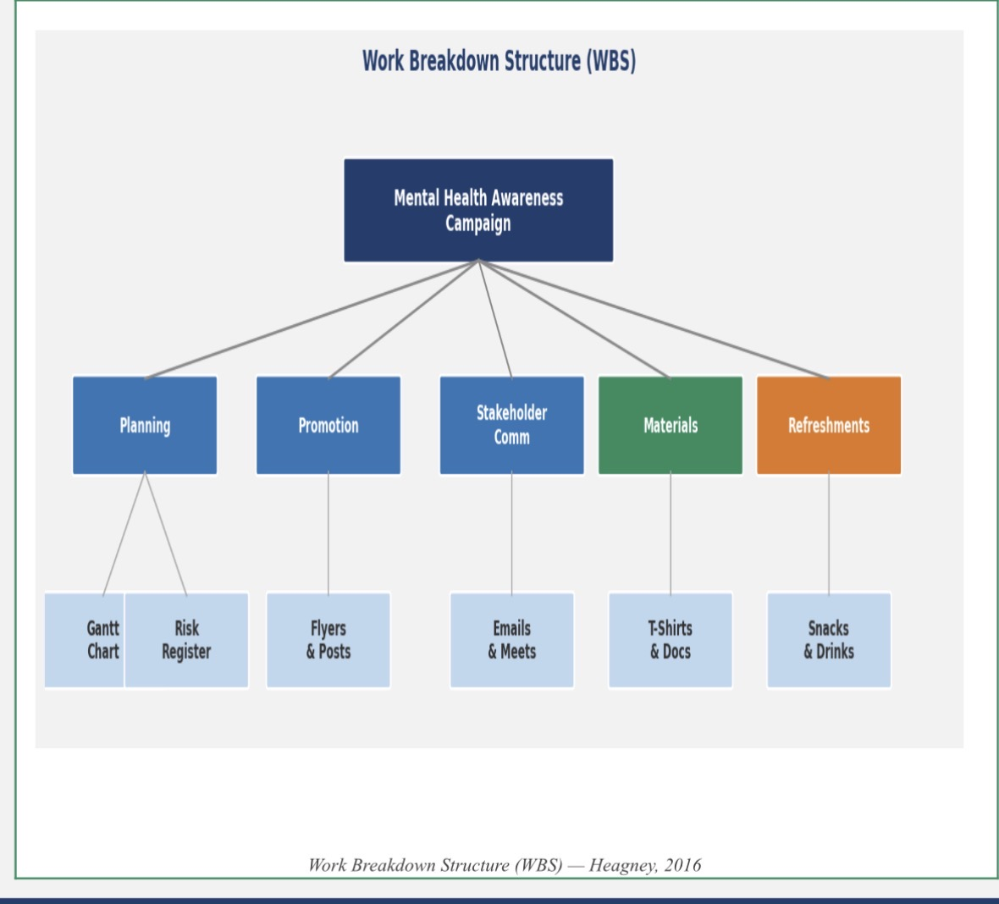
Figure 1: Work Breakdown Structure for the Mental Health Campaign
Source: Author’s own work (2026), informed by Heagney (2016).

The Gantt Chart seen in Figure 2, was effective for monitoring the campaign timeline because it showed preparation, promotion, Mind donation activities, event logistics, and post-event tasks. It helped the team see the event date as a key milestone and coordinate work around it. However, the need to reschedule showed that approval time had not been built into the schedule clearly enough. This was not a weakness of the Gantt chart itself, but of the early information used to build it. Reiss (2015) argues that project plans must remain realistic and flexible, which was important in this project.

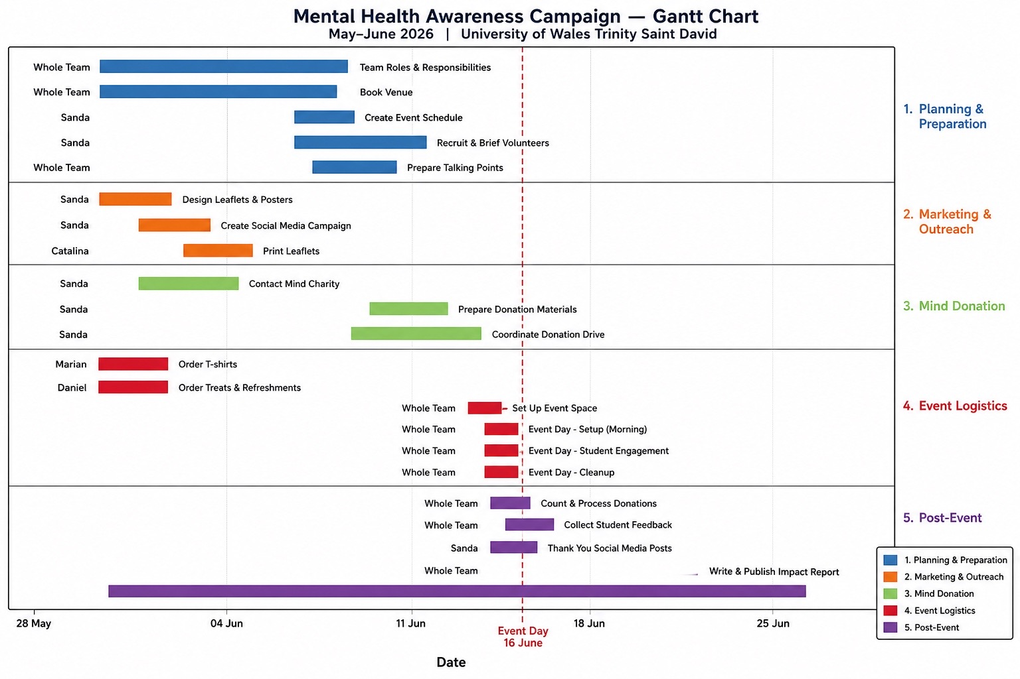
Figure 2: Gantt Chart for the Mental Health Awareness Campaign
Source: Author’s own work (2026).

The risk register was appropriate, but it could have been used consistently.
Approval delays, donation restrictions and stakeholder response times should have been treated as key risks early. A stronger approach would have included risk owners, review dates and trigger points. For example, if approval or donation arrangements were not confirmed by a set date, the alternative plan could have been activated sooner. This would have reduced delivery pressure.
The Iron Triangle helped keep the campaign realistic. A larger fundraising event would have increased the scope and required more time, approval, and resources. Keeping the project focused on awareness and voluntary donations was therefore sensible. However, this tool could have been used more formally during initiation to compare donation options and confirm the most suitable route within the available time, cost and scope.
The Power-Interest Grid seen in Figure 3, helped identify important stakeholders, including the sponsor, wellbeing team, students, university approval/operations, Mind, staff and the wider public. Its main value was showing that stakeholders did not need the same level of communication. However, university operations needed earlier attention because their approval role affected the schedule. Bourne (2015) argues that stakeholder engagement should be continuous. In this project, the grid was successful, but regular updates would have reflected changes in stakeholder influence more accurately.

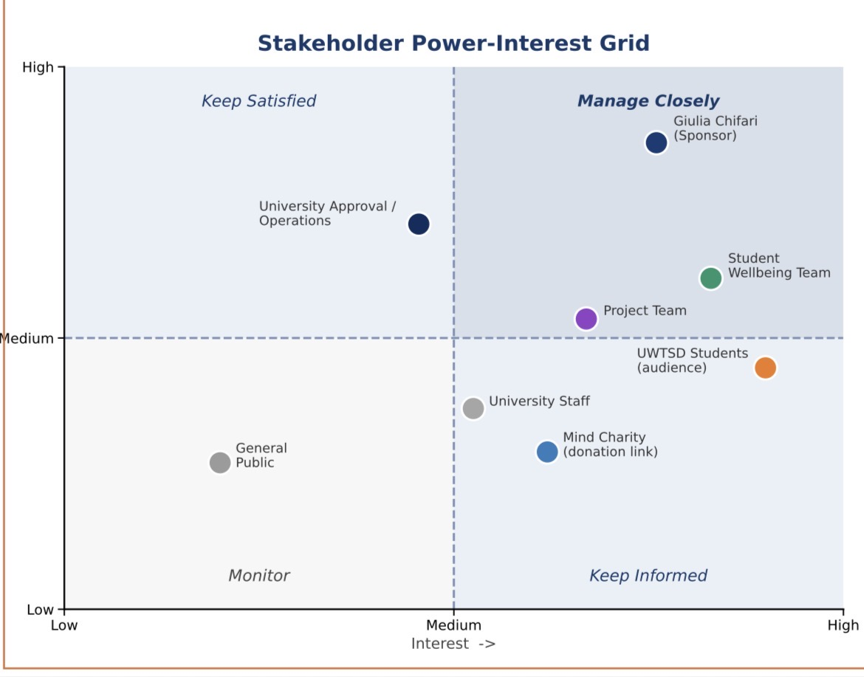
Figure 3: Stakeholder Power – Interest Grid for the Mental Health Awareness Campaign
Source: Author’s own work (2026).

Overall, the tools supported the project, but their application needed earlier review and stronger links between them. The campaign succeeded because the team adapted well, but the process would have been stronger if stakeholder analysis, risk planning and scheduling had been integrated from the start.

Communication and stakeholders

Communication was a strength of the project because different channels were used for different audiences. Social media, LinkedIn, leaflets, and face-to-face engagement were suitable for students and staff, while email was more appropriate for formal contact with wellbeing services. Maylor (2010) argues that communication should match stakeholder needs, which was mostly achieved.
Students were the main beneficiaries because the project aimed to raise awareness and signpost support. However, they had limited power over whether the event could take place.
Giulia Chifari, the project sponsor, and university operations had greater influence because they could guide or approve activities. The wellbeing team had specialist expertise, while Mind had lower direct control but became important because it gave the campaign a clear charity focus.
The project leader’s role was important in maintaining momentum. Northouse (2022) argues that leadership involves influencing people towards a shared goal. This was shown through coordination, communication, and responsibility for the campaign’s social media promotion, including creating and managing adverts and posts. The project leader also developed the Mind donation QR code, demonstrating creativity and practical problem-solving.
The main communication weakness was timing rather than effort. Approval routes and donation requirements should have been confirmed earlier because they affected the event schedule and campaign materials. Aaltonen and Kujala (2016) argue that stakeholder landscape are dynamic, and this project showed that clearly because university operations became more important once approval affected timing.
Evaluation communication was also limited. Although positive LinkedIn feedback was received and team feedback was completed after the event, structured feedback from students during the campaign was missed. Gibbs (1988) argues that reflection supports learning, but reflection is stronger when supported by evidence. Without event feedback, the team could reflect on delivery and teamwork but could not fully measure the campaign’s impact on student awareness.
Teamwork remained a clear strength. Belbin (2010) argues that effective teams benefit from complementary roles, while Tuckman (1965) suggests that teams develop through stages before performing effectively. The team worked well in a short timeframe, but clearer responsibility tracking would have reduced reliance on informal flexibility.

Conclusion

The Mental Health Awareness Campaign achieved its main aim by raising awareness of student mental health, engaging the university community, and directing support towards Mind through voluntary donations. The event was meaningful, visible and delivered through strong teamwork, creativity and adaptability under time pressure.
The project management tools applied – the WBS, Gantt chart, risk register, Iron Triangle and Power-Interest Grid were appropriate choices and collectively supported planning, scheduling, and stakeholder communication throughout the lifecycle. However, the critical learning from this project is not whether the tools were used, but how early and how actively they were applied.
The rescheduling of the event demonstrated that approval requirements, stakeholder dependencies and foreseeable risks needed earlier identification and stronger integration across all planning tools from the outset.
The Iron Triangle helped maintain a realistic scope within the £200 budget, but cost could have been used more deliberately as a planning control from initiation.
Communication was largely effective, but the absence of structured event feedback limited the team’s ability to measure impact beyond informal observation.
The five recommendations – earlier stakeholder mapping, a live risk register, contingency scheduling, a formal communication plan and structured post-event evaluation – are therefore directly connected to the gaps identified in the management process. Addressed together, they would not change the outcome of this campaign, which was successful, but they would make a successful outcome more assured, more evidence-based and less dependent on the team’s ability to adapt under pressure.

Future Improvements

As Project Leader, I recognised that approval requirements should have been confirmed earlier. In future projects, I would identify stakeholders with approval power and include their response times in the schedule. This would reduce uncertainty and strengthen stakeholder control, as influence can change during a project (Aaltonen and Kujala, 2016).
The risk register should become a live control tool containing risk owners, review dates, impact levels and contingency actions. This supports Kerzner’s (2022) view that control requires risks to be identified and addressed.
The Gantt chart should include contingency time for external responses and permissions. Wysocki (2014) argues that fixed schedules can create false certainty under uncertainty; therefore, schedules should remain flexible and regularly reviewed.
A communication plan should identify who contacts each stakeholder, what requires confirmation and when follow-ups should occur. Hollister (2017) highlights the importance of clear communication responsibilities.
Future campaigns should gather structured feedback through a QR survey, feedback cards or engagement counts. This would strengthen impact evidence and support reflection (Gibbs, 1988).
The resulting development actions are summarised in Table 1.

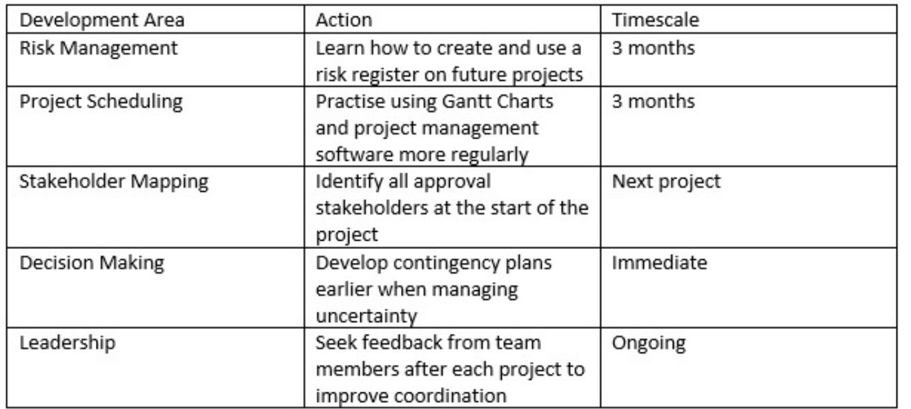
Table 1: Personal Development Action Plan
Source: Author’s own work (2026).

References

Aaltonen, K. and Kujala, J. (2016) ‘Towards an improved understanding of project stakeholder landscapes’, International Journal of Project Management, 34(8), pp. 1537–1552.
Association for Project Management (APM) (2019) APM Body of Knowledge. 7th edn. Princes Risborough: Association for Project Management.
Atkinson, R. (1999) ‘Project management: cost, time and quality, two best guesses and a phenomenon, its time to accept other success criteria’, International Journal of Project Management, 17(6), pp. 337–342.
Auerbach, R.P. et al. (2018) ‘WHO World Mental Health Surveys International College Student Project: prevalence and distribution of mental disorders’, Journal of Abnormal Psychology, 127(7), pp. 623–638. https://doi.org/10.1037/abn0000362.
Belbin, R.M. (2010) Team Roles at Work. 2nd edn. Oxford: Butterworth-Heinemann.
Bourne, L. (2015) Making Projects Work: Effective Stakeholder and Communication Management. Boca Raton, FL: CRC Press.
Burke, R. (2013) Project Management: Planning and Control Techniques. 5th edn. Chichester: Wiley.
Clegg, S.R., Skyttermoen, T. and Vaagaasar, A.L. (2020) Project Management: A Value Creation Approach. London: SAGE.
Freeman, R.E. (1984) Strategic Management: A Stakeholder Approach. Boston, MA: Pitman.
Gibbs, G. (1988) Learning by Doing: A Guide to Teaching and Learning Methods. Oxford: Oxford Polytechnic Further Education Unit.
Heagney, J. (2016) Fundamentals of Project Management. 5th edn. New York: AMACOM.
Hollister, S. (2017) Project Management: A Quick Start Beginners Guide for Easily Managing Projects the Right Way. CreateSpace Independent Publishing Platform.
Kerzner, H. (2022) Project Management: A Systems Approach to Planning, Scheduling, and Controlling. 13th edn. Hoboken, NJ: Wiley.
Kidston, P., Haward, K. and Association for Project Management (2015) Planning, Scheduling, Monitoring and Control: The Practical Project Management of Time, Cost and Risk. Princes Risborough: Association for Project Management.
Lock, D. (2020) Project Management. 11th edn. Abingdon: Routledge.
Maylor, H. (2010) Project Management. 4th edn. Harlow: Pearson Education.
Meredith, J.R. and Mantel, S.J. (2009) Project Management: A Managerial Approach. 7th edn. Hoboken, NJ: John Wiley & Sons.
Mitchell, R.K., Agle, B.R. and Wood, D.J. (1997) ‘Toward a theory of stakeholder identification and salience: defining the principle of who and what really counts’, Academy of Management Review, 22(4), pp. 853–886.
Northouse, P.G. (2022) Leadership: Theory and Practice. 9th edn. Thousand Oaks, CA: SAGE.
Project Management Institute (PMI) (2021) A Guide to the Project Management Body of Knowledge (PMBOK Guide). 7th edn. Newtown Square, PA: Project Management Institute.
Reiss, G. (2015) Project Management Demystified. London: Routledge.
Tuckman, B.W. (1965) ‘Developmental sequence in small groups’, Psychological Bulletin, 63(6), pp. 384–399.
Turner, J.R. (2014) The Handbook of Project-Based Management. 4th edn. New York: McGraw-Hill Education.
Wysocki, R.K. (2014) Effective Project Management: Traditional, Agile, Extreme. 7th edn. Indianapolis, IN: Wiley.

