Student Number and Name:
Cristina Tudureanu (1917153)
Ionut Tudureanu (1917144)
Minodora- Violeta Duluman (1919047)
Cosmin- Daniel Popa (1919080)
Anda- Maria Mircevi (1920426)
Programme : BA Business Management Level 4
Module: Introducing the Modern Workplace/ LCBB4003
Assignment Title: Assessment 2
Module Lecturer: Mr. Gregory Cowan

Introducing the Modern Workplace
Group presentation

Table of Contents
Executive Summary……………………………………………………….…………….. 3
Introduction 4
Tesco Company Overview 5
Goals and Objectives 8
Management and Leadership behaviour 12
Team and Group Behaivour 16
Motivation and Perception 20
Conclusion 25
PowerPoint Presentation 26
Reference 33

Executive Summary

The report examined the background of the project and is showing the overview of Tesco. The operations of Tesco are mainly based on four parts that include retailing service, global presence, nonfood sector and core industry of the UK, basically the history of Tesco. The report also shows that Tesco diversified their ranges of products based on general merchandise, groceries by comprising insurance, banking, telephone equipment, airtime and electrical goods.
The report explains the objectives and goals of Tesco, discusses the importance of setting goals and objectives in Tesco and it explains the way objectives and goals are established in company.
Furthermore, explains the behaviour of leadership and management in Tesco and the behavioural management approach. The report explains the variables that affect the leadership and management behaviour and it examines the leadership role in business. It discusses several factors that affect the behaviour of individuals in the Tesco.
The report explains the group and team behaviour in Tesco. It explains the major factors that affect the group and team behaviour and it also discusses the relevance of group and team behaviour in the business organisation.
The last part of the report explains motivation and perception, what determines the importance of motivation and perception in Tesco and it also examines the factors that affect perception and motivation in the business.

Introduction

As a project leader, Cristina Tudureanu explains the project background and discuss the company overview of Tesco. The report shows that Tesco started to expand its product ranges during the year 1960 by including clothing and household goods under the brand name of Delamare. It also shows that Tesco has a total of 200 stores that range from large extra hypermarket stores to the outlets of the high street. (Rosnizam et al., 2020).
Ionut Tudureanu being a group member examines the several goals and objectives set by Tesco, discuss the importance of setting goals and objectives in Tesco and further explains the way objectives and goals are established in Tesco.
Minodora-Violeta Duluman being a group member determines the importance of leadership and management behaviour in Tesco. It discusses several factors that affect the behaviour of individuals, define the behavioural management approach that shows the relation of the human aspect by examining the way business productivity depends on levels of workforce motivation. Furthermore, it explains the variable that affects the leadership and management behaviour in Tesco and examines the leadership role in business.
Cosmin-Daniel Popa being a member of the group discusses the behaviour of the group and team in Tesco and the importance of group behaviour. It explains the major factor that affects group behaviour in Tesco and then explains the factors and significance of team behaviour in Tesco.
Anda-Maria Mircevi being a member of the group explains the motivation and perception aspects in Tesco, the several factors that affect the motivation and perception of Tesco and further, explains the importance of motivation and perception in the Tesco.

Company Overview (Tesco)

Tesco is a multinational grocery company which was relatively founded in the year 1919. Jack Cohen is the key person who founded this company. Today is the world's largest retailer in terms of business gross revenues. Tesco is a public limited company operating in the retail sector (Rosnizam et al., 2020). It has a total of 6800 stores and shops in the global world. John Allan is the chairperson while Dave Lewis is the CEO of the Tesco Company (Park, 2017).

Tesco is the biggest British supermarket in the UK that dominates in the worldwide revenues and domestic shares of the market. It majorly operates its business in food segments but expanded the scope of its operations to consumer electronics, financial services, telecoms and garments. The operations of Tesco are mainly based on four parts that include retailing service, global presence, nonfood sector, and core industry of the UK. Tesco often has a brilliant team of management and operational strategies (Mooney, 2019). Tesco aims at increasing the client's value by earning the reliability in the time.

The position of Tesco as a leading global brand is clearly illustrated by its expansion of operations into 12 countries including China, Czech Republic, India, Malaysia, Ireland, Hungary and Poland. In 2013 Tesco employed in excess of 530,000 colleagues as the company leaders have always set high standards and clear goals, never settling for anything less than the best. (Business Case Studies, 2019).

In the year 1995, the company overtook the business of Sainsbury that is the largest supermarket in the UK. Tesco often engaged 15.6% of the groceries in the retail market of the UK and become the manager of the market with 6% that is the enormous share. The brand of the Tesco firstly appeared in 1924. When Jack Cohen buys tea shipment from Thomas Edward Stockwell then the name of Tesco firm was formed (Vu, 2006). Jack Cohen made certain new labels by significantly using the name of suppliers that is TES and the last two letters of his surname that is CO. This combination of words gave name Tesco that is the largest grocery Retailer Company in the UK. Jack Cohen opened his first shop in the year 1931 that was located at Watling Street in the Burnt Oak. Tesco floated on LSE in the year 1947 as with the name Tesco Holdings Limited.

The first shop of self-service was opened by Jack Cohen in the year 1956 at St Alban's. He opened the first supermarket in the year 1956 at Maldon. In the year 1961, Tesco Leicester made larges shop records in Europe as an appearance in Guinness Book (Alam and Raut-Roy, 2019). Tesco started to expand its product ranges during the year 1960 by including clothing and household goods under the brand name of Delamare. In the year 1974, Tesco opened its first petrol station.

Tesco also involved itself in the retailing of Internet groceries by significantly obtaining 35% based on their grocery works. Tesco purchases the hypermarket of 13 HIT in the year 2002 in Poland (Park, 2017). This hypermarket made a major move in the shop market of the UK. It purchased the C 2 network in Japan in June 2003. Tesco acquired the majority of its stakes in the chain of Turkish supermarkets. Tesco Lotus was a joint venture that faces much criticism based on hypermarket growth that was later sold in the year 2003.

The core purpose of Tesco is to become the customer champion in the retail industrial market by providing better quality goods for making the consumer lives easy (Wood et al., 2017). The individuals in Tesco work in a team by sharing their expertise, experiences, and knowledge. Tesco effectively looks towards the worker's and customers' culture by trusting their prominent values. Tesco made a positive contribution to the members of the community where it operates their business (Alam and Raut-Roy, 2019). Tesco increasingly listens to its customer requirement and workers' need by using major disposal tools like club cards and social media that help them to change and develop innovative new business ideas.

The main motive of Jack Cohen Company was “high piling by cheap selling”. He later added an internal motto in his business that was "You cannot operate the business by setting on Arse". Tesco planned to move towards the US by relatively opening a small formatted grocery shop chain in the western states like Nevada, California, and Arizona. He named this shop as Fresh and Easy (Awadari and Kanwal, 2019). Tesco often introduced a branded club and loyalty card and later the service of internet shopping in the year 1995 (Evans and Mason, 2018). When Tesco completed their takeover of Hostile in northern England then this way of expanding its store presence in Scotland was relatively weaker than England (Sparks, 2019).

Tesco has expanded its business with a major combination of new stores and retail services by adapting the customer's needs. Their primary aim was serving customers by making them happy. This aim of Tesco was more effective in terms of cost than acquiring a new objective. Tesco has a total of 200 stores that range from large extra hypermarket stores to the outlets of the high street (Vu, 2006). Tesco diversified their ranges of products based on general merchandise, groceries by comprising insurance, banking, telephone equipment, airtime, and electrical goods. This diversification leads the customers to shop at one place and store and their internet website attracts many users daily (Eastmure et al., 2020).

Tesco’s ‘Every Little Helps’ philosophy puts customers, communities and employees at the heart of everything it does. It prides itself on providing a great shopping experience for every customer it serves, whether in stores, online or in its many other service provisions.
Also, companies, like Tesco, that enjoy long-term success, are focused businesses and have a core vision that remains constant while the business strategies and practices continuously adapt to a changing world. In an increasingly competitive global environment, without a clear vision a business will lack direction and may not survive.
In other words, Tesco’s vision is to be the most highly valued business by the customers we serve, the communities in which we operate, our loyal and committed colleagues and of course, our shareholders. (Business Case Studies, 2019).

Goals and Objectives

The objectives and goals of the company help business reach the intended target by effectively utilizing their resources and time to make progress in the future. Without setting the objectives and goals, it will be difficult to determine certain tasks, jobs, promotions, and milestones. The goals and objectives underlie all the activities of strategic options and planning (Marzano, 2010).

Goals are considered as general guidelines of the business that explains their core purpose. The goals of the business usually represent the desired result and future that individuals plan, commit, and envision to attain (Elliot and Hulleman, 2017). Business endeavors to reach their goals within a certain time frame by setting deadlines.

Objectives explain the implementation steps and strategies for attaining the defined business goals. The objectives of the business are usually measurable, specific, and have a timeframe. Objectives are something that is neither imagined nor real. Objectives are the specific results that business aims to achieve within a particular fixed time frame with available resources(Acur, 2003).

For instance, an organisation's goal can be to grow their business revenues while its objectives can be to introduce new products for some years (Naidoo and Fisher, 2020). There can be more objectives of the business like increasing business revenue by some percentage in the coming years or reduce the cost of overhead by x% in the years.

Objectives and goals of Tesco
Tesco's objective lies in becoming innovative and energetic for taking business risks so that customer lives and experiences can be improved. Their goal lies in earning staff respect for such objectives and to appreciate the efforts made by them for achieving such business objectives. Tesco's goals lie in developing a large site for Internet shopping (Ding, 2010) and also wishes to provide electronics, clothing goods and electronics in the online platform (Veeriah et al., 2018). Moreover, pleasing workplaces so that customers are attracted and workers feel good to work:
- To expand organic manufacturing sales by 1 billion pounds in the next five years (Boccara et al., 2019).
- To become strong in the non-food items by increasing their market shares.
- To provide their intended customers an individual and outstanding service.
- To earn respect from customers and employees based on their contribution and values.
- To recognize the potential segments of the customers in the market (Sachs et al., 2019).
- To upgrade the existing stores based on customer and workers requirements.
- To make immense profits by maximizing the stakeholder values.
- To use the technology, scale, and intelligence for delivering better value to their customers.
- Revenue and wealth maximization (Naidoo and Fisher, 2020).
Tesco aims at developing the experience of online shopping to the customers (Marzano, 2010). Tesco wants to be the customer champion by providing them good living standard with better quality products.

Importance of business objectives and goals

These objectives and goals serve as important criteria for Tesco to create policy and evaluate performance. They can set objectives like minimizing expenses, making a profit, and expanding business globally (Poppes, 2002). The objectives and goals give a kind of ability to Tesco for monitoring the progress of its individuals and business (Boccara et al., 2019). They together provide them with checking ability to evaluate their employee's performance. The business objectives and goals help Tesco to focus on knowledge acquisition by organizing time and resources (Marzano, 2010). These give them a destination and direction to achieve high success:

- They give a clear focus to the business regarding important activities
- It helps in clear decisions
- They provide motivations to employees (Boccara et al., 2019).
- Objective and goals also give a personal satisfaction sense
- They give a purpose to business as well.

Steps involved in setting business objectives and goals

Setting the objectives and goals of the business is considered a common practice that is globally shared. Business organisations set the goals as well as certain objectives that help them to increase determination and motivation (Rouillard, 2003). The goals and objectives keep the business in the right direction (Sachs et al., 2019).

Define quantifiable purpose: The first step involved in setting business objectives is determining the actual purpose to accomplish. Business needs to make sure that their goals and objectives are worth their efforts (Marzano, 2010). At this step, the business sets the strategic options for attaining the objectives.

Make the goals specific: After determining purpose, the business makes sure that their objectives are not vague and inappropriate. They use a formula for setting goals and objectives that help in taking action. Business organisations then define the end purpose and goal by creating a roadmap for achieving objectives (Boccara et al., 2019). The business objectives and goals set by Tesco should be specific.
Commit to the purpose: After setting specific objectives and goals, Tesco stays motivated by committing to achieve it (Poppes, 2002). A business must enjoy during the process of accomplishing business objectives by rewarding themselves for staying focused.

Make public goals: After commitment to objectives, Tesco makes effective techniques for making their business goals public. Then team and individuals are invited to the business plan that faces accountability which can be motivating as well (Besley, 2016). After sharing objectives and goals, business organisations identify an individual's involvement in attaining such targets (Sachs et al., 2019).

Set a project deadline: After delivering goals to the team and public, Tesco set a particular time frame for accomplishing those goals. The business objectives without a certain deadline show that organisations are not fully committed to achieving those goals (Naidoo and Fisher, 2020). Here, a reasonable date is chosen for attaining business goals and objectives that should not be too far and aggressive.

Reward: After accomplishing the business milestones, goals, and objectives, Tesco rewards them to mark a particular occasion (Boccara et al., 2019). As immense time, determination and energy are invested in the achievement of business goals and objectives so a moment must be made for celebrating business success.

Therefore, objectives and goals are very crucial as they keep the business employees engaged over the years and months. They provide a certain direction and promote the actions of business individuals for achieving targets. The business goals and objectives also energize individuals that make them more challenging to achieve difficult goals by showing success (Poppes, 2002). These organisational goals and objectives synchronize the actions of management for guiding the workers.

Leadership and Management Behaviours

The behaviour of management and leadership is very important in the success of business organisations (Nguyen and Mohamed, 2011).
Management behaviour makes the best use of business resources so that it can achieve high performance by significantly attaining their objectives and goals. Management behaviour often creates a better learning environment for the workers (Peeters, 2000).

Management behaviour often lies in meeting the business responsibilities of customers, investors, and stakeholders. The management behaviour of Tesco helps them to properly address the interaction of individuals at work by understanding their actions like conflict, motivation, and expectations (Darroch, 2003).

Leadership behaviour usually determines the actions and traits that help business individuals to become effective leaders. This leadership behaviour in the business often directs, guides, and influences workers for meeting the organisational objectives and goals (Dierendonck, 2004). The factors affecting leadership behaviour include motivation, communication skills, workability, and skills in solving business problems (Adams and Blair, 2019).
Effective leadership behaviour in Tesco often increases the productivity levels, retains certain employees, and also nurtures the future business leaders (Harland et al., 2005). The actions and strategies are effectively learned by leaders in the business of increasing effectiveness.
Leadership Role
Leadership guides the individual action for leading workers in the business organisations to achieve goals. Leaders help business workers to achieve organisational goals by influencing their behaviours (Yang, 2007). Leaders often set a clear organisational vision and then guide and motivate employees throughout the work process by significantly building morale. Leaders make countless decisions in the business by facing several problems (Adams and Blair, 2019). Following are the major leadership roles that lead the Tesco to achieve immense success:
The leadership roles are essential aspects because it helps the Tesco to consciously align their team members for objectives and goals accomplishments (Behrendt et al., 2017).

Inspire Trust: Leaders often inspire trust in the workers by being credible which helps the employees to choose them with competence and character (Harland et al., 2005).
Create a vision: Leaders develop the business aims and create strategic ideas for achieving them (Yang, 2007).
Execute Strategy: Leaders consistently achieve results by going through a disciplined process (Uslu et al., 2018).
Coach potential: Leaders in Tesco often unleash the individual ability for improving performance, solving business problems, and growing careers (Rank, 2007).

Leadership in the Tesco usually increases the public and shareholder values. Leaders in the Tesco interpret and understand the business surrounding by developing certain winning strategies. They execute business plans in a brilliant way (Fahrioglu, 2001). Leaders also measure the strategy's impact by adjusting and developing personal, departmental, and organisational and team capabilities (Yang, 2007).

Variables determining effective leadership and management

The major variables that determine effective management behaviour include change rate, communication techniques, work nature, planning degree, and subordinate capacity (Uslu et al., 2018). The variables that affect effective leadership behaviour comprise time, money, and resources.

Leadership variables include:

Time: This variable is composed of two forms. First, the number of hours and second the deadline for completing the project and achieving objectives (Behrendt et al., 2017). There is nothing that adjusts time but a certain option is available for the deadline.
Money: This variable often gives the range of individual choices. While acquiring expertise, money is needed to accomplish goals as it shows the path to business and leader success (Rank, 2007).
Resources: This variable includes the individuals who complete the task; leaders in the Tesco often motivate and mobilize the workers for goals accomplishment (Rank, 2007). The most important variable for leadership is their management.

Management variables include:

Transparent communication: After setting the business goals, transparency behind such business objectives is the crucial management variable for engaging resources (Uslu et al., 2018).
Ownership Sense: To engage the business resources, ownership senses the effective driver for management in hitting company targets. It is delegation art that expresses the trust of management in business resources (Behrendt et al., 2017). Effective management seeks to match business opportunities based on their resource traits.
Recognition: It is an essential management variable that helps them to recognize certain achievements among the members of the team. This variable often makes a motivational kind of notion for increasing the business targets (Rank, 2007). Management provides clear directions based on developmental objectives and then analyze the resources timely.

Behavioural Management Approach

This management approach of behaviour in the business defines individual relations as it addresses the work dimensions of humans in the business. This behavioural approach of management assumes that a critical understanding of individual behaviours like team dynamics, motivation, conflict, and expectations increases the business organisation's productivity (Yang, 2007). It often manipulates the business surrounding properly for adjusting the probability of target behaviour. The principle of reinforcement is often applied to increase business probability.

To management, the behavioural approach shows the relation of the human aspect by examining the way business productivity depends on levels of workforce motivation (Stajkovic, 2003). This approach is divided into two parts that include behavioural science and human relations. The human relation approach explains the way business managers connect to their subordinates. Managers in the Tesco often face various problems as staff members are not attached to the balanced and predetermined behaviour patterns (Coleman, 2017). The approach of Behavioural science management is an addition of the human relation approach as it shows the attitude, values, behaviour, and performance of the individuals in the business organisations.

This management approach assumes that workers work in a better way if the managers in Tesco provide them the right environment that will also increase productivity(Riahi-Belkaoui, 2002). The way managers conduct themselves in the business organisation impacts the company and employees (Uslu et al., 2018). This approach helps Tesco to create better business conditions for motivating and satisfying employees.

Factors affecting individual behaviour differences

The behaviour of individuals in Tesco is influenced by factors like attitude, perception, race, gender, culture, abilities, and attribution (Behrendt et al., 2017). This can be categorized into three parts:

Personal factors: The major personal factors that influence individual behaviour in Tesco include age, marital status, gender, religion, experience, intelligence, ability, personality, attitude, perception, and values.

Environmental factors: The major environmental factors that influence the behaviour of individuals in Tesco employment, wages, rules, job design, career choice, and relations with colleagues (Uslu et al., 2018).

Organisational factors: The major organisational factors that affect individuals in Tesco include rewards, physical facilities like light, ventilation, heat, noise, organisational structure, design, and leadership(Boon, 2012).
Group and Team Behaviour

Group is considered as the interaction of two and more individuals who work together for achieving particular business objectives in the company. A group behaviour states the action and group course. Group behaviour increasingly helps the individuals in the business to feel stronger so that they can have few doubts and are also more contrary to the organisational threats (Barsade, 2002). Group behaviour is an organisational foundation. Group behaviour is a very crucial aspect in the business organisation that influences the work and it cannot be ignored. Group behaviour exerts much significance on the business organisation and they are inseparable from the business (Charness and Chen, 2020). Group behaviour also affects organisational productivity to great extent.
The importance of group behaviour is seen from time to time in the business. For example, Elton Mayo and their associates conducted Hawthorne experiments in the year 1920 that has major productivity impact on the business (Morris-Drake et al., 2019).
Every manager in the business needs to possess group behaviour knowledge with individual behaviour. A manager in the Tesco needs to fully understand the group psychology. The behaviour of individuals in the business is majorly influenced by group behaviour (Hu et al., 2016). Job satisfaction, effective performance, and individual work are influenced by group behaviour in the business (Chen et al., 2018). Employees in the teamwork to finish the business task assigned to them within a certain time frame.
The major factors affecting group behaviour in Tesco include:
- Norms
- Roles (Ahmad et al., 2019)
- Group size
- Management philosophy
- Organisational internal environment
- Leadership approaches (Charness and Chen, 2020)
- Different levels of understanding and perception
Tesco management makes concerted efforts for introducing industrial democracy at the organisational workplace. They use project teams, work committees, and task-forces where due representation is given to the workers. Group behaviour influences the decisions taken by members of the business (Hazari, 2015). As the task in Tesco is becoming complex, monotonous, and tedious (Huebner et al., 2019). Group and team behaviour are formed for monitoring such change and work in the business organisations.

Importance of Group behaviour in Tesco
- To make the management participative, effective, and relieve the business executives with heavy responsibilities so that tasks can be completed. Group behaviour influences the joint responsibility for carrying out organisational work (Litchfield et al., 2018).
- Group behaviour is important in Tesco as it invites cooperation regarding all business matters concerning human relations and production for making the business more effective.
- There are many tasks in Tesco that cannot be individually performed so groups are formed to complete them on time.
- Group behaviour makes a better judgment in Tesco as compared to individuals
- Group behaviour also helps individuals in Tesco to make innovative and creative ideas (Charness and Chen, 2020).
- Group behaviours and efforts substantially impact the individual’s behaviour and attitude in Tesco.
- Group behaviour satisfies the need of their members that make them feel security sense and they can also get assistance regarding technical work (Turner, 2010).
- Group behaviour helps the individual members in Tesco to get operational support when they are depressed and are not capable of performing tasks on time.
The group behaviour tends to follow all the organisational rules and norms where individuals are usually expected to follow orders considering work requirements in a disciplined manner (Huebner et al., 2019). Group behaviour is the human group behaviour from the formation process to dissolution.
Team behaviour often identifies individual behaviour in the business by creating a maximum level of cohesiveness and increasing productivity. Team behaviour affects the business to a great extent as their members make efforts in knowing the skills, personal background, and traits of individuals working in a team. Team behaviour majorly includes five behavioural aspects that are commitment, results, conflict, and trust. In team behaviour, trust acts as a foundation while results act as teamwork acme (Spector, 2004).
Team behaviour improves teamwork by significantly increasing business efficiency and fostering team spirit. Tesco needs to encourage as well as hold on the behaviour for expanding knowledge and expertise level so the business value can be effectively captured by clients, workers, and customers (Vegt, 2005). Team behaviour helps Tesco solve problems quickly by finishing tasks on time and it also increases creativity. Team behaviour improves the internal processes of Tesco by increasing collaboration and brainstorming (Huebner et al., 2019).
When individuals gradually accept other members of the business in the team then understanding the behaviour of particular individuals is considered an essential step for team development. Team behaviours show that members must learn the way to respect the differences of individuals in the team regarding personality traits and then adjusting themselves based on human attitudes (Turner, 2010). Team members often generate a collective behaviour in Tesco that is increasingly complementary to each individual for being effective.
Team behaviour influences the common business rules, code of conduct by consisting of the acceptable set of individual behaviours in Tesco (Frankel, 2006). The behavioural conduct is a crucial element in Tesco for building an effective team to accomplish their objectives timely (Litchfield et al., 2018).
Importance of team behaviour in Tesco
- Team behaviour often establishes a common understanding and shares team expectations.
- It also promotes desirable behaviour among team individuals.
- Team behaviour relatively develops the self-management aspect of a team.
- Team behaviour helps Tesco to provide a documented record based on team regulations and rules (Hu, 2016).
- Team behaviour also aids the team individuals in imparting the standards and limitations of the team.
- Team behaviour helps the individuals in Tesco to keep their problems on track.
With the supervision of team leaders in the business, team individuals implement rules conducts collaboratively. Team behaviour helps the members in Tesco to express their suggestions openly by considering certain guidelines. Team behaviour ensures a common understanding of the members before implementing certain rules (Johnson, 2014).
The major factors that affect team behaviours include individuals, group norms, size, leadership, stability, communication, and cohesiveness (Jin, 2014).
The team behaviour relatively benefits both the Tesco and their employees to a greater extent. Team behaviour mutually supports individuals by significantly reporting greater job satisfaction. Team behaviour makes the individual contributes to the teamwork for meeting the organisational goals within a certain timeframe (Araujo, 2016).
Thus, from the explanation given above it’s clear that the behaviour of team and group have major influence on Tesco's productivity and profitability.

Motivation and Perception

Motivation is considered an important factor that encourages individuals in the business for giving the best results by reaching the goals (Weiner, 2013). Motivated employees allow the business to achieve immense productivity with high output levels. It builds a determination in the business employees that helps them in attaining goals and objectives (Anderman, 2020). It is the one will that exerts efforts for goal accomplishment and it also conditioned by the ability to satisfy human needs.
Motivation relatively helps Tesco to reduce turnover, improve their productivity and relationship with trade unions. Motivation also helps Tesco to meet their business goals effectively (Heckhausen, 2008). Motivation is the inspiration that helps the workers to use their skills and knowledge for organisational development and growth (Badura et al., 2020).
The employees who are engaged in the Tesco Company must be motivated as without motivation they cannot properly use their skills and ability. Every employee’s in the business organisation has the capacity of completing work on time (Mulder, 2020). Motivation helps the workers to explore their working talents. Motivation often compels employees to act in certain ways by considering several organisational forces and factors.

Importance of Motivation in Tesco
The motivation of workers is a very important aspect as it gives many benefits to the company:
- It increases the commitment of employees as to when workers are motivated then they put immense efforts in the task assigned to them (Urdan and Kaplan, 2020).
- Motivation increases the satisfaction level of workers because it leads the company growth in a positive way (Steinmayr, 2009).
- Motivation leads to the ongoing deployment of workers as it facilitates employees to teach their personal goals. It helps the worker to establish a clear link among results and the efforts (Anderman, 2020).
- Motivation improves the efficiency of employees as it creates a good balance among the worker's ability that increases productivity (Ryan and Deci, 2020).
- Motivation also reduces strikes and conflicts because they are very harmful to organisational performance and productivity (Badura et al., 2020).

The major factors that affect employees in the Tesco include rewards, recognition, development, leadership, money, fear, work environment, and work-life balance. Motivation catalyzes organisational success (Sajeva, 2007). Motivation allows business organisations to meet their goals timely (Chen et al., 2019).

Need achievement theory of motivation
This theory was given by McClelland’s in the year 1938. It explains the need of motivating individuals in business organisations to achieving goals (Slavin, 2003). This theory explains two principles that include the individual motive for achieving success and avoiding failure (Broadbent, 2013). This motivation theory shows that high achievers in the business choose a challenging task while low achievers in the business choose the easier task. This theory focusses on three needs that are affiliation, power and achievement (Steinmayr, 2009).
Power needs: This need makes an impact on other individuals and influences their desire for bringing change. This need result in ultimate satisfaction (Groening and Binnewies, 2019).
Achievement needs: This theory helps individuals in Tesco to excel and achieve their goals by striving to succeed. Workers in Tesco who have high achievement needs perform better in the business (Chen et al., 2019).
Affiliation needs: This need aims at establishing and maintaining friendly relations with other members. The worker having this need in Tesco have strong acceptance and approve desire (Broadbent, 2013).
Thus, motivation persuades workers who work in a business organisation. Motivation is the psychological process that increases the individual willingness of doing work (Massenberg, 2017).
Perception is regarded as an act that apprehends the appreciation, sense, discernment, and understanding of the workers (Noe, 2004). Perception is critically associated with the understanding, comprehension, and awareness process (Chen et al., 2019).
Perception is very important as it helps Tesco management to understand human behaviour as every individual in the business approaches major problems by perceiving the global world differently (Groening and Binnewies, 2019). Perception also helps the Tesco managers to deal effectively with their peers and workers by understanding their perceptions.
Perception correlates, comprehends, and then correlates the diverse information and sensations from individuals that helps them to identify certain objects and things. Perception is considered as the subjective process that shows different people have different views based on the organisational situation (Noe, 2004). Tesco needs to effectively understand the individuals based on their moods, attitudes, and motives.
Importance of perception in Tesco
- Perception helps the business management to understand individual behaviour as every person perceives the global world and approaches differently (Broadbent, 2013).
- Perception helps Tesco to identify various needs of the individuals as perception is majorly influenced by human needs (Singh, 2010).
- Perception is crucial for managers that avoid them to make errors while dealing with certain events and people at work (Urdan and Kaplan, 2020). To deal effectively with the individual in Tesco, managers need to understand their perceptions in a proper way.

Perception can be improved by managers in Tesco through the following ways:
- Perceiving self- accuracy that is considered with improving one's awareness by frequently interacting with other employees (Chen et al., 2019).
- Improving own concept as it develops the self-regard and esteem in the managers (Steinmayr, 2009).
- Being empathetic by looking at the business problem from employee’s viewpoints (Urdan and Kaplan, 2020).
- Having a positive kind of attitude in the business as it makes the perception more absolute and accurate (Broadbent, 2013).
- Avoiding personal distortions by eliminating techniques like halo effect, attribution, and stereotyping (Banerjee, 2008).
- Communicating openly as experiences show that perception is distorted when there is a gap while exhuming ideas.

The major factors that influence perception in Tesco:
Numerous forces operate in the business for shaping and avoiding distort perception.
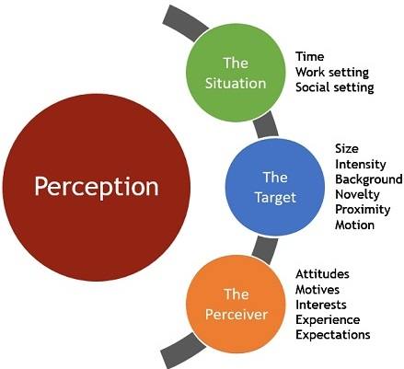
Source: businessjargons.com
Perceiver: The major features of perceiver that affects the Tesco includes attitude, motives, moods, interest, expectations, cognitive structure, and self-concept (Broadbent, 2013).
Target: The major characteristics of Target that affects the Tesco includes motion, novelty, size, background, proximity, and sound (Banerjee, 2008).
Situation: The major characteristics of situations that affect the Tesco include time, work, and social setting (Chen et al., 2019).
Perception is the mechanism that helps the individual in the business to select, interpret, and organize crucial information for creating a meaningful image (Urdan and Kaplan, 2020). Perception allows Tesco to act in certain ways by understanding human behaviours and their approaches.

Conclusion
The report explained an overview of Tesco that is the multinational grocery company. It examined the background of the project. It also showed that Tesco increasingly listens to its customer requirement and workers' need by using major disposal tools like club cards and social media that help them to change and develop innovative new business ideas.
The objectives and goals of Tesco concluded as they provide them certain directions and promote the actions of business individuals for achieving targets. It discussed the importance of setting goals and objectives in Tesco and explained the way objectives and goals are established in Tesco.
It also concluded that the behaviour of management and leadership plays an integral role in business success. It discussed several factors that affect the behaviour of individuals in the Tesco and it explained the behavioural management approach. Also, discussed the variable that affects the leadership and management behaviour in Tesco.
The report concluded that the team and group behaviour in Tesco Company are important aspects for increasing productivity as well as profitability. It examined the importance of group behaviour and the major factor that affects group behaviour in the company. It also explained the factors affecting team behaviour and the significance of team behaviour in Tesco.
Motivation and perceptions as a conclusion are an important aspect for Tesco to increase profitability and productivity. It determined the motivation and perception importance in the Tesco and, also examined the several factors that affect perception and motivation in the business.

PowerPoint presentation slides:



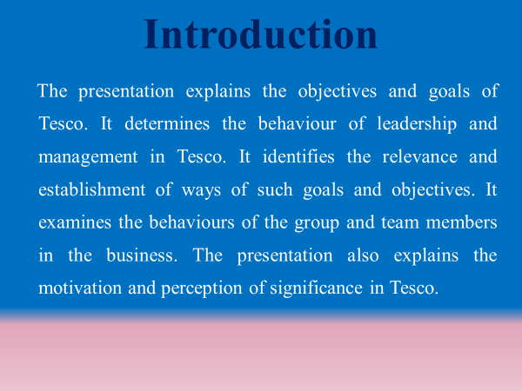
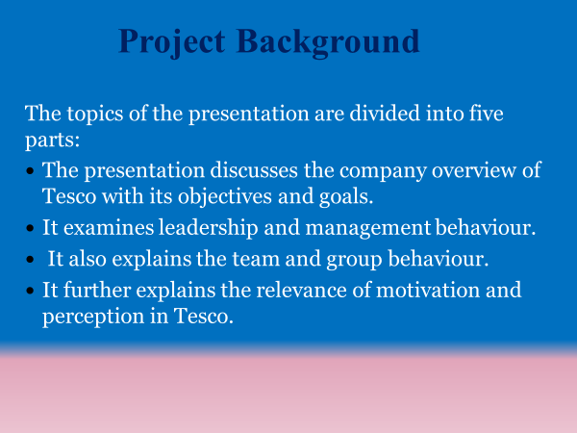

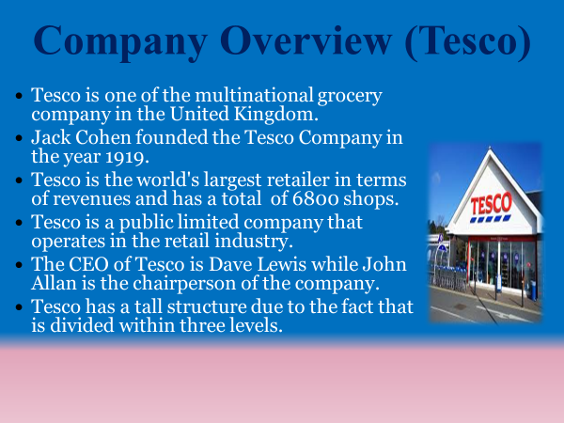
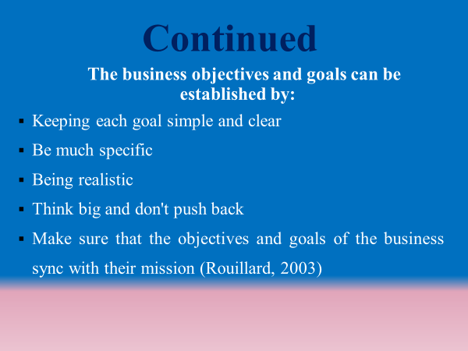

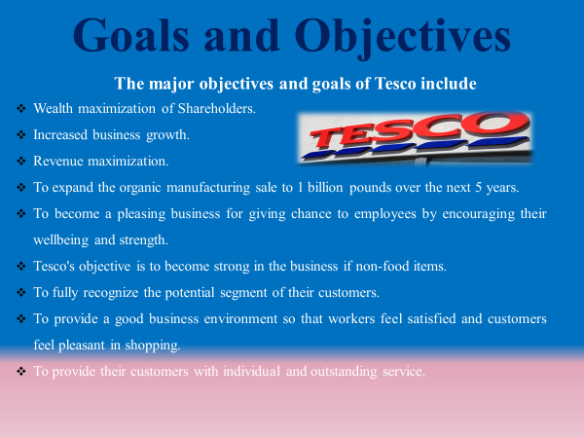
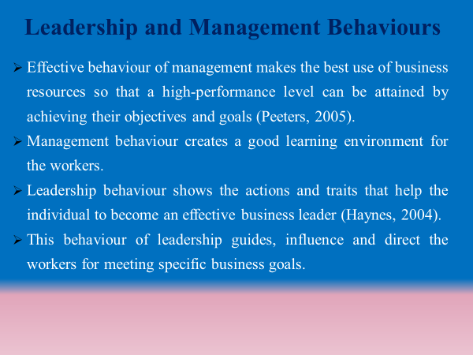

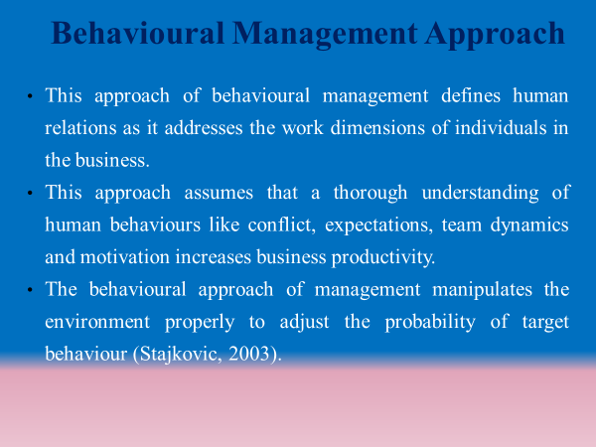
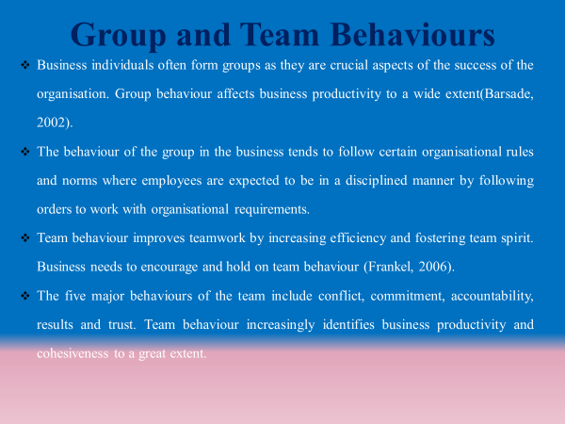

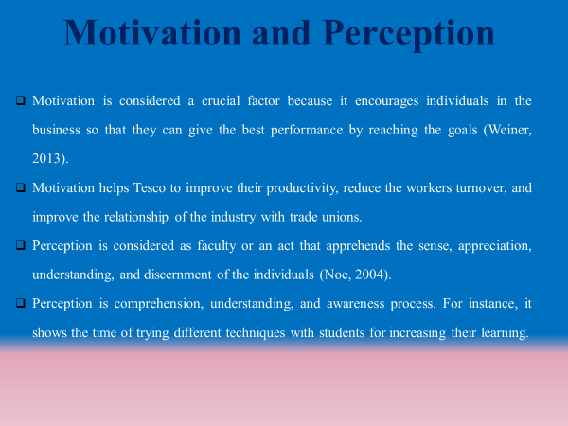
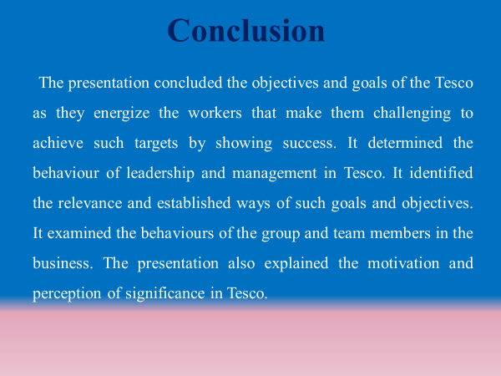

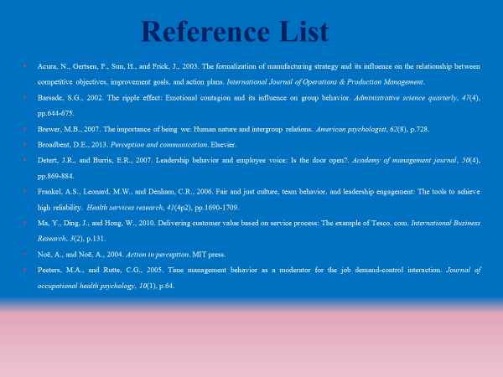
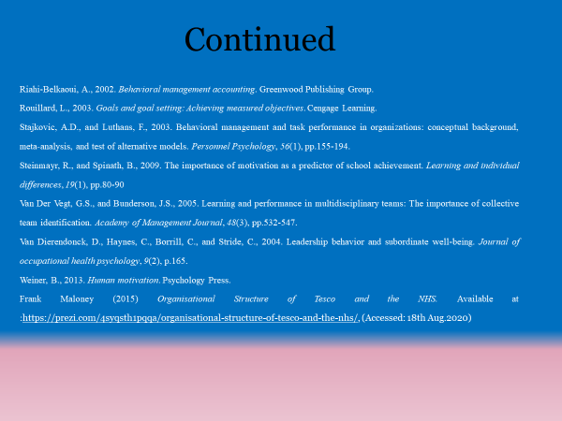

Reference List
Vu, M., 2016. IS THE BALANCED SCORECARD USEFUL IN A COMPETITIVE INDUSTRY?: Using Tesco PLC as a case study in the UK grocery retail industry.

Awadari, A.C., and Kanwal, S., 2019. Employee participation in organisational change: A case of Tesco PLC. International Journal of Financial, Accounting, and Management, 1(2), pp.91-99.

Business Case Studies, 2019. Vision values and business strategies. Available at: https://businesscasestudies.co.uk/vision-values-and-business-strategies/
(Accessed: 28th August 2020).

Wood, S., Wrigley, N., and Coe, N.M., 2017. Capital discipline and financial market relations in retail globalization: insights from the case of Tesco plc. Journal of Economic Geography, 17(1), pp.31-57.

Mooney, S., 2019. An investigation into attitudes of Tesco customers in South Dublin towards private-label brands (Doctoral dissertation, Dublin Business School).

Rosnizam, M.R.A.B., Kee, D.M.H., Akhir, M.E.H.B.M., Shahqira, M., Yusoff, M.A.H.B.M., Budiman, R.S., and Alajmi, A.M., 2020. Market Opportunities and Challenges: A Case Study of Tesco. Journal of the community development in Asia, 3(2), pp.18-27.

Park, T.M.S., 2017. Transnational retailers and corporate real estate management: cases of Wal-Mart, Carrefour, and TESCO (Doctoral dissertation, University of Reading).

Alam, S. and Raut-Roy, U., 2019. Evaluating the Effectiveness of Reward Strategy at Tesco: Evidence from Selected Stores in UK. Indian Journal of Industrial Relations, 55(1).

Evans, B. and Mason, R., 2018. The lean supply chain: managing the challenge at Tesco. Kogan Page Publishers.

Sparks, L., 2019. Tesco: how supply chain strategy supports retail success. The Business & Management Collection.
Eastmure, E., Cummins, S. and Sparks, L., 2020. Non-market strategy as a framework for exploring commercial involvement in health policy: a primer. Social Science & Medicine, p.113257.

Rosnizam, M.R.A.B., Kee, D.M.H., Akhir, M.E.H.B.M., Shahqira, M., Yusoff, M.A.H.B.M., Budiman, R.S. and Alajmi, A.M., 2020. Market Opportunities and Challenges: A Case Study of Tesco. Journal of the community development in Asia, 3(2), pp.18-27.

Acur, N., Gertsen, F., Sun, H., and Frick, J., 2003. The formalization of manufacturing strategy and its influence on the relationship between competitive objectives, improvement goals, and action plans. International Journal of Operations & Production Management.

Besley, J.C., Dudo, A.D., Yuan, S., and AbiGhannam, N., 2016. Qualitative interviews with science communication trainers about communication objectives and goals. Science Communication, 38(3), pp.356-381.

Ma, Y., Ding, J., and Hong, W., 2010. Delivering customer value based on service process: The example of Tesco. com. International Business Research, 3(2), p.131.

Marzano, R.J., 2010. Designing & teaching learning goals & objectives. Solution Tree Press.

Poppes, P., Vlaskamp, C., de Geeter, K.I. and Nakken, H., 2002. The importance of setting goals: the effect of instruction and training on the technical and intrinsic quality of goals. European Journal of Special Needs Education, 17(3), pp.241-250.

Rouillard, L., 2003. Goals and goal setting: Achieving measured objectives. Cengage Learning.

Elliot, A.J. and Hulleman, C.S., 2017. Achievement goals.

Naidoo, R. and Fisher, B., 2020. Reset sustainable development goals for a pandemic world.

Sachs, J.D., Schmidt-Traub, G., Mazzucato, M., Messner, D., Nakicenovic, N. and Rockström, J., 2019. Six transformations to achieve the sustainable development goals. Nature Sustainability, 2(9), pp.805-814.
Veeriah, V., Oh, J. and Singh, S., 2018. Many-goals reinforcement learning. arXiv preprint arXiv:1806.09605.

Boccara, C.N., Nardin, M., Stella, F., O’Neill, J. and Csicsvari, J., 2019. The entorhinal cognitive map is attracted to goals. Science, 363(6434), pp.1443-1447.

Boon, L.K., Fern, Y.S., Sze, C.C. and Yean, O.K., 2012. Factors affecting individual job performance. International Conference on Management, Economics, and Finance.

Fahrioglu, M., and Alvarado, F.L., 2001. Using utility information to calibrate customer demand management behaviour, models. IEEE transactions on power systems, 16(2), pp.317-322.

Peeters, M.A., and Rutte, C.G., 2005. Time management behaviour as a moderator for the job demand-control interaction. Journal of occupational health psychology, 10(1), p.64.

Rank, J., Carsten, J.M., Unger, J.M., and Spector, P.E., 2007. Proactive customer service performance: Relationships with individual, task, and leadership variables. Human Performance, 20(4), pp.363-390.

Riahi-Belkaoui, A., 2002. Behavioural management accounting. Greenwood Publishing Group.

Stajkovic, A.D., and Luthans, F., 2003. Behavioural management and task performance in organisations: conceptual background, meta‐analysis, and test of alternative models. Personnel Psychology, 56(1), pp.155-194.

Van Dierendonck, D., Haynes, C., Borrill, C., and Stride, C., 2004. Leadership behaviour and subordinate well-being. Journal of occupational health psychology, 9(2), p.165.

Yang, J.T., 2007. Knowledge sharing: Investigating appropriate leadership roles and collaborative culture. Tourism Management, 28(2), pp.530-543.

Nguyen, H.N. and Mohamed, S., 2011. Leadership behaviours, organisational culture and knowledge management practices. Journal of Management Development.

Harland, L., Harrison, W., Jones, J.R. and Reiter-Palmon, R., 2005. Leadership behaviours and subordinate resilience. Journal of Leadership & Organisational Studies, 11(2), pp.2-14.

Darroch, J., 2003. Developing a measure of knowledge management behaviours and practices. Journal of knowledge management.

Adams, R.V. and Blair, E., 2019. Impact of time management behaviours on undergraduate engineering students’ performance. SAGE Open, 9(1), p.2158244018824506.

Behrendt, P., Matz, S. and Göritz, A.S., 2017. An integrative model of leadership behaviour. The leadership quarterly, 28(1), pp.229-244.

Uslu Divanoğlu, S. and BAĞCI, D., 2018. Determining the Factors Affecting Individual Investors’ Behaviours. International Journal of Organisational Leadership, 7, pp.284-299.

Coleman, K., 2017. Individual differences in temperament and behavioural management. Handbook of primate behavioural management, pp.95-114.
Barsade, S.G., 2002. The ripple effect: Emotional contagion and its influence on group behaviour. Administrative science quarterly, 47(4), pp.644-675.
Turner, J.C., 2010. Social categorization and the self-concept: A social cognitive theory of group behaviour.
Frankel, A.S., Leonard, M.W., and Denham, C.R., 2006. Fair and just culture, team behaviour, and leadership engagement: The tools to achieve high reliability. Health services research, 41(4p2), pp.1690-1709.
Hu, Y.Y., Parker, S.H., Lipsitz, S.R., Arriaga, A.F., Peyre, S.E., Corso, K.A., Roth, E.M., Yule, S.J. and Greenberg, C.C., 2016. Surgeons' leadership styles and team behaviour in the operating room. Journal of the American College of Surgeons, 222(1), pp.41-51.
Johnson, C.L., and Gonzalez, A.J., 2014. Learning collaborative team behaviour from observation. Expert Systems with Applications, 41(5), pp.2316-2328.
Van Der Vegt, G.S., and Bunderson, J.S., 2005. Learning and performance in multidisciplinary teams: The importance of collective team identification. Academy of Management Journal, 48(3), pp.532-547.
Araújo, D., and Bourbousson, J., 2016. Theoretical perspectives on interpersonal coordination for team behaviour. Interpersonal coordination and performance in social systems, pp.126-139.
Hazari, S., and Thompson, S., 2015. Investigating factors affecting group processes in virtual learning environments. Business and Professional Communication Quarterly, 78(1), pp.33-54.
Spector, M.D., and Jones, G.E., 2004. Trust in the workplace: Factors affecting trust formation between team members. The Journal of social psychology, 144(3), pp.311-321.
Jin, L., and Zhong, Y., 2014. Contextual factors affecting the influence of perceived organisational support on team innovative performance. Social Behaviour and Personality: an international journal, 42(3), pp.517-528.
Charness, G. and Chen, Y., 2020. Social identity, group behaviour, and teams. Annual Review of Economics, 12.
Morris-Drake, A., Christensen, C., Kern, J.M. and Radford, A.N., 2019. Experimental field evidence that out-group threats influence within-group behaviour. Behavioural Ecology, 30(5), pp.1425-1435.
Huebner, B., Jebari, J., Sprevak, M. and Colombo, M., 2019. Computational theories of group behaviour. The Routledge handbook of the computational mind. New York: Routledge.
Hu, Y.Y., Parker, S.H., Lipsitz, S.R., Arriaga, A.F., Peyre, S.E., Corso, K.A., Roth, E.M., Yule, S.J. and Greenberg, C.C., 2016. Surgeons' leadership styles and team behaviour in the operating room. Journal of the American College of Surgeons, 222(1), pp.41-51.
Chen, M.H. and Agrawal, S., 2018. Exploring student’s team behaviour through entrepreneurship education: a time-lagged study. Education+ Training.
Ahmad, S., Bryant, A., Kleinman, E., Teng, Z., Nguyen, T.H.D. and Seif El-Nasr, M., 2019, October. Modeling Individual and Team Behaviour through Spatio-temporal Analysis. In Proceedings of the Annual Symposium on Computer-Human Interaction in Play (pp. 601-612).
Litchfield, R.C., Karakitapoğlu‐Aygün, Z., Gumusluoglu, L., Carter, M. and Hirst, G., 2018. When Team Identity Helps Innovation and When It Hurts: Team Identity and Its Relationship to Team and Cross‐Team Innovative Behaviour. Journal of Product Innovation Management, 35(3), pp.350-366.
Weiner, B., 2013. Human motivation. Psychology Press.
Heckhausen, J., and Heckhausen, H. eds., 2008. Motivation and action (Vol. 22). New York: Cambridge University Press.
Steinmayr, R., and Spinath, B., 2009. The importance of motivation as a predictor of school achievement. Learning and individual differences, 19(1), pp.80-90.
Noë, A., and Noë, A., 2004. Action in perception. MIT press.
Broadbent, D.E., 2013. Perception and communication. Elsevier.
Singh, A., 2010. A study on the perception of work-life balance policies among software professionals. IUP Journal Of Management Research, 9(2).
Massenberg, A.C., Schulte, E.M., and Kauffeld, S., 2017. Never too early: Learning transfer system factors affecting motivation to transfer before and after training programs. Human Resource Development Quarterly, 28(1), pp.55-85.
Šajeva, S., 2007. Identifying factors affecting motivation and loyalty of knowledge workers. Economics & Management.
Banerjee, R., 2008. An examination of factors affecting the perception of workplace discrimination. Journal of Labor Research, 29(4), p.380.
Slavin, R.E., Hurley, E.A., and Chamberlain, A., 2003. Cooperative learning and achievement: Theory and research. Handbook of psychology, pp.177-198.
Anderman, E.M., 2020. Achievement motivation theory: Balancing precision and utility. Contemporary Educational Psychology, p.101864.
Badura, K.L., Grijalva, E., Galvin, B.M., Owens, B.P. and Joseph, D.L., 2020. Motivation to lead: A meta-analysis and distal-proximal model of motivation and leadership. Journal of Applied Psychology, 105(4), p.331.
Mulder, M., 2020. Group structure motivation and group performance (Vol. 3). Walter de Gruyter GmbH & Co KG.
Ryan, R.M. and Deci, E.L., 2020. Intrinsic and extrinsic motivation from a self-determination theory perspective: Definitions, theory, practices, and future directions. Contemporary Educational Psychology, p.101860.
Urdan, T. and Kaplan, A., 2020. The origins, evolution, and future directions of achievement goal theory. Contemporary Educational Psychology, p.101862.
Chen, C., Elliot, A.J. and Sheldon, K.M., 2019. Psychological need support as a predictor of intrinsic and external motivation: the mediational role of achievement goals. Educational Psychology, 39(8), pp.1090-1113.
Groening, C. and Binnewies, C., 2019. “Achievement unlocked!”-The impact of digital achievements as a gamification element on motivation and performance. Computers in Human Behaviour, 97, pp.151-166.

