NAME: Semmie Adeniran Ogunwolu
STUDENT NUMBER: 2130575
MODULE CODE: LCHS4001
MODULE TITLE: Academic And Employability Skill
LECTURER’S NAME: Timothy Hopkin
ASSIGNMENT TITLE: ACE Practical Portfolio

EXACT WORD COUNT: 2000 WORDS

  - Time Management Skills
Gibbs model of reflection (GMR):
Since he made his debut publication on “learn by doing”, Professor Graham Gibbs has encouraged so many people including me to think systematically and more discretely about life’s numerous experiences at specific situations as they unveil. Gibbs did not only preach a sermon, he went further to prescribe the step by step approach to realise his popular maxim “learn by doing”. Gibbs created a circle model which he also structured in phases, to help practitioners to breakdown or simplify their experience and reflect deeply on them (Ugboro & Obeng 2000). Gibbs model of reflection has taught me that, if I could reflect (think deeper) on my learning experience (things that have repeatedly happened to me), it would assist me to understand and perform better when similar situation(s) presents itself in the future. That is, without a proper application of Gibbs principle in my learning process, I would never grow and improve on my performance. Gibbs says that, experience is not good enough; everyone has had experience at one point in time. The difference between experience and learning is reflection (Gibbs 1998).
Considering Gibbs reflective model on the time management skills, I could realise my folly or rather my ineptitude because I was not able to fully deploy the reflective model on the things that consumed my time. Before we had the class on the time management skills, I was always thinking that, I could gain an extra hour in a 24-hour; but this never happened. Then gradually through conscientious efforts, I realised that if I could apply Gibbs model of reflection on time-management skills, I could make a difference. Time management means planning and controlling the amount of time spent on a task. Effective time management skills requires an individual to accomplish more tasks in lesser time. As a student I realised that I did not have all the time; therefore, I needed to improve on time-management skills. After our classes on the time-management skills, I realised for the first time that, setting achievable goals and a time limit to accomplish the goal; taking a break in between tasks; organizing myself; removing unimportant task and planning ahead are keys to subvert the time-management crisis. Since I deployed these keys, I have become more efficient, productive and successful with no stress.
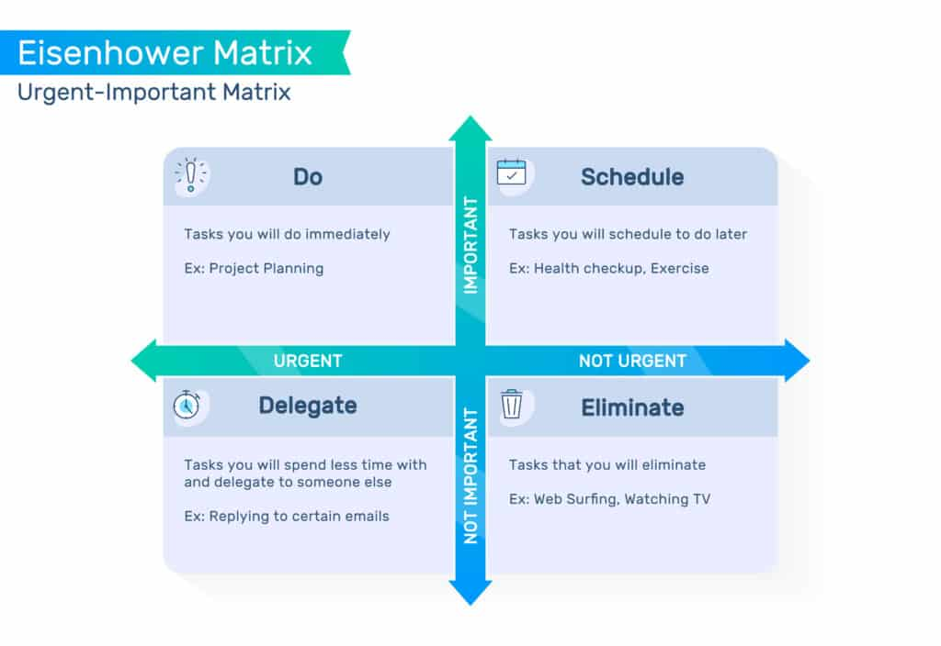
Thereafter, I make use of Eisenhower’s method to group and prioritize tasks by their urgency and importance. The Eisenhower tool helped me to apportion task into four boxes which include the tasks to do first, tasks to schedule later, tasks to delegate, and tasks to delete. While Gibbs model helped me to think and reflect, Eisenhower model helped me to prioritise tasks to establish an efficient workflow. In conclusion, the initiate application of Gibbs-Eisenhower’s methods in time-management development was not easy at first, but progressive application has produced a more productive outcome.

1.2 Summarising
Summarising is a powerful study strategy or technique that allows individuals to identify and select the most vital points in a text and present them in a clear and concise form (Jones 2007). Summarising moves readers or listeners from elaborate work to a condensed work while maintaining the salient points.The main purpose of summarising is to state the major points of a work, art or proceedings to provide the basis for argument (Guthrie 2003). During the course of the classes on summarising skills, I understood that summarising skill is an important tool every student must have. Unfortunately, it was difficult to sift important points from a passage because the necessary skills was lacking. In my learning experience, I discovered that I am not a long reader; I like when a story is short and catchy. I find it difficult to stay with a long passage especially those that have too many irrelevant information. Reason being that we are in a sound-graphic era due to technological advancement. Therefore, there is a need to learn and develop a summarising skill to keep our stories short. Thanks to this Module, which re-ignited my passion and interest to pursue my dream of learning a coveted skill - summarising skills to keep my stories short. The key to summary is reading the passage first to understand the author’s mind (Dunlosky et al 2013).
Through our classes on summarizing skills, I have learned how to identify the most salient points in a passage, how to snub irrelevant information, as well as how to constructively express the fundamental ideas in the passage. Above all, summarising skills have improved my overall thinkability; and my approach to reading a passage has significantly been changed. I can now apply the summarising strategy to every content (Dirkx 2014) I read including writing this assignment. There are also other ways summarising has impacted me. I now realise that the strongest way to process information is to read a text and process it in my own words. Before now, I not process things on my own because I had always done things on instinct without understanding their implications. But now, I can read, retrieve, reprocess and paraphrase things in my own words.
The summarising class has also presented me with some problems. For example, I am not sure if I have developed enough competence to determine what should appear in a summary and what should not. The most important thing in learning a new thing lies in what the individual already know (Ausubel 1963). If little is known about a thing, then the ability to determine what is important and what is not important will be weak. Secondly, summarising is a skill that needs to be consistently taught and practised. Teaching summarising once or twice is not enough to master the necessary skills to function in this capacity (Bereiter 1985). Summarizing is tricky, it moves one from a story to retelling to determining essential components and condensing the information into a summary.
1.3 Academic Writing
It never dawn on me that there are different types of writing with each type having a unique principle. In academic writing, the primary purpose is to inform a specific audience. Academic writing is an academic exercise in which students are exposed to the techniques of writing clear and well-structured essays backed up by reference (Oregon State University 2012). Because the idea is to educate, the language tone and style is kept straight and formal with special consideration on the audience’s background. On this module, I understand that academic writing has some key features in all fields of life. This set of principles provides a guide or virtual template that guides every writer.
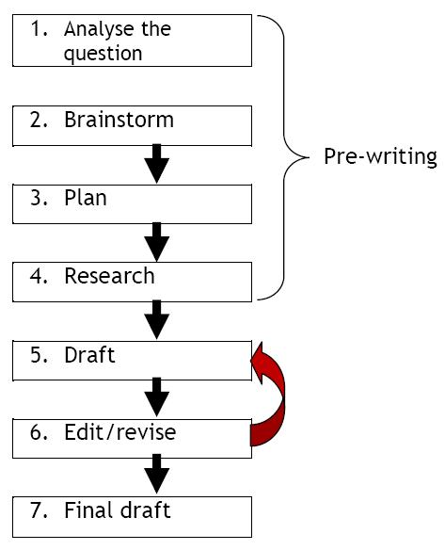
The foremost characteristics of academic writing is planning and focusing (Perez 2020). When I write, I make sure that I demonstrate a thorough understanding of the subject matter that answers the questions of the mind. I write with answers in view and through the minds of my potential readers. Another important feature of academic writing is structure: it must be well structured (Wiens 2020). One of the greatest challenges I had as a beginner was the problem of structure. I didn’t have a structure albinitio. However, in our module discussion, I realised that a good academic writer must be coherent and logical.

Thirdly, academic writing must be evidenced. Initially, when I engaged in academic writing, I was not used to citing references (in-script and bibliographic) to back up the writing. Reasons being that where knowledge is deficient, abuse is inevitable. I didn’t know the importance of references and how to cite them. Interestingly, I now realise the importance of citing previous works in my writing to back up the claims. In other words, academic writing must be evidenced to demonstrate knowledgibility in the research area and to support opinions or arguments. Academic writing must be formal in tone and style (Moore 2016). Every good writer would admit that writing is a journey not a destination. Even the best writings are still subject to corrections. As much as I write, I keep the tone and style formal with no pretense. I make sure that I use befitting language and sentences that are clear, concise and balanced. I set specific criteria such as clarity, brevity, and relevance.
I feel happy with the writing skill because it will live with me for life. It will also aide me in the job hunt after school (Wiens, 2012). As I journey into the limelight of great academic achievement, it is my earnest desire to communicate effectively through writing. I intend to simplify ideas and give my reader a broader knowledge and understanding. However, as highlighted in the summarising skill, academic writing requires continual practice and persistence to remain relevant in the field (Copland 2015). I get increasingly better after each writing assignment just as Gibbs model of reflection suggested. However, I strongly recommend our module instructor to continually assess our individual performance until we learn to stand on our feet.
1.4 Public speaking and giving presentations
Life is not mute even though nature may appear calm. Everyone must speak at some points in life. As Gibbs reflective model suggested, if one thinks deeper, one would perform better. No matter who we are and where we live, chances are that, at some point in time, nature will beckon on us speak in public as part of life’s inevitable assignment. While this experience seems intimidating and daunting, the benefits outweigh the perceived fears (Aras 2012). Like any other skills, public speaking and presentations can be taught and learned. No one is born a public speaker; it is a learned behaviour; and so, I learn.
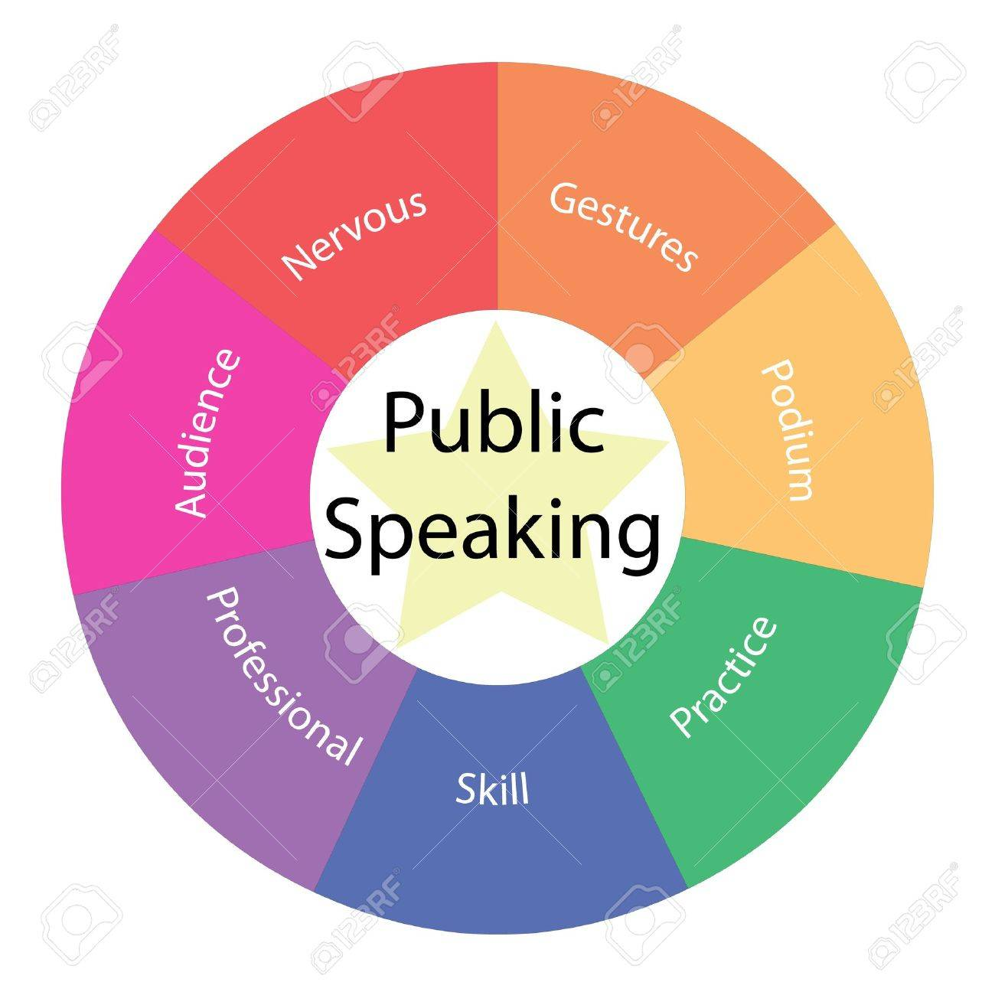
The first thing that I learned in this module is that public speaking and presentation has changed my thinking. I had thought that public speaking is standing before a large audience and giving a presentation (Barnlund 2008). However, I now understand that I may not necessarily make a regular presentation before a group; but for sure, the skill is relevant in every area of life including in family raising. At some points in time, I may be asked to represent my organisation at a function or make a speech after receiving award or make a speech at a friend’s wedding or my spouse wedding or make a closing remark after a board meeting. In all these, good public speaking skills can open doors while poor public speaking skills can shutdown doors. Because knowledge enhances boldness, being good at a skill enhances boldness and boost self-confidence and connects one to opportunities when they arise (Farrell 2011). One might know well, but if he does not present his points well, it would create a false impression about him.
Since I learned the secrets of making a good public speaking in this module, I write them boldly beside my reading table; and they include planning, practicing, engaging my audience, maintaining a body language, thinking positively and calming nerves. Planning: Since I learned this skill, I no longer speak without planning my speaking engagement or rehearsing the words to gain a mastery. In fact, right from the first words that proceed from my mouth through the closing statement, I plan them. The principle is to intrigue and captivate my audience and remain relevant throughout the speaking exercise. Practice: It is often said practice makes one perfect. One cannot be a confident and eloquent speaker if he does not practice. To get to practice, I seek opportunities to speak in front of others; and when I am not invited, I speak to myself in a mirror. When I am planning to deliver a presentation, I try as much as I can to create the content early and practice (Rhodes 2010). Engaging the Audience: I try as much as possible to engage my audience like asking questions to carry everyone along (History.com 2012). Body Language: This gives my audience a subtle clue about my inner state - whether nervous or not (McKay 2005).

References
Aras, K. (2012) The nuts and bolts of public speaking: Practical tools for powerful presentations.
Barnlund, D. C. (2008) A transactional model of communication. In. C. D. Mortensen (Eds.), Communication theory (2nd Ed), pp. 47-57. New Brunswick, New Jersey: Transaction.
Bereiter, C. (1985) Toward a solution of the learning paradox. Review of Educational Research, 55(2), 201–226.
Copland, J. (2015) The problem and importance of academic writing 29 Jul 2015.
Dirkx, K. J. H. (2014) Putting the testing effect to the test. Why and when is testing effective for learning in secondary school. Unpublished doctoral dissertation. Heerlen: Open University of the Netherlands
Dunlosky, J., Rawson, K.A., Marsh, E.J., Nathan, M.J., & Willingham, D.T., (2013) Improving students’ learning with effective learning techniques: promising directions from cognitive and educational psychology. Psychological Science in the Public Interest, p. 4-58
Gibbs, G. (1998) Learning by Doing: A Guide to Teaching and Learning Methods. Oxford: Further Education Unit, Oxford Polytechic.
Guthrie, J. T. (2003) Concept-Oriented Reading Instruction: Practices of Teaching Reading for Understanding. In C. Snow & A. Sweet (Eds.), Reading for Understanding: Implications of RAND Report for Education (pp. 115-140). New York: Guilford.
Farrell, R. (2011) Soft skills all great leaders should have. CareerBuilder.
History.com. (2012) The KennedyNixon Debates. History.com. Retrieved from
Jones, R. (2007) Strategies for Reading Comprehension: Summarizing. Retrieved 2008, January 29, from http://www.readingquest.org/strat/summarize.html.
McKay, J. (2005) Employers complain about communication skills. Pittsburgh Post Gazette.
Moore, K. (2016) Employers want candidates with this skill 7 April 2016.
Oregon State University 2012. The importance of writing in the workplace 2012.
Perez, M. (2020) Brief introduction to academic writing [Online video].
Rhodes, T. (Ed.) (2010) Assessing outcomes and improving achievement: Tips and tools for using rubrics. Washington D. C.: Association of American Colleges and Universities.
Ugboro, I.O. and Obeng, K., 2000. Top management leadership, employee empowerment, job satisfaction, and customer satisfaction in TQM organizations: an empirical study. Journal of quality management, 5(2), pp.247-272.
Wiens, K. (2012) I won’t hire people who use poor grammar 20 July 2012. [Online]

