

University of Wales
Trinity Saint David
School of Engineering
Motion Simulation and FEA
Xiaotong Jiang
1904747
Year 3
26/01/2020
Advanced Computational Methods(M6X00408)

Content
1. Introduction 3
2.1 Sketching 4
2.2 Modelling 4
2.2.1 part 1-5(wooden boards) 4
2.2.2 part 6 (wooden slide) 6
2.2.3 part 7 (sheet metal) 8
2.2.4 Part 8 (rotation shaft) 9
2.2.5 Part 9 (ball) 10
2.2.6 Part 10 (handle) 10
2.3 Assembly 11
3. Motion Simulation 15
3.1 Motion study 15
3.1.1 Motor 15
3.1.2 Contact 15
3.1.3 Gravity 16
3.1.4 Calculate the motion study 16
3.2 Motion simulation applied 17
4. Modifying and comparison 21
4.1 Fillet 21
4.2 stepped shaft (cannot optimize) 21
4.3 Changing size of the model 22
5.Conclusion 24
Reference 25

Introduction
This report mainly puts emphasis on the entire processes from modelling to motion simulation and FEA which could enhance the understanding of these functions and analyse the stress for the part of the model. In the first step, a suitable assembly which was named as ‘Flowing ball’ was sketched, modelled (including equations) and assembled by 10 parts.
Secondly, the author observed the dynamic state of the assembly after conducting the initial settings for motion part which will be beneficial to understand the relationships amongst these parts and mates. Also, the author conducted the motion simulation on the rotation shaft part where the forces would be exported. Then author decided the start and end of time for simulation. After running for the entire scenarios, the plot that Von-mises stresses are for y-axis and sets are for x-axis could be conducted. Finally, the author chose the scenario with maximum stress to observe its static stress distribution and undergo the analysis. This is the whole process of FEA.
In addition, analysis and results of FEA could be used for modifying the rotation shaft to optimize the model. The modified one needs to be tested and compared with the previous one. Throughout this process, the capability of building a more reasonable model could enhance and the understanding and applying of motion simulation part also increases.

2. Sketching, Modelling and Assembling
For the modelling part, the author did the sketch of the ‘Flowing Ball’ to design the dimensions of every part which is convenient for the later assembling. And this model is made up of 10 parts (five wooden boards with different height, rotation shaft with cams, handle, sheet metal, ball and wooden slide).

2.1 Sketching
The author sketched probable model on the paper which is convenient for following modelling.
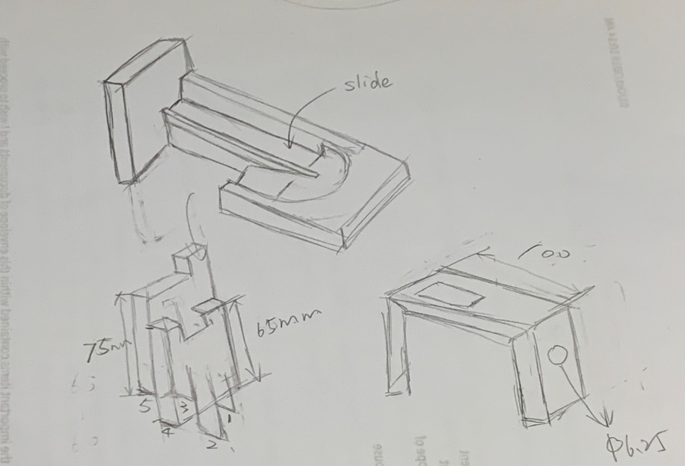
The sketch could be beneficial to imagine how this model operate.
Figure2.1 Sketch

2.2 Modelling

2.2.1 part 1-5(wooden boards)
Wooden boards are the parts which are in contact with each cam and moving up and down when receiving the cams moving.
For the first board, the author sketched and extruded the following shape whose sunken part is used for contact and contains the ball and the ranges within vertical direction for the ball is 10mm.
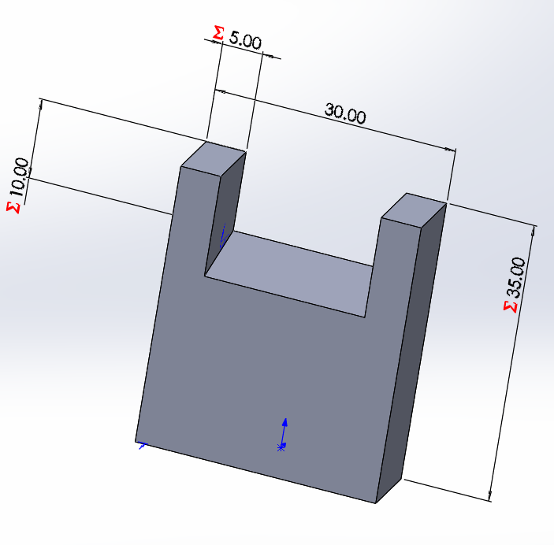
Also, the draft needs to be applied to make the sunken face inclined to let the ball go for the next board.
Figure2.2 Sketch of 1st board
For other 3 models, they all have the same shape except the difference in height. These five boards need to form like a inclined part so the height of other 3 model is respectively 45mm, 55mm, 65mm.
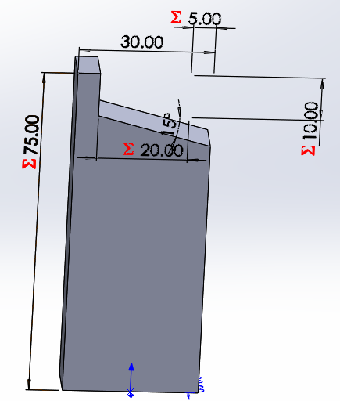
The last board is sketched as followed.
Figure2.3 part 5

2.2.2 part 6 (wooden slide)
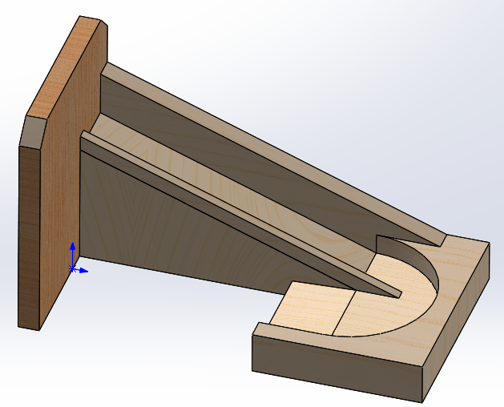
The wooden slide shown below is a structure which provide the ball with a inclined part and round runway to go back to the starting point, and the ball can ‘flow’ up and down like a circus to circulate.
Figure2.4 part 6
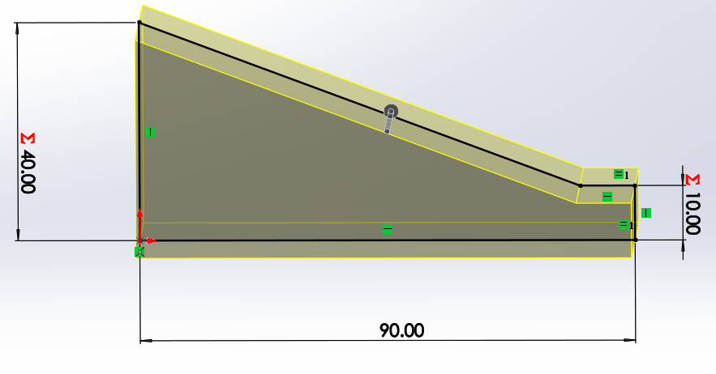
Figure2.5 1st step
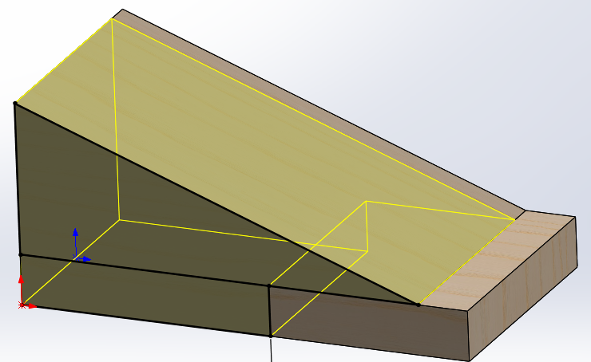
The graph above shows that the first step is to generate a simple angled slide. And the graph below shows that the yellow area was subtracted.
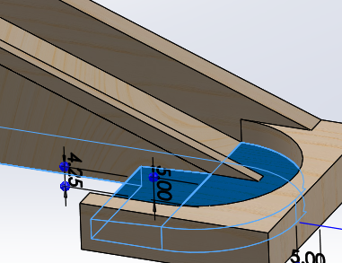
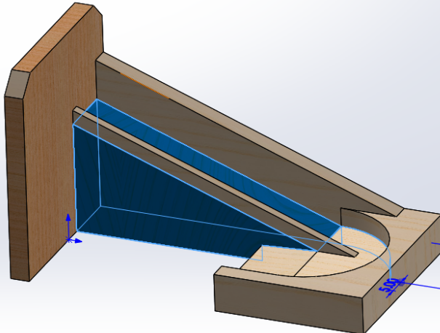
Figure2.6 2nd step

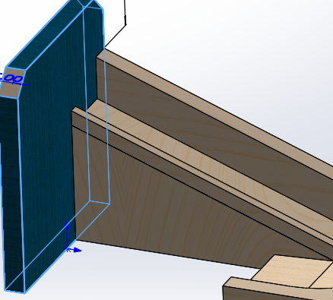
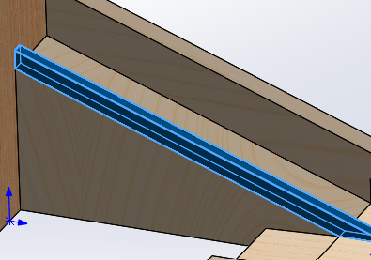
Figure2.7 Extruding process
The graphs above show the process of extruding these small parts of the slide.

2.2.3 part 7 (sheet metal)
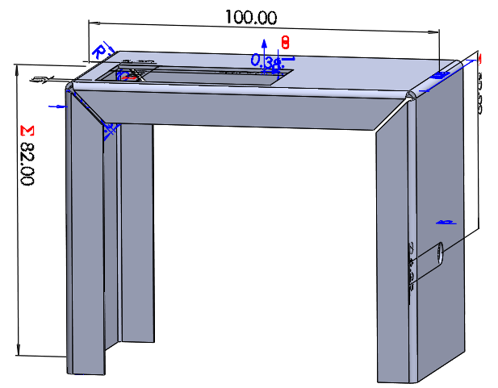
Metal plate is the supporting item where the wooden slide needs to be placed and the rotation shaft is placed and supported through the two circular holes.
Figure2.8 part 7
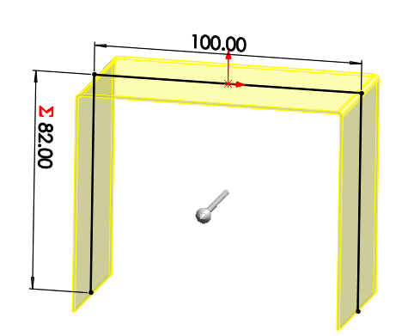
To model this sheet metal, firstly the author sketched the external and probable lines and then chose ‘Base Flange’ from ‘Sheet Metal’ part and defined the width of the metal as 60mm. And ‘Edge-Flange’ was applied as followed. The author chose ‘bend outside’ formation.
Figure2.9 Base flange

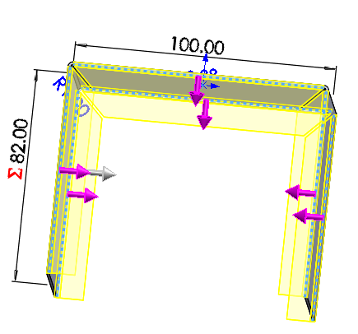
Figure2.10 Edge flange
Two circuses designed 6.25mm were cut-extruded
For the top of the metal, a rectangular part was cut-extruded where the five boards need to be placed and move up and down.

2.2.4 Part 8 (rotation shaft)
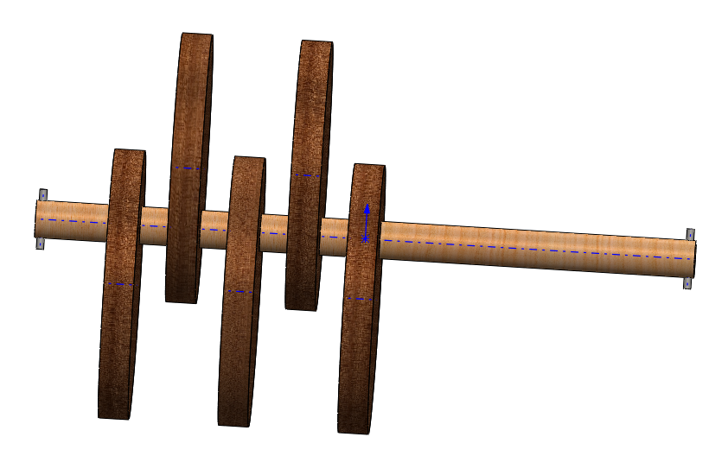
The rotation shaft with eccentric cams serves as the function that handle drives the shaft to rotate and then cams through the eccentric part push the boards up and down.
Figure2.11 Rotation shaft
Firstly, the author built a 110mm long shaft with 6.25mm radius. And then one eccentric cam was modelled 20mm from the left side of the shaft.
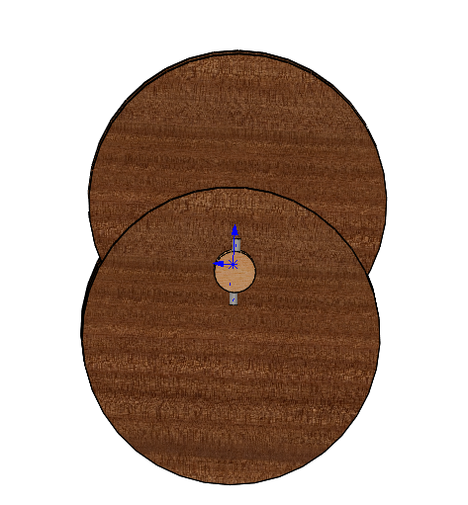
The author used the liner array feature to generate two cams in same direction and then applied move/copy body feature to generate remaining cams and rotate 180 degrees.
Figure2.12 Rotation shaft

2.2.5 Part 9 (ball)
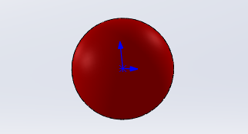
A plastic ball model was built and defined material as followed.
Figure2.13 part 9

2.2.6 Part 10 (handle)
The following graph shows the handle model where the torque inputs. The handle is subjected to torque and drive the shaft to rotate. The material for the handle was defined as brass.

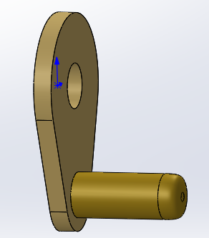
Figure2.14 part 10

2.3 Assembly
After modelling 10 parts, the author started to assembly. The author set the following mates to realize the successful assembly.
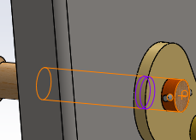
(1) Concentric mate (link between shaft and sheet metal)
Figure2.15 mate 1
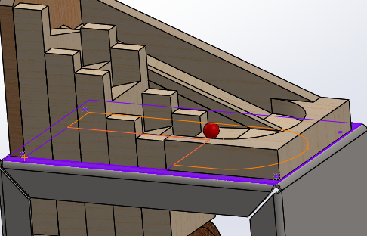
(2) Coincidence mates (links between slide and sheet metal)

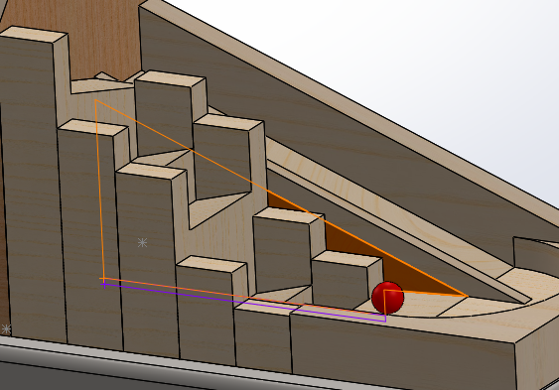
Figure2.16 mate 2
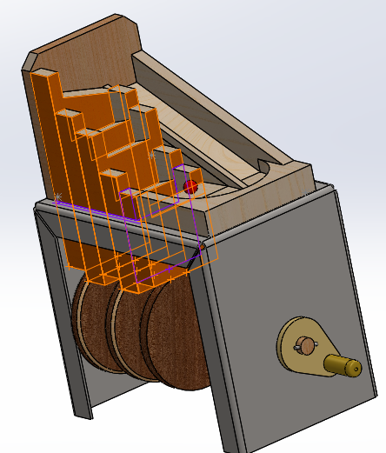
(3) Coincidence mates (5 boards & slide & sheet slide)
Figure2.17 mates 3

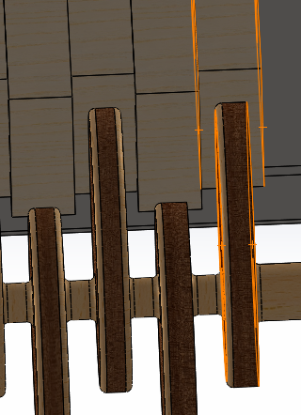
(4) Width mate (1st board & cam)
Figure2.18 mate 4
(5) Lock setting (handle & rotation shaft)
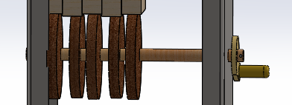
The author set the lock rotation between shaft and handle to make sure that the torque applied to the handle can drive the shaft rotate synchronously.
Figure2.19 mate 5
(6) Positioning mate (ball & slide)
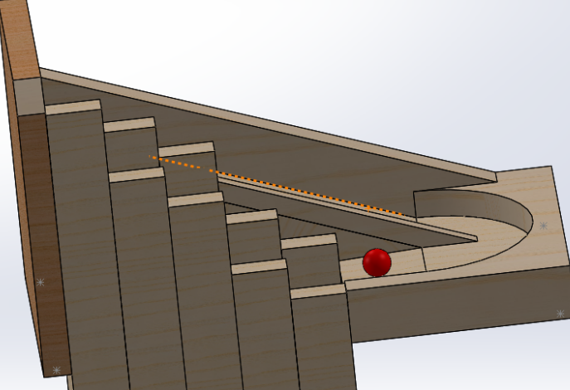
The author put the ball on the inclined faces of slide to make sure that the ball can start to move through the gravity, and it is the starting point of the moving. But the mate is only used for positioning the ball.
Figure2.30 mate 6
Hence, after setting all the mates the author could imagine, manual simulation was conducted to see whether boards could move up and down through the rectangular area and make sure that every adjacent board movement is opposite.
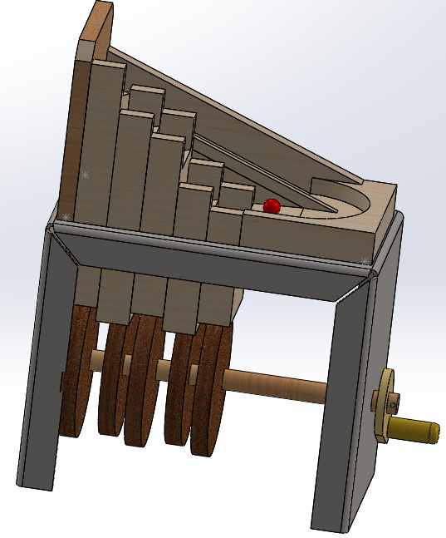
Finally, the entire assembly was completed with reasonable mates.
Figure2.31 Assembly finished

3. Motion Simulation
Since the assembly was finished, motion study needed to be conducted to observe how it moves and simulation and FEA for one special part.

3.1 Motion study
In the first place, the author opened SOLIDWORKS motion part and started to set some parameters like motor, contact, gravity etc.

3.1.1 Motor
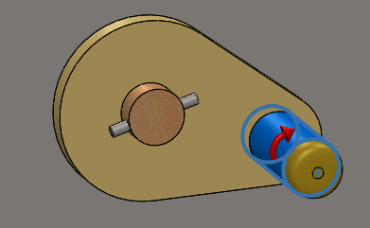
The author clicked on the motor and chose the small handle for motor rotating position. The speed to rotate the handle was defined as 75 RPM.
Figure3.1 Motor setup

3.1.2 Contact
For the mates-settings in the assembly, the ball was only positioned at the beginning point and was not bound or linked. Hence, the contact needed to be applied to limit the ball’s movement.
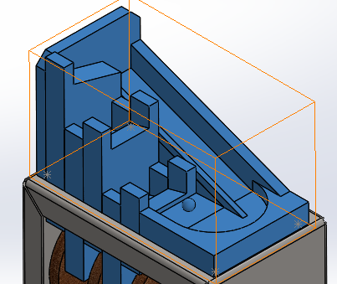
Considering the expected motion trajectory of the ball, contacts needed to take place between the ball and 5 boards and slide. The graph shown below could vividly indicate the contact.
Figure3.2 Contact

3.1.3 Gravity
In order to realize the ball’s movement from up and down, gravity along the y-axis should be applied in the motion.

3.1.4 Calculate the motion study
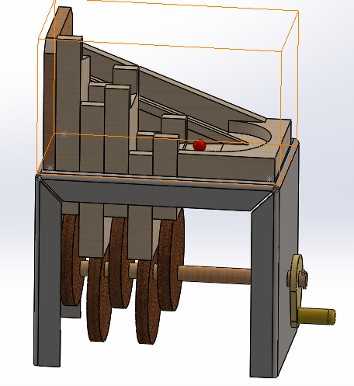
The author set a 4-second interval for motion simulation and started to calculate. Within 4 seconds, the ball could run twice. The first graph below is the beginning of the movement and the other one is the state intercepted randomly during the movement. The rightmost board is at its highest point and starts to decline when the motion begins. When the ball slides to the edge of this board it would not be blocked by the board. The same method is also used for following movements.
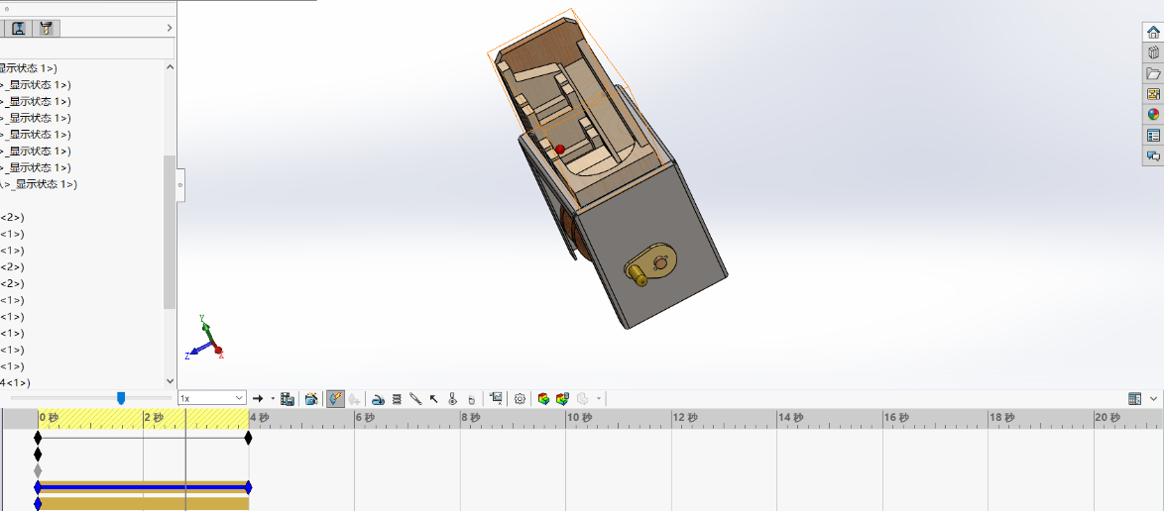
Figure3.3 Beginning point
Figure3.4 Random scene

3.2 Motion simulation applied
The next step is to do the simulation part. For this model, the simulation part is to calculate the stresses and displacements when the force on specific and individual part is exported from the motion part.
Firstly, the author determined part 8 (rotation shaft with cams) to do the simulation which receives the torque from the handle and then employ cam to push the board up and down to transfer motion.
Before simulation, load-bearing faces needed to be defined entirely.
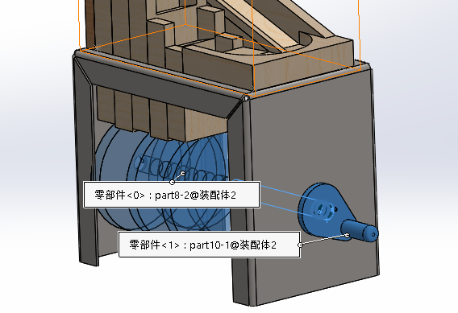
(1) Part 10 & part 8
Figure3.5 load -bearing face 1
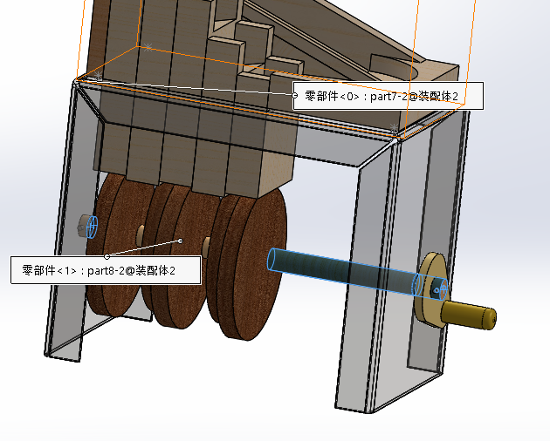
(2) Part 7 & part8
Figure3.6 load -bearing face 2
(3) load-bearing faces between every board and cam
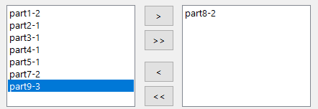
Then, the author needed to decide a movement interval to do the simulation. The author decided to analyze the process from the beginning that the ball slides to the first board to the time when the ball leaves from the last board, and the interval is probably from 2.2s to 3.8s. Hence, the graph showed below demonstrate the settings of importing motion loads.
Figure3.7 Importing motion loads
Furthermore, the author opened the ‘part 8’ file to do the simulation. And two simulation studies (design & static) showed on the interface. Firstly, the author clicked static study and assign the Balsa to this part. The author conducted the running process for the static study.
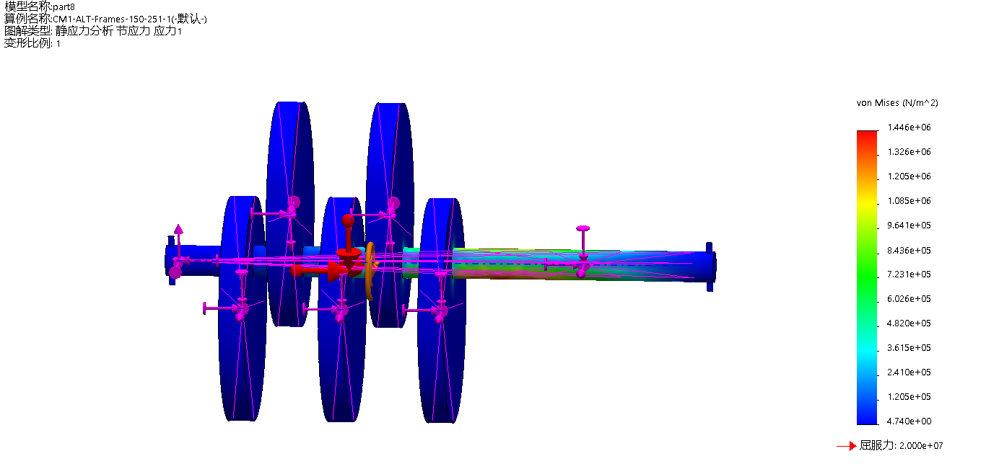
The static study result shows below. But motion study needs to be done, this static stress result doesn’t make much sense.
Figure3.3 Static stress analysis
Hence, the author turned to the design tree to run the 103 scenarios to observe the changes in stress. Through Results and Graphs parts, the author selected VON: von Mises Stress as y-axis and x-axis is the different sets. Then the graph about stresses produced as followed.

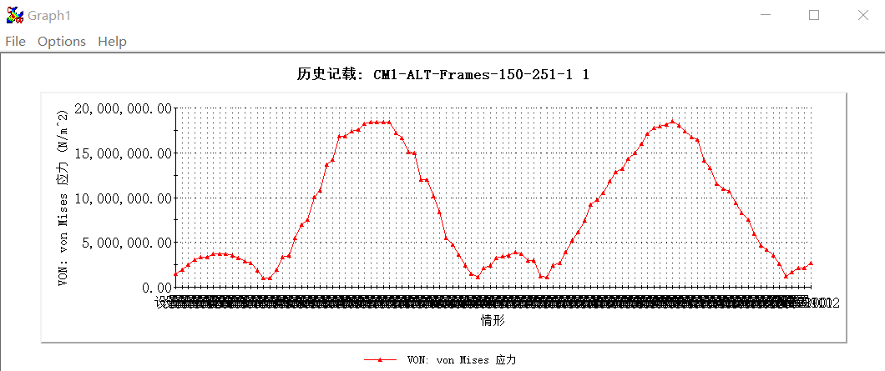
Figure3.3 Static stress analysis
From the graph, the maximum von mises stress would happen at set 33, 34, 35 or 80. The author chose scenario 33 to observe and analyze. The graph below shows at scenario 33 how von mises stress occur. The stresses on cams are reasonable and have small values. But the stresses on the shaft are complex.
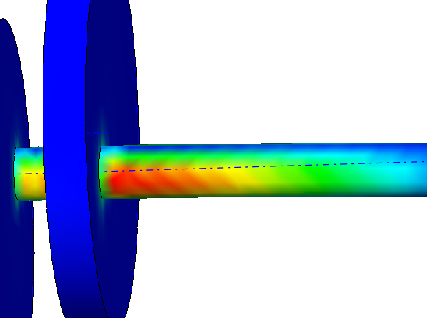
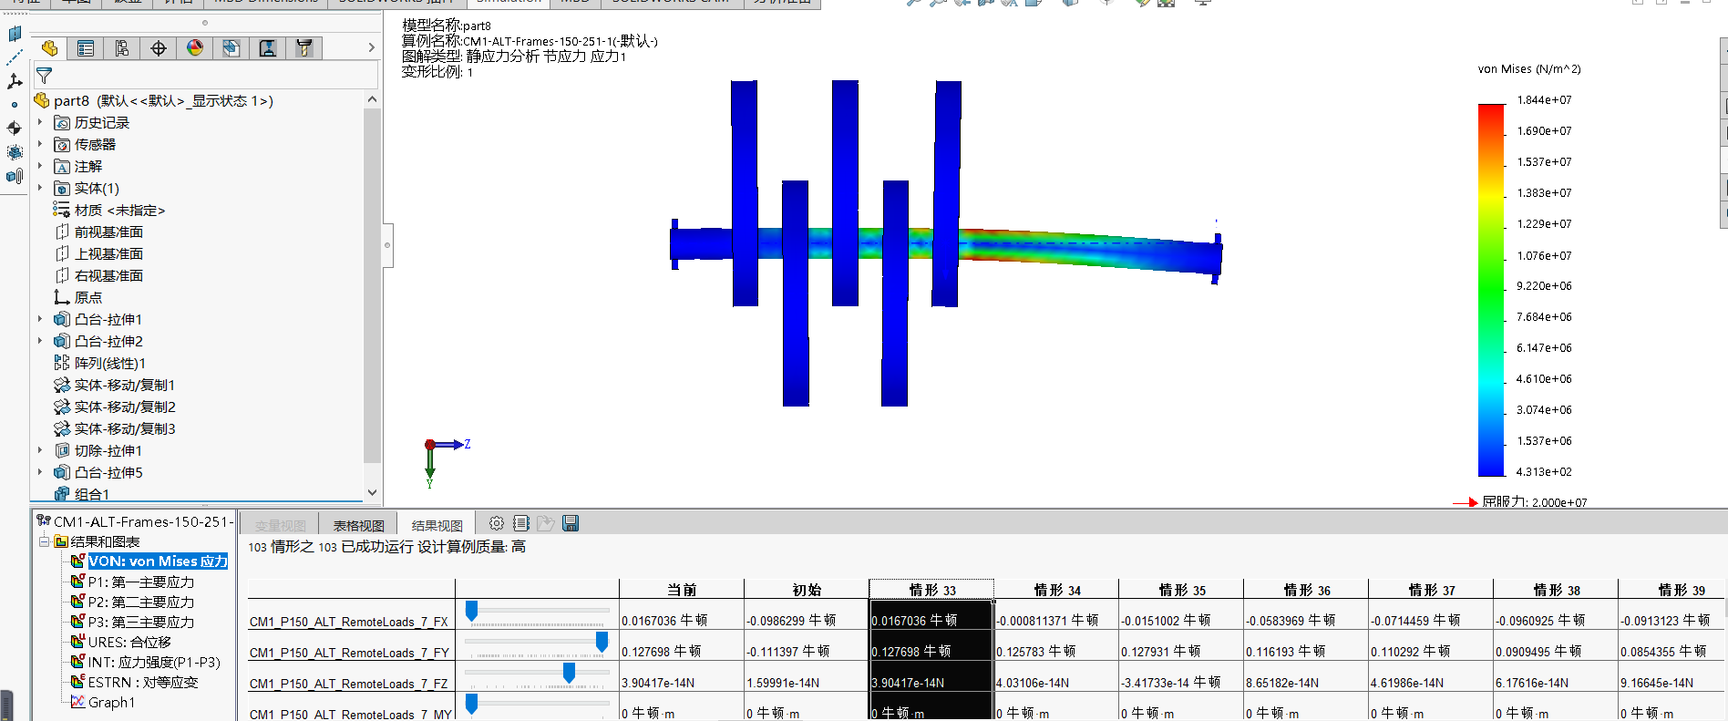
Firstly, the yield stress is $2*{10}^{7} N/m^{2}$ and the maximum stress on the shaft is $1.84*{10}^{7} N/m^{2}$ which is under tolerance. On the other hand, the area near the rightmost board indicates the stress concentration condition.
Figure3.3 Von mises stress at scenario 33
The author presented the 2nd main stress plot which indicates that maximum stresses occurs at the joints of the shaft and cams which means that they did not transition with the fillet or rounded corners. Also, stresses at joints reduces from right to left, so right area of the shaft is more dangerous and needed to be taken into account.
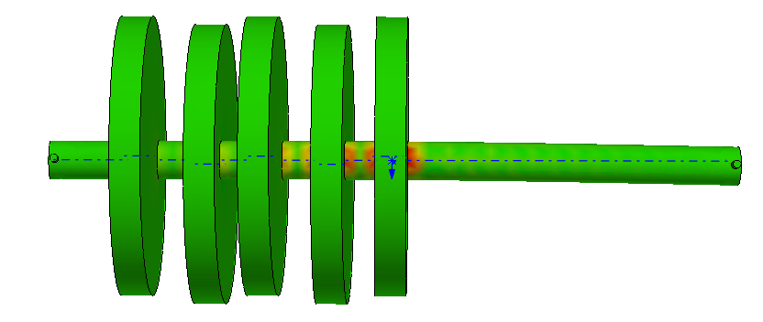
Figure3.4 2nd main stress at scenario 33
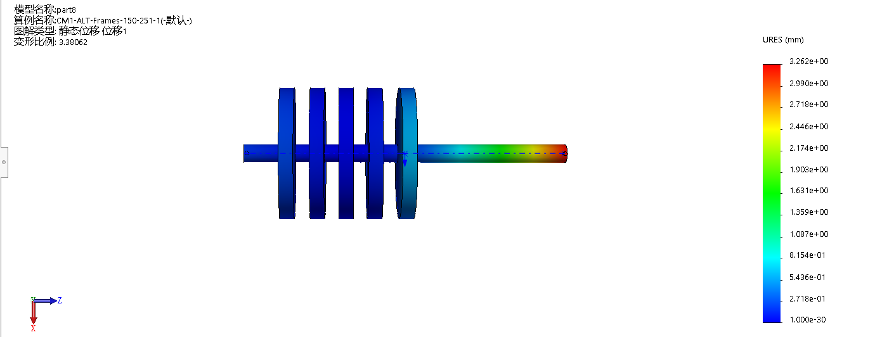
Also, the displacement at scenario 33 shows the largest displacement occurs at the right end of the shaft.
Figure3.4 Displacement at scenario 33

4. Modifying and comparison
In order to reduce the greater stress in some parts of the rotation shaft, modifying this model part can be applied to make it stronger.

4.1 Fillet
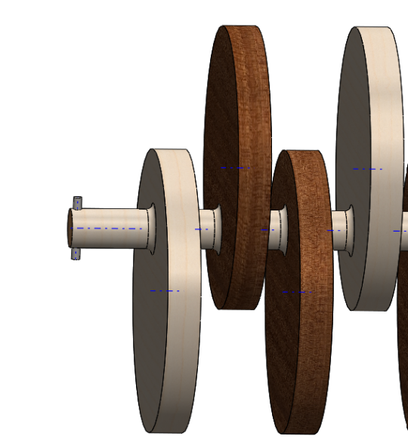
Throughout the previous analysis above, firstly the joints between shaft and cams need to be transitioned with fillet. Hence, the author chose every circus where cams and shaft link together and applied fillet function to these edges which is shown below. And filleting can avoid stress concentration to enhance the quality and strength of the model.
Figure 4.1 The fillet applied to ever edges of cam

4.2 stepped shaft (cannot optimize)
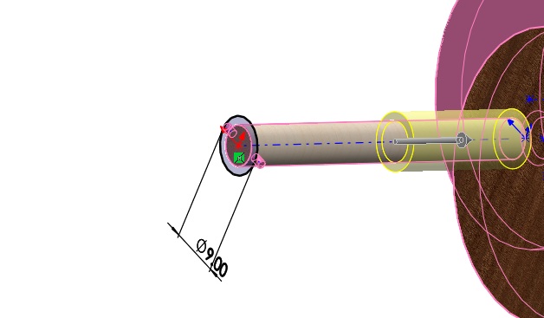
In addition, stepped shaft principle can also be applied to this condition in the light of weakness on the right of the shaft. As the graph shows below, the author widened the radius of part of shaft where strong stress occurs in the previous analysis to enhance its strength. The author added a sleeve with a radius of 9mm as it shows below.
Figure 4.2 stepped shaft applied
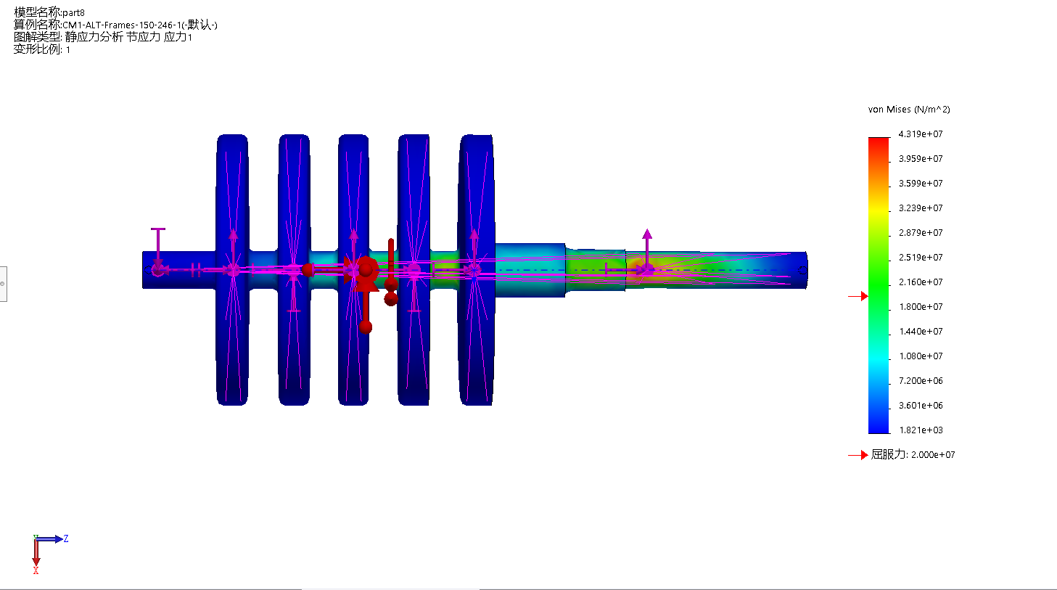
However, the author tried several designs of the stepped shaft, it all shows stronger stress even over the yield force.
Figure 4.3 Greater stress

4.3 Changing size of the model
Similarly, in order to reduce the maximum stress, the author changed the model size. Since the shaft is too long to tolerate strong forces, the author shortened the shaft length to 100 mm and the length of sheet metal was changed to 90mm. The reduction of length on the right side of the shaft can bring out smaller stress because it can reduce the bending moments on the shaft.
After modifying the model, motion simulation needed to be conducted. When importing motion loads, the start and end of the time for the ball movement changed since the sets of motion changed.
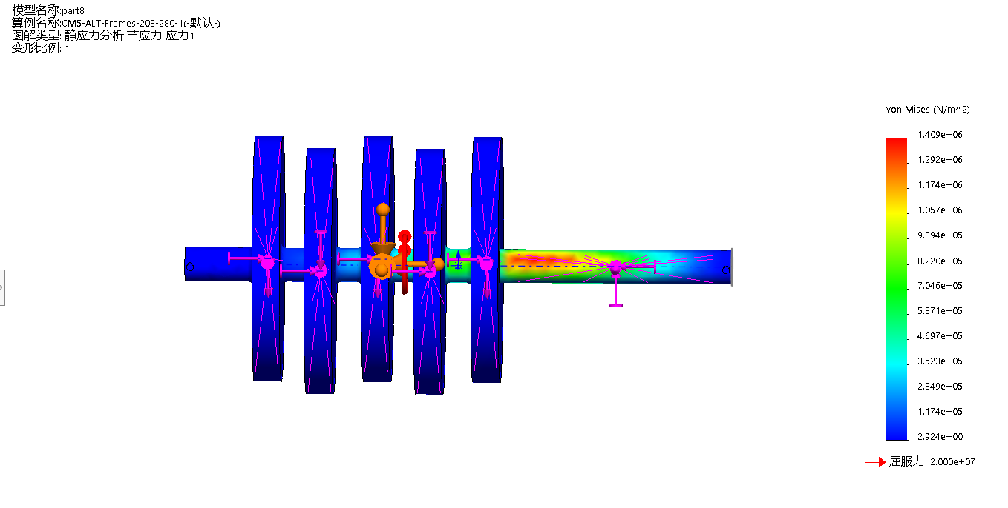
The graph below shows the static stress at the beginning. When compared it with the previous one, it shows smaller maximum stress.
Figure 4.3 Static stress at beginning for modified model
 | Previous model | Modified model
Maximum stress at the beginning | 1.844e+06 | 1.409+06
Table 4.1 Maximum stress at beginning for two models
Since the previous plot indicate that one circle for the ball has two similar curves, for this modified one, the author only chose the first half procedure for simulation.
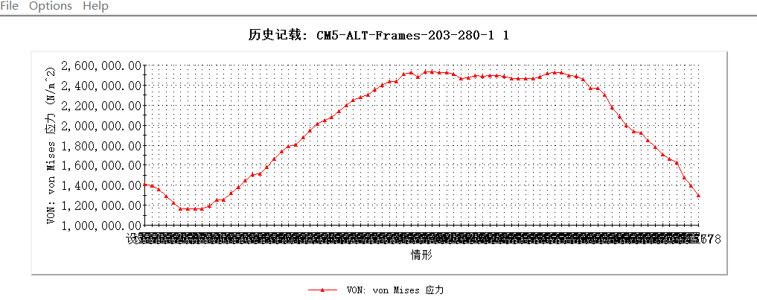
Figure 4.4 von mises stress for modified model
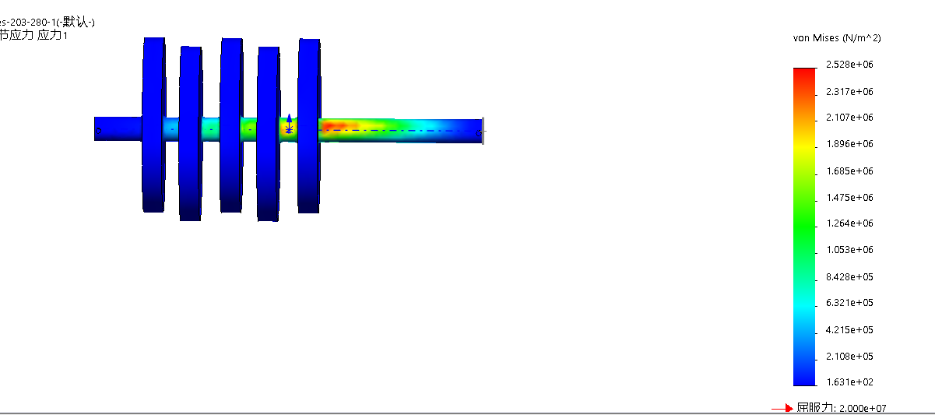
The author chose the 58th scenario to see the maximum static stress which is shown below.
Figure 4.5 stress of 58 scenario for modified
When compared to the maximum stress of the previous model, modified shows 2.528e+06 stress while the previous one shows 1.844e+07. It is obvious that modified one shows smaller stress and its strength is also enhanced.

5.Conclusion
Through this report, the author conducted this task for modelling, assembly, motion simulation and modifying part.
For modelling and assembling, the understanding of the mates and constrains enhanced.
During the motion simulation part, the author learned to set bearing faces and learned the method for analysing the stress when model is in motion.
For modifying the model, conclusions are drawn that for a shaft part, in order to increase its strength, the parts on the shaft should be reasonably arranged to reduce the load on the shaft. Hence, the load should not be too concentrated on and two sides of the shaft should not be too long. The cam should be as close as possible to the support points on both sides.

Reference
1. Chang, K.-H., 2009. Motion Simulation and Mechanism Design with SolidWorks Motion
2. Kurowski, P. M., 2010. Engineering Analysis with SolidWorks Simulation

