Data Handling and Business Intelligence

Module: Data Handling and Business Intelligence, LCBB5000
Lecturer name: Dr Md Nazmul Hasan
Student Name: Ana Maria Hasu
Student ID: 1922794

Table of Contents

Introduction: 4
Section 1: The use of Excel for pre-processing, analysing and visualising the data: 5
Present trends in data warehousing, business intelligence and data Mining: 5
Different trends in data warehousing: 5
Trends in Business Intelligence: 6
The pre-processing, analysis, and visualisation of the data using Excel and determine the decline in sales/profits over the years: 7
Pre-processing: 7
Data analysis and visualisation: 7
Section 2: Working with Excel and providing an explanation of the outcomes: Smile Clinic: 11
Calculate the value of Smile Clinics: 11
a) K-Means clustering: 14
b) Most common use data mining method: 14
c) Benefits and Drawbacks of SPSS over Excel: 15
Conclusion: 16

List of figures:
Figure 1: Characteristics of Datawarehouse 4
Figure 2: Sales year by year 7
Figure 3: Sales amount year by year 8
Figure 4: Discount year by year 8
Figure 5: Unit Price year by year 9
Figure 6: People Eat rice 10
Figure 7: Male and Female customers 11
Figure 8:Mean and Median Age 12
Figure 9:Mean and Median People Who Eat Rice 12
Figure 10: K-Means clustering 13

List of Table:
Table 1: Percentage of people Eat rice 11
Table 2: Male and female percentage 12
Table 3: K-Means clustering 16

Introduction:
Business intelligence and data mining are tools, processes, and applications used to analyses data and provide information to assist businesses to make better business choices. Data management is the essential process that organisations perform to organise and understand data to get accurate outcomes. In order to stay on top of the global market, a large number of companies have made considerable expenditures in business intelligence (Plotkin, 2017). A vital role for data mining and business intelligence is that they help turn raw data into usable information that displays a real picture of market performance. This allows for a thorough examination of data to uncover key patterns that can be used to implement or amend strategic goals. The first section of this research will look at sales and profit patterns over time. The part will also provide a Microsoft Excel analysis of supermarket data. Data pre-processing, analysis, and visualisation will all be part of the superstore data analysis.
The analysis of Smile clinics.csv data will be the subject of the second section of this paper. An Excel software application will be used to analyse the data. The Excel programme will be used to examine how data behaves in various ways. This will also contain real-world data mining applications. The final half of this section will go through the benefits and drawbacks of SPSS over Microsoft Excel.

Section 1: The use of Excel for pre-processing, analysing and visualising the data:

Present trends in data warehousing, business intelligence and data Mining:

Different trends in data warehousing:
Data warehousing (DW) is the process of collecting and analyzing data from many sources in order to get useful business insights. A data warehouse is often used to combine and analyze company data from a variety of sources. The data warehouse, which is used to evaluate and report data, is at the core of the business intelligence (BI) system. It's a set of tools and components that assist with data strategy (Rizzi, Abelló, Lechtenbörger and Trujillo, 2017). The following figure represents the characteristics of data warehousing:
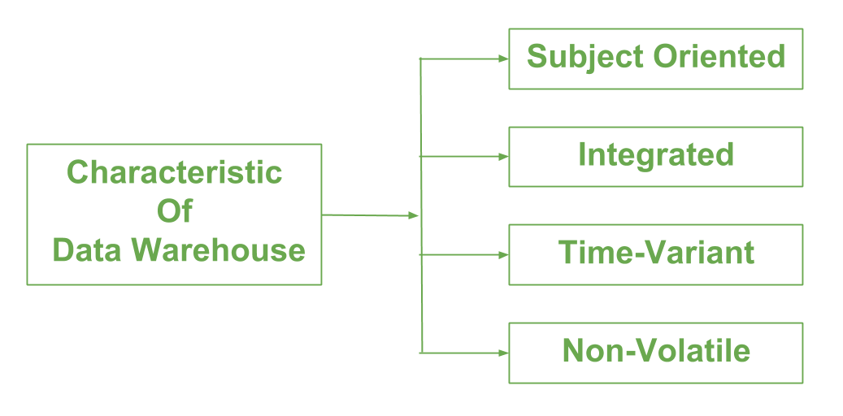
Figure 1: Characteristics of Datawarehouse
Source: (Plotkin, 2017)
Cloud technologies have advanced significantly in recent years, from traditional servers to current high-level services. In the current world, a new movement in data warehousing and big data analytics is transforming the image of the data warehouse. As the security and storage capacity requirement continues to rise, more businesses have turned to cloud servers. Due to the high demand for cloud servers, many solutions have been implemented to address the rising need for improved storage capacity (Ross and Kimball, 2017). Because most organisations are paid on growing demand by companies selling cloud services, cloud servers have played a crucial role in cost reduction. Below the trend is described:

The use of cloud storage is on the upswing:
Column-based storage outperforms row-based storage in instances where retrieving analytical questions is necessary. This corresponded to data warehousing industry developments. Data warehousing's primary purpose is to store data in a way that reduces query response time, allowing for more efficient data analysis and review.

Automation of the Data warehouse:
IT personnel are critical to the success of a data warehouse implementation. Even though it may take months or even years to build a warehouse, employing a data warehouse has significantly reduced these gaps in the overall cost and time associated with the process (Inmon, 2017). Because of this, hand-coding has been completely abolished, allowing firms to accomplish their projects more quickly than ever before.

Complex data marts will define the direction of business models:
Organisations have taken notice of data marts since they were created to meet specific operational requirements. Organisations now have access to secure data storage owing to the introduction of new data warehouse techniques that are both efficient and effective (Rizzi, Abelló, Lechtenbörger and Trujillo, 2017). Data marts are becoming more dependable and efficient due to this trend toward speed, which many businesses are adopting.

Cloud-centric data storage:
With the development of new technologies, it is now possible to store information more securely. There has been an increase in interest in using cloud storage systems because of their high data protection. The shifting patterns have influenced the adoption of cloud-centric data warehousing systems in data storage strategies. More complex data extraction and analysis techniques are needed as the number of accessible data storage systems grow with the rise of data warehousing (Plotkin, 2017). Companies see an increase in demand for data warehouses as a result of these trends

Trends in Business Intelligence:
BI (Business Intelligence) refers to a collection of methods, frameworks, and tools for transforming unstructured data into actionable insights that improve a company's bottom line. It is a collection of tools and services for turning data into useful information and understanding (Guru99, 2021).
BI directly influences the strategic, tactical, and operational business choices of a company. Instead of relying on conjecture and intuition, BI promotes historical data to enhance fact-based decision making. Business intelligence has seen several changes in recent years that have made it a vital tool in nearly every company (Wieder and Ossimitz, 2018). The majority of businesses are working to enhance their data storage infrastructure. Business intelligence appears to be undergoing a progressive shift shortly. Below the trends in business intelligence are presented:
For many firms, data security is a top priority in today's environment. Data security trends reveal that many firms are taking steps to protect their information. When it comes to the future of data storage, business intelligence trends have had a significant impact (Howson, 2018). In order to have the best outcomes, it has been crucial. Cybercrime continues to be a severe issue, and therefore this ensures that the data is protected.

The pre-processing, analysis, and visualisation of the data using Excel and determine the decline in sales/profits over the years:
Microsoft Excel is a critical tool for analysing and displaying data from Superstores. The term "data analysis" refers to the pre-processing, analysis, and display of data. All of these measures are critical for obtaining accurate data on profit and sales declines. The measures outlined below are intended to ascertain changes seen in the superstore.

Pre-processing:
This is the first stage in transforming raw data into a format that can be analysed. Raw data must be pre-processed before it can be transformed into a more usable and practical format. As a result, it is critical to pre-process data, removing flaws and inconsistencies that may obscure changes in an organisation's structure. As a result, part of the data in the superstore is unsatisfactory since it lacks certain features, is of low value, and is simply cumulative (Watson, 2016). Because of the various inconsistencies and numerous inaccuracies in unprocessed data, it cannot be used. There are two types of variables in a superstore: numeric and string. For both textual and numeric variables, a thorough processing approach is required to provide a clear picture of the trends. The first step in using Excel is to convert the data into numbers to be analysed.

Data analysis and visualisation:
When it comes to making business decisions, data analysis means cleaning, converting, and modelling data. Extracting usable information from data and making a decision based on the data analysis are the main goals of the Data Analysis process. In order to make data easier to understand and extract insights from, data visualization is the process of transforming data into a visual representation, such as a map or graph. The basic goal of data visualization is to make it easier to identify patterns, trends, and outliers in large datasets. all three phrases are commonly used interchangeably to describe the same thing: data graphics (SearchBusinessAnalytics, 2021). The SUM () of each year's sales will be used in data analysis for data visualisation. Graphs depicting changes in sales will be created using data from the PIVOT database. The primary motivation for examining superstore data is to identify a drop in profitability and sales.

Figure 2: Sales year by year
Source: (Self-Made)
From 2009 to 2012, the sales of the superstore shifted from the lowest to the top, as seen in the graph above. The superstore's maximum number of sales is a few hundred. It is evident from the graph that the company's revenues are dropping. The drop in sales of the superstore necessitates an analysis of numeric variables and other changes that indicate economic changes to determine the decline in sales of the superstore. Superstore sales are declining due to the association between the unit price and sales, which is seen in the graph.

Figure 3: Sales amount year by year
Source: (Self-Made)
The graph above depicts the total order quantity per year. The graph depicts a shifting pattern, with the most significant sales in 2009 and the lowest number of sales in 2011.

Figure 4: Discount year by year
Source: (Self-Made)
The graph above depicts the shifting patterns in the amount of discount. The graph illustrates that there has been no change in discount over the years. Compared to past years with about equal amounts of discount and sales, 2010 had the most considerable discount.

Figure 5: Unit Price year by year
Source: (Self-Made)
The unit price is shown in the graph. The price of each unit has decreased over time, following the company's sales.
Data analysis and pre-processing can be done with Microsoft Excel using the analysis from the superstore, and then data visualisation may be done using Excel. A drop in sales at a superstore may be determined using Excel, which illustrates that Excel can be utilised for this purpose.

Section 2: Working with Excel and providing an explanation of the outcomes: Smile Clinic:

Calculate the value of Smile Clinics:
Excel is a statistical software tool used for data analysis and data grouping (Watson, 2016). In the analysis of dietary nutrition, Excel is used. CSV to ascertain the fundamental cause of a drop in rice consumption.
i. Customers Eat Rice:
 |  | Frequency | Percent | Valid Percent | Cumulative Percent
0 | No | 40 | 40.0 | 40.0 | 40.0
1 | Yes | 60 | 60.0 | 60.0 | 100.0
 | Total | 100 | 100.0 | 100.0
Table 1: Percentage of people Eat rice
Source: (Self-Made)
Through Pie chart, the data is presented below:

Figure 6: People Eat rice
Source: (Self-Made)
The graph above reveals that 40% of customers at the smile clinic did not eat rice, whereas 60% ate rice.
ii. Customers are male and female:
 | Frequency | Percent | Valid Percent | Cumulative Percent
Male | 50 | 50.0 | 50.0 | 50.0
Female | 50 | 50.0 | 50.0 | 100.0
Total | 100 | 100.0 | 100.0
Table 2: Male and female percentage
Source: (Self-Made)
Through Bar chart, the data is presented below:

Figure 7: Male and Female customers
Source: (Self-Made)
There are equal male and female customers in the smile clinic, as seen in the bar chart above.

iii. Mean and Median Age:

Figure 8:Mean and Median Age
Source: (Self-Made)
From the above graph, it can be seen that the average age is 20.35 of the patients while the median age is 19.

iv. Mean and Median who Eat Rice:

Figure 9:Mean and Median People Who Eat Rice
Source: (Self-Made)
From the above image, it can be seen that the mean age of people who eat rice is 20.22 while the median age is 19

a) K-Means clustering:
K-means Clustering is a clustering analysis tool that is commonly used in data mining and statistics. Its goal is to divide a collection of observations into several clusters (k), resulting in Voronoi cell partitioning. It may be thought of as a means of determining which group a given object truly belongs to.
It is primarily employed in statistics, but it may be utilised in practically any field of study. In marketing, for example, it may be used to classify diverse demographics of individuals into basic groupings that marketers can target more quickly. Astronomers use it to filter through massive volumes of astronomical data; they need a means to statistically locate places of interest for observation and inquiry because they cannot investigate each item one by one (Sterling, Anderson, Bell and Brodowicz, 2018). Below the example is presented:
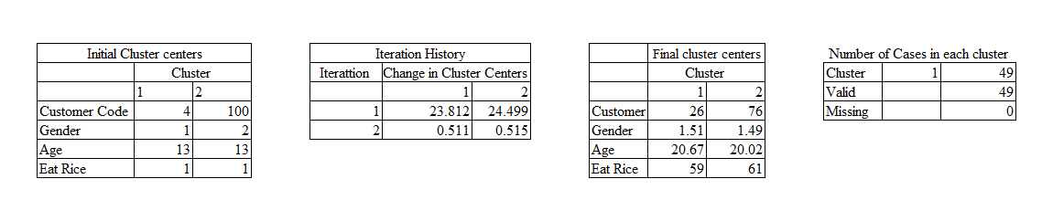
Figure 10: K-Means clustering
Source: (Self-Made)
Due to no or minor changes in cluster centres, convergence was obtained. For every centre, the maximum absolute coordinate change is.000. The current iteration is number three. Between the original centres, the iminium distance is 96.005.

b) Most common use data mining method:
There is more data than ever available to enterprises in the modern world. Unstructured data is notoriously tricky to work with, which is a serious problem when dealing with vast amounts of information. This makes it difficult to make progress because of unprocessed data. The term "data mining" refers to the practice of analysing a vast amount of data in order to discover new information. Information and data are generated through data mining, which helps with various activities (Han and Kamber, 2016). Using data mining, firms may discover patterns in their data and make inferences relevant to their business goals. Data science and business intelligence both rely on it. There are a variety of data mining techniques that have been developed and implemented by various organisations for data assessment and analysis purposes. When producing and maintaining an organisation's financial data, these strategies are essential and valuable tools. Below the most data mining method is presented:
Data mining is a method that relies heavily on data cleansing and preparation. For various analytic procedures, raw data must be cleaned and structured. Data transformation, data modelling, and data integration all play a role in data preparation and cleansing. Organisations might benefit from preparing and cleaning their data. A large number of businesses has used this strategy.
When it comes to data mining, pattern recognition is one of the most used techniques. As the name suggests, this is used to identify data points that deviated from their expected pattern. For this strategy, people are forced to put together certain traits in distinct groups. One of the techniques used in data mining is chucking, and it separates data into little groupings called chunks. After breaking data into smaller groups, intended results are next assessed. In order to do business intelligence, basic dashboarding, and reporting evaluations, structured data must be stored in a relational database management system. When it comes to storing data, cloud data warehouses have made it feasible to store more data than ever before, owing to technological advancements (Berry and Linoff, 2018). The corporation has been able to speed up the adoption of business intelligence thanks to advancements in the data warehouse.

c) Benefits and Drawbacks of SPSS over Excel:
SPSS is a statistical programme commonly used in data analysis, such as data preparation, modelling, data compilation, and analysis. SPSS has gained a lot of attention in the business sector because of its role in data analysis. In contrast, a growing number of businesses are relying on Excel for market research rather than SPSS. SPSS is the most reliable data analysis tool since it is easier and faster to use than any other way of data analysis (Field and Field, 2018). The following table represents the advantages and disadvantages of SPSS:
Advantages | Disadvantages
- SPSS has a far broader assortment of graphs and charts to choose from than Excel does. | - Sophisticated approaches, such as programmable coding, are not supported by SPSS.
- SPSS is more user-friendly than Excel. | - As a result of the high cost of SPSS, it is not frequently used.
- The accuracy and speed with which SPSS generates statistical data make it a better tool for the job. | - As a result, SPSS requires extensive training to get the most out of its capabilities.
 | - There is a greater level of complexity in SPSS graph features as compared to Microsoft Excel.
Table 3: K-Means clustering
Source: (Field and Field, 2018)

Conclusion:
During and after completing a research project, data management is the activity of guaranteeing that research data is retained, preserved, or disposed of safely and securely. Data storage, retrieval, and disposal may all be made more efficient and cost-effective with proper planning. Business intelligence's only objective is to aid and assist better business decisions. BI gives businesses access to data that is crucial to their performance in various areas, including sales, finance, marketing, and a slew of other departments. According to the assessment mentioned above, data mining and business intelligence have a bright future in business analytics since they aid in data analysis and better decision making. According to the paper, Excel is essential in data analysis since it shows market patterns. This makes it simple to spot business patterns, which may assist anticipate whether a company is losing money or gaining money.

References:
Berry, M. and Linoff, G., 2018. Mastering data mining. 5th ed. New York: J. Wiley & Sons.
Field, A. and Field, A., 2018. Discovering statistics using IBM SPSS statistics. 5th ed. London: SAGE Publications Ltd.
Guru99, 2021. What is Business Intelligence? Definition & Example. [online] Guru99. Available at: <https://www.guru99.com/business-intelligence-definition-example.html> [Accessed 15 November 2021].
Han, J. and Kamber, M., 2016. Data mining. 4th ed. Haryana, India: Elsevier.
Howson, C., 2018. Successful Business Intelligence. 10th ed. New York, NY: McGraw-Hill.
Inmon, W., 2017. Building the data warehouse. 6th ed. Indianapolis: Wiley.
Plotkin, D., 2017. Data stewardship: an actionable guide to effective data management and data governance. 3rd ed. Amsterdam [i pozostałe]: Morgan Kaufmann is an imprint of Elsevier.
Rizzi, S., Abelló, A., Lechtenbörger, J. and Trujillo, J., 2017. Research in data warehouse modelling and design. Proceedings of the 9th ACM international workshop on Data warehousing and OLAP - DOLAP '06.
Ross, M. and Kimball, R., 2017. The data warehouse toolkit. 4th ed. Hoboken, N.J.: Wiley.
SearchBusinessAnalytics, 2021. What is data visualisation, and why is it important? [online] SearchBusinessAnalytics. Available at: <https://searchbusinessanalytics.techtarget.com/definition/data-visualization> [Accessed 15 November 2021].
Sterling, T., Anderson, M., Bell, C. and Brodowicz, M., 2018. High-performance computing. London: Springer.
Watson, R., 2016. Data management. 6th ed. Prospect Press: London.
Wieder, B. and Ossimitz, M., 2018. The Impact of Business Intelligence on the Quality of Decision Making – A Mediation Model. Procedia Computer Science, 67, pp.1163-1171.

