Design of an Automatic Traffic Light Controller for T-Junction Road
  - Electronics 1
  - ACDB5002
  - By Bryan Skeen (2307828)
Abstract
Traffic light systems are a key tool in enabling safe traffic flow through junctions. T-junctions are an example of where traffic light system can be beneficial - especially if the junction is busy or has limit visibility. To be implemented at a T-junction, a traffic light system has been designed to provide fixed period control and pedestrian crossing facilities. This report presents the preliminary design of a system controller and traffic light units and its implementation up to the simulation stage using the Proteus 8 software.

Contents
1. Introduction 4
2. Literature Review 4
2.1 Fundamental Traffic Light Operation 4
2.2 Traffic Light Controllers 5
2.2.1 Fixed Period 5
2.2.2 Vehicle Actuation 5
2.2.3 Coordinated 5
3. Design & Implementation 6
3.1 System Overview 6
3.2 Circuit 7
3.2.1 Controller 8
3.2.2 Traffic Light Unit 10
3.3 Programming 12
3.3.1 Program Code 13
4. Simulation & Testing 15
5. Conclusion & Future Work 18
References 18
Appendix A 20

Introduction
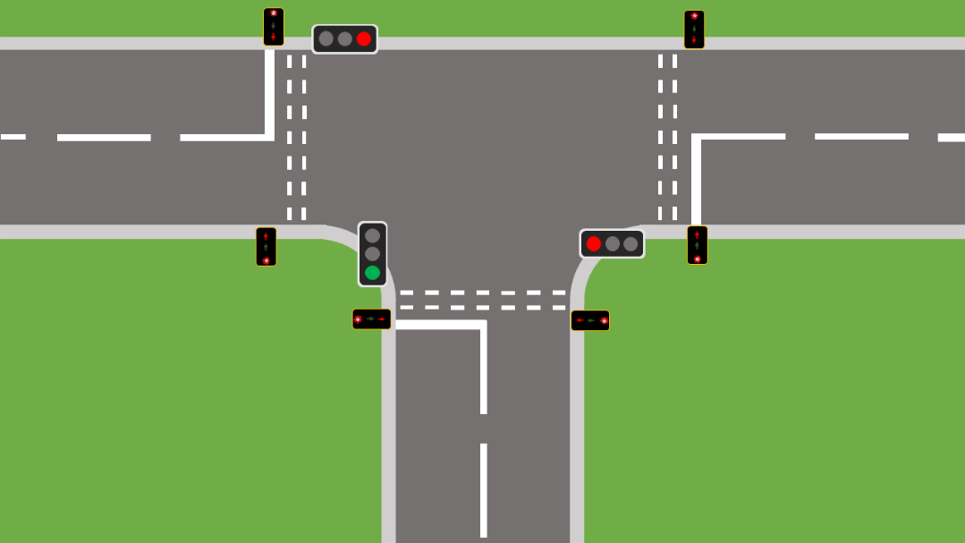
Traffic light (TL) control systems are a key tool in managing road space with high volumes of conflicting traffic. Their use can help to improve traffic flow, by minimising overall road user wait times at junctions, and also improving safety through overcoming intervisibility issues and helping pedestrian movements [1] [2]. A road layout where TLs can be necessary to install is the T-junction. The objective of this report is to present a design solution for a reliable and efficient TL control system for a T-Junction with pedestrian crossings. An intended example scenario layout is shown in Figure 1.
Figure 1. Target junction design for which a traffic light system is to be designed for.

Literature Review

Fundamental Traffic Light Operation
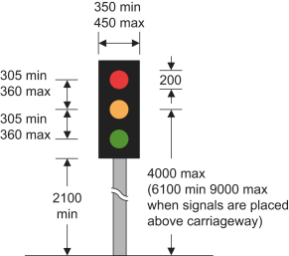
As mandated by the Traffic Signs Regulations and General Directions 2016 [3], vehicle traffic signals must include red, amber and green lights, conforming to the design shown in Figure 2. Their illumination and sequencing are dictated to be as follows:
Figure 2. Legislated design of traffic light signals within the UK as is specified in [3].
- Red: prohibiting entry in the junction.
- Red and Amber: indicating an imminent change to green, but still prohibits entry.
- Green: allows traffic to proceed into the junction.
- Amber: requires vehicles to stop unless unsafe to do so.
The red and amber signal must be illuminated for 2 seconds, and amber alone for 3 seconds, both with a tolerance of ±0.25s tolerance. Red and green durations are adjustable based on system implementation.
When pedestrian crossing facilities are provided, new installations must use Puffin crossings instead of Pelican, because of improved safety [4]. Apart of these pedestrian facilities are red and green figure lights to signal when it is safe or unsafe to cross, respectively. A specified in [3], both figures must never be illuminated at the same time. The green figure may only be shown when vehicle signals display red. An optional addition is countdown displays, aiming to reassure pedestrians with a visual cue of the remaining crossing time [4].

2.2 Traffic Light Controllers
At the heart of every TL system is a controller which coordinates the signal sequencing and timings. Controllers can be implemented for manual operation, but typically self-actioning control methods are used. There are a number of different control methods available which fall into 3 main categories [5]:
- Fixed period,
- Vehicle actuated,
- And coordinated.

2.2.1 Fixed Period
Fixed period controllers operate on pre-programmed sequences and timings, cycling continuously regardless of actual traffic conditions. This method is the simplest form of TL control, requiring no sensors, system integration, or algorithm development. While fixed timing can be optimised for specific traffic patterns, it may become inefficient under varying conditions. However, in environments like urban areas – where traffic flow tends to be more consistent – fixed time signals can be effective solution [6].

2.2.2 Vehicle Actuation
Vehicle actuated (VA) controllers are widely used in TL systems. They rely on sensors - such as induction loops, radar detectors, and laser techniques [7] – to monitor approaching traffic and adjust green phase timings accordingly. Green times are extended within a predefined minimum and maximum limits, based on vehicle detection, until a critical time gap occurs or the maximum duration in reached.
An advancement of traditional VA is Microprocessor Optimised VA (MOVA). MOVA uses junction’s layout, available signal stages, and real-time traffic conditions to dynamically control signal timings on a cycle-by-cycle basis. This enables optimal signal operation, reducing queues and improving flow through the junction. Compared to conventional VA, MOVA offers more effective green phase management and better handle queues at red approaches [8]. As a result, MOVA has become the default controller type implemented in TL systems [9].

2.2.3 Coordinated
Another type of TL control system is coordinated control, used across a network of TL junctions. Junctions communicate either via a Cableless Link Facility (CLF) in a standalone network or through a central hub in Urban Traffic Control (UTC) systems. In CLF networks, each junction operates their timing plan with an added offset to coordinate the sequencing between the junctions, improving traffic flow by producing corridors where traffic can easily move through the chain of junctions. UTC systems expand on this by centrally coordinating multiple junctions across a wider area, enabling more efficient traffic flow through a complete road network. Coordination can be based on fixed timings or adaptive control, using sensor data from each junction for real-time optimisation [5] [10]

Design & Implementation

System Overview
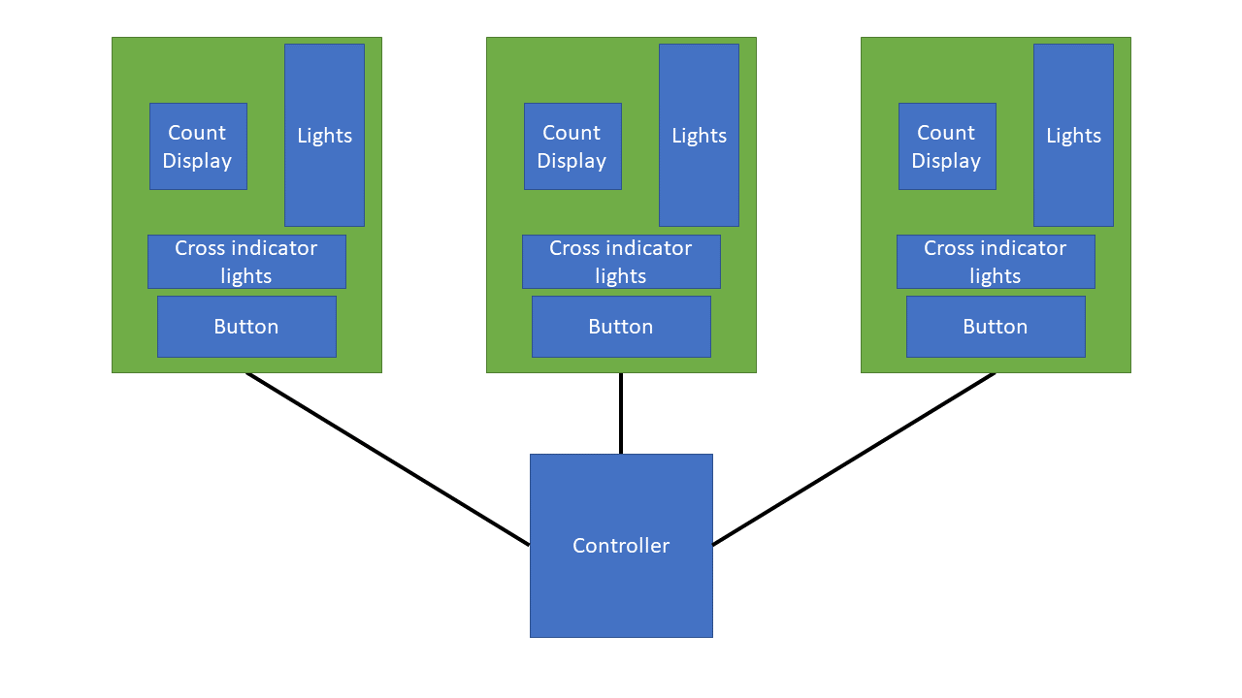
Implementing the T-junction TLs, a system consisting of a central controller with separate TL units has been designed. Figure 3 shows the block diagram of the system. The central controller has been designed to control the displayed signal on each TL unit, coordinate the signal sequencing and manage the pedestrian crossing demands. The control mode utilised for the designed controller is fixed period signalling. This is because fixed period controllers offer ease of implementing and are simple to maintain and reconfigure. Each TL unit consists of the red, amber and green signal lights, a 2-digit count display, pedestrian crossing indicator lights and a pedestrian demand button.
Figure 3. Block diagram of the designed traffic light system.
The system signal sequence has been configured to comply with standards described in [3]. Timings of each phase within the sequence which have been implemented in this report are described in Table 1, however within this design these could be changed to be better tailor the system after deployment.
Traffic Light |  |  | Cycle Display Time (s)
1 | 2 | 3 | Cycle Display Time (s)
 |  |  | 0-1
 |  |  | 1-3
 |  |  | 3-13
 |  |  | 13-15
 |  |  | 15-16
 |  |  | 16-18
 |  |  | 18-28
 |  |  | 28-31
 |  |  | 31-33
 |  |  | 33-36
Table 1. Implemented traffic light sequence and the number of seconds from the start of the cycle each sequence stage is displayed for.

Circuit
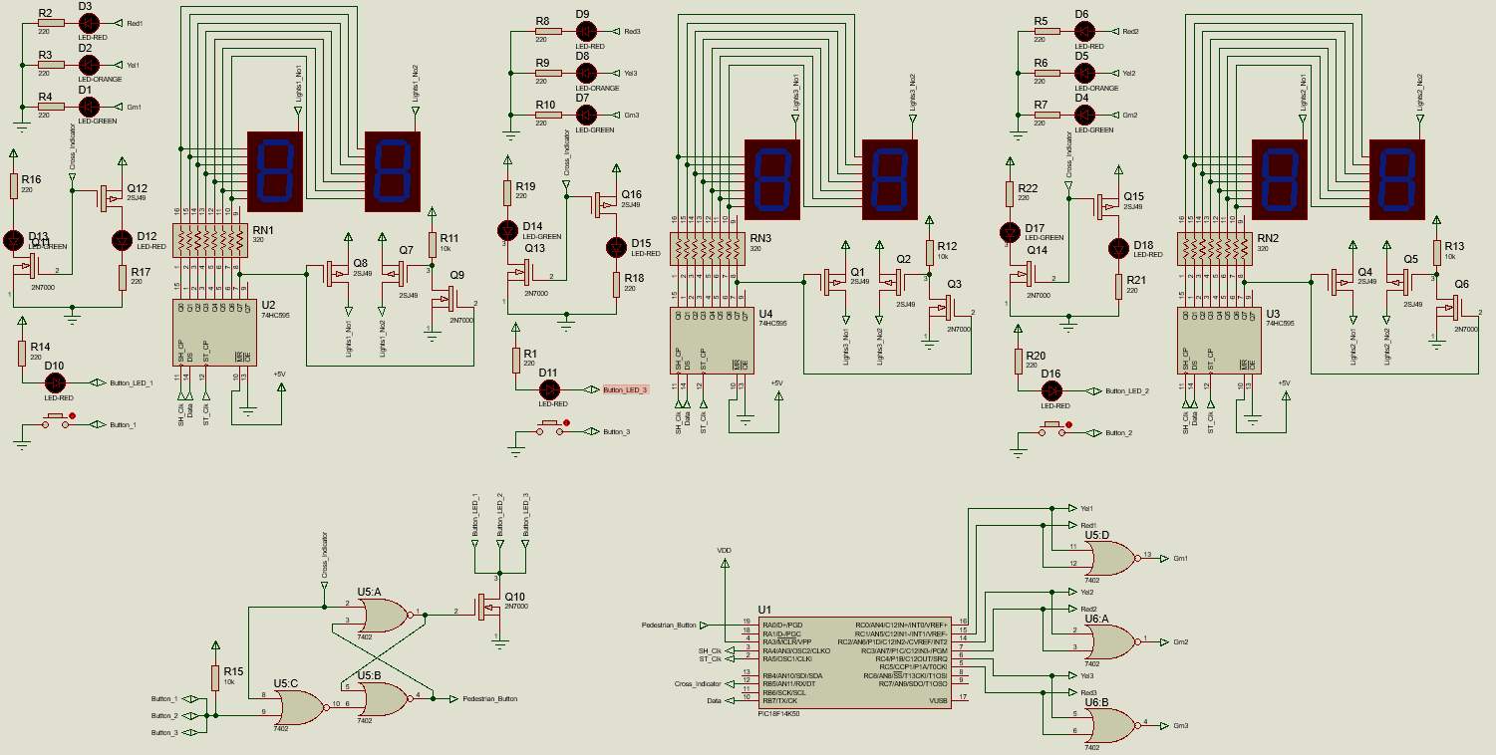
Designing the circuitry for the system was done using the Proteus 8 software, with Figure 4 showing the schematic of the whole system circuit, including controller and light units.
Figure 4. The designed circuit for the entire traffic light system including controller and each traffic light unit.

Controller
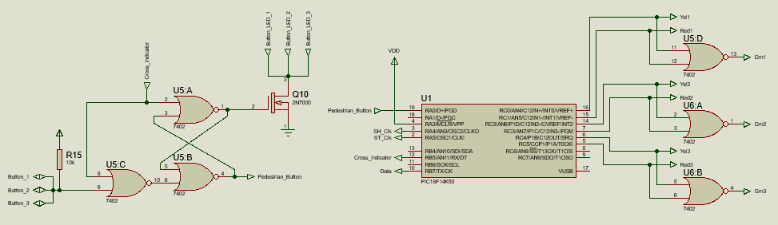
The TL system controller consists of the circuitry presented in Figure 5. At the centre of the controller is a PIC18F14K50 microcontroller. This is a single chip computer, consisting of a CPU, memory, GPIOs and peripherals, which can be programmed to performed specific tasks. The PIC18F14K50 has a number of features outlined in TABLE and was chosen because these offer the necessary capability to implement the controller design. The features sought after were:
Figure 5. Traffic light system controller circuitry.
- A minimum of 12 GPIO pins. The PIC18F14K50 provided 15 GPIO pins which satisfied this requirement and allows for additional interfacing if future development requires.
- A timer with program interrupt-on-overflow capability. There are 4 built-in timers which can used as a source for the timing control of the signal sequencing.
Additional benefits of using the PIC18F14K50 included the on-chip EEPROM which can allow for data to be stored on the device even without power, providing the opportunity for configuration data to be permanently remembered and be reconfigurable without reprogramming the microcontroller’s software.
Feature | Description
Program Memory size | 16kB
RAM | 768B
EEPROM Data | 256
Pin Count | 20 – 14 I/O pins and 1 input only able to sink/source 25mA of current
ADC | 9 channels with maximum 10-bit resolution
Comparators | 2 built-in
EUSART Peripheral | Can support RS-485, RS-232 and LIN 2.0
SPI Peripheral | 1 built-in
I2C Peripheral | 1 built-in
PMW | 5 channels
Oscillator | Has internal oscillator capable of speeds from 31kHz-16MHz or externally clocked up to 48MHz
Timers | 1 8-bit timer and 3 16-bit timers
Table 2. Features of the PIC18F14K50 microcontroller used within the controller circuit [13].

Providing the interface to the light signals, connections where made on port C of the PIC. For each light unit 2 connections were used one for the amber light and the other for the red light. A connection to the green light was determined to not be necessary, minimising the required number of GPIO pins of the microcontroller, as it is seen the green light will always be the logical NOR of the red and amber signals. Therefore, a SN74HC02N quad-channel 2-input NOR gate [11] was used to NOR the red and amber connections for each TL unit. Using this approach would also simplify code implementation as rather than all three light units being connected across multiple ports only one port is required to be used.
To handle pedestrian crossing button presses, the controller implements the circuit in Figure 6. This is an S-R latch with an additional NOR gate on the input to the set pin. When the crossing indicator lights are not active, as determined by the microcontroller, pressing one of the buttons at any of the light units pulls the input to the latch low, setting the latch. This will cause the button LED to be turned on and the input pin, RA0, of the microcontroller monitoring the button state to be pulled low signalling for a pedestrian sequence to be activated. When the pedestrian crossing indicator lights are activated, by pin RB5 being set high, the latch is reset and the acknowledgment of button presses are prevented. A truth table for this operation is shown in Table 2. Additionally, turning on the button LEDs from the S-R latch is done using a n-channel MOSFET; this is because the output of the NOR gate is only able to sink a maximum of 25mA [11], so by using the MOSFET all three LEDs can safely be driven together.
Button Input
Crossing lights active
$$Q$$
$$\overline{Q}$$
Figure 6. Pedestrian button interfacing circuitry of the controller for the traffic light system. Labelled in orange are the key inputs and outputs of the circuit.
Button Input | Crossing Lights Active | $$Q$$ | $$\overline{Q}$$
0 | 0 | 1 | 0
0 | 1 | 0 | 1
1 | 0 | 0 | 1
1 | 1 | 0 | 1
Table 3. Truth table for the S-R latch implemented in the controller circuit for the handling and control of the pedestrian demand buttons at each traffic light unit, as is seen in FIGURE.

For the control of the counter displays on each TL unit a shared 3 output pins of the microcontroller are used. These allow for display configuration data to be serial sent to all of the displays.

Traffic Light Unit
Each TL unit is constructed of the same circuitry as shown in Figure 7. The light signals used LEDs, which are illuminated by applying a 5V input from the controller. This forward-biases the LED, allowing current to flow. A current-limiting resistor is connected in series with each LED to prevent the current from exceeding the LED’s maximum rating.
Figure 7. Circuit design of a traffic light unit, consisting of the light signals, pedestrian cross indicator lights, pedestrian crossing demand button and 2-digit counter display.
The pedestrian crossing indicators use two LEDs: green for safe to cross, and red for do not cross. A single signal controls both LEDs, being connected to the gate of a p-channel MOSFET for the red LED, and an n-channel MOSFET for the green LED. When the signal is logic high (+5V), the n-channel MOSFET saturates, illuminating the green LED, while the p-channel MOSFET is driven into its cut-off region. When logic low (0V) the operation of each MOSFET is reversed and the red LED illuminates instead. This complementary configuration ensures the LEDs cannot be on simultaneously. Also, for the correct illumination of the LEDs a current limiting resistor is connected in series.
The 2-digit display uses two common-anode 7-segment displays with shared cathode connections routed through resistors to a 74HC595 8-bit serial-to-parallel shift register. Output Q7 of the shift register controls a p-channel MOSFET for activating the left digit, and also drives an n-channel MOSFET that inverts the signal to control the right digit’s p-channel MOSFET. This arrangement enables multiplexing [12], which reduces the number of required connections by rapidly switching between digits. Multiplexing works by toggling the power to each digit in turn while applying the correct segment pattern to the shared cathodes. When switching is fast enough, both digits appear continuously lit an observer. The 74HC595 allows control of the display using minimal GPIO pins. Data is shifted in serially via the DS pin on the rising edge of a clock on SHCP. Once all 8 bits are loaded, a rising edge on STCP transfers the data from the shift register to the storage register to be outputted. The master reset is tied high, as is not used, and output enable is tied to ground to always keep outputs active.

Programming
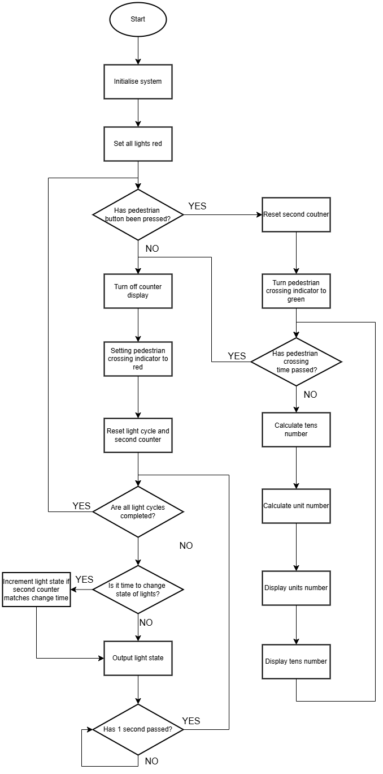
To implement the desired logical control of the TL system the PIC18F14K50 in the system controller has been programmed. This program has been written in C for the MPLAB XC8 compiler and can be found in its entirety in Appendix A. The program follow of the controller is outlined in the flowchart in Figure 8.
Figure 8. Flowchart describing the operation of the traffic light as has been programmed into the PIC microcontroller.

3.3.1 Program Code

3.3.1.1 Key Variables
The program’s operation is governed by a set of variables are used to track system state and control sequencing logic. A key structure is TrafficLight_t, with individual instances for each TL. This structure stores the current signal state and the time each state should be incremented. Another structure, ProgStatus_t, contains status flags, such as sequence completion indicators and a flag for when the secondCounter variable is incremented.
Additionally, the microcontroller’s EEPROM is used to store constant values, including byte patterns for the 7-segment display and timing data for state transitions. This allows traffic light timings to be reconfigured and retained even after power loss – beneficial for supporting future reconfiguration. EEPROM values are defined in the file eeprom.h.

3.3.1.2 Interrupt Routines
The program contains an interrupt routine triggered on the overflow of the microcontroller’s timer 0. This routine increments the secondCounter, sets the ProgStatus count flag and then adjust the timer 0 value so the next interrupt occurs after 1 second. The purpose of this interrupt is to have a second timer which can be used to sequence the TL signal changes.

3.3.1.3 Traffic Light Sequencing
Iterating through the light sequences is handled within a while loop, as shown in the code block below. The loop’s condition checks the first byte of the ProgStatus structure to determine if all light sequence completion flags are set. Inside the loop, the program first waits for the second count flag to be set, indicating that one second has elapsed. Once triggered, each traffic light is evaluated to determine if a state change is due. Finally, the updated light configurations are outputted via the disp_lights() function.
The function disp_lights() takes the light state of each TL, as is set in their respective TrafficLight_t structure, and uses them to set the necessary pins on port C of the microcontroller. This is done by performing a bitwise and operation on the corresponding pins controlling the TL signals and its light status configuration left shifted for the correct port pins to be set.

3.3.1.4 Pedestrian Crossing Sequence
At the start of each program loop, the pedestrian crossing demand pin is checked. If the button has been pressed, the pedestrian crossing mode is initiated. This involves retrieving the crossing time from EEPROM, illuminating the green pedestrian indicator, and resetting the second counter. The program then enters a loop that runs until the elapsed seconds equal the crossing time. During this period, the countdown value is calculated, and its units and tens digits are determined. For the units digit, the corresponding byte is retrieved form EEPROM, the least significant bit (LSB) is set to set the right display, and the value is sent to the shift register using shift_out() and output_shift_reg(). The same process is repeated for the tens digit, but the LSB is cleared to set the left display.
The functions shift_out() and output_shift_reg() are implemented as follows:
shift_out() takes one byte of data as an argument and through a for loop clocks the SHCP pin of the shift register attached to pin LA4 and before the rising edge, each bit of the data byte is outputted to the shift registers serial input from the lowest significant bit to most significant. After this function, using output_shift_reg() provides a pulse for the STCP pin which transfers the shift register contents to the storage resister to be outputted. Within this function NOP() is used between setting the pin high and back to low, so that there is sufficient time for the shift register chip to see the clock pulse rise.

Simulation & Testing
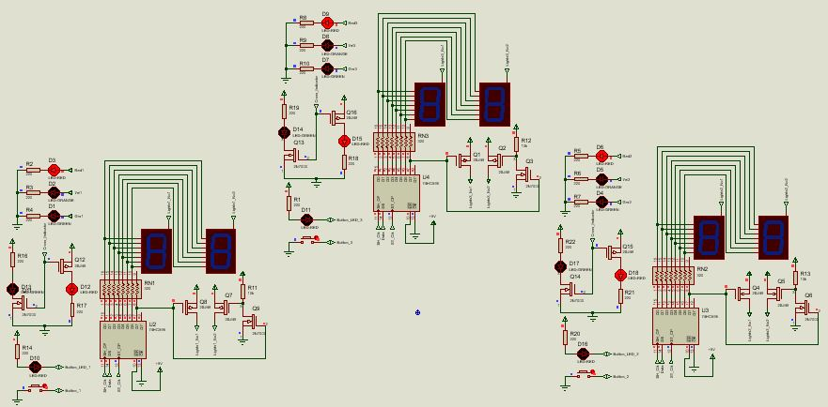
Within Proteus 8, the programmed microcontroller and system circuitry was simulated to test its operation. First the implemented sequencing of the TLs where assessed. It was seen the correct signals were displayed as shown in figures 9-18. Then to confirm the operation of the pedestrian demand button, this was tested by running the simulation and interacting with the button. When the button was pressed, the latch was set and the button LED at every unit illuminated, as shown in Figure 19. Once the traffic light cycle had completed, the system entered the pedestrian mode. This saw the crossing indicator light turn green and the countdown be displayed on the 7-segments displays. Figure 20 show the pedestrian mode and multiplexing of the 7-segment displays.
Figure 9. Initial start-up state of each traffic light unit, with all lights signalling red.
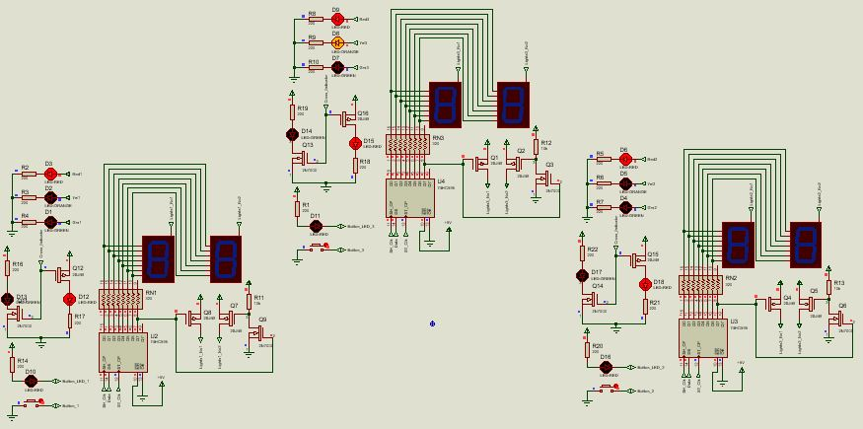
Figure 10. System cycling through control sequencing displaying centre light signal red and amber.
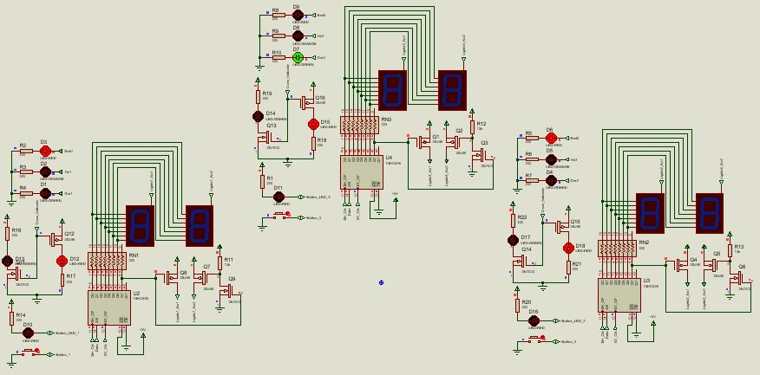
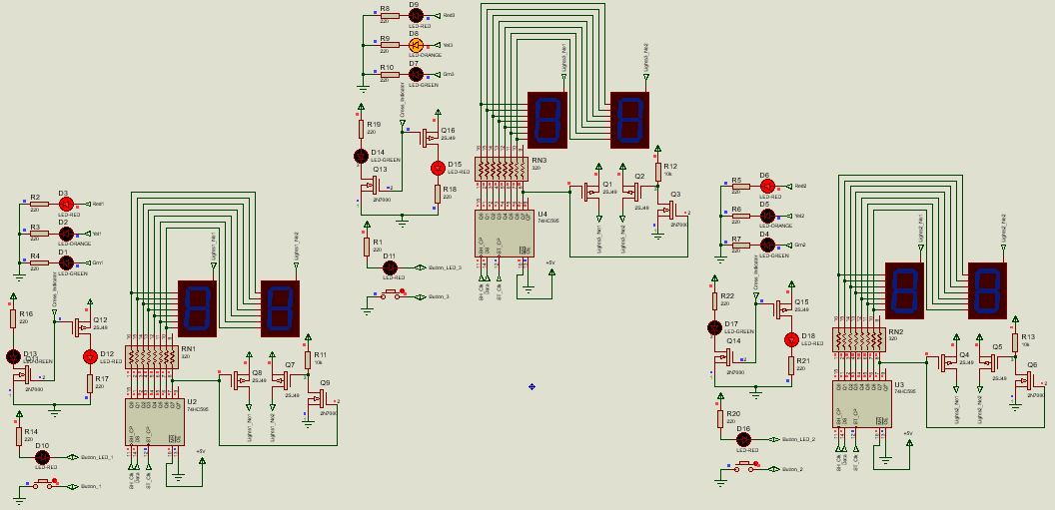
Figure 11. System cycling through control sequencing displaying centre light signal green.
Figure 12. System cycling through control sequencing displaying centre light signal amber.
Figure 13. System cycling through control sequence displaying the intermediate all red signals.
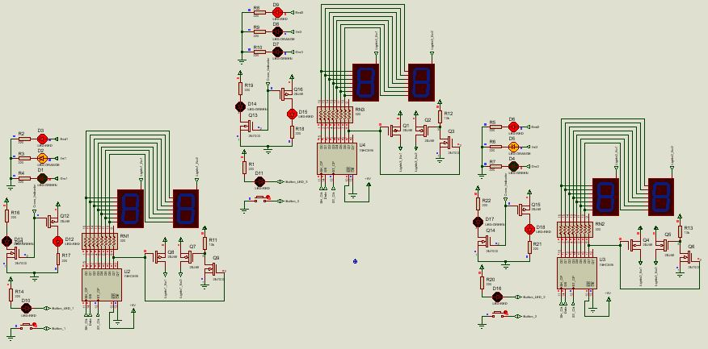
Figure 14. System cycling through control sequencing displaying left and right light signals as red and amber together.
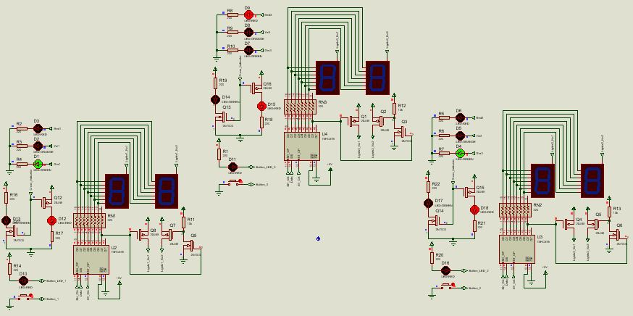
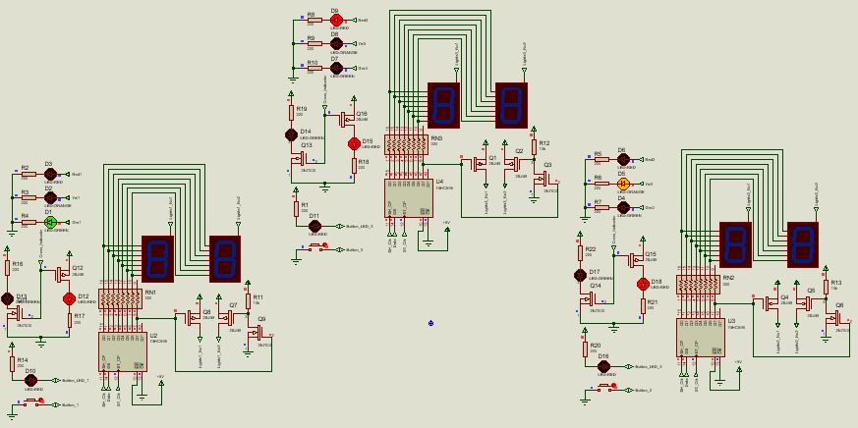
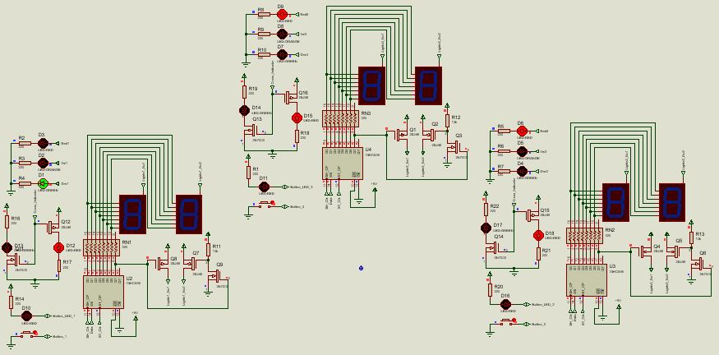
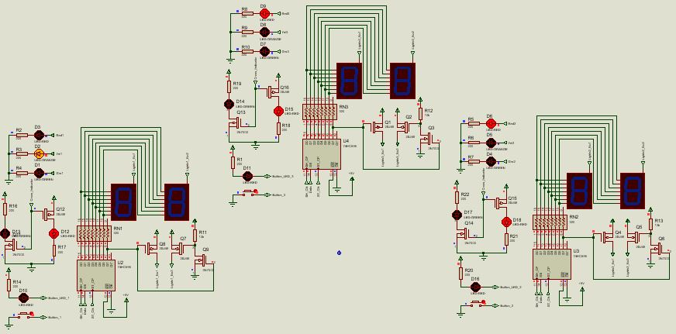
Figure 15. System cycling through control sequencing displaying the left and right light signals as green.
Figure 16. System cycling through control sequencing displaying the left light continuing to signal green and the right light has transitioned to amber.
Figure 17. System cycling through control sequencing displaying the left light continuing to signal green and the centre and right lights signalling red.
Figure 18. Final sequence step of the traffic light control cycle, displaying amber on the left light signals and red on the centre and right. Following this the light sequence checks if the pedestrian button has been pressed and restarts the cycle.
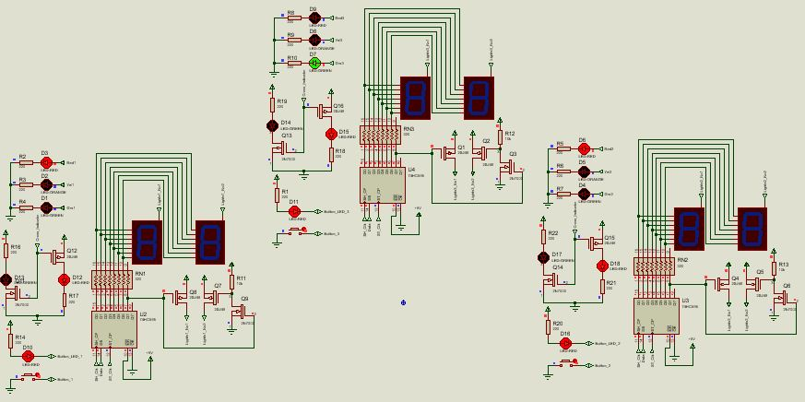
Figure 19. Traffic during cycling through normal signalling sequence showing pedestrian button having been pressed.

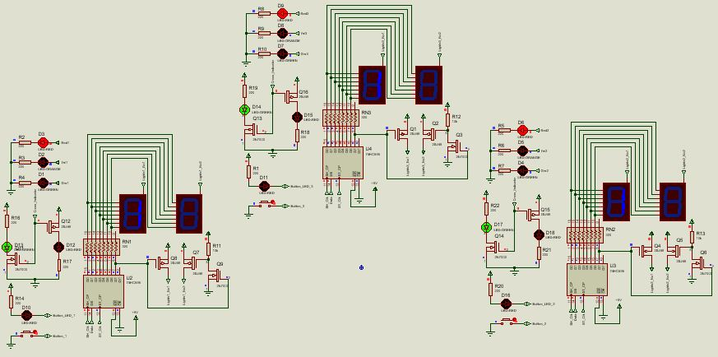
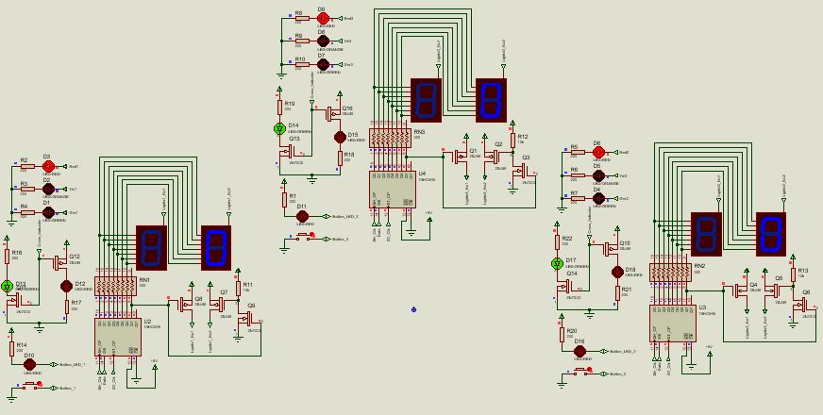
Conclusion & Future Work
Figure 20. Pedestrian mode of the traffic light sequence. Left shows the counter display when the tens digit is being displayed and right shows when the units digit is being displayed.
Within this report a design for a traffic light system to be implemented at a T-junction has been presented. The design implements a fixed period controller mechanism and through simulation has been shown to successfully cycle through the traffic light sequence and provide pedestrian interface to demand a crossing period.
Future work that needs to be conducted on the design is the implementation of the system on breadboard to confirm its operation outside of simulation an in the real world – breadboarding the design was unable to be conducted and presented for this report. Additional work which could be made to the design is the addition of a user interface to allow for easier reconfiguration of the sequence times stored in EEPROM. Also, considering adding vehicle actuation capability could greatly improve system efficiency when deployed at a junction. Choices made for the current design presented, such as the choice of microcontroller, were made with future developments this kind in mind.

References

[1] | F. L. Mannering and S. S. Washburn, “Traffic Control and Analysis at Signilized Intersections,” in Principles of highway Engineering and Traffic Analysis, 5th ed., John Wiley & Sons, Inc, pp. 225-284.
[2] | Department for Transport, “Traffic Advisory Leaflet: General Principles of Traffic Control by Light Signals Part 1 of 4,” 2006.
[3] | “The Traffic Signs Regulations and General Directions 2016,” 22 April 2016. [Online]. Available: https://www.legislation.gov.uk/uksi/2016/362/pdfs/uksi_20160362_en.pdf. [Accessed 10 April 2025].
[4] | Department for Transport, “Pedestrian, cycle and equestrian crossings,” 5 December 2023. [Online]. Available: https://www.gov.uk/government/publications/know-your-traffic-signs/pedestrian-cycle-and-equestrian-crossings#puffin-crossings. [Accessed 10 April 2025].
[5] | AECOM, “Introduction to Traffic Signals (UK),” 21 June 2022. [Online]. Available: https://www.mhaplus.org.uk/wp-content/uploads/filebase/professional_services/Presentation-content/Introduction-to-Traffic-Signals-Bitesize-Read-Onlyc.pdf. [Accessed 10 April 2025].
[6] | National Association fo City Transportation Officials, “Fixed vs. Actuated Signalization,” [Online]. Available: https://nacto.org/publication/urban-street-design-guide/intersection-design-elements/traffic-signals/fixed-vs-actuated-signalization/#:~:text=Application,predictability%2C%20and%20reducing%20unnecessary%20delay.. [Accessed 11 April 2025].
[7] | Automate Systems, “How Do Traffic Lights Sensors Work?,” [Online]. Available: https://www.automatesystems.co.uk/how-traffic-light-sensors-work/. [Accessed 12 April 2025].
[8] | Department for Transport, “The Traffic Advisory Leaflet 3/97: The "MOVA" signal control system,” 1997.
[9] | Department for Transport, “Traffic Advisory Leaflet 1/06: General Principles of traffic Control by Light signals Part 2 of 4,” 2006.
[10] | Sanderson Assosiates Traffic Signal Design, “Urban Traffic Control,” [Online]. Available: https://www.traffic-signal-design.com/urban-traffic-control.htm#:~:text=Urban%20Traffic%20Control%20(UTC)%20is%20the%20method,central%20computer%2C%20usually%20within%20the%20council%20offices.&text=The%20clocks%20in%20the%20controllers%20to%20be,used%20a. [Accessed 12 April 2025].
[11] | Texas Instruments, “SNx4HC02 Quadruple 2-Input Positive-NOR Gates,” 2020.
[12] | Analog Devices, “Charlieplexing - Reducing Pin-Count LED Display Multiplexing,” 10 Feburary 2003. [Online]. Available: https://www.analog.com/en/resources/technical-articles/charlieplexing--reduced-pincount-led-display-multiplexing.html. [Accessed 6 April 2025].

Appendix A
File: main.c
// Includes
#include <xc.h>
#include "fuses.h"
#include "eeprom.h"

// Global variables
struct ProgStatus_t {
char lights1_complete : 1;
char lights2_complete : 1;
char lights3_complete : 1;
char byte_align : 5; // Here so that light sequencing loop testing is simplified
char count_flag : 1;
} ProgStatus;

struct TrafficLight_t {
char light_state;
char red_time;
char ryl_time;
char yel_time;
char grn_time;
} TrafficLight_1, TrafficLight_2, TrafficLight_3;

char secondCounter;
char pedestrianCounter;
char tens;
char units;

// Function Prototypes
void start_up(void);
void disp_lights(void);
void configure(void);
void initialise_lights(struct TrafficLight_t* trafficLights, char light num);
char change_lights(struct TrafficLight_t* current_light);
void initiate_pedestrian_crossing(void);
void shift_out(char data);
void output_shift_reg(void);

///////////////////
// Main function //
///////////////////
int main(void) {
configure();
start_up();

// Initialising each traffic light control structure.
// State change times are loded in from EEPROM and current
// traffic light state is set to red
initialise_lights(&TrafficLight_1, 1);
initialise_lights(&TrafficLight_2, 2);
initialise_lights(&TrafficLight_3, 3);

while(1) {
// Testing if pedestrian button has been pressed
// - if so RA0 will be low and crossing sequence should be performed
if(!PORTAbits.RA0) {
initiate_pedestrian_crossing(); // setting up controls for the crossing sequence
secondCounter = 0;

// Count down from start pedestrian crossing time and display to displays
while(pedestrianCounter != secondCounter) {
char count = pedestrianCounter – secondCounter;
tens = count / 10; // Getting the tens digit
units = count % 10; // Getting the units digit
// Display units digit to right display – LSB must be set
shift_out(~read_EEPROM(units) | 1);
output_shift_reg();
// Display tens digit to left display – LSB must be cleared
shift_out(~read_EEPROM(tens) & 0xFE);
output_shift_reg();
}
LATBbits.LB5 = 0; // Setting pedestrian crossing indicator light back to red
}

shift_out(0xFF); // Clearing counter display
output_shift_reg();

// Resetting light sequence complete flags
ProgStatus.lights1_complete = 0;
ProgStatus.lights2_complete = 0;
ProgStatus.lights3_complete = 0;

secondCounter = 0;

// Loop for changing lights through cycle
// In the ProgStatus structure the first byte only contains the light complete flags thus
// by reading and testing the byte at the address of the structure it can be seen
// if all flags are set
while(((char*)&ProgStatus)[0] < 7) {
while(ProgStatus.count_flag == 0; // Waiting for second to have passed

ProgStatus.count_flag = 0;

// If light sequence isn’t completed see if lights need updating
if(!ProgStatus.light1_complete)
ProgStatus.lights1_complete = change_lights(&TrafficLight_1);
if(!ProgStatus.light2_complete)
ProgStatus.lights2_complete = change_lights(&TrafficLight_2);
if(!ProgStatus.light3_complete)
ProgStatus.lights3_complete = change_lights(&TrafficLight_3);

disp_lights();
}
}
}

///////////////////////
// Interrupt Routine //
///////////////////////
void __interrupt() isr(void) {
if(TMR0IF && TMR0IE) {
TMR0IF = 0;
++secondCounter;
ProgStatus.count_flag = 1;

// Setting the timer so next timer overflow is in 1 second
TMR0H = 0x0B;
TMR0L = 0xDE;
}
return;
}

///////////////
// Functions //
///////////////
void configure(void) {
// Oscillator setup – clock is configured to 16MHz
OSCON |= 0b1111001;

// Initialising ports as input or output
TRISA = 1;
TRISB = 0;
TRISC = 0;

// Configuring timers
T0CON = 0b10000101;

// Configuring interrupts
INTCON = 0b11110000;
}

void start_up(void) {
// Resetting the pedestrian button latch to ensure initial state is high on the input pin
LATBbits.LB5 = 1;
LATBbits.LB5 = 0;

// Setting all lights to red
LATCbits.LC1 = 1;
LATCbits.LC3 = 1;
LATCbits.LC5 = 1;

// Blanking counter displays
shift_out(0xFF);
output_shift_reg();
}

void initialise_lights(struct TrafficLight_t* trafficLight, char light_num) {
// setting state to red
trafficLight->light_state = 2;

// Getting light change times from EEPROM
trafficLight->red_time = read_EEPROM(10 + (4 * (light_num – 1)));
trafficLight->ryl_time = read_EEPROM(11 + (4 * (light_num – 1)));
trafficLight->grn_time = read_EEPROM(12 + (4 * (light_num – 1)));
trafficLight->yel_time = read_EEPROM(13 + (4 * (light_num – 1)));
}

void disp_lights(void) {
// shifting and masking bits so to output the correct configuration to each traffic lights
// corresponding pins
LATC = (0x03 & trafficLight_1.light_state) | (0x0C & (TrafficLight_2.light_state << 2)
| (0x30 & (TrafficLight_3.light_state << 4));
}

char change_lights(struct TrafficLight_t* current_light) {
if(secondCounter == current_light->red_time || secondCounter == current_light->ryl_time)
current_light->light_state++;
else if(secondCounter == current_light->grn_time)
current_light->light_state = 1;
else if =(secondCounter == current_light->yel_time) {
current_lights++;
return 1;
}
}

void initiate_pedestrian_crossing(void) {
// Loading pedestrian counter time from location in EEPROM
pedestrianCounter = read_EEPROM(22);
LATBbits.LB5 = 1; // Setting pedestrian crossing inicator light to green
}

void shift_out(char data) {
// Iterate over every bit of the byte shift it left by shifting the current bit to the LSB
// position then outputting it to the shift register data input along with pulse the clock
for(char i = 0; i < 8; i++) {
LATAbits.LA4 = 0; // setting clock pin low
LATBbits.LB7 = (data >> i) & 1; // setting current bit number state to data pin
LATAbits.LA4 = 1; // setting clock high as data is read in on rising
// edge
}
}

void output_shift_reg(void) {
LATAbits.LA5 = 1; // setting STCP pin high to make it see rising edge and output data
NOP(); // slight break before setting pin back to zero
LATAbits.LA5 = 0; // set STCP back to low
}

File: eeprom.h

#ifndef _EEPROM_H // Guard to prevent multiple inclusion of this file at compile time
#define _EEPROM_H

#include <xc.h>

// EEPROM variables – using compiler macro so these are added to eeprom when pic is programmed
__EEPROM_DATA(0b11111100, 0b11000000, 0b11011010, 0b11110010, 0b01100110, 0b10110110, 0b11111010,
0b11100000);
__EEPROM_DATA(0b00000000, 0b11100110, 15, 16, 31, 33, 15, 16);
__EEPROM_DATA(26, 28, 1, 2, 12, 14, 10, 0);

// bytes 0-9 – configuration for displaying nums 0-9 on 7-seg displays
// byte 10 – Traffic light 1 red change time
// byte 11 - Traffic light 1 red+yel change time
// byte 12 – Traffic light 1 green change time
// byte 13 - Traffic light 1 yel change time
// byte 14 – Traffic light 2 red change time
// byte 15 - Traffic light 2 red+yel change time
// byte 16 – Traffic light 2 grn change time
// byte 17 - Traffic light 2 yel change time
// byte 18 – Traffic light 3 red change time
// byte 19 - Traffic light 3 red+yel change time
// byte 20 – Traffic light 3 grn change time
// byte 21 - Traffic light 3 yel change time

// prototype for reading eeprom data at given address
char read_EEPROM(char addr);

#endif // Guard end

File: eeprom.c

#include "eeprom.h"

// definition of the eeprom data reading function – this function is required as the xc8 compiler does
// not provide built-in functions for interfacing with EEPROM for PIC18’s
char read_EEPROM(unsigned char addr) {
EEADR = addr;
EECON1 = (EECON1 & 0b00111110) | 1;
return EEDATA;
}

File: fuses.h

// This is a guard condition so that contents of this file are not included
// more than once.
#ifndef FUSES_H
#define FUSES_H

// CONFIG1L
#pragma config CPUDIV = NOCLKDIV // CPU System Clock Selection bits (No CPU System Clock divide)
#pragma config USBDIV = OFF // USB Clock Selection bit (USB clock comes directly from the
// OSC1/OSC2 oscillator block; no divide)

// CONFIG1H
#pragma config FOSC = IRC // Oscillator Selection bits (Internal RC oscillator)
#pragma config PLLEN = OFF // 4 X PLL Enable bit (PLL is under software control)
#pragma config PCLKEN = ON // Primary Clock Enable bit (Primary clock enabled)
#pragma config FCMEN = OFF // Fail-Safe Clock Monitor Enable (Fail-Safe Clock Monitor disabled)
#pragma config IESO = OFF // Internal/External Oscillator Switchover bit (Oscillator Switchover mode disabled)

// CONFIG2L
#pragma config PWRTEN = OFF // Power-up Timer Enable bit (PWRT disabled)
#pragma config BOREN = SBORDIS // Brown-out Reset Enable bits (Brown-out Reset enabled in hardware only (SBOREN is disabled))
#pragma config BORV = 27 // Brown-out Reset Voltage bits (VBOR set to 2.7 V nominal)

// CONFIG2H
#pragma config WDTEN = OFF // Watchdog Timer Enable bit (WDT is always enabled. SWDTEN bit has no effect.)
#pragma config WDTPS = 32768 // Watchdog Timer Postscale Select bits (1:32768)

// CONFIG3H
#pragma config HFOFST = ON // HFINTOSC Fast Start-up bit (HFINTOSC starts clocking the CPU without waiting for the oscillator to stablize.)
#pragma config MCLRE = ON // MCLR Pin Enable bit (MCLR pin enabled; RA3 input pin disabled)

// CONFIG4L
#pragma config STVREN = ON // Stack Full/Underflow Reset Enable bit (Stack full/underflow will cause Reset)
#pragma config LVP = ON // Single-Supply ICSP Enable bit (Single-Supply ICSP enabled)
#pragma config BBSIZ = OFF // Boot Block Size Select bit (1kW boot block size)
#pragma config XINST = OFF // Extended Instruction Set Enable bit (Instruction set extension and
// Indexed Addressing mode disabled (Legacy mode))

// CONFIG5L
#pragma config CP0 = OFF // Code Protection bit (Block 0 not code-protected)
#pragma config CP1 = OFF // Code Protection bit (Block 1 not code-protected)

// CONFIG5H
#pragma config CPB = OFF // Boot Block Code Protection bit (Boot block not code-protected)
#pragma config CPD = OFF // Data EEPROM Code Protection bit (Data EEPROM not code-protected)

// CONFIG6L
#pragma config WRT0 = OFF // Table Write Protection bit (Block 0 not write-protected)
#pragma config WRT1 = OFF // Table Write Protection bit (Block 1 not write-protected)

// CONFIG6H
#pragma config WRTC = OFF // Configuration Register Write Protection bit (Configuration registers not write-protected)
#pragma config WRTB = OFF // Boot Block Write Protection bit (Boot block not write-protected)
#pragma config WRTD = OFF // Data EEPROM Write Protection bit (Data EEPROM not write-protected)

// CONFIG7L
#pragma config EBTR0 = OFF // Table Read Protection bit (Block 0 not protected from table reads executed in other blocks)
#pragma config EBTR1 = OFF // Table Read Protection bit (Block 1 not protected from table reads executed in other blocks)

// CONFIG7H
#pragma config EBTRB = OFF // Boot Block Table Read Protection bit (Boot block not protected from table reads executed in other blocks)

#endif /* FUSES_H */

// CONFIG5H
#pragma config CPB = OFF // Boot Block Code Protection bit (Boot block not code-protected)
#pragma config CPD = OFF // Data EEPROM Code Protection bit (Data EEPROM not code-protected)

// CONFIG6L
#pragma config WRT0 = OFF // Table Write Protection bit (Block 0 not write-protected)
#pragma config WRT1 = OFF // Table Write Protection bit (Block 1 not write-protected)

// CONFIG6H
#pragma config WRTC = OFF // Configuration Register Write Protection bit (Configuration registers not write-protected)
#pragma config WRTB = OFF // Boot Block Write Protection bit (Boot block not write-protected)
#pragma config WRTD = OFF // Data EEPROM Write Protection bit (Data EEPROM not write-protected)

// CONFIG7L
#pragma config EBTR0 = OFF // Table Read Protection bit (Block 0 not protected from table reads executed in other blocks)
#pragma config EBTR1 = OFF // Table Read Protection bit (Block 1 not protected from table reads executed in other blocks)

// CONFIG7H
#pragma config EBTRB = OFF // Boot Block Table Read Protection bit (Boot block not protected from table reads executed in other blocks)

#endif /* FUSES_H */

