Your manager is keen that being responsible for the development of the graduate trainee is also a development opportunity for you. Your manager asks you to:
explain why learning and development activities are of benefit to the graduate trainee and Inter Luxe Hotel Group. (AC 6.1)
According to the CIPD (2024) on “Learning & Development strategy and policy”, learning and development strategy shows how an organisation develops it’s employees skills, experience and capabilities.
Inter Luxe Hotel Group Benefits
When looking at why learning and development activities would be beneficial to Inter Luxe Hotel Group, it would help the organisation to adapt to changing external pressures. When looking at Inter Luxe Hotel Group learning and development strategy, it would be beneficial to make sure that it reflects the overall business strategy and drive. It must also line up with the strategy that includes talent and recruitment. All of this helps learning and development to be understood access the organisation. When thinking of the benefits for Inter Luxe Hotel Group through learning and development activities, it would be a benefit to have in house training. This would save on cost for the company as there would be no need to pay for an external company to provide training. If Inter Luxe Hotel Group are looking at other benefits for learning and development activities, it improves staff performance and in turn this keeps employee retention low as it means they are happy in their role.
Graduate Benefits
For the benefit of the graduate, it would be vital to do on the job training in the workplace. When they would do on the job training it’s usually done through watching and taking notes from a colleague. This is a great way to learn as it normally is done in a one-to-one setting and the support and advise can be given straight away.
describe different types of learning needs and reasons why they arise for the graduate trainee and Inter Luxe Hotel Group. (AC 6.2)
According to the CIPD factsheet (2024) there various ways to gather data on learning needs. Learning needs mean that things like upskilling members of staff and getting them to adapt to new technologies when new technologies comes in. For a graduate there are a number of different types of learning needs. According to a Cardiff University document, learning needs are split into 4 areas. These are learning needs known to learner, learning needs unknown to learner, learning needs known to tutor and learning needs unknown to tutor. As for the graduate, it would be important to gather data on their learning needs through engaging with current learners in the real word. One of the main types of learning types of the graduate trainee would be development of their career. The graduate might have needs related to advancing their career and could take on new responsibilities in work. This would help them by continuing to improve their skills and processes. For Inter Luxe Hotel Group a learning need would be to adapting to new technologies. Due to being in the tourism sector, new technologies constantly appear, and organisation need to adapt and provide training for their employees. This in turn could prepare the organisation for future needs and prepare the workforce for anticipated upskilling requirements.
summarise different face-to-face and blended learning and development approaches, including facilitation; training; coaching; and mentoring that you could use when developing the graduate trainee. (AC 6.3)
After looking at the learning and development standards in the CIPD profession map, you can see that there are 4 levels of impact. These levels of impact are foundation level, associate level, charted member level and charted fellow level. When developing graduates, it would be helpful for them when using the blended learning method, it could be easier for the graduate to learn as this learning can be completed in their own pace, and they often incorporate different media elements. Another aspect of blended learning would be through the flex model. This model lets the learner to combine virtual learning with face-to-face learning. This will allow the learner to move between both as needed. The blended approach normally has a lot of benefits and can improve engagement and retention and can save on cost. If coaching is used when developing the graduate, the GROW model is normally use. The GROW model means, goal, reality, options and will. According to the Culture at Work website, the GROW model provides a framework for coaching, conversation and a project
Facilitation
Facilitation normally means that individuals create, discover and apply their own learning needs. This normally involves a guide along side who can then ask questions and moderate, this helps people to learn.
Training
Training learning is normally led by a trainer. This is normally designed to develop the learners’ skills and change their behaviour. Learning is usually contents based.
Coaching
If coaching a graduate, this method tries to get the best performance out of the graduate at work. This normally focuses on goals and the individual skills of the person.
Mentoring
Mentoring for the graduate would mean they would have a relationship with a colleague who has been in post longer and that colleague would pass on information and help the individual develop their skills.

.
explain how, in the design and delivery of learning and development initiatives, individual requirements and preferences of the graduate trainee must be accommodated. (AC 6.4)
When looking at the preferences, there are a number of different individual ways this can be accommodated. When looking at cultural sensitivity, it would best to tailor the training and delivery method to be inclusive of different cultures backgrounds within the workplace. Another way a graduate trainee reference could be accommodated is through self-directed learning options. This would mean giving the learner resources and a chance for them to follow self-directed learning. This is normally based on their interest and development needs. When thinking about individual needs, reasonable adjustments could be in place for learners who have disabilities under the Equality Act 2010. There are different ways this could be accommodated, one way a leaners need could be accommodated is through having access to software that recognises their voice to help whilst learning. Another accommodation that could help is to have clear motives and end goals. Adding information about how to get to the end goals would help the learner.
discuss at least two methods of evaluating the graduate trainee’s learning and development and its impact. (AC 6.5)
When evaluating the graduate trainee's learning and development organisations could use the Kirk Patrick Model. This model is recognised for evaluating how effective the training program is. According to the LinkedIn Talent Blog (2023) this tool helps learning and development to assess the training based on four aspects. These aspects are reaction, learning, behaviour and results. When looking at the reaction, this level can show how learners reacted to the learning they receive. Normally the way this could be measured would be through surveys after the course and asking questions to the learners. The second aspect of this model is learning. Traditionally the best way to measure this are tests or assignments to show the skills learnt. Behaviour is the third level, this is measured by any changes to the people’s behaviour that could be a result of the training. The final level of this is results, this can be seen through the output the learners are giving in their day to day work.

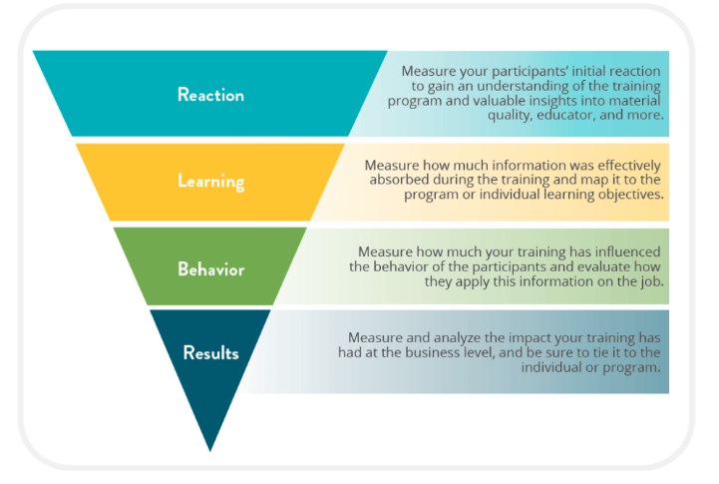
Another model used to evaluate learning and development, is the Brinkerhoff Success Case Method. This method is to see the impact and effectiveness of training. They vital aspects of the Success Case Method is that it is focuses on the success of something when it gets used. There are 5 steps to the SCM process.
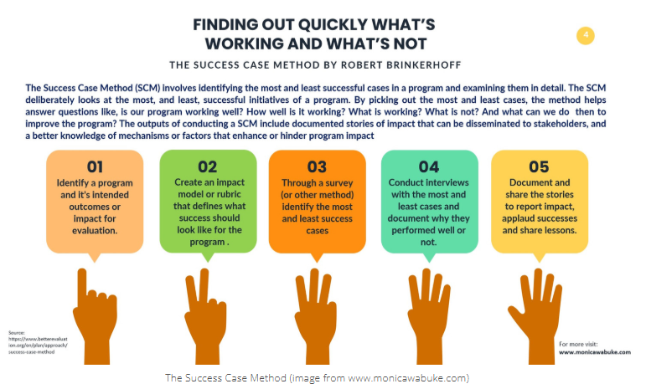
These models can help you collate feedback on the graduate role at Inter Luxe Hotel Group through seeing how the graduate is progressing in their role. For the organisation they could use the Kirk Patrick Model to see if there are any gaps in the training they provide and make relevant changes.
References
https://www.cipd.org/uk/knowledge/factsheets/strategy-development-factsheet/
https://www.cipd.org/uk/knowledge/factsheets/learning-needs-factsheet/
https://www.cipd.org/uk/the-people-profession/the-profession-map/explore-the-profession-map/specialist-knowledge/learning-development/
The GROW model Coaching Framework | Culture at Work
https://www.linkedin.com/business/talent/blog/learning-and-development/best-way-to-use-kirkpatrick-model
https://www.leadinglearning.com/episode-277-rob-brinkerhoff-daniela-schroeter/
https://www.cardiff.ac.uk/__data/assets/pdf_file/0003/1165098/How_to_Identify_Learning_Needs.pdf
https://www.cipd.org/uk/knowledge/factsheets/coaching-mentoring-factsheet/ https://www.commlabindia.com/blog/kirkpatrick-model-of-evaluation-part3
https://www.understood.org/en/articles/common-classroom-accommodations-and-modifications

