Resourcing and Talent Management

Jodie Barnett

Module code: BMHR7015

Student number: 1905258

Report title: A critical analysis of the current challenges facing an organisation, with specific focus on recruiting, promoting and retaining talent.

Word count: (3500) 3595

Executive summary
The aim of this report is to critically analyse current challenges faced by organisations, with specific focus on recruiting, promoting and retaining talent.
Talent management processes have become increasingly common following its creation in the early 21st century. Although there are varying definitions of what talent management actually means, all commonly refer to ‘recruitment, development, promotion and retention of its people’.
It is imperative that organisations constantly review both internal and external factors affecting talent management that will inform their strategic approach and support them in attaining a competitive advantage.
It could be considered that NPTC are ‘later’ in their approach to talent management given the creation of a team from January 2024 to support such strategies. Furthermore, the team have been appointed on a fixed term basis for a period of three years, arguing that could be insecurity in fulfilling their long term targets.
Work has already began with the implementation of their Forward Work Programme 2024/2027 sets out clear objectives, considering key priorities over a short, medium and long term period.
Findings identified that NPTC have taken initiative in adorning their employer brand and promoting that they are an ‘employer of choice’ through the achievement of recognised representation. This has supported them in increasing their new appointments, rise in publication of job adverts as well as number of applications received.
However, given that people are an organisations ‘most important asset’, it is vital that employees are at the forefront of their talent management processes that will support their approach to recruiting, promotion and retention. This will include line managers.
With the above findings in mind, it is recommended that NPTC introduce a ‘stay’ interview process, with the aim to avoiding exit interviews with best talent. Implement a professional development programme for current and prospective managers, to develop their people management skills, with particular focus on succession planning and recruitment. As well as considering an age inclusive recruitment process to encourage applications from both older and younger workers to support them in recruiting too hard to fill vacancies now and in the future.

Table of contents
 |  | Page
1. | Introduction
1.1 | Aim of the report | 5
1.2 | What is talent management? | 5
1.3 | What is resourcing? | 5-6
2. | Current external and internal factors affecting talent management
2.1 | How to recognise external factors | 6
2.2 | External factors affecting talent management | 6-8
2.3 | Internal factors affecting talent management | 8-9
3. | NPTC’s current approach to talent management
3.1 | Talent Management Team | 9-10
3.2 | Recruitment | 10-11
3.3 | Promotion | 12-13
3.4 | Retention | 13
4. | Conclusion | 13-14
5. | Recommendations | 14-15
 | References | 16-18
 | Appendices | 19-20

Table of figures

Figure 1 External factors affecting talent management

Figure 2 NPTC Indeed/Glassdoor Reviews

Figure 3 Recruitment at Neath Port Talbot

Figure 4 Recruitment of applicants by age range

Figure 5 NPTC leavers from 1st April 2024

- Introduction
1.1 Aim of the report
The purpose of this report is to evaluate both internal and external factors affecting talent management in organisations and to critically analyse Neath Port Talbot Council’s (NPTC) current approach on this, with specific emphasise on recruiting, promoting and retaining talent.
Recommendations will be provided for consideration.

1.2 What is talent management?
Talent management was first introduced in the 21st century and is largely used by organisations globally. Whilst it is considered to be pivotal in developing HR practices, the term ‘talent management’ can also create misperception due to it possessing widely varying definitions (Garrow & Hirsh, 2009, Taylor, 2022).
Wellins et al (2006) defines talent management as ‘the recruitment, development, promotion and retention of people, planned and executed in line with your organisation’s current and future business goals’.
Whereas, Quilliam & Aid (2024) defines talent management ‘is the systematic attraction, identification, development, engagement, retention, and deployment of those individuals who are valuable to an organisation, because of their potential or the critical role they have’.
Taylor (2022) highlights that talent management is essentially regarded as a ‘strategic kind of activity’ that can differ in not only what is regarded as ‘talent’, but also in terms of scope, in relation to the varying range of activities under Human Resource Management (HRM) and Learning & Development (L&D).
Despite the variances in definition, Hongal & Kinange (2020) emphasise the importance of organisational talent as being a primary source in achieving competitive advantage.

1.3 What is resourcing?
Whilst the term ‘resourcing’ is commonly used within the HR profession, it has never been specifically defined. Resourcing activities are fundamental to meeting HR objectives and are applicable to all organisations whom employ people. Taylor (2022) refers to there being six key activities that define resourcing; staffing, administration, change management, performance, employee wellbeing and reputation-building.
Pilbeam & Corbridge (2010) argues that people resourcing is crucial to HRM and concentrates on the recruitment and release of individuals, as well as the management of their performance and potential whilst employed by that organisation.
Peters (2024) states that key to organisational success starts with its people, arguing they are a business’s ‘most important asset’. A fundamental approach to achieving long-term business goals includes linking people management and development practices to provide particular focus on resourcing activities.

2. Current external and internal factors affecting talent management
2.1 How to recognise external factors
Kew & Stredwick (2016, p.5) describes the business environment as:
“The environment is anything outside an organisation which may affect an organisation’s present or future activities”.
Whiting et al (2021) highlights that organisations are operating in a broad and intricate environment, which is having a prominent impact on the way that HR carries out its practices. Furthermore, in order for organisations to remain operational in this shifting world, it is imperative that HR professions must keep in close touch with any changes in the external environment (Kew & Stredwick, 2016, p.6).
When examining the business environment, Taylor (2022) argues that organisations should adopt an analytic tool known as the PESTLE. Although this is considered to be a cost-effective, simplistic tool that is widely used when scrutinising changes in the external environment. To guarantee its effectiveness, an organisation must have the resources that will enable them to repeatedly review the process to keep with the pace of change (Battista, 2024).
A PESTLE analysis provides particular emphasis on the following six areas:
Political, Economic, Social, Technological, Legal and Environmental
Battista (2024) emphasises that adopting this management framework can support strategic decision-making by distinguishing expansive and long-term trends. Such a process will inform an organisations business planning that will provide decisive when considering both workforce and organisational change.

2.2 External factors affecting talent management
In a persistently changing business environment, Kumar (2021) reiterates the importance in gaining an understanding of the most significant contextual external factors that are having a substantial impact on HRMs ability to carry out talent management activities.
Taylor (2022) stresses that key to maximising valuable and long-term contributions that support organisational success through its resourcing and talent management function is the review of a continually changing environment.
A PESTLE analysis was concisely carried out referring to the CIPD template as a guidance, to recognise external factors affecting talent management (Battista, 2024) (figure 1).

 | External factors to consider | Factors affecting talent management processes
Political | Identity politics  Impending Employment Rights Bill | Promoting equal opportunities in recruitment, operating in a diverse and inclusivity organisation. Particular emphasis on unconscious bias (Taylor, 2022)  Unfair dismissal/probation period – supporting training and development needs for new recruits. Attracting and recruiting the right people for the right jobs (Lewis, 2024).
Economic | Unemployment rates | Vast increase in unemployment rates – TATA steel redundancies. Creating skills shortages with local residents leaving the area to find suitable work (NPTC, 2024a).
Social | Employer brand  Demographics | Good social image to be able to attract good and aspiring candidates to job vacancies. Retention of staff – promotional opportunities (Taylor, 2022).  Aging workforce.
Technology | Onboarding | An effective onboarding experience strengthens the long-term employment relationship between employees and employers (Milburn, 2022).
Legal | Discrimination Law | Although not a new law, organisations must conduct regular reviews of policies and procedures to ensure they are in compliance (CIPD, 2024).
Environmental | Reducing emissions | Taylor (2022) argues that HR can contribute to reducing car usage by raising awareness through practices.
Figure 1 - External factors affecting talent management

Gallardo-Gallardo et al (2020) argues that undoubtedly; attraction, development and retention of talent remains one of the most critical challenges faced by organisations. A hypothesis that clearly collaborates with the key findings identified within the CIPD Resourcing and Talent Planning report 2024 (Hogarth & McCartney, 2024).
The CIPD report sets out key findings in relation to recruitment, retention and talent management, intending to support organisations when developing their practices and inform decision-making.
Hogarth & McCartney (2024) state that whilst competition for talent continues to grow, organisations have not been able to attract candidates. Influential to attracting top talent starts with an organisation’s employer branding and their effectiveness to develop attraction strategies (Adams, 2022, CIPD, 2022).
Invented in the early 1990s, ‘employer branding’ was initially conceptualised to drive recruitment advertising. However, it now plays a fundamental role in supporting employment processes including an organisations reputation, engagement and retention (Martin et al, 2011, Taylor, 2022). Sivertzen et al (2013) argues that an effective employer branding can encourage competitive advantage, enhancing the attraction and retention of employees.
In the last year, there has been a greater emphasis on developing internal talent, with organisations expected to enhance their talent management programmes. Such an approach alludes the difficulties in the external labour market and the challenges that organisations are faced with in recruiting talent (Hogarth & McCartney, 2024, Skuza et al, 2022).
Organisations continue to compete with offering better pay and benefits, distinctively when it comes to recruitment and retention. The CIPD Resourcing and Talent Planning Report 2024 highlighted that increasing pay was the most common response made by those faced with retention difficulties (Hogarth & McCartney, 2024). However, Shuza et al (2022) argues that employee engagement outweighs pay and is decisive for those organisations confronted with retention issues. Those who are made to feel connected to their organisation, will inevitably increase commitment and performance across the workforce (Gallup, no date).
Further factors for consideration include offering flexible working benefits as this approach has been increasingly popular and definitive in addressing recruitment and retention issues (Mohammed, 2019). Following the implementation of the new flexible working laws from April 2024, Jackson (2024) argues that such a change should be embraced, accentuating that a swing in workplace dynamics “can lead to increased employee engagement, retention and a wider talent pool”.
It is worth noting that a rise in technology and data collection provides pivotal in supporting organisations when apprising their workforce planning and resourcing priorities; seeing an increase in prioritising talent management strategies. Furthermore, although there has been a sharp incline in the use of technology to support recruitment and onboarding experiences, it is argued that the wider implementation of many available technologies remains limited and comes with associated risks (CIPD 2023, Hogarth & McCartney, 2024).

2.3 Internal factors affecting talent management
The identification of internal factors is best conducted using a SWOT analysis, which is an acronym for Strengths, Weaknesses, Opportunities and Threats. This framework is designed to support organisations in aligning their goals, programmes and capacities to the environment in which they operate (Haan, 2024).
It is considered that the SWOT framework is regarded as flexible, promotes strategic thinking and enables senior managers to focus on strengths and opportunities, whilst forecasting future threats with the aim to minimising impact. However, vital to the success of this analysis depends on the reliability and validity of internal data. Furthermore, there is a risk of oversimplifying and capturing too much data which could lead to insufficiency and ‘paralysis’ (Dunne, no date, Haan, 2024).
NPTC’s Talent Management Team’s Forward Work Programme 2024/2027 (NPTC, 2024b) suggests that there are current weaknesses that are affecting talent management practices, with the upskilling of managers considered to be a key priority. It is argued that there is a perceived culture of bad practice management which is having an adverse impact on both retention and development of talent.
Bajorek (2023) outlines that there is a need for better management across UK organisations, arguing that good management practices support commitment and job satisfaction. Those who are not considered to be ‘managed well’ are driven by wanting to find a better supportive employer, portraying that ‘people leave managers, not companies’.
Furthermore, there continues to be a reactive approach taken by managers when it comes to recruitment, with particular prominence on those ‘hard to fill’ vacancies. Succession planning remains focal in determining critical posts that reflect business objectives with there being an evident gap in skills sets in many roles (NPTC, 2024b). However, managers continue to not take a proactive approach with succession planning with training needing to be pivotal to ensure that managers are future proofing their service areas.

3. NPTC’s current approach to talent management
3.1 Talent Management Team
Developed in January 2024, the talent management team which sits within the HR function, was formed to combat talent management and acquisition challenges as outlined within the Council’s Service Recovery Plan document 2023-2026 (NPTC, 2023a).
Whilst it could be construed that NPTC have been quiescent in their approach to talent management prior to the implementation of the team early this year, it is evident that work has largely progressed with key priorities identified within their Forward Work Programme for 2024/2027 (NPTC, 2024b). The plan sets out four decisive areas, with the intention of aiming to achieve progress over a three year period. These are:
- Workforce Planning/Succession Planning
- Recruitment, Retention and Onboarding
- Talent Planning and Development
- Retaining Talent / Managing Leavers
The team are on fixed term contracts which are currently funded until the end of March 2027. Whilst it is hoped that they will fulfil these contracts, there is undoubtedly an element of uncertainty on the future of the team in achieving their long term objectives.
3.2 Recruitment
The Forward Work Programme (NPTC, 2024b) sets out clear objectives, which includes developing new recruitment strategies with key stakeholders and partner agencies.
NPTC have undertaken significant work in developing their ‘employer brand’, with the intended purpose to “attract interest from the candidates with the skills, values and attitudes each employer is keenest to employ” (Taylor, 2022).
The implementation of a new recruitment webpage and literature which highlights the ‘Reasons to work for NPT’ (Appendix 1), provides a consistent message as well as the advantages associated with working for them (Taylor, 2022). Such an approach has considered them to be an employer of choice, giving them a competitive advantage over other local authorities (Figure 2).
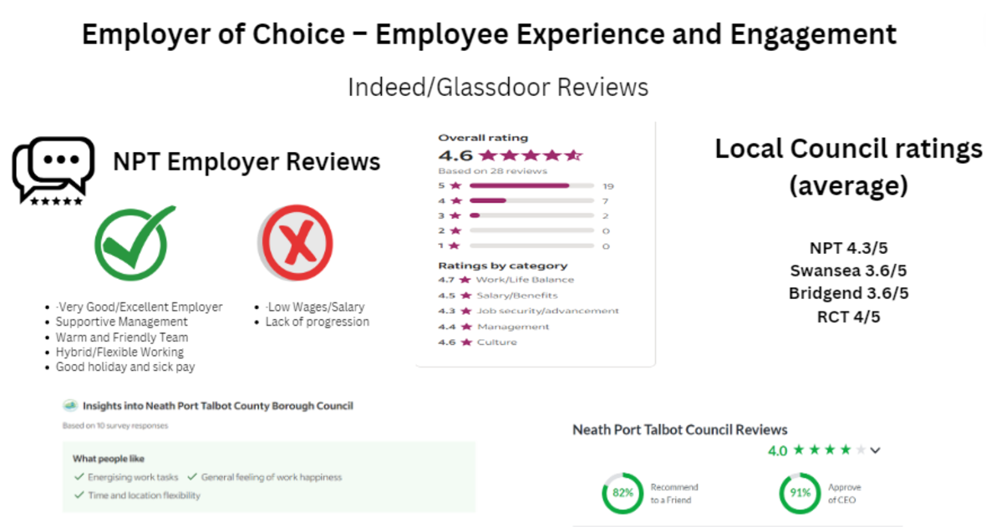
Figure 2 – NPTC Indeed/Glassdoor Reviews (NPTC, 2023b).
Furthermore, the establishment of a recruitment taskforce team between 2020 and 2023 provided invaluable support for managers with recruiting difficulties, which saw a significant rise in the publication of job adverts, applications received and appointments made (NPTC, 2023b) (Figure 3).
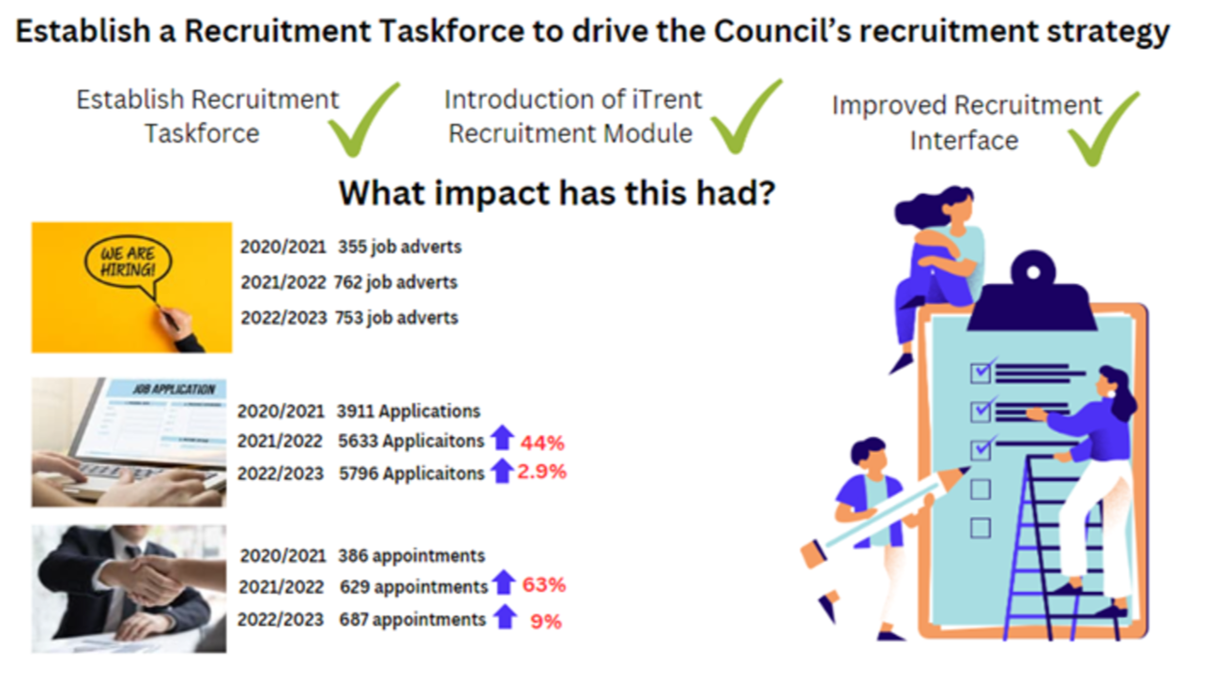
Figure 3 – Recruitment at Neath Port Talbot (NPTC, 2023b).
However, the data provided does not allude to the ongoing challenges NPTC is faced with in recruiting to ‘hard to fill’ roles. Since the COVID pandemic, they have been faced with significant pressures with an increased skills gap across the Council; particularly in suitably qualified roles (NPTC, 2022).
There is a notable divide in being able to recruit both older and younger workers (figure 4), arguing the need for NPTC to widen their external talent pool and focus on an age inclusive recruitment campaign. Such an approach will support them in narrowing the current skills gap by recruiting older (experienced and skilled) workers, whilst tackling their workforce planning future needs by promoting recruitment for younger workers (Hayden, 2024, McCartney, 2021).
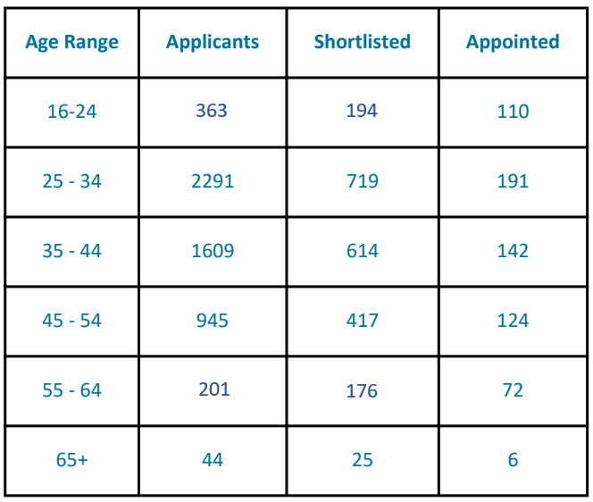
Figure 4 – recruitment of applicants by age range

3.3 Promotion
Shuster (2023) states that there are many benefits to an organisation whom encourages internal recruitment; given that it is cost-effective, saves time, creates an embedded culture and improves employee retention and engagement. Furthermore, it is imperative that organisations apply focus on internal ‘talent’, capturing their needs in different parts of the workforce as well as gaps in capacity and capabilities. Internal development could be a key to success in the future, however, the emphasis needs to be that of the organisation rather than just developing the potential of individuals (Garrow et al 2009, Whiting et al 2021).
The responsibility of identifying top talent lies with the line manager, making them key influencers for talent management and succession planning. Aligned with the wider organisational workforce strategy, managers play a pivotal role in supporting progression and promotional opportunities. However, it is imperative that a managers has the desired abilities as this could potentially impact on diversity, inclusion and progression opportunities (Green, 2021).
There is a clear cause for concern in relation to employee turnover within NPTC, with specific reference to promotion, accounting for roughly 80 leavers since 1st April 2024. ‘Promotional opportunities elsewhere’ was the third highest leaving reason, with retirement a close second (Figure 5).

Figure 5 – NPTC leavers from 1st April 2024 (SAP Business Objects 2024).
Whilst outlining the need to “improve talent retention of all our employees” within the Forward Work Programme (NPTC, 2024b), there is no precise indication of how they aim to do this. Furthermore, as outlined by Green (2021), line managers are fundamental to any development and promotional opportunities and this needs to be incorporated into their Work Programme ensuring that managers have the necessary abilities to be able to inclusively ‘spot talent’.
Whilst any promotional opportunities are not always guaranteed when a vacancy becomes available, with an individual needing to further develop their skills and abilities. It is important that NPTC acknowledges those talented individuals for the future to match to business critical roles.

3.4 Retention
It is argued that employee retention is a key priority commonly embedded in an organisations talent management strategies, as with NPTC. Given the external labour market challenges, organisations are taking fundamental steps to retain and develop existing employees (Shuza et al, 2022).
The talent management team support managers to secure and retain talent where required. The team have recently revised the exit questionnaire process, undertaking independent reviews and meet with impending leavers to establish why an employee is leaving the organisation (NPTC, 2024c). However, as this process is not a mandatory requirement, the team are very much reliant on a willingness to complete an exit questionnaire and therefore, capturing data can be fickle.
Furthermore, it is argued that NPTC have become complacent with exit interviews proving to be ‘too little, too late’ as an employee has already decided to leave their organisation. Hall (2024) stresses that a simple way to improve employee retention is to carry out routine ‘stay interviews’, looking “at the other side of the coin”, which can avoid your best talent from even reaching an exit interview (Taylor, 2022).
Taylor (2022) suggests that there are three main areas that will support organisations in improving employee retention; reward, developmental opportunities and effective line management.
It is considered that high levels of retention can be achieved without paying particularly well, adding that job satisfaction, training and development as well as receiving good supervision encourage an individual to remain with an organisation (Kumar, 2021, Taylor, 2022). NPTC reported that the main reason for employees leaving from 1st April 2024 was due to ‘resignation – personal reasons’. This provides them with a positive outlook as it could be considered that NPTC had no bearing on their reason for leaving (figure 5).

4. Conclusion
Given that talent management was only established in the 21st century, it is increasingly espoused by organisations to support them in achieving a competitive advantage in terms of recruitment, retention and development (Wellins et al, 2006).
Gallardo-Gallardo et al (2020) argues that it is evident that organisations are currently operating in an antagonistic environment, adversely affecting external and internal factors in relation to talent management. The public sector itself is faced with many challenges which are impacting on their talent management strategies, anticipating defies in an already difficult external labour market (NPTC, 2024b).
NPTCs approach to talent management is relatively new given that they have only recently developed a team to oversee this area at the beginning of this year, arguing that they could be at a disadvantage compared to their competitors. Further uncertainty remains in place for the future of talent management within NPTC, given the lack of job security within the team, as they have fixed term contracts in place.
However, that aside, the team have already made progress through the development of their Forward Work Programme 2024/2027 (NPTC, 2024b), observing anticipated challenges for NPTC in the next three years. In addition, revamping their employer brand has already seen a significant increase in job adverts, applications and appointments as well as given them ‘employer of choice’ status above some local authorities (NPTC, 2023b).
However, there are key priorities including the seemingly challenges relating to line management or ‘lack of’ in certain areas. Negative word of mouth is becoming an increased concern, arguing that there is custom and practice culture of bad management (Stockman et al 2020).
Furthermore, it is construed that managers are considered to be reactive in their approach to both recruitment and succession planning, creating uncertainty in the future when it comes to filling any specialised, hard to fill roles.
Whilst the talent management team have set their key priorities for the next three years, it is important that the team do not remain complacent and strive to continuously review their Forward Work Programme. It is pivotal that line managers are placed at the forefront of this work, which will prove vital in ensuring that NPTC and their services are safeguarded in the future.

5. Recommendations
The following recommendations are made based on the above findings:
- The introduction of a ‘stay interview’ process will encourage the retention of NPTCs best talent, supporting employees in their roles and career development opportunities. Vozza (2023) argues that planned stay interviews foster both trust and engagement which can help leaders to better understand what motivates and interests colleagues.
Stay interviews would be led by managers and should be considered on a quarterly basis. There are no associated costs, however, manager’s would need to utilise their time to plan and conduct.

- The Implementation of a Professional Development Programme for current and prospective managers. The programme will explore some of the challenges experienced by leaders, as well as highlighting positive, good practice associated with the role of manager. A number of workshops will cover important topics such as the employment cycle, recruitment and selection, managing leavers, developing effective teams as well as succession planning.
A similar programme was previously trialled for new and curious managers, with NPTCs Training and Development Team leading the sessions. Therefore, there is no associated monetary costs with time and resource required from the Training and Development Team.
CIPD (no date) emphasises the need to develop and improve professional practice which can be achieved by Continuing Professional Development (CPD).

- An age inclusive recruitment campaign to recognise longevity and promote a multi-generational workforce. Given that there is no longer a default retirement age and people are living longer, there is an expectancy to want and need to work longer. The promotion of recruitment advertising through various partner agencies including the Department for Work and Pensions 50 plus Champion programme, presents an opportunity to recruit those with significant work experience. This workforce could provide coaching and mentoring for those less experienced employees, strengthening succession planning.
Furthermore, creating early career pathways by increasing apprenticeships and graduate schemes will increase the representative of young people to NPTC.
Costs could be linked to various recruitment campaigns to promote job publications through various platforms encouraging applications from wider age representations.

References
Adams, B. (2022) Make your employer brand stand out in the talent marketplace. Available at: https://hbr.org/2022/02/make-your-employer-brand-stand-out-in-the-talent-marketplace (Accessed: 20 November 2024).
Bajorek, Z. (2023) ‘People leave managers, not companies’ – but is the manager really at fault? Available at: https://www.employment-studies.co.uk/news/%E2%80%98people-leave-managers-not-companies%E2%80%99-manager-really-fault (Accessed: 24 November 2024).
Battista, M. (2024) PESTLE analysis. Available at: https://www.cipd.org/uk/knowledge/factsheets/pestle-analysis-factsheet/#what-is-a-pestle-analysis-used-for (Accessed: 17 November 2024)
CIPD (no date) Continuing professional development. Available at: https://www.cipd.org/uk/learning/cpd/ (Accessed: 29 November 2024).
CIPD (2022) Resourcing and talent planning report 2022. London: Chartered Institute of Personnel and Development.
CIPD (2023) Technology use in recruitment and workforce planning. Available at: https://www.cipd.org/en/knowledge/guides/technology-recruitment-workforce-planning/ (Accessed: 24 November 2024).
CIPD (2024) Discrimination in the workplace. Available at: https://www.cipd.org/uk/knowledge/factsheets/discrimination-workplace-factsheet/ (Accessed: 20 November 2024).
Dunne, K. (no date) SWOT Analysis. Available at: https://www.mindtools.com/amtbj63/swot-analysis (Accessed: 24 November 2024).
Gallardo-Gallardo, E., Thunnissen, M., & Scullion, H. (2020) Talent management: context matters, The International Journal of Human Resource Management, 31(4), pp. 457-473. Available at: https://doi.org/10.1080/09585192.2019.1642645.
Gallup (no date) What is employee engagement and how do you improve it? Available at: https://www.gallup.com/workplace/285674/improve-employee-engagement-workplace.aspx# (Accessed: 22 November 2024).
Garrow, V., & Hirsh, W. (2009) Talent Management: Issues of focus and fit. Available at: https://www.employment-studies.co.uk/system/files/resources/files/hrp4.pdf (Accessed: 08 November 2024).
Green, M. (2021) Talent identification in practice: insights from line managers. Available at: https://www.cipd.org/uk/knowledge/bitesize-research/talent-identification/ (Accessed: 26 November 2024).
Haan, S. (2024) SWOT analysis. Available at: https://www.cipd.org/en/knowledge/factsheets/swot-analysis-factsheet/#what-is-a-swot-analysis (Accessed: 24 November 2024).
Hall, J. (2024) How to replace ‘exit interviews’ with ‘stay interviews’ and increase employee retention. Available at: https://www.forbes.com/sites/johnhall/2024/02/04/how-to-replace-exit-interviews-with-stay-interviews-and-increase-employee-retention/ (Accessed: 28 November 2024).
Hayden, D. (2024) Workforce planning. Available at: https://www.cipd.org/en/knowledge/factsheets/workforce-planning-factsheet/#key-action-points-for-workforce-planning (Accessed: 25 November 2024).
Hogarth, A. and McCartney, C. (2024) Resourcing and talent planning report 2024. London: CIPD.
Hongal, P., & Kinange, U. (2020) A Study on Talent Management and its Impact on Organizational Performance – An Empirical Review. International Journal of Engineering and Management Research, 10(1). Available at: https://papers.ssrn.com/sol3/papers.cfm?abstract_id=3559991.
Jackson, I. (2024) New flexible working laws: an employer’s guide. Available at: https://www.peoplemanagement.co.uk/article/1856168/new-flexible-working-laws-employers-guide (Accessed: 22 November 2024).
Kew, J. & Stredwick, J. (2016) Human Resource Management in a Business Context. 3rd edn. London: CIPD.
Kumar, S. (2021) The impact of talent management practices on employee turnover and retention intentions. Global Business and Organizational Excellence. 41(2), pp. 21-34. Available at: https://doi/epdf/10.1002/joe.22130.
Lewis, D. (2024) Employment Rights Bill: what do employers need to know? Available at: https://www.capitallaw.co.uk/news/employment-rights-bill-what-do-employers-need-to-know/ (Accessed: 20 November 2024).
McCartney, C. (2021) Focusing on age inclusive recruitment. Available at: https://www.cipd.org/en/views-and-insights/thought-leadership/cipd-voice/focusing-age-inclusive-recruitment/ (Accessed: 25 November 2024).
Milburn, T. (2022). Why effective onboarding is critical to employee retention. Available at: https://www.forbes.com/councils/forbesbusinesscouncil/2022/12/02/why-effective-onboarding-is-critical-to-employee-retention/ (Accessed: 20 November 2024).
Mohammed, A. (2019) Changing Dynamics of Talent Management: Analyzing the Impact of Business Environmental Factors. The Journal of Social Sciences Research, 5(2), pp. 583-595. Available at: https://doi.org/10.32861/jssr.52.583.595
NPTC (2022) The Future of Work Strategy – Strategic Workforce Plan 2022-2027. NPTCBC. Unpublished.
NPTC (2023a) Council’s Service Recovery Plan 2023-2026. NPTCBC, Unpublished.
NPTC (2023b) Recruitment at Neath Port Talbot. NPTCBC, Unpublished.
NPTC (2024a) Guaranteed interviews to be offered to all employees of TATA steel. NPTCBC. Unpublished.
NPTC (2024b) Talent Management Team – Forward Work Programme 2024/2027. NPTCBC. Unpublished.
NPTC (2024c) Workforce Information Report Quarter 2 2024. NPTCBC. Unpublished.
Peters, R. (2024) Strategic human resource management. Available at: https://www.cipd.org/en/knowledge/factsheets/strategic-hrm-factsheet/#what (Accessed: 08 November 2024).
Pilbeam, S., & Corbridge, M. (2010) People resourcing and talent planning. 4th edn. London: Pearson.
Quilliam, G.G., & Aid, C. (2024) Talent Management. Available at: https://www.cipd.org/uk/knowledge/factsheets/talent-factsheet/#Whatis (Accessed: 08 November 2024).
SAP Business Objects (2024) (Version 14.3.2.4272.4) [Computer program]. Available at: https://bi4-c9.webitrent.com/BOE/BI (Accessed: 11 November 2024).
Shuster, L. (2023) Why internal recruitment can be a smart strategy. Available at: https://www.forbes.com/councils/forbeshumanresourcescouncil/2023/02/22/why-internal-recruitment-can-be-a-smart-strategy-for-2023/ (Accessed: 25 November 2024).
Shuza, A., Woldu, H.G., & Alborz, S. (2022) Who is talent? Implications of talent definitions for talent management practice. Economics and Business Review. 22(8), pp. 136-162. Available at: DOI: 10.18559/ebr.2022.4.7.
Sivertzen, AM,. Nilsen, E.R,. & Olafsen, A.H. (2013) Employer branding: employer attractiveness and the use of social media. The Journal of Product and Brand Management. 22(7), pp. 473-483. Available at:
https://www.proquest.com/scholarly-journals/employer-branding-attractiveness-use-social-media/docview/1691005047/se-2?accountid=130472
Stockman, S., Van Hoye, G., & Veiga, S.M. (2020) Negative word-of-mouth and applicant attraction: The role of employer brand equity. Journal of Vocational Behavior. 118. Available at: https://doi.org/10.1016/j.jvb.2019.103368.
Taylor, S. (2022) Resourcing and Talent Management. 8th edn. London: CIPD.
Vozza, S. (2023) How managers can use stay interviews to improve retention. Available at: https://www.shrm.org/mena/topics-tools/news/hr-magazine/how-managers-can-use-stay-interviews-to-improve-retention (Accessed: 29 November 2024).
Wellins, R., Smith, A. & McGee, L. (2006) The CEO’s guide to talent management: building a global leadership pipeline. Pittsburgh: Development Dimensions International.

Appendix 1 – Reasons to work for NPTC


