MA Surface Pattern

Coexistent Perspectives (ADCD7001)

Critically analyse new fibres making processes of man-made materials used to replicate a natural process and compare with natural occurring fibres, In particular focusing on MicroSilk and comparing it to Silk and the possible unintended consequences of introducing this material.

Submission Date: Friday April 28th 2023
Word Count: 4000 Words approx.
By: Tia Charlie Howells
Contents
Introduction 2
Theoretical Background of Unintended Consequences 4
Its relations to Innovation, Human Nature, Capitalism and Consumerism 5
The Relation to the Precautionary Principle 7
Risks associated with the Precautionary Principle 8
What is MicroSilk, how is it made and what are the properties? 9
What is Silk and how is it made and what are the properties? 10
Comparing the Process of Silk to MicroSilk 12
Potential Negative Unintended Consequences of Introducing MicroSilk 13
Potential Positive Unintended Consequences of Introducing MicroSilk 14
Conclusion 16

Introduction
Have you ever considered the impact of innovation has had on the environment, morally or ethically? This essay will focus predominately on the unintended consequences of replicating natural occurring processes to engineer and make new textiles materials. Focusing on the introduction of MicroSilk, looking at the potential environmental and sustainable consequences of this material that implementing them potentially could have.
Simply put, MicroSilk has been made using a process known as Biomimicry. Biomimicry is simply ‘the practice of emulating natures patterns and strategies to direct product design, processes and policies and as such draws on the real world’. (Fletcher, Grose, 2011 p.114). MicroSilk has been made from the process used to make Spider Silk, which I will look in depth into later on. I will be comparing it to the Silk components and how Silk is produced. Looking at both the environmental and sustainable consequences of silk as well.
I will also be focusing on understanding the theory of Unintended consequences, how this has been applied to the precautionary principle and its relations to Capitalism and Consumerism.
Unintended consequences of design have been described as being both the positive and negative outcomes of products and ideas. The concept was first described by sociologist Robert Merton in 1936 in the American sociologist review. He coined ‘the phrase, unanticipated consequences of purposive social action’ (R.K. Merton, 1936, p.894). I believe what he means by this is the actions of people will always have an effect that are unanticipated or unintended. He put forward the idea we need a ‘systematic treatment’ (R Merton, 1936, P.894). A way to distinguish different factors from theological, technological, morally and scientifically and then determine a way to adapt.
What this means according to the documentary Design disruptors is being ‘aware of the fact that design interventions or proposals deeply infiltrate into the social, economic and political systems we are surrounded with’ (A. Dujardin,2017). This describes How we have implemented certain products into our lives and they have influenced us an everyday basis, in business, within our laws and beliefs.
Finally, looking at both the positive and negative consequences of introducing MicroSilk could be. What are the consequences of introducing man-made materials that replicate a natural process and what affect could it have on already existing materials?

Theoretical Background of Unintended Consequences
Unintended consequences simply put is the actions of people have effects that are unanticipated both in a positive or negative way. According to Robert k Merton he hypothesises in the article The Unanticipated Consequences of Purpose Social Action there are 5 possible factors to consider. (R. Merton, 1936). These factors are important as they describe the basic outline for unintended consequences.
The first factor that comes into considerations is ‘Ignorance’. In the article he says:
‘The importance of ignorance as a factor is enhanced by the fact that the exigencies of practical life frequently compel us to act with some confidence even though it is manifests that the information on which we base our action is not complete’(R. Merton,1936)
What he means by this is we can’t always know everything all at the time. Some of our information and knowledge will always be incomplete but we still base our actions on our preserved knowledge and what we think we know. An example of this would be the industrialised production of food and its leading to an obesity epidemic. if we look at the fact industrialised food now is ‘cheaper and more convenient’ (P, Gluckman, 2019, p173) and the fact our ‘energy intake is out of balance with energy expenditure of urban living’ (P, Gluckman, 2019, p173). We couldn’t have foreseen it entirely or the effect it would have on a global scale.
The second factor is ‘Error’. Described as being ‘a common fallacy is frequently involved in the too-ready assumption that actions which have in the past lead to the desired outcome will continue to do so.’ This entails repeating habits of the past which worked then but may not work now.
The third and fourth factor are similar. It involves ignoring possible long-term consequences for immediate results described by R. Merton as ‘imperious immediacy of interest, refers to instances where the actors paramount concern with the foreseen immediate consequences excludes the consideration of further or other consequences of the same act’. (R. Merton, 1936). An example would simple be the mass manufacturing of single used plastics. A solution to transport different goods with no regard on the impact it could have in the future, in particular the environment. What the factor means is understanding that doing certain actions that we consider right now, may result in changes later on.
The final factor is known as self-defeating prophecy defined as ‘public predictions of future social development are frequently not sustained precisely because the predictions has become a new element in the concrete situation, thus tending to change the initial course of developments. (R.Merton, 1936). This factor involves solving a problem which stops the problem occurring which then in turns causes other consequences. Understanding that the original intentions has resulted in an undesirable result contrary to what was originally set out.

Its relations to Innovation, Human Nature, Capitalism and Consumerism
Following on to really understand unintended consequences we need to look at its relations to innovation, capitalism and consumerism. To really understand the impact that introducing new materials could potentially have.
With this in mind according to unintended consequences of human innovation Peter Gluckman author of Ingenious he says ‘the ability to continually innovate and progressively change our environment is unique to humans’ he furthermore adds ‘the ingenuity is so central to human nature and so fundamental to humanity’s success in Darwinian terms that our technological achievements effectively define and become our nature’ (P. Gluckman, 2019). Based on this paragraph, I believe what he is saying is our need to innovate is what drives us to make advancements is not just for survival but for everyday life. Therefore, ingenuity is effectively human nature (P. Gluckman, 2019). We don’t just create technology, we redevelop, change and adjust to communicate better results. We are constantly changing and evolving ideas and this is where unintended consequences occur.

Human innovation has already brought about consequences from the rise of fast fashion and the impact this has had on the environment. The production of textile products including ‘Clothes, footwear and household textiles are responsible for water pollution, greenhouse gas emissions and landfill’ (euro parliament ,2022).
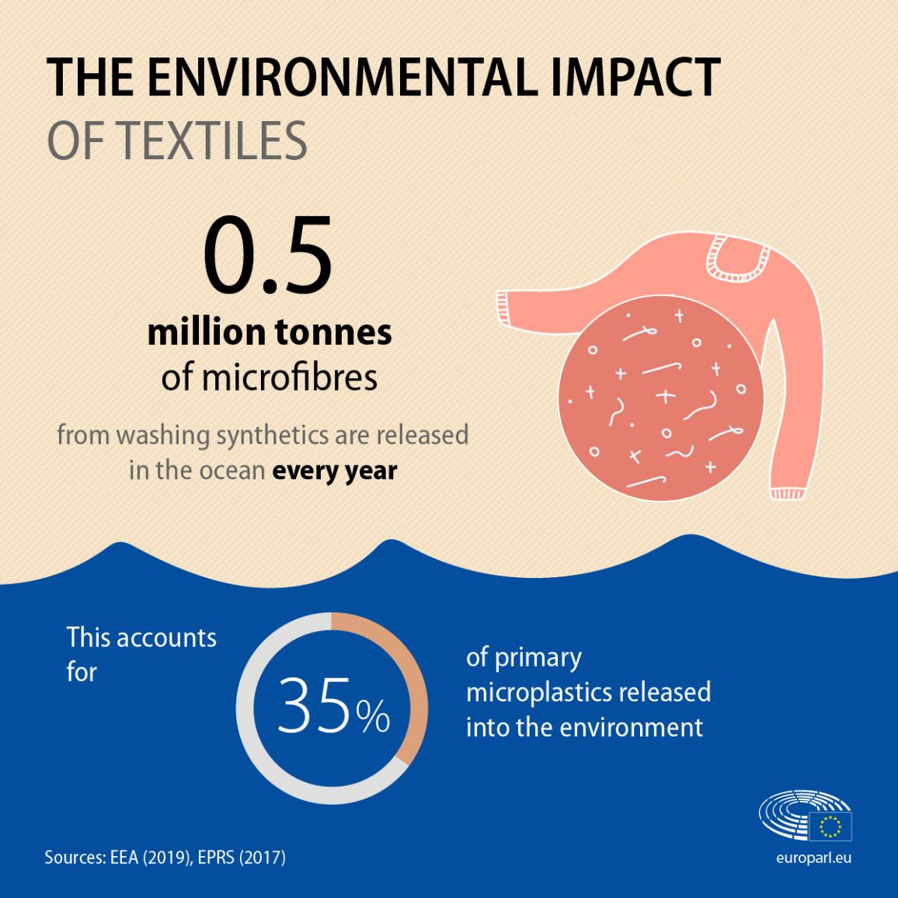

Figure 1. Infographic with facts and figures about the environmental impact of textiles, European Parliament, 2017
In view of this, the development of technology and innovation has a parallel relationship with capitalism and consumerism. At least according to the unintended consequences of technology which says ’technology transformed our ability as humans to alter the same world. And this altering of our world is now aligned and heavily driven by a major force known as capitalism’. (C. Ategeka, 2021). This proposes that technology is influenced by capitalism but also capitalism is influenced by technology.
Capitalism by definition is ‘an economic system where people and companies make more of the decisions and property. The means of production and largely or entirely privately owned and operated for profit rather than owned by a private state’ (Ategeka, 2019, p.3) Consumerism by definition means a personal wellbeing and happiness depend fundamentally on obtaining goods and material possessions. (Ategeka, 2019, p.5)
From my perspective consumerism is a driving force of why we buy products, such as fashion, footwear and household textiles which in turn is a consequence of capitalism. Both have advantages and disadvantages and have consequence on the world in which we live.
One positive advantage of capitalism is the increase in efficiency in both the manufacturing, production and delivery of products. These ‘incentives create pressure to cut costs and avoid waste’. (Ategeka, 2019, p.7). This is due to the demand of consumers. An example I would give of this is the rise and need of smart phones. We are heavily reliant on them to communicate with people from all areas of our life. Another important advantage is the innovation. As stated earlier our need to innovate is part of our human nature. It leads to ‘product development and more choice of goods (Ategeka, 2019, p.7). This then produces a high standard of living. An unintended consequence of capitalism is the idea of monopoly power, big companies ‘have exploited their position to charge higher prices, pay lower wages to workers, avoided paying their fair share in taxes’, (Ategeka, 2019, p.8). this biggest problem of this is it isn’t sustainable. The resources are not shared fairly, individual consciences aren’t factored or taken into consideration and at some point, all our resources will run out.

The Relation to the Precautionary Principle
Unintended consequences relate to the precautionary principle. According to the precautionary principle in environmental sciences it is defined as ‘when an activity raises threats of harm to human health of the environment, precautionary measures should be taken even if some cause and effect relationships are not fully established scientifically’ Peterson, (2017, p112). The four main components are
‘taking preventive action; in the face of uncertainty; lifting the burden of proof to the proponents of an activity, exploring a wide range of alternatives to passably harmful actions and increasing public participation in decision making’ Kriebel et al. (2001, p871).
These policies have come into action to protect human health, environment and uncertain risks. Essentially to premediate unintended consequences and come up with innovative ideas and solutions. It also to stop exploitation of big companies and their effect on the world around us. Again, there are both positive and negatives to the principle.

Risks associated with the Precautionary Principle
Firstly, it ‘isn’t well defined’ (Morris, 2000 cited in Ley, 2009, p. 87). This leaves it open to interpretation. Secondly, ‘obtaining proof of safety is epistemologically impossible requirements to provide would halt the development of new technology and science, i.e. in contradicts society’s emphasise on learning by trial and error’ (Morris, 2000 cited in Ley, 2009, p. 87). To put it another way, designing products for technology and science will always have problems and risks this is part of a user centred approach. To test products of consumers to see any faults or problems from different perspectives and come up with solutions. Thirdly ‘safer alternatives to prospective new technologizes would prove too costly and would take too long’ (Morris, 2000 cited in Ley, 2009, p. 87). This could stop innovation and the development of new ideas.

What is MicroSilk, how is it made and what are the properties?
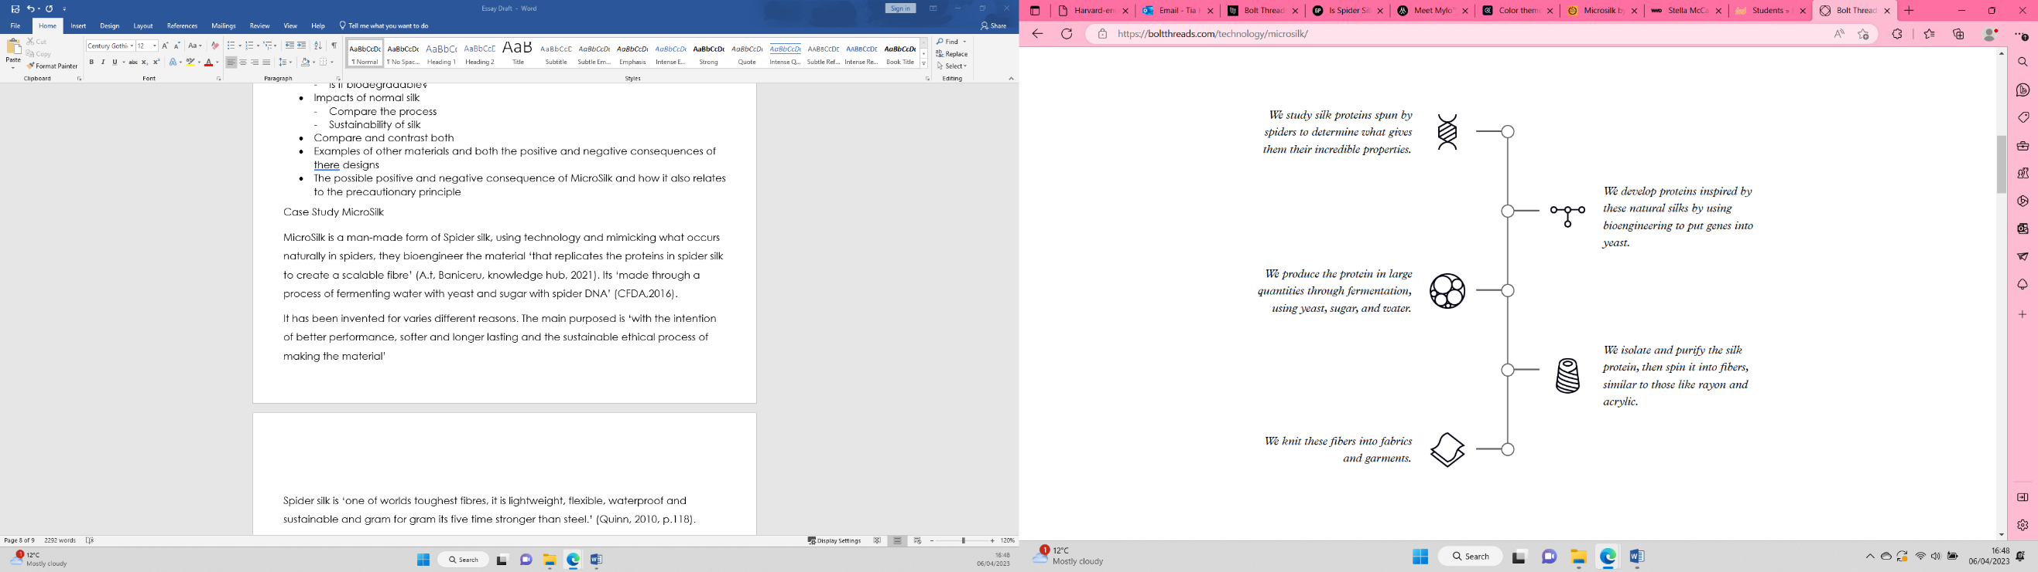
Looking at the impact the textiles industry has on environment and consumerism. It’s more important now than ever to develop more ethical, sustainable, biodegradable materials. Last year it was estimated ‘fashion industry is responsible for 10% of global carbon emissions – more than international flights and maritime shipping combined.’ (Europarl, Europa, 2022) With this in mind I have started looking at MicroSilk what it is and how its produced and then comparing the processes with Silk.

Figure 2. Bolt Technology Illustrations, Micro Silk, 2021

MicroSilk is a man-made form of Spider silk, using technology and mimicking what occurs naturally in spiders also known as Biomimicry. The company Bolt threads bioengineer the material ‘that replicates the proteins in spider silk to create a scalable fibre’ (A.t, Baniceru, knowledge hub, 2021). Its made by ‘creating proteins through bioengineering genes and inserting them into yeast. The proteins are made in large quantities through fermentation using yeast, sugar and water. They then go through an isolation, purification and spinning process similar to rayon and acrylic’ (A.t, Baniceru, knowledge hub, 2021)
It has been invented for three main reasons; sustainability, performance and future proofing. The main purpose is it ‘has the potential to biodegrade, unlike polyester and other synthetic fibres that are contributing to microfiber pollution’. (Bolt threads ,2021). What this means is its been designed with the intention of it being safe to dispose of and will reduce textile waste. According to Bolt threads it is’ more sustainable than petroleum-based fibres such as polyester’(Bolt threads ,2021).
MicroSilk is a man-made version of Spider silk. The benefit of spider silk is that it’s ‘one of world’s toughest fibres, it is lightweight, flexible, waterproof and sustainable and gram for gram its five time stronger than steel.’ (Quinn, 2010, p.118). in terms of fabric this would make it a longer lasting fabric and potentially improvement of durability. With this in mind Its high durance could be used for medical and military applications. For example, it could be used for as ‘alternative for bullet proof vest, as its tougher than Kevlar and weighs three times less’ (Quinn, 2010, p.119).

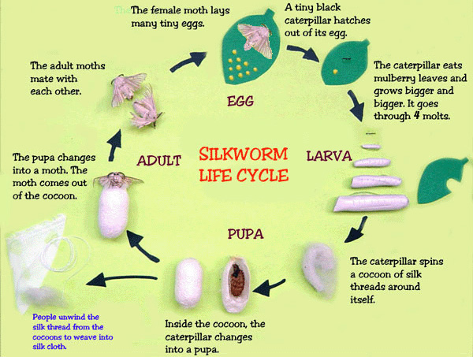
What is Silk and how is it made and what are the properties?

Figure 3. Silkworm Lifecycle, Oecotextile, 2010
Silk ‘is a natural protein fibre produced by the larvae of the moth. (CDFA,2016). Silk is produced when;
‘Moths are bred and lay eggs on a specially prepared paper. The most common moth for commercial silk is Bombyx mori. When the eggs hatch, the caterpillars, or larvae, are fed fresh, young mulberry leaves. After roughly 35 days the caterpillars are ready to begin spinning their chrysalis, or cocoon. The silkworm produces silk in two glands and forces the liquid silk through two spinnerets (openings in its head) in a figure-8 pattern. The silk strands solidify when they touch the air and are coated with sericin, a water-soluble protective gum. Within a couple days the silkworm will spin roughly a mile of filament and completely encase itself in the cocoon’. (CDFA,2016).
As we can see this is a natural occurring process but the process uses Mulberry leaves and isn’t vegan as it is used the Bombyx Mori Moth. Silk also varied properties including ‘good moisture absorption and can be dyed and printed in brilliant colours, it works well with natural dyes, has a nice drape, good to stay cool in hot weather as well as stay warm in cool weather.’ (CDFA,2016).

Comparing the Process of Silk to MicroSilk
When comparing the processes, we can see that MicroSilk uses nature as inspiration (Biomimicry). This is the ‘practice of emulating natures patterns and strategies to direct product design, processes and policies and as such draws its inspiration from the real world’(Fletcher, Grose, 2001, .p114). Whereas silk is already a natural process.
MicroSilk is the more ethical and vegan option as no insects or animals are used in the process. However, silk has been used for 1000 of years, it has ‘contributed to globalization and the sharing of knowledge, the arts, language, and religion which helped to shape many global cultures familiar to us today’(CDFA,2016). From this we can see that even though the material uses moths it has had positive impact on the planet.
MicroSilk has been designed for better performance and tensile strength. According to Jamie Bainbridge at Bolt thread ‘Spider silk is a much stronger natural fibre than a traditional silkworm silk’ (Bowe, 2018). What’s more both silk and MicroSilk have similar properties, they are both ‘smooth, lightweight, lustrous fibres that dye beautifully and have natural resistance to water’ (Bowe, 2018).
The main food source for Bombyx mori ova (the silkworm) is Mulberry tree leaves. as its ‘grown for silkworm rearing’ (DR, TK 2015) It is estimated ‘that one metric tonne of mulberry leaves is necessary for the rearing of silkworms emerging out of one case of eggs which will yield about 25kg of cocoons of high quality’ (DR, TK 2015). Essentially this means that a tonne of mulberry leave will only produce 2.5 kg of Silk and the death of 25kg of silk worms.
On the other hand, silk production ‘has the potential of poverty eradication and economic empowerment especially for women and youth in Kenya’ (DR, TK 2015). This could help bring more jobs and help reduce poverty in the third world.

Potential Negative Unintended Consequences of Introducing MicroSilk
Looking at both silk and MicroSilk, considering their similar properties. MicroSilk is a more ethical approach. But MicroSilk could make Silk obsolete if it is a more ethical and sustainable approach. If we look at R Merton’s factors we need to consider, if introducing new materials into the world such as MicroSilk could that result in changes later on. Looking at past prescendece cases such as the introduction of Facebook. It made myspace and Msn messenger obsolete. This was mainly because of rising competition and an inability to adapt. This could happen to silk and other materials if the introduction of new materials with better tactile strength, durability and more ethical processes are made.
If silk became obsolete what effect would that have on the Bombyx Mori moth. As we know ‘after hundreds of years of selective breeding, the bombyx mori, has lost its ability to fly, see, camouflage and fear predators. It is completely dependent on humans to survive’ (CDFA,2016). This could mean that species of moth becomes extinct as they rely solely on humans, if there is no longer a need to produce silk, as a more ethical, environmentally friendly option is available with better properties and what affect could that have on the physical environment. Also taking into consideration what impact could that have on workers and communities in rural areas who rely on silk production as their sole income. As discussed earlier it has the potential to eradicate poverty in certain parts of Kenya.
Despite this, could the potential extinction of the Bombyx mori moth help the environmental impact of mulberry tree cultivation. On average ‘one mature mulberry tree will produce enough foliage for 100 silkworms and 3000 cocoons go into making one yard of fabric’(CDFA.2016). This has could have a positive unintended consequence on the environment.
MicroSilk has also been designed ‘to meet consumer needs while minimizing impacts on the environment’ (Bolt threads, 2021). Referring back to R Merton’s factor as error, which means repeating the habits of the past which may have worked then but may not work now. Taking this into consideration making textile that meet consumer needs with lower environmental impact actually help the impact of textile production. Or will it just enable the problem fast fashion has had by still increasing the quantity of clothes produced and thrown away. I propose it may not, at least not if we consider the impacts consumerism have had on waste in the environment. If we look at a precedent case such as the rise of social media. Social media feeds ‘into consumerism where you need to get more of that validation, if you see people liking someone else’s material item, subconsciously you might want a similar item, so you too can get the same likes this leads to an unhappy vicious cycle of consumerism’ (Ategeka, 2022). This then leads to people getting rid of unwanted clothes. But even used clothes that are exported outside the EU, (87%) are incinerated or placed in landfill. (Europa, 2022).
We also need to consider the ethical consequence of copying a naturally occurring process. If we look at gene editing as an example. Currently there is a concern that gene editing ‘could create classes of individuals defined by the quality of the engineered genome, which could lead to the resurgence of eugenics’ (Ategeka, 2021). With the cost of MicroSilk high to purchase will only people with money be able to afford it. Could that then impact the price of other materials?

Potential Positive Unintended Consequences of Introducing MicroSilk
MicroSilk has reduced levels of processing inputs such as chemicals and energy. According to the website the ‘fibre-making process is sugar from plants that are grown, harvested, and replanted. Compare this renewable process to polyesters, which are made from petroleum derivatives. (Bolt, 2022). The process of making the material therefore is more renewable. This could only be positive.

MicroSilk has properties that can make it warmer than anticipated and combine that with its light weight it could be used for multiple purposes. Essentially as ’spider silk naturally shrinks when contacted by water, this makes the fibres tighten up and super contract’(Bowe,2018). This in turn could make it ‘30% Warmer than other anything else’ ( Bowe, 2018). This was used to make Best Made co’s. beanie.
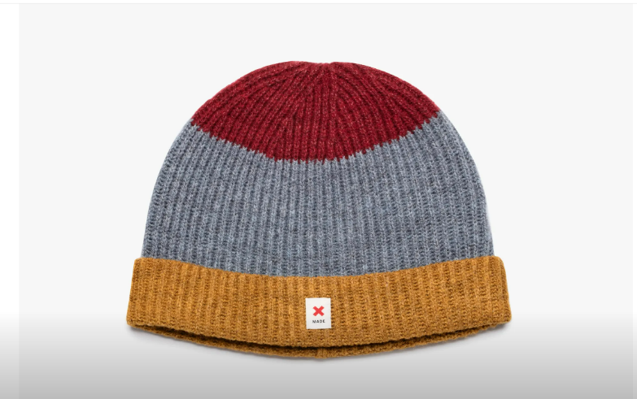

Figure 3 Bolt Threads , 2017, Available at: https://www.wired.com/story/bolt-threads-synthetic-spider-silk-hat/
This could also potentially make existing products lighter while the material keeps ‘it strong and durable’ (Bowe,2018). Given that it could be used to make sports and active wear this could mean the less fabric could be used to make same amount of clothes already being consumed which would reduce the amount going to land fill.
The material is also lightweight and could drastically reduce the weight of garments. It could be used instead of ‘as an alternative to traditional fibres like lycra, spandex, nylon and polyester to make all kinds of things, like workout clothes’ ( Bowe, 2018)
MicroSilk doesn’t contain plastics. From research microplastics need to be reduced we know ‘Laundering synthetic clothes accounts for 35% of primary microplastics released into the environment. (Europa, 2022) If we were to introduce the material into large quantities this could reduce the amount of microplastics released into the environment.

Conclusion
Looking at both the negative and positive consequences of MicroSilk I think we should introduce this material and as well as other man-made materials that replicate a natural process. The biggest factor to consider is the state textiles has had on the environment.
MicroSilk is a biodegrable fabric and the textiles industry synthetic fibres ‘accounts for 35% of primary microplastics released into the environment’ (Europa, 2020). The invention of MicroSilk helps tackle this issue as it is an example of a renewable fibre.
However, when we look at already occurring natural fibres like Silk, we have established there is a need for it too as the production of Silk could also effectively help reduce poverty and establish more jobs especially in places such as Kenya. Silk is also biodegrable which again will reduce the amount of microplastics we are putting out into the environment.
An important aspect of Unintended consequence is to also remember our need as humans is to innovate. At least According to Peter Gluckman and Mark Hanson ‘the ability to continually innovate and progressively change our environment is unique to humans. Our need to innovate is what drives us to make advantages not just for survival but for everyday life’. (Gluckman, 2019). This means we need to put systems into place when we adapt or make changes, to foresee what ingenuity can potentially create.
Bearing this all-in mind, we also need to understand the implications of innovating materials such as MicroSilk. When we look back, inventions such as industrialised production of food, its lead to an obesity crisis or the mass manufacturing of single used plastics lead to the devasting effects it has had on our environment. We need to consider the impact introducing new materials have by also considering implementing the precautionary principles.
Finally, if we don’t change or innovate by creating new materials such as MicroSilk ‘Europe will find itself in an unprecedented health and economic crisis’ (Europa, 2020). While also understanding, inventing new materials is only part of the solution. To finish with an important idea, I would quote ‘to truly enhance environmental and social quality involves a complex view of responsibility, one where rapid regeneration of a fibres source material is pursued not in isolation but part of a bigger strategy of safe and resourceful production of fibres for coherent plans for eventual reuse’ (Kate Fletcher 2012).
We need to create stimulating innovative solutions to tackle these problems. We need to create better biodegrable materials, while also supporting existing natural occurring biodegrable fibres such as Silk.

Bibliography
ATEGEKA, C., 2021. The Unintended Consequences of Technology. Newark: Wiley.
BANICERU, T., Andrea, Sep 17, 2017-last update, Microsilk by Bolt Threads: A bioengineered fibre inspired by spider silk [Homepage of Aroq Limited], [Online]. Available: https://knowledge-hub.circle-lab.com/article/9420?n=Microsilk-by-Bolt-Threads-A-bioengineered-fibre-inspired-by-spider-silk
BOLT THREADS, May 21, 2021-last update, MicroSilk. Available at: https://boltthreads.com/technology/microsilk/ [23/04/23]
BOWE TUCKER, , Is Spider Silk the Performance Fabric of the Future?. Available: https://www.gearpatrol.com/tech/a466684/bolt-threads-synthetic-spider-silk/ [04/04/, 2023].
CLARKE, S.E.B. and O'MAHONY, M., 1998. Techno textiles : revolutionary fabrics for fashion and design. London: Thames & Hudson.
CLARKE, S.E.B. and HARRIS, J., 2012. Digital visions for fashion + textiles : made in code. London: Thames & Hudson.
DR, T. and TK, K., 2015. Mulberry and Silk Production in Kenya. Journal of Textile Science & Engineering, 5(6), pp. 1.
DUJARDIN ALAIN, 2017-last update, The unintended Consequences of design
And the need for social-responsible design. Available: https://medium.com/greenberry/the-unintended-consequences-of-design-c613aa1ea086 [23-04- 23].
EURO PARLIAMENT, 26 April, 2022-last update, The impact of textile production and waste on the environment. Available: https://www.europarl.europa.eu/news/en/headlines/society/20201208STO93327/the-impact-of-textile-production-and-waste-on-the-environment-infographic [07/04/ 2023].
GLUCKMAN, P.D. and HANSON, M.A., 2019. Ingenious . Cambridge, Massachusetts: Harvard University Press.
HINES, T. and BRUCE, M., 2007. Fashion marketing : contemporary issues. 2 edn. Amsterdam ;: Butterworth-Heinemann.
KATE FLETCHER, L.G., 2012. Fashion & Sustainability. London: Laurence King.
KRIEBEL, D., TICKNER, J., EPSTEIN, P., LEMONS, J., LEVINS, R., LOECHLER, E.L., QUINN, M., RUDEL, R., SCHETTLER, T. and STOTO, M., 2001. The Precautionary Principle in Environmental Science. Environmental health perspectives; Environ Health Perspect, 109(9), pp. 871-876.
LEY, B.L., 2009. “We Should Not Have to Be the Bodies of Evidence”:; The Precautionary Principle in Policy, Science, and Daily Life. From Pink to Green. Rutgers University Press, pp. 81-105.
MERTON, R.K., 1936a. The Unanticipated Consequences of Purposive Social Action. American Sociological Review, 1(6), pp. 894-904.
MERTON, R.K., 1936b. The Unanticipated Consequences of Purposive Social Action. American Sociological Review, 1(6), pp. 894-904.
MILLER, D., 2005. Materiality. North Carolina: Duke University Press.
MORRIS, J., 2000. Rethinking Risk and the Precautionary Principle. London: Elsevier Science.
O'MAHONY, M., 2011. Advanced textiles for health and wellbeing. London: Thames & Hudson.
PAILES-FRIEDMAN, R., 2016. Smart textiles for designers : inventing the future of fabrics. London: Laurence King Publishing.
PETERSON, M., 2017. 112The Precautionary Principle. In: M. PETERSON, ed, The Ethics of Technology: A Geometric Analysis of Five Moral Principles. Oxford University Press, pp. 0.
QUINN, B., 2010. Textile Futures. English edition, first published edn. Oxford: Berg.
SALA DE MEDEIROS, M., GOSWAMI, D., CHANCI, D., MORENO, C. and MARTINEZ, R.V., 2021. Washable, breathable, and stretchable e-textiles wirelessly powered by omniphobic silk-based coils. Nano energy, 87, pp. 106155.
Silk. Available: https://cfda.com/resources/materials/detail/silk [04/04/, 2023].
STINSON LIZ, Dec 7, 2017-last update, This Striped Beanie Shows the Promise of Synthetic Spider Silk. Available: https://www.wired.com/story/bolt-threads-synthetic-spider-silk-hat/ [04/04/, 2023].
WU, R., MA, L. and LIU, X.Y., 2022. From Mesoscopic Functionalization of Silk Fibroin to Smart Fiber Devices for Textile Electronics and Photonics. Advanced science; Adv Sci (Weinh), 9(4), pp. e2103981-n/a.

Photo and Illustrations
Figure 1. Infographic with facts and figures about the environmental impact of textiles, European Parliament, 2017 Available at: https://www.europarl.europa.eu/news/en/headlines/society/20201208STO93327/the-impact-of-textile-production-and-waste-on-the-environment-infographic

Figure 2. Bolt Technology Illustrations, Micro Silk, 2021 Available at: https://boltthreads.com/technology/microsilk/
Figure 3 Bolt Threads , 2017, Available at: https://www.wired.com/story/bolt-threads-synthetic-spider-silk-hat/

Further Reading
Anonymous2021, Jan 4,. The impact of textile production and waste on the environment (infographic). M2 Presswire.
BEATA SEGERCRANTZ, KARL-ERIK SVEIBY and PERNILLA GRIPENBERG, 2012. Challenging the Innovation Paradigm. Taylor and Francis.
COOLE, D.H. and FROST, S., 2010. New materialisms : ontology, agency, and politics. Durham NC] ;: Duke University Press.
EAGLETON, T., 2016. Materialism. New Haven: Yale University Press.
GAMBLE, C.N., HANAN, J.S. and NAIL, T., 2019a. WHAT IS NEW MATERIALISM? Angelaki : journal of theoretical humanities, 24(6), pp. 111-134.
GAMBLE, C.N., HANAN, J.S. and NAIL, T., 2019b. WHAT IS NEW MATERIALISM? Angelaki, 24(6), pp. 111-134.
Meet Mylo Leather21 May, 2021-last update. Available: https://mylo-unleather.com/ [04/04/, 2023].
GROSZ, E., 2017. THE STOICS, MATERIALISM, AND THE INCORPOREAL. The Incorporeal. Columbia University Press, pp. 15-53.
TAO, X., 2015. Handbook of Smart Textiles. 1 edn. Singapore: Springer Singapore.
YAN, B., HUANG, S., REN, Y., ZHOU, M., YU, Y., XU, B., CUI, L., WANG, Q. and WANG, P., 2023. HRP-catalyzed grafting of MXene@PGA to silk fibers for visualization of dual-driven heating smart textile. International journal of biological macromolecules; Int J Biol Macromol, 226, pp. 1141-1153.

