Professional Behaviours and Valuing People (BMPD5017)

Mehrnoush Markey
Word count: 3182

Date: 08 February 2025
Submission date : 03 April 2025

AC 1.1

According to Australia’s Professional Standards Council, a professional is a member of a profession who are governed by code of ethics, and show commitment to competence, integrity and morality and fostering the welfare of the public within the area of expertise and responsible to those serve and to society (Taylor and Woodhams, 2022).

People profession who are qualified CIPD members has gone through training and programmes accredited by the professional body. Unlike other professions, it’s not compulsory to join the professional body, however like other professions failure to meet professional body standard (CIPD) may results in Membership termination (CIPD, 2024).

Any profession often faces value conflicts between stakeholders. Their ability to exercise situational judgment and uphold moral integrity fifer them from and support long term organisational sustainability.
To be able to have a great impact, people professional require credibility which will be achievable by become a CIPD members, which through Royal Charter it gives internationally recognised chartered statues. The profession Map sets international standards for all people professionals.
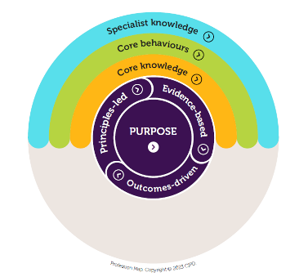
The Profession Map outlines the values, knowledge, and behaviours needed to make a positive impact at any level or specialism It champions better works and working lives by equipping people professionals with the expertise to navigate change and uphold professional values (CIPD, 2023).

The Purpose of the Profession Map is to make a better working environment. The values
that surround the purpose that leads to make a better decision are:
- principles-led
- evidence-based
- outcomes-driven.

A key objective of the CIPS is safeguarding public interests by establishing standards for professional and ethical practice. So, all members also follow the same code of conduct and ethics while they continue their professional commitments. The code is built around five Core values:
- Positive and active impact on working lives
- Civic virtue and stewardship
- Good character
- Professional service and competence
- Personal responsibility
the code applies to all members, when conflicts arise, members must prioritise higher principles and comply with laws. The code encourages ethical behaviour and sound judgment in decision-making. Professionals should reflect on the implications of their actions and integrate ethical values into their practice (CIPD, 2023).
According to CIPD Research report (2017) there are core elements that enable professionals to make ethical decision and be a professional:
- social and ethical responsibility commitment
- a body of expert knowledge and skills
- continuing professional development (CPD)
- situational judgement
- identity.

AC 1.2

Professional codes of ethics educate the public and professionals about the responsibilities of a role, provide accountability mechanism and offer guidelines to improve practice. while specific to each profession, most codes share core principles such as autonomy (self-determination) promoting good avoiding harm and justice. Ethical practice requires not just understanding these principles but actively integrating them into decision making, reflecting on guidelines, and collaborating with colleagues to apply them effectively (Parsons and Dickinson, 2016).
Ethical values provide the moral compass by which we live our lives and make decisions – 'doing the right thing' because it’s the right thing to do (CIPD, nd).

Being a foreign national helps me to appreciate the difficulties of feeling underappreciated at work. Still, the dedication to helping others is constant. One of my greatest strengths is my knowledge and my proactive approach to learning, which keeps me one step ahead in my employment. When coworkers need help, this usually makes me the first person they turn to; I am always eager to help.
As a resourcing officer, I ensure that every applicant that I deal with is treated fairly during the recruitment process. I achieve this by following impartial recruitment process, making sure that selections are based on qualifications and suitability instead of individual biases. I adhere to the NHS’s guidelines regarding diversity and inclusion, which encourage equal opportunities. By following these values, I help create a fair and inclusive environment that appreciates diversity and builds trust among all participants.
Respect is one of the core values I was raised with and continue to uphold in my professional life.in my role as resourcing officer, I respect the unique background of each candidate, maintain the professionalism and confidentiality while addressing any questions or concerns they may have throughout the recruitment process. This approach also extends to all individuals I interact with including colleagues, senior managers and anyone under my supervision. By fostering an atmosphere of respect, I ensure a supportive and inclusive environment for everyone, which is crucial for building trust and promoting positive relationship within the workplace.

AC 1.3

The ability to influence others is a key skill for people practitioners and is critical for promoting group projects, driving organisational goals, and managing workplace relationships. According to CIPD profession Map, influencing others enables people practitioners to promote change, match stakeholders with strategic objectives,this promotes confidence all around the company
CIPD,)
One of the main reasons influencing is crucial since it enables HR professionals to guarantee fair decision making and promote moral behavior.
Encouragement of inclusive policies among management, for instance, helps to increase employee engagement, retention, and general workplace environment.
Resolving disputes, managing resources, and obtaining support for new projects all require the ability to influence others. People practitioners might find it challenging to promote practices that are consistent with organisational values or to push for necessary changes without this ability (University of Minnesota, 2023).
If practitioners are unable or unwilling to influence others, there may be dire consequences. For instance, key HR initiatives like diversity and inclusion initiatives may not succeed due to a lack of leadership or employee support. Practitioners suffer the danger of losing credibility if they are unable to successfully defend their beliefs or challenge unethical behavior. This could lead to low employee morale, disengagement, and a disconnect between HR strategy and business objectives (Forbes Coaches Council, 2024).
Instead of exercising, practitioners who are unable to influence risk become vulnerable to legal issues rather than implementing significant changes. People practitioners need to be able to influence others in order to fulfill their duties, build beneficial relationships, and promote a great workplace culture. They can lose out on significant development opportunities and have less of an impact on the business without this capacity.

AC 1.4

recognising when and how to address unethical or illegal behaviour is vital for upholding ethical integrity and ensuring legal compliance in the workplace.
In NHS Wales, following the NHS code of conduct (SBUHB, 2023) and complying with relevant legislation, such as the Public Interest Disclosure Act 1998 (Gov.uk, 2020), is critical for establishing a work environment.
part of our resourcing team responsibility is to shortlist applications on behalf of the Ward managers. For instance, if a team member repeatedly processes applications that may not be suitable due to external requests, this behaviour, while it is not a direct legal violation, undermines the principles of honesty and integrity outlined by NHS Wales Code of Conduct. We must observe and gather evidence. Have an informal approach by discussing it directly with the colleague. if the behaviour continues, escalate the issue to our line manager through an informal conversation or if necessary following health board’s inter grievance procedure.
The last route would be using the NHS whistleblowing policy (NWSSP, 2013) to report concerns anonymously.

As per Health Board’s policy, team members are not allowed to access patients’ files and records without a legitimate reason and it is only allowed for treatments purposes, a colleague has been discovered checking their Friends and family’s record. This violates the General Data Protection Regulation (GDPR) and the Data Protection Act of 2018.
We must document the occurrence and notify the Data Protection Officer within the Health Board, ensuring that all reports are factual and accurate.
We need to follow the health board policy to ensure correct reporting and handling of the breach are followed. If the matter is not resolved internally, it may need to be reported to the Information commissions officer. Depends on the seriousness of the incident we may need to contact the relevant team to measure any harm caused by the breach, such as contacting the patients who their file has been accessed without reason.

Upholding professional standards and legal obligations requires responding correctly to unethical or unlawful concerns in the workplace. To safeguard the company and its stakeholders, NHS Wales workers must adhere to corporate procedures and applicable laws while handling data breaches or false documents.

AC 2.1

According to CIPD (2024) inclusion means fostering a workplace where everyone is treated fairly, individual differences are respected and each person feels empowered to be themselves. When an employee feels valued and respected for their unique perspective and experiences, regardless of their differences such backgrounds, social identities.
Inclusion in the workplace is an important part of any organisational diversity, equity, and inclusion (DEI) initiatives (Wormington, 2024).Since the start of human organisations, people have tried to understand what makes others want to work, their research has led to different ideas of motivation, Such as: Maslow’s Theory, Herzberg’s Two-Factor Theory, McClelland’s Need Theory, McGregor’s Participation Theory, Urwick’s Theory Z, Argyris’s Theory, Vroom’s Expectancy Theory, Porter and Lawler’s Expectancy Theory (Chand, S.nd)
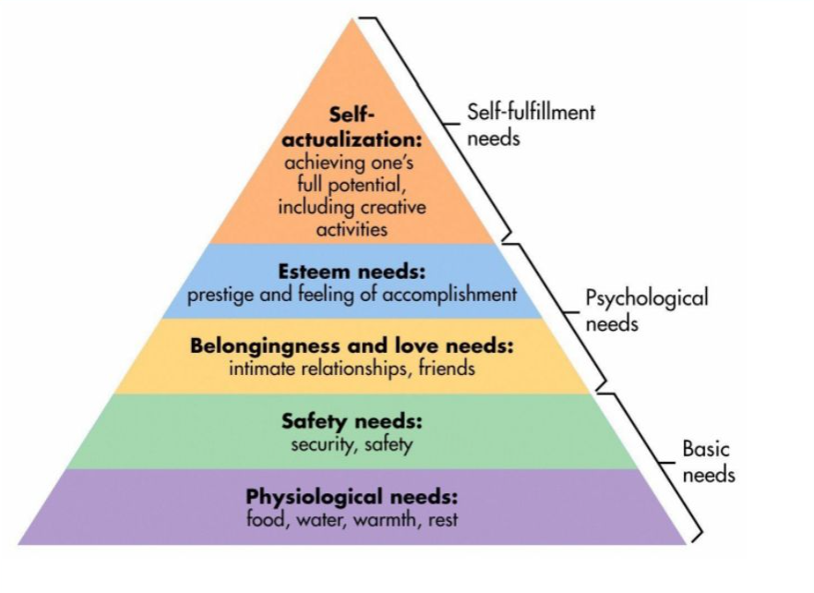
Maslow’s third level are the needs for belonging. It is important to help employees feel they belong. A Supportive and collaborative workplace builds a sense of community, which us key to their wellbeing and motivation. When employee feel part of the team and valued, they experience higher level of psychological safety and self-esteem which are crucial for personal growth and job satisfaction as they constantly trying to find ways to improve themselves as well as helping others to reach their team goals (Calicchio, 2023).

Both Inclusion and diversity together create a powerful synergy that drives innovation, growth and success. Promoting diversity and inclusion in the workplace have a significant benefit on individuals. Research shows diverse team foster creativity, innovation and better decision making due to varied perspectives. Inclusive environment improves employee engagement, satisfaction and retention by creating a sense of belonging and fairness. Businesses also gain external advantages such as reaching new markets, improving customer relations and enhancing their corporate reputation. Studies highlight that organisations with gender and ethnic diversity in leadership outperform less diverse counterparts financially. Inclusion not only attracts top talent but also drive productivity, flexibility and long-term success, offering competitive advantages in today’s global market.

AC 2.2

Inclusion can be achieved by embedding inclusive practices and values into an organisation’s culture. While not solely the responsibility of people professionals, they play a vital role in supporting employees, managers to foster inclusive behaviours, ensure policies are fair, and challenge practices that hinder inclusion. Actions should be data -driven, carefully evaluated, and tested to ensure their effectiveness in building inclusion.
There are also Five key actions to implement inclusion: Involving all employees, developing people manager capability, building senior commitment, evaluating policies and practices and Examine organisational culture, climate and values (CIPD, 2024).
Inclusive Leadership program

The health board has decided to promote diversity, equality and inclusion within organisation by focusing on Underrepresented groups and addressing the leadership gap for this groups.

This inclusive leadership program is designed to empower individuals from ethnic minority groups, women or employees with disabilities by including tailored content that addresses the specific challenges these groups face in leadership roles (NHS Wales, 2021).

Accessibility is critical to inclusivity. NHS Wales ensures training materials are accessible to individuals with visual and mobility difficulties and flexible participations options, such as virtual training sessions, allow employees with caregiving responsibilities or remote roles to engage fully (Health and care research Wales, 2021).

Engaging diverse employees in program design ensures initiatives meet participants needs. Employee networks and diversity forums can provide valuable insight to create relevant content (CIPD, 2023).

Effective communication strategies such as emails, internal posts and short videos detailing the program objectives and contacts for inquiries and Q&A sessions, build trust and increase participation rates (NHS Wales, 2021).

To guarantee inclusive adjustments, ask staff members for comments by means of surveys
and focus groups, use of existing data, frequent policy evaluations combined with
leadership accountability guarantees that required adjustments are done. This data-driven
approach produces observable outcomes and supports our inclusive leadership principles
(CIPD, 2019).

AC 2.3

In today’s work environments, promoting a culture of inclusion and respect for all is essential for developing strong connections. This entails recognising and accepting the different backgrounds, experiences, cultures, genders, ages, abilities, and perspectives of every person. This encourages teamwork, welcomes diversity, and guarantees that tasks are accomplished efficiently.

The CIPD profession map highlights the significance of inclusivity and relationship building as essential behaviours in valuing people and fostering an inclusive environment. The map indicates that HR professionals need to take initiative in fostering equitable environments, guaranteeing fair opportunities, and advocating for diverse perspectives to enhance decision-making and spur innovation.

In my role as a resourcing officer, I interact with employees from different backgrounds ,
assisting and advicing them through their visa processes and verifying their work eligibility.
I understand that immigration is a multifaceted and challenging topic, and it's essential to understand different cultures and personal situations to offer valuable support.

I recognise that immigration is a complex and stressful issue, and understanding various cultures and individual circumstances is crucial for providing effective support. I ensure that my communication is straightforward and tailored to each individual's requirements, considering any potential language barrier or unfamiliarity with UK culture and immigration regulations.
I put in the effort to foster a warm environment through kindness and empathy. Numerous employees seeking assistance with visas may experience anxiety or uncertainty regarding their circumstances. I hear their concerns, provide encouragement, and share straightforward guidance to assist them in facing these obstacles with greater assurance. This builds trust and strengthens a positive working relationship.

During my recent one-to-one meeting, my senior Officer provided valuable feedback that has boosted my confidence and confirmed that I am moving in the right direction towards achieving inclusivity.
“Mehrnoush demonstrates strong communication skills when working with colleagues and external stakeholders. Amongst the resourcing team Mehrnoush provides support to her peers and is approachable when help is needed.
In respect of working inclusively Mehrnoush has an open collaborative approach when assisting Ward Managers with onboarding and recruitment of candidates. There are also varying enquiries in relation to immigration and SBUHB has a multi - cultural workforce. Mehrnoush takes the time to consider each enquiry and provides a fair response and takes time to explain decisions. This is to ensure that applicants are provided with the correct information, and are supported. At times it can be difficult to manage to the varying different cultural backgrounds and candidates can be difficult to manage – however Mehrnoush is sensitive to their concerns and handles their objections professionally. “

AC 3.1

Today, human resources play a key role as a strategic partner achieving business goals, moving beyond its traditional transactional functions. As well as managing benefits and compliances, HR now focuses on shaping company culture, enhancing employee engagement, and contributing to business success. The growing diversity of the workforce and advancements in technology have further elevated the significance of the HR function.
To adapt a workforce changes, it is essential to be prepared, according to selecthub.com, there are several emerging HR trends that can help organisations stay ahead:

- Setting up the Hybrid working
- The role of Generative AI
- Human leadership
- Predictive Analytics for HR
- Change management
- People analytics
- Focusing on employee well-being
- DEI in the spotlight (Totah, 2025).

Professional development goals are set by individuals to improve their skills and knowledge in their chosen fields and designed to help people grow and advance in their careers, job satisfaction, and increase performance. The concept of professional development is based on the idea that learning and development are continuous processes that never stop, otherwise it will quickly become outdated and as well as not being the best practice it may be even illegal (Taylor and Woodhams, 2022).
Continuous Professional Development (CPD) is the learning process that further our professional growth, which can formal, informal training or any activity that helps us improve our practice, According to CIPD (2025), the stages of CPD cycle includes: Identify and plan, Learn, Reflect, Apply and share (CIPD, 2025).
In mu current role as resourcing officer, where I work closely with overseas team members, I actively engage with HR key trends, particularly internal changes and digital transformation. For example, any policy update can impact visa regulations, enquiring me to stay informed to provide accurate guidance.
A recent example is the home office’s introduction of E-visas, replacing physical cards. To support team members effectively, I must continually expand my knowledge and adapt to these changes. Similarly, diversity and inclusion strategies are evolving and I ensure stay up to date with the latest development in employment relationships and workforce diversity.
This not only helps me to stay at the top of my role but also allows me to support the well-being of our overseas team members by providing timely assistance, without this support, they may experience unnecessary stress, and in some cases, their employment could be temporarily paused until the issue is resolved.

AC 3.2

For my self-assessment I selected Professional Courage and influence valuing people as my two core behaviours (Appendix 1).
The assessment results provided five actions for me to take regarding professional courage and influence and two action plans for valuing people.
For professional courage the key recommendations were to reflect on what courage means to me, actively working on developing it, and seek opportunities to practice it, this includes seeking feedback from colleagues and using that feedback to improve and understands the impact of my actions.
The two suggested actions for valuing people are first to collaborate with other teams to help them understand the importance of valuing people and encourage them to integrate this into their roles. And it also recommended researching and participating different coaching models so I can use these methods to support others in developing a stronger focus on valuing people.
Feedback from my current line manager on the above points is;
Professional courage – learnt to be more confident and advocate for yourself over the past 12 months, in particular about your job description and your current role. Conversations had openly and in depth around responsibilities and how to ensure these changes to role are incorporated in the job description. That takes a lot of courage, particularly when being challenged or being posed questions from those in a higher banded role. I think you’ve learnt a lot from this process, and have grown as a person.
Valuing people – as part of the visa/COS/RTW elements of your role, you do value the employees you are dealing with, particularly as some of these queries can be quite emotional for some individuals involved (i.e. if going through a grievance/disciplinary/losing their RTW). You are attentive to their needs, and always provide as much information and support as you can do within the remit of your role. You already have plans in place to create some guidance for managers, to make these queries easier for them to understand, which will hopefully help improve their understanding and allow them to be able to support their employees in the right way.
Two areas I want to get confidence in are valuing others and professional courage and influence. Among my talents are empathy, responsibility, and helping others well-being. To properly influence people, nevertheless, I must develop confidence in discussion, strengthen team coaching and communication.
I wish to develop by asking for feedbacks, attending communication and coaching workshops, observing confident role models, and taking opportunities to lead inclusive team cooperation and discussion.

AC 3.3

Development plan

NAME: | Mehrnoush Markey | MEMBERSHIP NUMBER: | 89126220
COVERING THE PERIOD FROM: | 20/01/2025 | TO:

 | What do I want/need to learn? | What will I do to achieve this? | What resources or support will I need? | What will my success criteria be? | Target dates for review and completion
1 | I would want to develop my confidence to express my ideas, negotiate challenging situations, and properly influence others in a meeting and inside my team, especially in meetings involving senior managers from different departments.  Developing this confidence will enable me to more effectively reflect the viewpoint of my team, participate in more powerful collaboration across departments, and contribute more. | I will take advantage of online courses such as Professional Courage and Influence, as well as internal training like the two-day Courageous Conversations workshop.  I also plan to ask my managers if I can shadow her during higher-level meetings—not to speak initially, but to observe and become comfortable with this type of meeting. Over time I will prepare to contribute briefly to future meetings as a first step.  Leading the internal team meetings. | Access to the CIPD website Time to complete and self-reflect.  Attending the next Courageous Conversation workshop.  Scheduling with my manager to attend the next suitable meeting  Asking my manager to let me lead the weekly meetings. | Successful completion of my online CIPD course and attending the Courageous Conversation workshop.  To be able to run our weekly meeting without hesitation or my manager's involvement.  Demonstrating confidence in tea discussions and meetings. | 6 months to complete the online courses.  12 months to confidently attend the team meeting and management meetings
2 | I want to develop the skills to create a more inclusive environment by recognising and respecting diverse perspectives. I aim to support others in feeling valued and heard, and I hope to help my team do the same by fostering a culture of respect and inclusion. This will not only strengthen our collaboration but also lead to more balanced and representative decision-making across the team.  More understanding of different communication styles and cultural perspectives in a diverse workplace | I will complete online courses such as the Valuing People Online Course.  I will sign up for the internal diversity in the workplace workshop.  I will actively participate in meetings with overseas team members within the health board to gain broader cultural understanding and practical experience of inclusive communication. | Access to the CIPD website, time to complete, and self-reflection  I will be contacting the learning and education team at the health board to find out about more available workshops and webinars.  Attending the overseas team monthly meeting for wider exposure.  Support from my manager to attend training or shadow meetings.  Guidance from the learning and development team at the health board to identify further workshops or webinars. | Completion of all planned online courses and internal workshops.  Actively contributing ideas that support inclusion during team meetings. | 6 months to complete the online courses and workshops.  I will begin attending overseas team meetings during this time.  A review of progress in 6 months and a full evaluation of the impact of my training at 12 months.
3 | I want to develop leadership and coaching skills, learn more about diversity, inclusion, and equal opportunity in the workplace, enhance workplace culture and engagement, and improve employee management.  I would like to develop my ability to manage employee relationships and support professional development across the team. | To achieve these goals, I have enrolled in the CIPD Level 5 Associate Diploma in People Management. This course will help me build my knowledge and skills through structured learning across various people's professional modules. | Attending university to complete my CIPD Level 5.  Access to learning materials and support from tutors.  I schedule study time around my work commitments. Getting advice from my colleagues and manager to support practical learning | Successfully completing all 7 modules.  Successfully pass each module.  Applying key learnings from the course in my day to day role. | Achieving full completion of the qualification by the end of summer 2025.

AC 3.4

Development record

NAME: | Mehrnoush Markey | MEMBERSHIP NUMBER: | 89126220
COVERING THE PERIOD FROM: |  | TO:

c

 | Key dates | What did you do? | Why? | What did you learn from this? | How have/will you use this?  Any further action?
1 | 06/02/2025 | Completed the Valuing people Online Course  Appendix 2 | - I wanted to develop my HR skills and further my role in creating an inclusive workplace and to align with the organisation’s commitment to diversity and employee engagement.  - To further my career by understanding people management better. | - Learned the importance of DEI in the workplace.  - Effective communication and active listening  - How to create a positive and supportive work culture where everyone feels valued and heard, | - I will use my knowledge in team interactions and decision making.  - Supporting employee well being by having a respectful and open work environment.  - Applying DEI in policies, hiring, and leadership practices.
2 | 07/02/2025 | Completed professional courage and influence Online Course  Appendix 2 | - I completed this course to improve my leadership and communications skills.  - To improve my ability to manage conflict within my team.  - To prepare myself for future roles where influence and professional courage are key. | - I learned how to confidently voice my opinion and navigate difficult conversation.  - Influence others effectively while being professional  - Importance of ethical decision making and leadership. | - I will use to handle challenging work discussion with more confidence.  - Supporting colleagues and team members in developing communication.  - Will use it to present my ideas and be persuasive.
3 | 01/02/1025 | Attend the Cuppa Conversation- This a meeting for overseas nurses to come and talk to us over a tea and talk about their problems and asking for advice | As part of my role, I assist overseas team members with their right to work, visas, and any related issues, By building relationship with them, I believe they become familiar with me and know exactly who to contact for support. This helps them feel more confident and comfortable reaching out. In turn, it enhances my communication with the system and improve my ability to engage with a more diverse workforce. | - I learned the importance of establishing rapport, which will help overseas team members feel comfortable reaching out for assistance.  - Improved my ability to communicate clearly and supportively, especially when addressing sensitive topics like visas and right to work.  - Attending this meeting enhanced my understanding of different cultural perspectives and the challenges they face.  - Strengthened my confidence in providing guidance to support a diverse workforce. | - I will Share my insight with the rest of my team.  - Will continue engaging with the overseas team member.  - Will continue attending this meeting more regular.

Appendix 1:
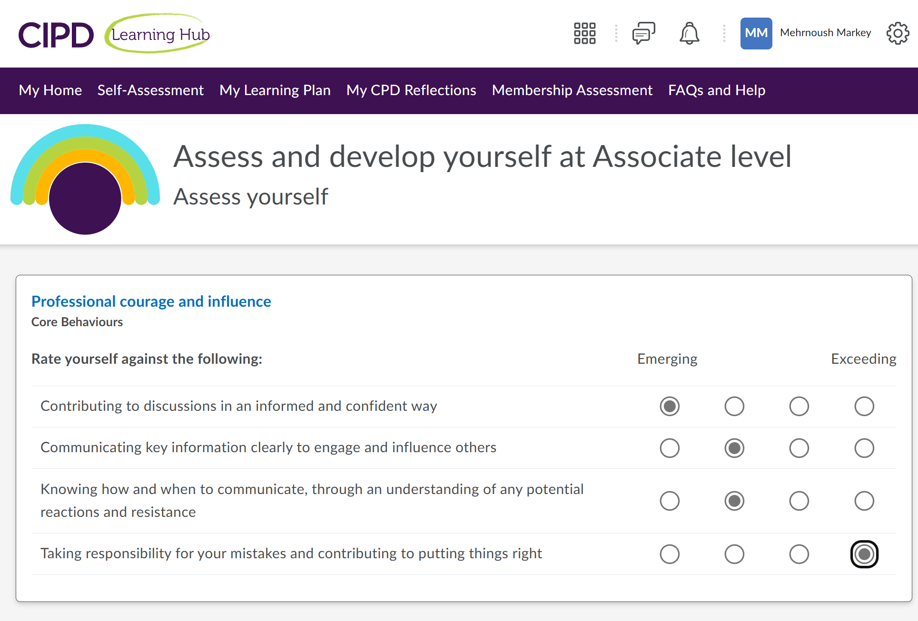
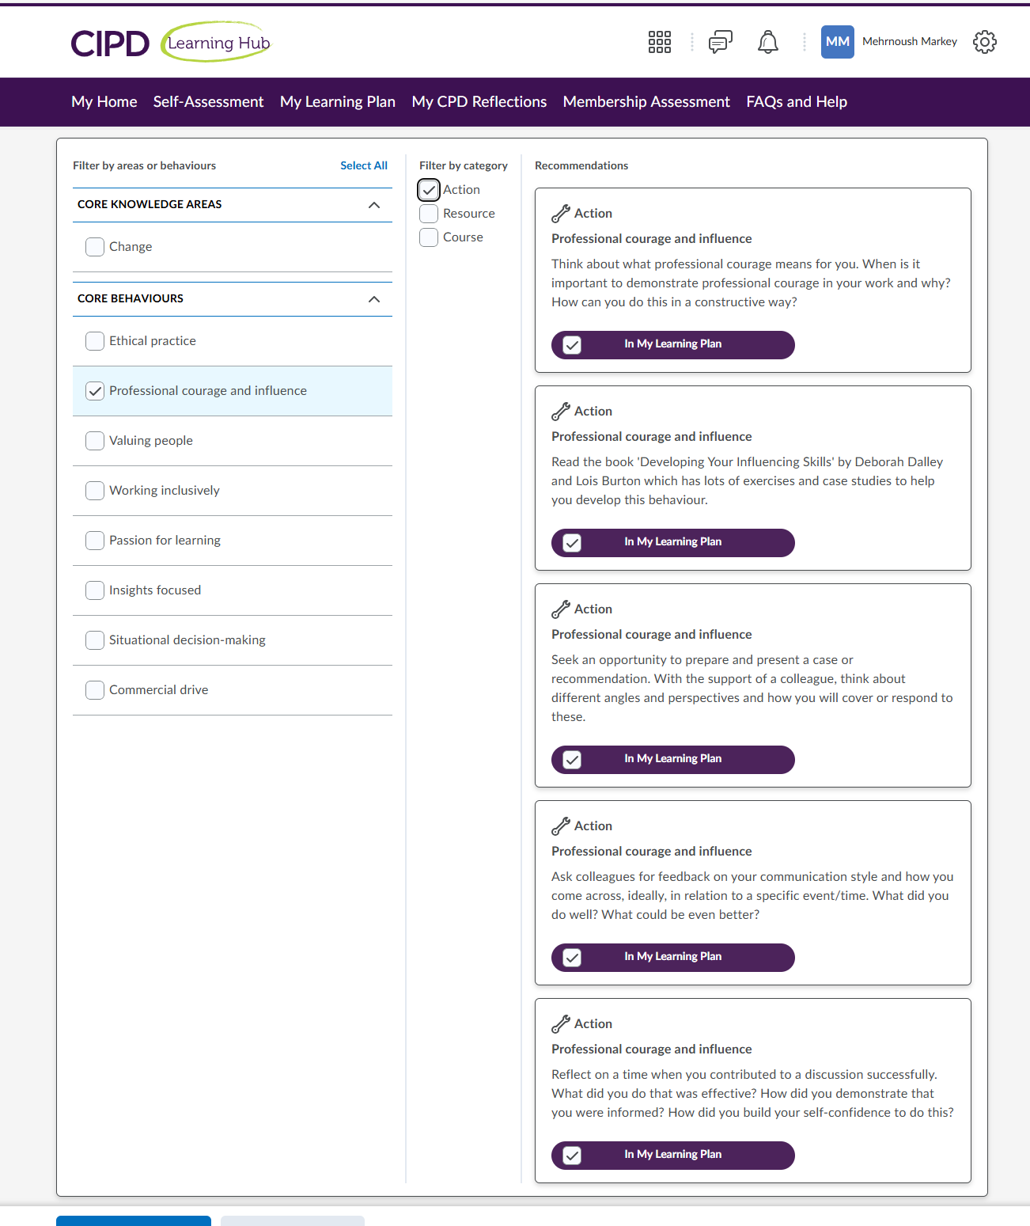

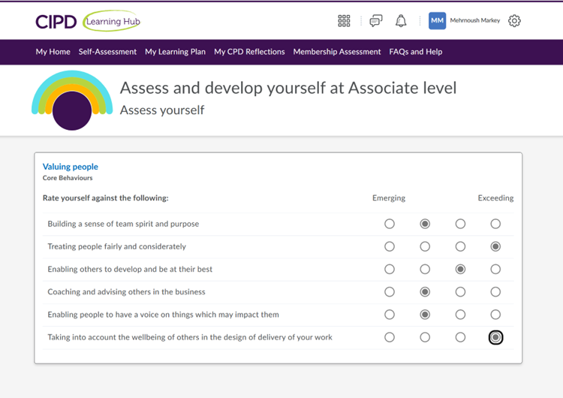

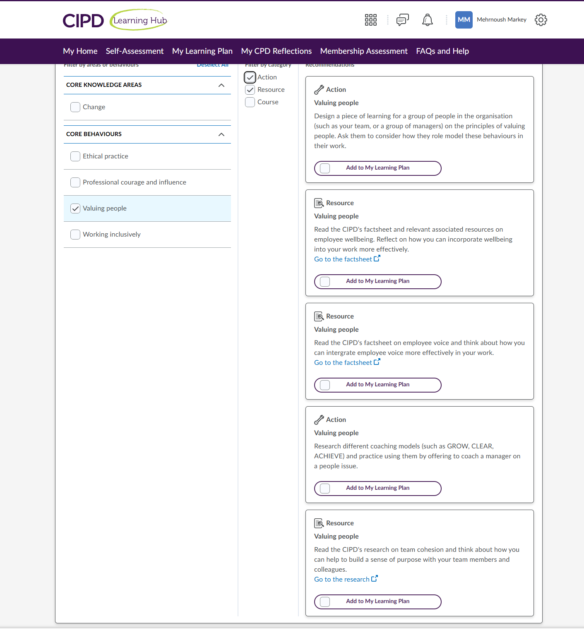

Appendix 2:
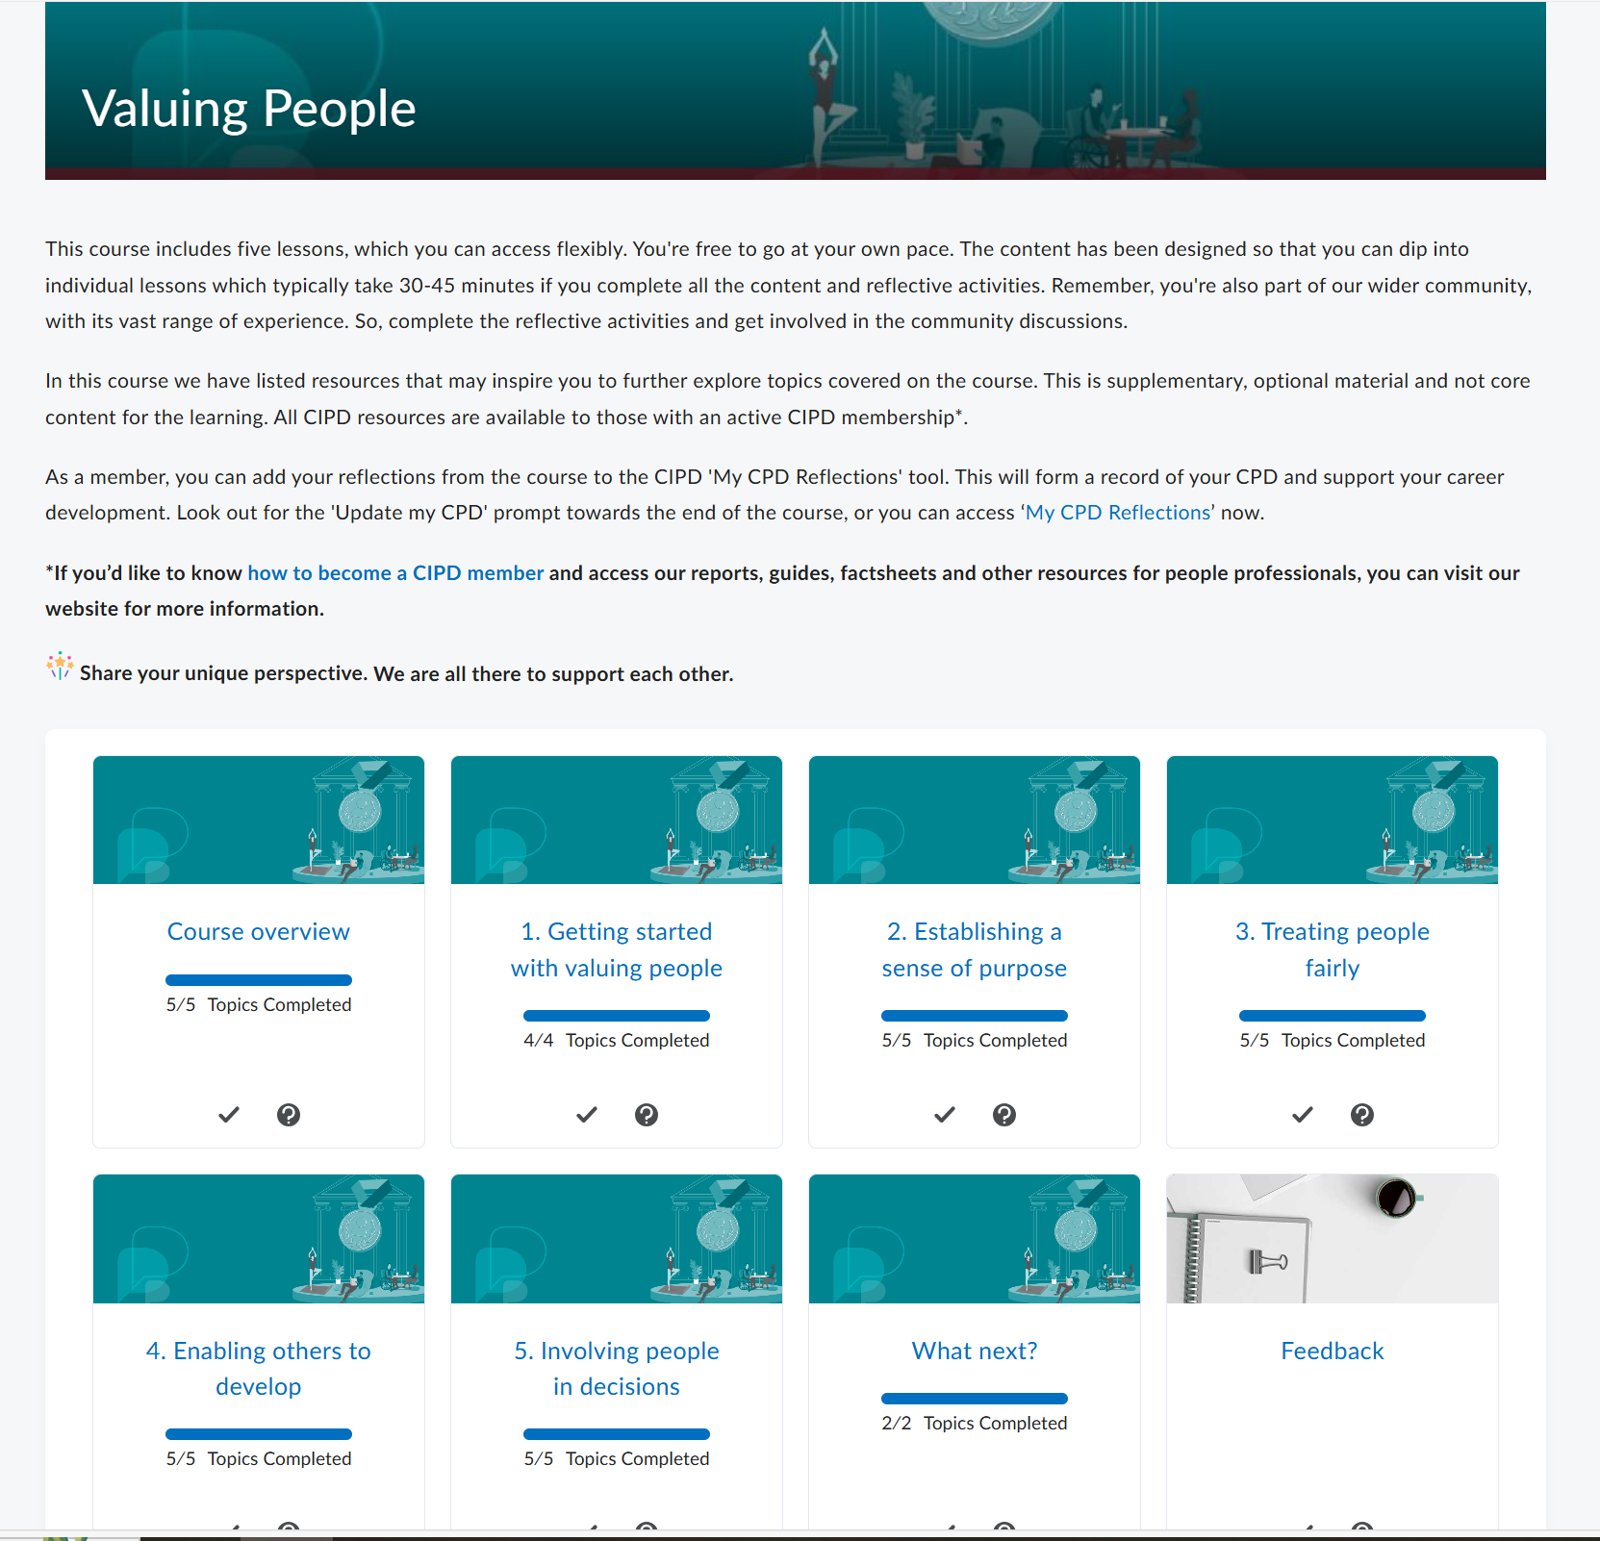
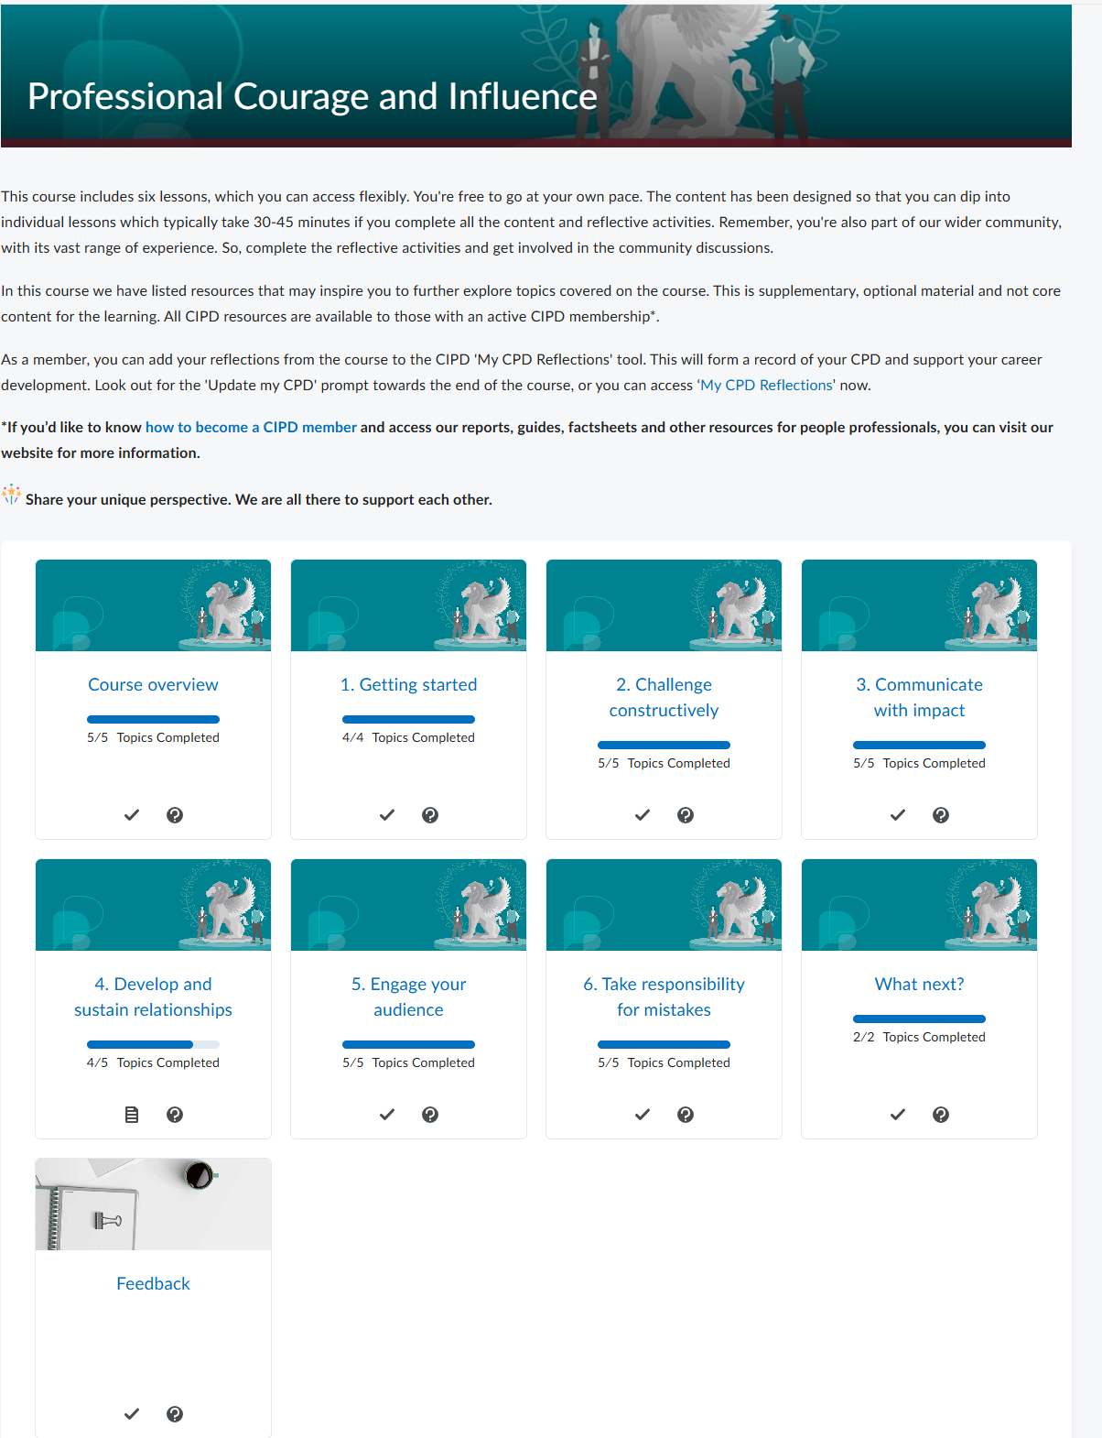
Bibliography:

Calicchio, S. (2023) Abraham Maslow, from the hierarchy of needs to self-fulfilment. Available at: https://www.perlego.com/book/4312982 (Accessed: 1 January 2025).

Chand, Smriti (n.d) Motivation Theories: Top 8 Theories of Motivation – Explained! Available at : https://www.yourarticlelibrary.com/motivation/motivation-theories-top-8-theories-of-motivation-explained/35377 (Accessed 01 January 2025).

- CIPD ( ) Professional courage and influence https://www.cipd.org/uk/the-people-profession/the-profession-map/explore-the-profession-map/core-behaviours/professional-courage-influence/ (Accessed: 16 December 2024 ).

- CIPD (2017) HR professionalism: what do we stand for? London: CIPD. Available at: professional-identity-research-report-updatedpffmay20_tcm18-17960.pdf (Accessed: 13 December 2024 ).

- CIPD (2019) Building inclusive workplaces London: CIPD. Available at: Building inclusive workplaces | CIPD (Accessed: 04 April 2025).

- CIPD (2020) Profession Map Webinar - Understanding Professional Values. 06 May. Available at: https://www.bing.com/videos/riverview/relatedvideo?q=concept+of+professional+integrity+according+to+cipd&qpvt=concept+of+professional+integrity+according+to+cipd&view=riverview&mmscn=mtsc&mid=E51F5490DB5582EF2767E51F5490DB5582EF2767&&aps=0&FORM=VMSOVR(Accessed:14 December 2024).

- CIPD (2023) Code of Conduct and Ethics https://www.cipd.org/globalassets/media/comms/code-of-conduct/2023-cipd-code-of-conduct-and-ethics.pdf (Accessed: on 14 December 2024).

- CIPD (2023) Explore the Profession Map https://www.cipd.org/uk/the-people-profession/the-profession-map/explore-the-profession-map/ (Accessed: 14 December 2024 ).

- CIPD (2024) Five actions you can take to foster inclusion https://www.cipd.org/uk/knowledge/guides/five-actions-fostering-inclusion/ (Accessed: 06 January 2025).

- CIPD (2024) Membership terms and conditions https://www.cipd.org/uk/terms-conditions/membership/#7-right-to-cancel-membership (Accessed: 13 December 2024).

- CIPD (2024), Equality, diversity and inclusion (EDI) in the workplace. London: CIPD. Available at: Equality, diversity and inclusion in the Workplace | Factsheets | CIPD (Accessed: 29 December 2024 ).

- CIPD (n.d) Ethical Practice https://www.cipd.org/uk/the-people-profession/the-profession-map/explore-the-profession-map/core-behaviours/ethical-practice/ (Accessed: 15 December 2024).

- CIPD (nd) Professional values and purpose https://www.cipd.org/uk/the-people-profession/the-profession-map/explore-the-profession-map/professional-values-purpose/(Accessed: 14 December 2024 ).
- Forbes Coaches Council (2024) 20 Consequences of Promoting Leaders Who Lack People Skills. Forbes, 5 March. Available at : https://www.forbes.com/councils/forbescoachescouncil/2024/03/05/20-consequences-of-promoting-leaders-who-lack-people-skills/ (Accessed: 16 December 2024).

- Gov.uk (2020) The Public Interest Disclosure Act. Available at: https://www.gov.uk/government/publications/guidance-for-auditors-and-independent-examiners-of-charities/the-public-interest-disclosure-act--2 (Accessed: 28 December 2024 ).

- Green,M. (2019) Creating ethical workplaces[Podcast]. 04 June. Available at: https://www.cipd.org/uk/knowledge/podcasts/ethical-workplaces/ (Accessed: 29 December 2024).

- Murray, Sarah.” Rescuing diversity from the DEI backlash.” FINANCIAL TIMES .21 June. 2024, Rescuing diversity from the DEI backlash.

- NWSSP (2013) Raising Concerns (Whistleblowing) Policy. Wales: Available at: nwssp.nhs.wales/corporate-documents/corporate-issues-and-complaints/whistleblowing-policy/ (Accessed: 28 December 2024 ).

- Parsons, R. and Dickinson, K. (2016) Ethical Practice in the Human Services. 1st edn. SAGE Publications, Inc. Available at: https://www.perlego.com/book/2800610 (Accessed: 15 December 2024).

- SBUHB (2023) Standards of Business Conduct Policy. Wales: Available at: sbuhb.nhs.wales/about-us/key-documents-folder/audit-committee-papers/audit-committee-september-20202/2-4-appendix-1-standing-orders-7-standards-of-business-conduct-policy-v8-pdf/ (Accessed: 28 December 2024 ).

- Taylor, S. and Woodhams, C. (2022) Studying Human Resource Management. 3rd edition London: Kogan Page.

- Taylor, S. and Woodhams, C. (2022) Studying Human Resource Management. 3rd edn. CIPD - Kogan Page. Available at: https://www.perlego.com/book/3709764 (Accessed: 9 February 2025).

- Totah, Z. (2025) HR trends in 2020: the future of human resource management. 22 January 2025 .HR Trends for 2025 | Future of Human Resource Management ( Accessed on 07 February 2025 ).

- University of Minnesota (2023) The importance of influencing skills and how to improve them. College of continuing & professional studies, 12 January. Available at: https://ccaps.umn.edu/story/importance-influencing-skills-and-how-improve-them (Accessed: 16 December 2024).

- Wormington,S (2024), What Is Inclusion in the Workplace? A Guide for Leaders. pp.3 Available at : What Is Inclusion in the Workplace_ A Guide for Leaders from Center for Creative Leadership.pdf (Accessed: 29 December 2024 ).

