
Trends in Business Intelligence
Jiaying He

29 November 2023
UWTSD

Contents
Content Page 2
Business Intelligence 3
Data Warehousing 7
Data Mining 10
References 14

Content Page
Blog address:
jiayinghe-businessintelligence.blogspot.com
Blog title:
Trends in Business Intelligence
Blog content:
- Business Intelligence
- Data Warehousing
- Data Mining

Business Intelligence
- How does BI evolve?
Business intelligence systems are defined as combining operational data with analytical tools to provide planners and decision-makers with competitive and useful information (Negash, 2004). With the rapid development of the world economy, the demand for intelligent analysis keeps increasing. BI has gradually evolved to meet the needs and provide convenience for business decision-makers.
The first generation of BI was built on an OLAP-based system that supported mostly relational data formats and integrated data via ETL/ELT (Bulusu & Abellera, 2021). However, it was limited to processing data in batches, and the decision maker cannot be involved in the operational BI process for targeted analysis.
The second generation BI architecture overcame this limitation, which took advantage of Data Integration 2.0 for high-level data processing and decision support. The three primary functions of BI in this generation include ad hoc querying, operational BI, and self-service analytics (Bulusu and Abellera, 2021), which enables users to make tailored analytical outputs.
In the third generation, the concept of Adaptive Business Intelligence emerged. ABI systems include elements of data mining, predictive modeling, forecasting, optimization, and adaptability (Michalewicz et al., 2007). More flexible and advanced ways of applying intelligence in business facilitate decision-making.
We are living in a new generation of BI now. It emerged as a result of the widespread use of mobile devices and cloud computing, which makes it possible for us to access at all times and places. Besides, massive volumes of data created and consumed are utilized to develop Big data technology, which is also a prominent feature in BI generation (Azevedo, 2020). Gradually, BI has become an essential part of modern business information integration and data processing.
- What does BI do?
  - Micro level
BI is composed of many important parts, as shown in Figure 1. First, data is collected from a variety of data sources, which can be structured, semi-structured or unstructured (Negash, 2004). The collected data is processed and sorted through extracting, transforming and loading by ETL tools into a unified format for further processing. The cleaned and consolidated data is stored in data storage systems such as data warehouses, which will be further analyzed using various processing techniques, such as SQL queries, data mining algorithms, machine learning models, etc. to discover patterns, trends, and insights in the data. Then, the processed data is used to create charts, reports, and dashboards.
Besides, BI systems often include security capabilities to monitor data changes in real time. Based on the evaluation of decision effectiveness, companies can adjust and improve BI processes if necessary.
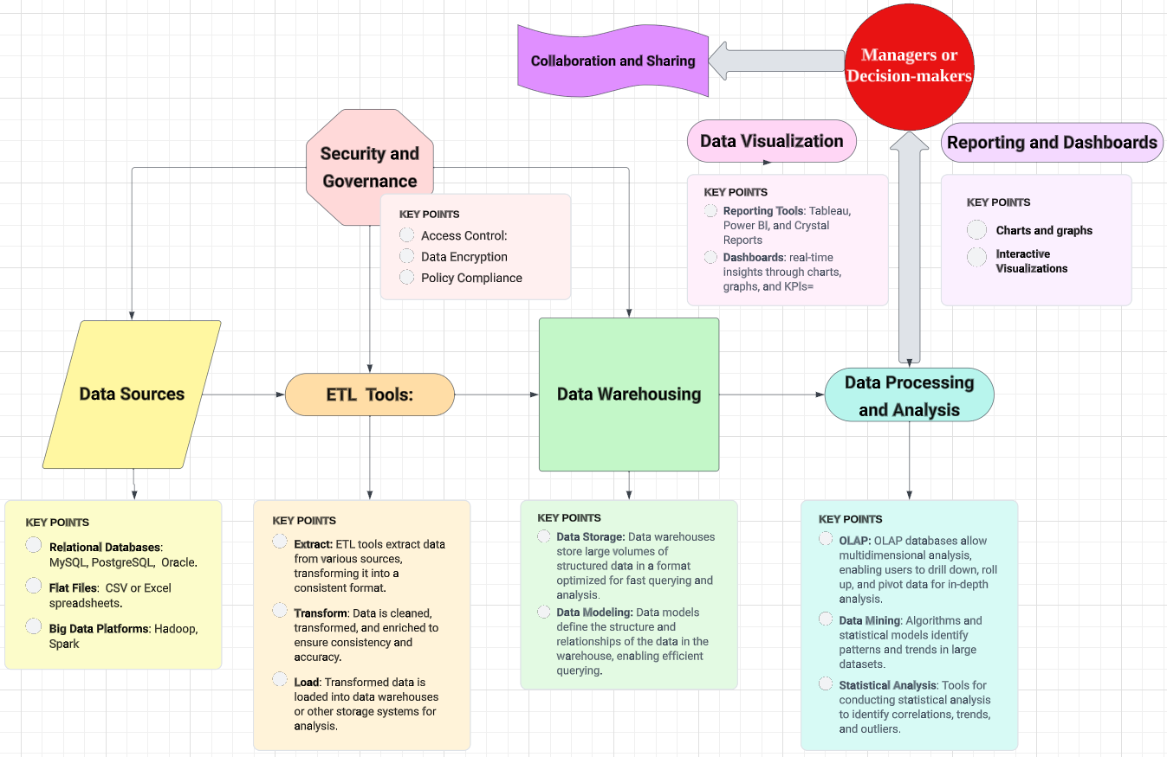
Figure 1
  - Macro level
By visualization and analysis of results, decision-makers can draw insights to make strategic decisions in many aspects. This may include processes related to three subjects (Figure 2).
Supply chain Analytics help companies analyze data about inventory levels, delivery times, supplier performance, etc., to optimize supply chain management and reduce costs. Cuba has built a data warehouse for natural disaster risk prediction and resource supply allocation through the use of BI technologies and tools, which is also an excellent case of applying BI for risk management (Milanés-Batista, 2020), worthy of reference for enterprises.
BI can be applied in operations including business analysis, KPI management, human resources analysis, financial analysis and so on. For human resources analysis, Kaewnaknaew (2022) has developed a business analysis model of talent management based on construction companies in Bangkok, Thailand, and this business analysis model formed by him can be applied to any department to improve organizational performance.
In terms of customer management, CRM (Figure 2) enhances the detection of customer’s satisfaction level for efficient service provision and is a great attribute of BI applications based on research about sustaining Retail Businesses in Nigeria (Nwinyokpugi and Lah, 2021).
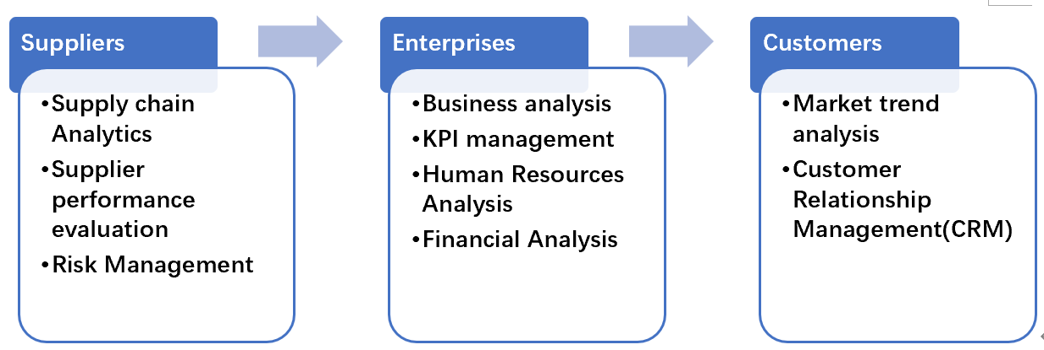
Figure 2
- What is the future of BI?
Looking into the future, the SWOT model can be properly applied to analyze the trend of BI.
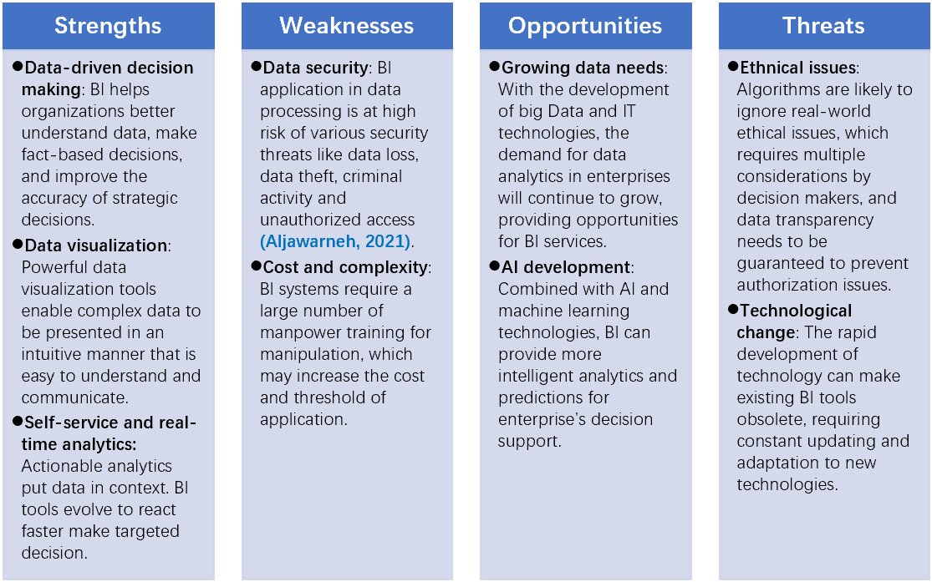
Figure 3
BI trends are influenced by changing technologies, market demands, and global economic conditions. The future development trend of BI is facing both opportunities and challenges, which requires decision-makers to be sensitive to the limitations of BI systems and consider various factors in the business environment. The proper use of BI will bring great benefits to enterprises.

Data Warehousing
- What is Data Warehousing?
Data warehouses are decision-making databases that store high-quality data taken from transaction systems, operational data stores, or other exterior source systems (Liu et al., 2019). It is often described as ‘Home of data assets’. The key point of the Data Warehousing (DW) system is periodic copies of various sources, in which data are sorted in a regular and controllable manner for batch-oriented processing (Hammergren and Simon, 2009). Under today’s fast-moving business environment, decision-makers realize that the biggest advantage to seize opportunities is to make full use of information. The invention of DW meets the need for valuable data by providing highly ordered databases, which has become a powerful tool in many industries.
In the 1980s, the concept of DW was first raised and formed. The goal was to provide a unified view of an organization's data from different sources. In the early 1990s, the first DW product was introduced. Teradata, one of the pioneers, released a parallel processing database designed for data warehousing (Page, 1992). From the 1990s to the 2000s, DW underwent the evolution of architecture. The use of star schemas, snowflake schemas, and multidimensional models became popular. Nowadays, DW derives many new forms and develops a lot. Cloud computing, machine learning and AI are increasingly integrated to derive deeper insights from data. These innovative solutions not only facilitate but also invigorate modern data processing.
- The structure of a Data Warehouse
A Data Warehouse often comprises several parts, including Data Sources, Staging areas, Data Storage and End-user access. Data extracted from source systems will be transformed and loaded in the staging area for further storage. Different forms of Data Marts, which refer to small-scale DWs, often constitute various types of Data Storage mode. According to Ariyachandra and Watson (2006), there are five basic architectures: 1) centralized, 2) independent data marts, 3) federated, 4) hub-and-spoke, and 5) Data-Mart bus. Other architectures are all variations of these five modes (Figure 4).
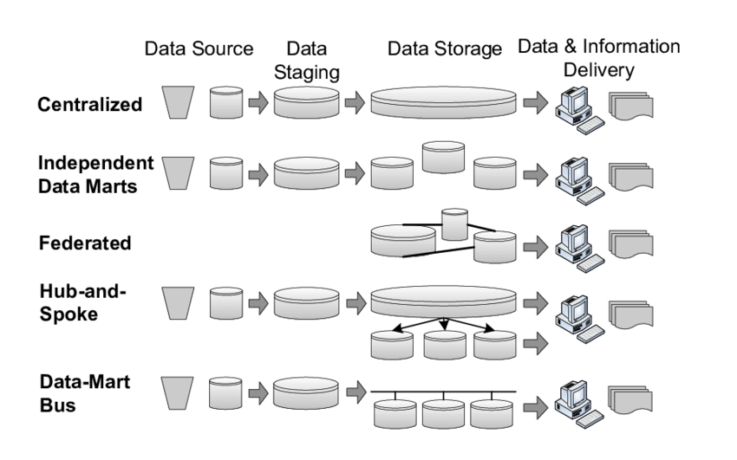
Figure 4
Centralized mode is suitable for enterprises whose data volume is relatively small, while independent Data Marts can be properly applied in large enterprises with decentralized business needs. Federated mode allows data integration without the need for physical centralized storage. Hub-and-Spoke mode can put data in a central location while providing independent data marts for each business unit, and Data-Mart Bus allows data marts to collaborate with each other, avoiding data duplication and consistency issues.
According to the evaluation conducted by Ariyachandra and Watson (2006), no single architecture is dominant. Each form has its unique characteristics and can be mixed according to the needs and context of the organization.
- What can Data Warehousing bring to us?
Why is the building a data warehouse so important and compelling in today’s business environment? There are many reasons shown below:
DWs are designed for easy access, which not only includes Metadata for professionals but also provides specific platforms for front-end users, better facilitating decision-makers to seize important information. Besides, employees will save much effort in creating reports when using a well-designed DW, because underlying transaction systems will be deployed for modifying and sorting data (Guerra and Andrews, 2011).
In addition, DW improves the accuracy and consistency of data. When a DW is used by all people in an organization, the data information is equally accessed by everyone. Thus, the accuracy will be verified and it will help reduce conflicts caused by data discrepancies from different sources. Besides, the sharing of data also provides faster connections between different departments and further stimulates more cooperation.
In terms of data security, DW often has more strict limits on data access compared with operational databases. The various architecture of data marts also provides multi-level protection of backup in case of loss of data.
- The future of Data Warehousing
Over the 1990s, data warehousing experienced rapid growth, providing a strategic advantage to early adopters. However, some organizations may encounter ‘Information Silos’. Therefore, the scalability of DW is particularly important. In future years, multimedia will likely be involved for wider information sources and better knowledge management capabilities (Gray and Watson, 1998). Armbrust et al. (2021) also claimed that the current DW will fade in the following years and be replaced by a new mode called the Lakehouse that combines machine learning for higher performance. DW’s infinite potential is still waiting for exploration in the future.

Data Mining
- What is Data Mining?
Data mining (DM) refers to a knowledge-discovery step in databases by finding valid, unique, potentially useful, and ultimately intelligible patterns in data (Fayyad et al., 1996). It involves the use of sophisticated analytical tools including Weka, SPSS, Tableau, etc. In recent years, with the rapid development of computer and programming, more powerful tools such as Python and R have also been introduced for deeper DM, which facilitate people to create automated programs for any data mining task.
- Background
The rise of DM is not without reason. First, the explosion of data volume is arguably the most striking feature of the Third Industrial Revolution, along with synchronized development of data storage technology. Thus, a great deal of valuable information is waiting to be mined. Besides, with the progress of globalization, the business environment has become increasingly competitive across the world. To seize the opportunity and thrive in the market, it is necessary for organizations to take advantage of valuable information. DM is exactly the proper tool to meet the needs (Gupta, 2014).
- Approaches
Faced with large amounts of raw data, how does DM work to handle them? A useful model is shown in Figure 5.
CRISP-DM is a model refers to the Cross Industry Standard Process for Data Mining, which frequently serves as the fundamental framework for carrying a DM task. During the cycle, the DM operator must consider many aspects comprehensively including the need of business, the quality of data, the way to organize data, the techniques needed, the standard to evaluate models, and how stakeholders access the results. The emergence of this model not only benefits analysts by streamlining and simplifying the complex process of DM but also clearly presents the operation links, enhancing the market's attention to DM and promoting its spread and development, which is seen as a milestone in DM (Wirth and Hipp, 2000).
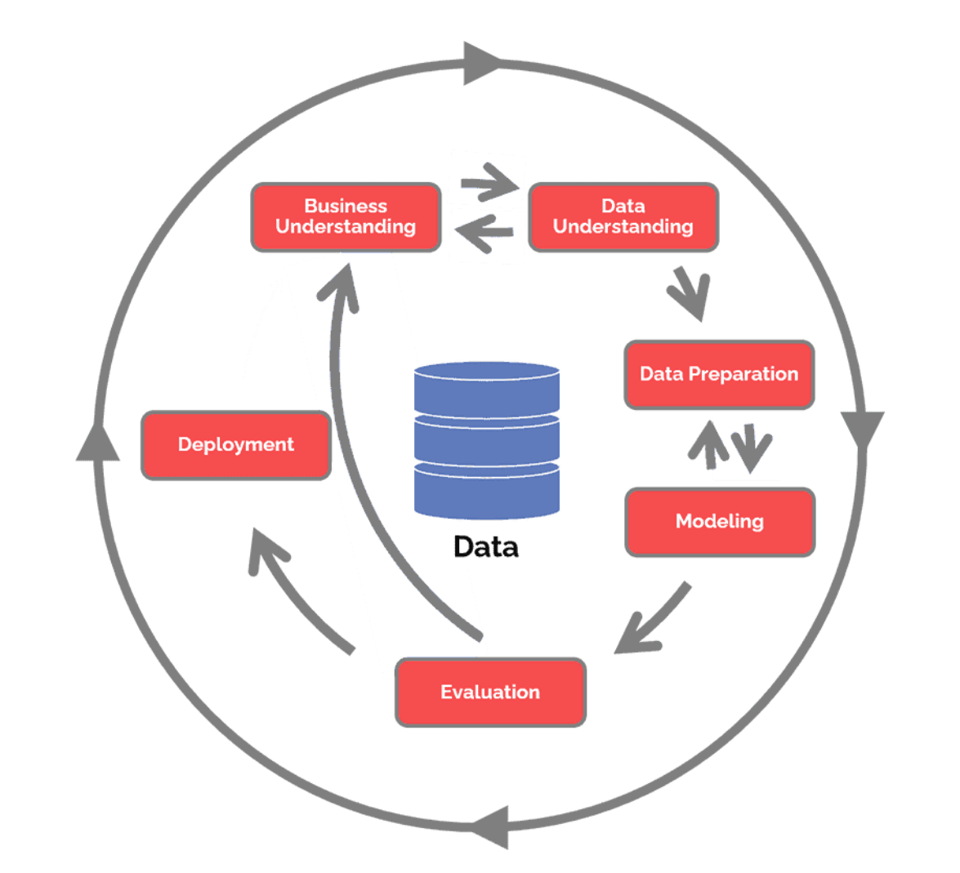
Figure 5 CRISP DM process (https://www.datascience-pm.com/crisp-dm-2/)
- Techniques and applications
There are 3 main techniques applied in DM.
Prediction refers to estimating the data trend or results based on previous experiences, which is the most commonly used technique in most fields. For example, Márquez‐Vera et al. (2016) applied DM prediction in education. They propose a DM algorithm to conduct comprehensible prediction of student dropout (Figure 6), which is trustworthy enough for schools to establish an early warning system for help and intervention. However, the limitation of this technique is its failure to fully account for contingencies change in future trends, but the involvement and consideration of more external variables could help reduce this risk to some extent.
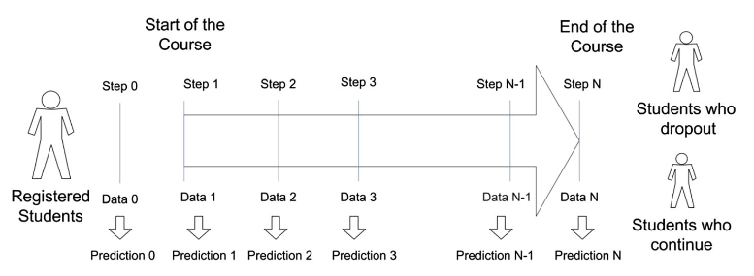
Figure 6 Dropout prediction model (Márquez‐Vera et al., 2016)
Classification is the process of grouping data to find patterns and categorical features, which helps reduce information complexity. One of the typical cases is its application in the medical area. Austin et al. (2013) developed a modern, flexible tree-based classification method, which offers substantial improvement in disease diagnosis. However, we should apply DM classification carefully because the biggest flaw is its uselessness for heterogeneous data (Kesavaraj and Sukumaran, 2013).
Unlike classification, the goal of clustering is to spontaneously discover the inherent features and structures in the data and group similar samples together to improve the similarity within the group and distinguish different groups. The prominent feature is the absence of pre-set categories. Tools such as Cluster 3.0 and Scikit-learn are useful in clustering tasks. Due to its advantages of automatic categorization, clustering can also be applied to evaluation based on group features. Grigoras and Scarlatache (2015) applied DM in the assessment of the renewable energy potential in Romania using K-Means clustering algorithm. The available data such as geographical location and electricity generation potential were clustered and representative zones were presented, facilitating the improvement of the electric networks in Romania.
Additionally, there are other techniques including Web data mining, Correlation mining, Association mining, etc. can also assist in the deep exploration of data for analysts.
- The future of Data Mining
DM has become widely used in the global development process in recent years. Liao et al. (2012) found that there are increasing DM applications in expertise areas and various social science disciplines. This trend indicates the requirements for further development of problem-oriented DM instead of a pure IT model. Besides, compatibility and adaptability to continual changes in the environment are also essential for accurate and efficient mining, which may become the future direction of DM development.

References
Aljawarneh, S. et al. (2021) ‘A Review of Trust and Security Concerns in Cloud Computing Adoption Intention in the Higher Education Sector: Research in Progress’, in Impacts and challenges of cloud business intelligence. Hershey, PA: Business Science Reference, an impact of IGI Global, pp. 1–12.
Aljawarneh, S., Malhotra, M. and Tuli, K. (2021) ‘Future of Business Intelligence in Cloud Computing’, in Impacts and challenges of cloud business intelligence. Hershey, PA: Business Science Reference, an impact of IGI Global, pp. 214–227.
Ariyachandra, T. and Watson, H. (2006) Which Data Warehouse Architecture Is Most Successful?, Business intelligence journal. Seattle: Data Warehousing Institute, pp. 4.
Armbrust, M., Ghodsi, A., Xin, R., and Zaharia, M. (2021) ‘Lakehouse: a new generation of open platforms that unify data warehousing and advanced analytics’, In Proceedings of CIDR，pp. 8.
Austin, P. et al. (2013) ‘Using methods from the data-mining and machine-learning literature for disease classification and prediction: a case study examining classification of heart failure subtypes’, Journal of clinical epidemiology, 66(4), pp. 398–407. Available at: https://doi.org/10.1016/j.jclinepi.2012.11.008.
Azevedo, A. (2020) Integration challenges for analytics, business intelligence, and data mining. Edited by A. Azevedo and M.F. Santos. Hershey, PA: IGI Global. Available at: https://doi.org/10.4018/978-1-7998-5781-5.
Fayyad, U., Piatetsky‐Shapiro, G. and Smyth, P. (1996) ‘From Data Mining to Knowledge Discovery in Databases’, The AI magazine, 17(3), pp. 37–54. Available at: https://doi.org/10.1609/aimag.v17i3.1230.
Gray, P. and Watson, H. (1998) ‘Present and future directions in data warehousing’, ACM SIGMIS Database: the DATABASE for Advances in Information Systems, 29(3), pp. 83–90. Available at: https://doi.org/10.1145/313310.313345.
Grigoras, G. and Scarlatache, F. (2015) ‘An assessment of the renewable energy potential using a clustering based data mining method. case study in Romania’, Energy, 81, pp. 416–429. doi:10.1016/j.energy.2014.12.054.
Guerra, J. and Andrews, D. (2011) ‘Why you need a data warehouse’, Copyright Andrews Consulting Group, pp. 1-8.
Gupta, G. (2014) ‘Introduction to data mining with case studies’, PHI Learning Pvt. Ltd.
Hammergren, T. and Simon, A. (2009) Data warehousing for dummies. 2nd ed. Hoboken, N.J: Wiley Pub.
Hotz, N. (2023) What is CRISP DM?, Data Science Process Alliance. Available at: https://www.datascience-pm.com/crisp-dm-2/ (Accessed: 13 November 2023).
Kaewnaknaew, C. et al. (2022) ‘Modelling of talent management on construction companies’ performance: A model of business analytics in Bangkok’, International Journal of Behavioral Analytics, 2(1), pp. 1-17, Available at: https://ssrn.com/abstract=4018709
Kesavaraj, G. and Sukumaran, S. (2013) ‘A study on classification techniques in Data Mining’, 2013 Fourth International Conference on Computing, Communications and Networking Technologies (ICCCNT) [Preprint]. doi:10.1109/icccnt.2013.6726842.
Liao, S., Chu, P. and Hsiao, P. (2012) ‘Data mining techniques and applications – A decade review from 2000 to 2011’, Expert systems with applications, 39(12), pp. 11303–11311. Available at: https://doi.org/10.1016/j.eswa.2012.02.063.
Márquez-Vera, C. et al. (2016) Early dropout prediction using data mining: a case study with high school students. Expert Systems, 33: 107-124. doi: 10.1111/exsy.12135., 33(1), pp. 107–124. Available at: https://doi.org/10.1111/exsy.12135.
Michalewicz, Z. et al. (2007) ‘Adaptive Business Intelligence: Three case studies’, Studies in Computational Intelligence, pp. 179–196. doi:10.1007/978-3-540-49774-58.
Milanés-Batista, C. et al. (2020) ‘Application of Business Intelligence in studies management of Hazard, Vulnerability and Risk in Cuba’, IOP conference series. Materials Science and Engineering, 844(1), p. 12033–. Available at: https://doi.org/10.1088/1757-899X/844/1/012033.
Negash, S. (2004). Business intelligence. Communications of the Association for Information Systems, 13, pp.176–196. https://doi.org/10.17705/1cais.01315
Nwinyokpugi, P. and Lah, F. (2021)‘Business intelligence applications; sustaining retail businesses in Rivers State, Nigeria’, INTERNATIONAL JOURNAL OF MULTIDISCIPLINARY RESEARCH AND ANALYSIS, 04(03). doi:10.47191/ijmra/v4-i3-13.
Page, J. (1992) ‘A study of a parallel database machine and its performance the NCR/teradata DBC/1012’, Lecture Notes in Computer Science, pp. 115–137. doi:10.1007/3-540-55693-1_35.
Taniar, D. and Rahayu, W. (2019) ‘A Two-Tiered Segmentation Approach for Transaction Data Warehousing’, in Emerging Perspectives in Big Data Warehousing. United States: IGI Global. Available at: https://doi.org/10.4018/978-1-5225-5516-2.ch001.
Wirth, R., and Hipp, J. (2000) ‘CRISP-DM: Towards a standard process model for data mining’, Proceedings of the 4th international conference on the practical applications of knowledge discovery and data mining,1, pp. 29-39.

