

University of Wales Trinity Saint David

Plant and Asset Engineering
Assignment 1

__________________
Evaluating the Effectiveness of Chosen Maintenance Strategies for Dedicated Equipment __________________________________________________

Author: Supervisor:

Morgan Wheeler

12th March 2024

Contents
1. Introduction: 3
2. Critical Review of Current Maintenance Practices: 4
3. Evaluation of how the current approaches to maintenance could be improved 6
4. Consideration of costs and resources for implementing proposed changes 8
5. Conclusion and recommendations 9
6. Bibliography 10
7. Appendix: 11

Table of Figures
Figure 1 - Bathtub Curve 5
Figure 2 - GEISS 5-Axis Router CNC Machine 6

Introduction:

Safran aerospace is a large company that has various different divisions such as nacelles, landing gears, cabin, seats and many others. Safran Seats GB (SSGB) is the division of Safran aerospace that produces business class and first class suites for various airline customers such as Emirates, Etihad and United Airlines who are large flagship carriers. Safran also designs and manufactures economy and premium economy seats in France and the US.
At SSGB, there are three main sites which are located next to each other, Kestrel House, Henry Thomas House (HTH) and Manufacturing Unit (MU). In MU, there are over thirty CNC machines including 3-Axis, 4-Axis, 5-Axis machines, routers, vacuum forming, punches and lathes. Within this report, the Geiss 5-Axis machines maintenance schedule will be inspected to determine what current breakdown strategy is used, and how a new strategy could be adopted to improve the future maintenance of the machine. The parts which are produced by the Geiss 5-Axis machine are all A-surface parts so all customers and passengers will see these components.

Critical Review of Current Maintenance Practices:

The Geiss router is used for trimming all of the excess material around the vac-formed parts, it also machines any holes, slots and features so that the part conforms to the technical drawing. As the machine has 5-Axis, it can move in the X, Y, Z, A and C directions, this will allow more complex parts to be machined but also increases the amount of maintenance due to the increased complexity and additional moving parts.
To begin, the work piece must be mounted onto a bespoke jig which is then secured to the bed of the machine. It is secured by a number of dowels stopping the jig from moving, also there is a vacuum suction pulling the vac-formed part down on the jig. A programme is then selected and uploaded to the machine which had been created by a programmer, who would’ve checked the tool path on the software to ensure no clashes occur with the part or jig.
Once the part has been machined, a finishing operation will take place to achieve accurate dimensions and the desired surface finish. The part is then unloaded from the bed and all dimensions and geometries are checked against a drawing for compliance.
The current maintenance practices that SSGB undertake on the Geiss machines are very reactive, otherwise known as the fire-fighting approach. Swanson (2001) describes how this approach is when the machinery is run until a component or system fails. This type of approach has some benefits and drawbacks, the first benefit being that little planning is required as the time until failure is unknown. This could mean that the maintenance teams may not have to repair a machine for weeks or months as it is running smoothly. Reactive maintenance can also be useful for prioritising critical or unpredictable failures which are not easy to predict or prevent. Some negatives of the reactive maintenance approach is that when the part fails, a new one will only be ordered once this is detected. This could mean the machine is out of use for some time, as it is reliant on the parts supplier to have quick lead times for every eventuality. To resolve some of this situation, parts could be kept in stock for the most common components however, SSGB does not do this as management see it as a waste of money to keep parts which may not be used for an extended period of time. Sullivan & Pugh (2002) highlights how using this approach can typically lead to the asset’s lifespan being reduced, this will impact on SSGB capital expenditure as they will need replacing more frequently. There is also an inefficient use of staff resources as the maintenance personnel are sitting down, waiting for a failure when they could be doing more pro-active weekly or daily checks on the machines. As the maintenance crew are skilled employees, it would make sense to utilize them as much as possible.
Reasons why SSGB has taken up this approach previously is due to the organizational culture and the decreased short-term cost. The organizational culture within Zodiac Seats which was then acquired by Safran Seats back in 2018 was very focused on the short-term gains, rather than having sustainable long-term goals. The initial cost also seems to be much lower until something critical goes wrong with the machinery due to insufficient maintenance.
In reality, the reliability of the Geiss CNC machine and any other type of machinery can be demonstrated by the ‘bathtub curve’.
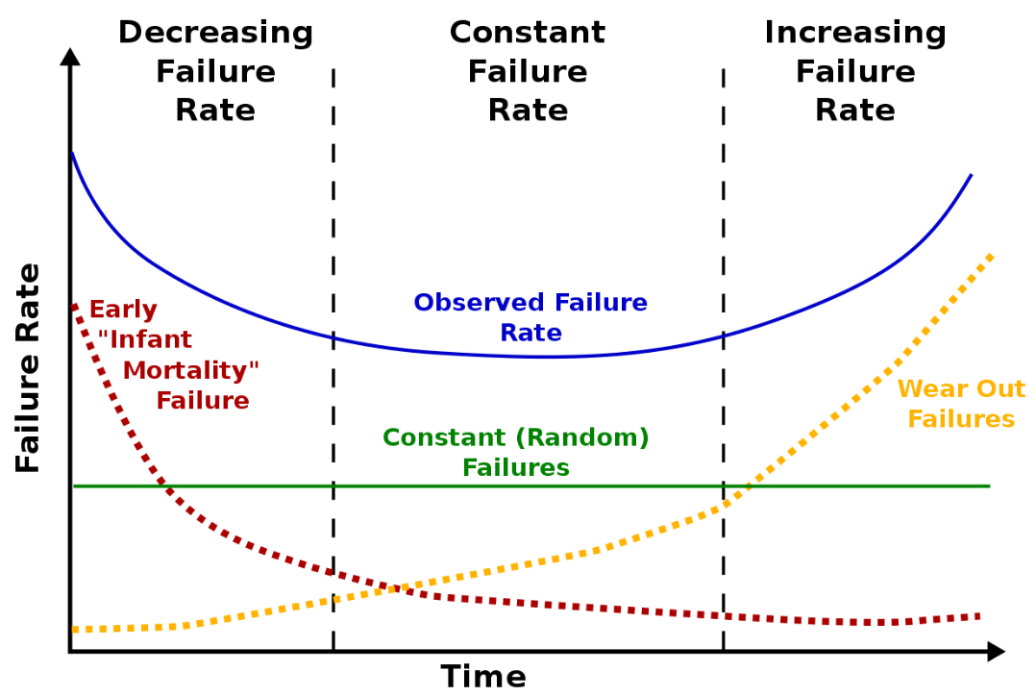
Figure 1 - Bathtub Curve
From Figure 1 Ohring (1995) mentions it is visible that throughout the machines lifetime, it will have random failures which could can’t be predicted as they could be due to human error or random system failures. When the machine is new, there will be some issues which arise early in the life of a machine due to poor installation, poor training or inadequate design. Once there is a solution for these, the failure rate decreases at a quick rate. At the end of the machines life, the wear and tear failures become greater until the asset needs to be retired and replaced.

Evaluation of how the current approaches to maintenance could be improved

After inspecting the breakdown schedule which can be found in appendix. 1, it was clear to see that Planned Preventative Maintenance (PPM) is scheduled twice a year for the Geiss CNC machines, five months apart from each other. As SSGB has a three shift pattern, this machine is being run day and night which triples the amount of wear and tear the machine would go through compared to a single shift.
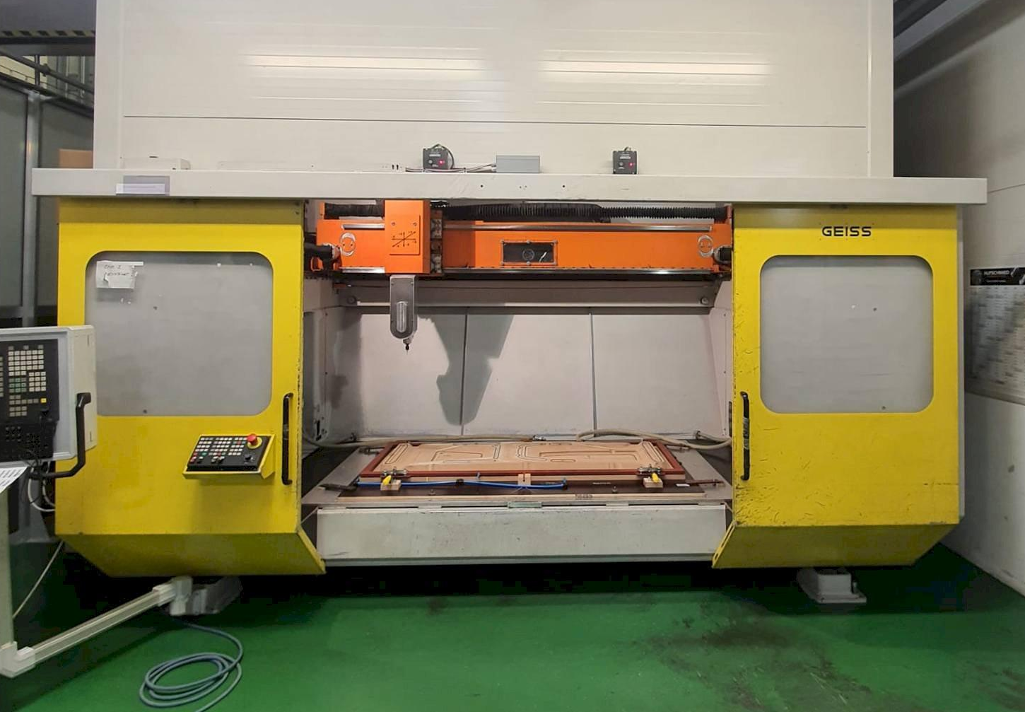
Figure 2 - GEISS 5-Axis Router CNC Machine
SSGB also only has one shutdown throughout the year at Christmas time, this only lasts a couple of day which should ideally be longer to carry out more maintenance on the machine. In addition to this, this schedule could be improved by adding in a ‘mini’ shutdown over a bank holiday weekend, where inspections, diagnostics and deep cleaning of the machine can be carried out.
During the shutdown periods, the maintenance which is carried out involves removing and replacing the vacuum pumps as if these do not work, neither does the machine. These will then get sent for overhaul so they can be fitted for the next shut down, or in case of an emergency repair. Any other repairs such as replacing pumps and any loose / worn contacts are also taken care of.
The GEISS suggested maintenance of the vacuum pumps can be found within appendix. 2.
Due to Safran having two GEISS machines, one can be serviced without effecting the operational efficiency too much which being serviced. If there wasn’t a back-up machine, there would be large backlogs when the machine was functional again.
There are various different strategies which could be implemented such as preventative maintenance, predictive maintenance or reliability centered maintenance (RCM).
Preventative maintenance is when schedules are produced and certain tasks are performed such as deep cleaning, lubrication of moving parts and replacement of parts and seals as explained by Almeida (2018). This will allow the machines wear and tear parts to be monitored and treated for them components to operate at optimal performance. The downtime for this to take place is minimal and may take several hours, so the work load could be progressed by using other backup machines.
Predictive maintenance uses historical data and failure data which has been previously recorded to then predict the lifespan of certain components. Mobley (2002) explains how machine learning algorithms can then identify any patterns or anomalies which occur within the data. Analysis of the predictive maintenance data can prove that critical systems, also wear and tear poblems will increase when the machine is coming near the end of it’s operational use.
Moubray (2001) describes how Reliability-Centered Maintenance (RCM) is a combination of predictive and preventative maintenance which focuses on the most critical components of the machine. This type of maintenance should be used on the most important machines to reduce downtime, which may lead to missing deadlines and shipping dates. RCM involves analysing the machines and detecting their potential failure modes, then the best suiting strategy can be implemented for that asset. Condition monitoring technology is vital so that data can be collected and evaluated so the frequency of maintenance can be adjusted.
The best strategy which SSGB could implement into future maintenance is preventative maintenance if it carried out correctly. This is due to the larger initial costs of predictive maintenance such as new software, also new condition monitoring sensors for machines which may not work very effectively on old machines.
Due to the age of some of the machines within SSGB, preventative maintenance such as lubrication, filter changes, inspections of gears, linkages and seals can be useful to stop any catastrophic breakdowns.

Consideration of costs and resources for implementing proposed changes

Maintenance is a necessary action which is required to keep a company’s assets in good working order. This costs money which some businesses feel is a waste because as long as the machines are working, the maintenance teams are waiting around until something fails or PPM activities are required. However, these teams are critical as the money which could be lost due to late delivery, non-conforming parts and operation interruptions is larger than hiring small maintenance teams.
Calculating the Mean Time To Repair (MTTR) should also be a key analysis before implementing any changes, as MTTF is vital for planning any periodic maintenance. The MTTR can be calculated as shown below:
Total No. of hours spent on repairs
MTTR = ____________________________

Total No. of repair jobs

The result for MTTR should ideally be as short as possible, whereas the Mean Time Between Failure (MTBF) should be as long as possible.
For SSGB to implement preventative maintenance, there would need to be an upfront investment cost covering any new training and upskilling which may be required for the maintenance teams, to have a better understanding of their new role. Ricks (2020) explains how some employees may be resistant to change within their business and role, so SSGB would have to communicate the benefits the machines will have, also to gain support from key stakeholders to buy-off the idea. New scheduling software should be used to ensure that data is safely and accurately stored on every machine. However, this may also call for better IT infrastructure within the Manufacturing Unit.
In this situation, Lewin’s three step force-field analysis could be implemented. This analytical technique was introduced in the 1940’s by Kurt Lewin (MindTools, 2019). The first step ensures the maintenance team know what the maintenance strategy change is, why a change in the process is required, also how they can benefit from such a change. This would ultimately be to ensure that the companies expensive assets last as long as possible and are well maintained. The next stage is to implement the new maintenance strategy which is the most challenging step due to uncertainties within the maintenance team, such as training, using new hardware, new software and new processes which can be daunting. The last step is to refreeze the new strategy and make it the new ‘normal’ and way of working within the department.
Financial resources can be utilized to assess the Return on Investment (ROI) of the new maintenance strategy. A new maintenance strategy should only be implemented if the company will gain from the benefits such as increased machine lifespan and increased efficiency of the machines. Some new budgets will need to be allocated to the new strategy which may involve increasing the maintenance team, as more tasks will be undertaken, or keeping some stock of critical parts which usually have long lead times.

Conclusion and recommendations

- Conclusion still to be completed

Bibliography
Almeida, A. T., 2018. Aircraft Preventive Maintenance Data Evaluation Applied in Integrated Product Development Process. Journal of Aerospace Technology and Management, Issue 10.
MindTools, 2019. MindTools. [Online]
Available at: https://www.mindtools.com/pages/article/newTED_06.htm
[Accessed 13 March 2022].
Mobley, R. K., 2002. An Introduction to Predictive Maintenance. Netherlands: Elsevier Science.
Moubray, J., 2001. Reliability-Centrered Maintenance. 3 ed. New York: Industrial Press Inc. .
Ohring, M., 1995. FAILURE AND RELIABILITY OF ELECTRONIC MATERIALS AND DEVICES. [Online]
Available at: https://www.sciencedirect.com/topics/engineering/bathtub-curve#recommended-publications
[Accessed 15 March 2024].
Ricks, A., 2020. HOW TO COMMUNICATE ORGANIZATIONAL CHANGE: 4 STEPS. [Online]
Available at: https://online.hbs.edu/blog/post/how-to-communicate-organizational-change
[Accessed 21 April 2022].
Sullivan, G. P. & Pugh, R., 2002. A Guide to Achieving Operational Efficiency. [Online]
Available at: https://d1wqtxts1xzle7.cloudfront.net/59086082/Operations___Maintenance_Best_Practices_Guide20190430-23048-1ueams0-libre.pdf?1556627413=&response-content-disposition=inline%3B+filename%3DOperations_and_Maintenance_Best_Practice.pdf&Expires=1710330269&Sign
[Accessed 13 March 2024].
Swanson, L., 2001. Linking maintenance strategies to performance. International Journal of Production Economics, 70(3), pp. 237-244.

Appendix:

Appendix 1. – Maintenance Schedule
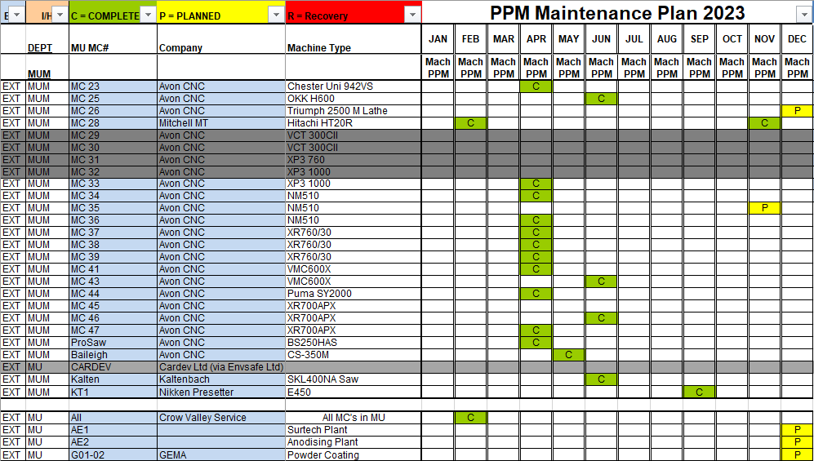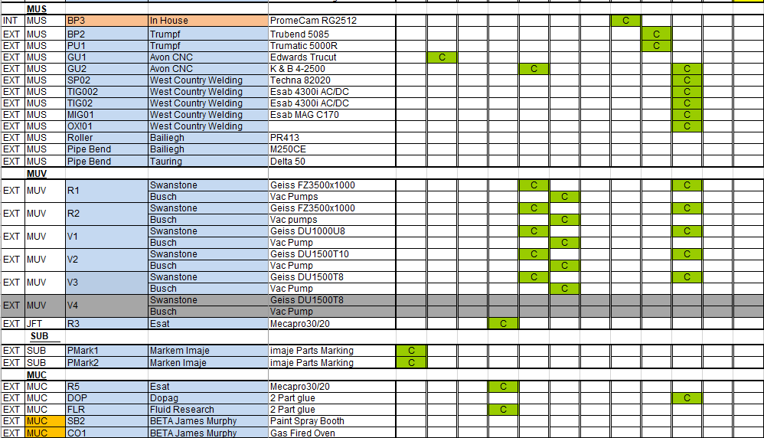

Appendix 2. – GEISS Recommended Maintenance


