  Component One:  What are the key skills required when working in the housekeeping team? 750 words (+/- 10%)  Contribution to Overall Module Assessment: 25% | Student No: | 2126259
 | Module Title: | Presentation
 | Module Code: | BMIH4006
 | Lecturer: | Natalie Brailsford
Housekeeping employees require excellent interpersonal and communication skills in order to effectively interact with other departments such as front desk and maintenance (Ninemeier & Perdue 2008). Housekeepers need to coordinate room statuses, identify issues quickly, and ensure repairs are made efficiently so rooms are available as promised. Strong verbal communication in guests' languages is also vital since housekeepers interact frequently with hotel residents. Housekeepers must be professional, polite and helpful if guests have requests or issues that need addressing. Listening skills, empathy and cultural awareness enable positive interactions with diverse guests. Housekeepers are hospitality professionals whose interactions directly contribute to guest satisfaction.

Time Management & Organisation

Housekeeping roles require considerable time management and organisational skills. Staff must clean a precise number of rooms on an exacting schedule while upholding quality standards; working efficiently means planning trolley loading routes, room routes, prioritising issues that arise and managing priorities when they do (Abbasi et al, 2011). Organization is necessary in restocking carts properly each day while multitasking abilities ensure rooms are thoroughly cleaned while responding quickly to radio calls or guest requests; effectively managing both time and workload is essential to productivity and guest satisfaction.

Precision in Cleaning
Sharpe (2013) emphasizes that careful attention to detail is of utmost importance in housekeeping services, since guests expect rooms that are cleaned thoroughly with everything in its place and neatly folded towels and amenities for guest arrivals. Housekeepers must pay careful attention to all details in each room including surfaces, floor, bathroom furniture walls mirrors fittings fixtures fittings fixtures lighting fittings fixtures surfaces floor bathroom furniture walls mirrors fittings fixtures fittings fixtures fittings fixtures fittings fixtures appliances check all appliances make bed with precision make sure all appliances work before leaving for arrival of another guest - Sharpe (2013) asserts consistency and perfectionism are necessary in room cleaning for successful results - which housekeepers learn through training and experience help achieve great results in room cleaning jobs.

Housekeeping roles require significant physical stamina as staff are on their feet for extended shifts, bending and lifting objects. Cleaners require both energy and mobility in order to push heavy carts, make beds for multiple guests at once, scrub bathrooms thoroughly and vacuum constantly as well as flip mattresses on a daily basis. Cleaners must also be able to reach all areas within each room effectively with each cleaning shift - hence stamina is key in order to complete physically taxing cleaning duties with efficiency and stamina in order to be successful in doing their jobs successfully. Good health and fitness provide strength as well as energy to complete demanding cleaning duties successfully.

Housekeeping roles often necessitate certain technical cleaning skills related to cleaning. Understanding chemicals, cleaning agents and procedures specific to various surfaces (Uniform System of Accounts for the Lodging Industry, 2014) is key. Recognizing stain removal strategies, optimal bathroom cleaning techniques with vacuums or shampooers as well as use of steam machines all help contribute to productivity and results.

Teamwork & Collaboration
Although housekeepers usually work alone in assigned rooms, teamwork and collaboration remain essential to successful operations. Housekeepers need to collaborate with room attendants in order to effectively clean stay-over rooms (Kappa et al., 1997). Cooperating with maintenance is necessary in fixing room issues promptly while communicating with front desk staff assists with room status/availability coordination and availability communication. For successful operations to occur all departments involved must work together towards mutual goals - housekeeping included!

Problem Solving
Housekeepers require excellent problem-solving abilities in order to address all the various challenges presented in their work. When guests make special requests, housekeepers must adapt procedures and schedules accordingly (Gundersen et al., 1996). When furnishings, fixtures or equipment in rooms malfunctions they must report it accurately so it can be resolved efficiently; and if rooms aren't ready when guests arrive they may quickly clean extra rooms in order to meet demand - in these instances a strong attention to detail helps housekeepers identify issues while effective problem-solving abilities allow housekeepers to address them effectively (Gundersen et al. 1996).

Housekeeping professionals need many key skills, including interpersonal and communication abilities, time management and organisation, attention to detail, physical stamina, technical cleaning expertise, teamwork/collaboration capabilities, problem-solving abilities and self-management. An effective housekeeping team that maintains hotel cleanliness while improving guest experiences requires hiring staff with these attributes and nurturing these skills through training; doing this allows managers to select staff with multiple abilities who will keep rooms immaculate while satisfying customers. With their broad skill sets motivated housekeepers can keep the customer experience seamless.

Word Count | 756

Component Two:
Contribution to Overall Module Assessment: 25%
In this scenario – You have just been promoted to team leader for a floor within the hotel. A guest complains that on their arrival, their room had not been properly cleaned. Create an action plan and answer the following questions.

Problem | Why did it happen? | What are you going to do? | How will you prevent this from happening in the future? | Measures to Improve Team Effectiveness
Immediate Cleaning Oversight | Possible miscommunication among the cleaning staff or oversight | 1. Conduct an immediate inspection of the guest's room and rectify any cleaning issues promptly. 2. Apologize to the guest and offer appropriate compensation or amenities to make up for the inconvenience. | 1. Implement a double-check system: Introduce a procedure where a second staff member verifies the cleanliness of each room after it has been cleaned to catch any overlooked details. 2. Enhance communication channels: Establish a more efficient communication system within the cleaning team to ensure that all staff members are aware of their responsibilities and any special requests from guests. | 1. Organize regular team meetings: Conduct frequent meetings to discuss challenges and share best practices among the cleaning staff, fostering a collaborative environment. 2. Provide additional training: Identify areas for improvement through feedback and offer additional training to enhance the team's attention to detail.
Communication Breakdown | Possible miscommunication among the cleaning staff | Investigate the root cause through discussions with the cleaning staff to understand and address any breakdowns in communication. | Enhance communication channels within the cleaning team to prevent future miscommunications, ensuring clear understanding of responsibilities and guest requests. | Organize regular team meetings: Conduct frequent meetings to discuss challenges and share best practices among the cleaning staff, fostering a collaborative environment.
Root Cause Analysis Needed | Lack of clarity on why the oversight occurred | Hold a team meeting to analyze the incident, encouraging open communication to identify any systemic issues or areas for improvement. | Regularly review and analyze cleaning processes to identify and address root causes of issues, ensuring continuous improvement. | Provide additional training: Identify areas for improvement through feedback and offer additional training to enhance the team's attention to detail.
Preventive Measures Insufficient | The current preventive measures may not be robust enough | Evaluate the effectiveness of existing preventive measures and identify and implement additional measures as needed. | Regularly review and update preventive measures to address evolving challenges and ensure long-term effectiveness. | Conduct team assessments: Periodically assess team dynamics, strengths, and weaknesses to identify areas for improvement and implement necessary changes.
Team Effectiveness Concerns | Overall team effectiveness may be compromised | Evaluate team dynamics and identify areas for improvement to enhance overall team effectiveness. | Implement team-building activities and provide necessary training to improve collaboration and efficiency. | Implement a feedback system: Introduce a system where team members can provide feedback on challenges and suggest improvements, fostering a culture of continuous improvement.
Guest Satisfaction Impact | Negative impact on guest satisfaction | 1. Conduct an immediate inspection of the guest's room and rectify any cleaning issues promptly. 2. Apologize to the guest and offer appropriate compensation or amenities to make up for the inconvenience. | Implement a guest feedback system: Introduce a system where guests can provide feedback directly, enabling quick resolution of issues and continuous improvement. | Conduct customer service training: Provide ongoing training to the team on delivering excellent customer service and addressing guest concerns effectively.

Component Three:
Contribution to Overall Module Assessment: 50%
Your task is to create and prepare a presentation following the detailed scenario provided below.

As the floor housekeeping manager and given the recent guest complaints you need to put together a basic training presentation for your colleagues within the housekeeping team to get the best out of them, ensure that brand standard is being achieved and that Health and Safety procedures are also being followed.


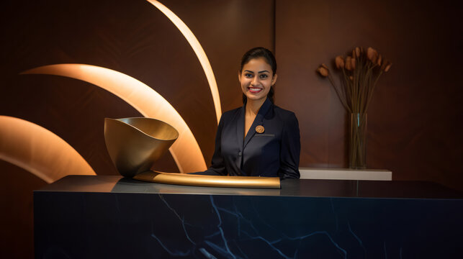

Training Notes: As many of you know, we recently received some negative guest feedback regarding the cleanliness of our hotel rooms. As floor housekeeping manager, it is my duty to immediately address these concerns; thus I devised this training presentation reviewing standards and procedures so we can deliver outstanding services our guests demand and deserve. My goals include upholding brand standards while adhering to health and safety guidelines; motivating housekeeping team; as well as creating exceptional guest experiences.
With renewed focus and teamwork, I know we can achieve success together. Thank you for dedicating your time and dedication towards excellence - let's make this year incredible!




Training Notes: raining Notes: Our brand stands for luxury, attention to detail and anticipating our guests' every need; therefore our housekeeping services must always exceed expectations. Key standards to keep in mind include cleaning, sanitizing and freeing all surfaces from dust and debris. Bathrooms must be impeccable with tiles, mirrors, showers and toilets all shining clean; beds must also feature immaculate bedding that remains wrinkle-free and smooth. Floors should be vacuumed wall-to-wall and mopped thoroughly; furniture should be polished, arranged neatly, amenities replenished as necessary and any maintenance issues reported immediately; garbage/recycling bins emptied and relined. We should take pride in the impeccable care given to every room by working as a team to uphold these standards.

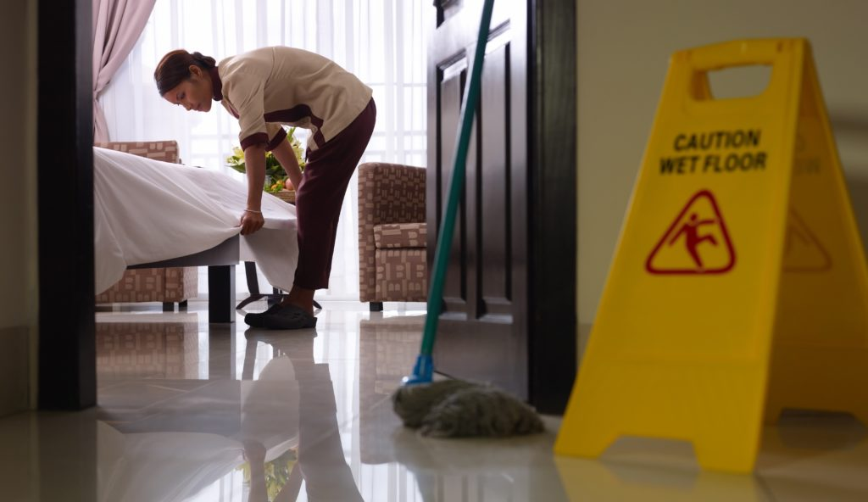

Training Notes: At all times, we must abide by all health and safety procedures to protect both guests and ourselves. Key areas include using PPE such as gloves, masks and goggles when necessary; employing safe lifting/bending practices in order to avoid injury; understanding evacuation and emergency procedures in detail; regularly washing hands to sanitize surfaces as required; immediately reporting any hazards to their supervisor; disposing trash/waste properly in designated bins; as well as keeping our janitorial closets organized - there can be no shortcuts when it comes to health & safety! Taking all necessary measures every day is vitally important!


Training Notes: Delivering outstanding service relies heavily on effective teamwork and communication among employees. Each of us contributes something unique towards the guest experiences we create, so fostering effective dialogue among team members and working collaboratively as teams is of utmost importance! Likewise, keeping lines of communication open between members is imperative! Keeping all these moving parts working harmoniously as one is key!




Training Notes: Time and resource management is essential to meeting brand standards consistently across rooms and floors. Strategies to promote efficiency may include: Prep carts carefully so they contain all needed supplies and tools; arrange each day's room assignments efficiently; use checklists to ensure tasks are completed on time; report maintenance issues immediately to avoid delays; restock carts and closets at the end of every shift, review schedules and staffing needs proactively, ask for help when you fall behind if needed, strive to complete rooms before next check-in, identify opportunities to enhance systems and processes and identify improvements that can improve productivity - let's work smarter, not harder; monitoring time and productivity will help us reach our goals

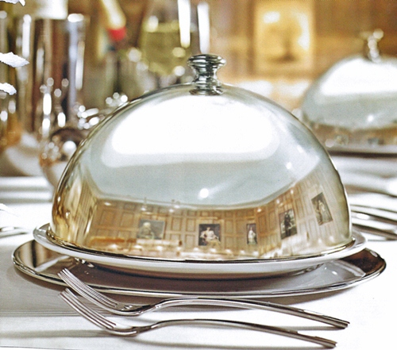

Training Notes: At our resorts, it is of utmost importance that we implement effective measures to guarantee high-quality work and guest satisfaction. To this end, our procedures involve supervisors conducting room inspections using a detailed checklist; regularly reviewing guest satisfaction scores and comments; holding monthly audits to ensure staff adhere to standards; offering additional training as necessary to address gaps or issues; certifying new hires both classroom and on-the-floor; documenting issues thoroughly prior to taking corrective actions where applicable and directly soliciting guest feedback whenever possible; documenting issues thoroughly prior to taking corrective actions where applicable and sharing positive reviews or success stories among team members - these steps ensure we will always maintain the highest standards.

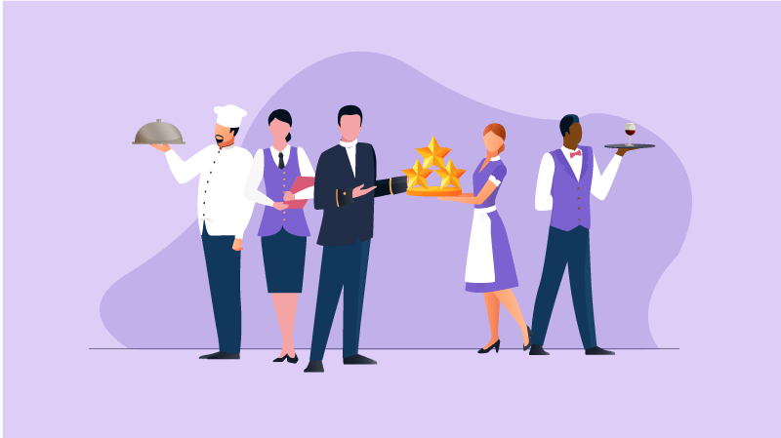

Training Notes: My goal is to ensure our team feels motivated, valued, and recognized for all of the hard work you are contributing. To this end, I will host regular one-on-one meetings to review progress; celebrate individual and team accomplishments; send thank you notes when exceptional efforts have been noted; offer training opportunities as necessary for staff advancement; promote good health and wellness practices through team building activities; solicit feedback regarding morale/satisfaction ratings/guest comments as appropriate; thank you all for making our hotel what it is today - your contributions are much appreciated; thank you all a part in its success; thank you all a part in its success; your efforts are greatly appreciated! Thank you all a part in its success; your efforts are greatly appreciated! Thank you all a part in its success - your efforts are greatly appreciated! Thank you all a part in its success; thanking all involved. Thanking all involved; thanking you all involved! Thanking all involved; thanking those responsible.



Training Notes: At times we may come across unsatisfied or difficult guests. Here are some strategies for handling stressful interactions: actively listen and empathize with their concerns; take ownership rather than assign blame elsewhere; remain calm and professional during conversations and actions; focus on finding root cause instead of defending oneself; involve supervisor if situation escalates further; follow-up personally once issue resolved or debrief colleagues after incident occurs; report harassment/threats immediately etc. Handling challenges professionally is key to maintaining our reputation; don't feel unsafe - seek assistance if needed



Training Notes: We welcome your input on how we can continually enhance housekeeping services, from processes or training. Please share ideas openly about better processes or training - any roadblocks or frustrations impacting your work could be resolved with better tools, technology or resources; job making easier, safer and more efficient would also be greatly appreciated; what other departments could assist in providing exceptional service more efficiently; goals we should set out in coming months... Your contribution is essential in elevating guest experiences - I welcome any conversations or ideas regarding ways we could continue enhancing them - my door is always open!
Excellence in housekeeping means adhering to rigorous brand standards, adhering to health and safety practices with diligence, providing personalized, exceptional service, cultivating strong communication among team members and encouraging strong teamwork between team members. Furthermore, excellence means creating an uplifting work environment while upholding quality standards while professionally meeting challenges - this allows us to give our guests exceptional experiences! I truly appreciate all your hard work; together we can give them unforgettable ones. Thank you so much!

References
- Abbasi, G.A., Malik, S.A., Chaudhry, I.S. and Imdadullah, M. (2011) ‘A Study on the Role of Punishment and Reward towards Organizational Performance: Public vs. Private Organizations of Pakistan’, European Journal of Economics, Finance and Administrative Sciences, (29), pp.110-116.
- Gundersen, M.G., Heide, M. and Olsson, U.H. (1996) ‘Hotel guest satisfaction among business travelers: what are the important factors?’, The Cornell Hotel and Restaurant Administration Quarterly, 37(2), pp. 72-81.
- Kappa, M., Nitschke, A. and Schappert, P. (1997) ‘Cleaning Standards, Procedures and Methods’, in Rutherford, D.G. (ed.) Hotel Management and Operations. New York: Van Nostrand Reinhold, pp.343–356.
- Ninemeier, J.D. and Perdue, J. (2008) Hospitality Operations: Careers in the World’s Greatest Industry. Upper Saddle River, NJ: Pearson Prentice Hall.
- Sharpe, E.K. (2013) ‘Theories and Theory Use in Studies of Hotel Housekeeping and Cleaning’, International Journal of Hospitality & Tourism Administration, 14(3), pp. 282-302.
- Uniform System of Accounts for the Lodging Industry (2014), 11th edn. Lansing, MI: Educational Institute of the American Hotel & Lodging Association.

