
Skills for the Workplace
Module Assignment Submission
Student Name: | DONNA DYER
Student Number: | 2000181
Module No: | BMSK4007
Module Title: | Digital Skills and Personal Branding

Statement of Confirmation of Authenticity
By the act of making this submission, the student declares that this is the work of the student named above. The work has not, in whole or in part, been knowingly presented elsewhere for assessment, or where assessment has been built on a previous assessment, this has been identified. Where materials have been used from other sources it has been properly acknowledged. If this statement is untrue, the student acknowledges that an assessment offence has been committed.
Attention is drawn to the plagiarism and unfair practice policies of both the University and of ILM.
Permission for ILM to use this script
ILM uses learners’ submissions – on an anonymous basis – for assessment standardisation. By submitting, both the centre and the learner agree that ILM may use this script on condition that identifying information is removed. However, if you are unwilling to allow ILM use this script, please refuse by ticking the box: □

Table of Contents
What has been the impact of 21st Century Technologies on the modern workplace? 3
Evaluate the appropriate use of modern technologies and social media in the workplace generally 3
Explore the use of modern technologies and social media in own workplace 4
How can Personal branding help YOU? 5
Your LinkedIn Profile to promote your Personal Brand 5
Evaluate the value of other social media platforms to enhance networking and career prospects 5
Examine the impact of Personal Branding on your own employability 6
Discuss personal and professional security and safety online. 6
References 8
Appendix 1 8
Appendix 2 9

What has been the impact of 21st Century Technologies on the modern workplace?
The workplace is a very different place to what it used to be 30 years ago or more. “From the introduction of technology and tools, to the rising trend of remote working, the modern office has adapted in a number of ways to cater for changes in employees’ needs and working styles”. (Dukes.E 2016).
The workplace has changed dramatically from 20th Century to the 21st Century. Many Companies had found it difficult to keep up with the change and therefore found it hard to survive, leading businesses to become extinct. With modern technology we now have access to the internet we can find out anything we need to know by researching online. We also have the use of emails which is a more faster and convenient way of communication.

Evaluate the appropriate use of modern technologies and social media in the workplace general
The appropriate use of modern technology in the workplace is a major part of your business becoming successful. In 1990 World Wide Web (www) was invented which allowed customers to browse and purchase items online. In 1997 the first social media site was created “Six Degrees” users were able to upload their profile picture and connect with friends. In 2004, a group of friends at college created an innovative new social media of connecting Havard students through an online community. Fourteen years later Facebook was invented which took over the World, with approximately 2.2 billion monthly users. By 2006 people from all over the World were able to connect with Facebook. Technology has helped us to have a faster and more convenient way of communication. In 2010 Adobe created cloud . Business people from all over the World can now communicate with their business partners via virtual online meetings, they also have the use of skype where they are able to see and talk to the other person. Modern technology has also made a way of shopping more convenient as you can now order via click and collect throughout stores, we also benefit from doing our grocery shopping online and it being delivered to our home. Petrol stations now have pay at pumps with your bank card, therefore everything is so much easier and more convenient. We are now able to have online banking and bank transfer, it is a faster way on managing your bank account and making payments, we are able to use these facilities by simply downloading an app on our smartphone or laptop. Another new invention which become popular was the electronic cigarette (Ecig). “The WHO report on the global eperdemic 2019. The report finds that more countries have implemented tobacco control policies ranging from graphic warnings and advertising bans to no smoking areas”. (Geneva:WHO;2011).
Education has also become easier, you can research information on line for anything you want to learn about. Educational text books has now been replaced with tablets and laptops. Due to Covid 19 pandemic children and students are able to do school work online by using their laptops, children are still getting their education and university students are still able to do their course work.

Explore the use of modern technologies and social media in own workplace
Technology in my workplace as a Carer has helped with the task of helping patients with their education as we can now click a remote connection to the hospital wide education network. Modern day nursing is more efficient as we now have monitors which allows us to check on patients whilst doing other tasks. Hospitals now have IV Smart pumps which are a more accurate and efficient way of administrating medication. The smart beds in hospitals can now monitor a patients weight and also helps move a patient to prevent bedsores. Computers have made life so much easier for nurses as it is a much quicker and more efficient way of keeping up with patients records, they can obtain all patients appointments, scans, bloods and many different results. Technology has helped patients tremendously as they now have use of laptops or smartphone to communicate with their friends and family on social media, they can Facetime to speak face to face, of have Facebook to message their friends. Due to the Covid 19 pandemic, modern technology has made life so much easier for the individual, especially those suffering with mental health, not having their family visiting is a major impact on their wellbeing. Workplace aspects can play a crucial role in moderating or worsening mental health of people facing this pandemic scenario.

How can Personal branding help YOU?
Personal branding is extremely important for people to get an excellent first impression of yourself, it is a combination of your skills and your experiences, it is how you present yourself to an employer. Personal branding will differentiate you, and also help build trust with employers/clients. Your strengths and talents are what employers look for. You should give as much information about yourself as possible, your strengths, talents and commitment.

Your LinkedIn Profile to promote your Personal Brand
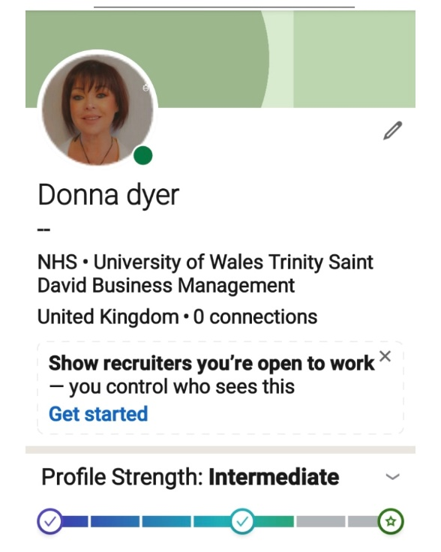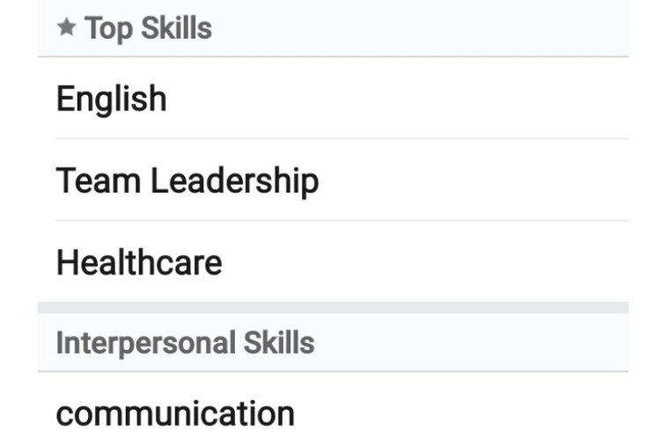
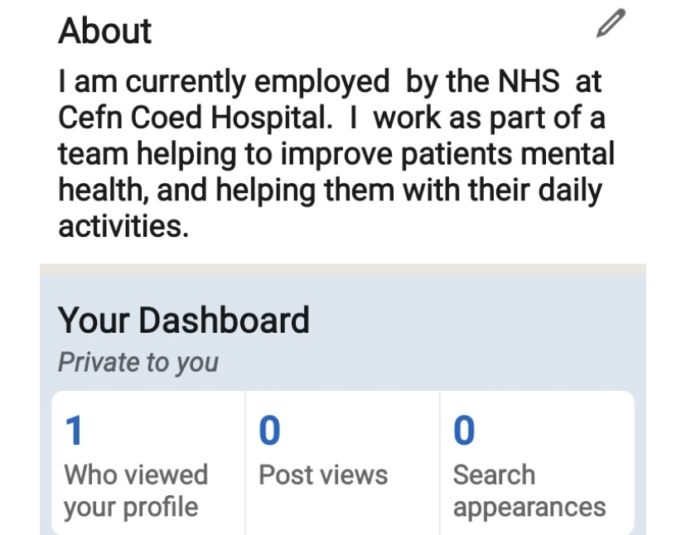

Evaluate the value of other social media platforms to enhance networking and career prospects
There are many different social media sites being used, the most popular sites being used are:
Facebook:
Facebook is a networking site where you can connect with friends from around the World. You can choose to keep your profile private so only certain people can see it, you have setting options to keep your profile public or private. People also sell and advertise on Facebook and you can also promote your business. It’s a great way of putting your business out there just by adding may be pictures and sharing them with family and friends You can also share photos and videos with friends or even call them using facetime. Facebook claims over three quarters of a billion people have joined their networking site.
Twitter:
Twitter is a social media site which allow people to connect with others and share their thoughts known as “tweets”. It is a great networking platform and a great starting point to build your business. Famous people posts tweets to inform their fans on new music releases and gigs. You have to be a registered user to be able to post tweets, but if you are not registered you can still browse.
Instagram:
Instagram is a social media site where you can take edit and share videos. It is entirely a visual programme. You can choose whether you want your account to be private or make it public. You can follow your friends and family. When sharing photos you can edit them by using filters to get a unique look, you can also share your photo/ video to your other accounts like Facebook and Twitter. Instagram is also good for promoting your business as your followers can become your customers.
Linkedin:
Linkedin ia a social media site which was created over sixteen years ago, when it was launched it was for recruiters to list jobs and for individuals to create a profile to promote themselves in finding employment. Linkedin has been the been the most successful business platform in the world.
By creating your profile, it is beneficial to the employer, as they can determine if you are the suitable candidate for what they are looking.
Creating my Linked in profile as a Psychiatric carer, working for NHS at Cefn Coed Hospital and describing myself, helps the employer decide if he thinks that I would be the right person for the vacancy.

Examine the impact of Personal Branding on your own employability

Creating an effective personal brand is important to decide what first impression you wish to give to recruiters. You need to show them what you have achieved and what you have to offer. It is vital to show them your strengths and skills, and your goals and aspirations, and what type of personality you have, as this is what they are looking for. When you create a profile make sure you have privacy settings on, and always choose a professional photo of yourself. Sometimes recruiters can check on your other social media profiles, therefore be selective and only keep appropriate photos. Be careful when posting and don’t be critical too others, you need to prove that you reach the expectations of what they are looking for.

Discuss personal and professional security and safety online.
Personal and professional security is so important when online. When using your personal profile for example, employers do not need to know your relationship status, or your home address, they have ways of contacting you via email or private message.
When using online banking you must always make sure you use a VPN (virtual private network) so that you know you have a secure connection. Passwords are extremely important, most people tend to use their date of birth, or a simple number or name, remember to use a strong password so that it is not easy for hackers to have access to your account. Set up alerts especially on financial accounts.
When purchasing online always check the site that you are using is secure this is so important.
It is strongly recommended that all software is up to date, and that your computer has anti virus and spyware software so that it is protected.
GDPR is a data protection, these days everything is tracked, more and more of our personal information is stored and collected. Companies hold details of your contact details, race and even your computer. Nowadays they need to prove they have a lawful reason for holding a persons data, and need to show that it is protected and safe.

References
Baiju,N.T.(2018).five advantages and disadvantages of using cloud storage. Available at:
https://bigdata-madesimple.com/5-advantages-and-disadvantages-of-cloud-storage/
Dukes, E. (2016)
Available at:
http://iofficecorp.com/blog/4-ways-technology-has-changed-the-modern-workplace(Accessed 11 March 2016)
Doraszelski,U.& Jaumandreu.j.(2018).Measuring the Bias of Technology change.Journal of Political
Economy.126(3)
Geneva:WHO;(2011)
Available at:
http://whoint/tobacco/global_report/en(Google Scholar)

Information Commisioner’s Office.(2018) Guide to the UK General Data Protection Regulations(UKGDPR).
Available at :https://ico.org.uk/for-organisations/guide-to-data-protection/guide-to-the-general-data-protection-regulations-gdpr/
Morgan,P.(2017).The Business Student’s Guide to Study and Employability. London:SAGE.
Vodnik,s(2018)how to include your publications in your linkedin profile
https://blog.taaonline.net/2018/03/how-to-include-your-publications-in-your-linkedin-profile/

Appendix 1

Appendix 2

