principles of Health and social care
Student name: Ana Maria Elena Stanciu Student number: 1909953
Lecturer: Magdalena Wronska

Table of Contents
Introduction 2
Description 2
Analysis 5
Evaluation 5
Recommendations 7
Conclusion 8
Reference list 8

Introduction

According to Alzheimer's society (2017), Alzheimer is a disorder that can inflict brain traumas subsequently resulting in dementia, however, Alzheimer is the most popular factor but not the only one. For instance, a succession of strokes can also result in dementia. This report seeks to illustrate, present, analyse, evaluate and provide suggestions for principles of assistance within the health and social care for an 85-year-old couple suffering from progressive dementia and other chronic conditions. Mr and Mrs T, always been autonomous have agreed that they want maintenance since Mrs T has recently suffered a medical procedure and has complications with mobility. Essentially the couple is looking at some assistance with hose tasks, improve her mobility, personal care and any social occasions that will enable them to live independently for as long as possible.

Description

The signs of dementia relying on the type of the lines and what fraction of the brain is affected, therefore, each individual will endure dementia in their distinctive manner. However, signs of dementia can consist of:
Remembrance- an individual that suffers from dementia can forget names can get lost in familiar locations or/and experience difficulties retaining new information.
Cognitive capacity in refining information- besides affecting their engagement, people with dementia may have troubles with the time and place as well as the capacity to make decisions.
Communication- sometimes people with dementia tend to repeat themselves, reading and writing can become challenging as well as finding the right words. Yet another important aspect of dementia is that people can suffer attitude modifications, manner swings, uncertainty and depression. They are different types of dementia as it has already been said in the introduction, Alzheimer is the most popular type of dementia in the UK. (Dementia UK, 2018). The second greatly popular type is vascular dementia, inflicted by strokes which affect rooms of localised cell blockade in the brain.
Frontotemporal dementia is a progressive disorder and inclines to perturb people aged 45 years to 65 years and affects the frontal and temporal lobes of the brain.
Dementia with Lewy bodies is also a progressive disorder and usually affects motions and motor management rather than memory loss.
Bolton, S.C. and Wibberley, G. (2014), asserted that hired care employees that visit the houses of elderly people to support with private routine, house chores and other necessities are defined as domiciliary carers. Over the past twenty years, it has been an improvement in the delivery of domiciliary supervision which has been coordinated conform demand standards and depicted as the favourable category of legal supervision; saving money to local authorities and grant autonomy for elders.
Helping Hands is a family-owned and supervised organisation that works with over 90 departments nationwide since 1989, fully supervised by the Care Quality Commission (CQC) and Care Inspectorate Wales (CIW). Because they are enrolled, authorized and governed with the CQC and CIW they deliver full-service home care, managing and supporting the patient from beginning to end with strict regular checks on the carers and the caregiving. Yet every available care employee is hired literally by the Helping Hands benefiting from carer training in line with the UK Care Certificate, acknowledged by the CQC, personal manager, instructor, dementia care specialists and clinical specials, accessible 24/7, somebody to go to with questions or personal additional assistance. Perceived as the UK’s main domiciliary care providers.
Helping Hands will be the adequate home care provider to assist Mrs and Mr T in finding a local branch to support them with their needs, they will take the couple step by step through the necessary information to establish a personal assistance plan established on their everyday routine and what is essential for them. Also, even if Mrs and Ms T do not have advanced dementia, they, however, have progressive dementia which requires special supervision. Helping Hands furnish trained carers and administrators who have obtained the essential training and examination to outstanding principles, entirely legislated throughout the Care Quality Commission and authorized as a Centre of Excellence.
Skills for care authorization is the custom integrity dent, provided to the good understanding and improvement providers within the adult social care area and ingrains the following:
- Civil examination
- Framework
- National Occupational and Health Standards for Learning and Development
- Administration Qualities Framework
Moreover, they perform nearly with the University of Worcester, Dementia UK, and Dementia Congress.
They are fully accountable for how they govern Privacy Policy under the General Data Protection Regulation (GDPR) which correlates to any UK or European resident.
Their Data Protection Officer ensures and monitors the data processing activities collected is:
- Used legally, relatively and in a translucent means
- Pertinent and for intentions that the client is told the data is for
- Precise and up to date
- Saved just for as long as is required
- Maintained securely
To meet the cost of the client care they also have the immediate needs annuity policy, which is an insurance policy that guarantees a regular income, and it can include:
- Immediate care allowance
- Allowance for residence maintenance expenses
- Instantaneous maintenance schemes
- An immediate need for care allowance
- A long-term maintenance allowances
The cost of the plan is determined by several factors such as:
- The necessary monthly fee the client needs
- Young gender, the client gender and their health conditions
- The client medical record
The payment plan is made around each other needs; therefore, it is not a fixed plan.
Complaints, compliments, whistleblowing and comments policy. The service user has to contact the organisation on the contact details given in the Support Plan or emailing to their email address if the complaint is about a care worker and a manager will investigate the concerns. If the problem is not worked out in phase one, the case will be appointed to a senior manager and if that has not been solved the problem the service user can reach the Local Government Ombudsman who will yet investigate the problem unassisted for the client.
Tomkotowicz, S. (2011) publishes that in September they will update a supervision planning legislation which will deliver an extraordinary connection crossing the space between providers of care and economic assistance. Furthermore, they will publish several ambitions supporting those glancing at care allo
wance.
Yet Tomkotowicz, S. (2016) again published that the EU Referendum will not have an unexpected influence on Helping Hands employment pursuing the United Kingdom Homecare Association acknowledgement to the EU referendum.

Analysis

Overall Helping Hands seem to have the best care program for Mrs and Ms T, providing professional care workers with 24/7 supervision and attendance. Nevertheless, The Health and Social Care Act 2008, is a code of practice that refers to preventing infection by maintaining a clean, prudent and antimicrobial environment for people who are using the services of health and social care. Care Quality Commission (CQC) have the responsibility to assure that the care people receive, meets the fundamental standards of quality and safety (Department of Health, 2015). Helping Hands appears to be CQC regulated which it means that they do indeed respect the Code of Practice, however, they do not provide health and safety policy at all. According to the Health and Safety Executive (2014), social care is about people, practically people care for a helpless people, therefore, workers possess the right to function in a healthy and save work situation, while patients should acquire safe care and accepts their wishes, independence and importance into the record under the Health and Safety Work etc Act 1974 and Management of Health and Safety at Work Regulations 1999.
Yet there is not work and safety regulations on their website either.

Evaluation

Human existence background is composed of people and persons. The word ‘person’ arrives from the Greek term ‘persona’ or ‘mask’ and offers a surge to the English term for ‘personality’. The term mask or persona granted individuality in Greek acting; and the narrative strategy to emotional occurrence indicates that people experience themselves as individuals who take verdicts and create options that indicate their individualities as the writers of their tale (McAdams, D.P, 2015).
Person-centred care has not a single agreed description because is nevertheless, a developing and growing sector and also because individual supervision relies on the person requires which are not certainly identical for everyone and people demands may alter once the illness has progressed, however, is utilized to apply to numerous principals and activities.
The Health Foundation (2016) has named a framework that includes four principals of person-centred care such as:
- Allow people importance, attention and admiration
- Giving coordinate supervision, assistance or therapy
- Giving personalised supervision, assistance or therapy as it is illustrated in Figure 1.

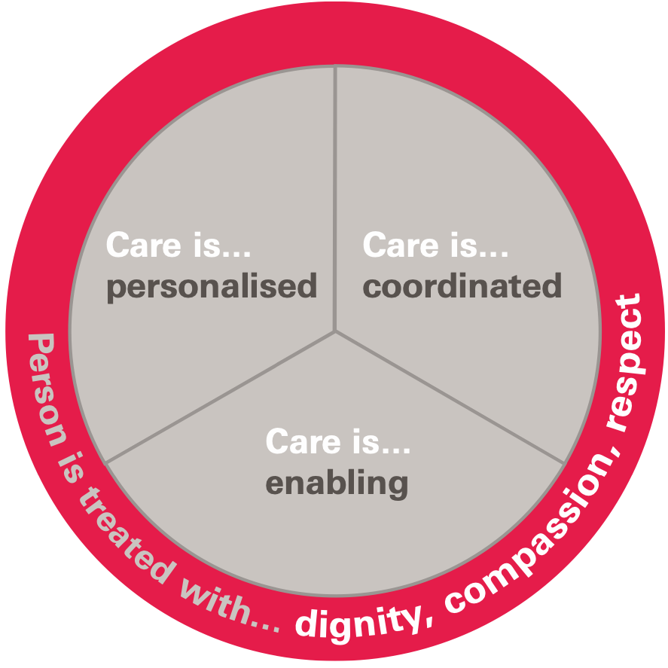
Figure 1. Source: The Health Foundation (2016).

Person-centred care is a recent theory utilized in health and social care therefore, it may come across as:
- Patient-centred supervision
- Personalisation
- Relationship-centred supervision
- Mutuality (usually in Scotland)

Person-centred care is important financially because care should depict value for money which guarantees that assistance is created on the necessities and intentions of users, rather than on the comfort of providers. Yet, care that is person-centred it is important for the patients being encouraged and supported on their independence and also for the care workers because as the patient engagement increases, staff performance and confidence discern a complementary improvement.
Helping Hands seems to have professional staff fully acknowledged about person-centred care, giving by their qualifications and skills which is the best care that Mrs and Ms T can get since they still want to retain their independence as much possible. Moreover, the psychologist Carl Rogers was the first person who used person-centred care concerning psychotherapy in the early 1060s and used client-centred in the early 1950s.

Recommendations

There is a chronological indication that domiciliary supervision is vastly frequent delivered to elders with dementia and that is addressed to those who are most degraded (Challis, D. et.al., 2010).
Choosing domiciliary supervision when suffering from dementia seems to be the best option because the carers can care for longer, enable patients to stay at home for as long as possible, waiting for a place and formalities that home care requires and also can cost less than going into home care. Therefore, Mrs and Ms T are making the right choice by requiring domiciliary care, because they both suffering from dementia it will be in their best interest to have a family member either enquiring for them or helping them to do so.
Regarding the code of practice that refers to the prevention of infections Helping Hands should update The Health and Social Care Act 2008 on their website too since people are really worried, especially nowadays living in a world with the rising rate of infections. Similarly, the Health and Safety Work Act 1974 is missing from their policy and it should be updated to show that they care about their staff working in a safe environment.
Again, in 2011 they said (on their website) that in September coming, a new supervision planning legislation will be updated, which never happened. The same with the Referendum influence on staff never been updated since 2016. They seem to have a major problem with updating their website which is crucial for the service user and also for them as a company. The world population is seven billion of which two billion are internet users according to the Internet World Stats. The Internet represents an enlarged position in jobs and business, whether is about data or message it pertains to this technological creation. And yet it can bring tremendous prospect in the advancement of a business (Apavaloaie, E.I. 2014). That's why is extremely important for a company to have a website up to date.
Social care is indeed about caring for vulnerable people; therefore, it is all about people and their needs. Either Helping Hands or any care home in the UK they have a huge amount of information on their staff qualification, skills, tones of definitions of all the illness that they provide care for that is very helpful, but no one talks about staff experience, depict a normal day of caring for vulnerable, confide a story, highlighting accomplishments of specific care workers or concentrate in their enthusiasm for care. When people think about home care they think about enclosed space with strangers, therefore, building a website a little different than the standard people would feel better about the place or opening their does to a total stranger, they would feel more comfortable and not so far from the family hood.

Conclusion

Finally, the lifecycle procedure solidifies defencelessness and elasticity in older people which means that they get old age illness, and they need support. Health and social care are a sector build to help and support those people. Helping dos not refer only to do chores for people because you get paid for it, it means compassion, sympathy, respect and dignity and a social care provider should be able to retain those skills to deliver optimal care for vulnerable. Also, social care practice should ensure that their staff retain and deliver optimal care.

Reference list

- Alzheimer’s Society (2017) What is dementia? Available at: https://www.alzheimers.org.uk/sites/default/files/pdf/what_is_dementia.pdf (Accessed: 20 December 2020).
- Apavaloaie, E.I. (2014) ‘The Impact of the Internet on the Business Environment’, Procedia Economics and Finance, 15, pp. 951-958.
- Bolton, S.C. and Wibberley, G. (2014) ‘Domiciliary Care: The Formal and Informal Labour Process’, Sociology Journal, 48(4), pp. 663-681.
- Challis, D. et.al. (2010) Community Support Services for People with Dementia: The Relative Costs and Benefits of Specialist and Generic Domiciliary Care Services. Available at: https://www.housinglin.org.uk/_assets/Resources/Housing/Support_materials/Other_reports_and_guidance/Dementia_and_domiciliary_care_-_PSSRU_full_report.pdf (Accessed 23 December 2020).
- Dementia UK (2018) What is dementia? Available at:https://www.dementiauk.org/wp-content/uploads/2018/07/What-is-dementia-WEB-June-2018.pdf (Accessed: 20 December 2020).
- Department of Health (2015) The Health and Social Care Act 2008. Available at: https://assets.publishing.service.gov.uk/government/uploads/system/uploads/attachment_data/file/400105/code_of_practice_14_Jan_15.pdf (Accessed: 21 December 2020).
- Golaz, V., Wandera, S.O. and Rutaremwa, G. (2015) ‘Understanding the vulnerability of older adults: Extent of and breaches in support systems in Uganda’, Cambridge University Press, pp. 1-27.
- Helping Hands (1989) Person-centred, fully managed home care for total peace of mind. Available at: https://www.helpinghandshomecare.co.uk/about-us/ (Accessed: 21 December 2020).
- Health and Safety Executive (2014) Health and safety in care homes. Available at: https://www.hse.gov.uk/pUbns/priced/hsg220.pdf (Accessed: 22 December 2020).
- McAdams, D.P, (2015) The Art and Science of Personality Development. Guilford: Guilford Press
- The Health Foundation (2016) Person-centred care made simple What everyone should know about person-centred care. Available at: https://www.health.org.uk/sites/default/files/PersonCentredCareMadeSimple.pdf (Accessed: 23 December 2020).
- Skillsforcare (2020) Skills for Care Endorsement. Available ay: https://www.skillsforcare.org.uk/Learning-development/Endorsement/Endorsement.aspx (Accessed: 23 December 2020).

