HR： Resilience, Talent and Technology

Paper 1: Working from home during Covid-19: an overview

In 2019, a sudden virus changed many people's lives and worked. Governments around the world are asking staff to work from home in an effort to ease the burden on hospitals caused by the rapid spread of the coronavirus. Working from home (WFH) is an effective policy to reduce the spread of coronavirus disease and maintain production and employment during workplace closures (Arruda, 2020). Before coronavirus, working from home was considered not wanting to work. Before 2020, studies have shown that the productivity of working from home decreased by 12% compared with those who work in professional workplaces (Harrington, and Emanuel, 2020). Before the pandemic, some researchers' discussions about how to work in the future were unclear. However, the emergence of coronavirus has forced a decision. With the emergence of policies requiring home isolation by local governments, many enterprises have begun to implement home working (Vyas & Butakhieo,2021). In May 2020, 50 per cent of Americans worked from home, more than 8.2 per cent in February (Bick, Blandin, and Mertens 2020). In the UK, only 5.7% of the population worked from home in February. However, it was 43.1% by April, an eightfold increase (Felstead & Reuschke, 2020). The data showed that many people had to working from home because of the pandemic. This changed the attitude of many people towards WFH (working from home). This change in attitude also prompts more companies to offer employees more opportunities to work from home (Barrero, Bloom, and Davis, 2020). It is impossible to know whether working from home will be widely used in the future. However, surveys show that some managers expect employees to work more than three days a week in the company. Because managers believe that working in a company can support employees' innovation, motivate employees to work better, increase the cohesion between employees and the company and strengthen the company culture (Barrero, Bloom, and Davis, 2020).

Working from home was first defined as "telecommuting" or "telework". Nilles proposed it in 1973 (Vyas & Butakhieo, 2021). For the past four decades, WFH has been defined as an alternative work arrangement where employees work in flexible workplaces. It refers to people working at home and through network technology (Gajendran and Harrison, 2007). Afrianty et al. (2021) believe that working from home refers to the free choice of time at working at home. This arrangement is considered another form of work. Because WFH gives employees more freedom in terms of time, they can arrange their work and save employees commuting time. Deole et al. (2021) argue that WFH can be described as a principal-agent problem. The employee is the agent, and the employer is the principal. The link is that the employer pays fees to the employee whom to do the work. The employee does not have a strong sense of identity and contribution to the value of the company. The most immediate impact of WFH is that it gives employees more rights over their working hours and pace.

The January data from Global Report (Figure 1) shows that working from home is inefficient, especially when people are dissatisfied with their working experience at home, their work performance will decline.
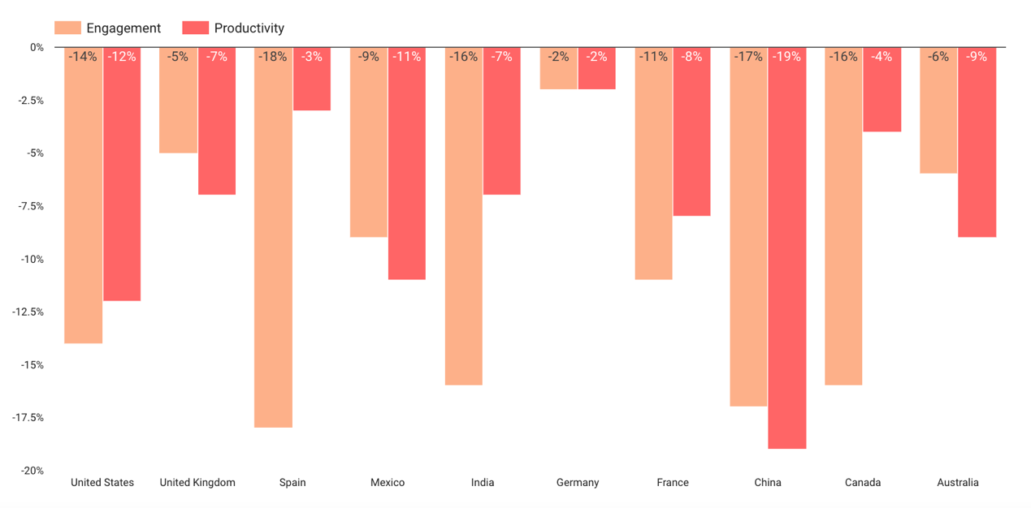
figure 1

Before coronavirus, WFH was considered a win-win approach. From an employer's perspective, offering WFH can attract and retain highly skilled employees, improve employee time utilisation, and solve the complexity of workflow (Afrianty, 2021).

However, the following two figures show that working from home has its benefits and challenges. Here are the employees in China and the UK thinking. These are the top three things.
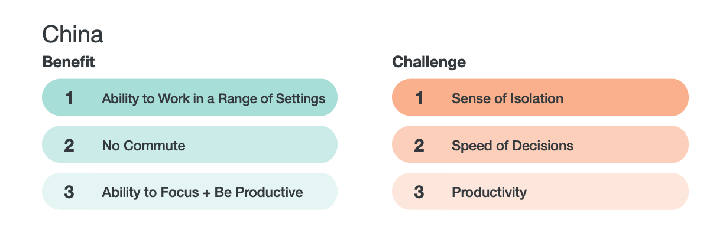
Figure 2
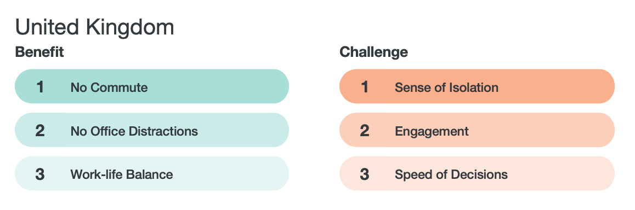
Figure 3

According to the above data, the most significant benefit of WFH is to reduce the commuting time and focus on their work. They could give more time to their family. Moreover, there are fewer office politics. Some studies have shown that working from home can reduce employee turnover and increase efficiency (Afrianty, 2021). WFH aslo allows employees to be more relaxed and have more freedom in their time.

However, WFH has many disadvantages. For example, the highest-ranking in both countries is loneliness. It is an important cause of loneliness for single people who have no one at home to talk to face to face. On the other hand, working from home presents many challenges for managers. For example, how to supervise employees, improve work efficiency, and whether the quality of training can be guaranteed. In terms of technology, how to get in touch with employees in a better and faster way and assign their respective tasks or group tasks (Afrianty, 2021). Whether WFH affects employee performance and efficiency has been studied in the past. After conducting WFH experiments on Chinese call centre personnel. The results showed a 13% increase in the performance of WFH employees. Of those, 9 per cent said their work environment has become quieter and more convenient. Another 4 per cent have fewer breaks because they work longer hours each day. Data are also available on the performance of UK workers during the pandemic. It found that employees working from home are more effective (Deole, et al, 2021). As the pandemic has changed the lives and work of many people, it has also led to changes in the labour market structure. Therefore, whether WFH is reasonable or not is very important to managers. WFH has both positive and negative effects on employee performance. Employees' familiarity with the whole WFH process, their mastery of WFH technology, their different living conditions, and the influence of family members. All these are related to the smooth implementation of WFH in the future (Deole, et al, 2021).

In the post-coronavirus era, it is becoming increasingly clear that working from home is not the right solution for everyone, nor is it ideal for every organisation/enterprise. Therefore, whether to use WFH needs to be considered in advance. Especially in terms of the practicality of employers and employees. Both the advantages and disadvantages of WHF need to be considered. In particular, managers need to evaluate whether the work efficiency of employees is increased or decreased.

Paper 2: The efficiency of employees working from home
1. background
As a way of work, WFH is bound to have an impact on the working efficiency of employees, this paper will discuss the pros and cons of WFH and the efficiency of employees working from home. The framework of the study is to analyse some factors affecting WFH. First, organisational/company and individual/family factors are linked to WFH efficiency in this framework. To study how these two factors affect the efficiency of WFH. Secondly, to explore the impact of companies and families on WFH, which focus on their specific causes. Finally, the pros and cons of the impact of work and family on WFH.
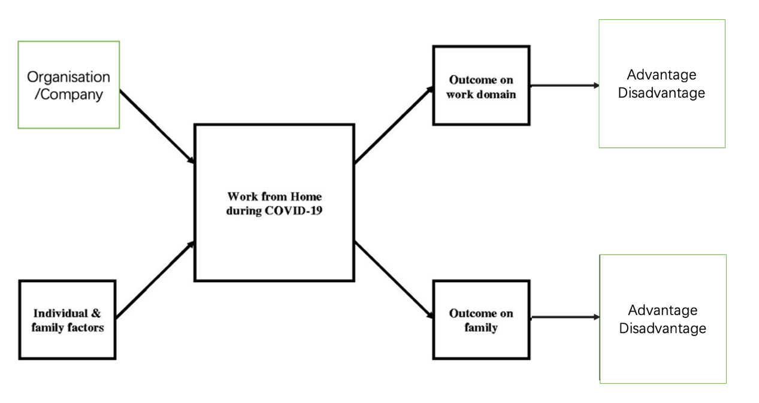
Figure 2: framework
Several factors influence a company/organisation's ability to working from home. Companies and organisations are implementing WFH due to COVID-19. Therefore, under the government policy, the way is carried out smoothly. In other aspects, the company's investment in WFH-related equipment, IT technology, human resource support, and corresponding training and communication are all reasons that affect employees' working from home (Baker et al., 2007). Moreover, other factors, for example, employee’s welfare, employees’ promotion, managers have trust in their employees. These are closely related to WFH (Vyas & Butakhieo, 2021). Previous studies have shown that WFH is affected by companies and by "individuals and families" (Baker et al.,2007). First, it is the ability of individuals to "discipline", "self-motivation", " stay alone ", and "time management" (Baruch, 2000). WFH still has not had a mature regulatory system, so the individual drive has a huge impact on WFH's efficiency. Studies have shown that the number of days employees work from home and their hours in the office can impact families. Since WFH has no fixed time, it is easy to affect life without a sense of boundary with family (Kossek et al. 2006). However, the living environment, the number of family members and even the age of children are all essential factors affecting WFH (Baker et al. 2007). In addition, an individual's workspace and quietness at home are factors that affect WFH efficiency.

2. Advantages of employees working from home
Company：
Firstly, during COVID-19, WFH can effectively protect employee health and prevent companies from getting into trouble (Alipour et al., 2021). Secondly, rent is rising day by day. WFH can reduce the cost of office rent. Moreover, WFH can reduce the rate of talent turnover because WFH has free time and relatively loose supervision, giving employees sufficient space. WFH will make employees feel trusted, and their work will be more positive (Bloom et al. 2013, Bao et al. 2020). Previous studies have shown that WFH can help some special people find jobs. For example, people with disabilities, transgender people, and housewives (Bao et al. 2020). Reducing commuting time saves employees time to do more work or take care of their families, enabling employees to achieve a better work-life balance (Bloom et al., 2013). Finally, WFH allows employees to focus more on their work without being disturbed by colleagues.

Family:
According to previous studies, WFH is associated with family and life satisfaction (Vyas, L. & Butakhieo, N. 2021). Because of WFH, employees spend less time commuting and putting on makeup. This extra time allows employees to engage in more activities, for example, family care and child companionship. WFH enables employees to better responsibilities on work-family balance (Sabrina P. &Victoria v. 2021). Even more, employees can start spending time on things that they enjoy or relax. Such as watching TV, sleeping, fitness, painting and other hobbies. In addition, by reducing commuting costs, employees also save money on commuting costs. (Global Workplace Analytics 2020).

3. Disadvantages of employees working from home
Company：
The main disadvantages of WFH are the remote support technology of IT and the organisational structure management of the company. Managers worry that allowing employees to work from home is a direct step away from leaders' supervision. This can lead to employee laziness (Bloom et al., 2013). However, employees worry that team leaders have less time to train. Less face-to-face time in the office with managers can hurt employees' long-term career chances. Statistics show that employee promotion is directly related to job performance. (Bloom et al.,2013). Because WFH makes it less likely for managers to notice employees' performance, managers are less likely to promote them. Employees bear the costs associated with WFH. For example, electricity fees, Internet fees, office supplies. (Purwanto et al. 2020). WFH also allows employees to mix work and life, which is hard for employees to work and life balance. It is lead to situations where employees are overworked (Bao et al. 2020).

Family/Individual：
For employees with families, WFH is easily disturbed by the surrounding environment. For example, take care of children or pets, cook meals, clean the house. These take up time and affect efficiency (Bao et al., 2020). Suppose employees who work from home are unable to separate their family and work responsibilities. In that case, they are more likely to experience stress and mental health problems, decreasing employee efficiency. There may even be conflicts with other family members (Sabrina &Victoria v. 2021). About one-third of their working time is spent multitasking between work and childcare (Lee & Tipoe, 2020). The study found that women working from home were more affected than men in families with children. Especially when children are 0-5 years old (Del Boca et al. 2020). Finally, if employees live alone, they are more likely to have aloneness because they lack opportunities to socialise in the office and after work (Bloom et al., 2013).

4. The efficiency of employees working from home
When WFH makes employees happy, and they can work and life balance. Employees are more efficient and earn higher wages (Sabrina &Victoria. 2021). Employees' efficiency also has the flexibility of their work (both in place and time) (Lee & Tipoe, 2020). However, the effectiveness of WFH can be related to how much and how difficult the work is. Some tasks with a large workload and serious difficulty are less efficient than working with colleagues (Bao et al. 2020). It is still not clear whether the office or the home is more effective for employees. However, the most important factor for efficiency is the work environment, organisational structure, the nature of the job, and the leader's personality.

Paper 3: The efficiency of women working from home during Covid-19 and HR support for the women of WFH

Since the pandemic has changed how many people work, WFH can complete its work well and maintain efficiency. Therefore, it is likely to become familiar and permanent (Herminia, Julia, and Tomas, 2021). As women's self-awareness grows, more and more women have full-time jobs. However, women have much resistance in the workplace due to their natural characteristics. For example, when a woman gives birth, her job is easily replaced. Women with children find it difficult to work and life balance (Susan Harkness,2019). As mentioned in paper 2, women with young children are not very satisfactory in their work performance. Because of the flexibility of WFH, it is perceived as a great balance for women's work. This has played a positive role in allowing women to continue full-time work because they do not have to commute and work at designated points. The flexible work ways allow mothers to work after childbirth and when the family needs them (Herminia, Julia, and Tomas, 2021). Some studies suggest that professional women are dual-centric workers. They want to be involved in their careers as well as their children's lives (Kossek et al., 2006).

Thus, WFH allows them to be highly involved in both roles (Kossek et al., 2006). WFH offers women the opportunity to take care of a family and a career. Women still spend more time on housework than men. Studies show that married women do an average of 37 hours of housework per week, twice as much as married men (Kossek et al. 2006). This means that married women's working hours are encroached upon, potentially affecting their efficiency. In the UK, women are less efficient and less satisfied than men, especially when they have young children (Feng, 2021).

The chart below shows that during the COVID-19 pandemic, women do work efficiency declined more than men.
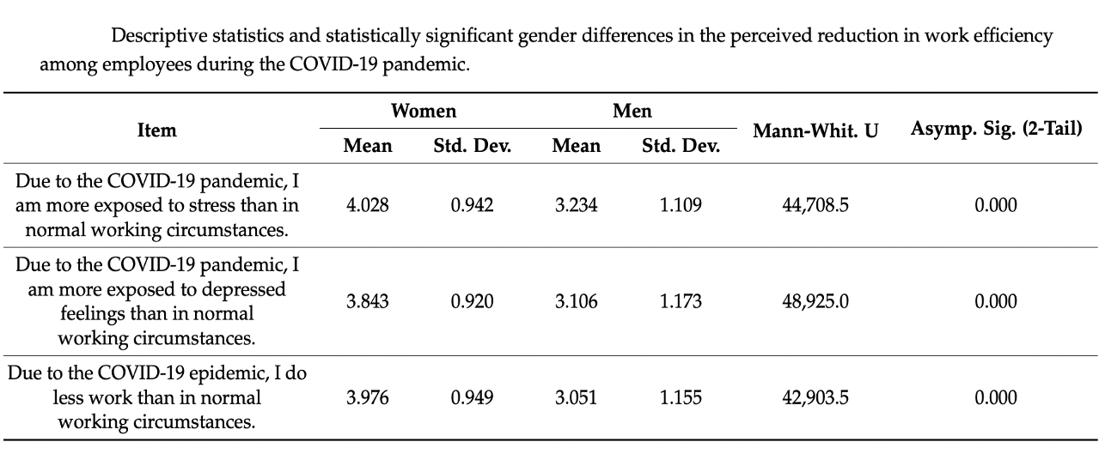
Table 1

Table 2 shows that women still spend more time taking care of children than men. Studies have found that because women have higher family needs, they need to take care of children and elderly relatives, which leads to shorter working hours and poor quality of work for women (Daniela et al.,2021).
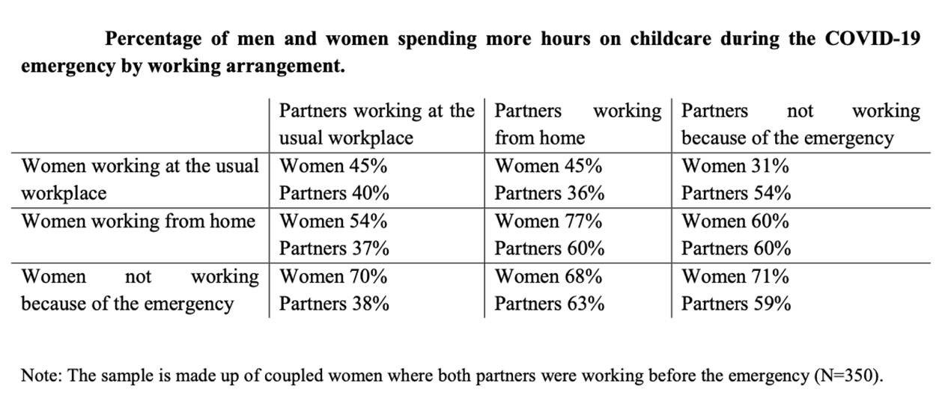
Table 2

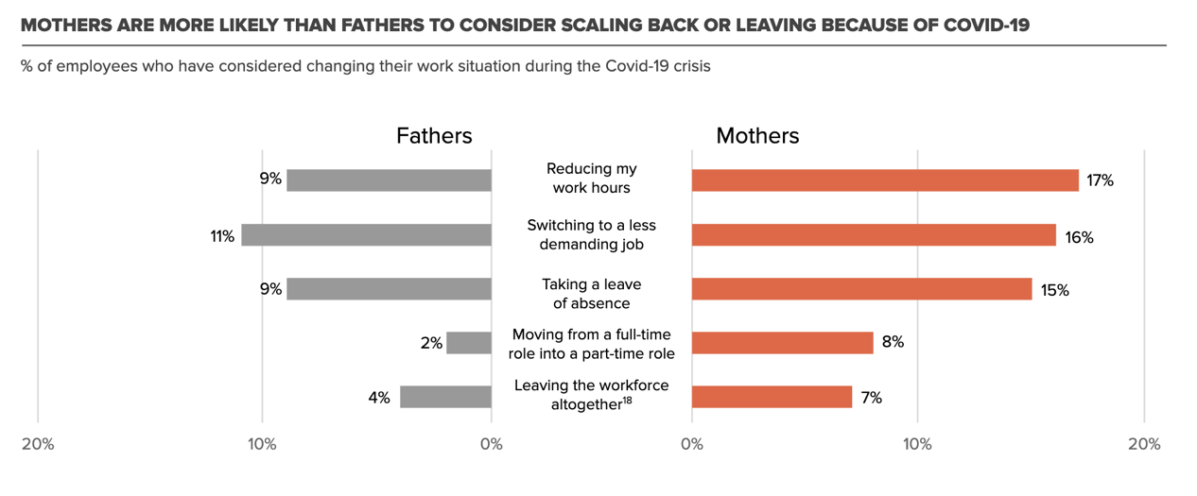
Table 3
Table 3 shows that 17% of mothers reduce their working hours. Only 9% of fathers said they would.

Research at this stage suggests that the during coronavirus could further increase women's workload because they need to take on work and more housework. Moreover, mothers with degrees are more likely to spend more time on their children's education. Even when they arrange jobs, they may still take care of the children first and finish later (Daniela et al.,2021).

Finally, WFH may have a significant impact on the gender gap. Some flexibility is desirable for a better work-life balance of men and women. However, if most men work in the workplace and women working from home (Lonska et al, 2021). It will increase the gap between men and women, which will have a negative effect on women's career development.

HR support for the women of WFH
HR is the most influential department in the entire organisation and company. Therefore, in the workplace for women, HR is needed to assist them to complete better their work (Lekchiri & Eversole. 2021). Because of the coronavirus, many employees' children are studying at home. As a result, many female workers have cut on their working hours (Collins et al., 2021). At this time, HR needs to make timely adjustments and consider taking care of a family when assigning women to work tasks and schedules. Also, HR can give more support to female workers. For example, flexible working hours, flexible deadlines, and some job support to help them relieve work stress (CIPD(1). 2021). In addition, HR could check employees' job satisfaction and efficiency to provide corresponding solutions. Meanwhile, HR should respond to the leaders promptly and adjust the company's goals (Maja et al., 2021).

Moreover, HR needs to be aware of gender discrimination and inherent bias and take action. For example, communicate with female employees promptly, respect their rights, and adjust personal and sick leave boundaries. HR needs to make women feel like they belong. In addition, HR needs to be fair and just from recruitment to employee dismission. HR needs to be fair when setting standards for employee benefits. In addition, HR can create a safer space for female employees to speak up about their needs without reservation and seek to solve problems without other harm (CIPD (2). 2021). In fact, in addition to the support of HR, the government also needs to introduce relevant policies to help more women get the respect and rewards they deserve in the workplace (Ohchr.org. 2014).

The author created a model for performance evaluation of female workers: in the evaluation, it is necessary to add and subtract these four quadrants to obtain scores.
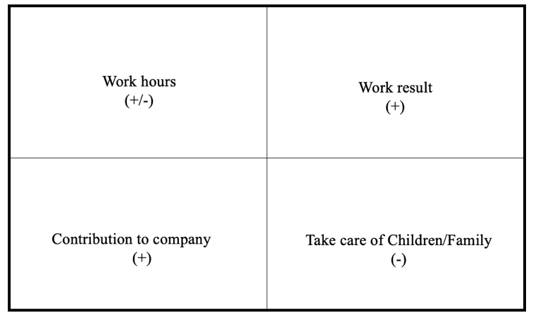

Limitations of this portfolio and future research directions
Limitation
This portfolio started research around WFH, mainly studying the efficiency of employees working from home. A further study looked at how effective women were working from home. The factors of different educational backgrounds, family background and age of employees are not considered. Moreover, the WFH of low-educated and low-income workers are not considered (Mongey et al., 2020).

The WFH approach has certain industry limitations. For example, WFH is more suitable for education, finance, information, art, and design. Like, installation, maintenance and repair, food preparation, transportation, and medical occupations, there are hardly any WFH (Sabrina &Victoria, 2021). These are not considered.

future research directions
In the future, when studying the efficiency of WFH, we can further understand the background of employees, their personality, emotional control and working environment at home (Bao et al. 2020). In addition, we can further explore the feedback of women's work effects under the social requirements. Furthermore, whether women's efficiency changes as they move up the social ladder.

References

Alexander Bick, Adam Blandin and Karel Mertens，2021. Work from Home After the COVID-19 Outbreak. [online] Available at: https://www.dallasfed.org/-/media/documents/research/papers/2020/wp2017.pdf [Accessed 30 August 2021].

Afrianty, T. W. et al. (2021) Working from home effectiveness during Covid-19: Evidence from university staff in Indonesia. Asia Pacific management review. [Online]

Alipour, J.-V. et al. (2021) My home is my castle – The benefits of working from home during a pandemic crisis. Journal of public economics. [Online] 196104373–.

Arruda, W. (2020) 6 Ways COVID-19 Will Change the Workplace Forever. Available at: https://www.forbes.com/sites/williamarruda/2020/05/07/6-ways-covid-19-will-change-the-workplace-forever/?sh=2c5b0d97323e [Accessed 28 August 2021]

Baker, E. et al. (2007) Satisfaction and perceived productivity when professionals work from home. Research & practice in human resource management. 15 (1), 37–62.

Bao, L. et al. (2020) How does Working from Home Affect Developer Productivity? -- A Case Study of Baidu During COVID-19 Pandemic. [online] Available at:
https://arxiv.org/pdf/2005.13167.pdf [Accessed 31 August 2021].

Baruch, Y. (2000) Teleworking: benefits and pitfalls as perceived by professionals and managers. New technology, work, and employment. [Online] 15 (1), 34–49.

Barrero, J., Bloom, N. and Davis, S., (2020) Why Working from Home Will Stick. SSRN Electronic Journal. Available at: https://www.nber.org/system/files/working_papers/w28731/w28731.pdf [Accessed 28 August 2021]

Bloom, N. et al. (2013) Does working from homework? Evidence from a Chinese experiment. Centre for Economic Performance, London School of Economics and Political Science.

Bick, A., Blandin, A. and Mertens, K., (2021) Work from Home Before and After the COVID-19 Outbreak. SSRN Electronic Journal. Available at: https://www.dallasfed.org/-/media/documents/research/papers/2020/wp2017.pdf [Accessed 28 August 2021]

Collins, C. et al. (2021) COVID‐19 and the gender gap in work hours. Gender, work, and organisation. [Online] 28 (S1), 101–112.

CIPD (1). 2021. Flexible working uptake | CIPD Viewpoint. [online] Available at: https://www.cipd.co.uk/news-views/viewpoint/flexible-working-uptake [Accessed 4 September 2021].

CIPD (2). 2021. Gender equality at work | CIPD Viewpoints. [online] Available at: https://www.cipd.co.uk/news-views/viewpoint/gender-equality-work#gref [Accessed 4 September 2021].

Daniela et al.,2021. Women’s Work, Housework and Childcare, before and during COVID-19. IZA – Institute of Labor Economics [online] Available at: https://covid-19.iza.org/publications/dp13409/ [Accessed 3 September 2021].

Deole, Sumit, Max Deter and Yeu Huang, (2021) "Home Sweet Home: Working from Home and Employee Performance during the COVID-19 Pandemic in the UK," working paper. Available at: https://www.econstor.eu/bitstream/10419/231328/1/GLO-DP-0791.pdf [Accessed 28 August 2021]

Felstead, A. & Reuschke, D. (2020) Homeworking in the UK: Before and during the 2020 lockdown. Wizard report, Cardiff: Wales Institute of Social and Economic Research.

Feng, K., 2021. Covid-19 created a gender gap in perceived work productivity and job satisfaction: implications for dual-career parents working from home. [online] Pesquisa.bvsalud.org. Available at: https://pesquisa.bvsalud.org/global-literature-on-novel-coronavirus-2019-ncov/resource/en/covidwho-1249367 [Accessed 3 September 2021].

Gajendran, R. S. & Harrison, D. A. (2007) The Good, the Bad, and the Unknown About Telecommuting: Meta-Analysis of Psychological Mediators and Individual Consequences. Journal of applied psychology. [Online] 92 (6), 1524–1541.

Global Workplace Analytics. (2020). Telecommuting trend data. Available at: https://globalworkplaceanalytics.com/telecommuting-statistics. [Accessed 30 August 2021]

Harrington, E. and N. Emanuel. (2020) Working Remotely? Selection, Treatment, and Market Provision of Remote Work. Unpublished Manuscript. Harvard University. doi: 10.2139/ ssrn.3601959.

Herminia I., Julia G., and Tomas P., 2021. Why WFH Isn’t Necessarily Good for Women. Harvard Business Review. [online] Available at: https://hbr.org/2020/07/why-wfh-isnt-necessarily-good-for-women [Accessed 3 September 2021].

Kossek, E. E. et al. (2006) Telecommuting, control, and boundary management: Correlates of policy use and practice, job control, and work–family effectiveness. Journal of vocational behavior. [Online] 68 (2), 347–367.

Lee I. & Tipoe E., 2020. Time use and productivity during the COVID-19 lockdown: Evidence from the UK. Available at: https://covid-19.iza.org/wp-content/uploads/2020/11/Time-use-and-productivity-during-the-COVID-19-lockdown.pdf [Accessed 30 August 2021]

Lekchiri, S. & Eversole, B. A. W. (2021) Perceived work‐life balance: Exploring the experiences of professional Moroccan women. Human resource development quarterly. [Online] 32 (1), 35–53.

Lonska, J. et al, 2021. Work–Life Balance of the Employed Population During the Emergency Situation of COVID-19 in Latvia. DOI: 10.3389/fpsyg.2021.682459

Maja Rožman et al. (2021) Gender Differences in Work Satisfaction, Work Engagement and Work Efficiency of Employees during the COVID-19 Pandemic: The Case in Slovenia. Sustainability (Basel, Switzerland). [Online] 13 (8791), 8791–.

Mongey, et al., 2020. WHICH WORKERS BEAR THE BURDEN OF SOCIAL DISTANCING? NATIONAL BUREAU OF ECONOMIC RESEARCH. [online] Available at: https://www.nber.org/system/files/working_papers/w27085/w27085.pdf [Accessed 4 September 2021].

Ohchr.org. 2014. Women’s Rights are Human Rights. [online] Available at: https://www.ohchr.org/Documents/Events/WHRD/WomenRightsAreHR.pdf [Accessed 4 September 2021].

Purwanto, A., M. and et al. 2020. (PDF) Impact of Work From Home (WFH) on Indonesian Teachers Performance During the Covid-19 Pandemic: An Exploratory Study. International Journal of Advanced Science and Technology. [online] Available at: https://www.researchgate.net/publication/341413246_Impact_of_Work_From_Home_WFH_on_Indonesian_Teachers_Performance_During_the_Covid-19_Pandemic_An_Exploratory_Study [Accessed 30 August 2021].

Sabrina P. &Victoria V., 2021. Telework, Wages, and Time Use in the United States. [online] Available at: https://www.aeaweb.org/conference/2021/preliminary/paper/zFQR4Qke [Accessed 30 August 2021].

Susan Harkness,2019. How women's employment changes after having a child | Understanding Society. [online] Available at: https://www.understandingsociety.ac.uk/2019/10/22/how-womens-employment-changes-after-having-a-child [Accessed 4 September 2021].

Vyas, L. & Butakhieo, N. (2021) The impact of working from home during COVID-19 on work and life domains: an exploratory study on Hong Kong. Policy design and practice. [Online] 4 (1), 59–76.

Figure1, 2, 3： Interiors, S., (2021) Global Report: Changing Expectations and the Future of Work - Sheppard's Business Interiors. [online] Sheppard's Business Interiors. Available at: https://www.sbi-omaha.com/wp-content/uploads/sites/798/2021/02/2021_AM_SC_Global-Report_Changing-Expectations-and-the-Future-of-Work-2.pdf [Accessed 28 August 2021].

Table 1, 2: Maja Rožman et al. (2021) Gender Differences in Work Satisfaction, Work Engagement and Work Efficiency of Employees during the COVID-19 Pandemic: The Case in Slovenia. Sustainability (Basel, Switzerland). [Online] 13 (8791), 8791–.

Table 3：McKinsey & company, 2021. Woman in the workplace. [online] Available at: https://www.mckinsey.com/featured-insights/diversity-and-inclusion/women-in-the-workplace [Accessed 4 September 2021].

