

BA Hons International Hotel Management

Title: Personnel Resourcing and Development
- Employee Engagement Essay

Module Code: BMIH5005

Student Name: Dillu Miah

Course Leader: Helen Evans/Emma Roberts

Student Number: 2118854

Actual Word Count:1974

Date of Submission: 12/06/2023

Introduction
This essay will provide an overview and in depth research about how the HR department at the Hilton brand of hotels can maintain and keep their staff and prolong the employee life cycle. It will talk about the different roles and responsibilities of the HR department and also the stages of the employee life cycle. It will also talk about examples of the Hiltons strategies within the employee life cycle and how that helps employees to stay at their brand.
Background
The brand of Hilton Hotels has different ways of keeping employees happy in order to keep them working for their brand. The Hilton hotel was ranked the second-best workplace in the world for two years in a row. It was also the only hospitality facility among the 25 competitor companies. And some of the greatest perks of working at Hilton include the culture, benefits, and travel programs (Bybee, 2022). Some of these benefits that their employees enjoy are expanded paternity leave, extended bereavement leaves, adoption assistance, and paid time off (Bybee, 2022). Hilton University (HWU) provides more than 5,000,000 hours of training each year through over 2,500 courses delivered in a wide variety of training formats, including classroom training, eLearning, webinars, e-books, live and taped programs, recommendations for on-the-job learning experiences, social learning, and more (Lisa, 2022).
The role of Human Resources (HR) in managing and developing talent is vital to the success and growth of an organization. HR professionals play a strategic role in attracting, recruiting, developing, and retaining talented individuals within the workforce. Their responsibilities encompass various aspects of talent management, including identifying and nurturing potential, facilitating employee growth and development, and creating a positive and inclusive work environment. Here are some key areas where HR plays a crucial role in managing and developing talent:
Recruitment and Selection: HR is responsible for designing and implementing effective recruitment and selection processes to attract top talent. They collaborate with hiring managers to identify the skills, competencies, and qualifications required for each role. Through job postings, screening applications, conducting interviews, and reference checks, HR ensures that the organization hires individuals who align with its goals and values.
Onboarding and Orientation: HR facilitates the smooth integration of new employees into the organization through comprehensive onboarding programs. They provide information about the company's culture, policies, procedures, and expectations, enabling new hires to feel supported and prepared for their roles. Effective onboarding enhances employee engagement and accelerates their transition into productive team members.
Performance Management: HR designs and implements performance management systems to assess and enhance employee performance. They establish clear performance expectations, set goals, and conduct regular performance evaluations. HR professionals also provide feedback, identify training needs, and support employees in their professional development.
Training and Development: HR identifies skill gaps and designs training programs to enhance the knowledge and capabilities of employees. They collaborate with managers and employees to create individual development plans, offer workshops, seminars, and online learning opportunities. HR may also organize mentorship programs and encourage participation in conferences or industry events to foster continuous learning and career growth.
Succession Planning: HR plays a pivotal role in identifying and developing future leaders within the organization. They work closely with managers to assess high-potential employees and create succession plans to ensure a smooth transition when key positions become vacant. By nurturing talent from within, HR helps build a pipeline of skilled individuals who can take on critical roles in the future.
Employee Engagement and Retention: HR focuses on creating a positive work environment that fosters employee engagement, satisfaction, and retention. They develop strategies to improve work-life balance, employee recognition programs, and initiatives to boost employee morale. HR professionals are often responsible for conducting employee surveys, analysing feedback, and implementing changes to address concerns and enhance employee experience.

Talent Analytics and Reporting: HR leverages data and analytics to gain insights into talent management practices. By analysing metrics such as employee turnover, training effectiveness, and performance ratings, HR professionals can identify trends, measure the impact of talent management initiatives, and make data-driven decisions to improve talent management strategies.
In summary, HR plays a critical role in managing and developing talent within an organization. By attracting, selecting, developing, and retaining talented individuals, HR professionals contribute to the overall success and growth of the organization, ensuring a skilled and engaged workforce capable of meeting current and future challenges.
Managing and developing talent is of paramount importance in the field of human resources. Here are several reasons why it holds such significance:
Attracting and Retaining Top Talent: Effective talent management practices enable organizations to attract highly skilled and qualified individuals. In today's competitive job market, talented professionals have numerous options available to them. By showcasing a commitment to managing and developing talent, organizations can differentiate themselves and become an employer of choice, attracting top talent and retaining them in the long run.
Driving Organizational Success: Talent management directly contributes to organizational success. By identifying and nurturing talented individuals, organizations can build a high-performing workforce that brings valuable skills, expertise, and innovation to the table. Developing and utilizing the strengths of employees optimizes productivity, efficiency, and overall performance, leading to improved business outcomes.
Succession Planning and Continuity: Effective talent management involves identifying and developing future leaders within the organization. By planning for succession, organizations ensure a smooth transition when key positions become vacant. Developing a talent pipeline ensures that there are skilled individuals ready to step into critical roles, reducing disruption and maintaining continuity within the organization.

Employee Engagement and Motivation: Managing and developing talent demonstrates a commitment to employees' growth and development. When employees feel valued and see opportunities for advancement and skill enhancement, they are more engaged, motivated, and committed to their work. Engaged employees are more likely to go above and beyond, contributing to a positive work culture, higher productivity, and improved employee retention.
Enhancing Organizational Agility: Managing talent effectively enables organizations to adapt to changing business needs and industry trends. By identifying and developing employees' skills, organizations can build a flexible and adaptable workforce capable of taking on new challenges and embracing innovation. This agility allows organizations to stay ahead of the curve, seize opportunities, and navigate dynamic market conditions successfully.
Knowledge Transfer and Learning Culture: Talent management involves creating a culture of continuous learning and knowledge sharing. By investing in employee development programs, organizations foster a collaborative environment where employees can learn from one another, share best practices, and acquire new skills. This knowledge transfer ensures the preservation and dissemination of critical expertise, fostering organizational growth and competitiveness.
Employee Satisfaction and Retention: Employees who feel valued and supported in their professional growth are more likely to stay with the organization for the long term. Effective talent management practices contribute to employee satisfaction, leading to improved employee retention rates. Reduced turnover not only saves recruitment and training costs but also promotes stability and continuity within the organization.
In conclusion, managing and developing talent is crucial for organizations' success, growth, and competitiveness. By attracting, nurturing, and retaining top talent, organizations build a skilled and engaged workforce capable of driving innovation, achieving strategic objectives, and maintaining a sustainable advantage in a rapidly evolving business landscape. Effective talent management practices foster employee satisfaction, motivation, and growth, ultimately benefiting both individuals and the organization as a whole.
The employee life cycle consists of 6 stages.
Attraction: This is the first stage where the employee is exposed to the brand.
Recruitment: This is the process and experience which allows someone to become an applicant and then an employee.
Onboarding: This is the stage where the applicant is made aware of the corporate/brands culture and helps them to blend in and understand it.
Retention: This stage involves keeping employees connected and satisfied and rewarding them with relevant rewards and recognising their efforts and good work.
Career Development: This is the stage where the company helps the employee to move further up in their role and advance their career within the brand.
Separation: This is the stage where the employee inevitably decides to part ways with the company.
(Personio, 2023)
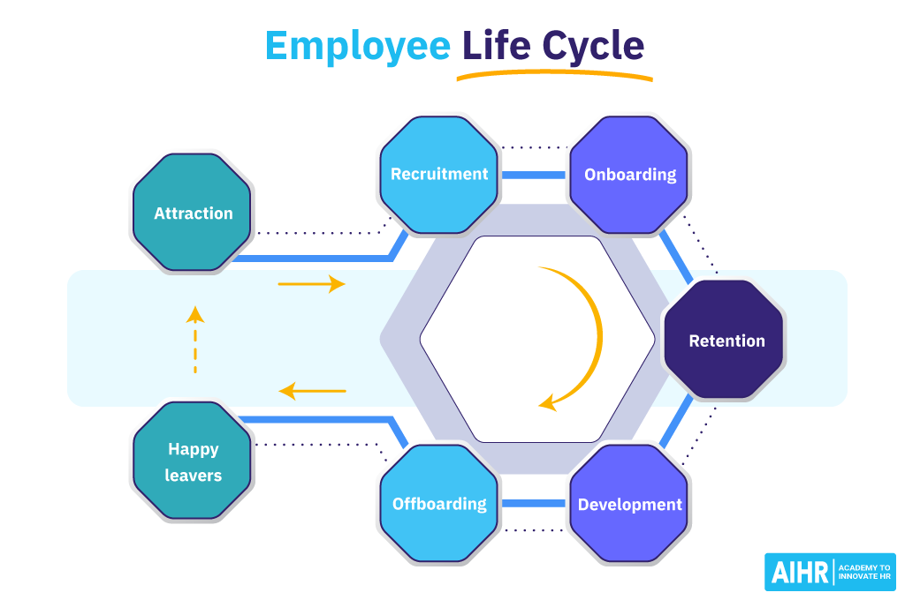
(Verlinden, 2020)
Hilton makes sure that its workplace is a pleasant place to work as one of its methods for keeping its staff content. Resources provides its employees with attractive furnishings, delicious food, and free Wi-Fi in addition to fostering a sense of community among its personnel. People are happier at work when there is a nice workplace and a sense of being around family and close friends (Mead,2016). Within the employee life cycle, the use of rewards is the stage known as retention. One of the phases of the employee life cycle model that takes the longest is employee retention. To keep your staff on board, you must constantly engage them. This not only enables you to create a dependable and effective staff but also helps you avoid spending money and time on the hiring process which is better in the long run for the business (Khan, 2023).
Investing in their employees' careers is another strategy. They provide Hilton University, which aids employees in developing new skills while assisting them in managing and planning their careers. Some businesses are turned off by having this kind of trust in their staff and investing in them because they believe that if they do, their people would quit. Smart businesses understand that assisting team members in setting and achieving professional objectives as well as promoting development will improve employee satisfaction and the business overall (Mead,2016). This stage is known as career development within the employee life cycle. Retention and employee development are intricately intertwined. People will quit if they believe they have no opportunity of advancement in their current position (Khan,2023). One of the main reasons individuals leave their employment after a pandemic, according to (De Smet et al., 2021), is a lack of professional growth. Understanding your workers' skills, how the business can use them, and giving your team plenty of learning and development opportunities are crucial.
These examples show that the Hilton has good strategies to try and keep their employees at their brand for a long period of time and how they try to avoid the end stage of the employee life cycle which is separation.
On the other hand, the Hilton did lose some employees due to the pandemic at the beginning of 2020. The Hilton had to lay off 2,100 of their workers in order to reduce their costs during the pandemic. However, the workers were promised severance pay (Sandler,2020). This could have been handled better as this would make employees feel like they were not appreciated during the hard times of the pandemic. This can also effect other employees at the brand. Even if an employee has received prior recognition for their excellent work and contribution, they may be experiencing self-doubt as a result of a co-worker’s unjust firing. As they don't know if their actions will be viewed as fireable, they could start to overthink everything they do at work. This will probably lead to more stress and burnout, and it could even lower productivity. Overall, it can cause the worker to look for work elsewhere (HR News, 2021).
Conclusion
Overall, this essay concludes that the main way of main way that employees had left the Hilton was due to the Corona virus pandemic and their poor decision of having letting employees go which could have a bigger effect on the brand as other employees might see this as unjustified and could lead to the separation stage of the employee life cycle to occur sooner than expected. This could have been avoided by reducing employee hours and reducing overtime which could cut down costs. Another option could have been encouraging employees to use their paid leave during a difficult time or even offering part time leave but keeping their place as an employee (Covington et al. (2020).

References
Bybee, N. (2022) How Hilton Keeps its Employees Happy (And Five Employee Retention Tips for the Hospitality Industry), www.linkedin.com. Available at: https://www.linkedin.com/pulse/how-hilton-keeps-its-employees-happy-five-employee-tips-bybee-cpa.
Corlett, P. (2021) Working safely and how to avoid dismissal claims arising out of the pandemic, Blake Morgan. Available at: https://www.blakemorgan.co.uk/working-safely-and-how-to-avoid-dismissal-claims-arising-out-of-the-pandemic/ (Accessed: 7 June 2023).
Covington et al. (2020) Ten Ways to Avoid Layoffs During the COVID-19 Pandemic, Lexology. Available at: https://www.lexology.com/library/detail.aspx?g=72d7712f-04c6-499b-ad79-954e8103cdeb.
De Smet, A. et al. (2021) How companies can turn the Great Resignation into the Great Attraction | McKinsey, www.mckinsey.com. Available at: https://www.mckinsey.com/capabilities/people-and-organizational-performance/our-insights/great-attrition-or-great-attraction-the-choice-is-yours.
Hotel HR Manager job description template | Workable (2018) Recruiting Resources: How to Recruit and Hire Better. Available at: https://resources.workable.com/hotel-hr-manager-job-description.
How an Unfair Dismissal Can Affect Your Remaining Employees (2021) HR News. Available at: https://hrnews.co.uk/how-an-unfair-dismissal-can-affect-your-remaining-employees/.
Human Resource Management in the Hotel Industry. (2023, January 31). Edubirdie. Retrieved June 6, 2023, from https://edubirdie.com/examples/human-resource-management-in-the-hotel-industry/
Khan, F. (2023) Employee Life Cycle: The Ultimate Guide for HR Online Coursein Karachi, Lahore, Islamabad, Pakistan Dubai, OMNI ACADEMY & CONSULTING. Available at: https://www.omni-academy.com/employee-life-cycle/?cv=1 (Accessed: 6 June 2023).

Lisa (2022) The secret to employee onboarding (actually 3) by the Hilton, Whale. Available at: https://usewhale.io/blog/hilton-secret-to-employee-onboarding/.
Mead, W. (2016) Why Employees Love Hilton, www.linkedin.com. Available at: https://www.linkedin.com/pulse/why-employees-love-hilton-wendy-mead.
Qualtrics (2021) The 5 Stages of the Employee Lifecycle Model | Qualtrics UK, Qualtrics. Available at: https://www.qualtrics.com/uk/experience-management/employee/employee-lifecycle-model/.
Sandler, R. (2020) Hilton Laying Off 22% Of Corporate Workforce, Forbes. Available at: https://www.forbes.com/sites/rachelsandler/2020/06/16/hilton-laying-off-22-of-corporate-workforce/?sh=5795a39112bc (Accessed: 7 June 2023).
Smyth, D. (2020) The role of the human resources department in a hospitality organization, Chron.com. Available at: https://smallbusiness.chron.com/role-human-resources-department-hospitality-organization-71891.html.
The Employee Life Cycle: Success In 6 Stages (no date) www.personio.com. Available at: https://www.personio.com/hr-lexicon/employee-life-cycle-model-uk/#what-are-the-stages-of-the-employee-life-cycle-model.
Verlinden, N. (2020) The Employee Life Cycle: 19 Tips to Get it Right, AIHR. Available at: https://www.aihr.com/blog/employee-life-cycle/.

‌

‌

