

Student Name :- Patel Manthan Sureshbhai
Student Id :- 2241308
Programme :- MBA- Master Of Business Administration
Module :- Marketing Management
Module Code :- LCMB7001
Lecturer Name :-Tushara balendran
Submission Date :- 17/04/2024

Table of Contents
Introduction 3
Company Background 3
Mission and Vision Statement of Zara 3
PESTLE analysis of Zara 3
Porter’s Five Forces Analysis of Zara 5
SWOT analysis 7
STP analysis of Zara 8
4P’s of the Marketing mix 9
Conclusion 9
Recommendations 10
References 11

Introduction

Company Background
The group of Inditex is also composed of Zara, the fashion brand recognized as the Spanish fast-fashion brand in its own country. In 1975, Amongio Laport Mera mentioned as a duo, Amancio Ortega and Rosalà Mèra founded their firm in A Coruña, Galicia, Spain. To illustrate the fast fashion concept, Zara is the producer that is known to produce, manufacture, and ship new designs to its shops in a timely: maybe within one week. Fans of the latest trends and bargains buying from Zara have the influx of new arrivals now and then, which are, as our customers would confirm, always on point (Chunling, 2020). Being supported by the staff with a high level of customer care, and its supply chain that is ahead of its time, the company has managed to record astonishing outputs.

Mission and Vision Statement of Zara
Zara aims to satisfy fashion enthusiasts with nice and high-quality wear but at the same time affordable. The business is a company of what is customer satisfaction, company greenness, and innovation of new ideas. Sustainable manufacturing is one of the strategic objectives that Zara company has when it came up with the idea of excess supply and new product arrival. Concerning eco-friendliness and efficiency, it is its top goal to take over the fashion retail industry. Thus, this brand assures a decrease in its impact on the environment and uses eco-friendly products besides, it keeps its suppliers and factory workers engaged through ethical practices (Tőkés, 2022). Hence, it is confident in building a sustainable future for all. To reinvent from a quick fashion perspective this firm wants to make sure that doing business in an environmentally and socially friendly way is one of its main principles.

PESTLE analysis of Zara
Political: Favorable and Unfavorable. Political stability in key markets like Europe and North America offers a conducive environment for Zara's operations. However, trade policies and tariffs can be unfavorable, affecting Zara's global supply chain and cost structures, especially given its centralized distribution system in Spain (BUSH, 2022).
Economic: Mixed. On the favorable side, global economic growth enhances consumer spending power, benefiting Zara. However, economic downturns and currency fluctuations can be unfavorable, impacting consumer spending and leading to increased costs for operations in different countries (BUSH, 2022).
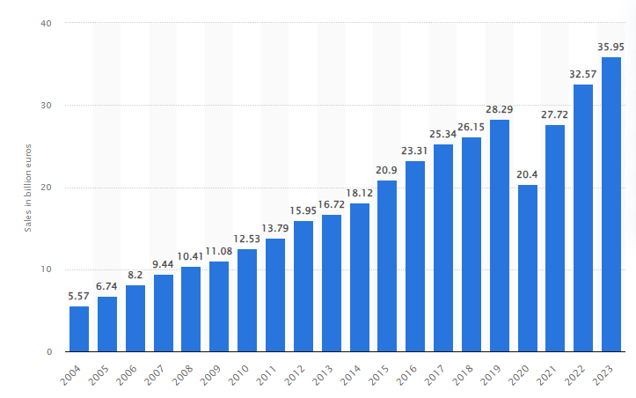
Figure 1: Zara’s Sales
Source: (Smith, 2024)
Sociocultural: Favorable. Zara thrives in a sociocultural environment that values fast fashion and constant renewal of wardrobe choices, aligning with consumer demands for the latest trends. The growing awareness and demand for sustainable and ethically produced clothing also align with Zara's increased focus on sustainability, though this also poses challenges to adapt quickly to these expectations (Smith, 2024).
Technological: Favorable. Advances in technology are highly favorable for Zara. The use of sophisticated supply chain and inventory management technologies enables Zara to maintain its fast-fashion model efficiently. Online retailing technologies and data analytics also allow Zara to understand consumer preferences better and tailor its offerings accordingly (Mao, 2023).
Legal: Mixed. Legal factors, including labor laws and regulations regarding international trade, can be both favorable and unfavorable. Compliance with these laws ensures smooth operations but can increase operational costs. Intellectual property laws in fashion can also pose challenges, requiring careful navigation to avoid litigation (Mao, 2023).
Environmental: Unfavorable and Favorable. The increasing focus on environmental sustainability is a challenge for fast-fashion models like Zara's, which are often criticized for their environmental impact. However, Zara has been making efforts to become more sustainable, which can turn these challenges into opportunities by aligning with consumer expectations for eco-friendly products and practices (Mao, 2023).

Porter’s Five Forces Analysis of Zara
Porter's Five Forces model is an effective tool for analyzing the competitive landscape that a company operates within. For Zara, a leading player in the fast-fashion industry, these forces shape its strategic decisions and market position.
Threat of New Entrants: Medium.
Entering the fast-fashion market requires significant capital investment in supply chains, manufacturing, and retail networks, which can be a barrier to new entrants. However, the rise of e-commerce has lowered entry barriers for online retailers. Zara, with its established brand and efficient supply chain, faces a medium threat from new entrants who might innovate in niche areas or leverage online platforms to challenge traditional players (mbaskool.com, 2022).
Bargaining Power of Suppliers: Low to Medium.
Zara has a unique advantage due to its integrated supply chain and long-term relationships with suppliers, mostly located near its headquarters in Spain or in closely monitored regions. This proximity and control reduce the bargaining power of suppliers. However, the shift towards more sustainable and ethical sourcing practices can increase the power of suppliers who can meet these higher standards, thus potentially moving this from low to medium (mbaskool.com, 2022).
Bargaining Power of Customers: High.
In the fast-fashion industry, customers have a high bargaining power due to the abundance of choices and low switching costs. Zara, though, mitigates this through rapid fashion turnovers and keeping production quantities limited, creating a sense of urgency and exclusivity. Despite this, the brand must continuously innovate and respond to consumer trends and preferences to maintain customer interest and loyalty.
Threat of Substitute Products or Services: Medium to High.
The threat of substitutes for Zara comes from the broad range of alternatives in the fashion industry, including traditional retail, online platforms, second-hand clothing markets, and rental services. While Zara offers trendy and affordable fashion, the increasing consumer awareness and preference for sustainability could drive customers towards more sustainable brands or second-hand clothing options, highlighting a medium to high threat.
Rivalry among Existing Competitors: High.
The fast-fashion industry is characterized by intense competition, with key players like H&M, Uniqlo, and Primark vying for market share. Zara distinguishes itself through its fast supply chain and quick turnover of fashion pieces. However, to maintain its competitive edge, Zara must continuously invest in innovation, marketing, and store experience to stand out, reflecting a high level of rivalry.
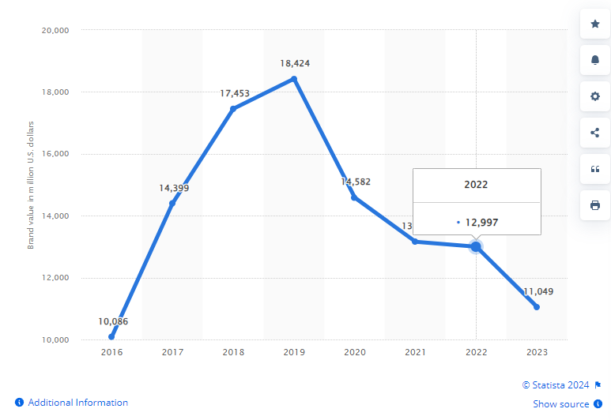
Figure 2: Zara’s Brand value
Source: (Sabanoglu, 2024)
In addition, digital transformation and sustainability are becoming increasingly important competitive factors. Zara has been focusing on enhancing its online presence and adopting more sustainable practices, which are essential to compete in the evolving retail landscape. The company's ability to quickly adapt to changing consumer preferences and technological advancements will be crucial in maintaining its competitive position amidst high industry rivalry and the other forces outlined by Porter's model.

SWOT analysis
Strengths
- Efficient Supply Chain: Zara's fast and flexible supply chain enables rapid response to fashion trends, translating customer desires into new designs in a matter of weeks.
- Strong Brand Image: Zara is recognized globally for offering the latest fashion trends at affordable prices, maintaining a strong brand presence (Duoyan, 2021).
- Innovative Business Model: Its fast-fashion model, with frequent stock turnover and limited supply, creates a sense of urgency among customers, encouraging quick purchases.
Weaknesses
- Dependence on European Markets: A significant portion of Zara's revenue comes from Europe, making it susceptible to economic fluctuations in this region.
- Environmental and Ethical Concerns: The fast-fashion model faces criticism for contributing to environmental degradation and questionable labor practices, impacting brand perception (Zhu, 2023).
Opportunities
- Expansion in Emerging Markets: There is potential for growth in Asian and African markets, where demand for fast fashion is increasing.
- Sustainability Initiatives: By enhancing its focus on sustainability, Zara can improve its brand image and cater to the growing market of environmentally conscious consumers (Zhu, 2023).
Threats
- Intense Competition: The fast-fashion industry is highly competitive, with many players offering similar products at comparable prices.
- Changing Consumer Preferences: The increasing demand for sustainable and ethical fashion poses a threat to the fast-fashion business model (Duoyan, 2021).
- Economic Fluctuations: Economic downturns can reduce consumer spending, affecting Zara's sales and profitability.

STP analysis of Zara
Zara employs a sophisticated approach to segmentation, targeting, and positioning (STP) that enables it to maintain a strong presence in the global fast-fashion industry. This STP strategy is crucial for understanding customer needs, preferences, and behaviors, allowing Zara to tailor its offerings and marketing messages effectively.
Segmentation: Zara segments its market based on demographic, psychographic, and behavioral factors. Demographically, it targets both men and women primarily in the 18-40 age group, who are fashion-forward and seek trendy apparel at affordable prices. Psychographically, Zara appeals to customers who value style and fashion trends but are also conscious of price and quality (Li, 2022). Behaviorally, the brand focuses on customers looking for a quick fashion fix, who appreciate the rapid turnover of clothing collections that reflect the latest trends. This segmentation allows Zara to cater to a broad yet targeted customer base.
Targeting: Zara adopts a differentiated targeting strategy to cater to the various segments identified. It offers distinct product lines for men, women, and children, encompassing a wide range of styles from casual to more formal attire. By constantly refreshing its product offerings, Zara targets fashion-conscious customers who desire new trends as soon as they emerge (Li, 2022). Additionally, through its sustainability line, Zara targets environmentally conscious consumers, recognizing the growing importance of sustainability in consumer purchasing decisions.
Positioning: Zara's positioning strategy is centered around fast fashion and value for money. The brand positions itself as a provider of high fashion at affordable prices, enabling customers to access the latest fashion trends without the designer price tag. This positioning is supported by Zara's agile supply chain, which allows for quick response to market trends and customer feedback, often bringing new products to the market in just a few weeks (Li, 2022). Furthermore, Zara emphasizes its commitment to sustainability in its positioning, aiming to appeal to a segment of the market that prioritizes environmental and social responsibility.

4P’s of the Marketing mix
Product: Zara offers a wide range of trendy and stylish clothing for men, women, and children, including accessories. The company's strength lies in its ability to quickly bring the latest fashion trends from the catwalk to the store shelves, with new products arriving twice a week (Xia, 2023). Zara emphasizes quality and affordability, ensuring continuous renewal of its product offerings to keep pace with fast-changing fashion trends.
Price: Zara adopts a value-based pricing strategy, setting prices that customers perceive to provide good value for the latest fashion trends. While not the cheapest in the market, Zara's pricing is competitive, attracting a broad customer base seeking style at affordable prices (Xia, 2023).
Place: Zara's stores are strategically located in high-traffic areas in major cities worldwide, enhancing brand visibility and accessibility. The company also has a strong online presence, offering an e-commerce platform that mirrors the in-store experience, thus catering to the growing trend of online shopping (Xia, 2023).
Promotion: Zara's promotion strategy is relatively low-key compared to competitors; it relies heavily on its fast-fashion model, store locations, and window displays to attract customers. Social media and the company's website are used to showcase new arrivals and fashion trends. Zara focuses on creating a sense of urgency among customers to make immediate purchases, rather than investing heavily in traditional advertising (Xia, 2023).

Conclusion
Zara's success in the global fast-fashion industry is a testament to its strategic mastery of the marketing mix, efficient supply chain, and adeptness at segmentation, targeting, and positioning. By focusing on rapid response to fashion trends, maintaining a strong online and physical presence, and catering to a diverse customer base with high-quality, affordable fashion, Zara has built a formidable brand. Despite challenges in the macro environment and competitive pressures, Zara's commitment to sustainability and innovation continues to drive its growth. As the brand moves forward, its ability to adapt to changing consumer preferences and technological advancements will remain key to its enduring success.

Recommendations
Zara should intensify its focus on sustainability and ethical practices to address environmental concerns and changing consumer preferences. Implementing eco-friendly materials and transparent supply chains would enhance its market position. Additionally, expanding its digital footprint and leveraging advanced technologies like AI for personalized customer experiences can drive online sales. Zara could benefit from exploring untapped markets, especially in Asia and Africa, where fast fashion has significant growth potential. Strengthening online and offline integration through omnichannel retailing will enhance customer convenience and satisfaction. Finally, investing in customer feedback mechanisms to better understand and react to shifting fashion trends and preferences can help Zara maintain its competitive edge. These strategies will ensure Zara's continued growth and relevance in the fast-paced fashion industry, keeping it ahead of market trends and consumer expectations.

References
BUSH, T., 2022. PESTLE Analysis of Zara. [Online]
Available at: https://pestleanalysis.com/pestle-analysis-of-zara/
Chunling, L., 2020. Analysis on the marketing strategy of fast fashion Brand Zara based on 4c theory. In 4th International Conference on Economics, Management Engineering and Education Technology (ICEMEET 2020) (pp. 3-5).
Duoyan, H., 2021. Research on ZARA strategy from the perspective of SWOT analysis method. In 2021 6th international conference on social sciences and economic development (ICSSED 2021) (pp. 201-205). Atlantis Press.
Li, H., 2022. Research on Digital Marketing Strategy of Fast Fashion Clothing Brand based on Big Data.
Mao, H., 2023. Analysis of the business strategy and potential challenges of Japanese fast fashion brand Uniqlo's entry into the CEE market.
mbaskool.com, 2022. Zara Porter Five Forces Analysis. [Online]
Available at: https://www.mbaskool.com/five-forces-analysis/companies/18278-zara.html
Sabanoglu, T., 2024. Zara's brand value worldwide from 2016 to 2023. [Online]
Available at: https://www.statista.com/statistics/980126/brand-value-of-zara-worldwide/
Smith, P., 2024. Inditex Group's sales worldwide from 2004 to 2023. [Online]
Available at: https://www.statista.com/statistics/268817/sales-of-the-inditex-group-worldwide/#:~:text=Between%202016%20and%202022%2C%20Zara's,2019%20at%2018.4%20billion%20dollars.
Tőkés, G.E., 2022. The Digital Brand Identity of Fast-Fashion Brand Zara. A Case Study. Acta Universitatis Sapientiae, Social Analysis, (12), pp.131-154.
Xia, Y., 2023. The 4Ps of Marketing and Applications in Various Brands. Journal of Education, Humanities and Social Sciences, 16, pp.165-170.
Zhu, Y., 2023, June. Research on Fast Fashion Industry Under Sustainable Development Model: Based on ZARA’s SWOT Analysis. In Proceedings of the 6th International Conference on Economic Management and Green Development (pp. 935-942). Singapore: Springer Nature Singapore.

