Presentation Slides and Script
Slides
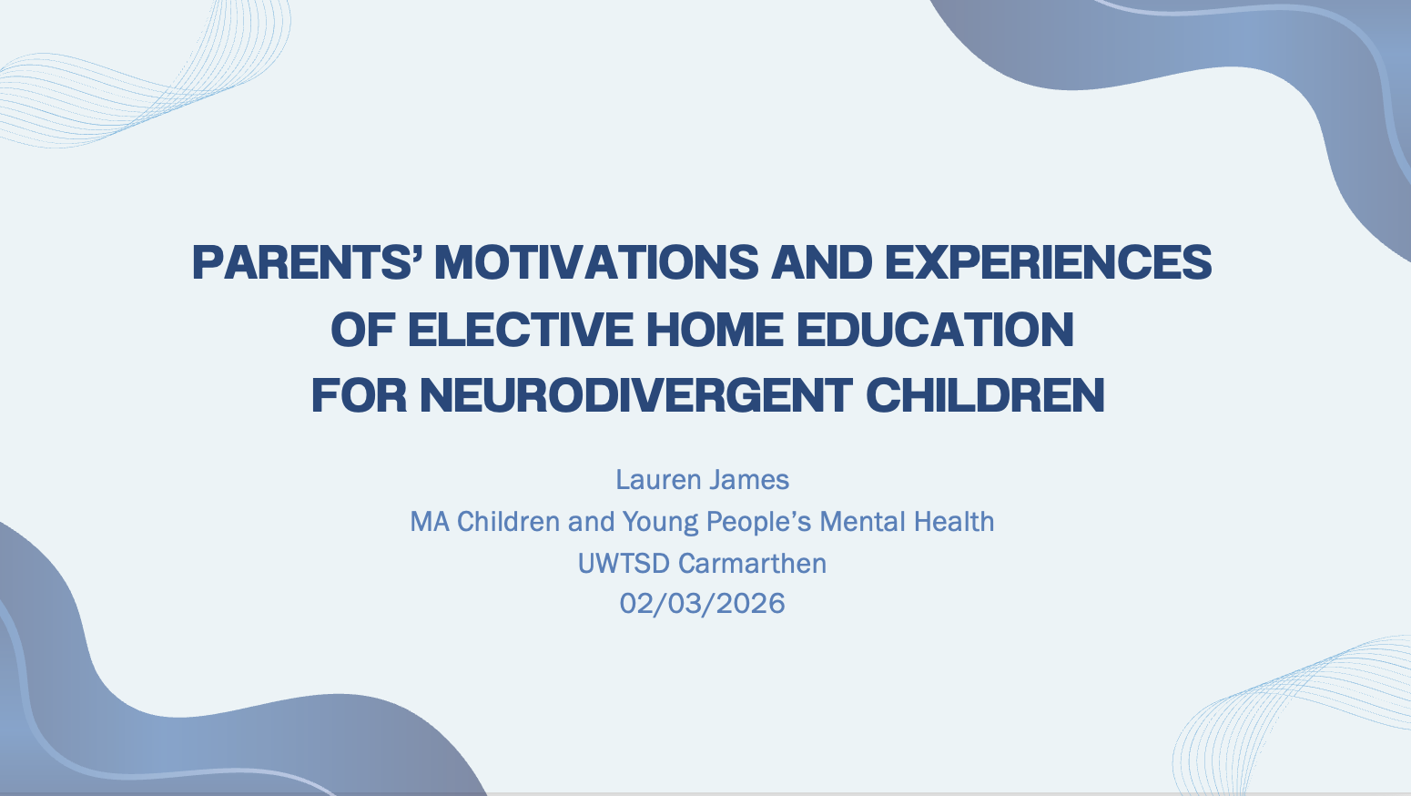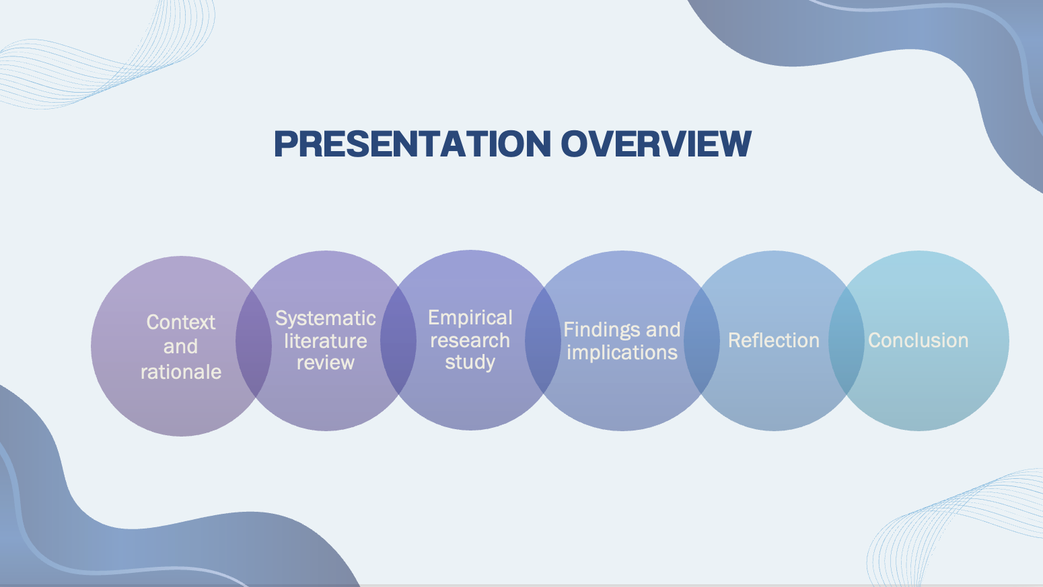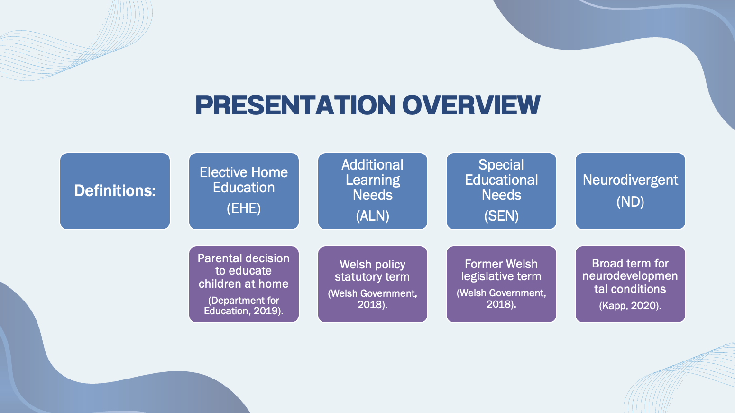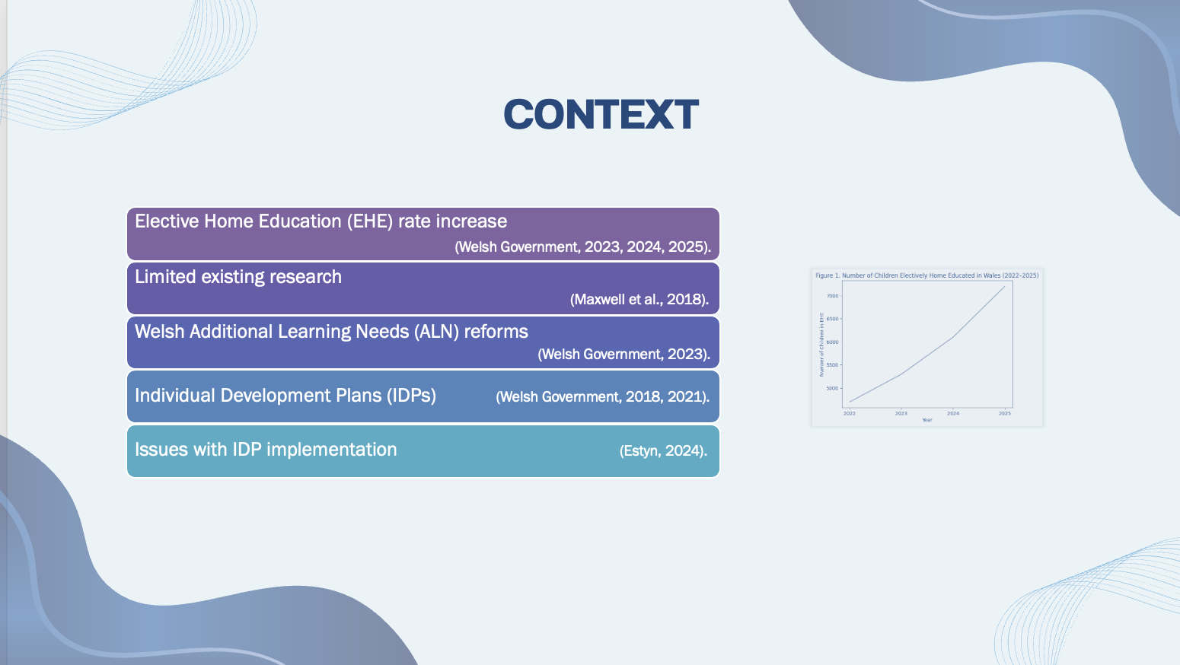
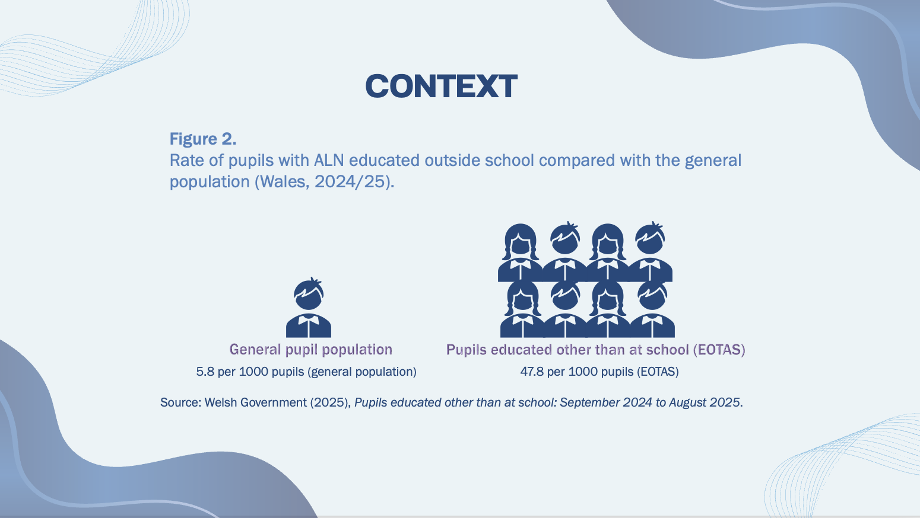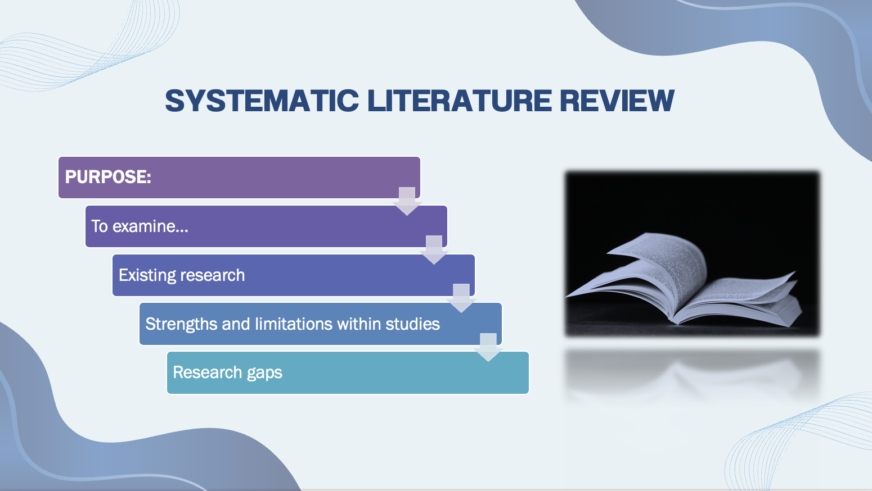
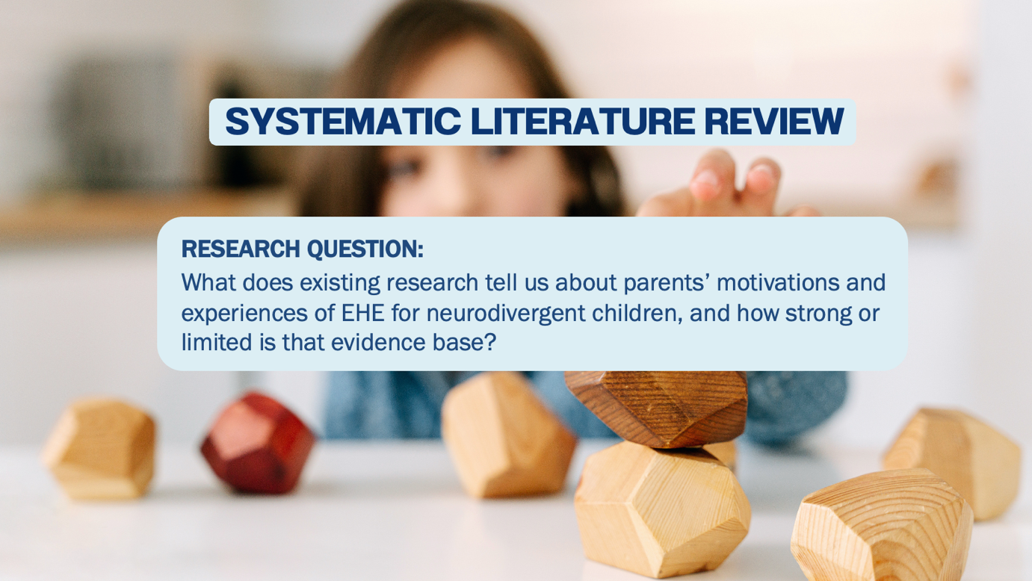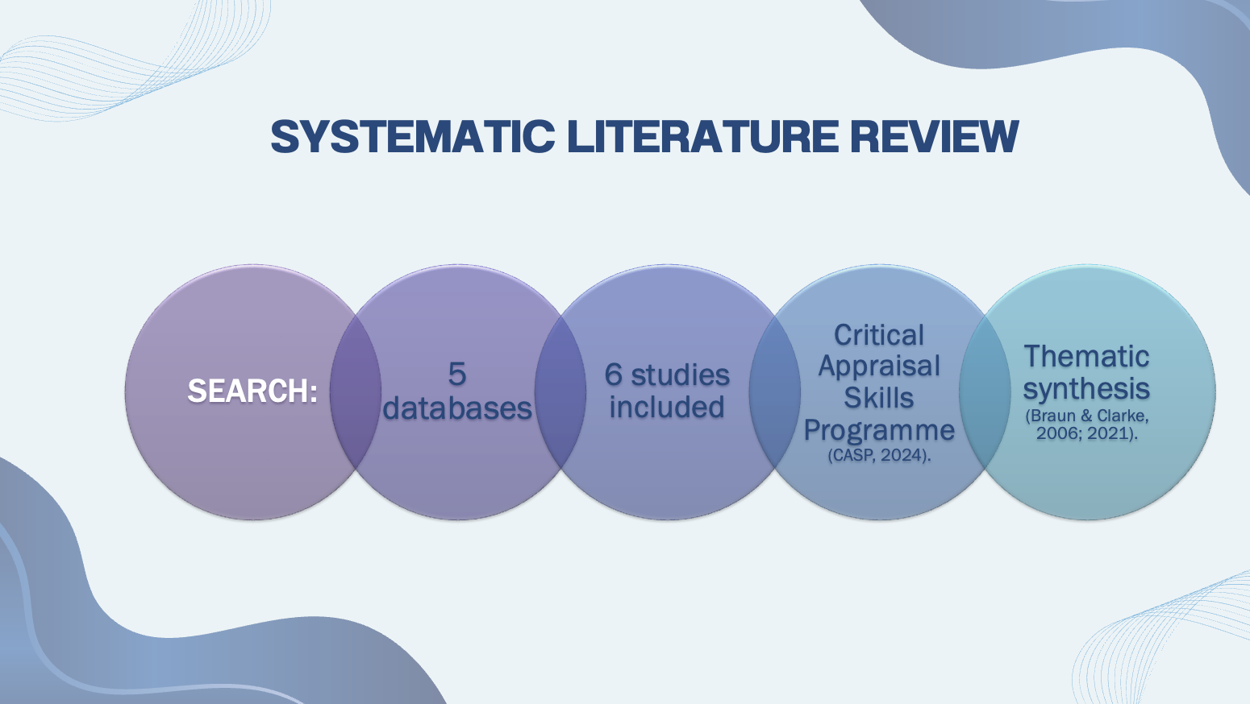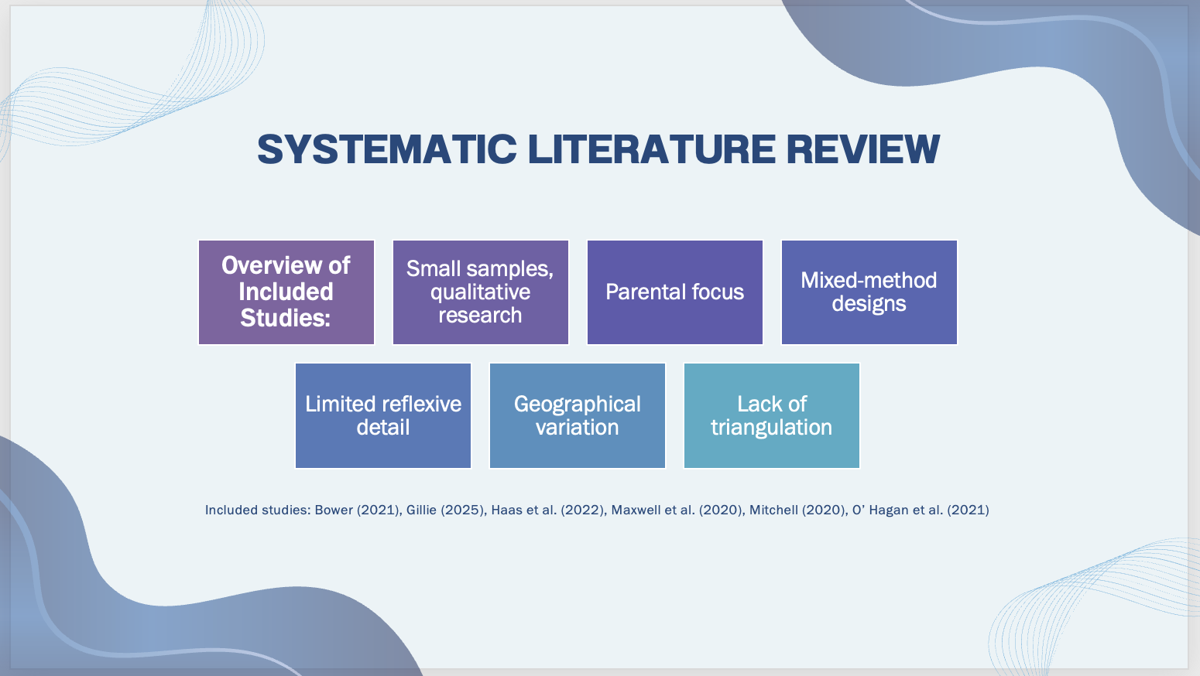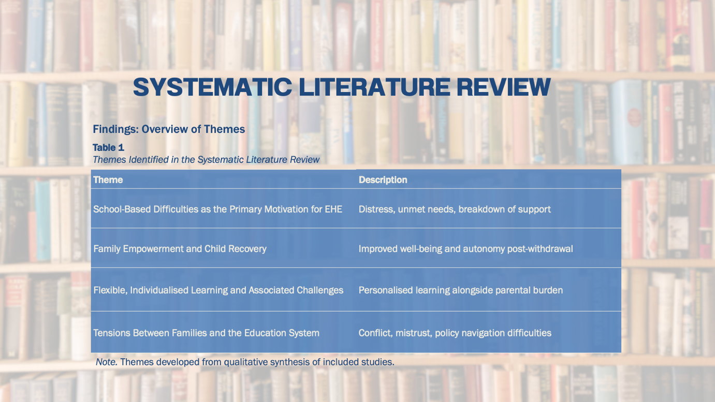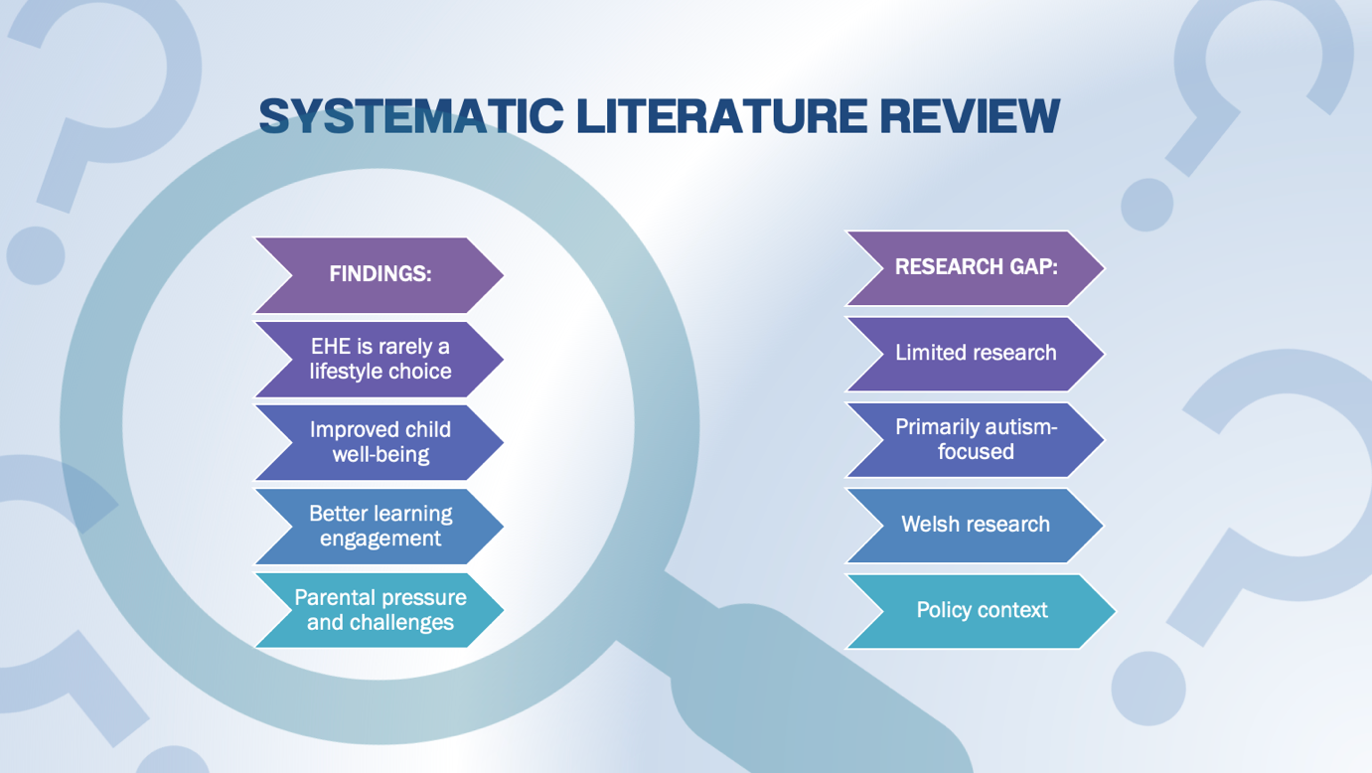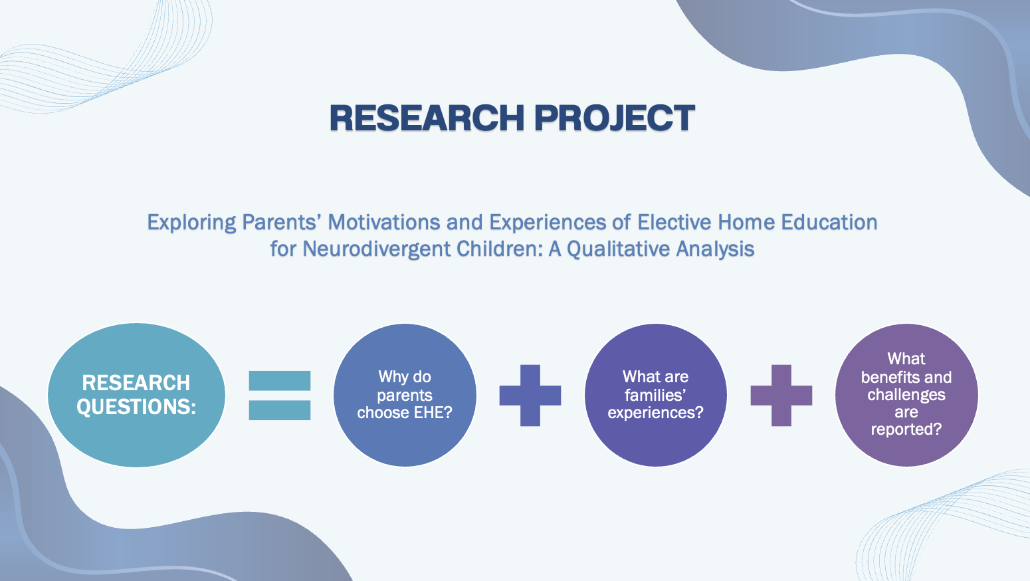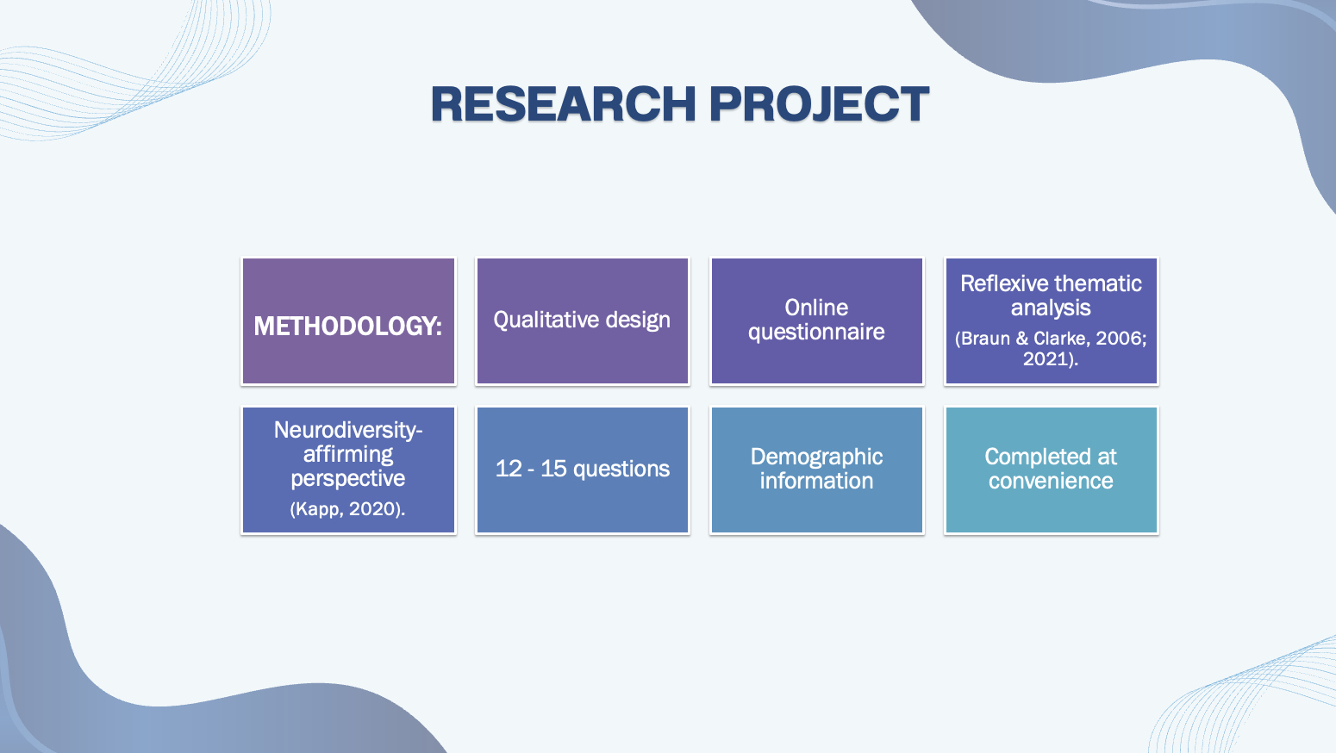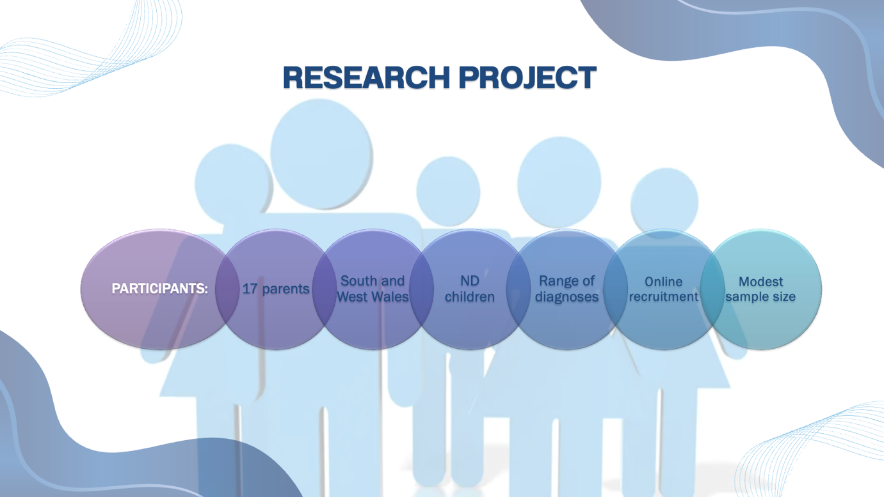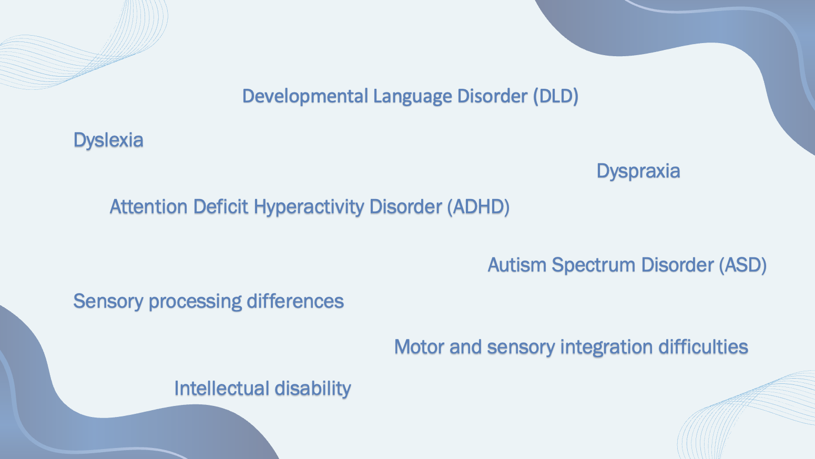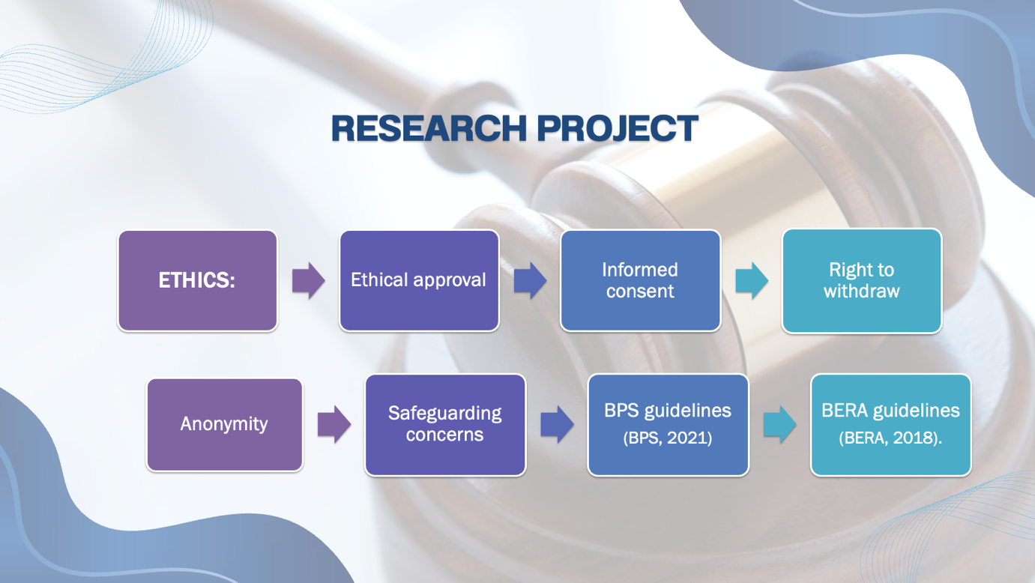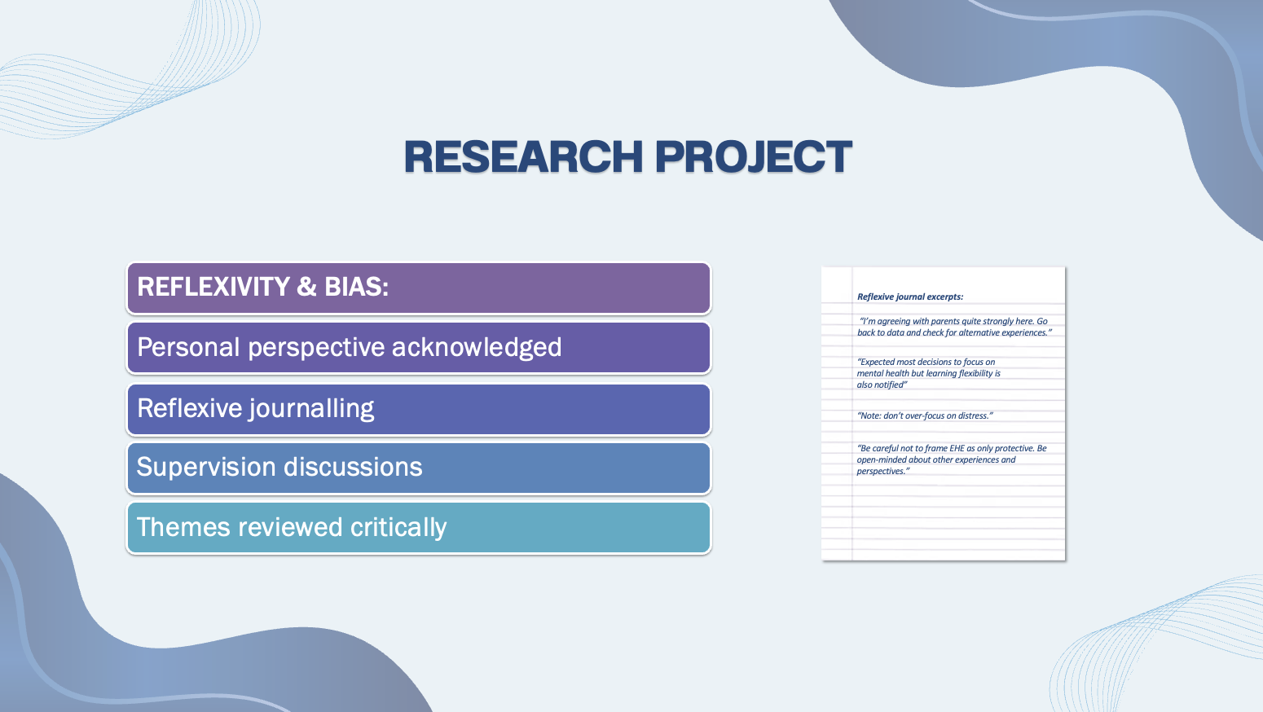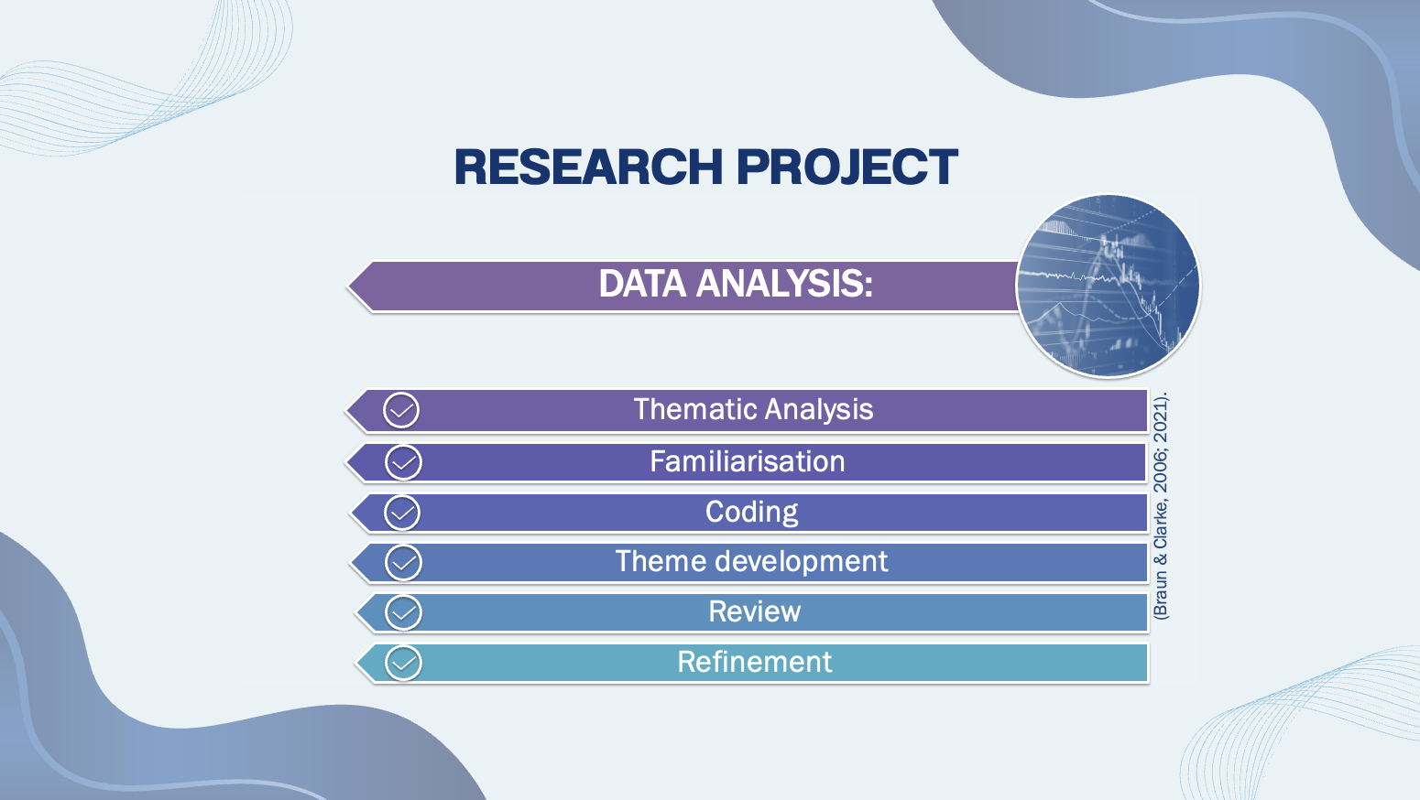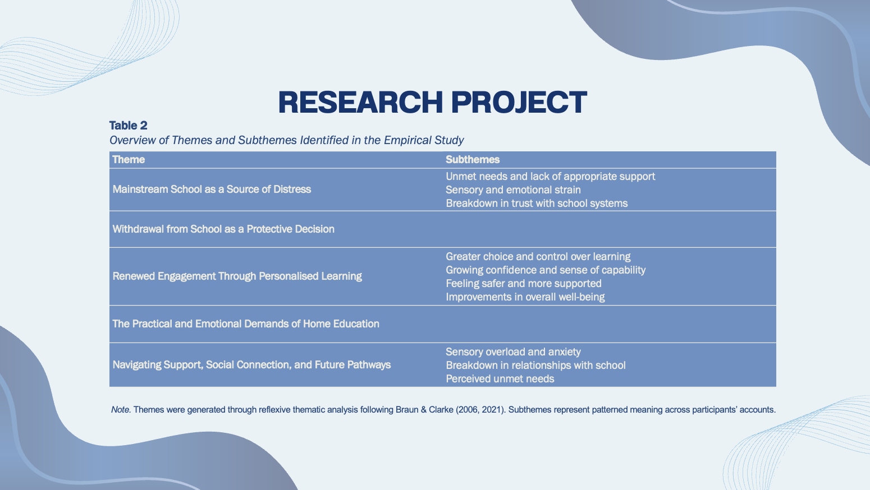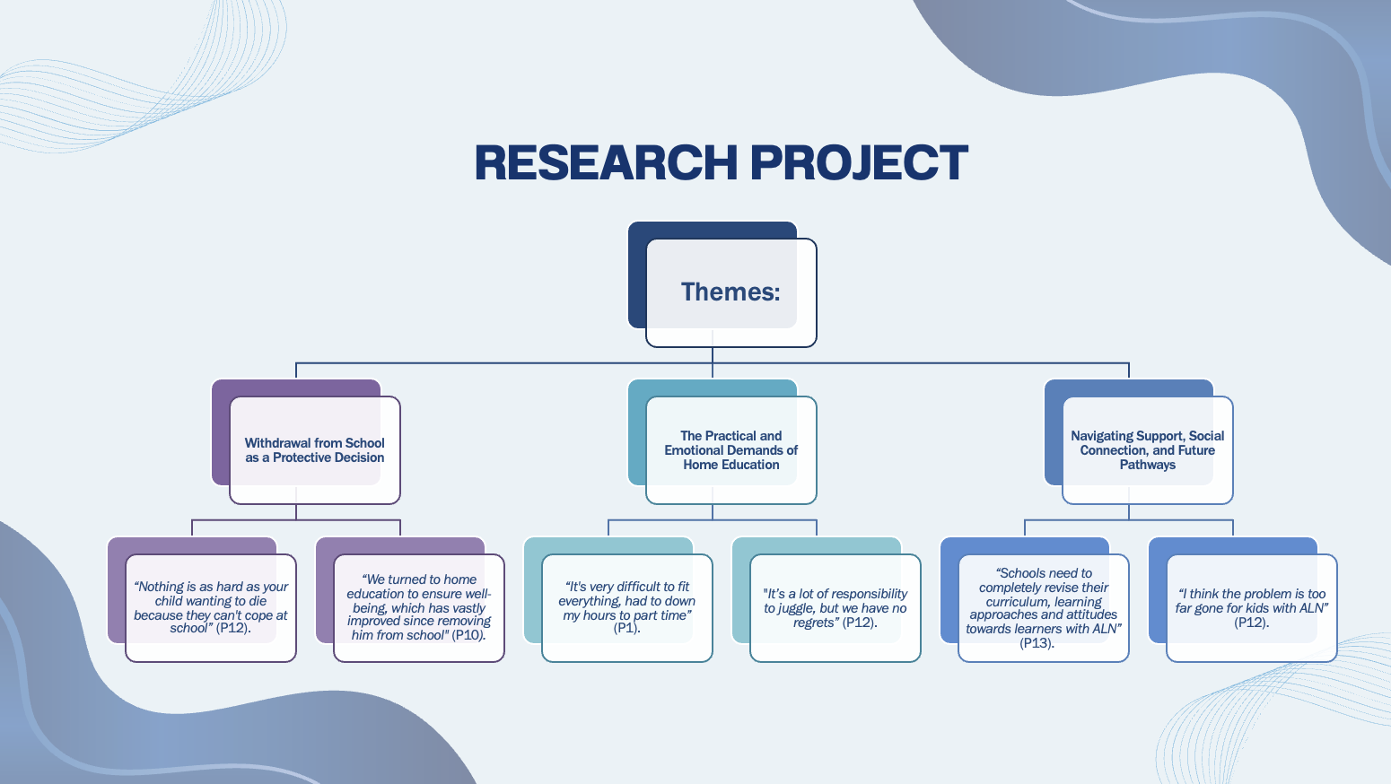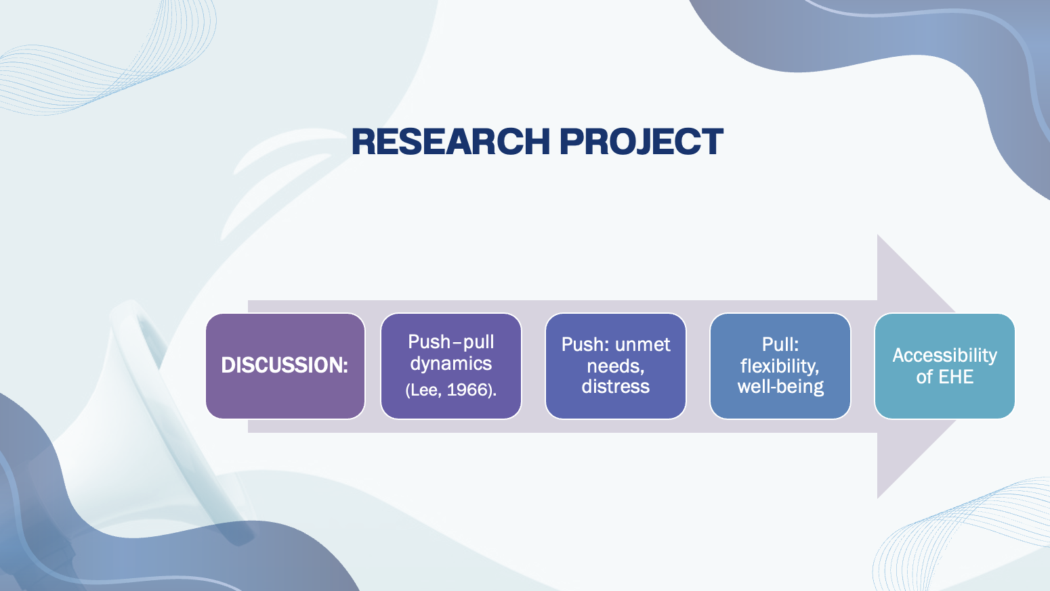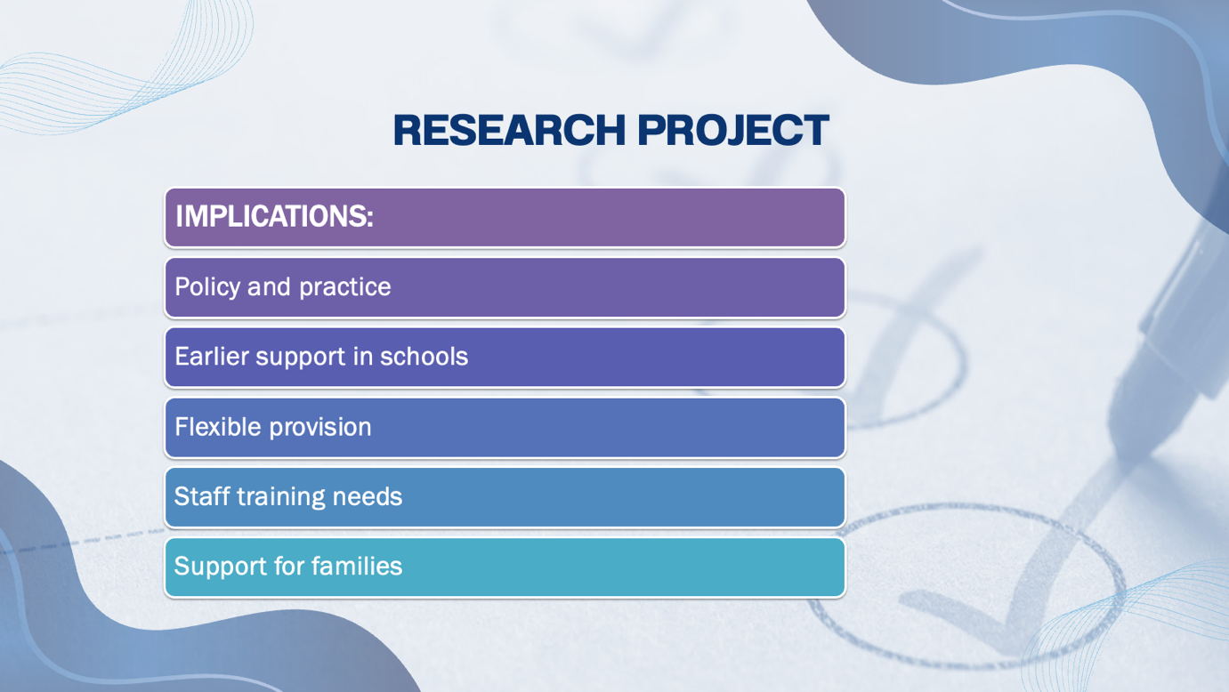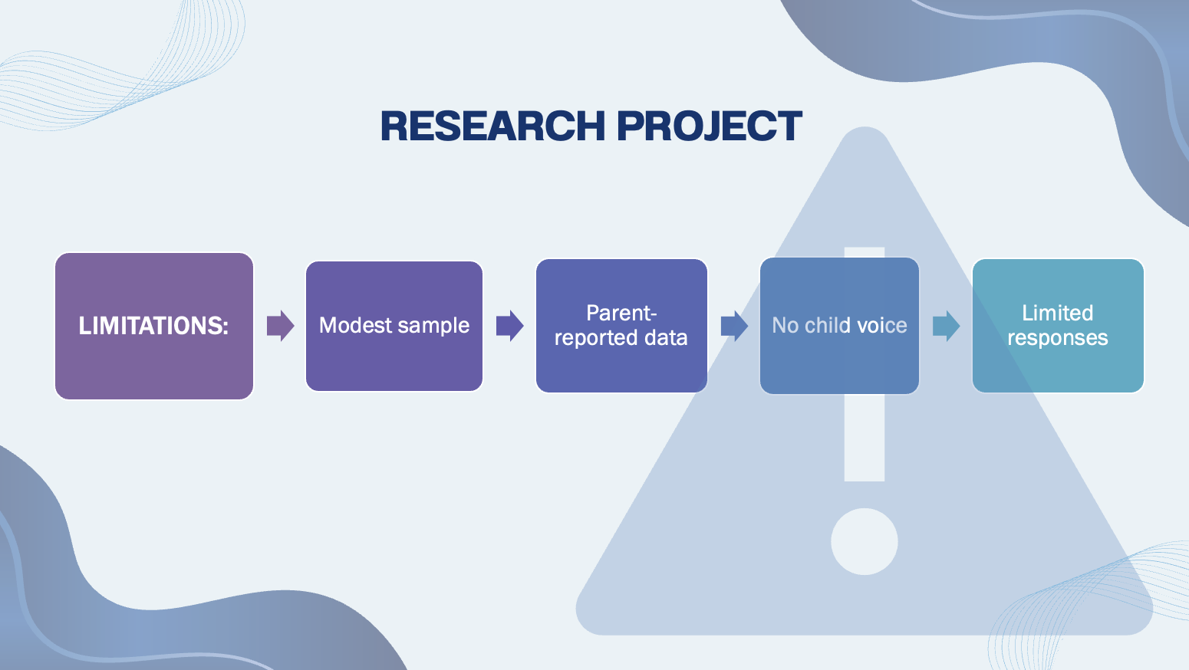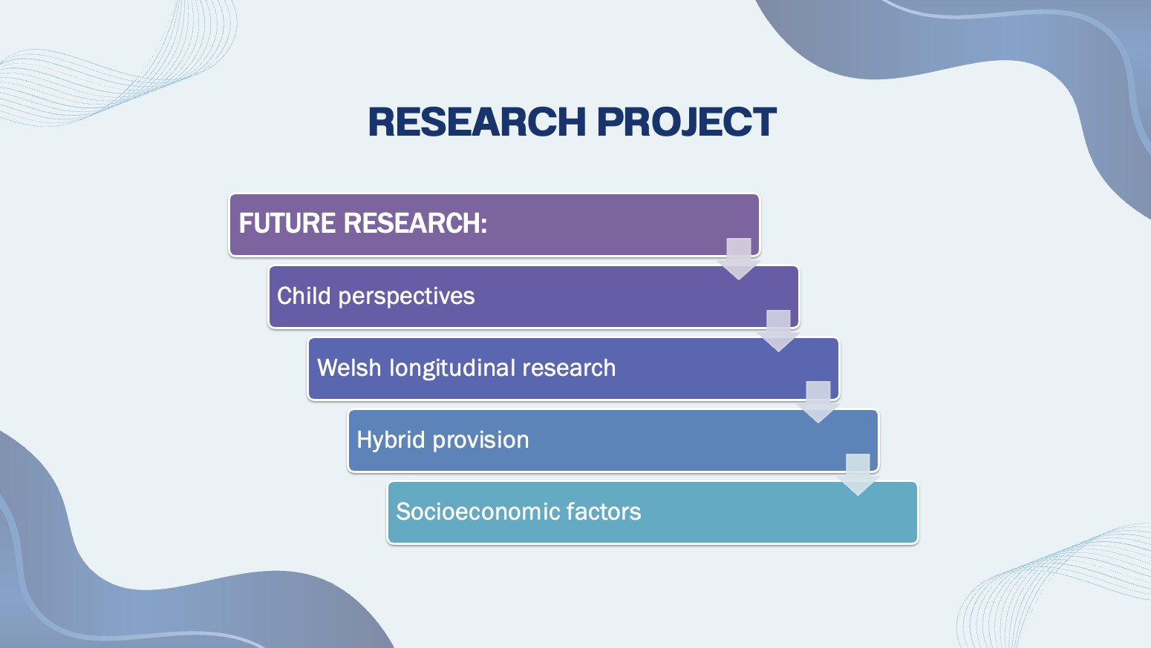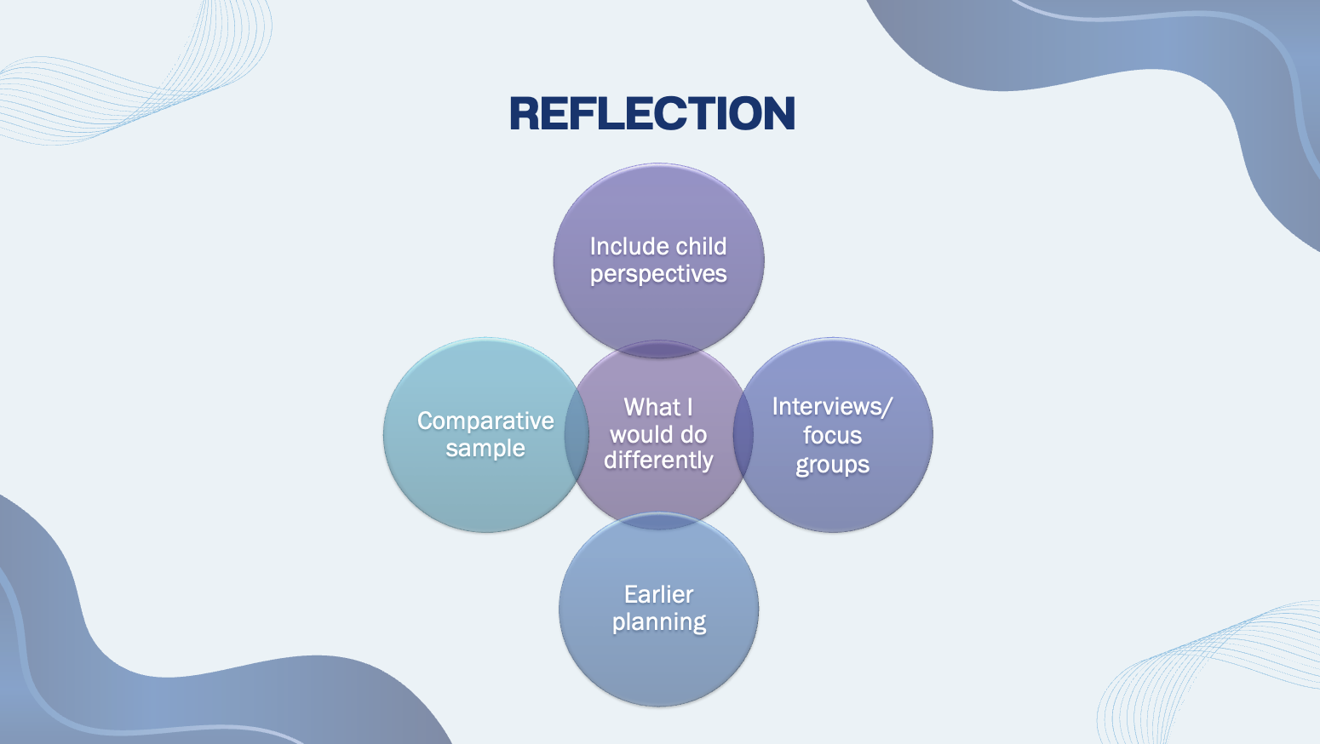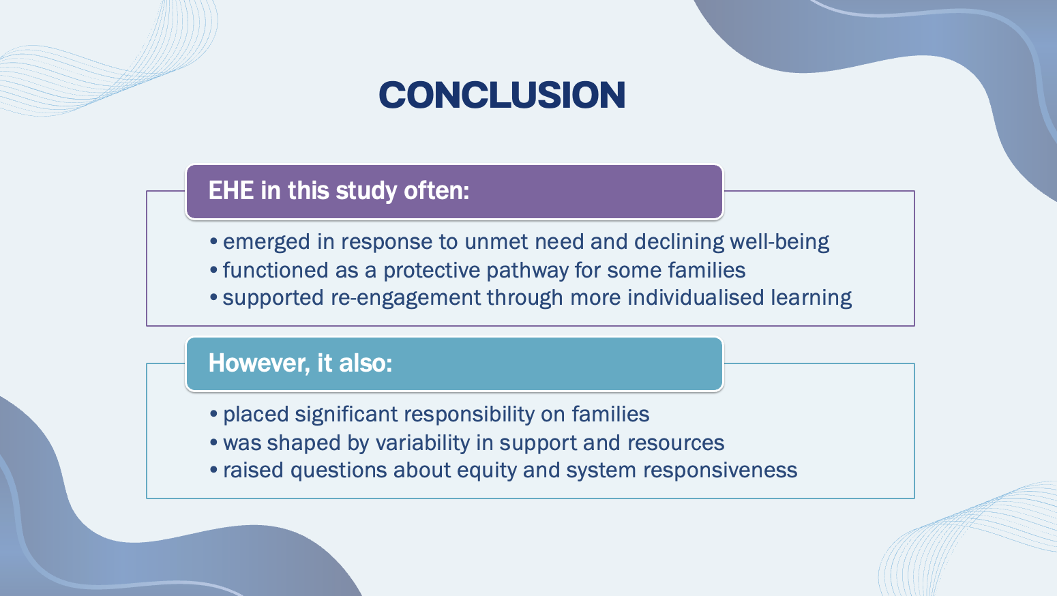


Script
SLIDE 1.
Good evening, my name is Lauren James, and this is my dissertation presentation, which explores parents’ motivations for and experiences of Elective Home Education for neurodivergent children.

SLIDE 2.
I will begin by outlining the context and the systematic literature review, then move to the empirical study, the findings, implications for policy and practice, a reflection on the research process, and finally the conclusion.

SLIDE 3.
Elective Home Education, or EHE, refers to the parental decision to educate children at home rather than through traditional forms of education, whereby parents assume full legal responsibility for providing a suitable education for their child (Department for Education, 2019). Additional Learning Needs, or ALN, is the legislative term used in Welsh policy. In contrast, Special Educational Needs, or SEN, is the former term previously used in Wales, referring to children requiring additional educational provision (Welsh Government, 2018). Whereas neurodivergence is used as a broader conceptual term for neurodevelopmental differences (Kapp, 2020; Welsh Government, 2018). While the categories are not identical, there is overlap between the groups discussed in this study.

SLIDE 4.
EHE is increasing in popularity throughout Wales, although research into the reasons for this remains limited (Maxwell et al., 2020).
This area is important for understanding this trajectory in the context of policy developments in Wales, particularly the ALN reforms (Welsh Government, 2023). The ALN and Education Tribunal (Wales) Act 2018 introduced a new statutory framework that replaced the former Special Educational Needs, or SEN, system for learners aged 0–25 (Welsh Government, 2018). This was enacted through the ALN Code and implementation guidance (Welsh Government, 2021; 2023).
Central to these reforms was the introduction of Individual Development Plans, or IDPs, intended to ensure timely, needs-led support for learners with ALN (Welsh Government, 2018; 2021).
However, the effectiveness of IDPs remains varied, with ongoing inconsistency in the implementation of provision and inclusive practices across schools and authorities (Estyn, 2024).

Slide 5
Welsh Government data also indicates a clear overrepresentation of pupils with ALN or SEN provision among those mainly educated outside mainstream schools.
This visual illustrates the scale of that difference. In 2024/25, the rate for pupils with ALN/SEN educated outside school was more than eight times higher than that of the general pupil population (Welsh Government, 2025).
Although these figures refer to EOTAS rather than EHE specifically, they illustrate a broader pattern of pupils with ALN being educated outside mainstream settings.
This provides an important contextual background for understanding parental decisions regarding home education and raises questions about inclusion, support, and how effectively mainstream schooling meets diverse needs.
Next, I turn to the systematic literature review.

SLIDE 6
The aim of the systematic literature review was to synthesise existing research on parental motivations, experiences, and reported outcomes of EHE for neurodivergent children.
While EHE has become increasingly visible in policy and practice (Welsh Government, 2025), the research base remains relatively small (Maxwell et al., 2018). Therefore, the review was guided by the following research question:

SLIDE 7.
What does existing research tell us about parents’ motivations and experiences of EHE for neurodivergent children, and how strong or limited is that evidence base?

SLIDE 8.
The search was conducted across five academic databases. Studies were included if they were peer-reviewed, qualitative, and focused on parents of neurodivergent children who had chosen to withdraw their child from school.
Six studies met the inclusion criteria and were appraised using the Critical Appraisal Skills Programme/ CASP qualitative checklist (CASP, 2024) to assess methodological quality and credibility. The studies were then synthesised using thematic analysis (Braun & Clarke, 2006; 2021) to identify patterns across the literature.
Studies were excluded if they did not focus on neurodivergent learners, were not peer reviewed, or did not report parental perspectives on EHE.
Although the number of studies was small, they provided useful insight into parental experiences and highlighted areas requiring further research.
With that context in mind, I will briefly outline the features of the included studies.

SLIDE 9
From the studies that met the inclusion criteria, the majority employed qualitative designs and involved relatively small samples (Bower, 2021; Gillie, 2025; Haas et al., 2022; Maxwell et al., 2020; Mitchell, 2020). One mixed-method study provided broader contextual data, although reflexive detail regarding the researchers' positionality was inconsistently reported across the literature, reducing transparency into how interpretations were developed. Geographically, most studies were conducted in England or the wider UK, alongside one Australian study, and only one study was specifically based in Wales (Maxwell et al., 2020).
Across the evidence base, there was a strong reliance on parent perspectives, with minimal inclusion of pupil or teacher voices. There was also a lack of diverse diagnoses among children in the literature (Bower, 2021; Haas et al., 2022).
Despite the relatively small and highly parent-focused evidence base, the studies provided valuable insight into parental decision-making but also reinforced the need for further research in Wales.

SLIDE 10.
Four key themes were identified across the literature and are presented here.
Together, these themes suggest that decisions to home educate are shaped by complex interactions between school experiences, child well-being, and family circumstances.
These findings will now be discussed in more detail.

SLIDE 11.
Across the literature, families often describe EHE as a reluctant last resort, yet many also report notable improvements in children’s well-being and engagement after being deregistered from the school system (Bower, 2021; Gillie, 2025; Maxwell et al., 2020).
At the same time, parents report significant pressures, including social isolation and the challenge of managing dual roles as educators and carers (Haas et al., 2022; Mitchell, 2020).
These findings highlight a complexity within the literature: EHE can represent resilience and adaptation within family units, while also reflecting structural challenges within formal education systems (O’Hagan et al., 2021). The evidence base remains limited in scope, consisting of a small number of predominantly qualitative studies. Most studies were conducted within the UK, with minimal international representation (Haas et al., 2022; O’Hagan et al., 2021). Several focus specifically on autism (Bower, 2021; Haas et al., 2022), with fewer examining broader neurodivergent or ALN profiles (Maxwell et al., 2020; Mitchell, 2020). International literature often uses the term “homeschooling”, reflecting regulatory frameworks that differ from the legislative context of EHE in Wales. There is also limited exploration of how families navigate Welsh education policy under the ALN legislation (Welsh Government, 2018).
These geographical and conceptual gaps highlight the need for Wales-focused qualitative research exploring parents’ motivations and experiences of EHE in greater depth.
These gaps directly informed the design of the empirical study, which I will now outline.

SLIDE 12.
The study was guided by three research questions:
- Why parents choose home education
- What families' experiences are
- What benefits and challenges they report.
These questions were designed to address the gaps identified in the literature.

SLIDE 13.
A qualitative design was used and data collected via an online open-ended questionnaire. This method enabled parents across Wales to participate and provided flexibility for families who may have found it difficult to attend interviews or focus groups due to caregiving responsibilities. Data were analysed using reflexive thematic analysis, chosen for its flexibility in identifying patterns while supporting ongoing reflexivity.
A neurodiversity-affirming perspective informed the study throughout (Kapp, 2020). Neurodivergence was understood as an individual difference rather than a deficit, and the focus remained on understanding experiences from parents’ perspectives without pathologising children’s needs.
The questionnaire included approximately 12 to 15 open-ended questions, along with brief demographic items, such as parent age, child age and diagnosis, and length of time home educating. Questions were designed to elicit reflective and narrative responses rather than short factual answers.
For example, parents were asked to describe their child’s experience of mainstream school prior to home education, the factors influencing their decision to withdraw, and how home education had affected their child’s well-being and engagement with learning.
Participants could respond in as much or as little detail as they wished and could skip any questions. Completion times varied considerably, from around six minutes to over three hours, with most taking between fifteen and forty-five minutes, depending on the depth of responses.
The online format allowed parents to complete the questionnaire at their own pace and at a time that suited them, which was particularly important given the demands of caregiving and home education.

SLIDE 14.
Seventeen parents met the inclusion criteria and took part in the study. Participants were primarily based in Carmarthenshire, with ages ranging from 28 to 49 years. The sample consisted predominantly of mothers, with two fathers participating, which may reflect broader gendered patterns in caregiving within home education.
Eligibility required participants to currently be home-educating at least one neurodivergent child, or to have done so within the last 12 months, and for children to have previously attended mainstream school. Participants were recruited through home-education networks and social media groups. Participation was voluntary, and no incentives were offered.
Most parents were home-educating one child, although several were educating more than one. The children ranged from primary to secondary school age, and families had been home educating for varying lengths of time, from less than a year to several years. This meant the data reflected both early transition experiences and longer-term perspectives from families who had been home educating for some time.

SLIDE 15.
This slide summarises the range of neurodivergent profiles represented in the dataset.
Many children had co-occurring needs, reflecting the complexity often reported in home-educating populations. The purpose of presenting this information is not to compare diagnostic categories, but to provide context for the findings and highlight the diversity of needs that families were supporting.

SLIDE 16.
Ethical approval was obtained prior to data collection. Participants provided informed consent and were notified of their right to withdraw at any time. Confidentiality, data protection, and safeguarding procedures were followed throughout.
The study also adhered to the British Psychological Society (BPS, 2021) and British Educational Research Association (BERA, 2024) ethical guidelines, which were particularly important given the sensitive nature of the topic and the involvement of families discussing children’s well-being and education.
Participants were also provided with information about local support services in case completing the questionnaire caused any distress. They were also informed that any disclosure indicating a risk to child welfare would be managed in line with the university's safeguarding procedures. Following completion of the questionnaire, participants received a debrief outlining the study's purpose, how the data would be used, and contact details for questions or a summary of findings.

SLIDE 17.
Reflexivity was central to the research process. As someone with personal experience of home education, I remained aware of how this could shape my interpretation.
I used supervision and a reflexive journal to critically examine assumptions and consider alternative perspectives. Throughout the analysis, I revisited the dataset to ensure themes were grounded in participants’ accounts rather than my personal expectations.

SLIDE 18.
The data was analysed using reflexive thematic analysis (Braun & Clarke, 2006; 2021).
I familiarised myself with the dataset through repeated reading before generating initial codes and organising these into potential themes. The themes were then reviewed and refined to ensure clarity and distinction.

These themes will be elaborated on in the following slide.

SLIDE 19.
The analysis generated five interconnected themes, shown here in the table. These themes reflect both the factors that led families to withdraw from mainstream education and their experiences of supporting neurodivergent children outside the school system. Together, they suggest that EHE was rarely experienced as a simple choice. Instead, it emerged as a complex response shaped by children’s needs, school experiences, and family circumstances.
For the purpose of the presentation, I will discuss three of these themes in more depth.

SLIDE 20.
The three most central themes to parents’ decision-making and ongoing experiences were:
Withdrawal from school as a protective decision, which reflects how parents often described deregistering their child from school as a reaction to escalating distress, unmet needs, or declining mental health for their child. Withdrawal was rarely framed as a proactive lifestyle choice and was more often presented as a necessary step to safeguard children’s well-being.
The practical and emotional demands of home education. Families expressed significant duties that came with assuming full responsibility for their child’s education. This included financial pressures, time commitments, and emotional labour. Navigating support, social connection and future pathways. Parents described mixed experiences when attempting to access services and support. Many also expressed concerns about long-term educational and social outcomes as they sought to create alternative opportunities and support networks.

SLIDE 21.
These findings suggest that, for this group of families, EHE was rarely framed as an ideological preference. Instead, it was explained as a response to cumulative unmet needs within mainstream schooling.
Parents’ accounts reflected a dynamic interplay between push and pull factors (Lee, 1966). Push factors, including perceived failure of support, escalating distress, and a breakdown of trust, were central to the decision to withdraw.
Pull factors such as flexibility, individualised pacing, and relational safety were described as sustaining EHE over time.
T he findings are consistent with the earlier literature, particularly regarding school-based distress and deregistration as a protective factor for child well-being (Bower, 2019; Gillie, 2025; Maxwell et al., 2020). However, this study adds Wales-specific insights, especially regarding ALN policy implementation (Welsh Government, 2018; 2021), and reflects a broader range of neurodivergent profiles than is typically represented in the predominantly autism-focused literature (Haas et al., 2022; Mitchell, 2020).
Parents often reported improvements in well-being, but these were accompanied by increased workload, constraints, and reduced formal support, leaving families to manage much of the ongoing demand themselves.
Overall, EHE appeared to operate as a protective mechanism within the context of cumulative unmet need. Rather than a simple alternative to school, it emerged as a complex and demanding response to circumstances that families felt unable to resolve within mainstream provision.

SLIDE 22.
These findings have several implications for policy and practice.
First, they highlight the importance of earlier and more responsive support for neurodivergent children within mainstream education. Many parents described repeated attempts to secure appropriate provision before deregistering their child, suggesting that more timely and flexible support may reduce escalation to a crisis point.
As discussed in relation to the Welsh ALN reforms (Welsh Government, 2023), several parents described delays or inconsistencies in the development and implementation of IDPs, indicating that policy effectiveness depends not only on legislation but on consistent application in practice.
The findings also point to the need for greater professional understanding of neurodivergence, including school-related anxiety and flexible approaches to attendance and learning. This approach to practice may strengthen trust between families and education providers.
Finally, the findings raise questions about equity. Sustaining home education requires time, capacity, and resources that may not be equally available to all families. This highlights the importance of ensuring that mainstream education systems are sufficiently responsive to diverse needs before families reach a point of withdrawal as their only option.

SLIDE 23.
Several limitations should be considered when interpreting these findings.
This was a modest sample recruited via a home-education network. While participants represented families at different stages of EHE, recruitment through established networks may mean the sample reflects those already connected to support communities, potentially underrepresenting families who are less connected to established home-education communities. The study also relied on parent report; while this is well-suited to understanding parental decision-making, it does not include children and young people’s perspectives. The use of an online qualitative questionnaire supported accessibility and participation, but it also limited opportunities for follow-up probing or clarification. Interviews may have enabled deeper exploration of some experiences and allowed emerging points to be explored in more detail.
Despite these limitations, the study contributes valuable Wales-specific insights to a relatively under-researched area.

SLIDE 24.
This study also highlights several areas for future research, including the perspectives of children and young people educated outside traditional school settings. This would provide a fuller understanding of children’s experiences alongside parental accounts.
Larger-scale or longitudinal research within Wales could explore longer-term educational and well-being outcomes for neurodivergent learners educated at home, particularly in relation to transitions into further education or employment.
Research could also explore hybrid or flexible arrangements between home and school, as some families described navigating partial or informal arrangements between settings.
Comparative research examining families who considered but ultimately did not opt for EHE could also provide insight into factors that support neurodivergent children's continued participation within mainstream education.
Finally, future research should evaluate how socioeconomic factors shape access to EHE and whether it functions as an equitable option across different family contexts.

SLIDE 25.
I will now briefly reflect on the research process using Gibbs’ reflective cycle (Gibbs, 1988), focusing on key learning points and challenges encountered throughout the dissertation.
Conducting this research highlighted the importance of reflexivity and managing my personal and professional connection to the topic. Although my experience supported contextual understanding, it also required careful awareness of potential bias.
Maintaining a reflexive journal and engaging in supervision helped mitigate this risk.
One of the most significant learning points was the practical complexity of conducting research with families who are home educating. Recruitment proved more challenging than anticipated, particularly within a community that, in my experience, was cautious about engaging with research. This required me to change my initial methodology from focus groups, despite many people expressing interest in participating in the study, which felt frustrating and uncertain, particularly given the time constraints. However, it further developed my understanding of the caregiving demands placed on parents and reinforced the importance of flexibility, transparency, and trust when engaging with participants. Consistent with the ethical principles outlined by the British Psychological Society (2021).
The research's emotional impact was also notable. Reading accounts of children’s distress required careful management of my emotional responses to maintain analytical focus. This highlighted the importance of upholding professional boundaries while remaining empathetic to participants’ experiences.

Overall, this research process strengthened my understanding of qualitative methods, ethical practice, and reflexive awareness when researching sensitive topics.

SLIDE 26.
Reflecting further, there are several aspects I would handle differently if I were to conduct the study again.
I would aim to include children and young people’s perspectives where appropriate and ethical. While this study focused on parental experiences, incorporating children’s voices would provide a more holistic and perceptual understanding of educational experiences and outcomes from the child's viewpoint.
I would also reconsider using focus groups or interviews alongside questionnaires. Although the online questionnaire supported accessibility and participation, my initial plan of focus groups may have enabled deeper exploration of individual experiences and allowed follow-up questions to further develop themes.
I would also aim to recruit a comparative sample, as previously mentioned, to provide contextual insight into alternative decision-making processes for educating neurodivergent children.
Earlier planning of recruitment strategies would also be beneficial. Recruitment proved more challenging than anticipated, and starting this process earlier may have generated a broader, more diverse sample.

Overall, these reflections highlight the importance of flexibility, forward planning, and inclusive research design.

SLIDE 27.
In conclusion, this study provides Wales-specific insight into parents’ motivations and experiences of EHE for neurodivergent children.
Withdrawal from school was most often described as a response to unmet need, declining well-being, and perceived inflexibility within mainstream provision, rather than as a purely elective or lifestyle choice. For many families, EHE functioned as a protective pathway, associated with improved well-being and re-engagement through more individualised learning.
However, this also introduced significant practical and emotional demands and was shaped by variability in available support.
The findings highlight how inclusive policy reforms, including the introduction of IDPs under the Welsh ALN framework (Welsh Government, 2023; Welsh Government, 2018), are experienced in practice. Inconsistencies in implementation appear to influence parental decision-making.
Strengthening timely, consistent ALN support and developing more flexible educational pathways may help reduce situations where families feel that deregistration from school is the only viable option. Greater alignment between policy intentions and children’s experiences may help ensure that decisions about provision are guided by child well-being and access to appropriate support, rather than by gaps in facilitation.
Overall, this research contributes to a growing evidence base in Wales and underscores the importance of responsive, collaborative, and flexible education systems for neurodivergent learners and their families.

SLIDE 28.
Thank you for listening.
I’m happy to take any questions or comments.

References
Bower, C. (2021). ‘Um, I was getting bullied at school because I didn’t believe in God’: One family’s experience of autism, school and home education. International Journal of Inclusive Education, 25(8), 914-927. https://doi.org/10.1080/13603116.2019.1588926
Braun, V., & Clarke, V. (2006). Using thematic analysis in psychology. Qualitative Research in Psychology, 3(2), 77-101. https://doi.org/10.1191/1478088706qp063oa
Braun, V., & Clarke, V. (2021). Thematic analysis: A practical guide (ISBN 9781473953246). SAGE Publications Ltd.
British Educational Research Association. (2024). Ethical guidelines for educational research (5th ed.). www.bera.ac.uk/publication/ethicalguidelines-for-educational-research-2024
British Psychological Society. (2021). Code of human research ethics (2nd ed.). https://doi.org/10.53841/bpsrep.2021.inf94
Critical Appraisal Skills Programme. (2024). CASP Qualitative Studies Checklist. https://casp-uk.net/casp-checklists/CASP-checklist-qualitative-2024.pdf
Department for Education. (2019). Elective home education: Departmental guidance for parents. https://assets.publishing.service.gov.uk/media/5ca21e22e5274a77d9d26feb/EHE_guidance_for_parentsafterconsultationv2.2.pdf
Estyn. (2024). Thematic report: The additional learning needs system https://estyn.gov.wales/app/uploads/2024/12/The-additional-learning-needs-system.pdf
Gibbs, G. (1988). Learning by doing: A guide to teaching and learning methods. Oxford Polytechnic.
Gillie, S. (2025). ‘It feels like we’re out of the rat race’: Family reflections on traumatic school experiences leading to home education. British Journal of Special Education. Advance online publication. https://doi.org/10.1111/1467-8578.70004
Haas, K., Carter, M., Stephenson, J., & Gibbs, V. (2022). Benefits and challenges of a hybrid distance education program for autistic school-age students: Parent, student and teacher perspectives. Australasian Journal of Special and Inclusive Education, 46(1), 62–75. https://doi.org/10.1017/jsi.2022.2
Kapp, S. K. (2020). Autistic community and the neurodiversity movement: Stories from the frontline. Palgrave Macmillan. https://doi.org/10.1007/978-981-13-8437-0
Lee, E. S. (1966). A theory of migration. Demography, 3(1), 47–57. https://doi.org/10.2307/2060063
Maxwell, N., Doughty, J., Slater, T., Forrester, D., & Rhodes, K. (2020). Home education for children with additional learning needs – a better choice or the only option? Educational Review, 72(4), 427–442. https://doi.org/10.1080/00131911.2018.1532955
Mitchell, E. (2020). Why English parents choose home education – a study. Education 3–13, 49(5), 545–557. https://doi.org/10.1080/03004279.2020.1742185
O’Hagan, S., Bond, C., & Hebron, J. (2021). What do we know about home education and autism? A thematic synthesis review. Research in Autism Spectrum Disorders, 80, Article 101711. https://doi.org/10.1016/j.rasd.2020.101711
Welsh Government. (2018). Additional Learning Needs and Education Tribunal (Wales) Act 2018. https://www.legislation.gov.uk/anaw/2018/2
Welsh Government. (2021). Additional Learning Needs Code for Wales 2021. https://www.gov.wales/sites/default/files/publications/2025-01/250124-the-additional-learning-needs-code-for-wales-2021.pdf
Welsh Government. (2023). Evaluation of the Additional Learning Needs system: scoping report (Summary). Welsh Government. Retrieved from https://www.gov.wales/evaluation-additional-learning-needs-system-scoping-report-summary-html
Welsh Government. (2023, September 20). Pupils educated other than at school: September 2022 to August 2023. https://www.gov.wales/pupils-educated-other-school-september-2022-august-2023-html
Welsh Government. (2024). Pupils educated other than at school: September 2023 to August 2024 (revised). GOV.WALES. Published 27 August 2024; last updated 12 September 2024.
Welsh Government. (2025, August 26). Pupils educated other than at school: September 2024 to August 2025. GOV.WALES. https://www.gov.wales/pupils-educated-other-school-september-2024-august-2025-html

