Question 5:
From the Lens-Based Image Making research strand lectures, choose a theme,
movement, or selection of artists or designers that relate to your practice or
interests, and construct a 2,500-word essay. Critically assess primary themes, key
writers, and relevant practitioners.
How Have Female Artists Used Their Practice to Respond to Issues of Female
Representation?

Katharine James
1800640
Photography in the Arts
Word Count; 2471
Paul Duerinckx

How Have Female Artists Used Their Practice to Respond to Issues of Female
Representation?

This essay will discuss the response that female figures in the art industry have towards subject
of the female representation within society, this will include the factors or objectification,
discrimination and misogyny. Throughout the work, I will be exploring different artists and
influencers whose work can relate to the themes in which I have chosen to pursue within my
own practice. Throughout history the representation of the female gender has often been
extremely negative and somehow has been completely normalized. Some of the most well-
known and successful artists including Pablo Picasso have portrayed discrimination artworks
and comments towards females. A quote from his own granddaughter, Marina Picasso “He
submitted them to his animal sexuality, tamed them, bewitched them, ingested them, and
crushed them onto his canvas. After he had spent many nights extracting their essence, once
they were bled dry; he would dispose of them.” (Lee, S. 2017).

During this essay will be a deconstruction of different examples of feminist artists and
influencers and analysing the different responses they have toward the issues of female
representation which face them and other women. This is a subject which I am extremely
passionate about am interested in using it within my own practice. Every day I am faced with
multiple different challenges just because I am a female, dealing with sexual harassment,
discrimination and misogyny. I am extremely interested in making work which will mean
something to other people and not just to benefit me. By creating work like this I know it will
help other women and reassure them that it is not just them who face issues regarding their
gender.

According to the official Tate website (N.D.), 51% of visual artists today are female, however the
representation in galleries and exhibitions, have statistics significantly lower than this. With
78% of London Galleries representing more male artists, only 5% of the galleries have equal
representation between both male and female artists.

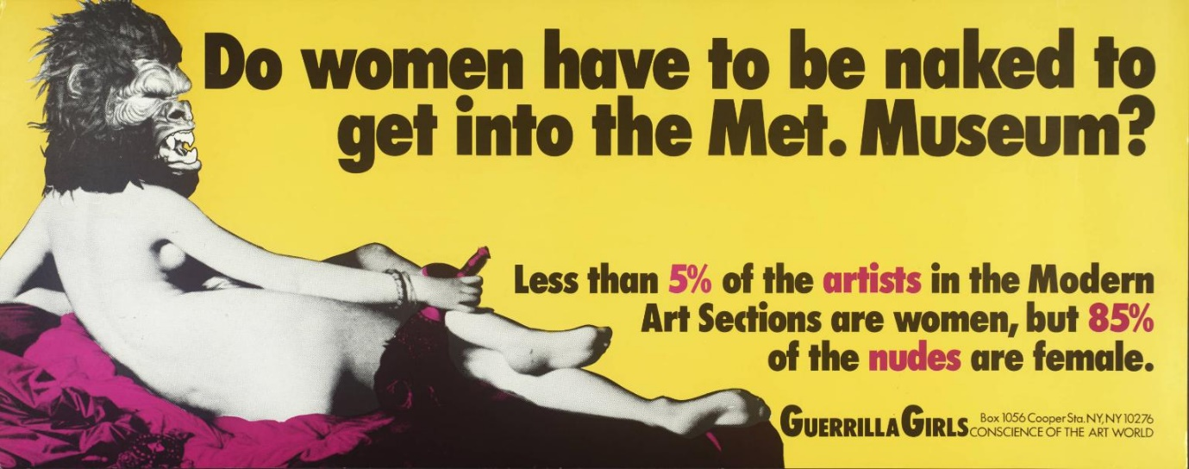
Figure 1; Do Women Have To Be Naked To Get Into the Met. Museum?
Guerrilla Girls, 1989

To start my research, I have found modern artist, Rora Blue. Her 2016 project, “Handle with
Care” includes a selection of six images which all contain different examples of sexist comments
which both the artist and other women have received. The images work extremely strongly
together, and I think that it Is an extremely helpful example with a response to feminism as it
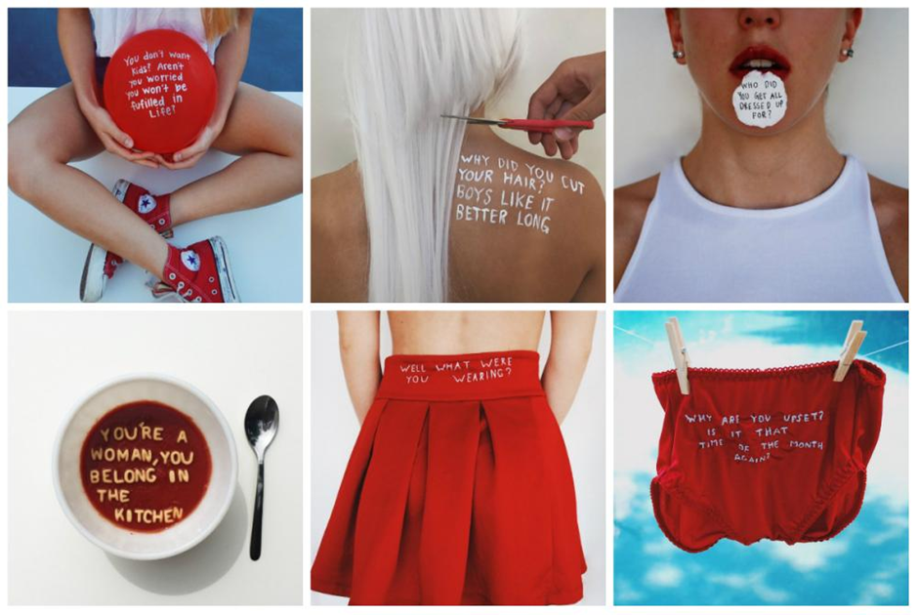
makes people more aware of what kind of comments woman must deal with.
Figure 2; Handle with Care
Rora Blue, 2016
I think that writing within imagery works well and therefore I have continued to look at artists
that use similar strategies with photographs and text, this led me to the finding of my next
subject.

Conceptual artist, Barbara Kruger is a leading light feminist within the art community, “known
for her combination of type and image that conveys a direct feminist cultural critique. Her works
examine stereotypes and the behaviours of consumerism with text layered over mass-media
images” (Kruger B, N.D.). As an artist and a female, Kruger’s work has had a lot of influence on
my practice and will continue to do in the future. Of all the pieces she has created regarding
society and gender roles, “Your Body is a Battleground”, the billboard style piece is the most
affective and meaningful towards to feminist community. The black and white image with red a
layering text, was originally created for the Women’s March in Washington in 1989, the piece
was to be used as a poster to support a women’s rights to choose. The aggressive but powerful
piece indicates to its viewers what struggles women must face and reminds them that
discrimination against women happens daily (K, Adela. 2014). The different use of colour, red
against grayscale is dramatic and bold which can suggest danger. Each red box featuring a short
however effective caption layered against the heavily contrasted black and white image. This
kind of image could easily be used or mistaken as I type of propaganda due to the association
with photo montage, it follows similarity to the propaganda Western Europe and for example,
Russian Communism

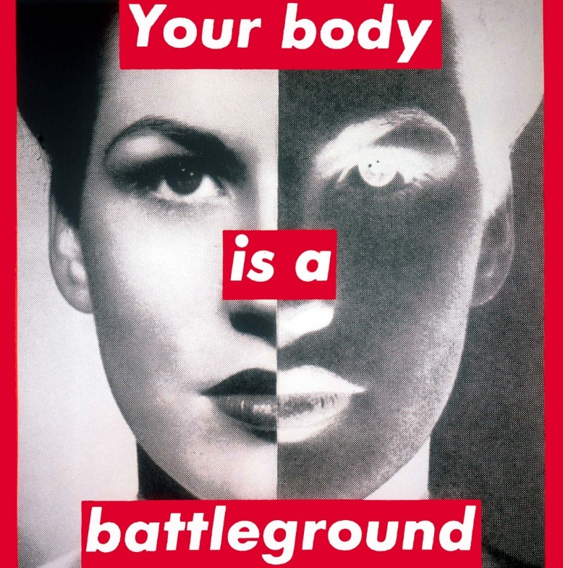

Figure 3; Your body is a Battleground
Barbara Kruger, 1989
The striking yet blunt pose pulled by the model leaves an uncomfortable feel between the
artwork and viewer because of the eye contact the model has made toward the camera, it feels
very intimidating.

To link this back to my question, I think the different techniques and styles in which Kruger
works with, are great examples of different responses from a female perspective on the different
discrimination that women face every day. Although, the work is based around female
discrimination, I think that it has a significant contribution to the development of the feminist
art practice. Due to this reasoning, I have decided to include her work within my essay.

Famous for her large portraits of the female flesh, Jenny Saville picks apart the real female body.
She often produces her canvases to be 6 by 6 foot which feature the real and raw details of the
female body, this will often include, saggy breasts, pregnant stomachs and flab. (Cohan, A.
2018). “Painters throughout history—Peter Paul Rubens, Titian, Willem de Kooning, Pablo
Picasso—have long objectified the body; the subject matter becomes newly shocking and potent
under Saville’s brush. If her oeuvre doesn’t offer a pretty picture of humanity, she believes it’s an
honest one.” (Cohan, A. 2018).

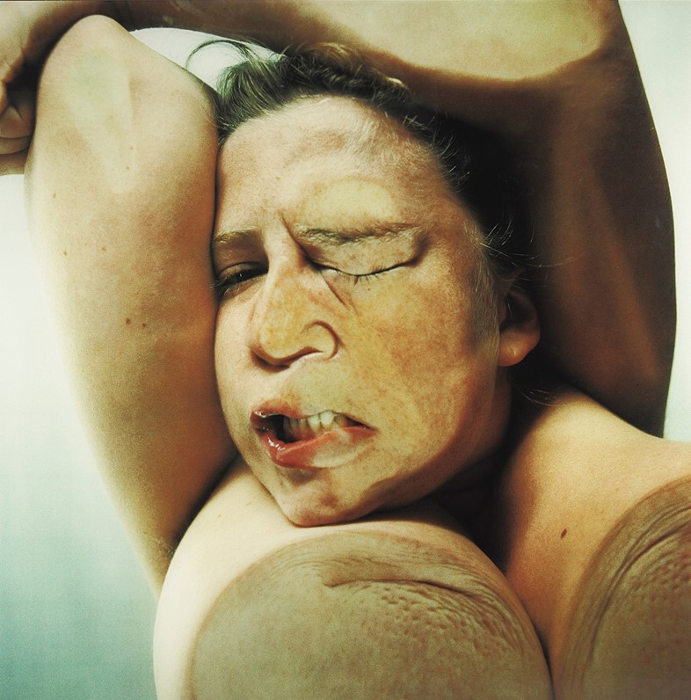

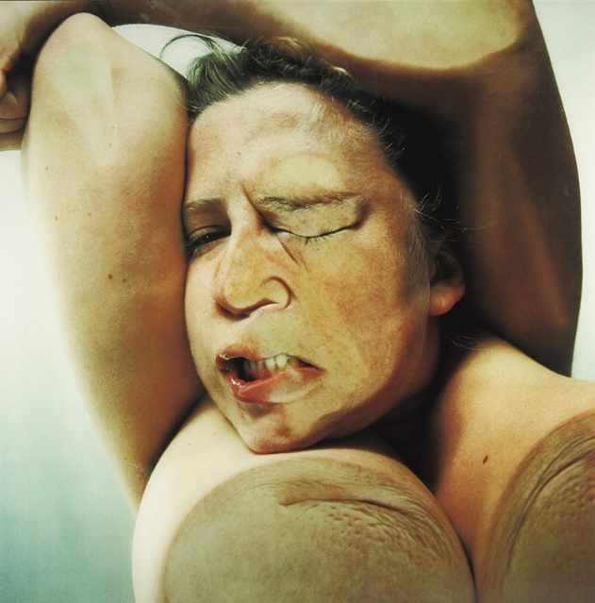

Figure 4; Closed Contact
Jenny Saville and Glen Luchford, 2018

Although unclear if Saville’s work was produced as support of the feminist movement from her
images, it is obvious that she has had a positive impact toward the fight of different bodily
standards which society has made women feel they need to achieve. Her project titled Closed
Contact which was created in collaboration with fashion photographer and filmmaker Glen
Luchford was produced to confront and challenge conceived notions of feminine beauty. The
work features Jenny Saville as the model in which she manipulates her own body by pressing up
against large sheets of Perspex ® while the images were taken by Luchford from below. The
variety of unflattering positions which Saville has shown to do, highlights the factor that the
objectification of women in art, is purely shown through the positioning of the subject. I believe
this due to that before seeing Saville’s works, I assumed that any work which involved the female
body in the nude would be shown in the sense of objectification however Closed Contact seems
to be the complete opposite and goes against any stereotypical photograph. “We need to
consider not only how photographs present women’s bodies for a male viewer but also how this
process spills over into everyday life and into how men view actual women, and how women
view themselves” (Wells L, 2009). This quote taken from “Photography: A critical Introduction”
really stood out to me due to the fact of if photographs of the female body continue to be taken
erotically, it may have a lot of negative impacts on female life every day. If women continue to be
objectified through the media of art, will society think it’s okay to objectify them in everyday life
as well. “The “male gaze” invokes the sexual politics of the gaze and suggests a sexualised way of
looking that empowers men and objectifies women. In the male gaze, woman is visually
positioned as an “object” of heterosexual male desire. Her feelings, thoughts and her own sexual
drives are less important than her being “framed” by male desire.” (Simmonds, A. 2016).

I believe that Jenny Savile is an influential artist within the feminist community and has had an
incredible response to female representation as she has completely changed the view of the
naked body without making it objectify in anyway.

“Feminism has changed the world we live in, and these days, many of us couldn't imagine
living in a world like The Handmaid's Tale. Not too long ago, though, that was basically what
reality was like for the ladyfolk throughout the world.” (Fortman, J. 2017) The different
feminist movements have come in different waves. The first starter point of feminism started in
the 18th century and was active until the 1920s, this was time in which women were fighting to
have a voice in society and the issues raised included, suffrage, racism and the right to divorce.
The second wave of Feminism is the most recognisable, this took place from 1920 right up until
the 1970s. This movement took note of the wage equality, the treatment of women in the
workplace, sexualization and civil rights. It is because of these two movements; I have decided to
look at an artist which was creating work during these times. I have decided to do this as my first
two examples are more modern and literate toward the feminist movement.

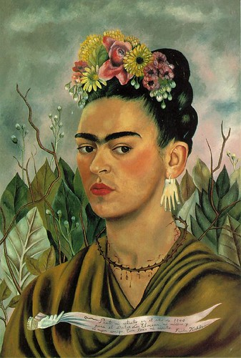

Figure 5; Self Portrait with Thorn Necklace
Frida Kahlo, 1940

Born in 1907, Mexican artist Frida Kahlo is a classic example of a more traditional artist. Her
uniqueness is seen in her raw self-portraits. “She was a brilliant painter of herself and of things
that came to her mind, as well as her sources of joys and sorrows, all of this she painted
unfettered. Her expressions were not moulded to fit the societally set standards of what was
“acceptable” but she followed her heart and mind.” (Ganeriwal, Y.2018). Not only her artworks
helped with the question of female representation, Kahlo herself was a great example of a
feminist icon. “The iconic uni-brow, hair adorned with flowers, and a slight moustache — these
are the features that Frida Kahlo is instantly recognised by,” (FP staff, 2017) She went against
the stereotypical appearance which women of her time were expected to achieve. Kahlo dressed
unlike other Mexican women of her time whose fashion consisted of suits, hats and luxurious
pearls. Her attire involved traditional Mexican clothing and would add accessories including
ribbon, scarves and bows, dressing differently became a big part of her identity. Although some
believe that she dressed differently due to her deformities caused by a variety of health
problems, it is obvious that she took pride in her appearance due to the paintings she has
produced of herself.

Kahlo Produced over 50 portraits which dealt with self-image, this led her to be called “very
much part of the narcissistic body culture” by the curator of her exhibition at the National
Museum of Women Artists. The opposite of Kahlo’s creative output is Cindy Sherman. An artist
who adopts different personas which she invents and photographs as a collection of self-
portraits. We don’t get to see the real Cindy Sherman as she seeks no artistic value in looking at
herself, this being completely different to Kahlo, who does not feel the need to use a character
within her images. (Allen P, 2011)

For the previous reasoning, I have decided that Frida Kahlo’s responses to the issues of the
female representation is extremely effective. She has a heavy influence on the feminist
community, her works are extremely raw and even her as a person had a great mindset on how
she wanted to live by going against the expected standards for a woman of her time.

While researching I came across a group of feminist activist artists, “The Guerrilla Girls”. The
group wears masks while in public and will use facts, humour and visuals in order to expose
gender and ethnic bias, not to mention the corruption in politics, film, art and pop culture. The
fact that they are an anonymous group keeps the focus on the issues instead of who they are;
they instead could be representing anyone from anywhere in the world. “We believe in an
intersectional feminism that fights discrimination and supports human rights for all people and
all genders. We undermine the idea of a mainstream narrative by revealing the understory, the
subtext, the overlooked, and the downright unfair.” (Guerrilla Girls, N.D). The Guerrilla Girls
have done multiple different projects across the globe including books, videos, actions and
posters not to mention that they’ve also gone on to do exhibitions and interventions at museums
and called them out for bad behaviour and discriminatory practices.

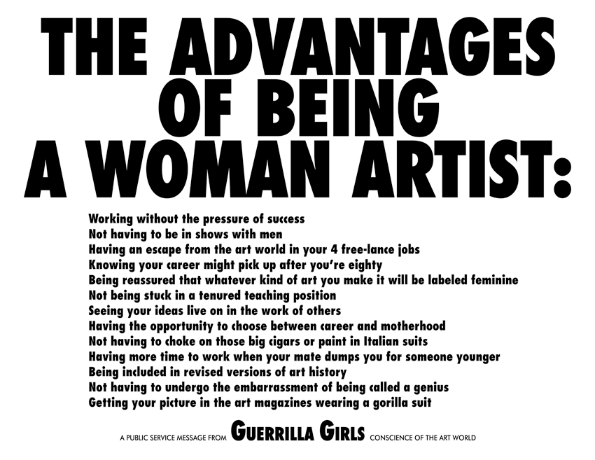

Figure 6; The Advantages of Being a Woman Artist
Guerrilla Girls, 1988
Although I was fascinated with most of the pieces created by the Guerrilla Girls, “The
Advantages of Being a Woman Artist” was a highlighted piece for me. The poster style image
lists 13 so-called “advantages” in which female artists are facing within their practice. "Seeing
your ideas live on in the work of others" alludes to women's innovations that have been
misattributed to men. "Knowing your career might pick up after you're eighty" refers to Louise
Nevelson, Lee Krasner, Barbara Hepworth, and countless other women artists whose
contributions to the history of art were only acknowledged at the very end of their careers.
"Having the opportunity to choose between career and motherhood" addresses the persistent
social expectation that women must choose (for men, there was no equivalent expectation).”
(The Art Story, N.D) The list ends with “Getting your picture in the art magazines wearing a
gorilla suit, this is in reference to the group getting more attention while wearing dress up, they
said themselves “we discovered that the art world takes feminists more seriously when they use
humour and wear a disguise”.

The Guerrilla Girls’ practice is an extremely good example of response towards different female
representation. It is a group which has had extreme exposure and has been around since 1985.
After my research, I have come to find several examples which are great examples of the
different type of responses which artists have given in response to Female Representation. I
have come to find artists which I think will have influence toward my future practice. Although
unfair, I think that women will always be given a negative representation within society due to
the fact, it is always been that way. However, I think that we should continue to do what we want
in order to try and overcome the negativity we receive. The essay I have written includes mostly
research from online resources and I am disappointed that I have not had the chance to use any
other forms of reference. If I had more time to write and learn about this ever-growing issue, I
would spend more time going into detail and using a wider variety of information. This however,
is a subject which I know I will continue to work with and expand my knowledge on and
therefore, I am happy with where I have gotten with this essay as I have obtained information
yet I know there is a lot more to learn.

List of images

- Do Women Have To Be Naked To Get Into the Met. Museum?, Guerrilla Girls, 1989
- Handle with Care, Rora Blue, 2016
- Your body is a Battleground, Barbara Kruger, 1989
- Closed Contact, Jenny Saville and Glen Luchford, 2018
- Self Portrait with Thorn Necklace, Frida Kahlo, 1940
- The Advantages of Being a Woman Artist. Guerrilla Girls, 1988

Bibliography, Harvard

Allen, P. (2011). In The Frame: How Did You Discover Feminist Art?. Available: https://www.bitchmedia.org/post/in-the-frame-how-did-you-discover-feminist-art. Last accessed 16/11/2019.
Barbara Kruger . (N.D.). Barbara Kruger (American, born 1945). Available: http://www.artnet.com/artists/barbara-kruger/. Last accessed 09/11/2019.
Biography.com Editors. (2014). Frida Kahlo. Available: https://www.biography.com/artist/frida-kahlo. Last accessed 16/11/2019.
Blue, R. (2016). Exhibitions. Available: https://www.rorablue.com/. Last accessed 23/11/2019.
Cohen, A. (2018). How Jenny Saville Changed the Way We View the Female Form in Painting. Available: https://www.artsy.net/article/artsy-editorial-jenny-saville-changed-way-view-female-form-painting. Last accessed 11/11/2019.
Dazed. (2018). Are these some of the most extreme works of art ever created?. Available: https://www.dazeddigital.com/art-photography/article/39534/1/extreme-art-marina-abramovic-carolee-schneeman-jenny-saville-glen-luchford. Last accessed 16/11/2019.
Deccan Chronicle. (2016). Artist uses sexist comments thrown at women to send powerful message. Available: https://www.deccanchronicle.com/gallery/lifestyle/180816/artist-uses-sexist-comments-thrown-at-women-to-send-powerful-message.html. Last accessed 23/11/2019.
Fortman, J. (2017). A Timeline of the Feminist Movement. Available: https://vocal.media/viva/a-timeline-of-the-feminist-movement. Last accessed 16/11/2019.
FP Staff. (2017). Frida Kahlo. Available: https://www.firstpost.com/living/frida-kahlo-femininity-and-feminism-why-the-painter-is-an-icon-for-so-many-women-3782365.html. Last accessed 16/11/2019.
Frank, P. (2016). Sick Of The Bulls**t, A Woman Is Turning Sexist Comments Into Feminist Art. Available: https://www.huffingtonpost.co.uk/entry/artist-transforms-sexist-comments-into-feminist-works-of-art_n_57a0e1cae4b08a8e8b5fb7b7?ri18n=true&guce_referrer=aHR0cHM6Ly9jb25zZW50LnlhaG9vLmNvbS8&guce_referre. Last accessed 23/11/2019.
Ganeriwal, Y. (2018). Frida Kahlo – The Woman, The Artist, The Feminist. Available: https://feminisminindia.com/2018/07/06/frida-kahlo-essay/. Last accessed 16/11/2019.
Guerrilla Girls . (1988). PROJECTS. Available: https://www.guerrillagirls.com/work. Last accessed 23/11/2019.
Guerrilla Girls . (N.D.). GUERRILLA GIRLS: REINVENTING THE 'F' WORD: FEMINISM. Available: https://www.guerrillagirls.com. Last accessed 23/11/2019.
K, Adela . (2014). Your body is a battleground . Available: https://www.thecrimson.com/column/the-art-of-protest/article/2014/4/9/art-of-protest-your-body-is-a-battleground/. Last accessed 09/11/2019.
Lee, S. (2017). The Picasso Problem: Why We Shouldn't Separate the Art From the Artist's Misogyny. Available: https://www.artspace.com/magazine/interviews_features/art-politics/the_picasso_problem_why_we_shouldnt_separate_the_art_from_the_artists_misogyny-55120. Last accessed 23/11/2019.
Liz Wells . (2009). Photography and the human body. In: Wells, L Photography: A critical introduction . 4th ed. London: Routledge. p180-182.
Moss, R. (2016). Röra Blue's 'Handle With Care' Project Turns Sexism Into Stunning Works Of Art. Available: https://www.huffingtonpost.co.uk/entry/rora-blue-handle-with-care-sexism-photo-project_uk_57d14527e4b0d45ff8711044. Last accessed 23/11/2019.
Printed Matter . (1989). Untitled, 1989 [Your Body Is a Battleground] Postcard. Available: https://www.printedmatter.org/catalog/36250/. Last accessed 16/11/2019.
Simmonds, A. (2016). Explainer: what does the ‘male gaze’ mean, and what about a female gaze?. Available: https://theconversation.com/explainer-what-does-the-male-gaze-mean-and-what-about-a-female-gaze-52486. Last accessed 30/11.2019.
Tate . (N.D.). What does it mean to be a woman in art?. Available: https://www.tate.org.uk/art/tate-exchange/women-in-art. Last accessed 09/11/2019.
TATE. (1989). Guerrilla Girls. Available: https://www.tate.org.uk/art/artists/guerrilla-girls-6858. Last accessed 30/11.2019.
The Art Story . (N.D.). The Guerrilla Girls American Photographers, Designers, Activists and Conceptual Artists. Available: https://www.theartstory.org/artist/guerrilla-girls/. Last accessed 23/11/2019.

