
Applied Computing

Wales Institute of Science and Art (WISA)

Networks and Cybersecurity Essentials (ACCA4024)

Lab 9: The art of ensuring Integrity
(Digital Signatures)



n.kaliyamurthy@uwtsd.ac.uk 1

Objectives
Using open source password cracking tool to recover the password.
Use of Digital Signatures.
Tasks
1. Use John the ripper tool to recover the passwords of Alice, Bob, Eve and Eric 2. Create digital Signatures to validate the document
Required Resources
- PC with Ubuntu 16.0.4 LTS installed in a VirtualBox or VMware virtual machine. (Alternatively, Any Linux Platform)
- Internet Connection to refer the outcomes o References:
- John the Ripper: http://www.openwall.com/john/ o Digital Signatures: http://nmichaels.org/rsa.py

Task 1
- Login as User Cisco.
- Go to Terminal and Type the following commands and examine
- Run John the Ripper (Hint: Change your directory to Downloads/ John-
1.8.0/run)
▪ cisco@ubuntu:~/Downloads/john-1.8.0/run$ sudo ./unshadow /etc/passwd /etc/shadow > mypasswd o This command will combine the /etc/passwd file where user accounts are stored, with the /etc/shadow file where user passwords are stored, into a new file called “mypasswd”.

  - Recover Passwords: Type the following command in terminal:
    - cisco@ubuntu: ~/Downloads/john-1.8.0/run$ ./john --show mypasswd
There are no cracked passwords at this point. Why?
There will not be any cracked passwords at this point as the document has only been created and has not been assigned with any passwords.

  - Type the following command in terminal:
    - cisco@ubuntu:~/Downloads/john-1.8.0/run$ ./john -wordlist=password.lst --rules mypasswd --format=crypt o The program, John the Ripper, uses a predefined dictionary called password.lst with a standard set of predefined “rules” for handling the dictionary and retrieves all password hashes of both md5crypt and crypt type.
  - The results should display the passwords for each account. To check the passwords and evidence them, open the file you have created to see the passwords cracked

There are cracked passwords. List the outcome.
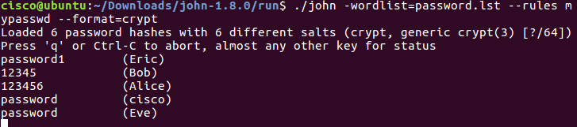

Task 2

Using Digital Signatures
In this part, you will use a website to verify a document signature between Alice and Bob. Alice and Bob share a pair of private and public RSA keys. Each of them uses their private key to sign a legal document. They then send the documents to each other. Both Alice and Bob can verify each other’s signature with the public key. They must also agree on a shared public exponent for calculation.
Table 1 - RSA Public and Private Keys
Public RSA Key | d94d889e88853dd89769a18015a0a2e6bf82bf356fe14f251fb4f5e2df0d9f 9a94a68a30c428b39e3362fb3779a497eceaea37100f264d7fb9fb1a97fbf 621133de55fdcb9b1ad0d7a31b379216d79252f5c527b9bc63d83d4ecf4 d1d45cbf843e8474babc655e9bb6799cba77a47eafa838296474afc24be b9c825b73ebf549
Private RSA Key | 47b9cfde843176b88741d68cf096952e950813151058ce46f2b048791a2  6e507a1095793c12bae1e09d82213ad9326928cf7c2350acb19c98f19d3  2d577d666cd7bb8b2b5ba629d25ccf72a5ceb8a8da038906c84dcdb1fe6  77dffb2c029fd8926318eede1b58272af22bda5c5232be066839398e42f5 352df58848adad11a1
Public Exponent | 10001
Sign the Document.
Alice signs a legal document and send it to Bob using the RSA public and private keys shown in the table above. Now Bob will have to verify Alice’s digital signature in order to trust the authenticity of the electronic document.
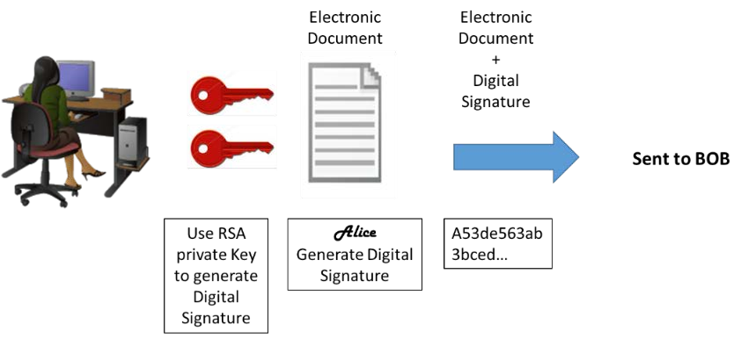
Verify Digital Signature.
Bob receives the document with a digital signature shown in the table below.
Table 2 - Alice's Digital Signature
Alice’s Digital Signature
0xc8 0x93 0xa9 0x0d 0x8f 0x4e 0xc5 0xc3 0x64 0xec 0x86 0x9d 0x2b 0x2e 0xc9 0x21 0xe3 0x8b 0xab 0x23 0x4a 0x4f 0x45 0xe8 0x96 0x9b 0x98 0xbe 0x25 0x41 0x15 0x9e 0xab 0x6a 0xfb 0x75 0x9a 0x13 0xb6 0x26 0x04 0xc0 0x60 0x72 0x28 0x1a 0x73 0x45 0x71 0x83 0x42 0xd4 0x7f 0x57 0xd1 0xac 0x91 0x8c 0xae 0x2f 0x3b 0xd2 0x99 0x30 0x3e 0xe8 0xa8 0x3a 0xb3 0x5d 0xfb 0x4a 0xc9 0x18 0x19 0xfd 0x3f 0x0c 0x0a 0x1f 0x3d 0xa4 0xa4 0xfe 0x02 0x9d 0x96 0x2f 0x50 0x34 0xd3 0x95 0x55 0xe0 0xb7 0x2a 0x46 0xa4 0x9e 0xae 0x80 0xc9 0x77 0x43 0x16 0xc0 0xab 0xfd 0xdc 0x88 0x95 0x05 0x56 0xdf 0xc4 0xfc 0x13 0xa6 0x48 0xa3 0x3c 0xe2 0x87 0x52 0xc5 0x3f 0x0c 0x0d
Click http://nmichaels.org/rsa.py to use the online RSA tool to verify the authenticity of Alice’s digital signature.
Table 3 - Online Digital Signature Tool
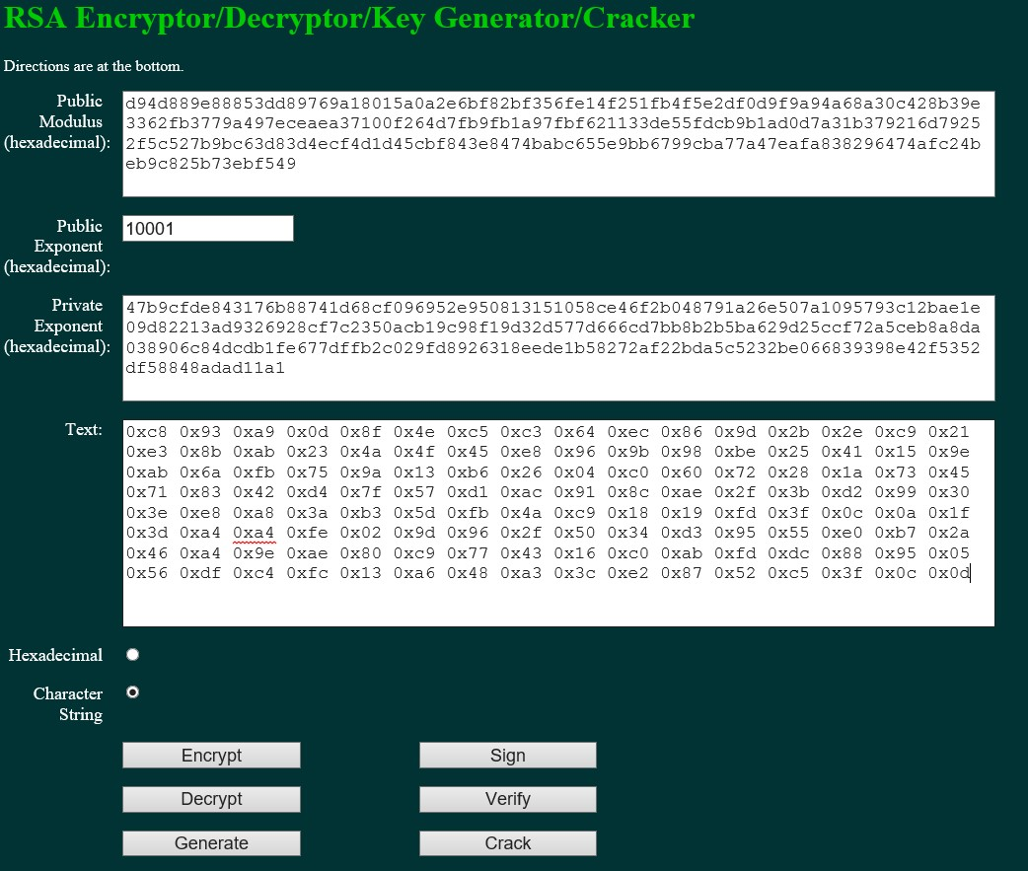
Copy and paste the public and private keys from Table 1 above into the Public Modulus and Private Exponent boxes on the website as shown in the picture above.
Make sure the Public Exponent is 10001.
Paste Alice’s digital signature from Table 2 in the box labeled text on the website as shown above.
Now BOB can verify the digital signature by clicking the Verify button near the bottom center of the website.
Whose signature is identified?
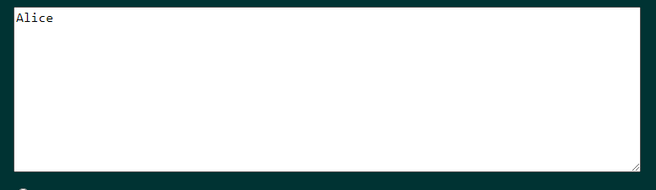
Generate a Response Signature.
Bob receives and verifies Alice’s electronic document and digital signature. Now Bob creates an electronic document and generates his own digital signature using the private RSA Key in Table 1 (Note: Bob’s name is in all capital letters).
Table 4 - BOB Digital Signature
BOB’s Digital Signature
0x6c 0x99 0xd6 0xa8 0x42 0x53 0xee 0xb5 0x2d 0x7f 0x0b 0x27 0x17 0xf1 0x1b 0x62
0x92 0x7f 0x92 0x6d 0x42 0xbd 0xc6 0xd5 0x3e 0x5c 0xe9 0xb5 0xd2 0x96 0xad 0x22
0x5d 0x18 0x64 0xf3 0x89 0x52 0x08 0x62 0xe2 0xa2 0x91 0x47 0x94 0xe8 0x75 0xce
0x02 0xf8 0xe9 0xf8 0x49 0x72 0x20 0x12 0xe2 0xac 0x99 0x25 0x9a 0x27 0xe0 0x99
0x38 0x54 0x54 0x93 0x06 0x97 0x71 0x69 0xb1 0xb6 0x24 0xed 0x1c 0x89 0x62 0x3d
0xd2 0xdf 0xda 0x7a 0x0b 0xd3 0x36 0x37 0xa3 0xcb 0x32 0xbb 0x1d 0x5e 0x13 0xbc
0xca 0x78 0x3e 0xe6 0xfc 0x5a 0x81 0x66 0x4e 0xa0 0x66 0xce 0xb3 0x1b 0x93 0x32
0x2c 0x91 0x4c 0x58 0xbf 0xff 0xd8 0x97 0x2f 0xa8 0x57 0xd7 0x49 0x93 0xb1 0x62
Bob sends the electronic document and digital signature to Alice.
Verify Digital Signature.
Copy and paste the public and private keys from Table 1 above into the Public Modulus and Private Exponent boxes on the website as shown in the picture above.
Make sure the Public Exponent is 10001.
Paste Bob’s digital signature from Table 4 in the box labeled text on the website as shown above. Now Alice can verify the digital signature by clicking the Verify button near the bottom center of the website.
Whose signature is identified?
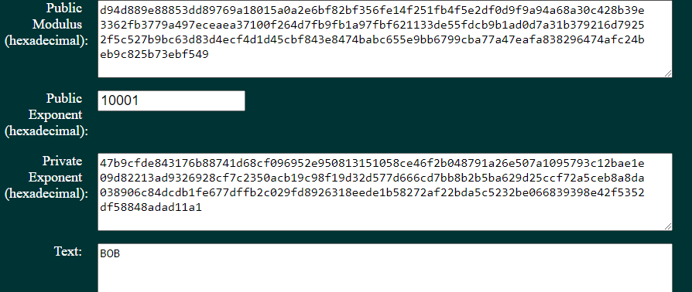

Verify this Digital Signature

Table 5 – Your lecturer’s Digital Signature
Public RSA Key | d639edcb90b508fba5005ed5f6e2b06f885e7a2ad5f6babbde7b0481e8b7 af73f4a821951757f797  6e2b8a925b6940e930a4bab189ccb93a9e81f74829140e767ec2ef3acad 7afecb3d1a114498524cd  084f9ae54a7ffd1f35c50ebdb24abb95dd5d8dfcd3ee7dd06630c831877b ee8549a1c2b615e53098  8f5cee0255a75f71
Private RSA Key | 63cf1d91885c30513e310bfe584689b98d29a775a9b6888ddb3c297f753 38f9550d9bcbbbfe28642  915bcbf6208ccb6759f885db0dbeca561b5fa61c82b70b7d2337c28ce193 4fc7ad035c87367a089a  24d2eca2583822fd5a7505bb76a7c3fd8486989ef8876617488a07330ca e414fce708b1c7278151d e92a994a639b85b9
Public  Exponent | 10001
Text | 0x8d 0x2d 0xcc 0x0c 0x12 0xdf 0xa2 0xbe 0x16 0x51 0x6e 0x5a 0x6a 0xf3 0x02 0xb9 0xf4 0x26 0x90 0xbe 0xfb 0x8f 0x3e 0x42 0xf4 0x59 0x60 0x6c 0xb5 0x44 0xbb 0x89 0xe1 0x8e 0x34 0x7f 0xa4 0x00 0xcf 0x30 0x12 0x89 0xb8 0x44 0x7f 0xde 0x23 0x70 0xad 0x92 0xdb 0xf9 0x77 0x87 0xf4 0x8e 0xe9 0xd2 0xd0 0xcc 0xa0 0x85 0x43 0x21 0xd1 0xcf 0x9b 0x51 0x11 0x39 0xe7 0xd2 0x6f 0xa3 0x1a 0x32 0xa6 0xed 0xe4 0x2d 0xbc 0x98 0xe9 0x69 0xaf 0xb7 0x4b 0x21 0xfe 0x62 0x38 0x10 0xfd 0x3e 0x79 0x90 0x75 0x08 0x14 0x0f 0x43 0x9b 0xb2 0xa5 0xe1 0x72 0xee 0x41 0xee 0x0d 0x2c 0xfb 0x2c 0x36 0x28 0x32 0xed 0xac  0x19 0x60 0x23 0x88 0x1d 0xd8 0x74 0xee 0x47 0xa0

Whose signature is identified?
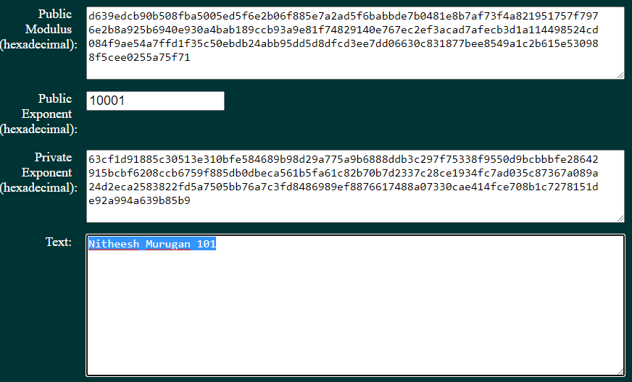

Create Your Own Digital Signature
Now that you see how digital signatures work, you can create your own digital signature.
Generate a New Pair of RSA Keys.
Go to the website tool and generate a new set of RSA public and private keys.
Delete the contents of the boxes labeled Public Modulus, Private Modulus and Text. Just use your mouse to highlight the text and press the delete key on your keyboard. Make sure the “Public Exponent” box has 10001.
Why should you have the Public Exponent as 10001? Research and
document your reflections here.
Not using 0x10001 (65537) can reduce the compatibility with currently available hardware/software or standards for security authentication. Any high public exponent then 0x10001 can also make the public RSA process slower.
It also helps to protect against different attacks which exploit bad messaging which can occur when message padding used.

Generate a new set of RSA keys by clicking the Generate button near the bottom right of the website.
Copy the new keys in Table 6.
Table 6 - New RSA Keys
Public Key
Public Key |  | A string of 256 hexadecimal characters will be displayed for both
Public Key |  | the public and private keys. The keys will be different from one
Public Key |  | another. | (bbb0b1d24fd47ccd85cdfa5b1fa501af88747b22539b30457595fed1dd7e70497de6dd94f1407648  f947d8b38520e5b9b40174d4c7e6682141f9b584f46b5b82655d6e4b66f4830513c1b4bfbb8ca436  0a266e5d81b43f6f36dee1d04ee4fc90ded47790a4d8e3eba3255cba7755b3f4ef17db1bb27fd451  0bc0159ef6954203)
Private key
Private key |  | A string of 256 hexadecimal characters will be displayed for both
Private key |  | the public and private keys. The keys will be different from one
Private key |  | another. | (8e7e1012862ee0ed3b876c699ff5aaf8f3d4d2e2f5ac5d126eba08b295c0f748a44010bb92090984  4f54bf6d5345ed8275e9a12425fb83d4b3fcfb554c26f15a192a7394ed92dc1b8d14264a3209598a  03fc7f4c629949510ce380014d674e78c814dcaf44ed5baa0dbffce88ad6050ff8e8789049e86ada  d10d9acc94a46051)
Now type in your full name into the box labeled Text and click Sign.
Table 7 - Personal Digital Signature
Personal  Digital  Signature
  A string of characters with this format will be displayed. 0x23
  0x90 ……. | (Connor Wilson)

V

Exchange and Verify Digital Signatures
Now you can use this digital signature.
Exchange your new public and private keys in Table-6 with your lab partner.
Record your lab partner’s public and private RSA keys from their Table-6.
Record both keys in the table below.
Table 8- Lab Partners RSA Keys
Public key
Public key |  | A string of 256 hexadecimal characters will be displayed for
Public key |  | both the public and private keys. The keys will be different
Public key |  | from one another. | (da2c87c557274f12660f9e73ac377479772ee29c9a469bd5af868f7eefac57b03ffa7bf573a38044  f7a389cb3acb830367baa4c1176b712506f09416f86228d2bcbc4bd990f1047c88c40886c92720dd  f57288c1a4508f069ce3b0cb84f21fc96706b72e5e5346b2d6d62e778d1400eaf638246aad31e2c4  f136b62f30c03211)
Private key
Private key |  | A string of 256 hexadecimal characters will be displayed for
Private key |  | both the public and private keys. The keys will be different
Private key |  | from one another. | (279af7d6aa1897b11657f582b81ba5083bcb8615b9a7e1b82bd1f890a97f96b78715b894f936101d  f4fa7a142b8b3030590f37c359b606671b5866f9b883513782704691d91af42ddf4a80003f10fa77  77df7a39903fb3a53df83f8c97b74f11288b397d178777d4312432a8189bff23cad18d4d01857a0a  854205e7c0d71a01)
Now exchange their digital signature from their Table-6. Record the digital signature in the table below.
Lab Partner’s  Digital  Signature
  A string of characters with this format will be displayed. 0x23
  0x90 ……. | (Vlad)
Verify Lab Partners Digital Signature
To verify your lab partner’s digital signature, paste his or her public and private keys in the appropriate boxes labeled Public and Private modulus on the website.
Now paste the digital signature in the box labeled Text.
Now verify his or her digital signature by clicking the button labeled verify.

What shows up in the Text box?
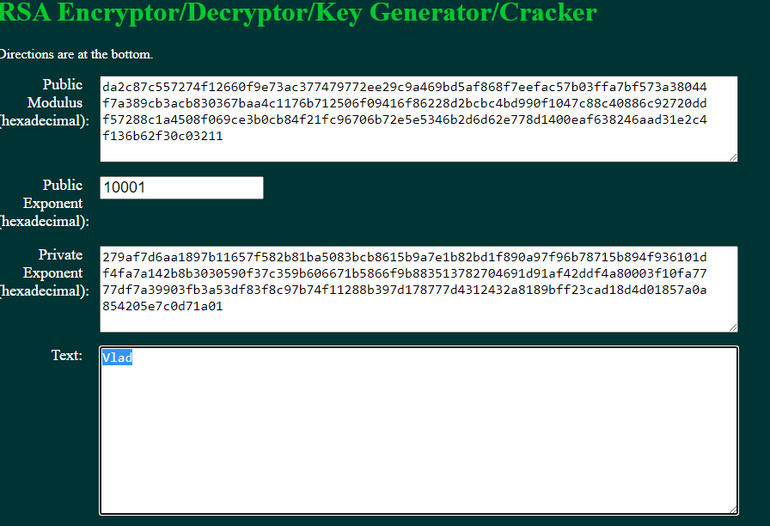

Learnings from tutorials so far:
Part 1 (Packet Tracer, Host Machines)
- Build a home Network
- Understand and configure IP Address
- Use Ping/ Trace route Utility to check the connection status
- Use ipconfig /all command to determine the MAC address of a Windows computer on an Ethernet network.
- Analyze a MAC address to determine the manufacturer.
- Analyze the Wired and Wireless Network connection.
- Analyze Address Resolution Protocol (ARP).
- Connect to a Wireless Router and configure the basic settings in a wireless router and add security features.
- Use nslookup command to understand the url to ip conversion.
- Configure basic connectivity settings in Intermediate devices (Switch/ Router).
- Work with SBA Packet Tracer Files/ environment
- Configure ftp, web, email, dns, ntp and aaa Servers Part 2
- Set up a virtual lab environment
- Troubleshooting the virtual lab environment
- Working with virtual machines
- Authentication, Authorization and Accounting
- Threats and Vulnerabilities – Using NMAP
- Hide and Seek – Use Steghide to hide a data file within an image file ✓ Password Cracking using John the Ripper ✓ Digital Signatures – Creating and Verifying.

