Managing Internationally

(SBUS6115)

Kaili Wang
09-05-2018

Content

Introduction

Factors That Influence Negotiation and Decision Making

Differences in Communication Preferences Between Cultures

How Culture Affects the Management of People

Internationally

How Culture Affects Leadership and Motivation

Conclusion

Reference

Introduction

International commercial trade not only crosses national boundaries but also cross-cultural. In the following article, I will list examples that international business companies did about cross-cultural management. Through these examples, I will use the academic models and theories to analyze why those company manage differently in different countries. This article includes 4 mainly parts. First part is Factors That Influence Negotiation and Decision Making, the second part is Differences in Communication Preferences Between Cultures, the third part is How Culture Affects the Management of People Internationally, the forth part is How Culture Affects Leadership and Motivation.

- Factors That Influence Negotiation and Decision Making

The discussion about the negotiating style of each country always revolves around the attitude of a culture to time. All practice creates time and the varying combinations of time within a social formation create a temporal structure or style. However, I believe that we should not merely say that social for- mations have their own temporal styles, but to go a step further and characterize social formations primarily in terms of their temporal styles of life (Gosden, 1994). Time may also be more generally associated with the degree to which a culture or society can be described as “slow” or “fast” (Levine, R. V. and A. Norenzayan,1999).

The misunderstanding of culture may cause a world trade company failed the negotiation and lost the corporation with party A. Here is an example that had big influence and received the attention of the mass media and the masses. The subsidiary of Enron, Dabhol Power, was challenged in the long-term power supply contract with the Maharashtra government in India, and was ultimately considered too bypassed by the fast authorization process required by this type of transactional practice during the negotiation process. The hurry is too shameful. As negotiations progressed too fast, an important Indian public rightly believed that the government did not protect the public interest. In the company’s response, Rebecca Mark, chairman and CEO of Enron International, told reporters: “We are very concerned about time because time is money for us.”. Enron’s Rebecca Mark: “You Have to be Pushy and Aggressive” (BusinessWeek, February 24, 1997). However, drawing lessons from this failure, U.S. companies tried to negotiate with the Indian side in a more formal way, and they also extended the planning cycle，when they later cooperated with other Indian companies.
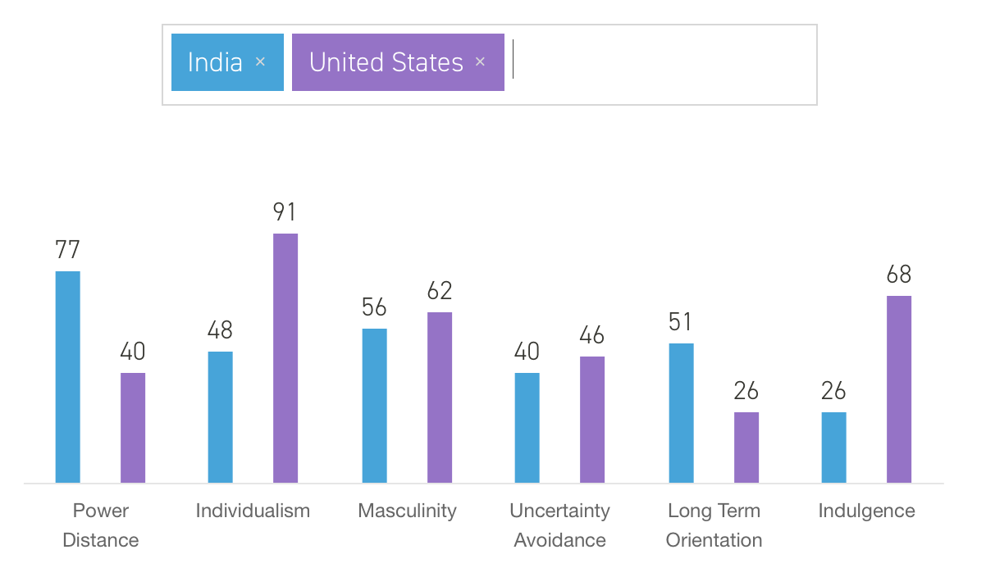 (www.hofstede-insights.com)

In Hofstefe Comparision, it shows that United States is an individualism country, but India is more like a collectivism country. Therefore, in India, the benefits of the big amount group people are very important. Cooperating or negotiating with the governments or companies in collectivism countries need to consider the satisfaction of other people, not only the leaders of those companies.

In addition, the different sensitive of time in this case also influence the negotiation. The discussion about the negotiating style of each country always revolves around the attitude of a culture to time. Some people say Germans are always on time, Latins are habitually late, and negotiations in Japan usually slow. Americans respond quickly. Therefore, Americans would like to minimize the necessary procedures and quickly complete one thing. In Japan and other Asians include India, a long-term business relationship is much more important than simply signing contracts. Long-term negotiation can help both parties know each other better. Because sometime, in order to try to hide something, they may actively shorten the negotiation time. In this case, the different sensitive of time caused misunderstanding between Indian and American. Hence, Enron lost the order from Indian government. Therefore, knowing the culture of our partners is very significant in negotiation.

2. Differences in Communication Preferences Between Cultures

Communication preference means of providing and/or receiving information. This may include expression of thoughts and ideas. The means for providing and/or receiving information may include face-to-face communication, telephone conversation, regular post office mail, Internet email, electronic bulletin board, radio, newspaper, television, etc(Stephen K. Aikins & Meena Chary,2010). For instance, a Chinese female employee who worked in a Sino-Dutch joint venture complained that one of her Dutch colleagues told her that her dress is not suitable for her it’s more suitable for the lady that slimmer than her. She feels uncomfortable, the relationship between this female employee and his Dutch colleague is getting worse. The managers published a notice in the office after they found the culture shock between China and Dutch, they arranged the culture training on Friday afternoon.

The barriers of verbal communication include information barriers, attitudinal barriers and environmental barriers. (Ingrid Koreneff & K Sims-McLean, 2005). The reason for the misunderstanding between these two employees is that the way that Dutch express his information too direct. Because Chinese feel that there is something that they do not have to say very direct and the other person can understand it. Because Chinese people think they don’t need to say all information, in case the other person may feel embarrassed. This facilitates future contacts. However, the Dutch people are totally different from the thinking of the Chinese. They do not know what the concept of euphemism is. The Dutch have always been known for their “direct speech. The euphemistic expression of Chinese and Dutch people can be expressed in thinking patterns vividly.

Thinking patterns includes Spiral Thinking and Linear Thinking (Kaplan， R. 1996). Dutch people are linear thinking, Chinese are spiral thinking. Therefore, their communication preferences are different.

Communication also have non-verbal communication. For the present, we must further concentrate on the functioning of the kind of non-verbal communication (Pierre Lemonnier, 2012). Sometime, the way that people expressed their feeling could vary a lot between different cultures and result could be negative feelings towards another. The exist of this prejudice is not the differences in themselves but the way in which the differences are interpreted. Therefore, non-verbal communication also can be a source of misunderstanding and irritation(Marie-Joëlle Browaeys，Roger Price,2008). Hence Understanding the communication preferences between cultures could reduce disputes and promote mutual relations in business and daily communication.

3. How Culture Affects the Management of People Internationally

There are often many foreign employees working in multinational trading companies. People in different countries have different cultures. In the world of globalization and high technology, geographic boundaries often become obscured. The workforce today consists of employees from various cultural backgrounds (Kennedy and Everest, 1991). Therefore, a world trade company should manage the local employees and foreign employees differently, or balance the culture differences. Otherwise, different cultures may cause conflict bewteen managers and employees. A misfit of cultures is often a cause of failure. (Cartwright & Cooper, 1996).
As early as 1992, Samsung began to enter China. In order to allow Chinese employees to be loyal to Samsung as well as South Korean employees, Samsung has conducted effective cross-cultural training. In addition to learning the differences between Chinese and Korean cultures and Samsung's corporate culture, the company often sends Chinese employees to the Samsung headquarters in Korea for study and advanced studies. The headquarters also regularly selects senior leaders to inspect and guide Chinese employees to a cross-cultural training course. Samsung's talent localization strategy has injected more fresh elements into Samsung to better understand the Chinese people's consumption habits, and to understand the needs of the Chinese market, and thus more easily develop the Chinese market.

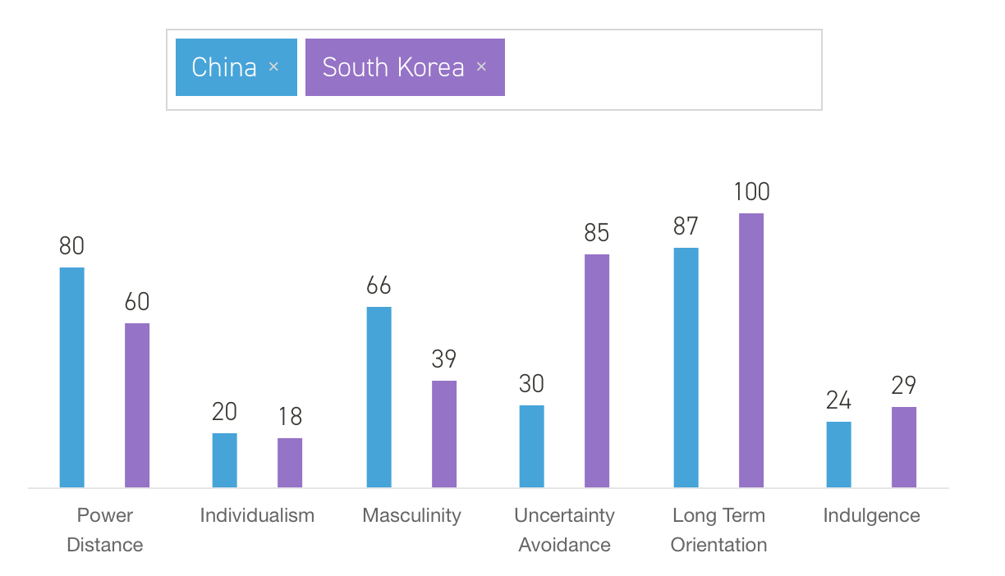(www.hofstede-insights.com)

From Hofstede comparision, Masculinity and Uncertainty Advoidance have big differences in China and South Korea. Samsung through cross-culture training and exchange learning between Chinese branch offices and Korean headquarters to increase the communication and understanding of these two cultures. Therefore,it is very necessary to improve the communication and exchange between the two cultures. Cross-cultural training is a very practical and effective way to reduce the conflicts caused by vary cultures.Intercultural conflict is a unique and interesting phenomenon that can facilitate group decision‐making, lead to effective decisions, and greatly benefit an organization if managed constructively (Putnam and Poole, 1992). However, understanding the culture of the other country in advance can better promote cooperation among employees in the companies. For manager, cross-culture manager always need to “Explains the behavior of people in organizations around the world and shows people how to work in organizations with employees and client populations from many different cultures” (Adler, 2002).

4. How Culture Affects Leadership and Motivation

Leadership and motivation are like brother and sister. It is difficult to think of a leader who does not motivate others(Adair, John.,2006). Here is a example of how leadership influenced the motivation.

For example, the Daewoo Motor Company(Korea) was facing bankruptcy in 2001, and Lee Jon Dae, its chairman, had to authorize a downsizing of 7,000 employees. His subse- quent extraordinary actions seemed to indicate that he was responsible for the unfortunate condition of the company. This was not accurate, as its founder was largely responsible and had fled the country with company funds (and is now in a Korean prison). Mr. Dae’s actions included enlisting politi- cians in a public endorsement of buying Daewoo cars; asking each politician to buy a Daewoo car; sending a personal letter to his counterparts at 26,000 companies, begging each of them to hire at least one of his downsized employ- ees; and abjectly bowing to a downsized employee at a job fair the company organized and profusely apologizing to him for having to lay him off. The employee was surprised at such total acceptance of responsibility and con- soled Mr. Dae with the statement that the downsizing was not his fault.
(Martin J. Gannon, 2008)

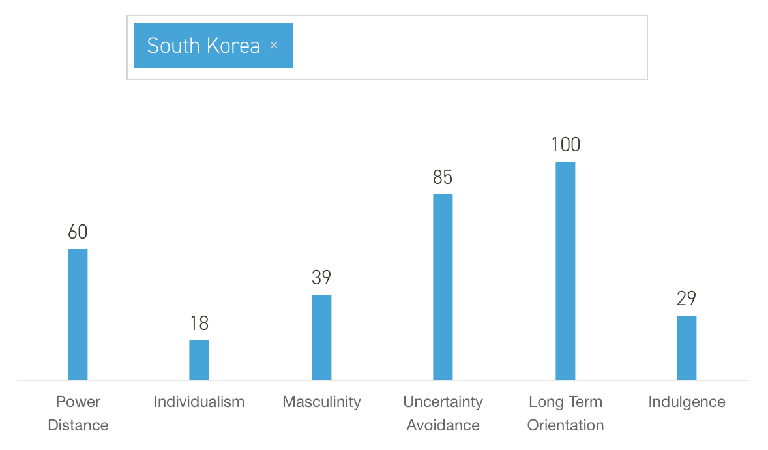 ( www.hofstede-insights.com )

As IT consultant Tim Bryce writes: All companies have a culture. In order for employees to function and succeed, it is essential they understand and believe in the culture (Schein, E.H. 2004)). As most Asian country, South Korea is a Collectivist country， the Individualism score is only 18. The reason why Mr. Dae assumed responsibility for the company and received recognition from his employees and society is they are all Collectivism. In this kind of environment, leadership is often very responsible in this environment, high responsibility is a kind of motivation for employees. In collectivist country, the succeed of their own country or the succeed of their working company could be the motivation for people. People prefer “Ours”, rather than “Myself”. Therefore, in this kind of culture, it is very important to maintain unity within this company or organization.

Conclusion

In this assignment, I evaluated 4 examples about the how different culture influence companies, then analyzed and explained those cases.
In the first case, I compared the differences of time sensitive between India and United Sates. Explained the reason why different time sensitive can influence negotiation. In the second case, I explained a conflict in a Sino-Dutch joint venture. Through analyzing the barriers of verbal communication and thinking patterns explained the differences in communication preferences between cultures. In the third case, there is a succeed case. In the example, Samsung through cross-culture training and exchange learning between Chinese branch offices and Korean headquarters to increase the communication and understanding of these two cultures. In the fourth case, the example is about a Korean leader took responsibility for dealing with the company before the company goes bankrupt. Using Hofstede comparison analyzed how culture influence leadership and motivation.

reference

Gosden, C. Social being and time. Oxford, UK: Basil Blackwell, 1994.

Levine, R. V. and A. Norenzayan. The pace of life in 31 countries. Journal of Cross-Cultural Psychology, 30, 1999, 178–205.

GMT, Rebecca Mark talks about how Enron bounced back, Business Week, 5 am, Feb.24, 1997

Stephen K. Aikins & Meena Chary, Mastering English Literature [m], Online Participation and Digital Divide: An Empirical Evaluation of U.S. Midwestern Municipalities, published by University of South Florida, USA, 2010, P1-20

Schein, E.H. Organizational Culture and Leadership, Third edition, San Francisco: Jossey - Bass. 2004

Kaplan, R. Mastering English Literature [m], Cultural thought patterns in inter-cultural education, published by University of Southern California, 1996. P1-20.

Ingrid Koreneff & K Sims-McLean. Mastering English Literature [m], Information Technology, published by Vivienne Petris Joannou,2005,P99.

Pierre Lemonnier, Mastering English Literature [m], Mundane Objects: Materiality and Non-verbal Communication, published by Taylor & Francis Group, 2012, P75.

Marie-Joëlle Browaeys，Roger Price, Mastering English Literature [m], Understanding Cross-cultural Management
,published by Pearson Higher Ed, 2008,p 258.

Kennedy, J. and Everest, A, “Put diversity in context: your company's success may depend on its ability to compete for tomorrow's multicultural workforce”, Personnel Journal, Vol. 70,1991, pp. 50‐4.

Cartwright, S. and Cooper, C.L. Managing Mergers, Acquisitions and Strategic Alliances: Integrating People and Cultures, Published by Butterworth-Heinemann, Oxford, 1996.
Adair, John. Mastering English Literature [m], Leadership and Motivation : the Fifty - Fifty Rule and the Eight Key Principles of Motivating Others, London: Kogan Page Ltd, 2006, P7-18.

Putnam, L.L. and Poole, M.S, “Conflict and negotiation”, in Jablin, F.M., Putnam, L.L., Roberts, K.H. and Porter, L.W. (Eds), Handbook of Organizational Communication, 3rd ed., Sage, Newbury Park, CA, 1992, P549‐99.

Nancy Adler, Marie-Joëlle Browaeys，Roger Price, Mastering English Literature [m], Understanding Cross-cultural Management
,published by Pearson Higher Ed, 2008,p 16.

Martin J. Gannon, Mastering English Literature [m], Paradoxes of Culture and Globalization, published by SAGE, 2008, P68.

Bryce, Tim. “Bryce’s Laws.” M. Bryce & Associates (MBA) (www.phmainstreet.com/mba).

www.hofstede-insights.com

