Student Name: Rahima Sheikh Ibrahim
Student ID number: 2336641
Module: Changemakers Creativity and Value Creation
Module code: BMHP5014
Lecturer: Dr Laila Surani
Component 2:

Assignment Title: The Family Connect Hub: A Digital and Community Support Service for Unpaid Carers

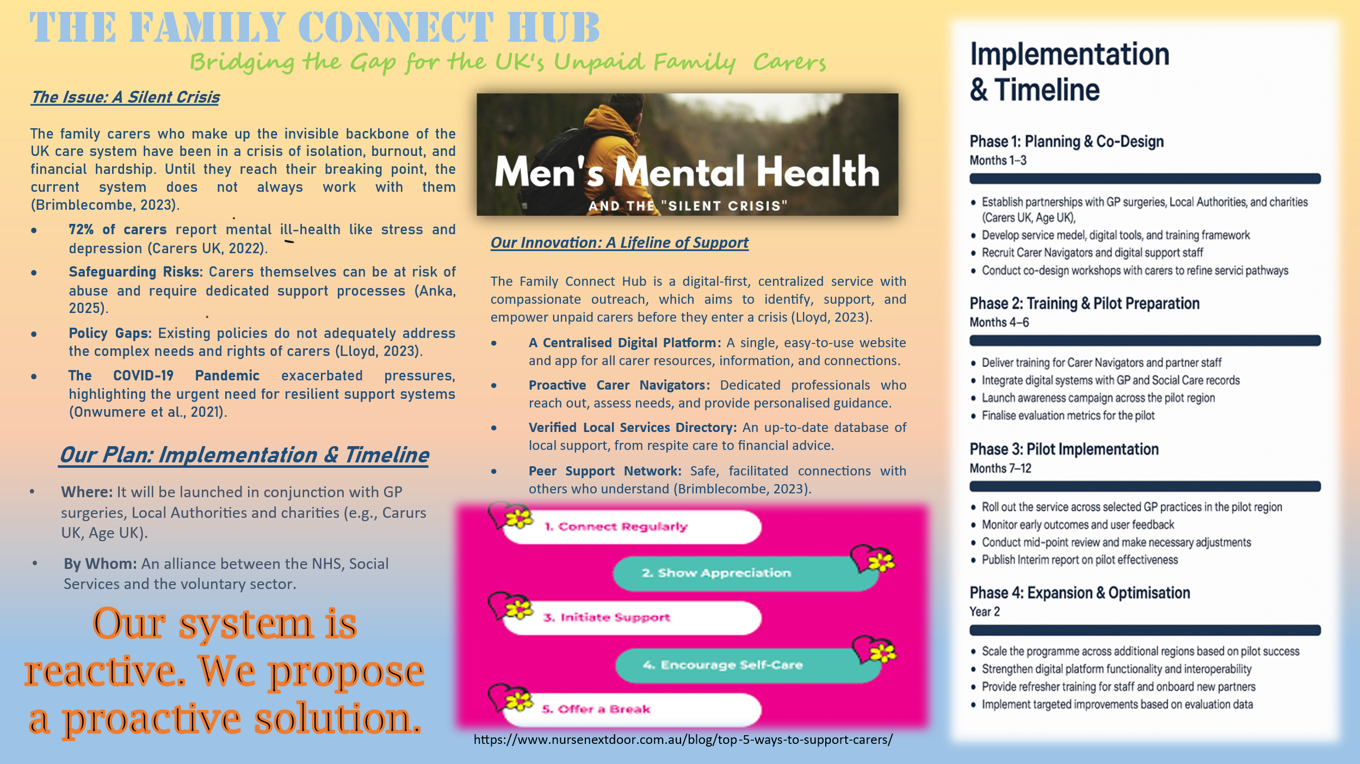
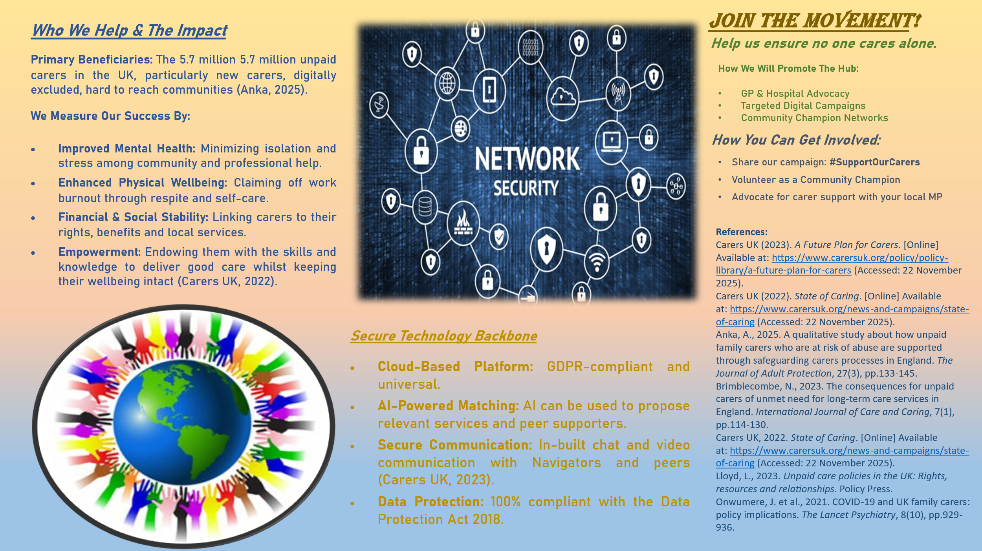
Part 2: The Accompanying Pitch
Title: The Family Connect Hub: A Proactive Lifeline for the UK's Invisible Army

Introduction
Millions of unpaid family carers keep the Health and Social Care system of the UK going. Such people are spouses, parents, children, and friends; they offer priceless physical, emotional, and medical assistance to their loved ones. Nevertheless, this devotion is usually a ruinous personal price. The existing system is essentially reactive, which means that it only comes in when a carer is at their breaking point (Williams and Lum, 2020). This pitch follows up on the poster to introduce the Family connect hub as a proactive integrated service and campaign that aims not only to support, but essentially change the experience of being an unpaid carer in the UK. It is a call to arms to the population, policymakers, and professionals to be inspired by an innovation that can protect our common good (Walker et al., 2020).

The Profound Need: Beyond the Statistics
Although the poster emphasizes the shocking numbers of 5.7 million carers who add 162 billion every year to the economy, there is a deeper human side. Being a caring person is a job that comes to one by accident, when one is diagnosed with a disease, when there is an accident or when he or she falls ill due to old age. This change in life is sudden and this is accompanied by a cliff edge of information. Careers are forced to work their way through a maze of health, social care, and benefits on their own, which results in what some would call carer burnout a condition of physical, emotional, and mental exhaustion (The National Archives, 2018).
The population is dissimilar, with one as young as a teenager and excited about a parent with Multiple Sclerosis and the other as an elderly spouse and is taking care of their dementia patient. The innovation is mostly aimed at the most vulnerable: newly bereaved to the position, not digitally savvy, people of ethnic minority status who might experience further cultural and language barriers. The mission of the Hub is to approach these people prior to the loss of their own health, when the carer too will be the patient (The National Archives, 2014).

A Deeper Dive into the Innovation and Its Impact
The Family connect Hub is not just a web site but it is a comprehensive support system. The Carer Navigators service is human-focused and should be considered the real innovation, which is mediated via the digital platform. These are trained professionals which are the main pillars of the proactive model. Instead of a carer waiting until they have the strength to seek assistance, the system, via GPs referrals, hospital discharge, or self-registration, generates a sympathetic outreach by a Navigator (Taylor et al., 2021).
This Navigator does not merely indicate, he or she listens, evaluates and develops a trusting relationship. They are able to clarify the diagnosis of a loved one, assist a carer in making a claim under the Carer’s Allowance, obtain emergency respite care or just get them connected with another carer with whom they are able to relate well (Taylor et al., 2025). It is this human touch that is enhanced with the use of technology that makes the Hub different. The hyper-relevant matching service provided by the AI-powered means that the provided support is highly relevant, whereas the peer network, with its peers filtered by safety, offers the empathy that is only possible to receive through similar experience. The effect is multidimensional: the wellbeing of a carer is maintained on a mental and physical level and, in turn, due to the wellbeing, the quality and safety of the care provided to the patient increases, forming a positive feedback loop of wellbeing (Onwumere et al., 2021).

Policy, Legislation, and Professional Context
The Hub is not developed within a vacuum but is aimed at integrating and reinforcing existing structures. It directly facilitates the main goals of the Health and Social Care Act 2012, and the further policies, which underline the focus on integrated care and prevention. It brings into effect the Care Act 2014, which provides all carers in England with the legal right to a Carer Assessment (Long, 2019). The Hub would serve as a major tool of screening carers capable of receiving such an assessment and facilitating them through the process.
On the legislative level, the Hub is constructed in terms of the privacy by design concept, being in perfect compliance with the Data Protection Act 2018 and UK GDPR (Lloyd, 2023). Any information exchange between the Hub and the NHS, as well as the local authorities would be controlled by rigorous procedures and express user consent, which would guarantee the credibility and security of users of such information. The Hub is an important collaborator to healthcare professionals. The GPs, social worker and community nurses who are usually time-starved can refer patients and their families to the Hub with the confidence that they will be provided with extensive and sustained assistance, thus saving them clinical time to implement medical interventions (Carers UK, 2023).

A Call to Action: Why Public Involvement is Crucial
To succeed in this endeavour, the initiative should not be a government service, but should be a social campaign. This is a universal problem which requires the participation of all of us since the issue of caring affects all families, communities and working places in the country. This campaign can be supported by the masses in a number of effective manners:
Awareness and Advocacy: Just discussing it is the least challenging but the most effective move. Message the Share the campaign to your friends on social media. When talking to your friends and family, pose the question, "Are you taking care of someone? Do you know your rights?" This assists in the breaking of the stigma and isolation (Carers UK, 2022).
Volunteering: The Hub will turn to the community champions such as those who have been carers or are plain generally sensitive persons who can assist in the running of local support groups and outreach events so that the service is made available to the people who are not online.
Corporate Partnership: Companies can be central to it. They have an opportunity to market the Hub to their employees who are often in the work and caring situations (the so-called sandwich generation) and to offer pro-bono knowledge or financial support (Brimblecombe, 2023).
Political Engagement: The community should activate their local MPs and councillors by writing to them, requesting their support and budget allocation to implement the Family Connect Hub in their constituencies stating that it will be a necessary investment in community resilience.
The involvement of the public does not only help to support carers; it also invests in the health of the whole country. They contribute to the prevention of crisis and decreasing the pressure on NHS and social services, as well as building more supportive and stronger communities. Helping carers is no niche and is a cardinal practice of saving our social fabric (Anka, 2025).

Conclusion
I think Family Connect Hub is a paradigm shift in the reactive model of carer support instead of a proactive model. It is a new, viable, and much-needed solution that uses technology and human relationship to deal with one of the greatest dilemmas in our health and social care environment. It complies with existing policies, and works within the legal frameworks, and gives real relief to millions. In the process of implementation and encouragement of this innovation, we will be able to start respecting the huge role that unpaid carers perform in the proper way so that their love does not cost their health, state of wellbeing, and future. We should unite in order to construct this lifeline. We do not want to make sure that no one in our society has to care.

References
Anka, A., 2025. A qualitative study about how unpaid family carers who are at risk of abuse are supported through safeguarding carers processes in England. The Journal of Adult Protection, 27(3), pp.133-145.
Brimblecombe, N., 2023. The consequences for unpaid carers of unmet need for long-term care services in England. International Journal of Care and Caring, 7(1), pp.114-130.
Carers UK (2022). State of Caring. [Online] Available at: https://www.carersuk.org/news-and-campaigns/state-of-caring (Accessed: 22 November 2025).
Carers UK (2023). A Future Plan for Carers. [Online] Available at: https://www.carersuk.org/policy/policy-library/a-future-plan-for-carers (Accessed: 22 November 2025).
Lloyd, L., 2023. Unpaid care policies in the UK: Rights, resources and relationships. Policy Press.
Long, E., 2019. Living Liminal Lives: Army Partners' Experiences and Perspectives of Navigating and Negotiating Avenues for Support. Lancaster University (United Kingdom).
Onwumere, J., Creswell, C., Livingston, G., Shiers, D., Tchanturia, K., Charman, T., Russell, A., Treasure, J., Di Forti, M., Wildman, E. and Minnis, H., 2021. COVID-19 and UK family carers: policy implications. The Lancet Psychiatry, 8(10), pp.929-936.
Taylor, D., Wainwright, J. and Vseteckova, J., 2025. Government spending impacts on unpaid carers in England since 2010: a systematic review. International Journal of Care and Caring, pp.1-24.
Taylor, J., Bradbury‐Jones, C., Held, J., Isham, L. and McConnell, N., 2021. Working with British Army families: A qualitative study of child protection practitioners' views and experiences. Child Abuse Review, 30(2), pp.166-173.
The National Archives (2014). Care Act 2014. [Online] Available at: https://www.legislation.gov.uk/ukpga/2014/23/contents/enacted (Accessed: 22 November 2025).
The National Archives (2018). Data Protection Act 2018. [Online] Available at: https://www.legislation.gov.uk/ukpga/2018/12/contents/enacted (Accessed: 22 November 2025).
Walker, J., Selous, A. and Misca, G., 2020. Living in our shoes: Understanding the needs of UK armed forces families.

