

Christopher Budden
P148323
Kenny Johnston
P148567
Dr Gary Jones

LEVEL/ LEfEL 5

SEMESTER 1&2

MODULE CODE/ Cod Y modIwl:
m2x8520_q
Group Project

aSSESSMENT TYPE/ mATH O ASESU: aSSIGNMENT

Assessment/Component/ AsESIAD/CYDRAN: 1

Abstract
Remote control plays a huge role in operating electrical and mechanical equipment in vehicles. The first unmanned vehicle used in anger was during WWII, where the 1st B17 prototype bomber was retrofitted with a remotely controlled Radio Frequency (RF) pilot controller system [1]. With the heavy losses of bomber air crew during this period, the technological advance of radio frequency control was implemented to save human cost. With the growing trend of IED’s in today’s climate threatened by terror in the Middle East, remote control EOD (Explosive Ordinance Disposal) robots are employed to take the fatal risks away from the EOD personnel.

This paper is a descriptive step-by-step on how to plan, program & fabricate a remote controlled three-wheeled buggy with the use of a Microcontroller. The method of wireless communications is critically reviewed and chosen for the best practicality and low cost. The buggy’s wiring schematics, designs and programming of the microcontroller is presented in this paper. The outcome of this group project is to produce a fully functional remotely controlled 3-wheel buggy that can move forwards, backwards, left & right in a controlled manner. The assessment of the final production of the buggy will be to maneuver it around a planned obstacle course set out by an appointed adjudicator and assessed on its maneuverability, accuracy, control & features.

Contents
Introduction to the Group Project 1
Project Specifications. 2
Project Methodology 3
Project Planning 8
Wireless Control. 9
Steering Inputs and Speed Control. 11
H-Bridge Motor Driver & Pulse Width Modulation (PWM). 14
Additional Functions. 15
Safety and Compliance. 15
Programmable Interface Controller (PIC) Requirements & Selection. 16
The functional I/Os of the Buggy were also tabulated. 16
Data packet Construction. 18
Controller Unit Development. 19
Buggy Development. 22
Introduction to Group Project (Buggy) 23
Methodology 23
Requirements/ User Specifications 24
Controller 24
Buggy 24
PIC Selection/ Requirements 25
PIC Selection: Controller & Buggy 26
Controller Pin-Outs 26
PIC Selection: Buggy/ Receiver 27
Buggy Pin-Outs 27
Microchip® PIC Selection 28
H-Bridge Motor Driver 29
CE Marking 33
Hexadecimal to Binary data packets 33
Gantt chart 34
Wireless Control Selection 35
Infrared 35
Ultrasonic 35
R.F. (Radio Frequency) 36
Wireless Transmission Decision 36
Components 37
PIC 37
H-Bridge 37
Transceiver 37
Voltage Regulators (5V & 3.3V) 37
7404 Hex Inverter 37
Procurement list 38
Safety Interlocks 38
Buggy Development 39
Buggy schematic 39
PIC ‘C’ Programming Writing 20
PIC Flashing 29
Buggy Fabrication 32
Testing 36
Adjustments 38
Lessons Learnt 38
Conclusion 39
References 40
Bibliography 40
Figures C.Budden 40
Figures. K.Johnston 42

This page is left blank intentionally

Introduction to the Group Project
The customer outlined the requirement for each group to design, build and test a battery powered, remote-controlled buggy in accordance with the specifications provided.
Throughout the duration of the project, the team is requested to discuss progress on the design concepts, development avenues and the implementation stage to the supervising lecturer.

Project Specifications.
The customer explained the requirement to design, build and test a battery powered, remote-controlled buggy, using a Programmable Interface Controller (PIC). The buggy must successfully traverse a test and evaluation track. No further requirements, evaluation criteria or the nature of the test track were supplied.
The buggy chassis will be provided including two DC motors and gearboxes. See Figures 1 and 2 below.
The completed buggy chassis and controller unit should be presented for assessment and testing at the end of Semester 2, the 23rd July 1017.
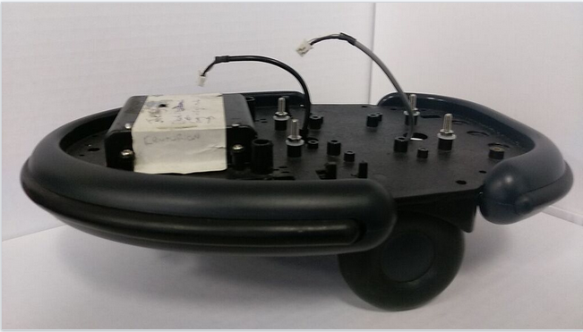
Figure 1: User provided buggy chassis
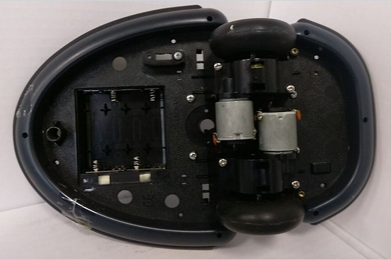
Figure 2: Motor and gearbox detail

Project Methodology
Initial discussions centred on the overall design blocks and how we were going to approach the communications issue.
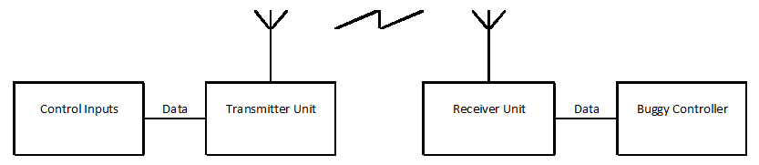
Figure 3: Initial system design.

This somewhat simplistic design demonstrated a logical division of tasks for consideration and investigation, the first of which was a method of communication. This was prioritised as it is the common link between two distinct parts.
After some discussion and research the options were narrowed to Radio Frequency (RF) and Infra-Red (IR). After considering available research ^{[A, B]} RF was chosen as the more appropriate solution for our requirements and listed for further investigation.
Attention then moved to the scope of movement control the buggy would need. The task requires the buggy to successfully manoeuvre through a set course, therefore it must be able to move forwards, backwards, and turn left and right. It was also decided that the buggy will need some form of speed control in order to allow the safe navigation of the course without error.

After a discussion - involving personal experience within the group - it was agreed that the control input for steering and speed would be delivered through a two-joystick input system configured as a differential drive steering system similar to early tank designs^{[C]}.
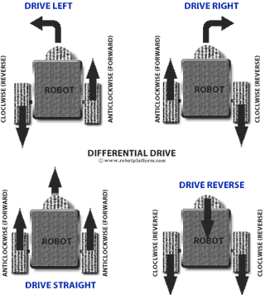
A Differential Drive system will mean each wheel will be independently speed controlled with any difference in wheel speed causing the buggy to turn right or left as required. ^{[1]} While such a system will require a little more hardware to implement, the control aspect would require only one solution, duplicated for the second motor. This was discussed and considered an acceptable avenue of development.
Figure 4: Differential Drive steering system

We are required by the customer to integrate the transmitter inputs and buggy outputs with a PIC microcontroller. The MicroChip© website^{[D]} offers a useful tool for selecting the most suitable PIC for the number of inputs, outputs and any other on-board functions that may be required.
A complete list of inputs, outputs and any other additional functions identified and the form they take (analogue or digital) will be required before it will be possible to select an appropriate device.
The desired result of the project is to drive the buggy. To do so we need to provide power and control to the motors. As we have identified the need to travel forwards and in reverse, an H-Bridge control circuit ^{[E, 2]} will be required.
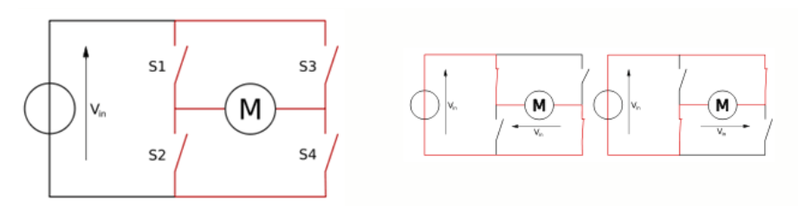
Figure 5: Basic H-Bridge layout and operation

In Figure 5, switches 1 and 4 are used together to provide power across the motor in one direction then when switches 2 and 3 are used, the polarity has changed and the motor turns in the opposite direction.
In this example, the voltage applied, V_{in}, is constant, and will cause the motor to turn at one speed only. “The most effective way to adjust the speed is by using pulse width modulation. This means that you pulse the motor on and off at varying rates, to simulate a voltage.” ^{[3]}
Therefore, a suitable H-Bridge solution and a method of producing a pulse width modulated (PWM) speed control must be identified to control both the direction and speed of each motor.
With the basic methods of input, steering, motor control and wireless transmission considered for investigation, possible additional functions within the transmitter and buggy were discussed.
It was agreed that the transmitter should be fitted with at least four switches for additional functionality. As the buggy is a remote vehicle, small and relatively silent, it was agreed that some form of on board lighting system, an audible alarm or horn and perhaps indicators to inform those nearby of a change in direction.
In addition to audio and visual safety features, the introduction of a fail-safe system was discussed at length. After much deliberation, it was decided to include two distinct bits in each transmitted data packet which would act as a ‘valid’ data flag for the receiver. Any packet that does not contain the correct flag will be considered invalid and will be rejected. The exact format of the flag will be considered after the selection of the most appropriate PIC. If this design function is included, if the buggy were to go out of range of the transmitter, a continuous stream of invalid data packets would leave the buggy disabled.
From a legislative perspective, CE marking is mandatory for products sold in the European Economic Area EEA, but only if they fall into certain categories. Mandatory categories include Low Voltage and Radio and Telecommunications Terminal Equipment (R&TTE) ^{[F]}
Investigation of the Low Voltage Directive (LVD)^{[G,4]} finds that “The LVD covers all health and safety risks of electrical equipment operating with a voltage between 50 and 1000 V for alternating current and between 75 and 1500 V for direct current.” Therefore, if operating above 50V AC or 75V DC the CE directive will apply.
The R&TTE Directive is in transition to the Radio Equipment Directive (RED)^{[H]} and as not yet fully formed, a RED guide was published in which “Radio equipment is defined … as and electronic product, which intentionally emits and/or receives radio waves for the purpose of radio communication and/or radio determination …”. ^{[5]} (Para 1.6.1)
The RED guide further states that there is “an exemption for the custom build evaluation kits destined for professionals” ^{[5]} (Para 1.6.2.5) There are several requirements to be met, all of which are applicable to this single project.
However, the paragraph continues and stipulates “If that evaluation kit is later on provided on a regular basis …., it can no longer be considered a custom-built evaluation kit”.
Therefore, as an evaluation kit this project is exempt. If the customer is satisfied with the project and wishes to acquire and use this product, it will then not be exempt and will fall under the mandatory legislation requirements.
It would be prudent to assume the required mandatory legislation applies and pursue due diligence on any pre-manufactured sub-assemblies that may be used prior to submitting the product for evaluation.

After considering our system requirements in more detail, our initial system diagram in fig. 3 has been improved upon (fig. 6) and now contains more detail. Project planning, division of labour and individual component requirements and selection follows.
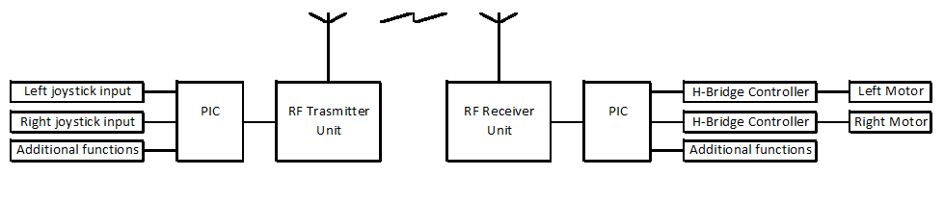
Figure 6: Improved system design.

Project Planning
With the improved system design agreed, it was then possible to discuss a more detailed development plan.
The logical division of labour provided the Controller Unit as one task and the Buggy development as another to be progressed concurrently but in close association, considering the common language that will be required to operate successfully. This is seen in fig. 7, below.
The projected development, procurement, construction and testing times are shown below. As these times are projections, there may be differences in the actual times spent on tasks. See Appendix A for detailed projections.
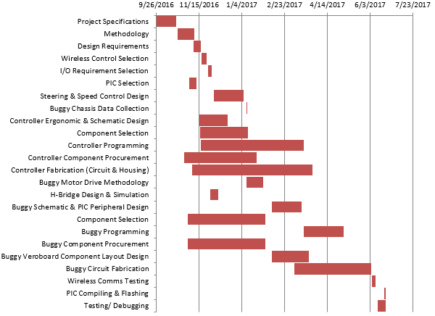
Figure 7: Project time allocations

Wireless Control.
As stated in para. 4.3, a wireless RF solution was chosen in preference of Infrared when consideration was given to the benefits and drawbacks of range, power consumption and data rate.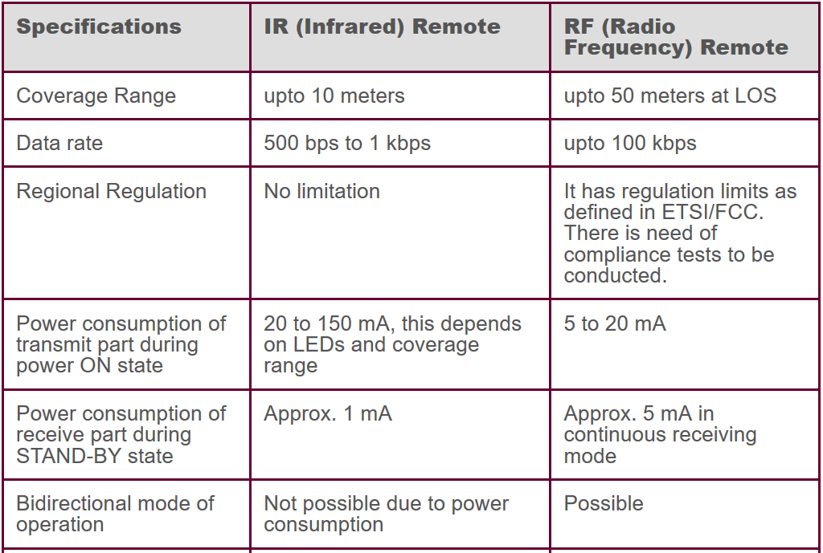
Figure 8: IR v RF transmission comparison
As seen in Figure 8 above, the comparisons provide both solutions with favourable characteristics. For the project in hand, it was decided that range and power consumption were of paramount consideration over data rate. Therefore, an RF communications solution was selected as the primary candidate.
Further detailed discussion centred on the use of a Transmitter – Receiver (Tx-Rx) system or a Transceiver pair (TRx).
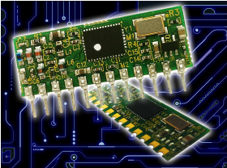
A Tx-Rx system will only permit data flow in one direction, i.e. From the Controller Unit to the Buggy. Such a system would be relatively low cost and have a low power consumption but also a little rigid in application and less adaptable to modification.
A Transceiver pair will permit data flow from the Controller Unit to the Buggy and, in return, from the Buggy to the Controller Unit. This data might be a tell-back from the Buggy or data from customer supplied equipment data installed on the Buggy. While such a system would be more complex and costly to instigate it could also be utilised in a more fluid role and be more adaptable to modification.
With these considerations in mind, we investigated possible solutions and agreed on a premanufactured TRx sub-assembly a KAPPA modem module M868. While this unit is costlier and of higher power consumption it provides us with two advantages:
Figure 9: KAPPA M868 modem module
The benefits of a TRx system can be demonstrated to the customer.
If the customer does not require a TRx, the unit can easily be easily replaced with a Tx-Rx system in a similar Single In-Line (SIL) package.
This model TRx accepts an RS232 data format and transmits an 868 Mhz output signal at up to 100 milli-watts using a simple Frequency Modulated (FM) technique.
If the customer selects the Tx-Rx option, one RS232 output from the Controller Unit PIC will be required and when fitted to the Buggy, one RS232 input pin will be required.
If the customer selects the TRx option fitted in this system, each TRx will require an RS232 input and output pin on each PIC.
As we have elected to design the system to accept a TRx, we will continue development under the assumption we are using a TRx pair. Therefore, we will require a PIC with an RS232 input and output pin available.

Steering Inputs and Speed Control.
It quickly became apparent that the group was very familiar with gaming console controllers and it was agreed to concentrate our efforts on identifying a ‘thumb-stick’ style joystick. A centre-neutral device will be required to provide both forward and reverse control.
As previously stated, two such input devices would be necessary, one for each wheel.
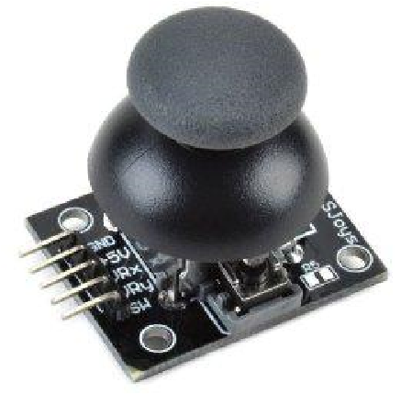
We identified a supplier on Amazon providing KY-023 type twin-axis thumb controllers. Although only one axis is required for the project, all functions of the controller were wired to the transmitter circuit board should they be required for use in the future.
Figure 10: KY-023 twin-axis thumb controller

Each axis is a simple variable resistor. A +5V DC supply across the resistor will provide a nominal +2.5V output when the joystick is in the centre-neutral position. This will be our Stop or Zero input position with full deflection forward providing an output of +5V and 0V for full deflection in reverse.
To provide the customer with a modicum of control, Fast, Medium and Slow speed settings were devised for use in both directions. The output voltage range that each speed setting would cover was calculated. See Figure 11.
Figure 11: Thumb-stick output voltage range

Figure 12: Thumb-stick output voltage graph

The data supplied in Fig. 11 has been used to construct the graph shown in Fig. 12 to further demonstrate the voltage ranges each speed selection will generate.
Each thumb-stick will require an 8-bit Analogue to Digital Converter (ADC) input on the selected PIC.
These voltages will be converted into a binary value from 0 to 255. This range is easily transferred from our graph in Fig. 12 to produce Figs. 13 and 14.
Figure 13: ADC binary conversion of thumb-stick input voltage

Figure 14: ADC binary output range table
The ADC range values for each speed and direction shown above will form the core speed and direction control parameters that will require interpretation by the PIC programming.

H-Bridge Motor Driver & Pulse Width Modulation (PWM).
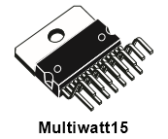
While researching H-Bridge motor drivers^{[E]} attention was drawn to an integrated dual H-Bridge driver manufactured by ST Microelectronics, the L298. Control of each bridge is by standard TTL inputs with an independent supply used to drive the motors.
Figure 15: L298 Dual H-Bridge Driver
Using a dual H-Bridge design such like the L298 is a sensible avenue to pursue as the buggy uses two independent motors which can then be controlled by two independent PWM’s. The L298 dual H-Bridge’s design is packaged into one IC (Integrated Circuit) chip providing a compact component for the construction phase.
Figure X demonstrated a simple H-bridge circuit with two pairs of switches enabling motor rotation in either direction. As the supply voltage to the motors is constant speed control is provided by manipulation of the time period each pair of switches is closed, dictating the speed at which the motor turns.
This technique is known as Pulse Width Modulation and is simply “a method for generating an analogue signal using a digital source”. ^{[6]}
A 5V source switched at 50% duty cycle will produce a 2.5V output and at 20% the output will be at approximately 1V. This manner of switching will produce a controllable voltage applied to the motors resulting in a controllable speed.

Additional Functions.
This somewhat generic term was applied to the functionality that was to be designed into the system to provide the customer with a communication avenue and/or activation function between the Controller Unit and the Buggy itself.
This somewhat generic term was applied to the functionality that was to be designed into the system to provide the customer with communication/activation functions between the Controller Unit and the Buggy itself.
As a remote vehicle, it was suggested that an audible movement alarm would be of benefit to the safe transit of the buggy and to act as an impending movement warning to those in close proximity.
In addition, visual indicators of intent were added, should the buggy be operating in a high noise environment, or in proximity to humans with impaired hearing (natural or man-made)
Finally, area illumination was added as the buggy may be operating in the dark, or be required to illuminate areas inaccessible to the operators.
With these functions considered, it was decided to provide the Controller Unit with two momentary contact, push button switches and four standard switches to permit these control inputs.

Safety and Compliance.
As with any remotely controlled vehicle, the intent of the human controller is not usually apparent until movement begins. In some cases – like that of an offensive drone, broadcasting position and intent before action is detrimental. For this project, the safety of the operators and public is paramount. Therefore, the system has been designed to include both audio and visual warning systems.
Additionally, it was deemed prudent to design in a physical dead-man switch should the controller become distracted or incapacitated for some reason. This was easily achieved through component selection. The thumb controllers identified in para 7.3 have a spring return to neutral design. When programmed, this neutral position will be designated a fail-safe or stop command.
Further thought on the safety case then moved to loss of data-link. The question was raised: How will this design respond without an input signal?
After discussion, it was decided to include a fail-safe ‘code’ within the control data which would verify the data as true. If this occurs, the buggy will act upon the command signals. However, if the fail-safe code is not received, the buggy will reject the code and stop.
This coding effects a second level of fail-safe but also adds an unexpected level to the fail-safe aspect of our control.

Programmable Interface Controller (PIC) Requirements & Selection.
The functional inputs and outputs (I/O) of the Controller Unit PIC were drawn up.
Input / Output | Qty | Type
Joystick controller | 2 | ADC
Audio Warning | 1 | Digital
Turn Indicators | 2 | Digital
Area illumination | 1 | Digital
Communications | 2 | RS232 Tx and Rx

The functional I/Os of the Buggy were also tabulated.
Input / Output | Qty | Type
PWM (Speed) | 2 | Digital
Audio Warning | 1 | Digital
Turn Indicators | 2 | Digital
Area illumination | 1 | Digital
Communications | 2 | RS232 Tx and Rx
Relay interlock | 1 | Valid state motor enable

In addition to I/Os, the memory requirements of the PIC were addressed. A PIC has three different types of memory: Programme, Data and EEPROM.
The programme memory contains the commands written by the user to execute in response to the specific application inputs. data memory is of random access type (RAM) and used to store working variables during the operation of the PIC. Data stored here is lost when power is removed from the PIC.
Electrically Erasable Programmable Read Only Memory is “a non-volatile memory but has slower response time. EEPROM memory can be used to store data such as sensor logs, device parameters which should not be loss during power loss or CPU reset” ^{[7]}
Due to the nature and applicability of these types of storage mediums on each PIC, we require a device with Program memory and RAM. EEPROM memory is of no use to us and therefore of no consideration in our selection process.
With some guidance from Learned Experts, a maximum of two hundred instruction works was suggested. As Instruction words are 14 bits long that produces a program memory requirement of: (200 x 14) ÷ 8 bytes = 350 bytes.
As engineers and programmers rarely agree, a double is never enough, so a quadrupling of the program memory capacity was considered acceptable.
With these requirements considered, the MicroChip PIC selection tool was used to identify a suitable PIC for our use. With our minimum requirements entered in the sorting tool, some options were available to us. (fig. 16, below)
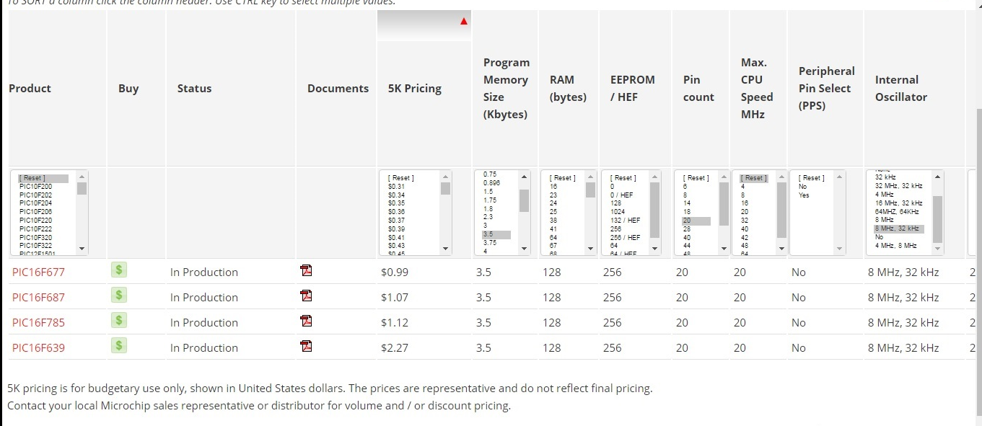
Figure 16: Initial PIC selection process
The PIC16F785 was identified as the most appropriate for the desired application. This was based on the previously discussed criteria, with cost and availability being the deciding factors.
The 20 pin DIL package was adopted into the design process.

Data packet Construction.
The nature of the customer requirement identified in section 3 ensured that the primary focus was on the speed, direction and finesse of the movement controls to be provided in the product.
The 8-bit data packet available to us was compared with the control required by the customer brief, the software safety device decided internally and the speed / finesse requirement stipulated by the customer.
With a Left/Right controller, four bits were allocated to Left and four to Right. Each four-bit nibble will utilise the same input and output protocols, reducing the coding and overall workload.
Two bits were allocated to Speed, one to direction and one to a Valid flag. Each 4-bit nibble, combined will provide a data packet similar to that shown below.
Bit 8 | Bit 7 | Bit 6 | Bit 5 | Bit 4 | Bit 3 | Bit 2 | Bit 1
Stay Alive | Left Direction | Left Speed | Left Speed | Stay Alive | Right Direction | Right Speed | Right Speed

Speed | Bit 1 | Bit 0
Fast | 1 | 1
Medium | 1 | 0
Slow | 0 | 1
Stop | 0 | 0
The provision of a two-bit speed value provided the control definition with on stop value and three movement values: slow, medium and fast. In conjunction with the Direction control bit, this would permit each motor seven speeds – three reverse, three forwards and stop.

Data-link loss safety protocol, as described in para 10.4, was designed into the system using two bits 8 and 4. When bits 8 and 4 are both value 1, the receiver will consider this a valid packet and proceed as instructed. If either bit is zero, the packet will be discarded and all buggy action cease.
The full, valid data-packet construction can be examined in Appendix B.
As the Left and Right speed and direction controller utilised the same programming parameters, with minor changes, PIC programme development time should be simpler than a WASD^{[K]} control systems.

Controller Unit Development.
With the basic requirements set in Section 3, and some specific components identified in Sections 6 and 8, parts procurement began.
While a chassis had been provided for the buggy, a suitable Controller Unit enclosure needed sourced with consideration to the suppression of any disadvantageous RF emissions. A suitable ferrous enclosure was identified and acquired.
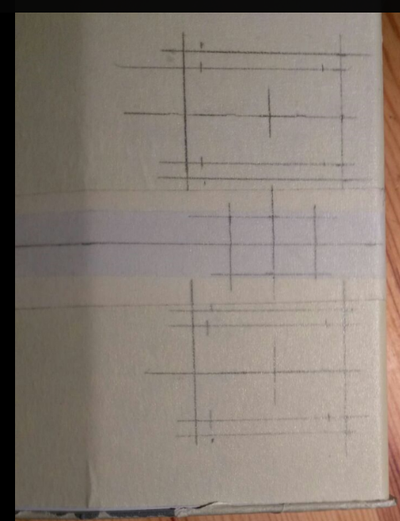
For construction ease and final presentation purposes, the enclosure was wrapped in masking tape. As suggested this provided two things – the protection of the aesthetics of the enclosure that might be damaged during construction and the provision of a suitable marking medium for component placement suggestion, hole marking and drilling.

The use of pencil on a paper based surface was most beneficial during the construction and component placement phase.The careful attention to the enclosure during construction resulted in a cleanly finished product. 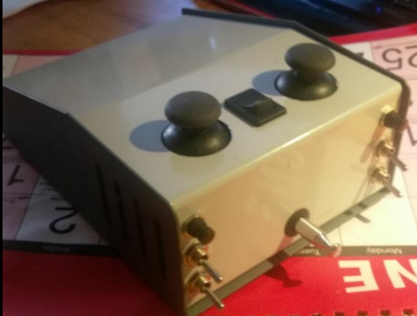
Figure 17: Completed Controller Unit - External
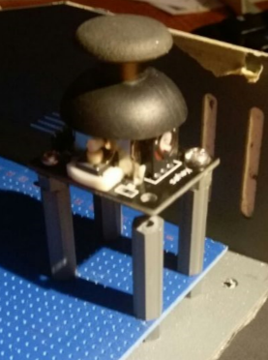
Internally mounted Veroboard was fitted to maximise the available track space – the design and manufacture of a bespoke printed circuit board was considered unfeasible.
As human / machine inputs can be, at times, aggressive, it was considered prudent to mount the thumb-stick controllers directly to the base of the enclosure in as secure a manner as possible. While securing the thumb-controllers, the additional mountings provided additional security to the Veroboard installation.
The Controller unit switches were fitted, wired and loomed within the top section of the Controller Unit enclosure.

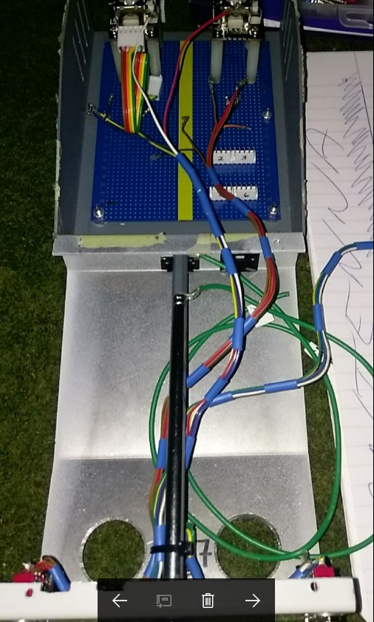
When loomed within the top section of the Controller Unit, the assembly was joined with the base to verify that the wiring layout was fit for function during live fault finding or analysis procedures.

While this field analysis / ease of access was not stipulated in the initial user requirement, such design features are often appreciated and can result in repeat
business.
With the top section complete, Veroboard design commenced. Pre-cut tracks were verified. Link wires, header locations and component placement were analysed for ease of access and wiring loom ergonomics.

The completed Controller Unit, shown below in maintenance mode. Note the four miniature LEDs at the bottom of the picture.
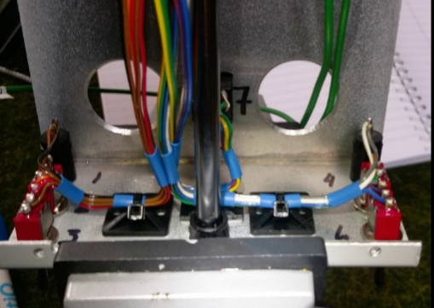

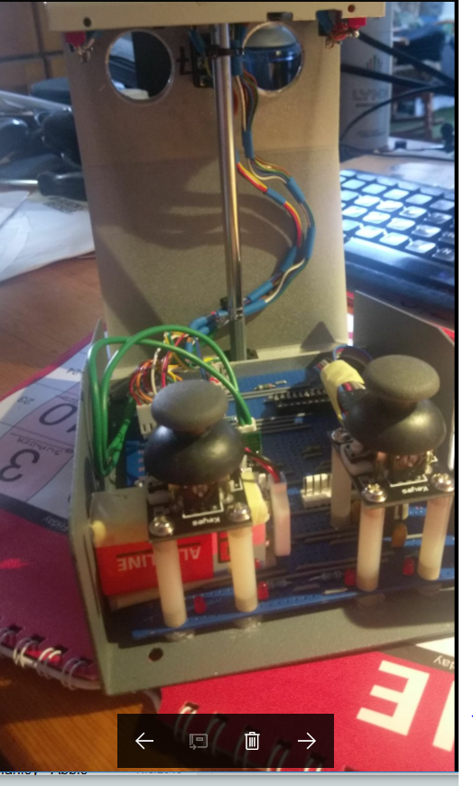

Buggy Development.
Buggy development was progressed as a semi-independent project. While communications and I/O concerns we common, PIC application, programming and specific circuit designs were progressed independently from the Controller Unit.
Throughout the project team communication was absolutely paramount due to the physical separation of team members incurred by natural location. Due to this lack of physical interaction, other avenues of communication had to be developed.
Social media provided an excellent near-instant text platform for queries, questions, idea exchange and, at times, robust discussions regarding the best way forward.
The file sharing service DropBox enabled the team to successfully compile a PIC programme while 400 miles apart.

Introduction to Group Project (Buggy)
In this Group Project, we are tasked with designing, programming and fabricating a remote control battery powered buggy. The buggy’s chassis is supplied to us from the University facility. The buggy’s chassis consists of two D.C. motors, a front jockey roller castor and the main chassis itself with the 4xAA battery compartment built in.
The decision is left to us on the design of the circuitry, the method of the wireless communication and programming the PIC to read inputs and process to control and give outputs to the buggy.

Methodology
The task is to make the buggy move forwards, backwards, and turn left and right. The buggy will need to be speed controlled in order to vary its speed of travel safely. We are to choose the suitable method of wireless communication ourselves, either it being RF (Radio Frequency, Typically 27MHz for R/C cars), IR, (Infra-Red) or Ultra sonic.
The main task of this project is to implement the use of two IC Microcontrollers by using MicroChip’s© PIC (Peripheral Interface Controller). The Task is to program two PIC’s, one on board the wireless controller to read the inputs from the joysticks, then send data packets to a secondary PIC on board the buggy. This is to control the D.C. motors in different sequences to move the buggy forwards, backwards, left and right in variations of speeds.
The speed control will be implemented via the PIC. The PIC will read the position of the joystick(s) along its axis of movement, the readings the PIC will take from the joysticks will be in the value of voltage. We will supply the joysticks 5v D.C. and the joysticks will be of variable resistor kind. Then it will convert these voltage readings into decimal values ranging from 0 to 255 and then the PIC will convert this into a binary bit sequence to transmit to the buggy’s PIC.
The method of the speed control itself will be done by PWM (Pulse Width Modulation) and again, the PIC’s programming will define at what level the joysticks readings are at in order to define the duty cycle of the PWM that will vary the speed of the D.C. motors.
The power management and speed control to the D.C. motors will be fed by a dual H-Bridge. This is because the PIC can only supply a limited amount of current to the motors and the PWM output from the PIC is used purely as a speed control signal. Therefore the Dual H-Bridge is needed to act as a power transistor, switching the large amount of current that the motors need. We are using a dual H-Bridge design as we are using two independent motors that are controlled by two independent PWM’s and the dual H-Bridge’s design is packaged into one IC (Integrated Circuit) chip.
The controller’s joysticks will be designed around the skid-steer system that’s commonly known for on tracked vehicles, this is because the buggies chassis has two independent rear powered wheels each with their own motor, plus the front wheel is a dummy castor roller, so a rack and pinion or servo tie-rod steering system is not an option at this early stage.
The Buggy will need a fail-safe system built into it, in case the buggy wanders off on its own accord or behaves in a sporadic manner that is uncontrollable by the user. This will be done either by a mechanical safety interlock or by the use of parity bit checking within the PIC programming.

Requirements/ User Specifications

Controller
On/ Off button with LED indicator
2 x Forward/ Backward levers (Left & Right Wheels)
Extendable/ Removable antenna
Battery powered, (PP3 9V)
Aux buttons for lights/ horn
PIC Microcontroller to interface & process peripherals
RS-232 Transceiver

Buggy
On/ Off button with LED Indicator
2 x D.C. motors (Independently Controlled)
Dual H-Bridge
PIC Microcontroller (to receive controller data & output to motors and lights/ horn)
RS-232 Transceiver
Motor fuses
Lights & Indicators
-Headlights
-Main Beams
-Indicators
-Brake lights
-Tx/Rx Status

PIC Selection/ Requirements
The PIC we will be selecting will be determined by the number of I/O’s (Inputs/ Outputs) that our controller & buggy will require.
We will be using MicroChips© online PIC selection wizard page to filter out and select the right PIC for our application.
The PIC Microcontroller uses quadrature architecture, by that definition it means that it can process 1 instruction for every 4 clock cycles.
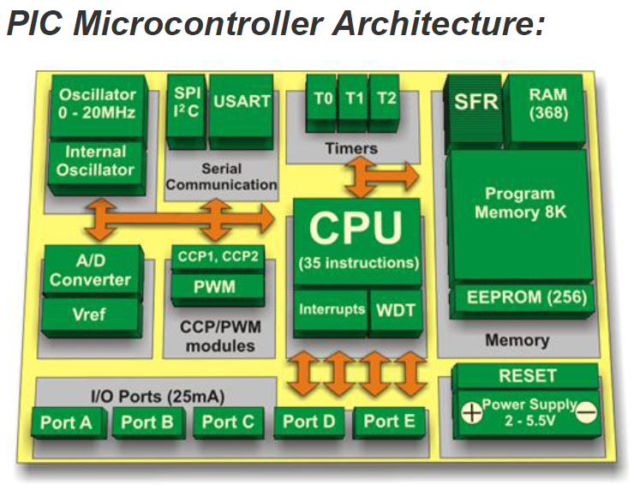
E.g. a PIC with 8 MHz clock cycle can process $\left(\frac{8 MHz}{4}\right)$ which equates to 2 Million Instructions per Second or (2 MIPS).
The PIC itself contains;
- CPU,
- RAM,
- EEPROM,
- Program Memory,
- SFR (Special Function Register),
- I/O Ports (A to E),
- A/D (Analog to Digital Converter(s),
- Internal & External Oscillators,
- SPI I²C & USART,
Figure 1
- Timers & Interrupts.
These peripherals are the basic fundamentals for any type of PIC Microcontroller. The CPU is the main component that is the key feature in the PIC as it carries out all the mathematical operations from reading inputs on the A to E Ports, to ‘crunching’ numbers, storing them in the Special Function Registers as well as recalling stored memory data. It contains an ALU (Arithmetic Logic Unit), Memory Unit (MU) and Control Unit (CU). It is what processes the instructions that are stored in the Program memory.
The Program memory contains the written code that’s in ‘C’ language, the code is executed by the CPU one instruction after another. The Data memory, Random Access Memory (RAM) contains the Special Function Registers (SFR) as well as General Purpose Registers (GPR). These contain the variables that are needed to process the instructions that the program memory holds.
In order to choose the correct PIC microcontroller for our application, we need to calculate how big the Instruction words set will be. This is the program that will be written in the ‘C’ language and then compiled into binary so that the PIC can interpret the instructions in a form of 1’s and 0’s. The PIC Microcontrollers are divided into ‘Families’ of Microcontrollers. When you look up PIC models, the first numbers you’ll see are digits such as 12F, 14F or 16F. These families share the same instruction word bit count. In our case, we will be working with 14-bit PIC’s as the common majority of the 8-bit PIC’s use the 14-bit word instructions.[2]

PIC Selection: Controller & Buggy
So, to calculate the maximum possible instruction words we need, that is calculated in Kbytes is as follows;
We can estimate that our maximum instruction words are 200, so,
× 14-bit (Instruction Words)
÷ 8-bits (8-bits = 1 byte) = 350 bytes
And so we quadruple to give us headroom for improvements/ modifications;
= 350 bytes × 4 = 1400 bytes (1.4 Kbytes)
Next is to work out how many pins our PIC(s) will need, this will ultimately define on what PIC chip model we will need;

Controller Pin-Outs
2 Analog inputs (Left & Right Joysticks)
4 Digital Inputs (Dipped beam Lights, main beam lights, Left indicator & Right Indicator) [ADC]
1 Rx Data Input
RS-232 (UART or USART) [ADC]
1 Tx Data Output
1 LED Output (Dipped Beam Lights) [ADC]
1 LED Output (Main Beam Lights) [ADC]
1 LED Output (Left Indicator) [ADC]
1 LED Output (Right Indicator) [ADC]
Total: 12 Pins +50% = (Say) 15 Pins

PIC Selection: Buggy/ Receiver

Buggy Pin-Outs
2 Pulse Width Modulation Outputs (PWM) (Left & Right Motor Speeds) [Digital]
1 Rx data Input
RS-232 (UART/ USART) [Digital]
1 Tx data Output
2 TTL Outputs (Left & Right Motor Direction) [Digital]
1 LED TTL (Dipped Beam Lights × 2) [Digital]
1 LED TTL (Full Beam Lights x4) [Digital]
1 LED TTL (Left Indicators) [Digital]
1 LED TTL (Right Indicators) [Digital]
Total: 10 Pins +50% = (Say) 15 Pins

The parameters that our PIC selection will be determined by is as follows;
- Minimum of 15 pins for the controller & Buggy
- Buggy PIC to have 2 independent PWM’s (Pulse Width Modulations)
- Tx/Rx RS-232/ USART ports
- 1.4Kbytes Program Memory minimum
- Controller to have 2 ADC inputs minimum
- Controller to have 4 Digital inputs minimum
- 8MHz minimum clock speed

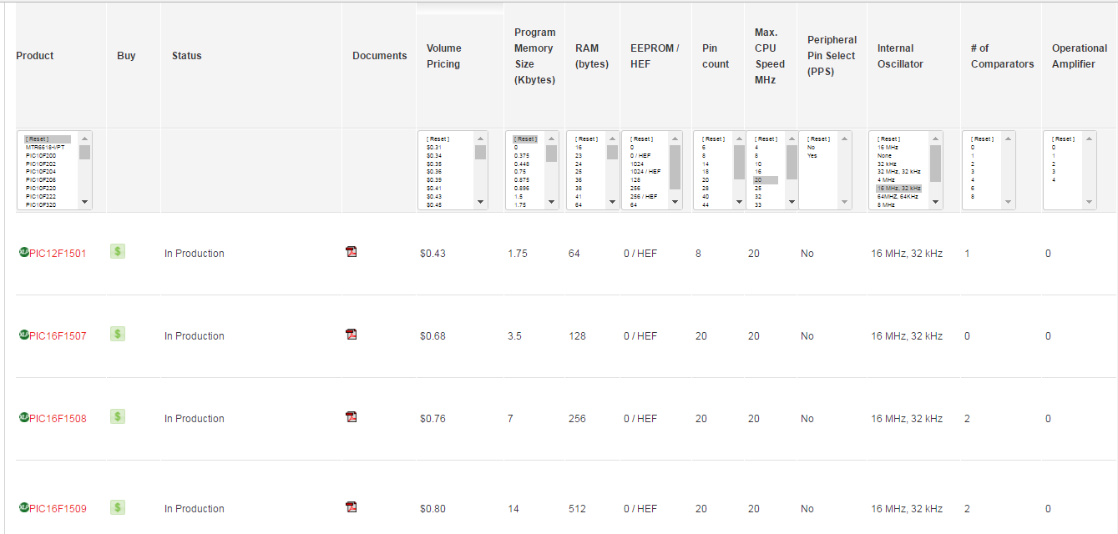
Microchip® PIC Selection
Figure 2
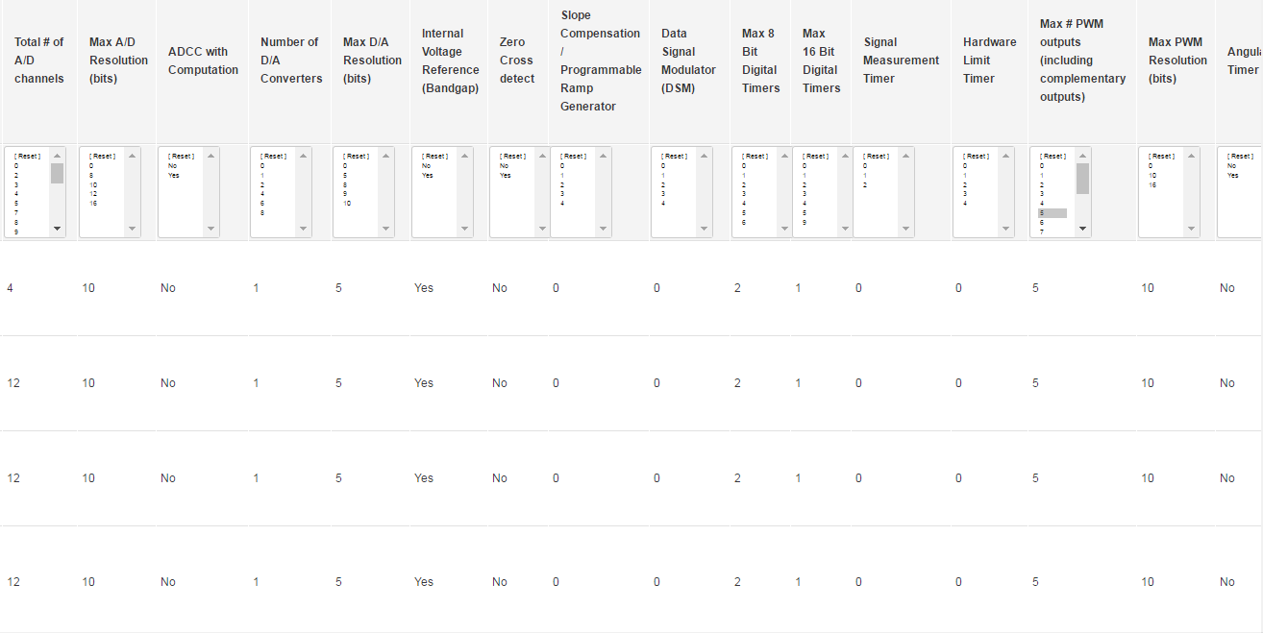
Using Microchip’s PIC selection page, the correct PIC Microcontroller was defined using the parameter heading filters that will narrow down the suitable PIC for our application.
In our application, a PIC with more than 15 pins, 1.4kbytes of program memory and minimum 2 PWM generators is needed. Another note to factor in is the availability of some of the PIC chip models.
Figure 3
The PIC16F1508 was selected for the buggy due to Microchips® PIC selection & product availability.

H-Bridge Motor Driver
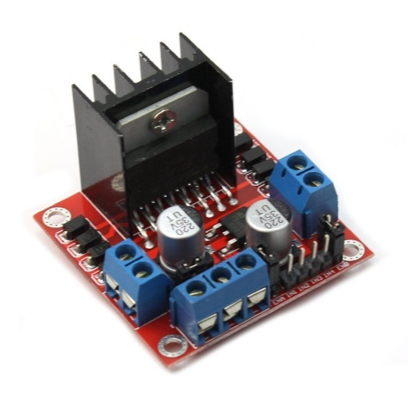
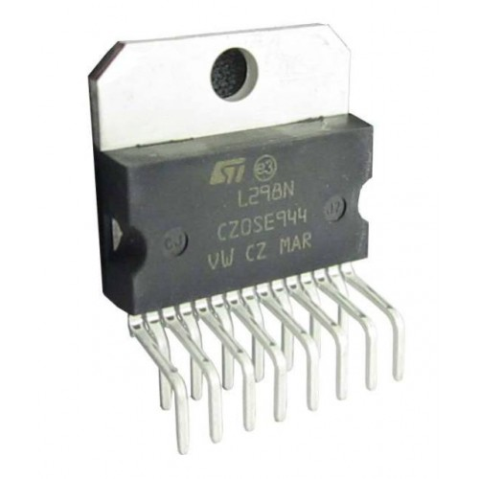
The H-Bridge that will be used will be the L298N model, as this has the capability of controlling and running two independent motors. The L298N comes as a standalone IC chip or as an IC controller board module. The advantage of procuring the H-Bridge control board module over the standalone IC chip is the cost, space saving, due to the printed circuit board and the advantage that the module comes with the installed components needed for the H-Bridge. These additional items on the module include; the on board 5v logic voltage regulator, 8 back EMF diodes, decoupling capacitors and the connection terminals.

Figure 4
Figure 5

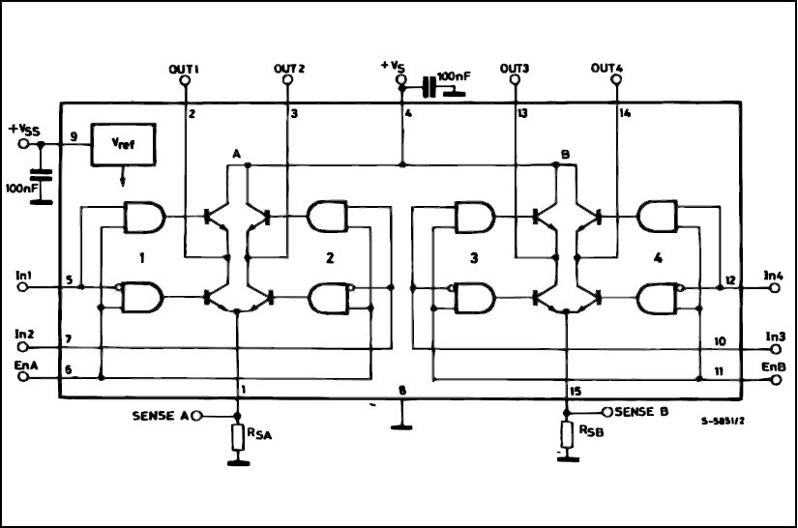
The H-Bridge module will require battery voltage supply to drive the motors; this will be fed directly from a fused supply. A 5v supply will be fed to Vss to the H-Bridge to power the L298N IC Chip.
The H-Bridge’s logic schematic, shown above here in Figure [6] will define the motors input control terminals. According to the datasheet, ‘En A’ and ‘En B’ sets the ‘on’ command to the L298N chip to drive the motors. ‘In 1’ & ‘In 2’ sets the polarity of the motors, in that will switch on the diagonal pairs of transistors inside the L298N chip to send current to the motors in one of the given directions.
Figure 6
The method that will be employed for controlling the motor, through speed and direction, is to firstly use PWM (Pulse Width Modulation) that the PIC will generate through its programming. This PWM will vary depending on the received signal from the controller’s joystick position. The duty cycle of the PWM is what governs the speed. This will be fed directly into ‘En A’ & ‘En B’ for the given motor.
The direction will also be controlled by the PIC, depending on the controller’s joystick position, back or forward direction, the PIC will send out a TTL command that will set the direction. As there are two inputs for each direction, the TTL logic will need to be opposite for ‘In 1’ & ‘In 2’. If both directions were set to TTL logic ‘1’, the potential risk of damaging the H-Bridge is imminent, as this would result in a direct short. So to safeguard this, a 7404 Hex inverter will be used to reverse the TTL logic on the opposite direction.
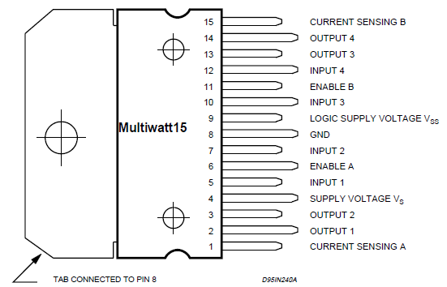
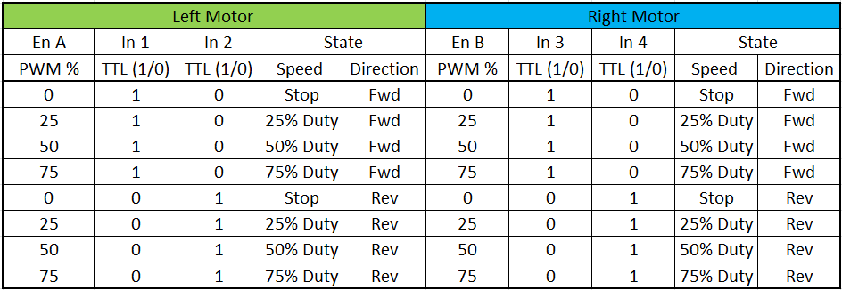
The H-Bridge’s pinouts are displayed here in Figure [7]. The independent motor speed PWM pulses will be connected to Enable A and Enable B, the motor directions will be fed into Inputs 1, 2, 3 & 4. Input 1 TTL high & input 2 TTL low is forwards for motor 1, Input 1 TTL 0, Input 2 TTL high is reverse for motor 1, this logic applies for motor 2 on inputs 3 & 4 respectively. Outputs 1, 2, 3 & 4 are the motor connections, 1 & 2 being the Left motor, 3 & 4 being the right motor. These can be alternating polarities depending on the direction set on the input pins.
Figure 7

Figure 8

Displayed above in Figure [8] is the logic table for the H-Bridge, the left and right motor’s speed and direction combination are identical to the same logic input.

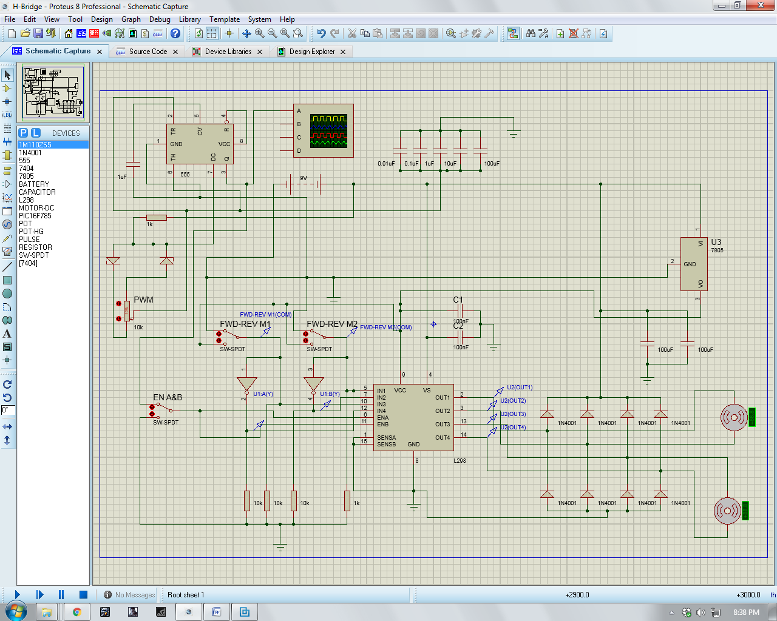
Figure 9

The H-Bridge is then simulated in Proteus to prove system functionality. For this simulation, a 555 timer is employed purely just to produce a PWM (Pulse Width Modulation) that is variable by an input potentiometer to the 555 timer. The single PWM output from the 555 timer is fed into the H-Bridge’s inputs ‘En A & En B’ to vary the speed. The various PWM’s generated by the 555 timer is fed by the 5 different value capacitors in the top centre of the picture above, these capacitors produce different frequencies when the potentiometer is varied, and the 555 timer outputs a digital square wave with a duty cycle depending on the charge & discharge frequencies produced by the capacitors.
The motors directions, ‘In 1 & 2’, ‘In 3 & 4’ are switched to a 5V supply logic via a switch, this 5V logic is fed directly into ‘In 1’ & ‘In 3’ and the 5V logic is then fed into an inverter for ‘In 2’ & ‘In 4’ to reverse the logic from the opposing input directions, to protect the H-Bridges circuit from short-circuiting.

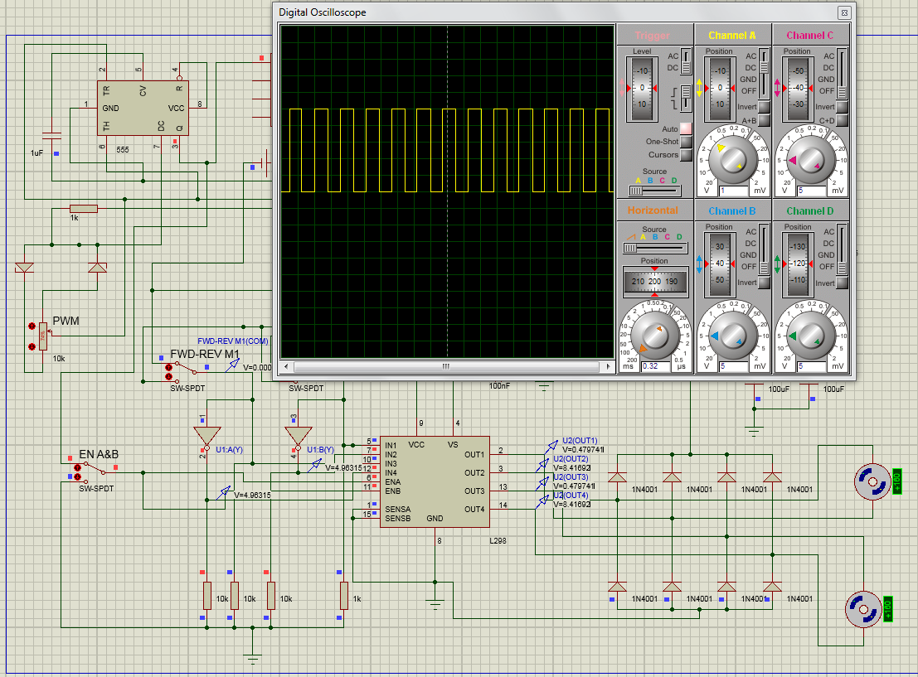
Figure 10

The simulation is then run and the potentiometer to vary the PWM of the 555 timer is adjusted to give various speeds (Middle Left of picture). Pictured above in Figure [10] is the duty cycle from the output of the 555 timer’s PWM to ‘En A’ & ‘En B’. The speed is dictated by how long the pulse is ‘on’ compared to ‘off’ states, known as ‘duty cycle’
The 8 diodes pictured on the H-Bridge’s output to the motors are to stop the back-flow of EMF (electromotive force). The purpose of this is so that when the motors are suddenly loaded, the motor’s armature will slow down and move slowly through the magnetic field, thus the current will increase and the back-EMF voltage falls. The armature will draw as much armature current to overcome the load introduced until it is equal, and therefore the EMF voltage will be equal to the voltage applied to the motor. [https://www.quora.com/What-is-the-significance-of-a-back-EMF-in-DC-motors][3]

CE Marking
The H-Bridge is available in two types of packages currently out on the market. They come as a standalone single IC package which only encompasses the L298N Dual H-Bridge chip. The other package is the Dual H-Bridge module, which includes the necessary components so that the module can simply ‘drop in’. The regulation with using a pre-manufactured electrical item is that it needs to conform to the CE marking regulations. CE stands for ‘Conformité Européene‘[4] and translated from French means: European Conformity, it conforms to standards; 2014/35/EU [5]. Products with voltage ratings of 75V to 1500V are under the low voltage directive (LVD). So the H-Bridge does not have to comply with these regulations as the Max. Operating voltage is 12V given by the manufacturer by the datasheet.

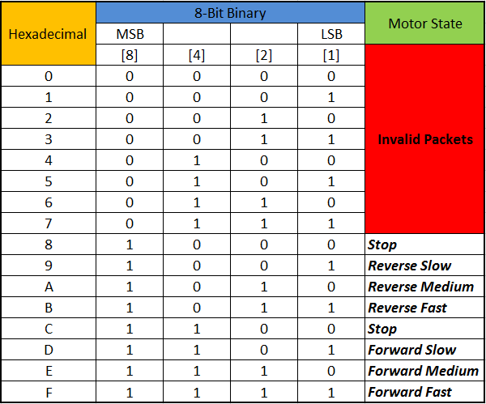
Hexadecimal to Binary data packets
The data packets received by the buggy’s PIC will be done via RS-232 (UART) communications port on the PIC 16F1508. The transmitted data packets will be in the Hexadecimal language for the PIC to de-construct into Binary format. Pictured here in Figure [11] is the logic table that shows the operation of the motor state output. The input data packets will start from the left column (Hexadecimal) then the PIC will convert this into 8-Bit Binary, which it will also convert this into decimal. The table above is one half of the byte, known as a ‘Nibble’ or ‘Nybble’ as the table only shows 4-bits. As the transmitted string is 8-bit data packet and 4-bits per wheel, the table here in Figure [11] is displaying the Hexadecimal to binary conversion for one wheel, as both wheel configurations are identical, apart from the fact that left wheel is bits 5-8 and the right wheel is 1-4 bits.
Figure 11
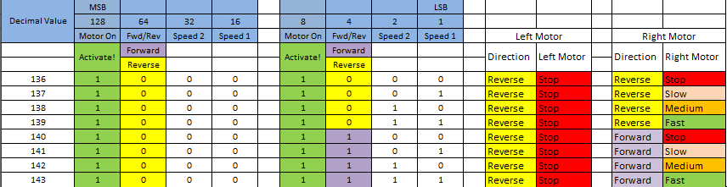
Shown below is a section of the 8-bit motor state table, which contains both motor states.
Figure 12

Gantt chart
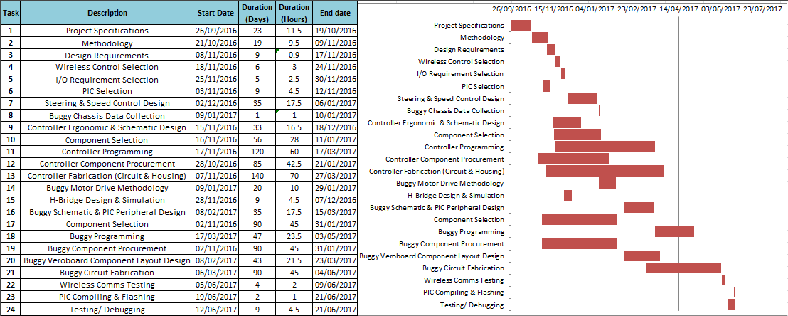
The projected timescale is planned utilising the use of a Gantt chart in order to adhere to good timekeeping and aiming for short ‘milestones’ so that the tasks can be undertaken and completed seamlessly.
Figure 13
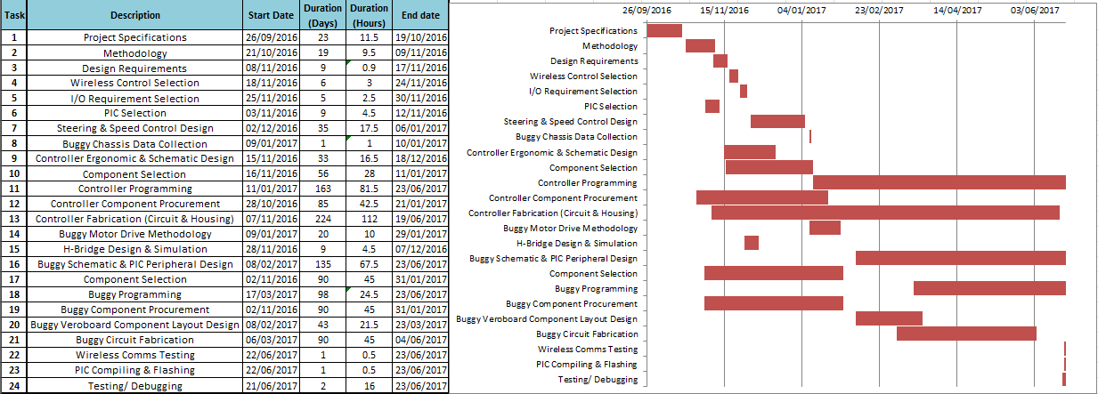
Shown above is the predicted timescale when the project was first undertaken. All thoughts and efforts were taken into account to pre-determine how the project time scope would be laid out. The downside to this is that any problems that can arise will push the next task in line further back; this causes a ‘knock on’ effect to all of the other tasks in line. The best practicable solution is to create and amended Gantt chart at or near completion to give an accurate timeline of how the tasks were met.
Displayed above in Figure [14] is the final Gantt chart at the final stage of the project, the report. The noticeable difference on the projected tasks is the increased duration on the schematic planning, buggy & controller fabrication & the programming for the controller & buggy. The decrease in time was on the wireless communications testing, compiling & flashing & testing stage. This was due to problems that arose during the build that pushed the programming stage further towards the end of the project, which will be discussed in lessons learnt section in this paper.
Figure 14

Wireless Control Selection
Several options have been given for the technological method for wireless control of the buggy. Those options are as follows;
- Infrared
- Ultrasonic
- RF (Radio Frequency)
The method for the type of wireless control is selected by the group based upon; cost, application, ease of use, configuration and suitability of the environment.
Each of the wireless control methods will be analysed against each other and the most suitable outcome will be generated by this on the comparisons.

Infrared
Cost
- £5.71 (RS Components) OPB100Z Optek [RS: 880-1999]
Application
- Remote controls
Configuration
- 1x IR LED Emitter & 1x IR Phototransistor
Suitability
- For short, direct line of sight communications
Advantages
- Small package size
- Cheap
- High data Baud rates compared to other methods (115Kbps)
Disadvantages
- Communications signal easily blocked by objects
- High current draw (Typically 100mA) [OP100Z Optek]

Ultrasonic
Cost
- £20.07 (DigiKey UK)
Application
- Car parking sensors
- Non-Destructive pipeline testing
Configuration
- 1x piezoelectric ultrasonic transducer emitter, 1x ultrasonic receiver
Suitability
- For short range, low noise environments & high data transmission rates
Advantages
- High frequency bands up to 40KHz
Disadvantages
- Most expensive method of communication
- Poor performance in noisy environments
- Limitations on range capability, max range typically <0.5m

R.F. (Radio Frequency)
Cost
- £13.87 (RS Components) KAPPA M868 Transceiver [111-0159 RS No.]
Application
- Telecommunications
- Encrypted Data transmissions
- Radio controlled hobby toy cars, boats, planes & tanks
Configuration
- 1x Transmitter, 1x Receiver Or 2x Transceivers
Suitability
- For long range data transmission in multiple frequency R.F. user environments
Advantages
- Communication ranges up to 1km distance
- Low transmit power ~20mA
- Low cost
- Wide range of frequency bands for multiple user channels
Disadvantages
- Susceptible to RF interference
- Data rates typically <56Kbps

Wireless Transmission Decision

The Method for wireless communications is decided to be Radio Frequency (R.F.). This is due to cost effectiveness, as long ranges can be achieved with a pair of transceiver units with adequate Baud rates. As the controller will transmit no more than 16 bits/Sec, a transceiver pair with a maximum data transmission rate of 56Kbps is more than adequate. There is also a wider variety of R.F. Transceivers on the market to choose from to suit the needs of this particular application.

Components

PIC
The PIC chosen for the controller is the PIC16F785 and the PIC selected for the buggy is the PIF16F1508, The PIC16F785 was initially chosen to be used with both the controller and buggy to utilise the programming set-up and procurement costs. But it was later found that the H-Bridge needed two independent PWM’s for their respective motors. Therefore, the PIC selection process was undertaken again, but with the mind-set for one that was capable of generating two independent PWM’s.
The PIC’s will be powered from 5V supply via a 7805 linear voltage regulator. The PIC’s will be de-coupled on the positive and ground terminations to inhibit noise and power fluctuations with a 0.1uF ceramic capacitor. The PIC’s will be mounted into a pre-soldered 20-pin DIN socket on the circuit board for ease of programming & installation.

H-Bridge
The L298N Dual H-Bridge module will be used as a separate sub-board that will be mounted on top of the main circuit board of the buggy, this is to save space and ease of cable routing to the module. The module is chosen over the IC Chip due to cost saving, and ease of R+R (Remove & Replace) if a fault occurs with it.

Transceiver
The KAPPA M868 Tx/Rx Transceiver is to be used and is chosen from the list of available products from RS components online. This particular model is chosen due to its ease of installation & set-up as the module is already set-up by default for radio communications on RS-232.

Voltage Regulators (5V & 3.3V)
The peripheral components, such as the PIC, 7404 Hex Inverter and wireless transceiver & H-Bridge logic supply requires a limited linear voltage supply according to their respective datasheets. The voltage regulators (5V & 3.3V) will be chosen according to the total circuit current drawn.

7404 Hex Inverter
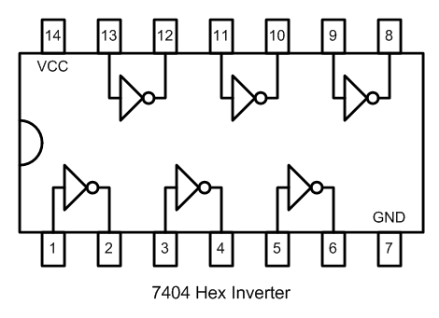
The 7404 Hex inverter was decided to be employed as a safeguard against the short circuit of the H-Bridge’s direction. The theory is, that when the direction is set by the PIC, it will output a TTL logic (Low or High, 0-5V). The H-Bridge’s input terminals have two directions per motor, therefore the opposite logics have to be set on both direction inputs, otherwise, the transistors will short circuit and damage the H-Bridge if the same TTL logic levels are inputted to directions ‘In 1 & In 2’. Using the 7404 Hex inverter also uses two less pins and fewer instructions on the PIC and programming side.

Illustration of the 7404 Hex Inverter will be utilised to output the opposite TTL logic outputted from the PIC for the motor directions.

Figure 15

Procurement list
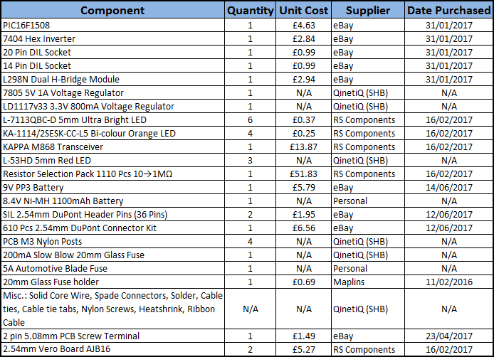

Figure 16

Figure [16] above is the procurement list for every component purchased for the buggy alone. Where possible, as many already available components have been acquired from the Electronic Workshop at QinetiQ Shoeburyness to save costs. Components such as the PIC and H-Bridge, for example, have had to be procured as they are specifically chosen for the requirements of the system. Other items, such as the 8.4V Ni-MH battery was utilised as they were personally available that were spare.

Safety Interlocks
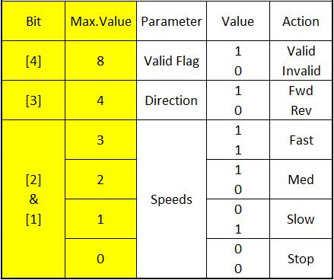
The Buggy is to have a safety mechanism which is imbedded into the programming of the PIC. This is done by including a ‘valid flag’ bit to the transmitted data string. This will be the MSB (most significant bit) that when the buggy receives the data string from the controller, will set the 8th bit to a ‘1’ for a valid data packet which will in turn enable the drive signals to the H-Bridge. If the receiving PIC doesn’t receive this data packet, or only part of it, it will automatically set the ‘valid flag’ to a zero, disabling any drive or functions. This will be covered under ‘PIC Programming’ Section
Figure 17

Buggy Development

Buggy schematic
The schematic for the Buggy’s circuitry is manually drawn electronically below in Figure [18]. This is in case any changes or modifications have to be made during the build or testing stages. The wiring traces to each component in the circuit is defined by the components respective datasheet, in that, the PWM output from the PIC, for example, is noted in the datasheet to which pin it will be outputted on. The interface from the PIC’s PWM output to the H-Bridge, as the same example is compatible with its input termination, in this case its ‘En A & En B’.
Once the wiring schematic is drawn out with the wiring traces clearly visible and easy to trace, with every termination and pin outputs labelled, the next step is to design a Vero board or stripboard layout. This is needed in order to physically plan and place each component onto the pre-drilled through hole stripboard. This aids us in a few ways, firstly, it scales the physical dimensions of each component, limits us physically as to how much space is available on the stripboard, plots where the track breaks are needed, and where the jumper wires are laid out to connect each component together. Finally it gives a working instruction schematic that only requires the user to place each component on and solder in place. This reduces the human errors during the build, as the thinking and planning of the component placement is taken away in the soldering stage.
Displayed below in Figure [18] is the electronic wiring schematic plan for the buggy’s controller circuitry & Figure [19] is the Vero Board component layout plan that is used in the build stage.

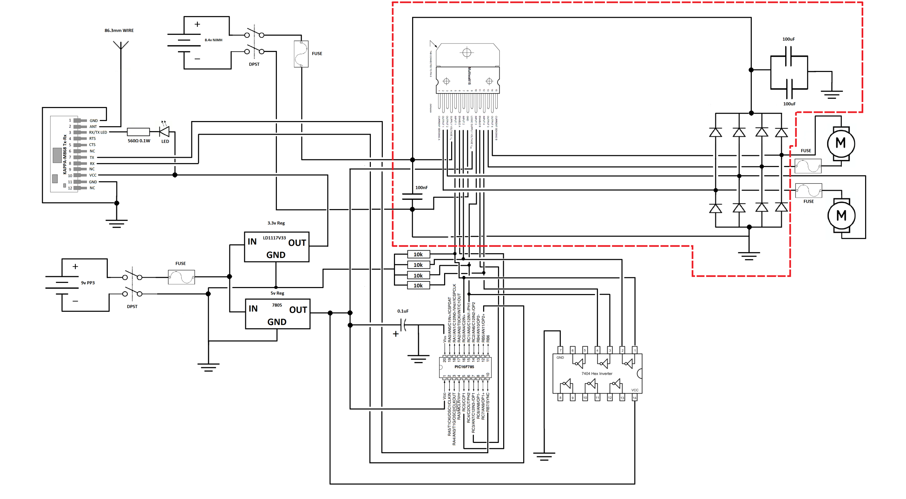
Figure 18
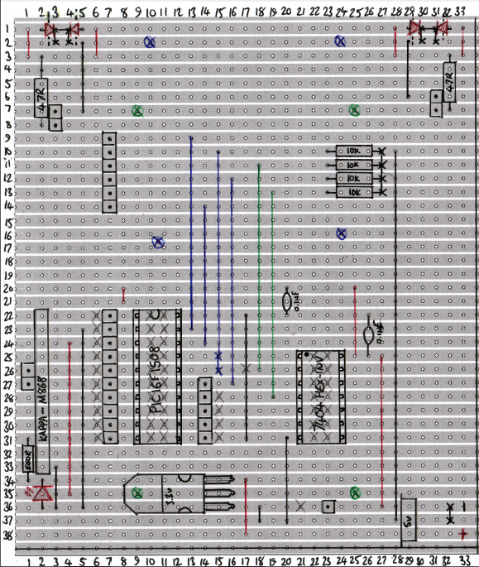
Figure 19

PIC ‘C’ Programming Writing
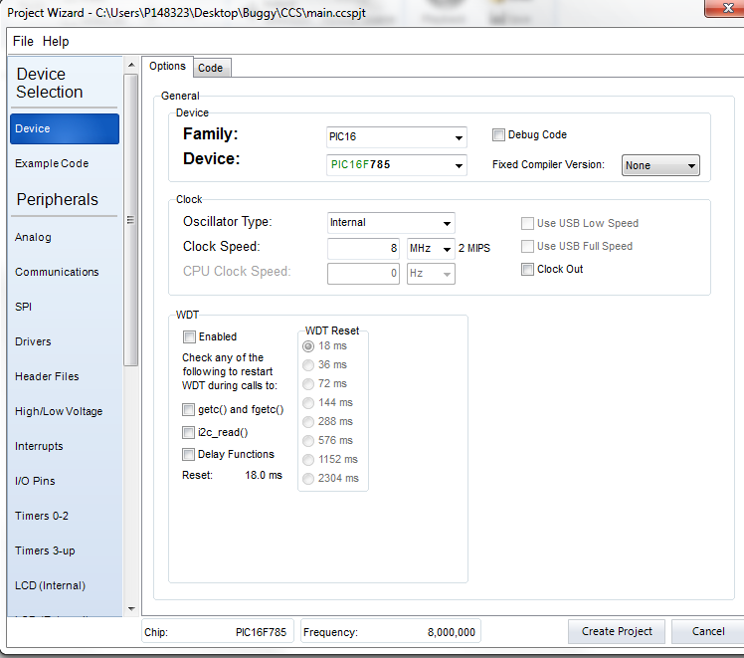
In order to start the programming of the PIC, the PIC main.h file is set up using CCS PIC Wizard in order to set up the PIC’s peripherals, clock speed, analog inputs, communication ports, and set the I/O (Input/ Output) pin names for later in the programming stage on Proteus.
The first stage on the CCS PIC Wizard program is choosing the PIC model and setting the clock speed pictured here in Figure [20].

Figure 20

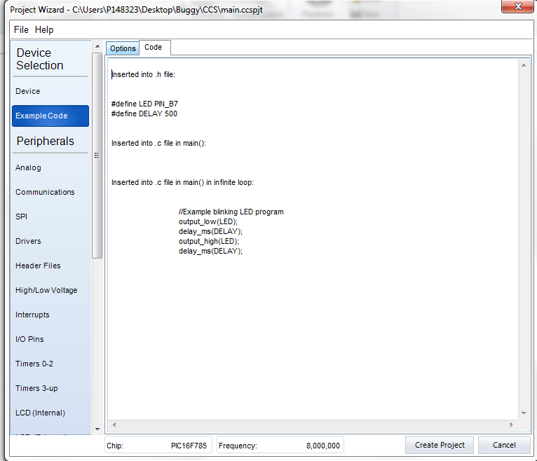
Sample code is given in the Wizard in order to give a quick check that the physical PIC is working as intended. In this case, an example code is given to blink an LED.

Figure 21

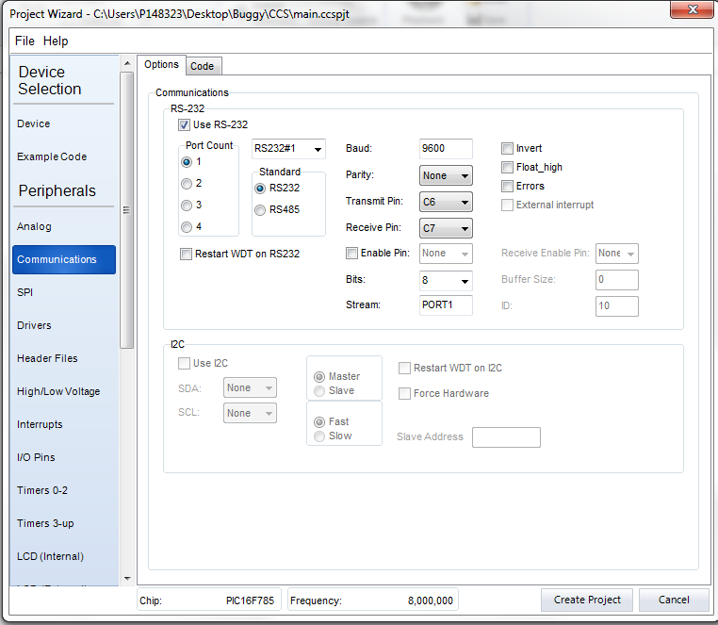
Pictured here in Figure [22] is the set-up for the RS-232 communications port. The Tx/Rx (Transmit/ Receive) ports are given from the PIC’s datasheet and this set-up is governed by this. Here is where the Baud rate is set also.

Figure 22
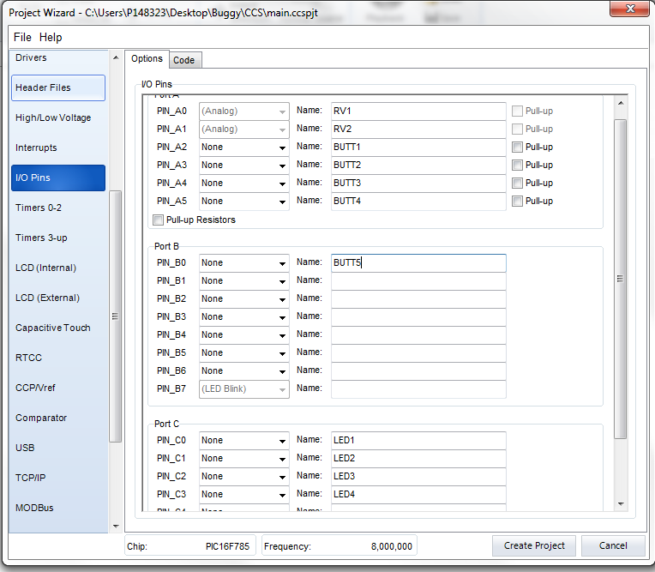

Pictured Left, here in Figure [23] is the page to set up the I/O (Input/ Output) pins for the PIC. The feature with this Wizard is that you can name the specific pins, e.g. BUTT1, for button 1 and in the Proteus programming window; the code refers to the pins name which is assigned in this section. This saves having to go back and refer to the assigned pin numbers from the PIC’s schematic.
Figure 23

Pictured below in Figure [24] is the next stage before writing the code is undertaken. The configuration word needs to be set in the schematic of the PIC’s settings. The configuration word is set by the PIC Wizard set-up. The configuration word tells the PIC what to do on a basic level, i.e. what pins are assigned to do, such as which pins are used to program. [http://modtronicsaustralia.com/support/pic24-microcontroller-tutorials/pic-microcontroller-tutorial-config-words/]. The purpose of this step is to copy the configuration word which is found on the Debug.lst found on, Source > Open File > Debug.lst and scrolling down to the bottom of this list to obtain the configuration word. This is then copied into the PIC’s simulation component settings in order to run the simulation according to how it is set up in the PIC Wizard program.

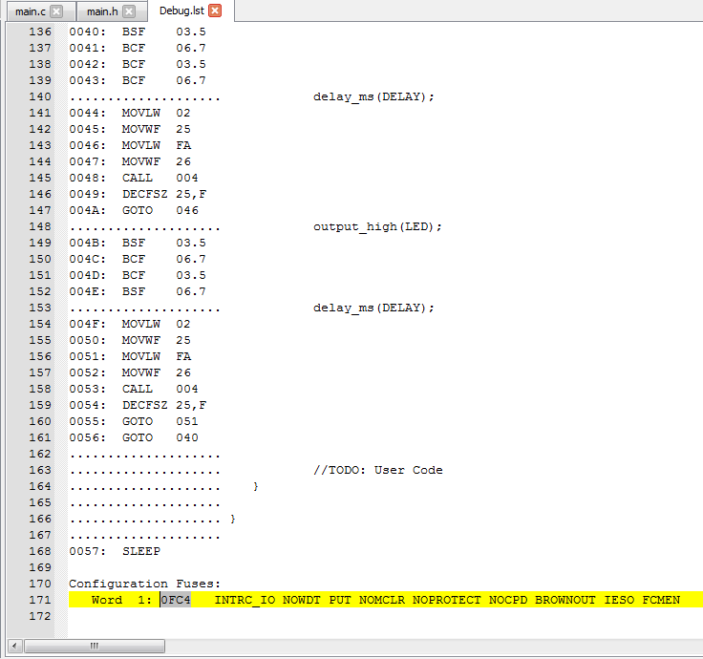
Figure 24

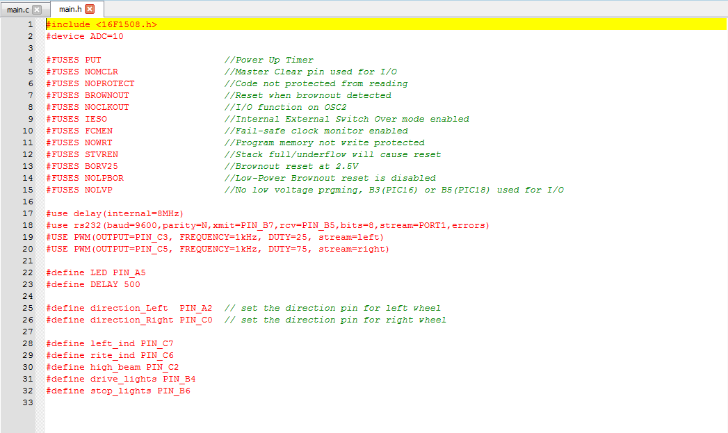
Figure 25

The Hex file, which is written by the CCS PIC Wizard is saved into a folder created called CCS. When the code is written in main.c, CCS software compiles this into the Hex file (main.h) to which the code is converted into the PIC’s Hexadecimal language. The compiled code written in main.c is added to this main.h file shown above in Figure [25].
Figure [25] above shows pin set-up parameters, i.e. what pins are assigned as analog or digital inputs/ outputs, and in this case, which pinouts are to generate the PWM (Lines 19 & 20) and which pins are the motor directions (Line 25 & 26).

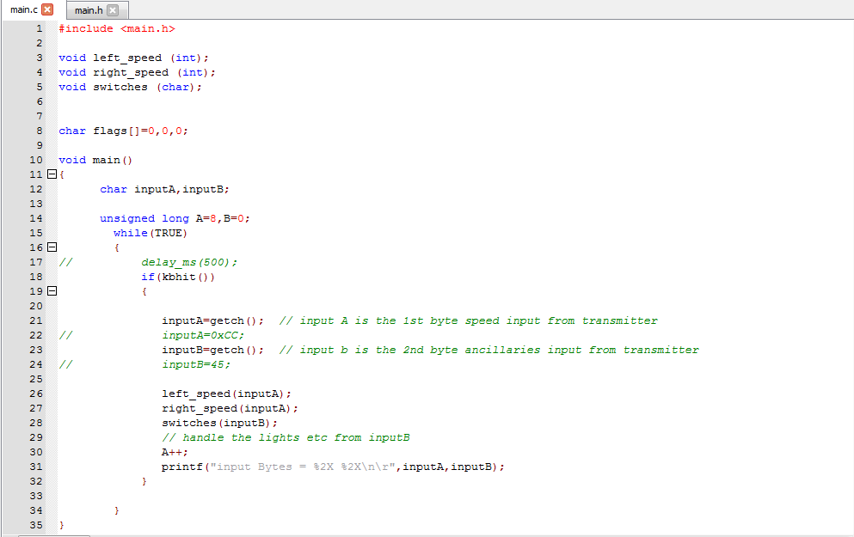
The next programming stage is to write the code statements that will be the instruction set for the PIC. The structure of the code is put into a format so that the PIC can read each instruction or line one at a time. The indentations in the code are statements within an instruction, for example, ‘If InputA high’ ‘enable LED1_Low’, in short, if an input pin to the PIC reads high TTL state, turn on LED 1, otherwise carry onto the next instruction.
Figure 26
Figure [26] above is the start of the buggy programming code; the start of the coding basically means that ‘void’ is an absent whole number value, which is what ‘int’ is short for integer. By that, it means that there is no value set for the left and right motors, which is what ‘inputA=getch()’ is written on lines 21 & 23 to get the transmitted signal from the controller to determine the motors state, i.e. the binary value for the left and right motor.
The statements above instructs the PIC that the wheel data is the first transmitted bit received, and the auxiliary commands, i.e. lights, are the 2nd bit received.

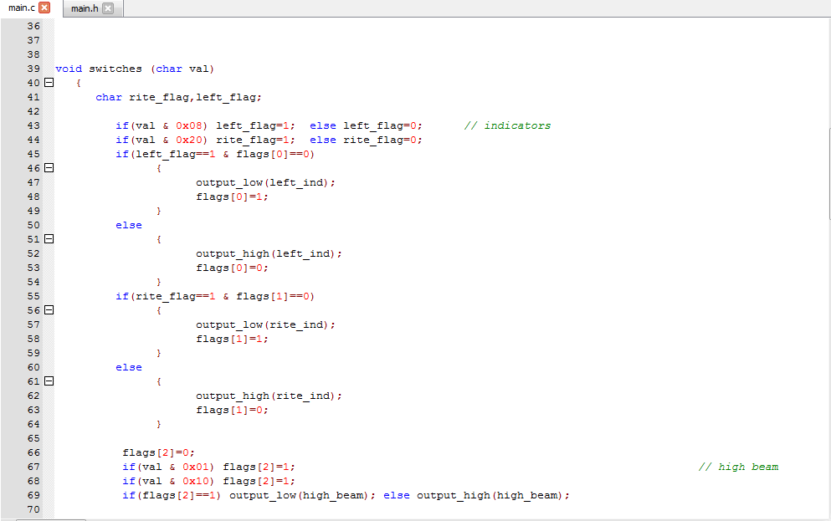
Lines 39 to 69 pictured below in Figure [27] are the instructions for the lights. An ‘else’ statement is used to turn the indicator lights on or off depending on the controllers switch position, this is to make sure that the indicators do not inadvertently turn on or off.
Lines 43 & 44 instructs the PIC as to which part of the Hexadecimal code that the indicators are on or off
Lines 66 (Figure [27] above) to line 71 (Figure [28] below) are the instructions for the high beam and driving lights, it is a simple statement that tells the PIC also which part of the Hexadecimal value those functions are in, and uses ‘flag’ statements to turn them on or off.
Figure 27

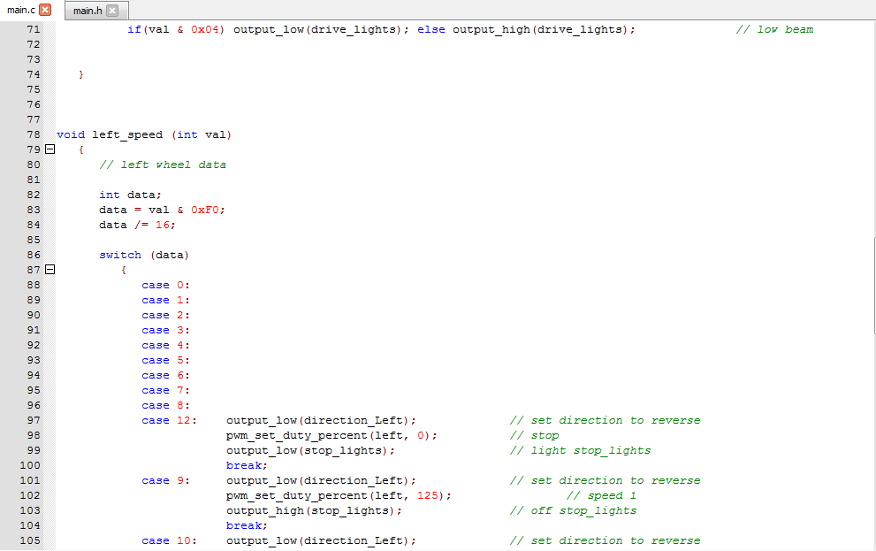
Figure 28

The next instructions starting on line 82, shown above in Figure [28] is to break down the Hexadecimal input data that the PIC receives on the Rx pin. The purpose of breaking the data sting down is to read the data bits for each wheel. As the transmitted data is converted from 8-bit binary to Hexadecimal, transmitted then back to binary again, each wheel has 4 bits of data each. So taking the 8-bit transmitted data (converted from Hex format) and dividing that string to either read left or right wheels, 1 to 4 bits being the right wheel and 5 to 8 bits being the left, the PIC can then ascertain the speed and direction of each wheel.
Once the data packet has been broken down to its respective wheel, case statements are written to define the motors output states. The cases relate to the hexadecimal value relating to the table in Figure [11] in section: ‘Hexadecimal to Binary data packets’. For example, cases 0 to 7 are invalid data packets, and cases 8 & 12 on the Hex to Binary table are ‘Stop’ commands. As cases 0 to 7, 8 & 12 are stop states, they share the same instruction that is to set the PWM duty cycle to zero, despite the fact that cases 0 to 7 are invalid as the most significant bit is the valid flag bit in order to enable drive to the motors.

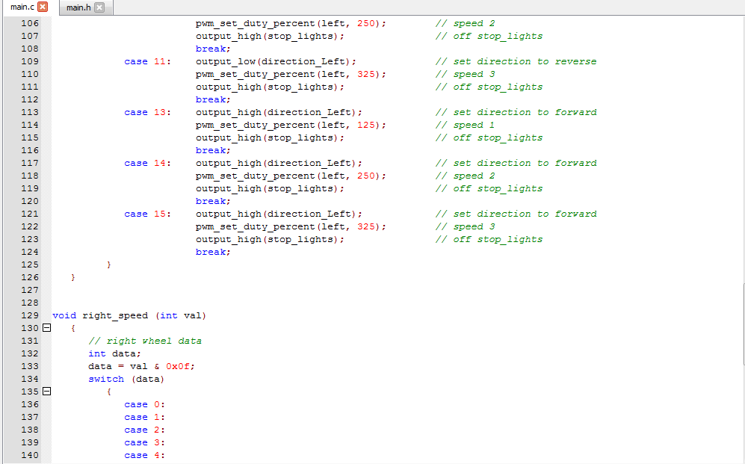
Figure 29
Figure [29] above is the continuation of the previous page’s Figure [28]. The PWM duty cycle is set in Red, this is the ‘on’ time in milliseconds out of the total 1kHz cycle. Below each case statement is the instruction for the stop lights. The stop lights are configured to go ‘Low’ (Ground) on stop and invalid flag cases, and ‘high’ (open circuit) when the buggy is commanded to move. ‘Low’, or ground is the PIC’s command to complete the LED’s light circuit to turn on, and ‘High’, open circuit to turn the LED off.

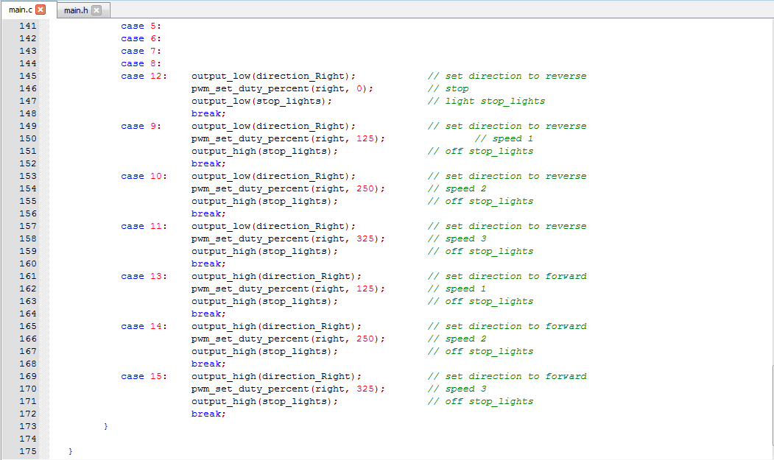
Figure 30
Figure [30] above is the duplicate instruction code for the motor control for the right handed wheel. Same instructions apply to this from previous Figures.

PIC Flashing
Once the programming stage is completed on Proteus and simulated, the next stage is to flash the selected PIC using Microchip’s MPLAB IPE® software. This is a free to download software that used with the Microchip’s® PICKit 3 can flash the PIC with the exported Hex file.
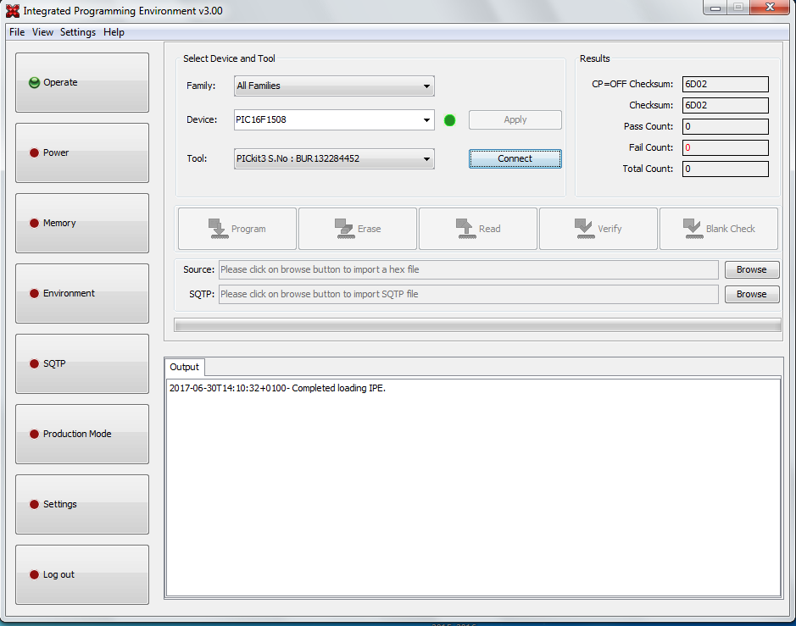
In order to flash the PIC, a release compiled Hex file needs to be made in Proteus in order to export it. This is done in the previous section ‘PIC ‘C’ Programming Writing’ by selecting ‘Release’ from the top menus drop down option and then pressing F7 to compile using CCS. This then creates a released Hex file in the Proteus folder location which is named as the PIC used, i.e. ‘PIC16F1508.h’.
Figure 31
Figure [31] above is the main IPE (Integrated Programming Environment) main screen where the PIC ‘flashing’ takes place. Here the chosen PIC is selected under ‘Device’ and the PICKit 3® is selected under tool.

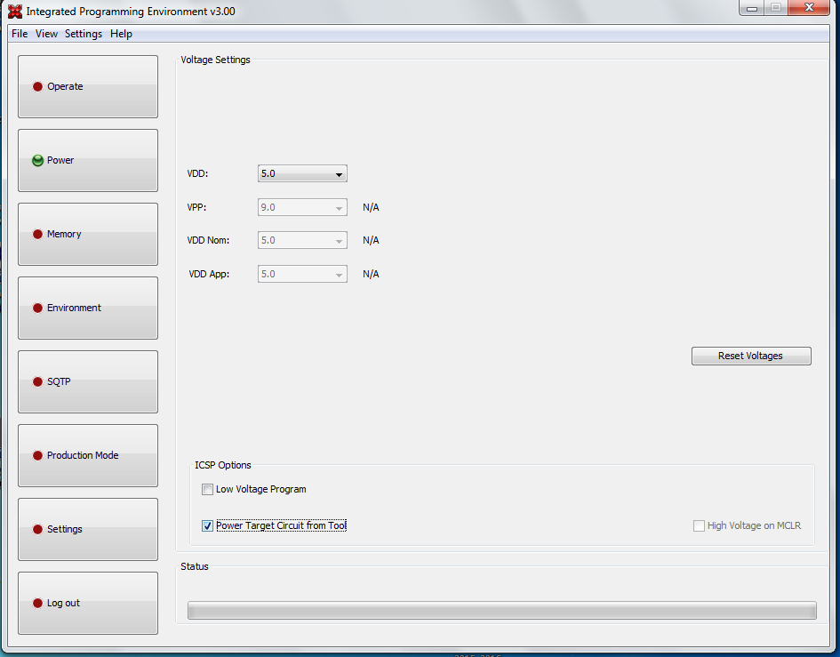
Then the PIC is powered from the target device under ‘Power’ options menu from the side bar. In order to reach this option, under ‘Settings’, ‘Advance Mode’ is chosen to where a default password is entered, which is ‘microchip’.

Figure 32
Then under ‘Power’ under ICSP Options, ‘Power Target Circuit from Tool’ option is checked. But before this is applied, the PIC’s datasheet is adhered to for the correct operating voltage. Under VDD, 5V is selected in the case for the PIC16F1508.

Once the PIC is powered from the Target Device, the next step is to connect the IPE® software & PICKit 3® to the selected PIC, which is simply done by selecting ‘Connect’ option to the right of the ‘Tool’ drop down box below in Figure [33].
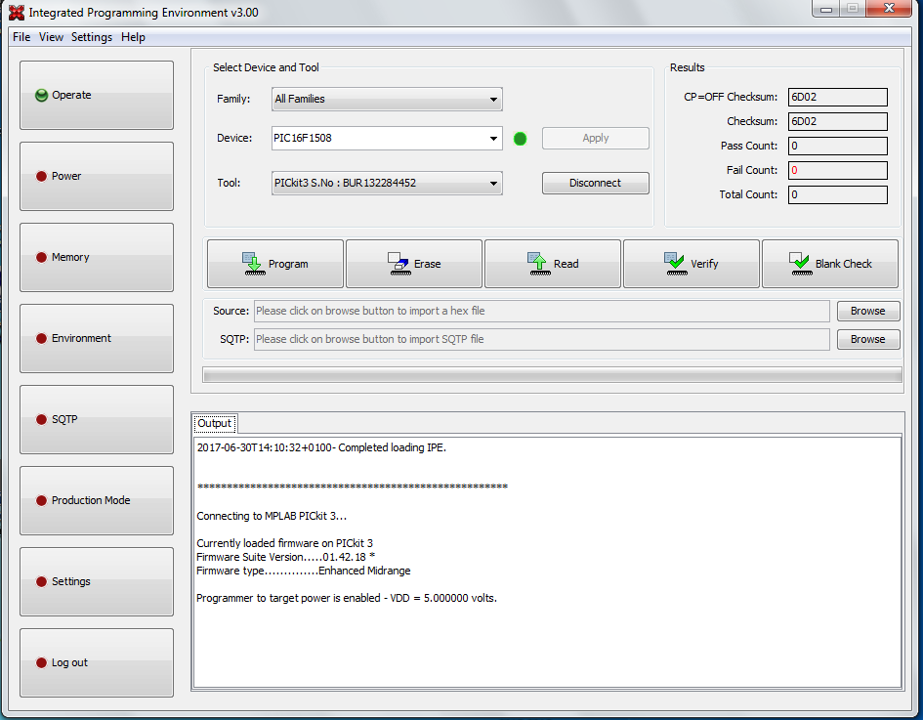
Figure 33
Once the PIC is connected, the software will perform an automatic Firmware download for the PICKit 3®, and then the ‘Flashing’ operation can be undertaken.
To Flash the PIC, the released Hex file is selected under ‘Source’, and then the PIC is ‘Erased’ to clear any stored program. A blank check is performed after this to confirm. Then ‘Program’ is selected, it will run through the flashing sequence, then it will confirm. A manual ‘Verify’ is also selected to prove the flashing is successful.
After these stages, the PIC is now programmed with the written code. It can then be unmounted from the target device and inserted into the buggy’s DIL socket.

Buggy Fabrication

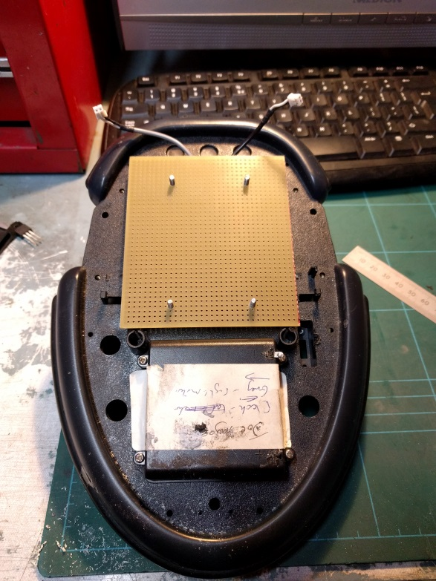
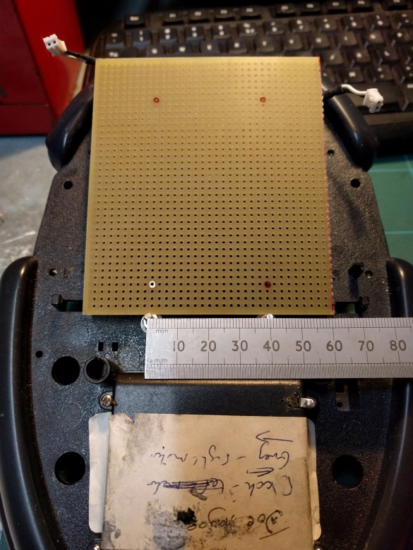

Figure 34
Figure 35
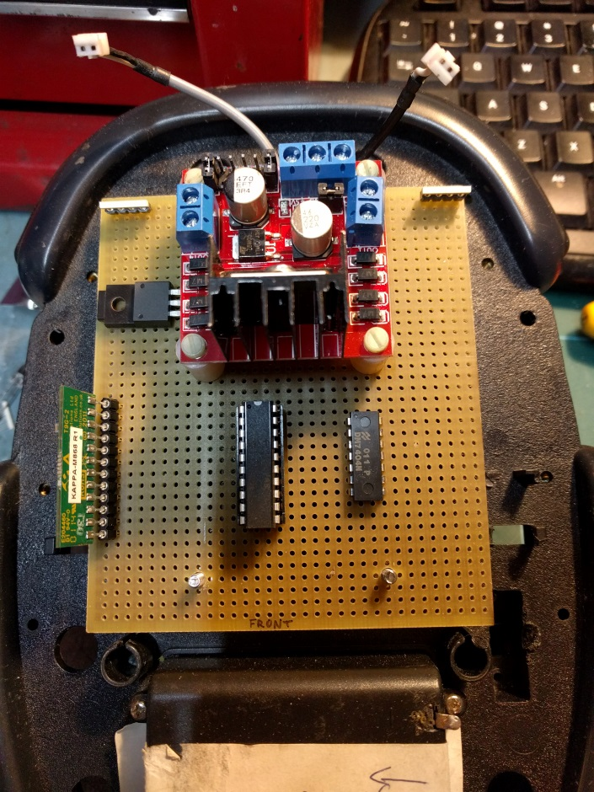
The fabrication of the buggy’s circuitry is based around the mounting points already on the buggy. Figures [34] & [35] above are the task carried out to position & drill the mounting holes to mount the main circuit board to the chassis.

Figure [36] shown left is positioning where the main components will be placed. This stage is carried out in accordance with the veroboard design sheet for this circuit board.
The components placement, (although their placement and design is laid out in the supporting document design drawing) is dictated by the veroboard’s mounting holes that affixes it to the buggy’s chassis.
Figure 36

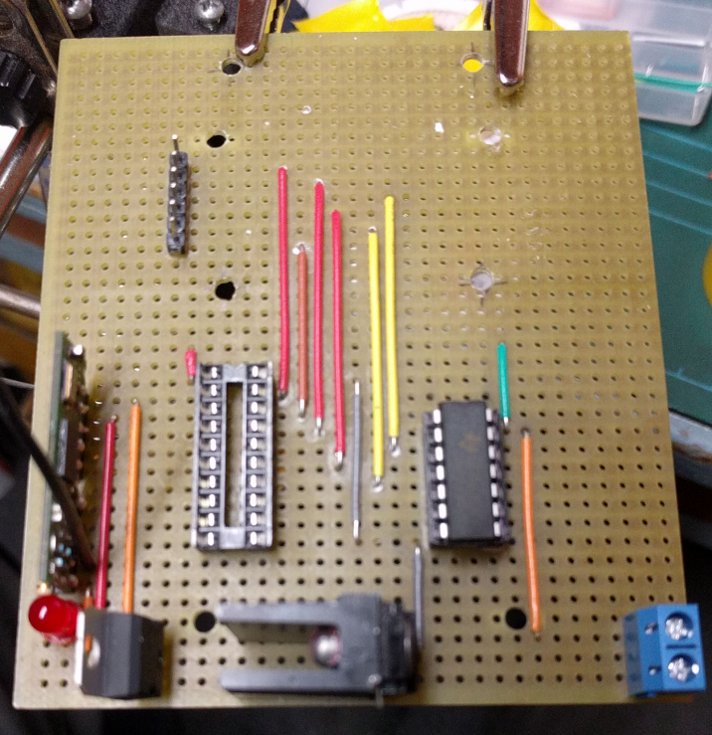
The Spacing between the PIC16F1508 & 7404 Hex Inverter is determined by the motor signals out from the PIC. Pictured here in Figure [37] is the soldering stage for the main circuitry components. The Red, Brown & Yello jumper wires are the motor controls for the H-Bridge, which terminates on a 6-way DIL header pins then a 6-way DuPont connector will interface this to the H-Bridge.
The bottom rails on the picture are the power rails for the components. The 3.3V regulator is positioned correctly at later stage.

Figure 37

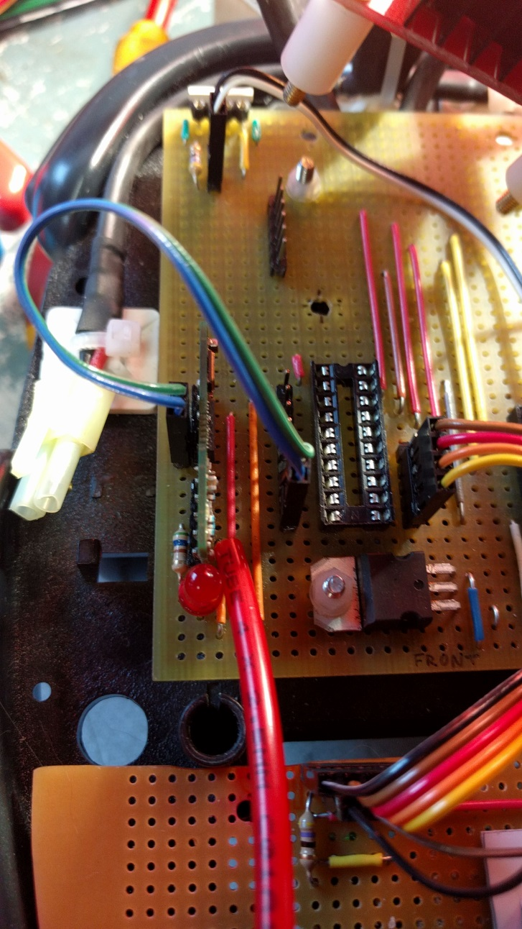
Figure 38
Pictured Right in Figure [38] is the final stages of the build. The interconnections for the main components, such as the Kappa transceiver is connected to the Tx/Rx pins of the PIC via DuPont connections. This is to have flexibility over the pin configuration connections of the PIC, and to save jumper wire space on the Vero board.
.
The 3.3V regulator that powers the transceiver is also re-positioned due to the Gnd, Vout & Vin pins on the main power rail. It is also bolted down to the board to protect it.
The Transceiver also features a communications LED to visually see weather data is being sent and received.
The antenna is installed by a ‘whip’ style tube to keep the antenna upright and secure.

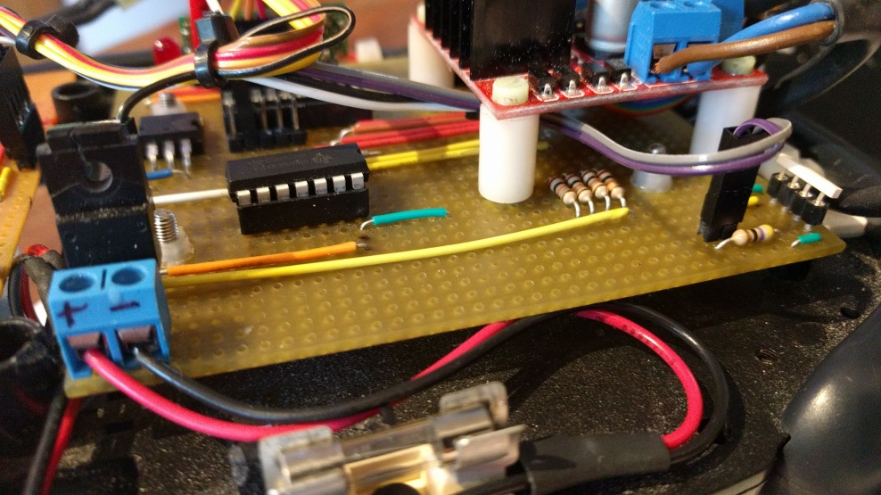
Pictured here in Figure [39] is the side view of the circuit board. The H-Bridge is mounted on upright stand-off posts to save space on the main Vero board and to change the component easily if a fault arises. The pull-down resistors for the motor direction signals are installed under the H-Bridge module that is connected to ground
Figure 39

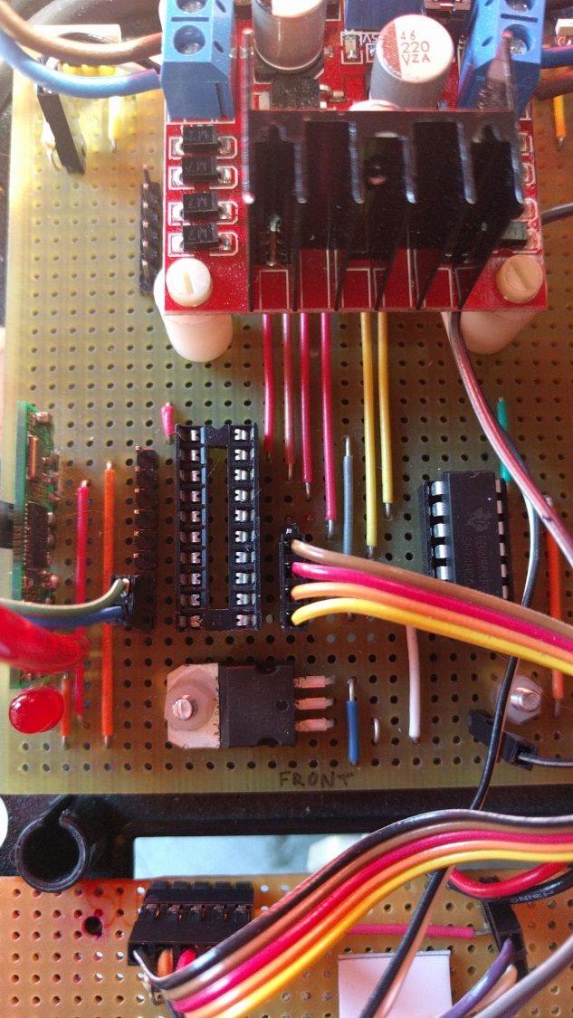

Pictured right, here in Figure [40] is the top view of the main circuit board. The PIC has SIL (Single in Line) header pins installed on the remaining I/O PIC pins for the accessories so that there is flexibility in where the DuPont jumper cables can connect to.
This also connects the main buggy’s motor controller circuit board to the auxiliary board to the front of the buggy which contains the indicators and lights (bottom of picture).

Figure 40

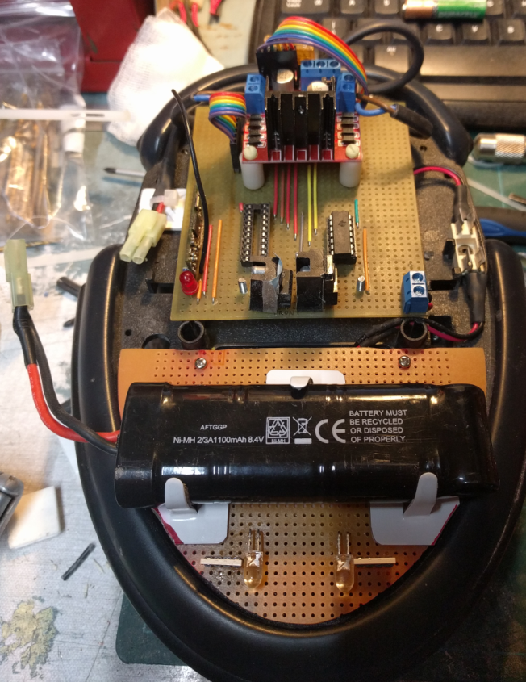
Figure [41] Shown left is the stage after the motor’s supply battery cells are installed. The front Auxiliary veroboard serves three purposes;
Figure 41
1. To mount the front lights and indicators
2. To mount the motors 8.4V Ni-MH battery pack
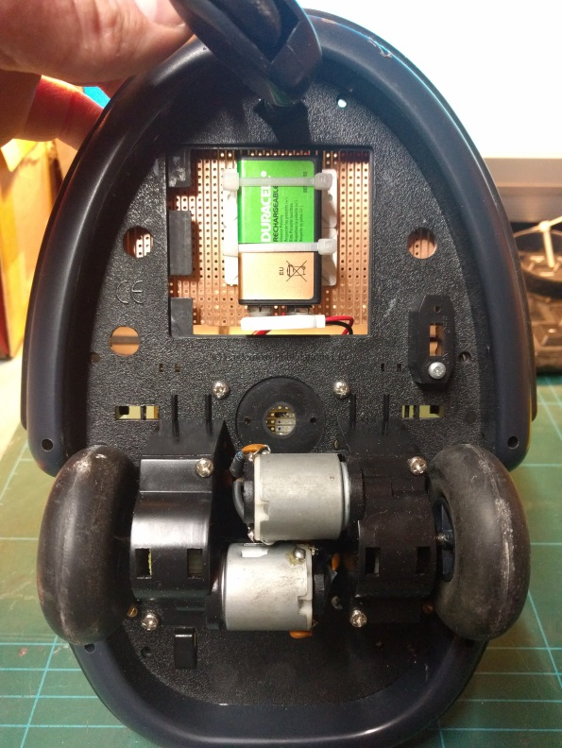
3. To mount the circuits 9V PP3 battery cell

Figure 42
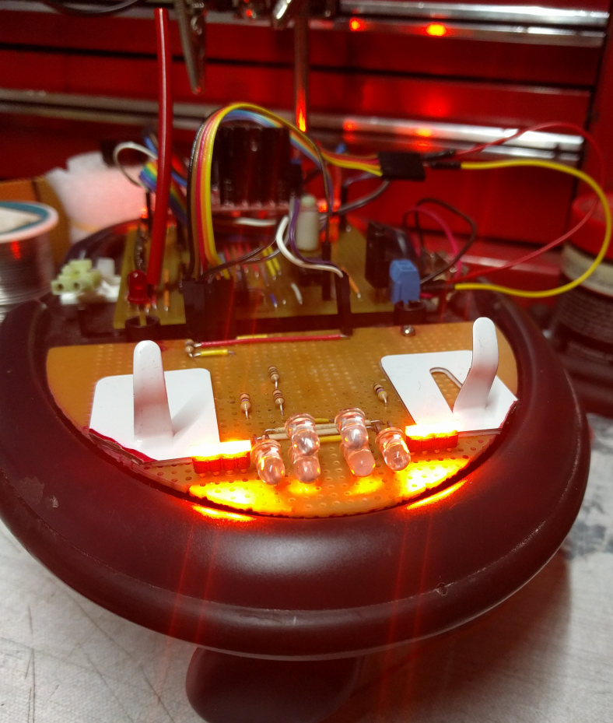

Figure [43] shown here is the testing of the side indicators of the buggy. Without the PIC installed, the LED’s can be tested by simply grounding the LED’s negative DuPont jumper wire.

Figure 43

Testing
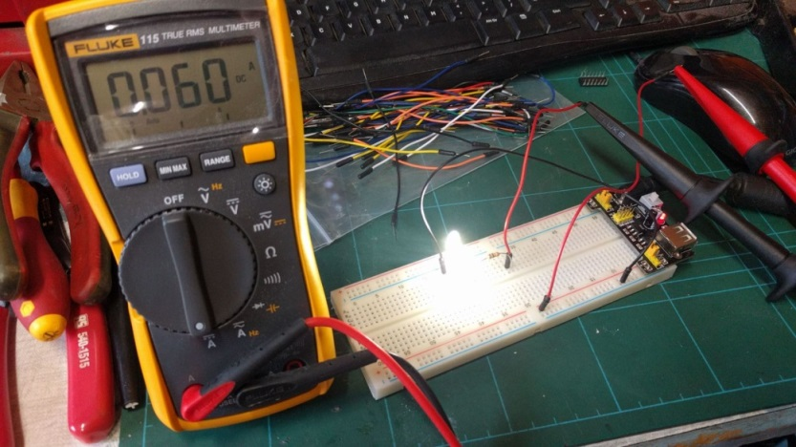
The Ultra Bright LED’s used for the headlights were prototyped on the developer’s breadboard. This is to measure the current drawn, shown here in Figure [44]. This is done in order to confirm the current drawn using multiple LED’s and calculate the adequate resistor to drop the voltage needed for the forward voltage on the diode.
Figure 44

Figure [45] shown here (Immediate left) is the measurement to confirm the voltage dropped over the diode. The calculated resistor value is as shown:
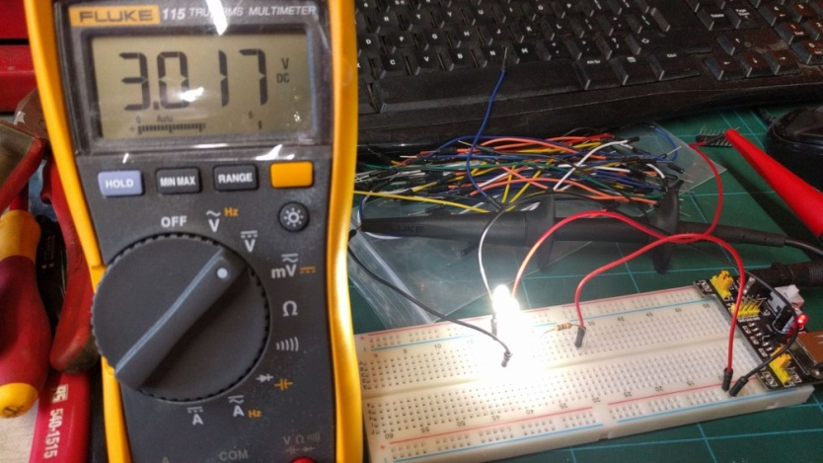
Figure 45
$$\frac{Supply Voltage -Forward Voltage}{Max. total Current (A)}=Resistor Value (Ω)$$

Figure [47] (Bottom Right) is the simulation carried out on EveryCircuit® App on Android to simulate the LED’s operation and to check the voltage and current values. Figure [46] (Bottom Left) is the demonstration of the Buggy’s side lights and full beams, total of 6 Ultra Bright LED’s at night time.
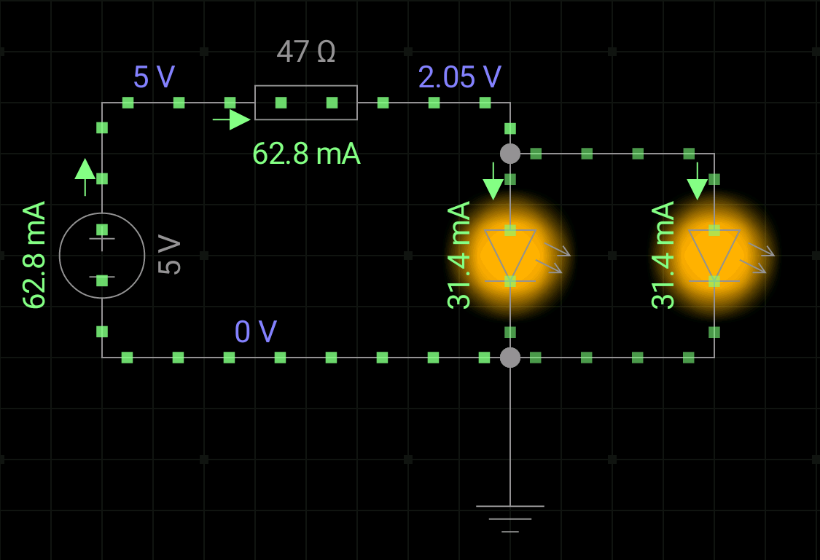
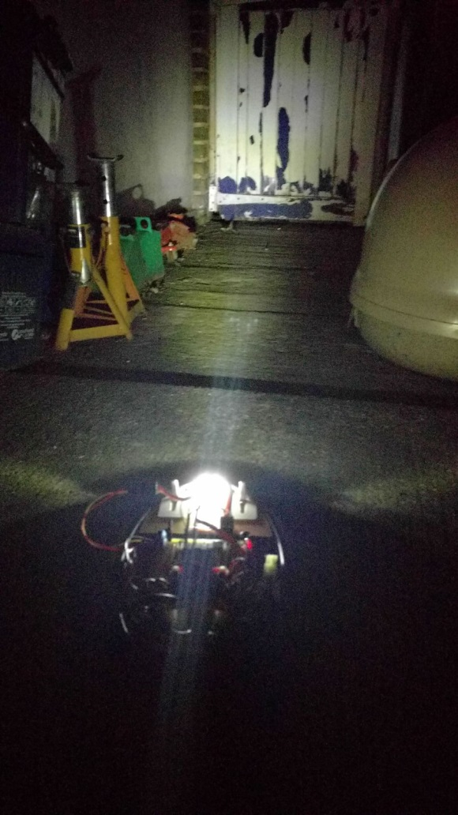

Figure 46
Figure 47

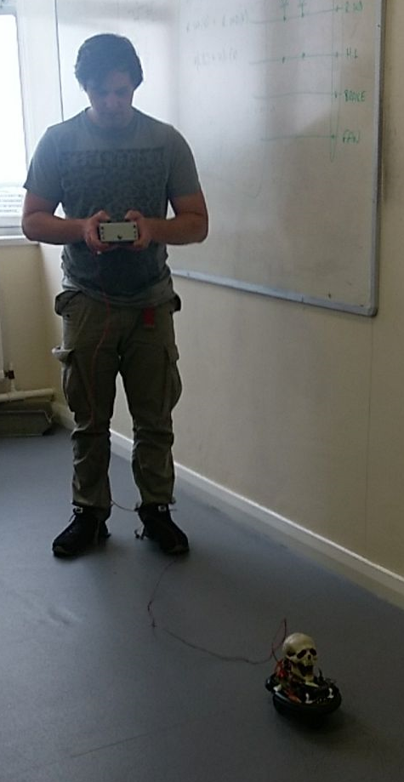
The final testing stage, after flashing the PIC with the current PIC16F1508.h (Released Hex File) from Proteus, to which is compiled by CCS is to mount the programmed PIC onto the buggy’s 20 Pin DIL PIC socket, power the circuit and motors up and test run the buggy.
Due to difficulties and lack of time near the end of the project, the wireless communications set-up couldn’t be fulfilled. Instead, a transmit wire was run from the controller to the buggy as a compromise to this complication.
The first impressions over the control of the buggy’s actions were surprising to the team, in that the buggy accelerated quickly, but suffered in response to the command of the controller.
Apart from these minor issues, the buggy still operated all auxiliary accessories, i.e. the indicators, lights and brake lights as intended.
The next stage is to ‘Fine Tune’ the buggy so that the final assessment of driving the buggy around a set obstacle course can be undertaken with precision control

Figure 48
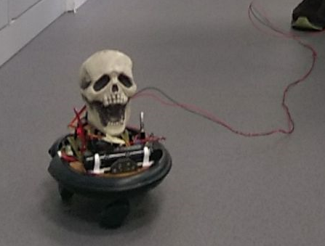
Figure [49] (Left) is the live test run of the buggy after successful PIC ‘Flashing’. An adequate ‘Drive by wire’ cables were connected directly to the PIC’s Rx (Receive) pin from the controllers Tx (Transmit) pin and a ground wire run to the battery negative rail to eliminate noise.
Figure 49
Approx. 5m of solid core thin gauge wire was used to interface the controller to the buggy.

Adjustments

Adjustments had to be made to the buggy’s speed control. This was easy to rectify, as this can be adjusted within the programming in Proteus. During the testing of the Buggy at UWTSD (University of Wales Trinity St David), it was found that the buggy was difficult to maintain adequate control over the speed of the buggy. Adjustments had to be made to the time delay set the programming, this resulted in a delayed response from the controllers joystick movement to the buddy’s motion response, as it was initially programmed and the PIC was flashed to receive data every 500ms. This was then amended to 125ms and found on further testing that this was adequate.
The initial 3 stage speed was set to 250ms, 500ms & 750ms ‘up time’ duty cycle out of 1 kHz. During the programming stage, these duty cycle times were thought and agreed to be suitable. During the 1st test drive of the buggy, there was a finite threshold for the slow speed on the joystick, and only took little movement for the buggy to travel at full speed.
It was decided by the team and head course lecturer (Dr Gary Jones) that the duty cycle time within the buggy’s PIC programming can be further reduced to precisely half the duty cycle time of; 125ms (Slow), 250ms (Medium) & 325ms (Fast). The explanation for the overly fast speed initially was due to the higher motor supply voltage from the 8.4V 1100mAh Ni-MH (Nickel Metal Hydrate) Cell.
Upon further test runs, the adjustments made within the programming code were satisfied, and the buggy’s response was vastly improved to an expected standard for controlling it through an obstacle course.

Lessons Learnt

This project has been a major challenge to the team on the programming side of this project. The team members, (C.Budden & K.Johnston) have several years’ personal experience with building electronic circuitry, despite this, the coding of the microcontroller has been a particular downfall due to the inexperience with it.
The team has learnt a major lesson in the fundamental of this project; understanding how a microcontroller operates for the task in hand. The binary, digital and hexadecimal theory for taking a commanded analog input and translating this into a binary format is the biggest fundamental lesson I have learnt in this project.
The timescale for completing and test running the buggy was just met, but with the sacrifice of not being able to establish radio communications wirelessly with the buggy was unfortunate. Predictably, with a few more hours and testing, the wireless communications could have been achieved.
Although the Programming of the microcontroller was aided by Dr. Gary Jones, it would not have been possible to program the PIC and achieve the goal of controlling the buggy remotely.

Conclusion

To conclude this Group Project, the major lesson that was learnt by both parties in this group was collaboration & communication. The project wouldn’t have been a success if it wasn’t for the responsibilities and communications from both members. The tasks needed and theory for the initial workings of the buggy was passed to and fro by the team members.
The downfall was the competencies of the students of this project with the ‘C’ Programming of the microcontroller. But this was overcome with personal tutorial lessons with the head course lecturer, Dr Gary Jones, to whom the group commemorates their gratitude’s to.
The purpose of this project was to overcome a problem of controlling a remotely controlled buggy using a microcontroller. And this was achieved.

References

[4] CE Definition - http://www.ce-marking.org/what-is-ce-marking.html - Accessed: 17/12/16 15:30pm

Bibliography
[1] ‘Operation Aphrodite’ RF Guided B17 Bombers - http://ww2days.com/drones-to-destroy-nazi-rocket-sub-bases.html – Accessed: 14/1/17 13:45pm
[2] PIC Microcontroller & its Architecture - http://www.electronicshub.org/pic-microcontroller-architecture/ - Accessed: 30/10/16 10:15am

[3] Back EMF in D.C. Motors - https://www.quora.com/What-is-the-significance-of-a-back-EMF-in-DC-motors – Accessed: 01/03/17 17:25pm
[5] CE EN Standards - https://en.wikipedia.org/wiki/CE_marking - Accessed:12/12/16 19:20pm

Figures C.Budden

Figure 1: PIC Architecture - http://www.electronicshub.org/pic-microcontroller-architecture/ - Accessed: 30/10/16 10:15am
Figure 2: PIC Microcontroller Selection - https://www.microchip.com/ParamChartSearch/chart.aspx?branchID=1002&mid=10&lang=en&pageId=74 –Accessed: 09/10/16 16:30pm
Figure 3: PIC Microcontroller Selection - https://www.microchip.com/ParamChartSearch/chart.aspx?branchID=1002&mid=10&lang=en&pageId=74 – Accessed: 09/10/16 16:30pm
Figure 4: L298N IC Chip - http://techdelivers.com/L298N-High-Current-Dual-H-Bridge-Motor-driver-ic – Accessed: 13/03/2017 12:25pm
Figure 5: H-Bridge Module - http://www.ebay.com/itm/L298N-DC-Stepper-Motor-Driver-Module-Dual-H-Bridge-Control-Board-for-Arduino-/151914259372?hash=item235ecba3ac:g:19gAAOSwwE5WbNCR - Accessed: 13/03/17 12:30pm
Figure 6: L298N Logic Circuit Diagram - https://www.google.co.uk/search?q=L298N+manual&oq=L298N+manual&aqs=chrome..69i57.5758j0j4&sourceid=chrome&ie=UTF-8#q=L298N+data+sheet – Accessed: 13/01/17 09:45am
Figure 7: L298N IC Chip Pins Layout - https://www.google.co.uk/search?q=L298N+manual&oq=L298N+manual&aqs=chrome..69i57.5758j0j4&sourceid=chrome&ie=UTF-8#q=L298N+data+sheet Accessed: 13/01/17 09:45am
Figure 8: Motor Logic Table – C.Budden
Figure 9: Proteus H-Bridge Simulation – C.Budden
Figure 10: Proteus H-Bridge Simulation – C.Budden
Figure 11: Hexadecimal to Binary Data Packet Table – C.Budden
Figure 12: Motor State Binary Table – K.Johnston
Figure 13: Pre-Project Gantt chart – K.Johnston & C.Budden
Figure 14: Post-Project Gantt chart – K.Johnston & C.Budden
Figure 15: 7474 Hex Inverter Pin outs - https://www.google.co.uk/search?q=7404+hex+inverter+datasheet&oq=7404+hex+inverter+datasheet&aqs=chrome..69i57.7006j0j4&sourceid=chrome&ie=UTF-8 – Accessed: 15/03/17 20:05pm
Figure 16: Procurement List – C.Budden
Figure 17: Safety Interlocks Table– K.Johnston
Figure 18: Buggy Wiring Schematic– C.Budden
Figure 19: Buggy Circuit Veroboard Design Layout – C.Budden
Figure 20 to Figure 23: CCS PIC Wizard Set-up – C.Budden
Figure 24 to Figure 30: Proteus PIC Programming Code – C.Budden & Dr. Gary Jones
Figure 31 to Figure 33: MPLab IPE V 3.00 PIC Flashing – C.Budden
Figure 34 to Figure 46: Buggy Fabrication Screenshots – C.Budden
Figure 47: EveryCircuit Android App LED Simulation – C.Budden
Figure 48: Buggy Test Run (UWTSD 23.6.17) – K.Johnston & C.Budden
Figure 49: Buggy Test Run (UWTSD 23.6.17) – K.Johnston & C.Budden

Figures. K.Johnston
Figure 1: User provided buggy chassis 5
Figure 2: Motor and gearbox detail 5
Figure 3: Initial system design. 6
Figure 4: Differential Drive steering system 7
Figure 5: Basic H-Bridge layout and operation 8
Figure 6: Improved system design. 11
Figure 7: Project time allocations 12
Figure 8: IR v RF transmission comparison 13
Figure 9: KAPPA M868 modem module 14
Figure 10: KY-023 twin-axis thumb controller 16
Figure 11: Thumb-stick output voltage range 17
Figure 12: Thumb-stick output voltage graph 17
Figure 13: ADC binary conversion of thumb-stick input voltage 18
Figure 14: ADC binary output range table 18
Figure 15: L298 Dual H-Bridge Driver 19
Figure 16: Initial PIC selection process 23

