Task 1: Locating Sources
Identify and locate three different sources (a report, a journal article, and a website) related to the question
“What employability skills do university graduates need to succeed in the workplace?”
Show how you used keywords, search terms, and Boolean operators to find them, and explain how you know which type of source each one is and why it is appropriate for the research question.

Source Type & Why It Is Appropriate | URL/DOI | What search engine did you use? Google/Online Library/Library AI Assistant | Keywords/Boolean Operators Used
Journal | https://doi.org/10.69965/danadyaksa.v3i2.248 | Library | Employability skills AND Business graduates
Article | https://www.proquest.com/scholarly-journals/graduate-readiness-employment-market-4th/docview/2256019828/se-2?accountid=130472 | Library | Employability skills AND Business graduates AND workplace
Article | https://doi.org/10.30794/pausbed.1508772 | Google | What employability skills do university graduates need to succeed in the workplace article

Task 2: Evaluating Information (CRAAP Test)
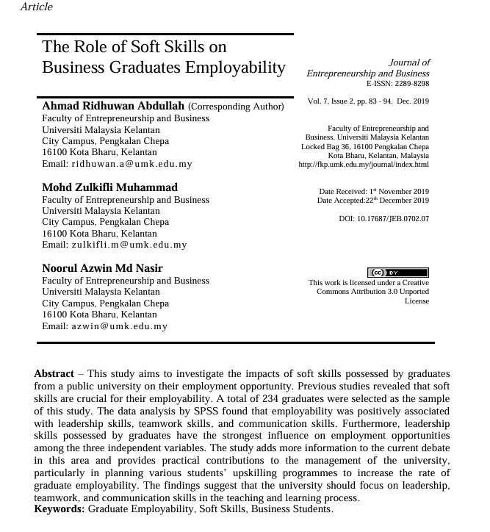
Your colleague has forwarded you a source from a peer reviewed journal, and they are not sure whether it is appropriate to use and has asked for your help. Your task is to evaluate the source by using the CRAAP Test to assess its appropriateness for the following question “What employability skills do business university graduates need to succeed in the workplace?”

CRAAP Test
Currency | The Article l is accurate and up to date because is published in 2019, is not to old and we can use the information.
Relevance | It is relevand and useful because are about graduate employability,employability skills and business graduate and business students.
Authority | Source of the information is an Article published in 2019 by the Faculty of Enterpreneuship and Business Univeristi Malaysia Kelantan
Accuracy | The finding results ruggest that the university must focus an lidership, teamwork and speciale communication skills in the teaching and learning process
Purpose | The prupose of this article was to investigate the impact of soft skills possessed graduate for a public university on their employment opportunity
Task 3: Source Analysis
Your manager has provided you with a short extract from a source and has asked you to analyse the source by Identifying one strength, one weakness, and providing a brief explanation of the strength and weakness identified.
If you want to read the article online, please click the following link: https://www.universitiesuk.ac.uk/latest/news/strong-demand-graduates-employers

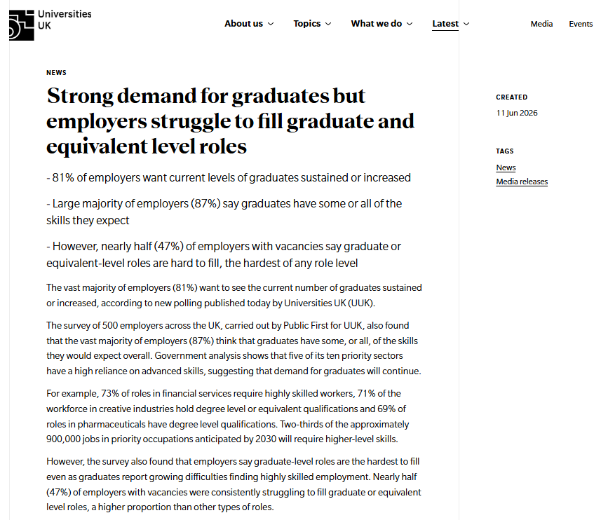
.

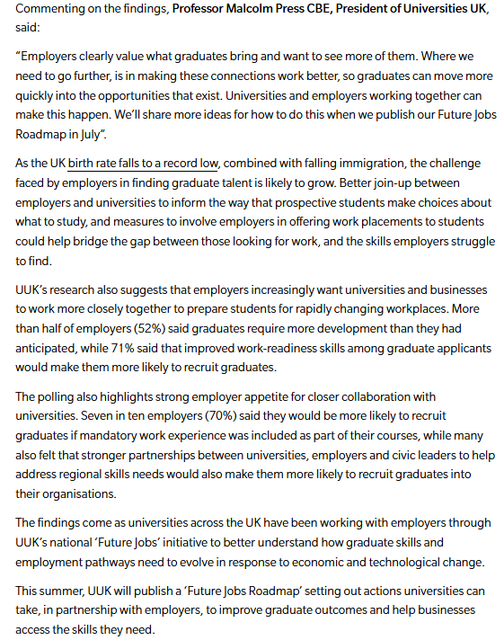

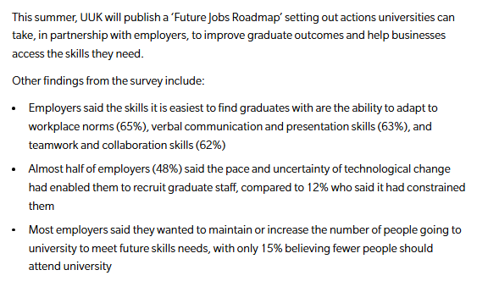

Strength of the Source:

Weakness of the Source:

