

University of Wales Trinity Saint David
School of Engineering

Title of the Coursework
Heat Exchanger Laboratory Analysis

Name and P Number
Danny Richardson
P151196

Module Name and Code
Thermofluid Mechanics
M5X00406

Date
05/04/19

Lecturer’s Name
Rob Goodson
Contents
1. Introduction. 1
2. Background research. 1
3. Experimental Procedure. 1
1. Effect of Varying water flow rate. 2
2. Effect of Varying Air Flow Rate. 2
3. Effect of Varying Air Flow Rate. (Lower inlet Temperature) 3
4. Results. 4
5. Analysis. 7
6. Conclusion. 7
7. References 7

Table of Figures
Figure 4-1 Experiment 1 results table. 4
Figure 4-2 Experiment 1 power transfer Vs water mass flow rate 4
Figure 4-3 Experiment 1 Efficiencies Vs water mass flow 4
Figure 4-4 Experiment 1 Heat transfer coefficient Vs water mass flow 4
Figure 4-6 Experiment 2 Efficiencies Vs water mass flow 5
Figure 4-5 Experiment 2 power transfer Vs water mass flow rate 5
Figure 4-7 Experiment 2 Heat transfer coefficient Vs water mass flow 5
Figure 4-8 Experiment 2 results table. 5
Figure 4-9 Experiment 3 results table. 6
Figure 4-12 Experiment 3 Efficiencies Vs water mass flow 6
Figure 4-10 Experiment 3 power transfer Vs water mass flow rate 6
Figure 4-11 Experiment 3 Heat transfer coefficient Vs water mass flow 6

Introduction.
This report has been written with the intention of outlining the influence of flow rates and pressure changes on how temperatures can be controlled within a heat exchanger device, based on the use of the fundamental thermodynamic equations of heat transfer and the laws the govern heat exchangers.
Aims of this report -
  - Using data collected from the experiment, calculate the efficiencies of the fluids, the heat transfer coefficient and the power transfer.
  - Demonstrate the effect of varying mass flow rate of water when pressure is constant.
  - Demonstrate how varying the pressure of air effects heat transfer when mass flow rate of water remains constant.
  - Demonstrate the change in efficiency when the water is held a lower temperature and the air pressure is changed.

Background research.
Given that its known that during reactive processes there will always be an exchange of energy; be it kinetic, sound, chemical, heat and so on. Although most energy tends to be lost in these processes, there are ways of controlling the energy transfer rate and recovery, i.e. a heat exchanger for precise management of thermal energy transfer (Solar Schools, n.d.). This is done through various ways depending on both the application of said exchanger and its desired effect, in the automotive world there’s engine temperature management which are based on crossflow fluid transfer. When using parallel and counterflow types the applications are very similar but the reasoning for use depends of the amount of heat transfer required. Parallel flow heat exchangers provide rapid initial heat exchange and as a product of this it’ll decrease fluid viscosity which can result in the reduction of pumping required. Counterflow types are more efficient at reducing temperatures than parallel flow, so when the desire is

Experimental Procedure.
The experiments were conducted using the guidelines given by the manufacture TecQuipment Ltd, and procedures were done on the basis that; the water flow was parallel through the heat exchanger tubes, the temperature within the room should remain as close to constant at 20°C (293.15K). Then because the equations require adaptations for various results, the ambient pressure of the day [as recorded by the Met office] was noted so that it could be used as a correction factor, because it will have a direct effect on air density.
Before each test, the equipment should be left to stabilise both temperature and pressure before any changes are made, then when testing it’s important to record the flow rate and pressure values as they tend to drop out of tolerance.
Also, before testing is conducted, note the size of the intake orifice. Its stamped on the face. (100.11mm in diameter)

1. Effect of Varying water flow rate.
  - The procedure is selected to show how the change of Water mass flow rate will affect the temperature for a fixed inlet temperature and air pressure.
  - Start with the having the water temperature set at 60°C (highest safe temperature, do not exceed) allow to stabilise.
  - Turn on the fan and using the slide door on the exit orifice, make a change in size until the pressure on the display reaches 250Pa (+/- 5Pa).
  - Switch on the pump for the water to start the water circulation, set the water flow valve so that the rate is 2.25L/Min and allow to stabilise [around five minutes] (+/- 0.01L/Min).
  - Tests for water mass flow rate are based on setting at: 2.25L/min, 1.75L/min, 1.25L/min, 0.75L/min and finally 0.25L/min
  - Record readings from the temperature display and on the right of the equipment, these can then be implemented to the table provided [Appendix].

2. Effect of Varying Air Flow Rate.
  - The procedure is selected to show how the change of Air mass flow rate will affect the temperature for a fixed inlet temperature and Water mass flow rate.
  - Start with the having the water temperature set at 60°C (highest safe temperature, do not exceed) allow to stabilise.
  - Switch on the pump for the water to start the water circulation, set the water flow valve so that the rate is 2.25L/Min and allow to stabilise [around five minutes] (+/- 0.01L/Min).
  - Turn on the fan and using the slide door on the exit orifice, make a change in size until the pressure on the display reaches 250Pa (+/- 5Pa).
  - Then using the sliding “valve “ on the end of the air flow channel changes in increments for the different tests: 250Pa, 200Pa, 150Pa, 100Pa and 50Pa.
  - Record readings from the temperature display and on the right of the equipment, these can then be implemented to the table provided [Appendix].

3. Effect of Varying Air Flow Rate. (Lower inlet Temperature)
  - The procedure is selected to show how the change of Air mass flow rate will affect the temperature for a fixed inlet temperature and Water mass flow rate.
  - Using the same principles as the test two, but now setting the inlet temperature to 45°C.
  - Proceed to adjust the air pressures at: 250Pa, 200Pa, 150Pa, 100Pa and finally 50Pa.
  - Record the temperature results within the table provided [Appendix] for analysis and calculations.

Results.
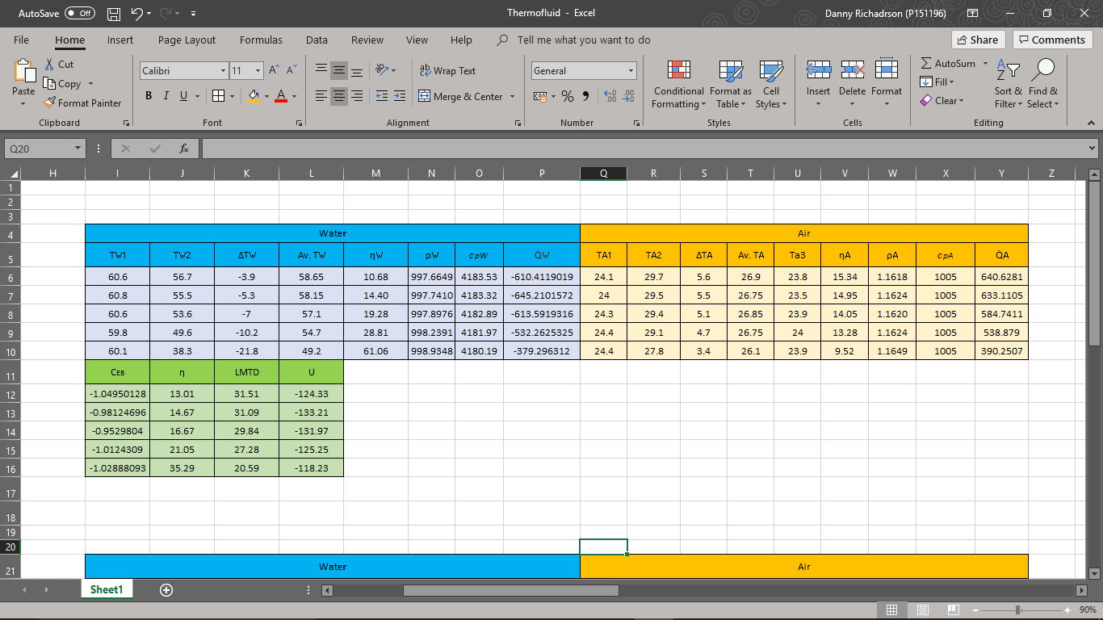
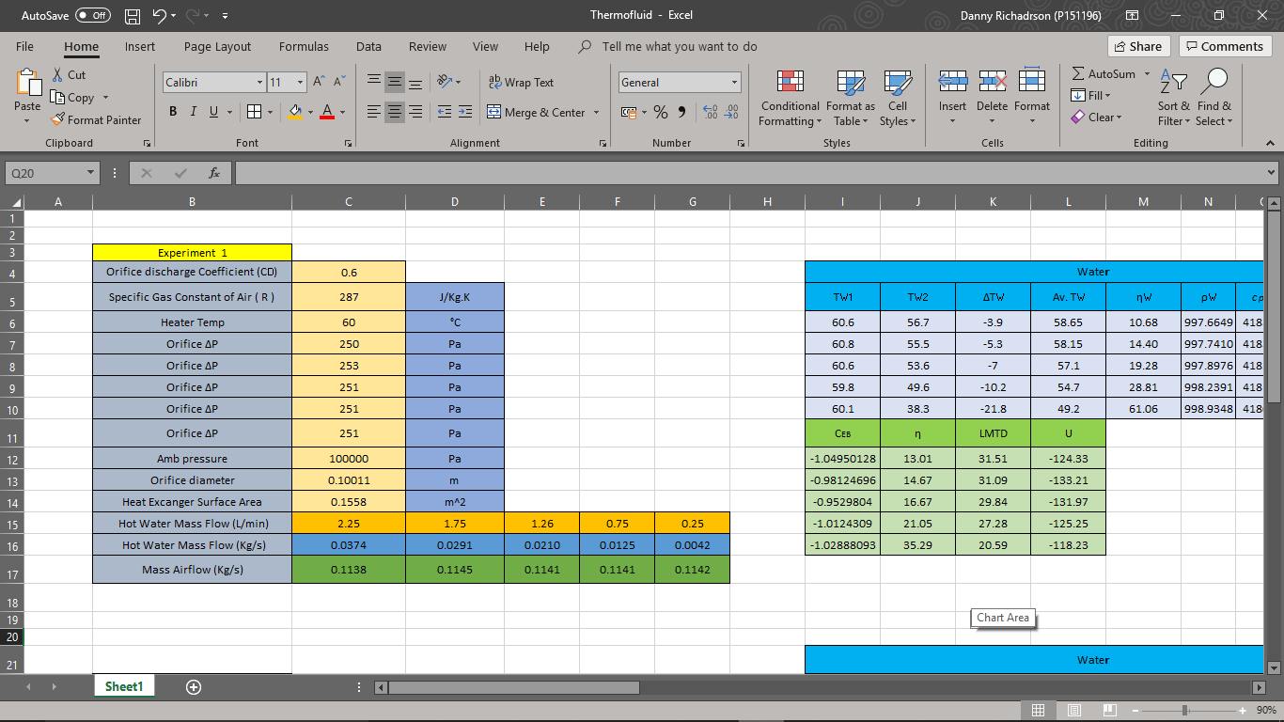
Experiment 1.
Figure 4-1 Experiment 1 results table.
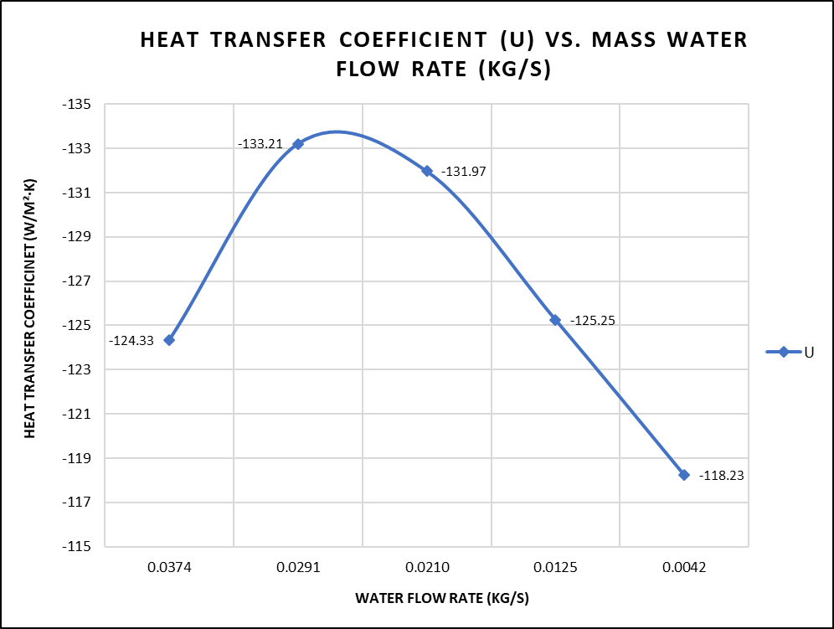
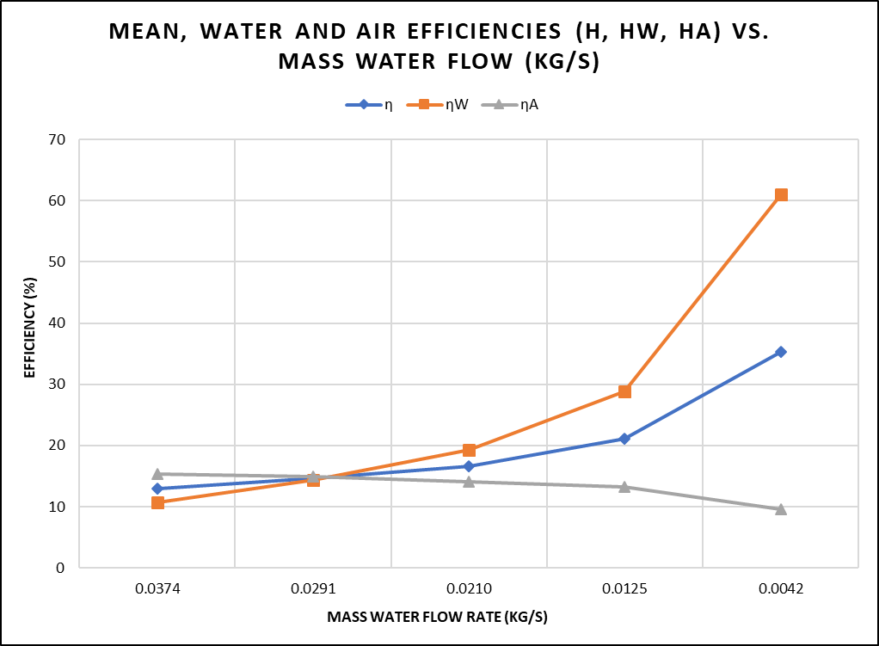
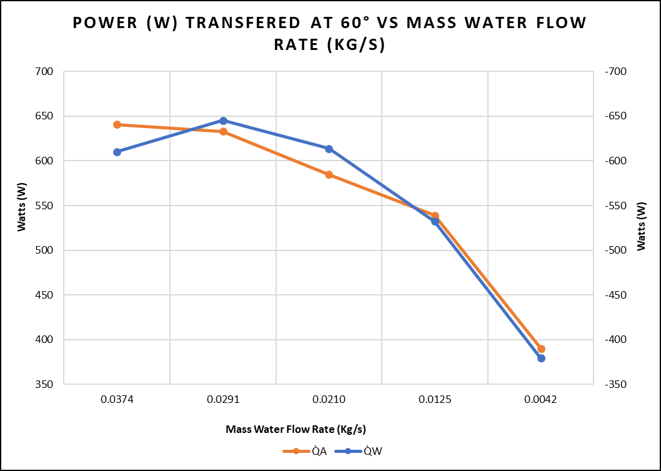
Figure 4-2 Experiment 1 power transfer Vs water mass flow rate
Figure 4-3 Experiment 1 Efficiencies Vs water mass flow
Figure 4-4 Experiment 1 Heat transfer coefficient Vs water mass flow
Experiment 2.
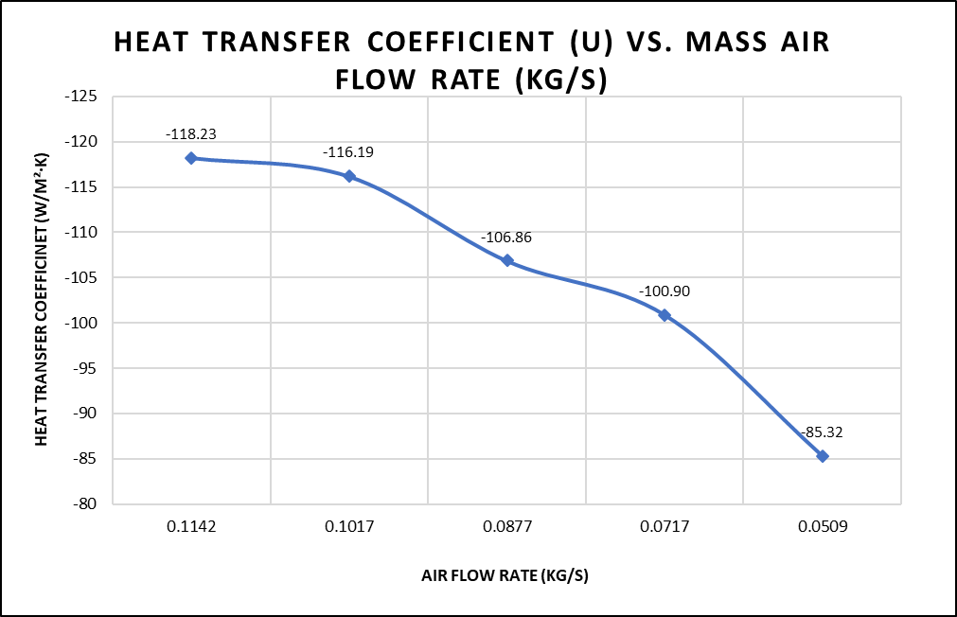
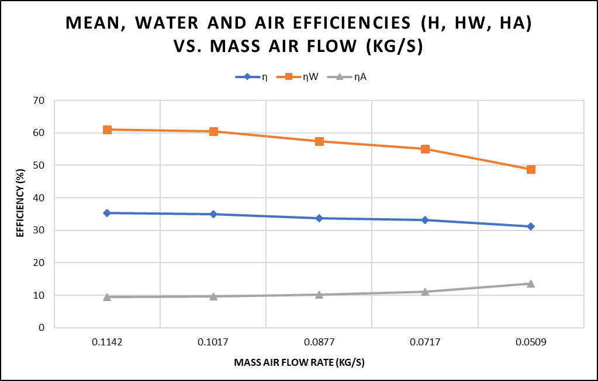
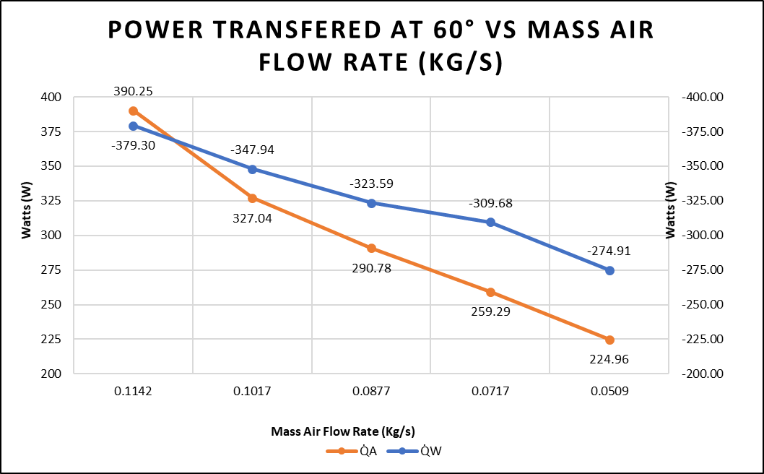
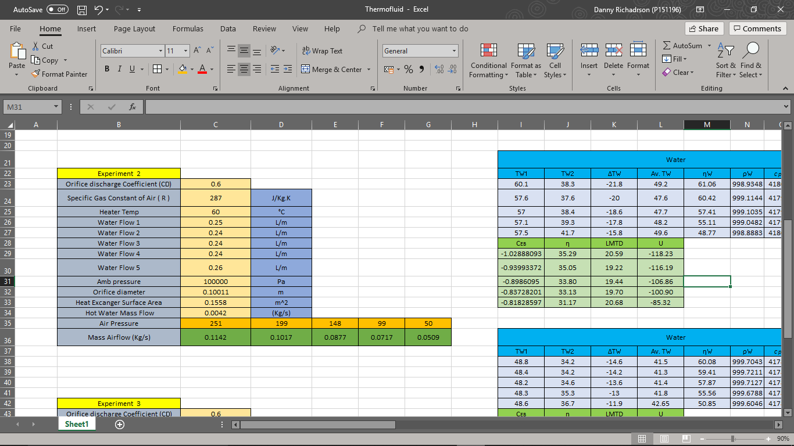
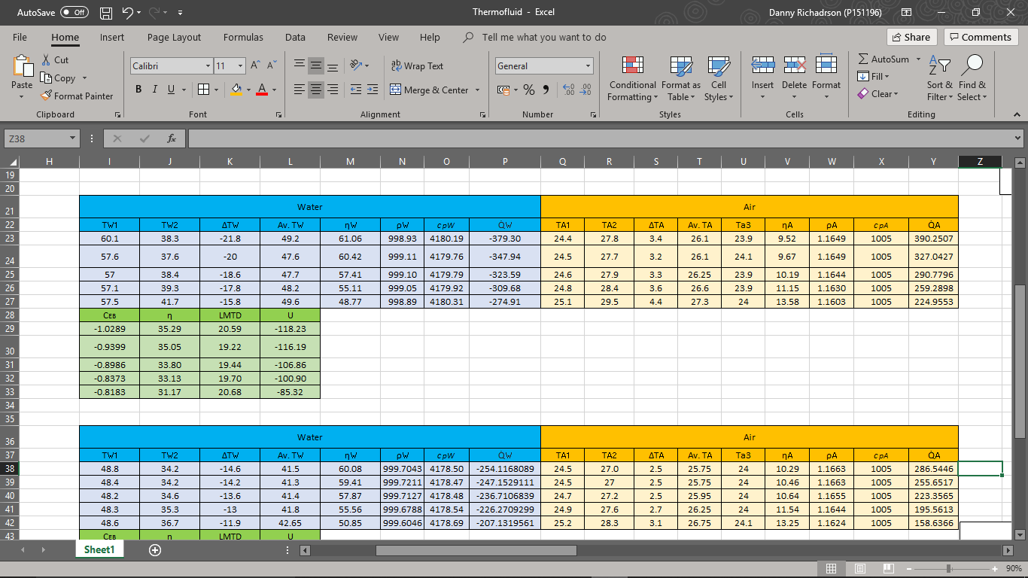
Figure 4-7 Experiment 2 Heat transfer coefficient Vs water mass flow
Figure 4-6 Experiment 2 Efficiencies Vs water mass flow
Figure 4-5 Experiment 2 power transfer Vs water mass flow rate
Figure 4-8 Experiment 2 results table.

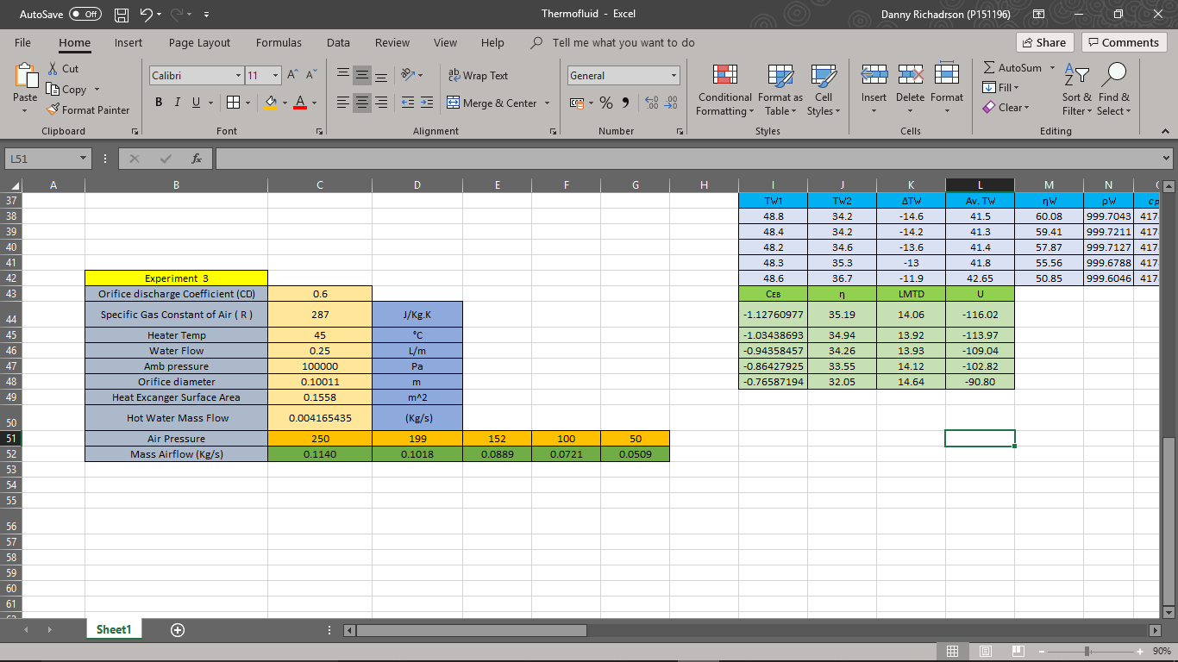
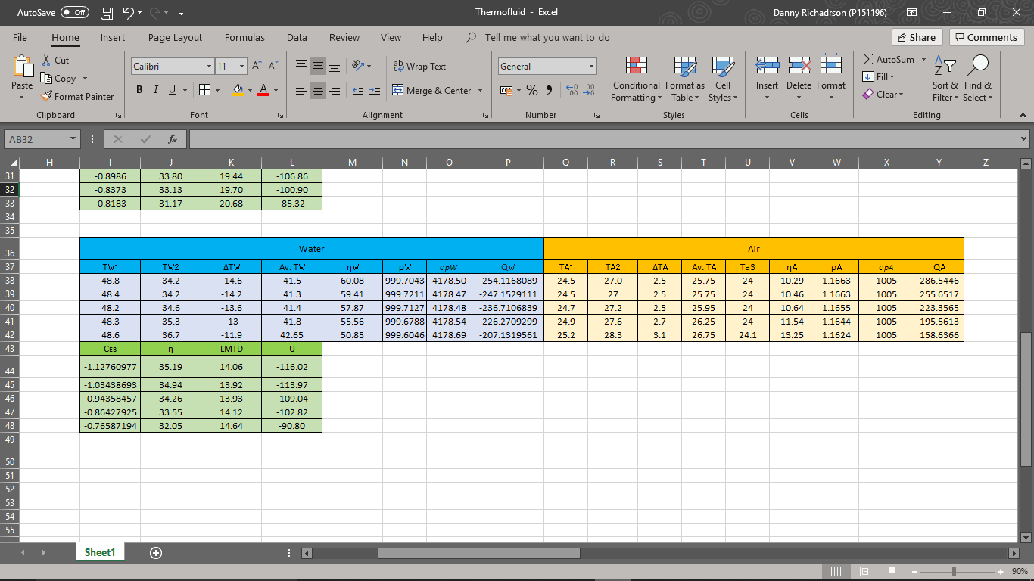
Experiment 3.
Figure 4-9 Experiment 3 results table.
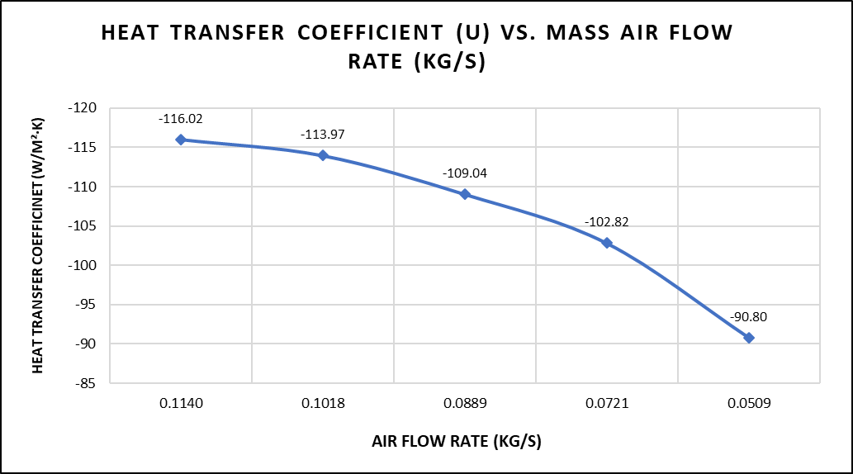
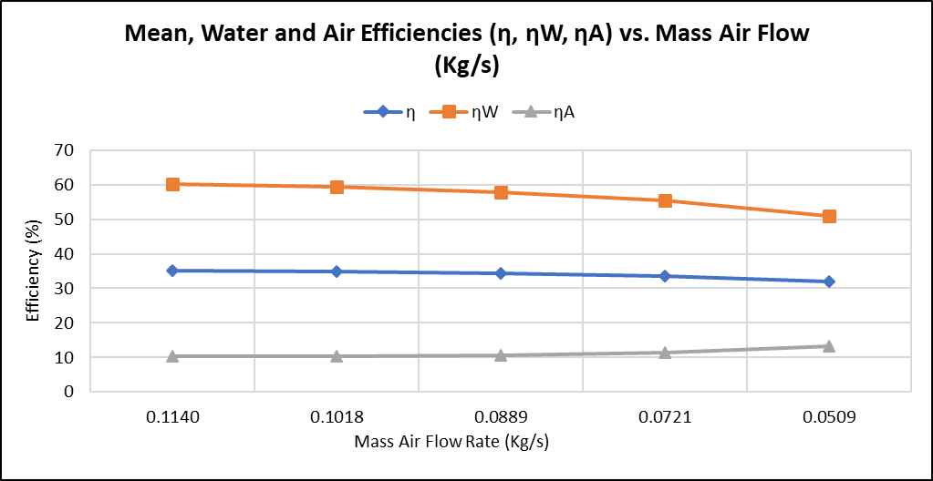
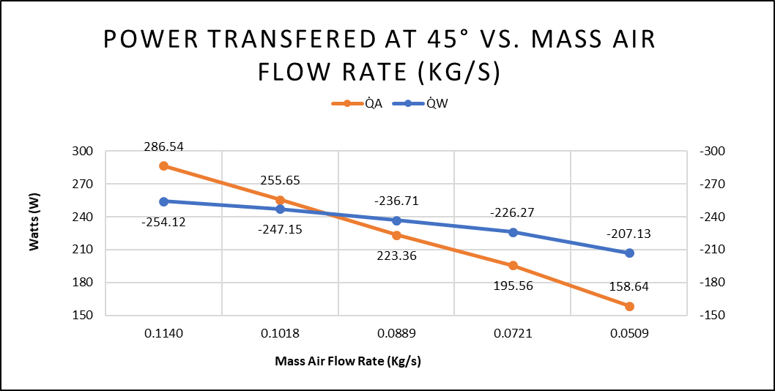
Figure 4-12 Experiment 3 Efficiencies Vs water mass flow
Figure 4-10 Experiment 3 power transfer Vs water mass flow rate
Figure 4-11 Experiment 3 Heat transfer coefficient Vs water mass flow

Analysis.
Results obtained were tabulated for each experiment, starting population with the measured values and then with the use of the equations that govern the laws behind heat exchangers, allowed for the addition of the extra required data that would in turn update automatically when different values of data were added.
For each experiment, the change and average in temperatures was found for the varying test methods. Then with the use of known values and equations, you calculate the densities for both water and air at the separate temperatures measured.
The water flow rate is to be converted into mass flow rate, along with finding the air mass flow rate. This is for calculating the specific heat capacity for water, as for the air it was assumed that the specific heat capacity is 1005 J/Kg·k (TecQuipment Ltd, 2014). The heat energy transfer, that was either emitted or absorbed was calculated, along with the mean temperature efficiencies and the Log Mean Temperature Difference (LMTD). The LMTD is found so the overall heat transfer coefficient (U) could be found.
The graphs depicted above were created with the horizontal axis comprising of the water mass flow rate in (Kg/s) going from the highest value to the lowest, therefore demonstrating the effect a change in flow rate would make. In the first, left hand graphs (figures; 4-2, 4-5, 4-10) the heat emitted from the water, and power absorbed by the air plotted on a second primary axis, allowing for ease of comparison. The second graphs in the centre of the pages above (figures; 4-3, 4-6, 4-12) are plotted using the air, water and mean temperature efficiencies, to highlight how varying the flow rate of air effects the efficiency. The final graphs on the righthand side (figures; 4-4, 4-7, 4-11), show the overall heat transfer coefficient values (U) as the air mass flow rate changes.
- In the first experiment carried out, the water flow rate was the variable changed to establish the effect on the heat exchanger performance. Figure 4-2 shows how as the flow rate decreased, the power absorbed by the air decreased from 640 to 390 Watts and then that the power emitted from the water decreased from -610 to -379 Watts (minus due to emission) and this simply highlights the transfer of energy between the fluids isn’t a completely direct transfer and that there will always be loses in some form or another. Another way to look at it is, the values of the energy balance coefficient as shown the tables (figures; 4-1, 4-8, 4-9) and as shown the values that range from -0.95 to -1.05 which again shows that it’s not a 100% efficient energy transfer.
Looking at figure 4-3 it compares the temperature efficiencies of the water and air. As can be seen, as the water flow rate decreases the efficiency of the air begins to decrease also. But as for the water and mean efficiencies, they increase with a significant exponential pattern. The water efficiency increase shown is due to the heat exchanger providing a larger difference in the same emitted power at the lower water flow rates and as a result of the water efficiency, the general increase of mean efficiency is due to seeing higher temperature changes within the water compared to the air.
With the heat transfer coefficients shown in figure 4-4, the values for the coefficient decrease as the water flow, except for at the starting flow rate but after discussion and comparison with results of the same testing procedures, this result should be disregarded and seen an anomaly.
- The second and third experiments as showing the effect of air flow on the performance of the heat exchanger, with the difference being two temperatures tested, 60°C and 45°C respectively. As seen from figure 4-5 the heat energy starts to converge at higher flow rates and begin to part more at lower flow rates. The loss in the power absorbed suggest losses exist within the heat exchanger, such as the material it’s made of conducting some of the heat energy. Comparing this to figure 4-10 where the water temperature in the test is lower, the heat absorbed and emitted follow the same trend but with a less aggressive line.
Looking at the comparison of efficiencies and heat transfer coefficient, figures 4-6 and 4-7 respectively (60°C), with a decrease in water flow rate, the water efficiency and subsequently the mean efficiency reduces, whilst air efficiency increases. The heat transfer coefficient value decreases with decreased air flow, showing that higher values of airflow can lead to increased heat transfer and better performance from the heat exchanger. Comparing this to figures 4-12 and 4-11 carried out at 45°C, it can be seen that the results are very similar when at the lower temperature. Demonstrating that it doesn’t have a large effect on the heat transfer coefficient.

Conclusion.
In order to improve the performance of the heat exchanger, fins on the heat exchanger and more tubes can be beneficial, changing the type of connection to series can also return a performance benefit in some study cases. (TecQuipment Ltd, 2014)
Looking at the results of the heat exchanger test, having a high water and air flow rate demonstrate larger values of the heat transfer coefficients (U) and therefore better heat exchanger performance, but it should be noted that a lower temperature will reduce this effect.

References
Solar Schools. (n.d.). Types of Energy. Retrieved from Solar Schools: https://www.solarschools.net/knowledge-bank/energy/types
TecQuipment Ltd. (2014). TD1007 User Guide. Nottingham.

