Jamie Parry (2104099)

Is there a problem with knife crime amongst young people in deprived areas of the UK, and is the government doing enough to tackle the issue?

Abstract

This paper examines the current prevalence of knife crime amongst young populations in deprived areas of the UK. At this time, knife crime is comparable to an epidemic amongst younger generations, as knives and other bladed articles are easily accessed in the UK, making them responsible for a greater proportion of deaths in the UK than firearms. The research also identifies the successes and failures of the UK Government’s response to the issue and identifies areas in need of improvement.
Incorporating research from academic literature, current news and media publications and the views of the general public, this study demonstrates that knife crime is a prevailing issue amongst young populations in deprived areas and that the current measures undertaken by the UK government in response to such are in need of improvement. The research argues that knife crime has become a major concern in recent years and that younger generations in deprived urban areas are most at risk, while also identifying that the UK government must update their responses to prevent discrimination caused by current measures.

Acknowledgements

I would like to express my gratitude to my tutor Mike Durke, for their continued support and feedback which has been fundamental to this research project. I am also grateful to my family and friends for their moral support and continued belief in me that kept my spirits and motivation high during this project.

Declarations
This work has not previously been accepted in substance for any degree and is not being concurrently submitted in candidature for any degree.
STATEMENT 1
This dissertation is being submitted in partial fulfilment of the requirements for the degree of BSc.
STATEMENT 2
This dissertation is the result of my own independent work/investigation, except where otherwise stated.
Other sources are acknowledged in the Reference Section.
STATEMENT 3
I hereby give consent for my dissertation, if accepted, to be available for photocopying and for interlibrary loan, and for the title and summary to be made available to outside organisations.
STATEMENT 4
I hereby give consent for my dissertation, if accepted, to be available on the university’s IT system to those who have consent to use the system.

Jamie Parry
Signed: J. Parry

Date: 05/05/2024

Contents
Abstract 1
Acknowledgements 2
Declarations 3
1. Introduction 6
Objectives. 7
Scope. 8
2. Literature review. 10
Historical trends and the impact of the Covid-19 pandemic on knife crime. 10
Young people and knife crime. 13
Government responses to knife crime. 16
3. Methodology. 20
Research Onion. 20
Research Philosophy 21
Research Approach. 22
Research Strategy. 23
Choices. 24
Time Horizon. 24
Techniques and procedures. 25
Limitations. 26
4. Data analysis. 27
Historical trends and the impact of the Covid-19 pandemic on knife crime. 30
Young people and knife crime. 34
Government responses to knife crime 37
5. Conclusion. 41
Historical trends and the impact of Covid-19 pandemic on knife crime. 41
Young people and knife crime. 42
Government responses to knife crime. 43
6. Bibliography 45
7. Appendix. 53
1. Questionnaire and Literature Review matrix. 53

Table of figures.
Figure 1.0 21
Figure 2.0 28
Figure 3.0 29
Figure 4.0 30
Figure 5.0 31
Figure 6.0 32
Figure 7.0 33
Figure 8.0 34
Figure 9.0 35
Figure 10.0 36
Figure 11.0 37
Figure 12.0 38
Figure 13.0 39
Figure 14.0 40

Introduction

The Offensive Weapons Act 2019 explains knife crime as crimes involving the use of knives or other bladed and pointed articles, as the carrying and use of such is prohibited in a number of contexts (College of Policing, 2021). A violent crime which is brought about by the accessibility of knives in comparison to firearms, making knives responsible for a greater proportion of deaths in the UK than firearms (Coid et al, 2021). In the year ending 2023, 50,500 knife crime offences were recorded in England and Wales (Allen, Carthew and Zayed, 2023).
Currently, the British Medical Association are calling for knife crime to be considered a public health concern (Coid et al, 2021), as certain areas in the UK have become hot spots for the crime, particularly urban areas with higher levels of street gang prevalence and county line drug distribution networks (Harding, 2021) with West Midlands Police force facing the highest levels of knife crime in the year ending March 2023 (Allen, Carthew and Zayed, 2023).
The research focuses on young people. A study of 13,000 teenagers living in the UK, found that one in eleven males had carried or used a knife by the age of 17 (Centre for Longitudinal Studies, 2021), highlighting the prevalence this crime has amongst younger generations whilst giving a brief insight into the implications the crime has on affected families. A study of news reports surrounding knife crime also found that those aged between 11-20 were the most vulnerable to falling victim and that males are most commonly victims, the same study also revealed that street violence, fights, gang attacks and robbery are all issues that are often found to be causes of knife crime (Kabir et al, 2022). This research also focuses on areas of socioeconomic deprivation as studies have shown that these areas are where knife crime predominantly occurs. One study investigated the link between the risk of knife crime and socioeconomic disparity by observing patients of knife crime aged 17 or under at a UK trauma centre, finding that of the 139 children sampled, most of them came from areas of socioeconomic deprivation (Reilly et al, 2022). As for the time period, it is important to address current issues regarding knife crime, as up to date statistics and modern causes of knife crime are a fundamental part of this study, therefore this study is concerned with the present day and recent years, with a specific focus on the effects of the Covid-19 pandemic which began in 2020.

Objectives.

The overall aim is to identify if there is a problem of knife crime amongst young people in deprived areas of the UK and to assess whether the government is doing enough to tackle the issue, which will be achieved through three key objectives. The first is to analyse historical trends and the impact of the Covid-19 pandemic on knife crime. Police recorded crime figures published by the Office for National Statistics show an increase of 21 percent for knife and offensive related cases between the years ending September 2021 and 2022. It is possible that this may be as a result of an increase in police activity following the pandemic or a direct effect caused by the pandemic (Ministry of Justice, 2023). This objective will uncover the reasoning for the increase in knife crime in recent years and conclude whether increased deprivation and financial struggles across UK as a result of the pandemic are responsible. The second objective is to identify whether young people are more vulnerable to knife crime. Evidence has shown that there are three main reasons people carry knives, of which are self-protection, self-presentation and utility (McNeill and Walker, 2019). This research will assess the likelihood of young people carrying knives for these reasons and assess whether younger generations are more likely to fall victim to knife crime than older generations. The final objective is to assess the response to knife crime from the UK Government. Over the last few years, there have been a general increase in law enforcement and funding to tackle issues of serious violence including knife crime (Home Office, 2022). 18 violence reduction units have been introduced as well as developments in knife crime prevention orders and public health approaches (Ryan, Brown and Holland, 2021). This objective will assess the success of such strategies and responses and identify potential improvements.
For all objectives, quantitative methods of research are to be conducted through the use of literature. National statistics and government documents, alongside a range of relevant textbooks and journals are to be utilised in order to draw the necessary information needed to conclude. primary research is also going to be conducted to gather qualitative data to discover the thoughts and feelings of the general public. A questionnaire is to be utilised, which will be posted to an existing social media account where approximately 100 members of the general public can express their views on the governmental strategies in place to tackle knife crime and to uncover the general viewpoint surrounding knife crime today.

Scope.

This topic is of great relevance today as the volume of knife crime occurring in the UK is often comparable to an epidemic amongst younger generations as figures have increased continually since 2013. Homicides by knife crime are currently at its highest rate in the last ten years, and while there is limited understanding as to what is causing the statistics of knife crime to continually increase (Haylock et al, 2020), an opportunity is presented to identify potential reasons for this while also adding value to existing research by developing a further understanding of the perpetrators of knife crime to disregard the belief that it is a ‘black crime’. This belief arose after 2006, when the crime was heavily linked to the ethnicity in the media due to the increase in social anxiety amongst suburban middle classes and disproportionate coverage by the press (Olajide, 2024). For example, in the case of Tom Rhys Pryce, who was a wealthy white male killed by two working class black teenagers, Pryce was given significantly more coverage than other victims from ethnic minorities who were killed on the same day (Williams, 2023). In addition to this, current literature surrounding the prevention of knife crime is heavily orientated around public health approaches to tackling the issue, with little focus on the legal measures rejected by the government, such as criminal sentencing, the use of civil orders and stop and search tactics (Stone, 2022). Therefore, an overall review of the governments strategies from both perspectives is important to balance the focus of existing research and potentially uncover new methods that can be used to tackle knife crime. This research also serves purpose to raise awareness of the effects knife crime has on families and communities (College of Policing, 2021).

Literature review.

This chapter analysis and reviews current and existing academic literature surrounding each of the objectives. The purpose of this is to draw conclusions from previous research to aid in developing an answer for the overall aim, assess what research has already been conducted and to discover any gaps in the subject area that need addressing.

Historical trends and the impact of the Covid-19 pandemic on knife crime.

National Statistics (2023) show that in the year 2022/2023, the most recent recordings, around 50,500 knife crime offences were committed, a 4.7% increase on the previous year, though 7% lower than what was recorded in 2019/2020. However, there was a drop in the year 2020/21 when Covid-19 was prevalent (Allen, Carthew and Zayed, 2023). Statistics also highlight that knife crime was relatively low between the recordings of 2010/2011 and 2013/2014 before a steady increase in knife crime over the following five years. Recent recordings state that the West Midlands Police faced the highest levels of knife crime, whereas North Yorkshire recorded the fewest offences (Allen, Carthew and Zayed, 2023). However, Bailey, Harinam and Ariel, (2020) argue that the increase in statistics is not necessarily as a result of increased offences, but due to increased police activity, such as stop and searches, as knife crime statistics include possession offences. They propose that knife possession and violent crime should be recorded as separate offences, while differences in the methods of policing adopted by forces across the country can also impact the validity of statistics. Browne et all (2022) emphasise that participation of knife crime is not always driven by general violence, as data shows that the increase in knife crime does not mean an increase in violent offending. This can be suggested by the fact that knife carrying does not always lead to a violent offence.
Current mayor of London, Sadiq Khan claims a major factor for the increase in knife crime is austerity, when the UK government cut public services budgets in effort to minimise public expenditure. From April 2010, The UK’s Conservative-led coalition, which promised to reduce expenditure by £85 billion (Reeves et al, 2013), led to reductions in the size of UK police forces, making them less equipped to fight violent crime. Between 2010 and 2019 the UK had lost around 20,000 police officers, while it is estimated between 400 and 600 police stations closed (Kirchmaier, 2019). This data shows a strong correlation with the increase of knife crime that began in 2013. With a weakened police force, public confidence in the police is also likely to fall. The Crime Survey for England and Wales showed that the public perception of the police dropped from 63% of the public believing the police were doing an excellent job in 2015/16 to 56% in 2019/20, since then the methods of gathering this data changed, making newer findings incomparable (Tudor, 2023). Skarlatidou et al (2023) claim that young people’s reduced confidence in the police leads to the increased likelihood of knife carrying as a form of self-defence, as they experience higher feelings of unsafety and develop the attitude that the police cannot protect them. The increase in knife crime and decrease in public confidence of policing correspond, highlighting that there could be a direct connection. The increase in gang culture across the UK is also a potential cause for increasing knife crime as the Children’s Commissioner estimates around 27,000 children are currently members of a gang (Taylor, 2022), the Serious Violence Strategy puts heavy emphasis on the rise of county lines drug gangs as a cause for the increase in violence amongst youths, with blame to social media for encouraging gang life and making knife carrying appear to be normal (Densley, Deucher and Harding, 2020). Data shows that gang culture is particularly common amongst public housing and high-rise council estates. Which, Kirchmaier Machin and Villa-Llera (2020) argue generally accommodate those with lower incomes, as high-rise buildings in London were less likely to be gentrified and therefore are of lower value, meaning that deprivation is more common amongst such areas. As gangs are more prevalent in these areas, it can highlight a link between increased deprivation and knife crime.
As for the Covid-19 pandemic, there was a drop in knife crime in the year 2020/21, when Covid-19 was most prevalent, this could be as a result of different policing practises, although further research is needed to conclude. Hickland et al (2022) found that while the first lockdown led to a reduction in knife crime, by the third lockdown, levels had resumed at their normal rate and have increased since. They also call for further research into the effects of the Covid-19 restrictions on knife crime. Current evidence proposes that the main causes of knife crime include poverty and adverse childhood experiences (HM Inspectorate of Probation, 2019). which can potentially explain the increase in knife crime following the pandemic. Poverty is likely to have increased drastically as Covid-19 led to job losses, financial strain and food insecurity amongst deprived areas of the UK (Holt and Murray, 2019), which links to the beliefs of McNeill and Walker (2019) who argue that a strong factor for knife carrying is to commit theft for self-gain, which can be financially motivated. As for adverse childhood experiences, the Covid-19 pandemic had strong connection with poor mental health which can be a cause of adverse childhood experiences which can lead to criminality and can potentially be responsible for some of the knife crime that contributed to the increase post pandemic (Alradhi et al, 2022). Overall, the literature has found that some of the factors that led to the rise in knife crime since 2013 include austerity, reduced confidence in the police and that gang culture is becoming increasingly popular, while poverty and adverse childhood experiences caused by the pandemic have contributed post pandemic. In addition to this, it was identified that further research is needed to address the effects of Covid-19 restrictions on knife crime and whether different policing practises that were adopted during the pandemic had an impact on the amount of knife crime recorded.

Young people and knife crime.

In cases of knife crime throughout the UK, young people are often the victim, though not always the perpetrator. This is particularly common amongst urban populations, in which young people are most frequently subject to knife crime and become under a higher risk of long-term psychological issues as a result of such (Vulliamy et al, 2022). In the year ending March 2022, there were 99 recorded deaths of people under the age of 25 caused by knife crime, 13 of which were under 16 (Akinsanya, 2023). As for the perpetrators, statistics provided by the Ministry of Justice for the year ending 2023, show that there were 19,000 cautions and convictions of knife crime and those under the age of 18 made up only 18% (Allen, Carthew and Zayed, 2023). In addition to this, in 2018, the Office for National Statistics sampled a number of people from groups aged between 10-15 and 16-29 regarding knife carrying and found that 6.5% of the younger group knew someone who had carried a knife, while the percentage for 16–29-year-olds was slightly less at 5.7%. For both age groups, less than 1% of them had carried a knife themselves (Allen, Carthew and Zayed,2023). This is the most recent data for this study and shows minor difference between the age groups, though further sampling could have been done on an older group of people. Traynor (2016), states that amongst young offenders of knife crime the gender ratio is roughly 3:1 in favour of males. As for ethnicity, most victims and perpetrators of knife crime aged between 10-25 were from Black or Asian ethnic backgrounds in 2022 (Kabir et al, 2022), it is believed that structural inequality has led to most black and minority ethnic communities being disadvantaged socio-economically and that there is a link between structural factors such as poverty and knife crime (Gwata et al, 2024).
The College of Policing (2019) propose three key motivators for knife crime, which are for self-protection, to increase street credibility and respect and for use as a tool for other offences. Self-protection refers to the fear of victimisation and the need to carry a knife as a self defence mechanism. The Protection motivation theory can be used to explain why people carry knives and two key elements of the theory are the risk severity and vulnerability of the person (Palasinki et al, 2019). From this theory, many would argue that younger people are more vulnerable, a study into the behaviours of 10–25-year-olds found that many of them had in fact carried a knife as a result of previous violence they had experienced (Hibson, Yesberg and Bradford, 2022) and therefore had carried one to protect themselves if necessary. On top of this Ramshaw and Dawson (2019) argue that the mass-media campaigns in place to prevent knife carrying amongst young people that include photographs of seized weapons, can actually have a negative effect on young people and make them more worried about knife crime, potentially leading them to carry one as a means of protecting themselves, this is known as the law of unintended consequences. As for street credibility, this can be popular amongst younger people who want to fit in or get themselves affiliated with dangerous people. Young people who have friends prone to delinquency, know of gang members or spend more time on the street are at a higher risk of turning to gang culture (MacFarlane, 2019), which knife crime is heavily linked to. Retribution against rival gangs often leads to violence, with knives being a commonly used tool for such (Salt, 2022). The Centre for Social Justice (2018) estimates that gangs are responsible for up to half of the knife crimes recorded in London. With more young people carrying knives to achieve respect and to fulfil gender identities, Squires (2018) identifies that knife carrying by someone who may be seen as a threat motivates others to carry knives in response. As for knives being used to commit other offences, Traynor (2016) identified that the increase in street robbery the UK seen in the early 2000s was caused by the introduction of recent technology such as mobile phones and other valuable items. Such items are more appealing to younger audiences and may motivate them to commit a street robbery with a knife to obtain such items, particularly amongst people of lower socioeconomic backgrounds who have problems affording them. Traynor (2016) also recognises that knives are commonly used by young people to intimidate members of rival gangs.
Brenner (2022) addresses the idea that young people may be more likely to commit knife crime due to a lack of youth centres in their community, which is less of a problem for older generations. In addition to this, while young people may be more vulnerable to gang culture, Former Metropolitan Police Commissioner Sir Bernard Hogan-Howe claims that 75% of knife crime amongst those aged 25 and under are not gang related while emphasising the role of status and fear as a factor leading to knife carrying amongst young people (Tribe, Harris and Kneebone, 2018). Overall, literature in this area has identified that young people are very vulnerable to being the victim or perpetrator of knife crime, although in existing research, there is a heavy emphasis on young people. further research conducted on older people in this subject area would be beneficial for comparative purposes to fully conclude the difference in vulnerability between older and younger people.

Government responses to knife crime.

Currently, the Conservative party forms the majority of the UK government (UK Parliament, 2023). Though, In January 2024, the Labour party announced an action plan to cut knife crime as part of the ‘Take back our streets’ campaign. The party call for tougher consequences for offenders, early interventions, reductions in knife availability, the ending exploitation of young people and a new coalition to end knife crime. Claiming that the current Conservative government have failed to keep the streets safe (Pope, 2024).
Initial research identified that current literature surrounding the prevention of knife crime is heavily orientated around public health approaches, with little focus on legal measures such as criminal sentencing, the use of civil orders and stop and search tactics (Stone, 2022). As for criminal sentencing, the average custodial sentence length for adults increased from 7.1 months to 7.9 months between 2013 and 2020, though the average custodial sentence length for 10–17-year-olds fell from 8.2 months to 7.0 months between 2013 and 2023, while the number of offenders given suspended sentences has increased (Ministry of Justice, 2023). Therefore, while the length of sentences has slightly increased, the number of offenders receiving them has decreased, highlighting that custodial sentencing has decreased.
The most recent legislation surrounding knife crime is the Offensive Weapons Act 2019. Knife crime prevention orders were first introduced under this act to interfere with those most at risk (Hendry, 2022). However, Green and Hendry (2022) propose that these orders emphasise the belief that knife crime is a Black crime as those targeted for knife prevention are often black, young and poor. Martin (2021) further adds to this by explaining that knife crime prevention orders give additional powers to police officers to stop and search, which are already 19 times more likely to be performed on Black minorities than white people. On top of this, for a knife crime prevention order, the court must only decide whether it is more likely than not that the potential offender is likely to offend in the future, which many believe does not warrant a high enough standard of proof, which leads to the criminalisation of disadvantaged children. Such criminalisation can mean innocent children face issues gaining employment which can increase the likelihood of them offending in the future. Teeple (2020) argues that the government are not responding to knife crime fast enough as the House of Lords and House of Commons could not agree on how bladed products can be delivered to homes without ending up in the hands of an irresponsible individual, he proposes that businesses that sell knives should work with local authorities to regulate who becomes in possession of knives.
In 2021, Home Secretary Priti Patel announced plans to recruit 20,000 additional police officers and introduce new stop and search powers to prevent violent crimes, as for young people, she also introduced early intervention programmes to prevent young people from turning to gangs and their associated violence (Home Office, 2021). Chivers (2020) questions is police numbers actually affect knife crime, finding a causal link between police numbers and crime, therefore, recruiting police officers is likely a good decision from the government. However, Roberts (2019) argues that multi agency partnerships would have a more significant impact, using the success of the Scottish Violence Reduction unit as an example. The government should focus on improving the resources for agencies to communicate and share information regarding knife crime in order to tackle it.
In 2017, the Government set out the London Knife Crime Strategy to reduce violent crime in the UK capital. The strategy backed the use of the Gang Matrix, which identifies the most dangerous gang members in the city and aids with the identification of young people at risk of becoming associated with such gangs (Greater London Authority, 2017). Densley and Pyrooz (2020) believe that the validity of the matrix must be questioned as it causes further discrimination with an overrepresentation of black people in gang lists, though the Metropolitan Police (2012) claim that it is compliant with the Human Rights Act and is monitored to ensure that is it used only to reduce crime proportionately. Drill music is also commonly listed as an encouraging factor for knife crime, leading to bans against music videos and criminal behaviour orders against drill artists (Fatsis, 2019). Fatsis (2019) then argues that the impact of such music on knife crime is a misinterpretation and highlights the government’s failure in addressing the real causes of knife crime including social inequality, poverty and childhood trauma and proposes a new crime reduction model based on the Scotland Violent Crime Reduction Unit, while Ullman et al (2024) calls for further care and support in preventing young people from being exploited by county line gangs that often leads to knife crime.
Overall, this review of literature has found a reoccurring theme that while the government is responding to knife crime amongst young people, the focus is placed on the wrong areas thematically which impacts the effectiveness of them and leads to implications of discrimination against minorities.

Methodology.

The purpose of this study is to assess the correlation between knife crime and young people in deprived areas of the UK, and to evaluate the responses to which from the UK government. The purpose of the primary research being undertaken is to explore issues which relate directly to the objectives of the research and address the gaps identified while conducting the literature review (see appendix 1), as primary research is not limited to what is currently found in existing literature (Driscoll, 2011). For example, a significant finding in chapter two was the absence of existing literature in relation to older generations regarding knife crime for comparative purposes to that of younger people. The use of primary research also allows for the opportunity to ask open questions in order to gather qualitative data based on opinions and relationships that are not fully assessed with the quantitative data provided in existing literature (Cypress, 2015).

Research Onion.

Saunders et al (2016) clarify that the research onion is a framework which aims to encourage a structured approach to undertaking research. It explains the numerous considerations that must be acknowledged when developing a research methodology in the form of 6 layers, these are the research philosophy, research approach, research strategy, choices, time horizon and techniques and procedures.
Figure 1.0
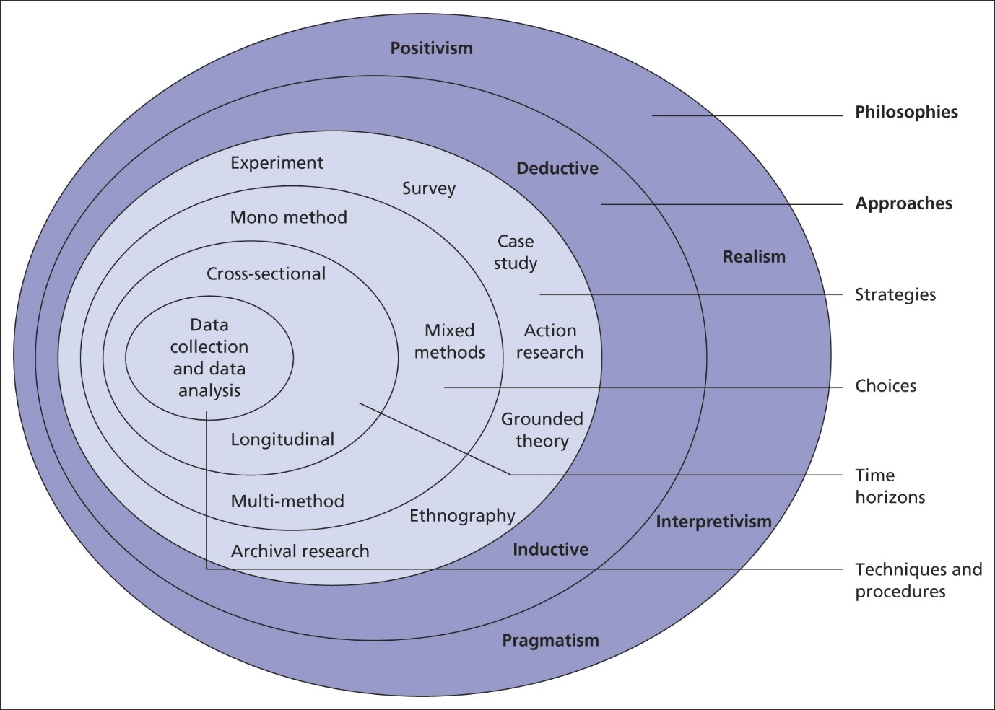

Research Philosophy

The research philosophy is the set of beliefs and assumptions that develop knowledge in relation to research (Saunders et al, 2009), this is often taken in the form of ontology and epistemology. Ontology being the branch of philosophy that is concerned with what is real (Smith, 2012) while epistemology questions what makes knowledge valid and how it can be obtained (Al-Ababneh, 2020). As for this research, a pragmatic approach where public perceptions of knife crime will be sought is preferred to a profound philosophical exploration of the nature of reality and knowledge. The gathering of qualitative data through the use of open questions based on perspectives, means the positivism approach to philosophy is disregarded while an interpretivism approach is utilised to consider the differing views held by members of the public regarding knife crime and attitudes towards the police, as interpretivism considers the differing views of individuals in oppose to a generalised understanding (Alharahsheh and Pius, 2020).

Research Approach.

The research approach refers to the manner in which research is gathered and takes one of two forms, these are the inductive approach and the deductive approach. Soiferman (2010) acknowledges that inductive research begins specifically to the topic and moves towards a more general understanding through observation and probability, whereas deductive is reasoned by necessity and leads with general data and moves towards specific data throughout. Therefore the inductive approach to research is concerned with the observation and development of new theories based on data collected, whereas the deductive approach is based on an existing knowledge. Due to the nature of this research, aspects of both research approaches are to be utilised. The primary approach to the research is to be inductive as a conclusion is to be made through the analysis of the research findings, the inductive approach is also to be utilised of the purpose of addressing gaps in the current literature, of which were identified through the conducting of secondary research, as new theories and understandings are to be developed. Although, aspects of the deductive approach are displayed when primary research is based on supporting data found in existing literature. In addition to this, both quantitative and qualitative data are to be gathered, while inductive research is generally associated with qualitative data and deductive research with quantitative (Newman, 2000), meaning that a mixed approach is appropriate to this study as it provides all the necessary data needed in order to conclude.

Research Strategy.

This project utilises the survey approach, which is the collection of data from a sample of people who have been asked a series of questions (Ponto, 2015). The survey approach is of great use to this study as it provides important data regarding the attitudes, beliefs and knowledge of the general public of which can be assessed to conclude (Story and Tate, 2019). The survey in question will gather public perceptions regarding knife crime and the government’s responses to identify if the general public are satisfied with how knife crime is currently being controlled and assess whether people are fearful of knife crime in their area. The survey approach also allows for the gathering of demographic data regarding age and area of residence, which can be analysed for comparative purposes to examine differing responses by age group and area of residence. Differing responses from older and younger groups of people can be assessed to identify whether younger people are more vulnerable to knife crime and area of residence is important to investigate differences in levels of deprivation in relation to knife crime. Other approaches to be considered include the grounded theory approach, which involves the use of systematic guidelines to collect and analyse data in order to create new theories (Charmaz, 2014), as it allows for the development of new theories regarding the reasoning for the recent increase in knife crime to be expressed. The other approach that is beneficial to this study is ethnology, which focuses on the differing characteristics of individuals over time. This is important for this study as it involves an emphasis on differing characteristics based on age and socioeconomic class as an explanation for knife crime. Therefore, analysing data collected from a range of individuals with differing characteristics will allow for correlations and relationships between characteristics and knife crime to be identified and analysed effectively.

Choices.

Due to the importance of both quantitative and qualitative data in relation to this study, a mixed approach to data collection is required, as it allows for the collection of both types of data. To achieve this, the use of a questionnaire is to be utilised, as it allows for a substantial amount of relevant data to be collected in a short period of time (Kent, 2020)

Time Horizon.

As there is no time dimension for the survey, the cross-sectional approach to research is to be used as data is collected at a given point in time (Kesmodel, 2018) This is beneficial to the study as it allows for relevant data regarding the current situation, meaning that data collected is up to date and reliable. Longitudinal studies consist of gathering data over prolonged periods of time for comparative purposes over time (Caruana et al, 2015). Though, due to the nature of this study and time frame available, this method of data collection is unnecessary.

Techniques and procedures.

The use of a questionnaire is best suited to this study, as it allows for the gathering of specific data, that may not be as accessible through other means of research (Dewaele, 2018). This method of research is also effective for gathering data as it is easily accessible for recipients due to the use of online platforms, in which the survey will be shared too. This in turns allows for the opportunity to reach an appropriate audience and therefore obtain adequate responses. The use of an online questionnaire also rules out geographical restrictions and allows for anonymous responses that can be stored appropriately to minimise ethical risks (Nayak and Narakyan, 2019). As for the participants, participation will be optional and chosen at random and in order to access participants, the survey will be posted to online social media platforms, giving potential participants the option to complete the survey or decline participation. The use of online platforms to access participants is more reliable than the use of paper-based surveys as it decreases the likelihood of participants not receiving the survey (Rada and Dominguez-Alvarez, 2014). As for the sample size, the questionnaire aims to gather approximately 100 responses, as this will allow for enough data to analyse appropriately and limit the risk of the quality of the data being compromised.
The questionnaire is being developed via Microsoft Forms, a software that records responses and categorises results automatically. To further analyse the results, two key methods are to be used. The first of which is statistical analysis, in order to identify trends over time in relation to public perception of safety and the impact of Covid-19 on knife crime (Ali and Bhaskar, 2018). The other method of analysis is content analysis, in order to assess the differing responses given by age category to develop an understanding as to whether young people are more fearful or vulnerable to knife crime and to identify if the public are confident in the government’s response to knife crime.

Limitations.

It is important to address any limitations that may be faced during data collection. Firstly, the likelihood of gathering responses from a range of demographics, to ensure this is the case, the questionnaire is to be posted to a wide range of social media platforms that are catered to both younger and older generations to encourage members of the public of all ages to participate. In addition to this, there is always a risk of careless responses which can impact the quality of data (Meade and Craig, 2012). In order to reduce the impact of this, it is important to achieve a reasonable number of responses to minimise the effects from minority careless responses on data as a whole. This also highlights the issue of not getting enough responses. Therefore, developing the questionnaire in advance will allow for a reasonable amount of time to gather data effectively. The consideration of such limitations means that it is likely that the data collected will be reliable and beneficial to the study.

Data analysis.

For objective one, primary research will gather public perceptions regarding people’s feelings of safety or fear of knife crime over time and how their confidence in the police has been affected. As for objective two, primary research can allow for age specific analysis in relation to vulnerability and likelihood of knife carrying to deduce whether young people are in fact more vulnerable. Finally, primary research can provide relevant and specific data for objective three in the form of general public viewpoints surrounding how the government tackle knife crime and provides opportunity for them to suggest their own ideas.
This chapter serves to present and analyse the primary data collected from the survey in which collected 104 responses. Consisting of 20 questions, quantitative and qualitative data was gathered for all three objectives of this project, which were to analyse historical trends of knife crime and impact of Covid-19, investigate the relationship between young people and knife crime and to assess the response to knife crime from the UK government, Meaning public perceptions surrounding each subject were identified. As for the presentation of findings, a systematic approach is to be utilised in which data is analysed and synthesised, comparing and contrasting primary findings to that of secondary research found in the literature review (Gurevitch et al, 2018).
The survey was shared to social media platforms to identify participants, those who opened the survey were notified of their anonymity and their consent to participation was acquired through the introductory briefing statement. Participants were also informed of the recording and storing of data in compliance to the ethical considerations (Plutzer, 2019)
To comply with ethical considerations regarding primary data collection, the first question asked for the formal consent of anyone who considered participating in the survey allowing them the right to refuse participation (Martin and Marker, 2007). 100% of respondents consented to participation. When completing this survey, answering ‘no’ to this question would result in the closure of the survey for the individual.
Figure 2.0
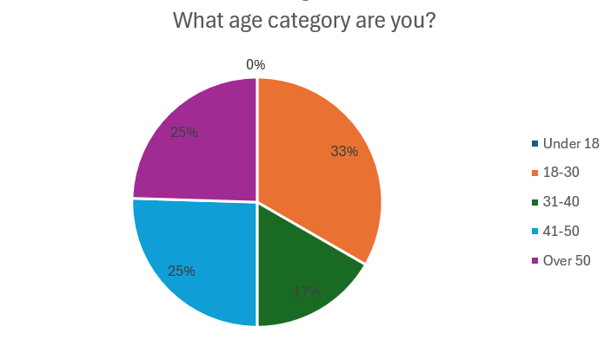

As part of data collection regarding the demographics of participants, the second question asked for the age category of respondents in order to assess the responses to qualitative and quantitative questions asked later on in the survey regarding objective two. The literature review also discovered a lack of existing research surrounding older generations in regard to knife crime compared to that of younger generations, therefore gathering responses from a variety of age groups is beneficial to the study and the topic as a whole. The results show an equal range of responses from all age categories, with the majority being from the 18-30 category (33%) and an even split of people aged under and over 40. In addition to this, to comply with ethical considerations, the ‘under 18’ option for this question would result in the closure of the survey for the individual to prevent any data collection from those under the age of 18.
Figure 3.0
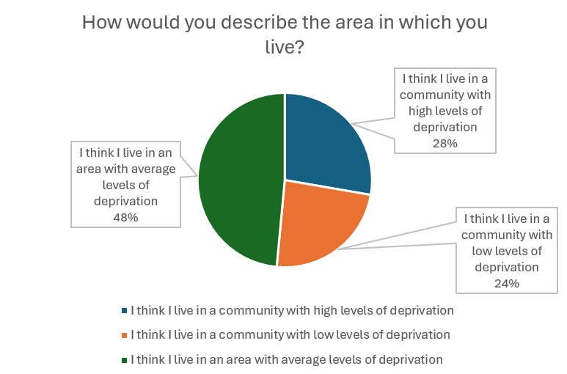

To further gather demographic data, participants were asked to consider the levels of deprivation for the area in which they live, as this is a key element of the research question. The results show that the majority of participants consider the area they live to be of average levels of deprivation (48%), though as each category has received adequate responses, samples of participants of all areas regarding deprivation have been acquired, allowing for a fair representation of each when considering data collected from questions further on. Though postcodes of respondents were also gathered as it is common for individuals misinterpret the levels of deprivation in their areas of residence.
When asked for the reasoning for their response, the most common responses included home ownership and levels of crime. Using the grounded theory approach to assess this qualitative data, a link can be formed between deprivation and crime, of which supports the findings from existing literature that state this (HM Inspectorate of Probation, 2019).

Historical trends and the impact of the Covid-19 pandemic on knife crime.
Figure 4.0
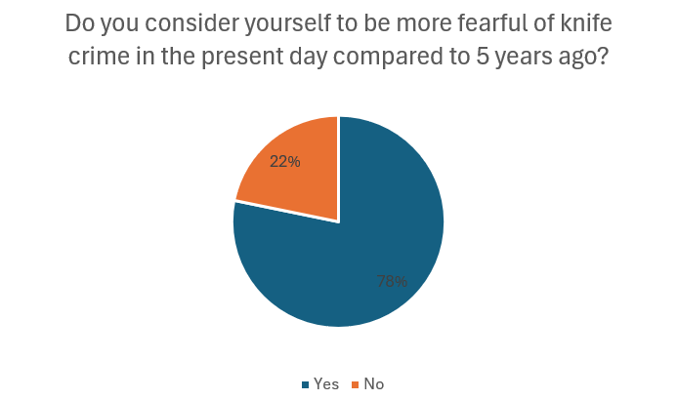

When asked if participants were more fearful of knife crime today compared to five years ago, the majority of people answered ‘yes’ (78%) suggesting that knife crime has become more prevalent in recent times and has impacted the public perception of safety, though it is important to note that statistical data is needed to prove this as public perceptions are not always reality. However, this data coincides with the National Statistics (2023), of which have showed a general increase in knife crime since 2013/2014. However, Bailey. Harinam and Ariel (2020) argue that the statistics had risen as a result of increased police activity, though primary data contradicts this as increased fear of crime is not commonly linked to increased police activity.
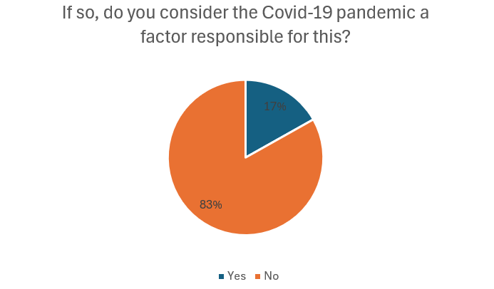
Figure 5.0

Hickland et al (2022) identified that the first lockdown led to a reduction in knife crime. They also called for further research to be conducted regarding lockdown restrictions and knife crime. The data shows that the majority of participants do not consider the Covid-19 pandemic to be a factor for their increased or decreased fear of knife crime (83%). As the majority of people answered ‘yes’ to question seven, it can be drawn that the majority of people don’t consider the Covid-19 pandemic to be a reason for the increased fear of knife crime amongst the population, despite poverty and adverse childhood experiences being major causes of knife crime (HM Inspectorate of Probation, 2019), and the increases of such that arose from the pandemic due to financial strain and job losses (Holt and Murray, 2019). Therefore disproving findings from the literature review.

Figure 6.0
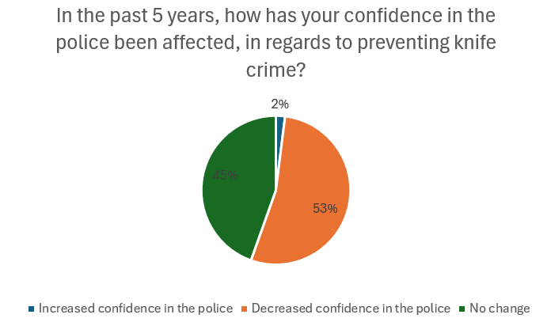

As Skarlatidou et al (2023) claim that a potential factor responsible for knife crime is confidence in the police, question 9 asked the public how their confidence in the police had changed in the past five years in regard to knife crime. While 45% of participants recorded no change, 53% of participants claim to have a decreased level of confidence in the police, which conforms to the general trends provided by the Crime Survey for England and Wales. This also supports the connection between knife crime and confidence in the police as people become more likely to turn to knife crime as a form of self-defence in oppose to relying on police forces (Skarlatidou et al, 2023). Furthermore, this data can be used as an explanation for the findings of question seven which identified that people are more fearful of knife crime today as a link between decreased confidence in the police and increased fear of crime is identified.
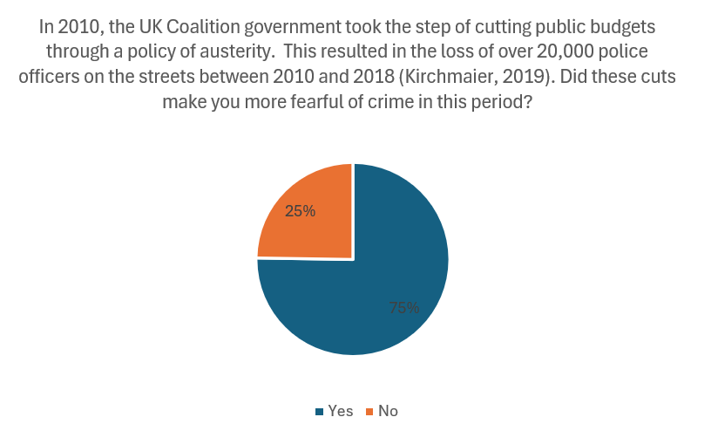
Figure 7.0

Question 10 assessed the effects of austerity, a significant issue of the Coalition Government from 2010 onwards, on the fear of crime amongst the general public. 75% of participants answered ‘yes’ to this question suggesting that the majority of people feel less safe with reduced police officers on the streets. When comparing these findings to that of question nine, a link between austerity and public confidence can also be formed, as people reportedly experience less confidence in the police simultaneously to increased fear of crime as a result of austerity. This supports Sadiq Khan’s claim that austerity is a major factor for the increase in knife crime (Kirchmajer, 2019), and the statistics that show the increase in knife crime that occurred simultaneously to the reduction of police officers from 2010.

Young people and knife crime.

Figure 8.0
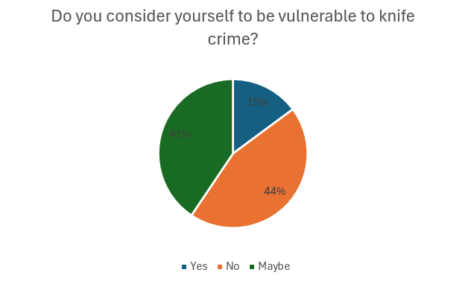

Question 11 asked participants to consider their vulnerability as part of a deductive approach to conclude whether young people are more vulnerable to knife crime than older people. Given that question one indicates that almost equal responses were received from all age categories, data provided by this question is inconclusive for the hypothesis. Though such data can be used to support the belief that knife crime is most common amongst urban populations (Vulliamy et al, 2022), as when participants were asked for their postcode, the majority provided postcodes of rural areas. Given that 44% of participants answered ‘yes’ compared to the 15% that answered ‘no’ it can be suggested that people are less vulnerable of knife crime in rural areas. Ministry of Housing, Communities and Local Government (2019) explain that deprivation is more common amongst urban areas, suggesting that young people in deprived areas are most vulnerable to knife crime, which is a key element of the research question, Though literature states that males in early adulthood are most at risk (Kabir et al, 2022), meaning it is difficult to establish who is most at risk which causes complications in prevention.

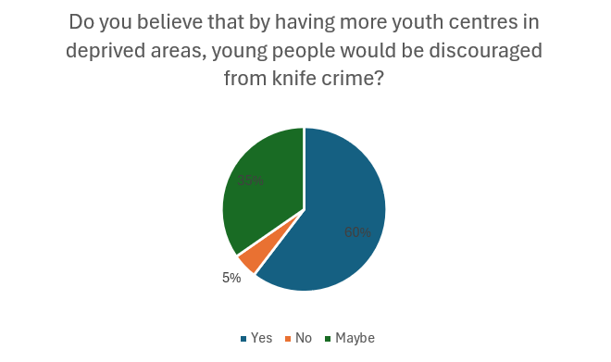
Figure 9.0

Based on the belief that young people are more likely to commit knife crime due to a lack of youth centres in their community (Brenner, 2022), question 14 asked for public perceptions surrounding this statement in order to assess its validity. As the majority of participants answered ‘yes’ (60%) and little answering ‘no’ (5%), it is clear that the general public are in favour of youth centres as a discouragement from knife crime by providing safe environments for vulnerable young people which can deter them from knife crime. In addition to this, given that youth centres are associated with younger populations, it can be drawn that knife crime is generally associated with younger people and is therefore a problem amongst younger populations, of which this research is orientated around.

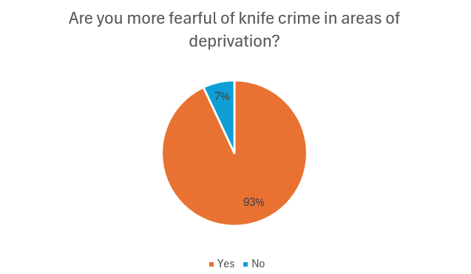
Figure 10.0

Given that the research question is concerned with areas of deprivation, question 15 asked participants whether they were more fearful of knife crime in more deprived areas. 93% of respondents claimed that they were more fearful of knife crime in areas of deprivation suggesting that high deprivation is associated with lower levels of safety and higher rates of crime in the eyes of the public. Supporting research from Kirchmaier, Machin and Villa-Llera (2020) who claim that gang culture is common amongst public housing and high-rise council estates, of which are commonly linked to deprivation. As the Centre for Social Justice (2018) estimate that gangs are responsible for half of the knife crimes recorded in London, it can also be believed that younger people are more vulnerable to knife crime in these areas as young people who know of gang members or spend more time on the street are at a higher risk of turning to gang culture (MacFarlane, 2019)

Government responses to knife crime.
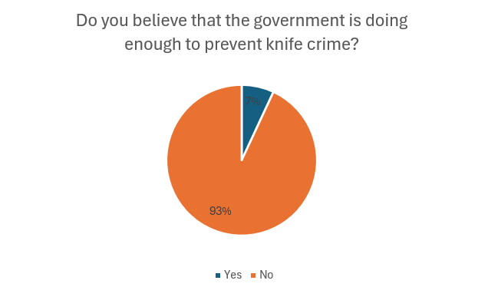
Figure 11.0

Objective three is orientated around how effective the UK government are at preventing knife crime, therefore question 16 gathered the public perception regarding this. The majority of participants answered ‘no’ to this question (93%) highlighting that the general population hold the belief that the government are not appropriately dealing with knife crime and that more needs to be done in order to reduce knife crime, this data can also be linked to the findings from question five, in which identified that 78% of participants were more fearful of knife crime today compared to that of five years prior, suggesting that there is a growing belief that the government are failing to address knife crime and the public are becoming more fearful of the crime as a result. Conforming with the beliefs of Teeple (2020) who argues that the government are not responding to knife crime fast enough.
Figure 12.0
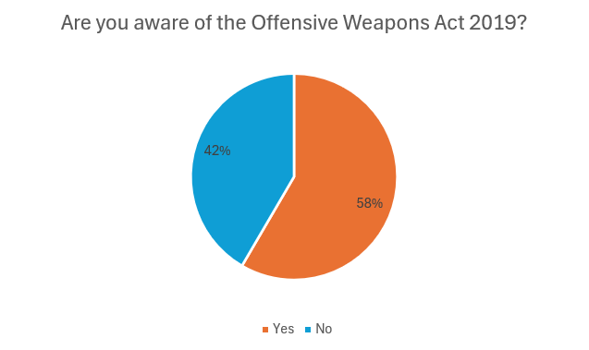

Question 17 asked participants if they were aware of the Offensive Weapons Act 2019 to assess how aware the general public were of the measures undertaken by the UK government in response to knife crime. While the majority of respondents were aware of the act (58%) a relatively high number of people were unaware (42%). Given that 93% of participants held the belief that the government are not doing enough to prevent knife crime, it can be drawn that almost half of these respondents were unaware of the measures taken by the government and can therefore be used as an explanation for the findings.

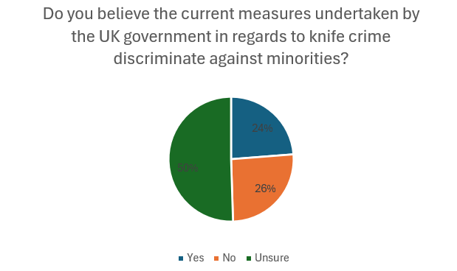
Figure 13.0

A major finding from the literature review was that many people hold the belief that measures undertaken by the UK government in response to knife crime discriminate against ethnic minorities (Green and Hendry, 2022). Therefore question 18 asked for the general consensus surrounding this. The findings show that the majority of people were unsure (50%), while the number of respondents who answered ‘yes’ or ‘no’ were relatively similar, disproving the belief given by Green and Hendry (2022) to be a representation of the general public. This data also disproves the theory from Martin (2022) who argued that knife crime prevention orders targeted minorities. However, such orders were introduced as part of the Offensive Weapons Act 2019, which 42% of respondents were unaware of.

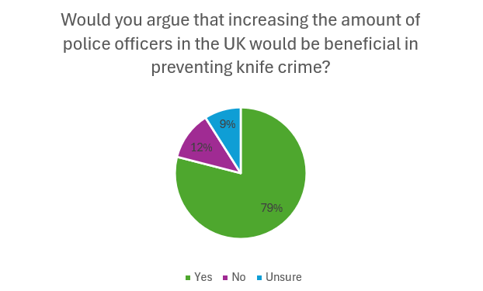
Figure 14.0

Question 19 asked participants if they held the belief that increased police officers would aid in preventing knife crime. The vast majority answered ‘yes’ to this question. This data supports the belief from Chivers (2020) who argued in favour of the recruitment of police officers after identifying a link between police numbers and crime, though arguing against Roberts (2019) who suggests finances are better spent on multiagency partnerships.
Question 20 asked participants for any suggestions they may have as to measures for preventing knife crime in order to gather qualitative data for the subject area. The most common suggestions included education and increased policing. While the increase of police officers is heavily addressed in existing literature, education is rarely touched upon in great detail. A significant finding from the literature review was that government responses currently in place focus on the wrong aspects, therefore this data complies with this belief and emphasises that more should be done preventing knife crime through education in oppose to some of the measures introduced as part of the Offensive Weapons Act 2019.

Conclusion.

A limitation of this research was the lack of responses from older generations for comparative purposes with that of younger generations, which was also identified in current literature, therefore, this is a recommendation for further consideration.
The overall aim of this research was to analyse the connection between young people in deprived areas and knife crime and assess responses from the UK Government. The specific research objectives in place to establish this were to analyse the historical trends of knife crime and the impact of the Covid-19 pandemic, identify whether young people are more vulnerable to knife crime and to evaluate the success of UK government policies and measures in place to tackle the crime.

Historical trends and the impact of Covid-19 pandemic on knife crime.

Chapter two established a strong foundation of insightful research showing an increase in knife crime offences since the recordings of 2013/2014 (National Statistics, 2023) while primary research found that fear of knife crime amongst the general public has simultaneously increased, highlighting that knife crime is a growing issue. Austerity (Kirchmaier, 2019) and decreased confidence in the police (Skarlatidou et al, 2023) are likely responsible for this, which findings from primary research have since supported, meaning that austerity and decreased confidence in the police have led to the increase of knife crime offences that occurred since 2014/2014.
As for the Covid-19 pandemic, National Statistics (2023) highlighted that there was a drop in knife crime for the year 2020/21 when restrictions were in place, though different policing practises could be responsible for this. Hickland et al (2022) identified that while the first lockdown led to a reduction in knife crime, the levels of knife crime offences resumed at their normal rate by the third lockdown. Primary research found that the Covid-19 pandemic was not a major factor for the increased fear of knife crime amongst the general public despite literature arguing that poverty and adverse childhood experiences are major factors responsible for knife crime (HM Inspectorate of Probation, 2019) and that the pandemic caused an increase in such due to financial strain and job losses (Holt and Murray, 2019). Therefore, it can be argued that the pandemic is a small factor for the increase in knife crime offences though there is a link between deprivation and knife crime. Overall, it can be concluded that knife crime is a major concern at this point in time.

Young people and knife crime.

Literature identified that young people are very vulnerable to being the victim or perpetrator of knife crime as statistics show that they are most frequently subject to knife crime offences (Vulliamy et al, 2022). Literature also explains that young people in deprived areas are most at risk. The Ministry of Housing and Local Government (2019) found that deprivation is most common amongst urban areas while primary research found that the general population were less fearful of knife crime in rural areas.
Primary research also argues that the general public are more fearful of knife crime in deprived areas, while Kirchmaier, Machin and Villa-Llera (2020) state that gang culture is most common amongst public housing and high-rise council estates, which are commonly linked to deprivation. In addition to this, The Centre for Social Justice (2018) claim that gangs are responsible for half of the knife crime offences in London while Macfarlane (2019) acknowledges that young people who know of gang members or spend more time on the street are at a higher risk of turning to such gang violence. Finally, it is believed that young people are more likely to commit knife crime offences due to a lack of youth centres (Brennan, 2022), primary research found that the general public agree with this statement. Overall, research has concluded that young people in deprived urban areas are most vulnerable to knife crime and that increased youth centres can be a potential deterrence for knife crime amongst these populations.

Government responses to knife crime.

Overall, both literature and primary researched have shown that the general belief of the UK population is that while the government have responded to knife crime, the effectiveness of such responses is not adequate. Though it is important to note that a large number of participants were unaware of the Offensive Weapons Act 2019.
Findings have shown that the government focus on the wrong aspects of knife crime prevention, which often leads to discrimination against minorities such as the overrepresentation of black people imposed with knife crime prevention orders (Green and Hardy, 2022), and that the general population believe that the government should increase the amount of police officers as literature has shown a link between police numbers and crime (Chivers, 2020). In addition to this, it was found that the public would like to see an increase in education surrounding the crime in order to prevent it in oppose to the current methods used.
In regard to the overall research aim, it can be concluded that knife crime is a prevailing issue amongst young people in deprived areas at this point in time compared to that of previous years and that the government must improve their methods of tackling the issue such as adequate funding for public services and further resourcing to concentrate on the geographical areas where statistics show knife crime to be most prevalent. While police forces face enormous pressures in recent years, there is evidence in the Barber review that there is effort to ensure policing issues are dealt with and policing has a more secure and confident future (Barber, 2022).

Bibliography

Akinsanya, S. (2023). How Do We Truly Tackle Knife Crime - Some Solutions – Fighting Knife Crime London - Available at: https://www.fightingknifecrime.london/news-posts/how-do-we-truly-tackle-knife-crime-some-solutions#:~:text=99%20young%20people%20aged%20under (Accessed 22 Nov. 2023).
Al-Ababneh, M. (2020). Linking ontology, epistemology and research methodology. Science & Philosophy, 8(1), pp.75-91.
Alharahsheh, H.H. and Pius, A. (2020). A review of key paradigms: Positivism VS interpretivism. Global Academic Journal of Humanities and Social Sciences, 2(3), pp.39-43.
Ali, Z. and Bhaskar, Sb. (2018). Basic statistical tools in research and data analysis. Indian Journal of Anaesthesia. 60(9), p.662.

Allen, G. Carthew, H and Zayed, Y. (2023). Knife Crime in England and Wales. Parliament.uk. Available at: https://researchbriefings.files.parliament.uk/documents/SN04304/SN04304.pdf. (Accessed 21st November 2021). xxx
Alradhi, M.A., Moore, J., Patte, K.A., O’Leary, D.D. and Wade, T.J. (2022). Adverse childhood experiences and COVID-19 stress on changes in mental health among young adults. International journal of environmental research and public health, 19(19), p.12874.
Bailey, L., Harinam, V. and Ariel, B. (2020). Victims, offenders and victim-offender overlaps of knife crime: A social network analysis approach using police records. PLOS one, 15(12), p.e0242621. xxx

Barber. (2022). A New Mode Of Protection. Redesigning policing and public safety for the 21st century. The Police Foundation. Available at: https://policingreview.org.uk/wp-content/uploads/srpew_final_report.pdf. (Accessed 4th May 2024).
Brenner, E. (2022). Youth Knife Crime in London and Croydon. Contemporary Challenges: The Global Crime, Justice and Security Journal, 3, pp.118-136.
Browne, K.D., Green, K., Jareno-Ripoll, S. and Paddock, E. (2022). Knife crime offender characteristics and interventions–A systematic review. Aggression and violent behavior, p.101774. xxx
Caruana, E.J., Roman, M., Hernández-Sánchez, J. and Solli, P. (2015). Longitudinal studies. Journal of thoracic disease, 7(11), p.E537.
Centre for Longitudinal Studies (2021). UCL | One in 11 males have carried or used a weapon at age 17. Available at: https://cls.ucl.ac.uk/one-in-11-males-have-carried-or-used-a-weapon-at-age-17/#:~:text=Dr%20Villadsen%20said%3A%20%E2%80%9CAlthough%20previous (Accessed 11th October 2023).
Centre for Social Justice (2018). IT CAN BE STOPPED A proven blueprint to stop violence and tackle gang and related offending in London and beyond. Available at: https://www.centreforsocialjustice.org.uk/wp-content/uploads/2018/08/CSJJ6499-Gangs-Report-180911-FINAL-WEB.pdf. (Accessed 21st February 2024).
Charmaz, K.(2014). Constructing grounded theory. sage.
Chivers, T. (2019). Do police numbers really affect knife crime? UnHerd. Available at: https://unherd.com/2019/03/what-have-police-numbers-got-to-do-with-knife-crime/. (Accessed 27th November 2023).
Coid, J. Zhang, Y. Zhang, Y. Hu, J. Thomson, L. Bebbington, P. and Bhui, K. (2021). Epidemiology of knife carrying among young British men. Social Psychiatry and Psychiatric Epidemiology, 56(56).
College of Policing (2021). Defining knife crime. College of Policing. Available at: https://www.college.police.uk/guidance/knife-crime-problem-solving-guide/defining-knife-crime. (Accessed 30th October 2023).

College of Policing. (2021). Tackling knife crime with local communities. College of Policing. Available at: https://www.college.police.uk/article/tackling-knife-crime-local-communities. (Accessed 11th April 2023).

Cypress, B.S. (2015). Qualitative research: the “what,”“why,”“who,” and “how”!. Dimensions of Critical Care Nursing, 34(6), pp.356-361.
Densley, J., Deuchar, R. and Harding, S. (2020). An introduction to gangs and serious youth violence in the United Kingdom. Youth justice, 20(1-2), pp.3-10.
Densley, J.A. and Pyrooz, D.C. (2020). The matrix in context: Taking stock of police gang databases in London and beyond. Youth Justice, 20(1-2), pp.11-30.
Dewaele, J.M. (2018). Online questionnaires. The Palgrave handbook of applied linguistics research methodology, pp.269-286.
Driscoll, D.L. (2011). Introduction to primary research: Observations, surveys, and interviews. Writing spaces: Readings on writing, 2(2011), pp.153-174.
Fatsis, L. (2019). Policing the beats: The criminalisation of UK drill and grime music by the London Metropolitan Police. The sociological review, 67(6), pp.1300-1316.
Greater London Authority (2017). The London Knife Crime Strategy. Available at: https://www.london.gov.uk/sites/default/files/mopac_knife_crime_strategy_june_2017.pdf. (Accessed 24th November).

Green, A. and Hendry, J. (2022). Ad Hominem Criminalisation and the Rule of Law: The Egalitarian Case against Knife Crime Prevention Orders. Oxford Journal of Legal Studies, 42(2), pp.634-660.

Gurevitch, J. Koricheva, J. Nakagawa, S. and Stewart, G. (2018). Meta-analysis and the science of research synthesis. Nature, 555(7695), pp.175-182.
Gwata, D., Ventriglio, A., Hughes, P. and Deahl, M., 2024. Structural inequalities, knife crime: A qualitative study. International journal of social psychiatry, p.00207640231221092.
Harding, S. (2021). Four Reasons why Gang and Knife Crime is on the Rise. Government Events. Available at: https://www.governmentevents.co.uk/four-reasons-why-gang-and-knife-crime-is-on-the-rise/. (Accessed 4th April 2024).

Haylock, S. Boshari, T. Alexander, E.C. Kumar, A., Manikam, L. and Pinder, R. 2020. Risk factors associated with knife-crime in United Kingdom among young people aged 10–24 years: a systematic review. BMC Public Health, 20(1), pp.1-19.
Hendry, J. (2022). ‘The usual suspects’: Knife crime prevention orders and the ‘difficult’regulatory subject. The British journal of criminology, 62(2), pp.378-395.
Hickland, M.M., Massouh, P., Sutthakorn, R.E., Greenslade, C., Jennings, C., Cantle, F. and Bew, D. (2022). The impact of the COVID-19 pandemic on the number of presentations of penetrating injuries to a UK major trauma centre. Journal of Public Health, 44(1), pp.e126-e132.
HM Inspectorate of Probation (2022). Promising approaches to knife crime: an exploratory study. Available at: https://shura.shu.ac.uk/30260/1/RAB-2022-03-Promising-approaches-to-knife-crime-v1.1.pdf. (Accessed 21st November 2023).
Hobson, Z., Yesberg, J.A. and Bradford, B. (2022). Fear appeals in anti-knife carrying campaigns: successful or counter-productive?. Journal of interpersonal violence, 37(23-24), pp.NP21573-NP21598.
Holt, L. and Murray, L. (2022). Children and Covid 19 in the UK. Children's Geographies, 20(4), pp.487-494.
Home Office (2021). £130.5 million to tackle serious violence, murder and knife crime. Gov.uk. Available at: https://www.gov.uk/government/news/1305-million-to-tackle-serious-violence-murder-and-knife-crime. (Accessed 27th November 2023).

Home Office (2022). Efforts to tackle serious violence and homicide stepped up. GOV.UK. Available at: https://www.gov.uk/government/news/efforts-to-tackle-serious-violence-and-homicide-stepped-up#:~:text=The%20government%20has%20made%20%C2%A3,tackling%20serious%20violence%20is%20working. (Accessed 17th October 2023).

Kabir, R., Vinnakota, D., Rahman, Q.M., Sathian, B., Bai, A.C.M., Deividas, N., Pellissery, M.-V., Kareem, S.K.A., Hasan, Md.R. and Parsa, A.D. (2022). Exploring UK Knife Crime and Its Associated factors: a Content Analysis of Online Newspapers. Nepal Journal of Epidemiology, 12(4), pp.1242–1247. doi:https://doi.org/10.3126/nje.v12i4.49994.
Kent, R. (2020). Data construction and data analysis for survey research. Bloomsbury Publishing.
Kesmodel, U.S.,(2018). Cross‐sectional studies–what are they good for?. Acta obstetricia et gynecologica Scandinavica, 97(4), pp.388-393.
Kirchmaier, T. (2019). Policing and crime. Centre for Economic Performance, p.140. xxx
Kirchmaier, T., Machin, S.J. and Villa-Llera, C. (2020). Gangs and Knife Crime in London. SSRN Electronic Journal. doi:https://doi.org/10.2139/ssrn.3521766.
Macfarlane, A. (2019). Gangs and adolescent mental health: A narrative review. Journal of child & adolescent trauma, 12(3), pp.411-420.
Martin, D. (2021) Knife crime prevention orders: A life saving measure or a step too far? JMW. Available at: https://www.jmw.co.uk/blog/criminal-defence/knife-crime-prevention-orders-life-saving-measure-or-step-too-far (Accessed 27th November 2023).
Martin, J. and Marker, D.A. (2007). Informed consent: Interpretations and practice on social surveys. Social Science & Medicine, 65(11), pp.2260-2271.
McNeill, A. and Wheller, L. (2019). Understanding the causes of knife crime. College of Policing. Available at: https://www.college.police.uk/guidance/knife-crime-evidence-briefing/understanding-causes-knife-crime. (Accessed 11th October 2023).
‌Meade, A.W. and Craig, S.B. (2012). Identifying careless responses in survey data. Psychological methods, 17(3), p.437.
Metropolitan Police (2012). Gangs violence matrix | The Met. Police.uk. Available at: https://www.met.police.uk/police-forces/metropolitan-police/areas/about-us/about-the-met/gangs-violence-matrix/. (Accessed 21st February 2024).

Ministry of Housing, Communities and Local Government. (2019). Deprivation. Available at: https://assets.publishing.service.gov.uk/media/5dfce0d2ed915d1f2c718355/Deprivation_2019.pdf. (Accessed 20th March 2024).
Ministry of Justice (2023). Knife and Offensive Weapon Sentencing Statistics: April to June 2023. Available at: https://www.gov.uk/government/statistics/knife-and-offensive-weapon-sentencing-statistics-april-to-june-2023. (Accessed 9th April 2024).
Ministry of Justice (2023). Knife and Offensive Weapon Sentencing Statistics: July to September 2022. GOV.UK. Available at: https://www.gov.uk/government/statistics/knife-and-offensive-weapon-sentencing-statistics-july-to-september-2022#:~:text=The%20recent%20police%20recorded%20crime. (Accessed 11th October 2023)
Nayak, M.S.D.P. and Narayan, K.A. (2019). Strengths and weaknesses of online surveys. technology, 6(7), pp.0837-2405053138.
Newman, I. (2000). A Conceptualization of Mixed Methods: A Need for Inductive/Deductive Approach to Conducting Research.
Olajide, P. (2024). Between the lines-How do UK news media outlets report on Black homicide victims in London?.
Palasinski, M., Brown, W., Shortland, N., Riggs, D.W., Chen, M. and Bowman-Grieve, L. (2019). Masculinity, Injury, and Death: Implications for Anti-Knife-Carrying Messages. Journal of Interpersonal Violence 36 (13-14), p.088626051882234.

Plutzer, E. (2019). Privacy, sensitive questions, and informed consent: Their impacts on total survey error, and the future of survey research. Public Opinion Quarterly, 83(S1), pp.169-184.
Ponto, J. (2015). Understanding and evaluating survey research. Journal of the advanced practitioner in oncology, 6(2), p.168.
Pope, C. (2024). Labour’s Action Plan to cut knife crime. The Labour Party. Available at: https://labour.org.uk/updates/stories/labours-action-plan-to-cut-knife-crime/. (Accessed 9th April 2024).
Rada, V.D.D. and Domínguez-Álvarez, J.A. (2014). Response quality of self-administered questionnaires: A comparison between paper and web questionnaires. Social Science Computer Review, 32(2), pp.256-269.
Ramshaw, N. and Dawson, P. (2023). Exploring the impact of knife imagery in anti-knife crime campaigns. Policing: A Journal of Policy and Practice, 17, p.paac045.
Reeves, A. Basu, S. McKee, M., Marmot, M. and Stuckler, D. (2013). Austere or not? UK coalition government budgets and health inequalities. Journal of the Royal Society of Medicine, 106(11), pp.432-436.
Reilly, J.-J. Naumann, D.N. Morris, L. Blackburn, L. and Brooks, A. (2022). Injury by knife crime amongst children is associated with socioeconomic deprivation: an observational study. Pediatric Surgery International, 39(1). doi:https://doi.org/10.1007/s00383-022-05298-6.
Roberts, S. (2019). The London killings of 2018: the story behind the numbers and some proposed solutions. Crime prevention and community safety, 21, pp.94-115.
Ryan, J. Brown, J. Holland, S. (2021). Tackling knife crime. house of commons library. Available at: https://researchbriefings.files.parliament.uk/documents/CDP-2021-0129/CDP-2021-0129.pdf (Accessed 17th October 2023).
Salt, C. (2022). A psychoanalytic perspective on knife crime. Psychodynamic practice, 28(2), pp.193-199.
‌Saunders, M., Lewis, P. and Thornhill, A. (2009). Understanding Research Philosophies and Approaches. ResearchGate. Available at: https://www.researchgate.net/publication/309102603_Understanding_research_philosophies_and_approaches. (Accessed 20th January)

Saunders, M., Lewis, P. and Thornhill, A. (2016). Research Methods for Business Students. 7th ed. Harlow, Essex, England: Pearson Education Limited.
Skarlatidou, A., Ludwig, L., Solymosi, R. and Bradford, B. (2023). Understanding knife crime and trust in Police with young people in East London. Crime & Delinquency, 69(5), pp.943-970. xxx
‌Smith, B. (2012). Ontology. In The furniture of the world (pp. 47-68). Brill.
Soiferman, L.K. (2010). Compare and Contrast Inductive and Deductive Research Approaches. Online Submission.
Squires, P. (2018). Between the rocks and hard places: young people negotiating fear and criminalisation. Working with Children and Young People: Co-constructing Practice, p.157.
Stone, D., 2022. To What Extent Can Legal Means Provide Adequate Remedies against Knife Crime Offending?. Leeds Student Law & Criminal Justice Review, 2, p.54
Story, D.A. and Tait, A.R. (2019). Survey research. Anesthesiology, 130(2), pp.192-202.
Taylor, R. (2022). Violent crime, burglaries and gang activity. House of Lords Library. Available at https://lordslibrary.parliament.uk/violent-crime-burglaries-and-gang-activity/#heading-4 (Accessed 4th May 2024)
Teeple, N.J. (2020). Offensive Weapons and the Future of Arms Control. Canadian Journal of European and Russian Studies, 14(1), pp.79-102.
Traynor, P.R. (2016). Closing the ‘security gap': Young people,‘street life’and knife crime (Doctoral dissertation, University of Leeds).
Tribe, H.C., Harris, A. and Kneebone, R. (2018). Life on a knife edge: using simulation to engage young people in issues surrounding knife crime. Advances in Simulation, 3(1), pp.1-9.
Tudor, S. (2023) Police standards and culture: restoring public trust. House of Lords Library. UK Parliament. Xxx
UK Parliament (2023). State of the parties - MPs and Lords - UK Parliament. Parliament.uk. Available at: https://members.parliament.uk/parties/Commons. (Accessed 9th April 2024)

Ullman, R., Lereya, S.T., Glendinnin, F., Deighton, J., Labno, A., Liverpool, S. and Edbrooke-Childs, J. (2024). Constructs associated with youth crime and violence amongst 6-18 year olds: A systematic review of systematic reviews. Aggression and Violent Behavior, 75, p.101906.
Vulliamy, P. Hancorn, K. Glasgow, S. West, A., Davenport, R.A. Brohi, K. and Griffiths, M.P. (2022). Age-related injury patterns resulting from knife violence in an urban population. Scientific reports, 12(1), p.15250.
Williams, E., 2023. Policing the Crisis in the 21st Century; the making of “knife crime youths” in Britain. Crime, Law and Social Change, pp.1-22.

Appendix.

Questionnaire and Literature Review matrix.
Questions | Association with the Literature review
Q1) Do you consent to be part of this survey? | Q1) asks participants for their consent to be part of this research to ensure research is carried out ethically.
Q2) What age category are you? | Q2) Demographic question to understand the age category of participants.
Q3) How would you describe the community in which you live? | Q3) Demographic question to understand the types of areas participants are from.
Q4) With reference to question 3, can you explain why? | Q4) To understand how participants measure deprivation in their area.
Q5) Remembering that the questionnaire is anonymous, would you please provide the postcode for area you live? | Q5) Demographic question to understand the types of areas participants are from.
Q6) If you are content to share your postcode, please write it here. | Q6) Demographic question to understand the types of areas participants are from.
Q7) Do you consider yourself to be more fearful of knife crime in the present day compared to 5 years ago? | Knife crime offences have increased over the last 5 years (National Statistics, 2022).
Q8) if so, do you consider the Covid-19 pandemic a factor responsible for this? | Q8) First lockdown led to a reduction in knife crime, though by the third lockdown, levels of knife crime had resumed at their normal rate (Hickland et al, 2022).
Q9) In the past 5 years, how has your confidence in the police been affected, in regard to preventing knife crime? | Q9) The Crime Survey for England and Wales showed that the public perception of the police dropped from 63% of the public believing the police were doing an excellent job in 2015/16 to 56% in 2019/20, (Tudor, 2023).  young people’s lack of confidence in the police leads to the increased likelihood of knife carrying as a method of self-defence, as they experience higher feelings of unsafety and develop the attitude that the police cannot protect them (Skarlatidou et al, 2023).
Q10) In 2010, the UK Coalition Government took the step of cutting public budgets through a policy of austerity. This results in the loss of over 20,000 police officers on the streets between 2010 and 2018 (Kirchmaier, 2019). Did these cuts make you more fearful of crime in this period? | Q10) Current mayor of London, Sadiq Khan claims that austerity is responsible for the increase in knife crime (Kirchmaier, 2019).
Q11) Do you consider yourself to be vulnerable to knife crime? | Q11) For use alongside demographic questions for comparative purposes in relation to objective 2.
Q12) Would you carry a knife for any reason? | Q12) In cases of knife crime throughout the UK, young people are often the victim, though not always the perpetrator. This is particularly common amongst urban populations, in which young people are most frequently subject to knife crime and become under a higher risk of long-term psychological issues as a result of such (Vulliamy et al, 2022).  Statistics provided by the Ministry of Justice for the year ending 2023, show that there were 19,000 cautions and convictions of knife crime and those under the age of 18 made up only 18% (Allen, Carthew and Zayed, 2023).  in 2018, the Office for National Statistics sampled a small number of people from groups aged between 10-15 and 16-29 regarding knife carrying and found that 6.5% of the younger group knew someone who had carried a knife, while the percentage for 16–29-year-olds was slightly less at 5.7%. For both age groups, less than 1% of them had carried a knife themselves (Allen, Carthew and Zayed,2023).
Q13) Please explain the reasoning for your answer. | Q13) There are three key motivators for knife crime of which are for self-protection, to increase street credibility and respect and for use as a tool for other offences (College of Policing, 2019).
Q14) Do you believe that by having more youth centres in deprived areas, young people would be discouraged from knife crime? | Q14) Young people may be more likely to commit knife crime due to a lack of youth centres in their community (Brenner, 2022).
Q15) Are you more fearful of knife crime in areas of deprivation? | Q15) Knives are used to commit other offences, the increase in street robbery the UK seen in the early 2000s was caused by the introduction of recent technology such as mobile phones and other valuable items. Such items are more appealing to younger audiences and may motivate them to commit a street robbery with a knife to obtain such items, particularly amongst people of lower socioeconomic backgrounds who have problems affording them. (Traynor, 2016).
Q16) Do you believe that the government is doing enough to prevent knife crime? | Q16) The government are not responding to knife crime fast enough as the House of Lords and House of Commons could not agree on how bladed products can be delivered to homes without ending up in the hands of an irresponsible individual, businesses that sell knives should work with local authorities to regulate who becomes in possession of knives (Teeple, 2020).  Multi agency partnerships would have a more significant impact on knife crime using the success of the Scottish Violence Reduction unit as an example. The government should focus on improving the resources for agencies to communicate and share information regarding knife crime in order to tackle it (Roberts, 2019).
Q17) Are you aware of the Offensive Weapons Act 2019? | Q17) For use alongside questions 16 and 18.
Q18) Do you believe the current measures undertaken by the UK government in regard to knife crime discriminate against minorities? | Q18) Knife crime prevention orders emphasise the belief that knife crime is a Black crime as those targeted for knife prevention are often black, young and poor (Green and Hendry, 2022).  Knife crime prevention orders give additional powers to police officers to stop and search, in which are already 19 times more likely to be performed on Black minorities than white people (Martin, 2021).  For a knife crime prevention order, the court must only decide whether it is more likely than not that the potential offender is likely to offend in the future, which many believe does not warrant a high enough standard of proof, which leads to the criminalisation of disadvantaged children. Such criminalisation can mean innocent children may face issues gaining employment which can increase the likelihood of them offending in the future (Martin, 2021).
Q19) Would you argue that increasing the amount of police officers in the UK would be beneficial in preventing knife crime? | Q19) In 2021, Home Secretary Priti Patel announced plans to recruit 20,000 additional police officers and police resources and new stop and search powers to prevent violent crimes (Home Office, 2021).  There is a causal link between police numbers and crime (Chivers, 2020).
Q20) Is there anything you would suggest as a measure for preventing knife crime? | Q20) Qualitative question to understand what the general public would propose as methods for preventing knife crime.

