Business Report

BMSW 4002 – Effective Team working and communications

Student name: Akramul Hoque

Student number: 1812868

Tutor’s name: Eric Osei

Executive summary

Table of contents
Executive summary Page 1
Introduction Page 2 – 3
Communication in Sarah’s Business
- Importance of effective communication
- Importance of two-way communication (Models of Communication)
- Effective methods of communication
- Significance of non-verbal communication
- Action Plan
Conclusion
References
Appendix

Introduction
Sarah Davis’ shop is a large discount store based in Birmingham. Over the last year the business has grown rapidly, from employing 3 people one year ago the store currently employs 20 people. Due to the rapid expansion in the short space of time, the dynamics of the store have changed. The store and the business must adapt to keep up and stay effective in its growth. With 20 members of staff in the business, the importance of communication and its effectiveness is of paramount importance.
In this report I will be looking at communication within the workplace. Communication can be defined as imparting or exchanging of information by speaking, writing, or using some other medium. The workplace can be defined as a place where people work, such as a shop, office or factory. As a business consultant I will offer my advice in maintaining effective communication within the workplace.

Importance of effective communication
As Bhatt comments:
Having effective communication skills is imperative for your success. Positive communication will certainly increase the opportunities you find in your career and business. Having good communication skills will enable you to get ahead in certain areas where others who are less assertive may not succeed. (Bhatt, 2013, p.83)

Importance of two-way communication (Models of Communication)
The Schramm model of communication seeks to explain how meaning is transferred between individuals, corporations, and others.
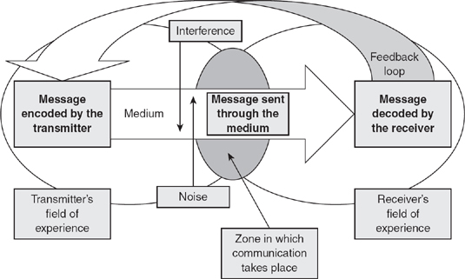
The most commonly taught and widely used theory of communication is that proposed by Wilbur Schramm in the late 1940s. The Schramm model views communication as a process that takes place between a sender (transmitter) and a receiver: there will be also a message, and a medium through which the message can be transmitted (Schramm, 1948). (Blythe, 2009)
One of the issues many businesses fall into is to communicate from ‘our perspective’, not through a two-way communication. Businesses need to think about what team member care about. Some of us believe mistakenly that everyone else thinks as we do, so if we want to get a get certain information via email everyone wants it that way and the reality is that is not the case. Some people think as we do, others think differently. So being successful at moving staff members to action is thinking about what team members care about and framing our communication so that it is audience focused. It is as if we want to get into the heads of what team members think, so we can think like they do; so, we can adjust our message to best match our audience. The principle to take note of is the more I know about you and what you think; the more I can persuade, motivate and move you to action. Remember what the goal is, shared understanding leads to action. This can sound very simple, but many businesses fail to establish an effective two-way communication and cause many harms to the business.
Two-way communication creates a healthier environment, where staff members can share their ideas, opinions and thoughts, regardless of their position in the business, and improves relationships right across the business.
Effective two-way communication is required in order to solve problems better. It helps everyone understand the business better and creates better relations throughout the company by ensuring everyone is engages with the latest business updates, objectives, and progress.

Effective methods of communication

Significance of non-verbal communication

Action Plan
Action | Cost | Responsibility
Intranet – Microsoft 365 Business | £15.10 + VAT per month | Sarah Davis
Video conference – Webex | £11.25 per month | Sarah Davis
Video conference - Skype | Included in Microsoft 365 Business | Sarah Davis
PA systems - Tannoy | £159.00 | Sarah Davis
Website – design and maintenance | £480 one off  £40 per month | Sarah Davis

The colleague on maternity leave, I advise she is provided with a tablet device – so she can participate in monthly team meetings. These meetings should be She can also keep herself update on
Conclusion

References
Bhatt, R (2013) ‘Tips for Effective Communication Skills’, Indian Journal of Applied Research, 3(1) p.83
https://www.worldwidejournals.com/indian-journal-of-applied-research-(IJAR)/file.php?val=January_2013_1357046079_cf1fd_32.pdf

Blythe, J (2009) Key Concepts in Marketing 1st Ed. Plymouth: SAGE Publications Ltd

http://dx.doi.org/10.4135/9781446221617.n46

Appendix

