[Document title]

Children, Young People & Families

1. Umar Bilal Rahman
2. Student ID: 2018610
3. Module code: BMhp5004
4. Assignment: essay
5. Lectures Name: Dr Muhammad Hossain

Table of contents

- Introduction……...…2
- Main body.……….…3
- Analysis………….….4
- Assess…………...….5
- Conclusion……….…9
- References…………10

Introduction:

The essay will give readers an understanding how covid-19 impacted children and young families. Readers will get an understanding into how implementing safeguarding measures have been put into place for children and families. Critically discussing the crises which covid-19 had on communities. Furthermore, research which was taken to ascertain how multidisciplinary teams with policies responses with how they function. One will examine how health services have given development methods of well-being for children, and families.
There will also be a discussion over how the procedures of safeguarding children or neglect, preventing impairment of his\her growth and wellbeing, and order to ensure that those who grow up in circumstances that allow them to have the best possible life chances and enter adulthood successfully includes the provision of safe and effective care.
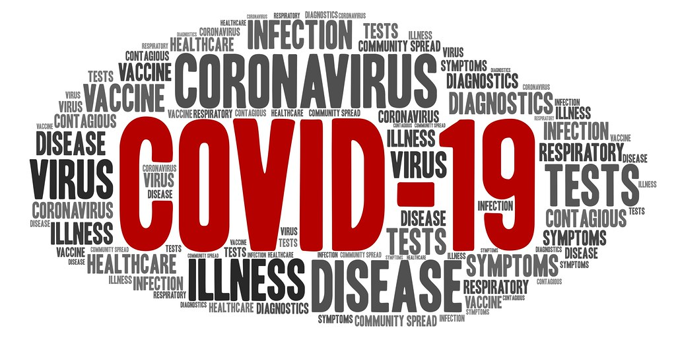
Therefore, finalising this essay will show how some theories can be implemented to help development an improvement. Frameworks cycle for children services will also be discussed along with Freud's stages of development for young children. This will be a separate topic to finish off this essay, alternatively one will be talking about how challenges children’s young people and families are facing in the UK. Providing the information, the reader can make sound judgement to get a clear understanding what the challenges have been in the COVID-19 pandemic with the impact it had people hello young and old.

Main body:

To begin, in this section of the article discussing child and family safety concerns during the COVID-19 crisis, the wellbeing of children must be a top priority, and parental responsibility is the right of parents to provide adequate support for children. furthermore, local authorities we are no longer being implemented due to safety concerns this was impeding children and families who needed to be safeguarded and whose welfare needed to be promoted throughout the pandemic?
Research has proven the risk of children from sexual abuse, and related mental health problems in the COVID-19 pandemic along with risks for child protection, due to UK having the highest Coronavirus death rates in Europe while the pandemic clearly posed a risk to the lives in well-being of vulnerable groups. Public health measures taken to delay or limit the spread of the virus had led to having distinctive challenges for prevention family support, court process, placement, and alternative care.

According to (Bhopal, 2021). The pandemic has also come about at a time when statuary changes to partnerships had led to a reduction in the importance of educational professional representation with new formulations in England and Wales. However, there have been concerns voiced that essential social separation and, in specifically, lockdown measures are having harmful, often unanticipated, repercussions for children and young people's health and well-being. "Collateral harm" has been coined to describe these effects.

Measures to combat the COVID-19 pandemic have been claimed to increase the risk of a secondary pandemic of child neglect and abuse. While family frustration is high and families are confined to the home, the children's commissioner for England has expressed concerns throughout government those children are at higher risk of abuse and neglect during the epidemic. Social services, schools, and other government and non-profit organisations are less able to maintain frequent touch with children who are known to them.
Risk factors for children and families during covid-19 pandemic:
- Poverty
- Abuse and harm to children and other family members
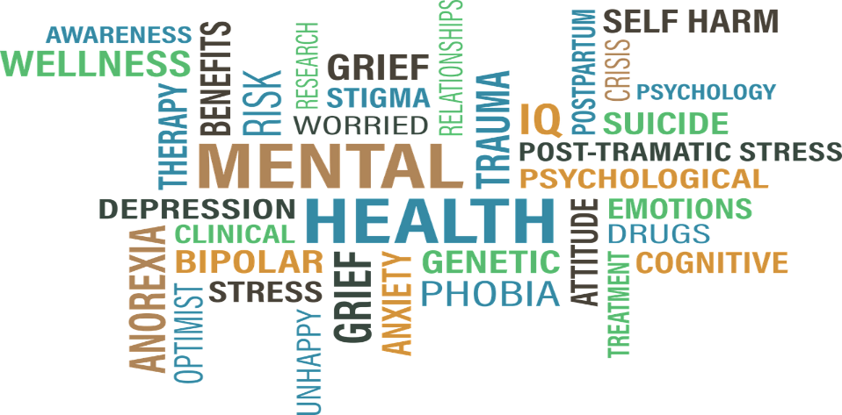
- Domestic abuse
- Substance abuse
- Neglect
- Children with additional needs
- Exploitation
- Reduction in services
- Online grooming
- Mental health
- Sexual harm
- Housing insecurity
- Basic essentials insecurity

Above some analysis of risk factors during the covid-19 pandemic Have been outlined so one who is reading this paper can get an understanding of what children and families Could be in harm of. The impact of this disease in his early days were not known to the world in effect people did not understand the severity and how quickly one can get overwhelmed with this disease this led to an high number of fatalities and hospital admissions.

Furthermore, the effects on children's long-term health and security, as well as what steps can be taken to mitigate this impact in the future. Increases in poverty were linked to increases in housing insecurity, and food insecurity was a prominent contributor throughout the pandemic, according to the findings. This featured an increase in world poverty.


School closures, for example, have had a disproportionate impact on those enduring severe social determinants. According to (ScienceDirect, 2022). During the pandemic, there has been a significant increase in reports of abuse-related injuries and other injuries that are symptomatic of child abuse. Furthermore, COVID-19 has vastly greater effects based primarily on disadvantage children’s and families. It is obvious that as a result of the epidemic, children are exposed to more unfavourable factors, with both short- and long-term consequences. Lage number of families resulted in having to use food banks in the local communities some members of their families and especially children could get a meal in the day. Many families depended on school dinners to feed the children but as a result of the pandemic school closures meant the other means of providing lunches and dinners became a challenge for parents.

According to (Noemi, 2020). “Covid-19 has posed
major challenges to societies all over the world.”
While efforts to contain the virus are vital to protect
vulnerable children and disadvantaged families,
with health issues such as obesity, asthma, along
with poor diets and other underlying health issues
which may be a factor to cause serious illnesses in children.

- Safeguarding Policies for children and families during the coronavirus crisis:
During the Covid outbreak, rules were put in place to protect children and their families. Schools and colleges will have a robust child protection policy in place that reflects normal operations. This should have already been updated to reflect the coronavirus response. When you're pretending to move, it's a good idea to think about doing some more research. A coronavirus annex/addendum may be required in specific instances. That summarises any significant modifications linked to the Coronavirus and are therefore more comprehensive than incorporating and reissuing the entire policy. The revamped child safety strategy should take into account the increased number of youngsters returning to school.
- Ensure that all children at risk I reached with an offer of help.
- Ensure that all vulnerable children are supported to go back to education’.
- Put experiences of children and families at the heart of future responses.
- Be ambitious in national policy changes.
- Ensure multidisciplinary teams don't have low visibility of children during lockdown.
- Degree of safeguarding oversight is maintained in the community.
- The NSPCC Service helpline is available for the public to raise concerns, children.
- Charity ChildLine, Is available for all children to access For help.

According to the (ncb.org.uk). “The recovery plan-safeguarding and child protection and welfare system”. Support in establishing local recovery plans in place, detailing the significant implications of COVID-19 on protecting children in the areas and specifying ways to address them?
A standardised recovery plan for vulnerable children is required, backed by adequate long-term investment to adjust systems and allow local governments to restructure ability to spend toward elevated prevention strategies services and intervention programs, as well as to address the issue of children's social care being underfunded prior to the pandemic's onset.

Education settings are the source of a large proportion of new referrals to children's services. Referral units for most children and families have closed. Lecturers and other professionals have less opportunity to recognise and support children who are victims of abuse, neglect, or exploitation, which could lead to new problems. Statistics have shown 15% of all children and young people after the pandemic had a social worker, data showing this was 47,000 Children and young people who were classified as “Children in need”.

- Multidisciplinary Nature of health services in relation to children and families:
According to (Holmes, 2020). “Multidisciplinary teams are made up of people from many professions who work together to diagnose, treat, and plan for children and families who are receiving health and social care services”. When specialists from many disciplines collaborate to provide complete treatment that addresses as many of a patient's requirements as feasible, this is referred to as multidisciplinary care. To redefine, re scope, and reconceptualize health and social care delivery difficulties, multi-agency working requires effectively utilising knowledge, skills, and best practise for multiple professions across service provider borders, integrated care or volunteer and private sector providers. According to (Koller, 2010). Parents might have supplied crucial information about priorities, strengths, and child needs, as well as information regarding the cultural and developmentally appropriateness of goals and intervention measures, during the pandemic.
The pandemic has outline multidisciplinary teams could treat entire patients and provide comprehensive care. With each physician focus on a different aspect of the patient’s health, provided a more likely to identify areas of need and subsequently manage those needs in an effective way and could also identify vulnerable children in need of attention due to neglect or abuse. According to (Stawicki, (2020). Multidisciplinary teams a vital for service users in the community specially identifying obesity and other health issues which could subsequently lead to hospitalisation due to coronavirus.
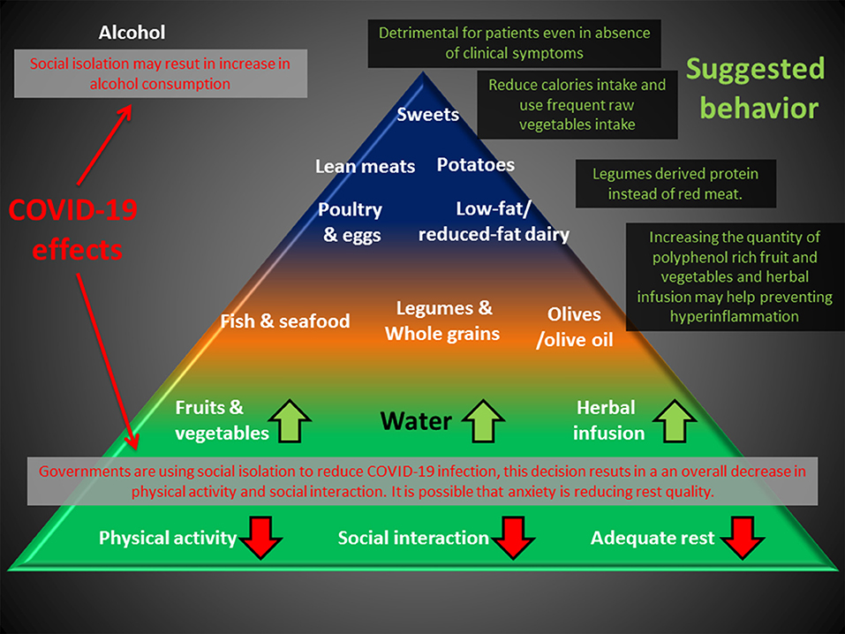
According to the National Institute of health and care excellence (NICE). Many multidisciplinary teams have described the symptoms of “Long COVID” The symptoms can be described as physically and mentally draining and challenging for patients and cannot be explain by alternative diagnosis. Doctors and nurses have described patients who find it challenging and straining just to even climb the stairs in their home. Patients who do not require hospitalisation have mentioned the symptoms of “Long COVID These are members in the community They haven't had any inpatient care at hospital.

- Social construction of childhood and family:

In health and social care family systems theories are used by medical professionals to evaluate the social aspect of sickness. Individuals and organisations create their own perceptions of reality, according to social constructionism, and better understanding is a matter of individual characteristics.

Social constructionism can assist us expand policy debates and decisions by providing a crucial counterpoint to medicine's largely conventional methods to sickness and illness. Once you've grasped the concept of wellbeing awareness as a social construct, you'll notice that a person's current understanding of health is strongly affected by their socioeconomic status, which creates awareness, work opportunities, and standard of living, as well as their social cultural social standing, which includes relatives, colleagues, the information providers, faith, society, and social and political environment.
Childhood is defined as a period of innocence, widely recognized find it hard to understand, whereby babies require parental safety and wellbeing for the reason that of their cognitive and psychosocial vulnerability. According to Freud's psychosexual theory, a child's growth takes place in a sequence of stages. The child's body is focused on several pleasure zones.
Furthermore, Freud’s theory suggested the importance of early childhood experiences and the events in early childhood have a great influence and our adult lives, shaping our personality these events that occur in childhood can remain in the unconsciousness, and cause problems as adults according to Freud all children go through the same five stages of development oral, anal, phallic, latency, and genital.
Psychodynamic theory stresses relationships between family members particularly Immediate members of the family, suggesting parents particularly is very important and paves the wave for a healthy functional development of a child In the early stages.
According to the UN Convention rights of children (1989.). Views of a child and subsequently listening to children’s rights of expression is paramount for them to have a voice to be heard.

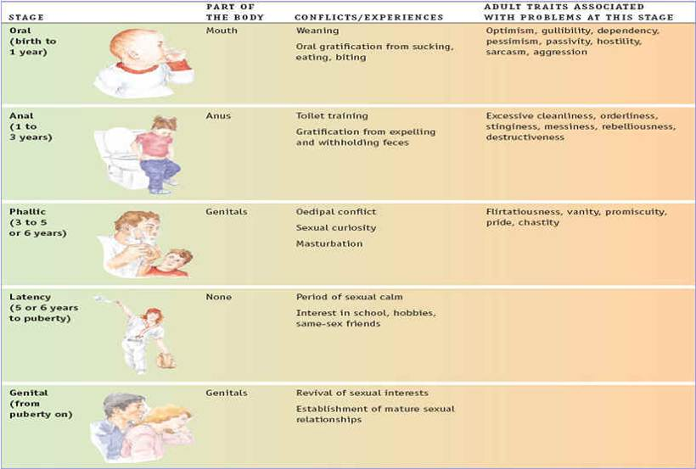

- Example of safeguarding concerns:
According to (Buheji, 2020). During the pandemic development of children became a real concern for children who are classed as vulnerable. Due to the lockdown rules relatives, family members, friends and family could not associate with each other this led to Many children being neglected and abused but adults who was supposedly meant to look after them.
One such case came into light in Birmingham was the case of Arthur Labinjo Hughes who was six years old. On 16th of June 2020 this child was severely beaten by his stepmother this was at the time when the first national lockdown rules came into place. due to social distance rules immediate family could not come and visit so the scale of his injuries and severity of his abuse was missed.
The following day June the 17th due to the prolonged Period of violence Arthur suffered a campaign of intimidation, and torture the child passed away in hospital. The case highlighted how COVID-19 restrictions gave a loophole for families which meant to be under supervision. this led to social services and other safeguarding agencies having to play catch up when lockdown rules will eased.

Analysis:

Analysing this essay has shown during the COVID-19 pandemic children and families had to adapt to a post-apocalyptic type of situation which nobody has so coming. The situation can be likened to the Spanish flu epidemic which occurred in 1918-to 1920. The Pfizer vaccine was the first to be administered from the Food and Drug administered (FDA). The vaccine was distributed globally in under one year. This was no small feet and helped to lower the death rates in hospital all over the world. Cooperation between multidisciplinary teams and people living in the community helped the country to get out of lockdown rules. face masks a social distancing became the norm, living with the pandemic And adapting The methods of self isolation and working from home has helped many families and children required the education which is so urgently needed. Educational institutes and young people have Had to adapt the strategies Legislation's which required To evaluate the guidelines And teaching policies.
Social obligations where detrimental for everyone Living with the crisis coronavirus. The mental well being and safeguarding of children and young people is of paramount important, Solutions therefore have been put into place for society. Government funding is important for service users and providers now that we have one has to live with COVID-19 as we live with the flu. Alternatively Communities coming together to support one another and the resilience of young people and children will hopefully help us to get through this crisis that took the world by storm in a matter of months.

Conclusion:

Subsequently reiterating and moving on to consider the conclusion to this paper one has to understand that COVID-19 is still rearing its head up as days go by. Even though society has learned to live with the lockdown rules and social distancing, one was clearly understood the children and young people have had the biggest impact undereducation and therefore their lives. Learning to live and adapting to the coronavirus and now all young people I started to receive the vaccine, The impact UN children’s mental state and well-being will in time arguably prioritise safeguarding of children. Families who have had to use food banks just to get by Therefore adapting How coronavirus has changed lives globally. Furthermore, this pandemic has shown systematic failures from authorities and even service providers with people having to wait for cancer and other treatments. multidisciplinary teams and their contribution to healthcare sector have given patients much needed relief in their care. Improving medical facilities and aiming to provide the best care possible for children and families For the well-being and safeguarding roles that social workers provide, with the collaboration of all these teams the best care possible can be provided two people from all walks of life. Learning to live with coronavirus and avoiding by the rules and policies have kept his safe. Education providers must have the knowledge to notice any changes or abnormalities with the children and young people who learning is provided for. one hopes the essay which has been written gives an insight into the crisis which occurred in the last two years and this has still not gone away. Furthermore, it has shown the reader what challenges children and families faced during the pandemic, and the roles of multidisciplinary teams and some frontline workers.

References:
Abrams, E.M., et al (2022). The COVID-19 pandemics: Adverse effects on the social determinants of health in children and families. Annals of Allergy, Asthma & Immunology, 128(1), pp. 19-25. (Accessed: 02 April 2022).
Adams, E.L., et al (2020). Food insecurity, the home food environment, and parent feeding practices in the era of COVID‐19. Obesity, 28(11), pp.2056-2063. (Accessed: 07 April 2022).
Bhopal, S., Buckland, A., McCrone, R., Villis, A.I. and Owens, S., (2021). Who has missed? Dramatic decrease in numbers of children seen for child protection assessments during the pandemic. Archives of disease in childhood, 106(2), pp.e6-e6. (Accessed: 05 April 2022).
Buheji, M., et al (2020). Children and coping during COVID-19: A scoping review of bio-psycho-social factors. International Journal of Applied Psychology, 10(1), pp.8-15. (Accessed: 08 April 2022).
Davis, C., Fraser, J., and Walter, D. (2019). Establishing a framework for listening to children in healthcare. journal of child health care: For professionals working with children in the hospital and community, Available at: https://doi:org/10.1177/1367493519872078 (Accessed: 08 April 2022).
Garcia, J. L. (1995). Freud's psychosexual stage conception: A developmental metaphor for counsellors. Journal of Counselling and Development: JCD, 73(5), 498. Available at: doi:http://dx.doi.org.une.idm.oclc.org/10.1002/j.1556-6676.1995.tb01785.x (Accessed:08 April 2022).
Guessoum, S.B., et al (2020). Adolescent psychiatric disorders during the COVID-19 pandemic and lockdown. Psychiatry research, 291, p.113264. (Accessed: 07 April 2022).
Henderson, C., et al (2022). Supporting children experiencing family violence during the COVID-19 pandemic: IPV and CPS provider perspectives. Academic paediatrics. (Accessed: 02 April 2022).
Holmes, E.A., O'Connor, R.C., Perry, V.H., Tracey, I., Wessely, S., Arseneault, L., Ballard, C., Christensen, H., Silver, R.C., Everall, I. and Ford, T., (2020). Multidisciplinary research priorities for the COVID-19 pandemic: a call for action for mental health science. The Lancet Psychiatry, 7(6), pp.547-560. (Accessed: 01 April 2022).
Koller, D., Nicholas, D., Gearing, R. and Kalfa, O., (2010). Paediatric pandemic planning: children’s perspectives and recommendations. Health & social care in the community, 18(4), pp.369-377. (Accessed: 06 April 2022).
Levine, D.T., Morton, J. and O’Reilly, M., (2020). Child safety, protection, and safeguarding in the time of COVID-19 in Great Britain: proposing a conceptual framework. Child Abuse & Neglect, 110, p.104668. (Accessed: 06 April 2022).
Masten, A.S. and Barnes, A.J., (2018). Resilience in children: Developmental perspectives. Children, 5(7), p.98.(Accessed: 02 April 2022).
National Institute Care Excellence (2021) COVID-19 rapid guideline: managing the long – Nice Available at: https://www.nice.org.uk (Accessed: 06 April 2022).
Parkin, A., et al (2021). A Multidisciplinary NHSCOVID-19 Service to Manage Post-COVID-19 Syndrome in the community. Journal of primary care & community health, 12, Available at: https://doi.org/10.1177/21501327211010994 (Accessed: 04 April 2022).
Pereda, N. and Diaz-Faes, D.A., (2020). Family violence against children in the wakeof COVID-19 pandemic: a review of current perspectives and risk factors. Child and adolescent psychiatry and mental health, 14(1), pp. 1-7. (Accessed: 04 April 2022).
Rogers, B.H., (2020). Tips for helping kids cope during COVID-19 pandemic: [Video] Available at: 4678 hello 12 https://youtu.be/fWCZTkrO2SU (Accessed: 05 April 2022).
SAGE journals (2021) A multidisciplinary NHS VOVID-19 SAGE Journals available at: [web] https://journals.sagepub.com (Accessed: 01 April 2022).
Stawicki, S.P., (2020). The 2019–2020 novel coronavirus (severe acute respiratory syndrome coronavirus 2) pandemic: A joint american college of academic international medicine-world academic council of emergency medicine multidisciplinary COVID-19 working group consensus paper. Journal of global infectious diseases, 12(2), p.47. (Accessed: 07 April 2022).

