To Infinity OR Beyond?


Is it possible to change the outcome of situations? Can we break the cycle or are we in a constant cycle with a never-ending repeat of situations with no way out? Can we change our fate or are we doomed forever in insanity?
“Insanity is doing the same thing over and over and expecting different results.” Rich (2021)
According to Albert Einstein, repeating an action and expecting different results is the definition of insanity and personally I would agree, would you put your hand on a hot stove and think you won’t get burnt? No. However with intense research there is a way to change the cycle. Reflection. Reflect on your actions, thoughts and feelings of past events and analyse each one in order to learn from them and change the outcome of any situation that arises, whether that is personally, professional or academically.
“Reflective writing requires you to think deeply and write about an experience, event or course content.
This involves writing about:
- What happened (positive or negative) and what you personally learned from the experience.
- What it means, and how it changes the way you think or understand something.
- What you can change or how you can apply the new learning in the future.” RMIT (n.d.)

The best way to reflect on situations is to ask yourself questions, spot any patterns in your actions or thoughts and identify the links between them that could lead to similar outcomes of future experiences.

“When you see a pattern, it can change your life. Seeing a pattern can even make you smarter. Recognizing a pattern is like looking through a telescope for the first time. As if with new eyes, you see things that you have never seen before.” Robert C. Barkman Ph.D. (January 18th 2018)

We need to think critically, to analyse everything we see and hear, to make an informed decision of our own. Reflecting in an academic setting helps you to understand and question your own personal goals and limitations, Can I achieve this? Could I do better? What is stopping me? Everyday life experiences are times on which we could reflect on, the ups, the downs and the shoulda woulda coulda moments that life continuously brings.
“For many people, there is a clear distinction between what actually happened and what they wished would have happened in a given situation. Sometimes, people realize a number of options they could have or should have taken instead of the action they actually took. This feeling of regret or second-guessing is summed up in the expression woulda coulda shoulda.” Michael Pollick(2023)
Us Humans need to be more reflexive in life’s moments, to be more openminded to our previous influences and experiences, in order to make better informed decisions for ourselves. What lead us down the path that resulted in the end result and what would we do to change it for the better in order to grow academically, professionally and personally. The constant questioning of one’s actions, thoughts or feelings will enable us to build a stronger more resilient way of looking at the world and of life’s scenarios.
“SRA is a “meta-cognitive” ability, meaning that it involves thinking about and reflecting on one’s own mental processes.” Gregg Henriques Ph.D (2016)

There are two types of reflection of one’s actions and view of the world, locus of control, the internal locus of control and the external locus of control. Are your actions already predetermined to fate or are you the master of your own destiny and can make your own luck.

In my conclusion to are we in an infinite recurring cycle with the same outcome, No. Ideally a person needs to believe in both fate and changing of your own luck, you could strive for better if you chose, work harder and more efficient to achieve your ultimate goal, however somethings are just meant to be and completely out of our control, but it’s the reflection of ourselves that could make the biggest change by the smallest question.

Gregg Henriques Ph.D (2016) Self-Reflective Awareness: A Crucial Life Skill https://www.psychologytoday.com/us/blog/theory-knowledge/201609/self-reflective-awareness-crucial-life-skill (accessed 15/01/2023)

Michael Pollick (January 15th 2023) What does “Woulda Coulda Shoulda” Mean? https://www.languagehumanities.org/what-does-woulda-coulda-shoulda-mean.htm (accessed 15/01/2023)

Rich (November 22nd 2021) Albert Einstein’s Definition of insanity changes everything https://hashimashi.com/albert-einsteins-definition-of-insanity/#:~:text=Einstein%E2%80%99s%20classic%20definition%20of%20insanity%20is%20%E2%80%9Cd%20oing,repeating%20the%20same%20mistakes%20and%20expecting%20different%20results.%E2%80%9D (accessed 14/01/2023)

RMIT (no date) Writing an academic reflection https://emedia.rmit.edu.au/learninglab/content/writing-academic-reflection (accessed 14/01/2023)

Robert C. Barkman Ph.D. (January 18th 2018) See the World through patterns https://www.psychologytoday.com/us/blog/singular-perspective/201801/see-the-world-through-patterns (accessed 14/01/2023)

Time Management is a key skill to possess, especially within an academic setting. The ability to set tasks to benefit you to ensure that targets are met by a particular deadline. S.M.A.R.T. goals can be beneficial to students to ensure time management is being used to its full potential. Specific, Measurable, Achievable, Relevant and Time. “First, a S.M.A.R.T. goal helps to give you an objective. In doing this, you are able to identify strengths and weaknesses. Second, a S.M.A.R.T. goal provides motivation to succeed. When you know where the goal line is, you’ll want to work to meet or beat it. Third, a good S.M.A.R.T. goal, while attainable, will also be challenging and force you out of your comfort zone.” Forbes (2022).
Specific, being able to keep on the specific task and topic will help with Time Management, as not to wonder off topic and knowing exactly what you want to accomplish. The measurable element within Time Management, could be to improve your final grade or to achieve a pass. Setting your task to be able to determine and measure the progress of your goal. All goals set should be achievable to the student, having the correct equipment and tools, breaking down the assignments into manageable time frames to be able to achieve completion of the work and to be inspired and motivated in developing new skills. Another focus of time management is the relevancy of the work to the student e.g., to graduate, appropriate to current work placement or career goal. Time bound, does the student have enough time to be able to complete the assignments by the set deadline? Goals that lack realistic timing are more than likely going to be unsuccessful. All SMART GOAL points are the key factors for good time management. “Setting SMART goals means you can clarify your ideas, focus your efforts, use your time and resources productively, and increase your chances of achieving what you want in life.” Mind Tools(2022)
Many students within an academic setting struggle with time management due to procrastination, delaying a task until last minute or past deadline despite the consequence, due to it being boring or unpleasant. “One of the biggest factors contributing to procrastination is the notion that we have to feel inspired or motivated to work on a task at a particular moment.” Verywell mind (2022). Overestimating on time length left to complete assignments, future motivation and frame of mind, underestimating how long a task will take to complete are all factors into procrastinating assignments. There are two types of Procrastinators, Passive and Active. Passive procrastinators are people that have trouble making decisions therefore results into delayed tasks, whereas Active procrastinators are people that delay tasks due to working under pressure, making them feel more motivated to complete the task at hand.

Good time management is to set and complete tasks effectively without disruption and by prioritising work by their importance. “complete simple tasks first, try getting them out of the way before moving on to tasks that require a lot of focus. This can help to alleviate some of the pressure by checking a couple things off your to-do list “ Lian Parsons (2022). Focusing precious, valuable time on tasks that are essential and reducing time on non-essential tasks will ensure the completion and accomplishment of tasks at hand, being able to give your full attention and focus where it is needed. “Time management is inclusive of orgainizing, aligning, productivity, objective, goals, saving time and accomplishing what you had in your checklist of to-dos.” Dr. George G. Tumanishvli (2021)

The good first tip for good time management is being realistic with how much time you are able to spend on studying and working on assignments, also taking into consideration the timing of the day and when is best for you to maximise your potential. Secondly, avoiding distraction is another key element to the completion of tasks and another good practise of time management. Preparation of study time and assignment writing will be beneficial and reduce any stress or procrastination, being able to focus on the set task. Creating a schedule will help to control learning and completion of work, a clear way to maintain focus. Rewarding yourself is a positive way to encourage the completion of a task, ensuring your well being is at a high to enable you to reach your full potential, as any academic setting can be extremely stressful. Allowing short intervals whilst learning and social time, will ensure you to maintain your focus. “Time management isn’t just about getting work done. It’s also about ensuring that you can put yourself and your mental wellbeing first.” Lian Parsons (2022)

In conclusion to obtaining good time management skills, you benefit from increased efficiency and productivity and gain a sense of achievement and fulfilment within your academic career. It also improves self-discipline and helps to destress and decreases the risks of procrastination whilst working. Mainly it improves the ability to make quality, rational, educated decisions in all areas of both personal and professional life.

References
Dr. George G. Tumanishvili (2021) What is Time Management https://time-management.org/what-is-time-management/ (accessed 22nd November 2022)
Kendra Cherry (2022) What Is Procrastination https://www.verywellmind.com/the-psychology-of-procrastination-2795944 (accessed 22nd November 2022)
Kimberlee Leonard, Rob Watts (2022) The Ultimate Guide to S.M.A.R.T. Goals https://www.forbes.com/advisor/business/smart-goals/ (accessed 22nd November 2022)
Lian Parsons (2022) 8 Time Management Tips for Students https://summer.harvard.edu/blog/8-time-management-tips-for-students/ (accessed 22nd November 2022)
Mind Tools (2022) SMART GOALS https://www.mindtools.com/a4wo118/smart-goals (accessed 22nd November 2022)

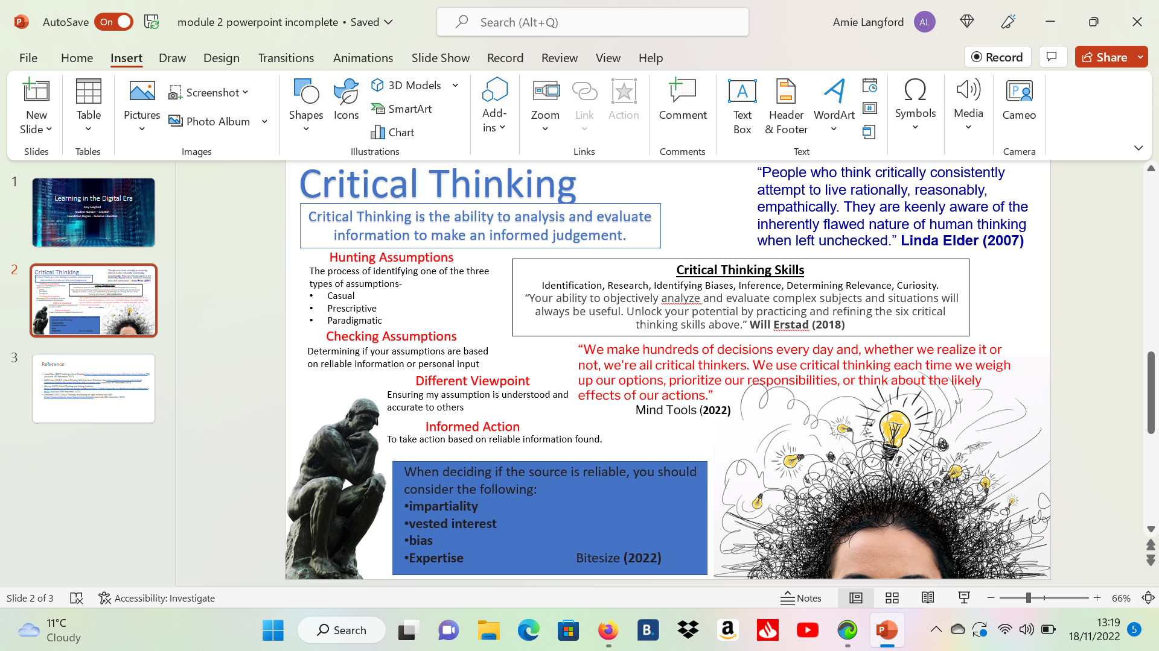

References
Bitesize (2022) Critical Thinking and Solving Problems https://www.bbc.co.uk/bitesize/guides/zcjhfcw/revision/11https://www.bbc.co.uk/bitesize/guides/zcjhfcw/revision/11 (accessed 18th November 2022)
Linda Elder (2007) Defining Critical Thinking https://www.criticalthinking.org/pages/defining-critical-thinking/766 (accessed 15th November 2022)
Mindtools (2022) Critical Thinking, developing the right mindset and skills https://www.mindtools.com/a3ixqae/critical-thinking (accessed 18th November 2022)
Will Erstad (2018) 6 Critical Thinking Skills You Need To Master Now https://www.rasmussen.edu/student-experience/college-life/critical-thinking-skills-to-master-now/ (accessed 15th November 2022)

