Paula Smith 1903588 HPHP4019 Quentin Drew. Due 19/12/21.

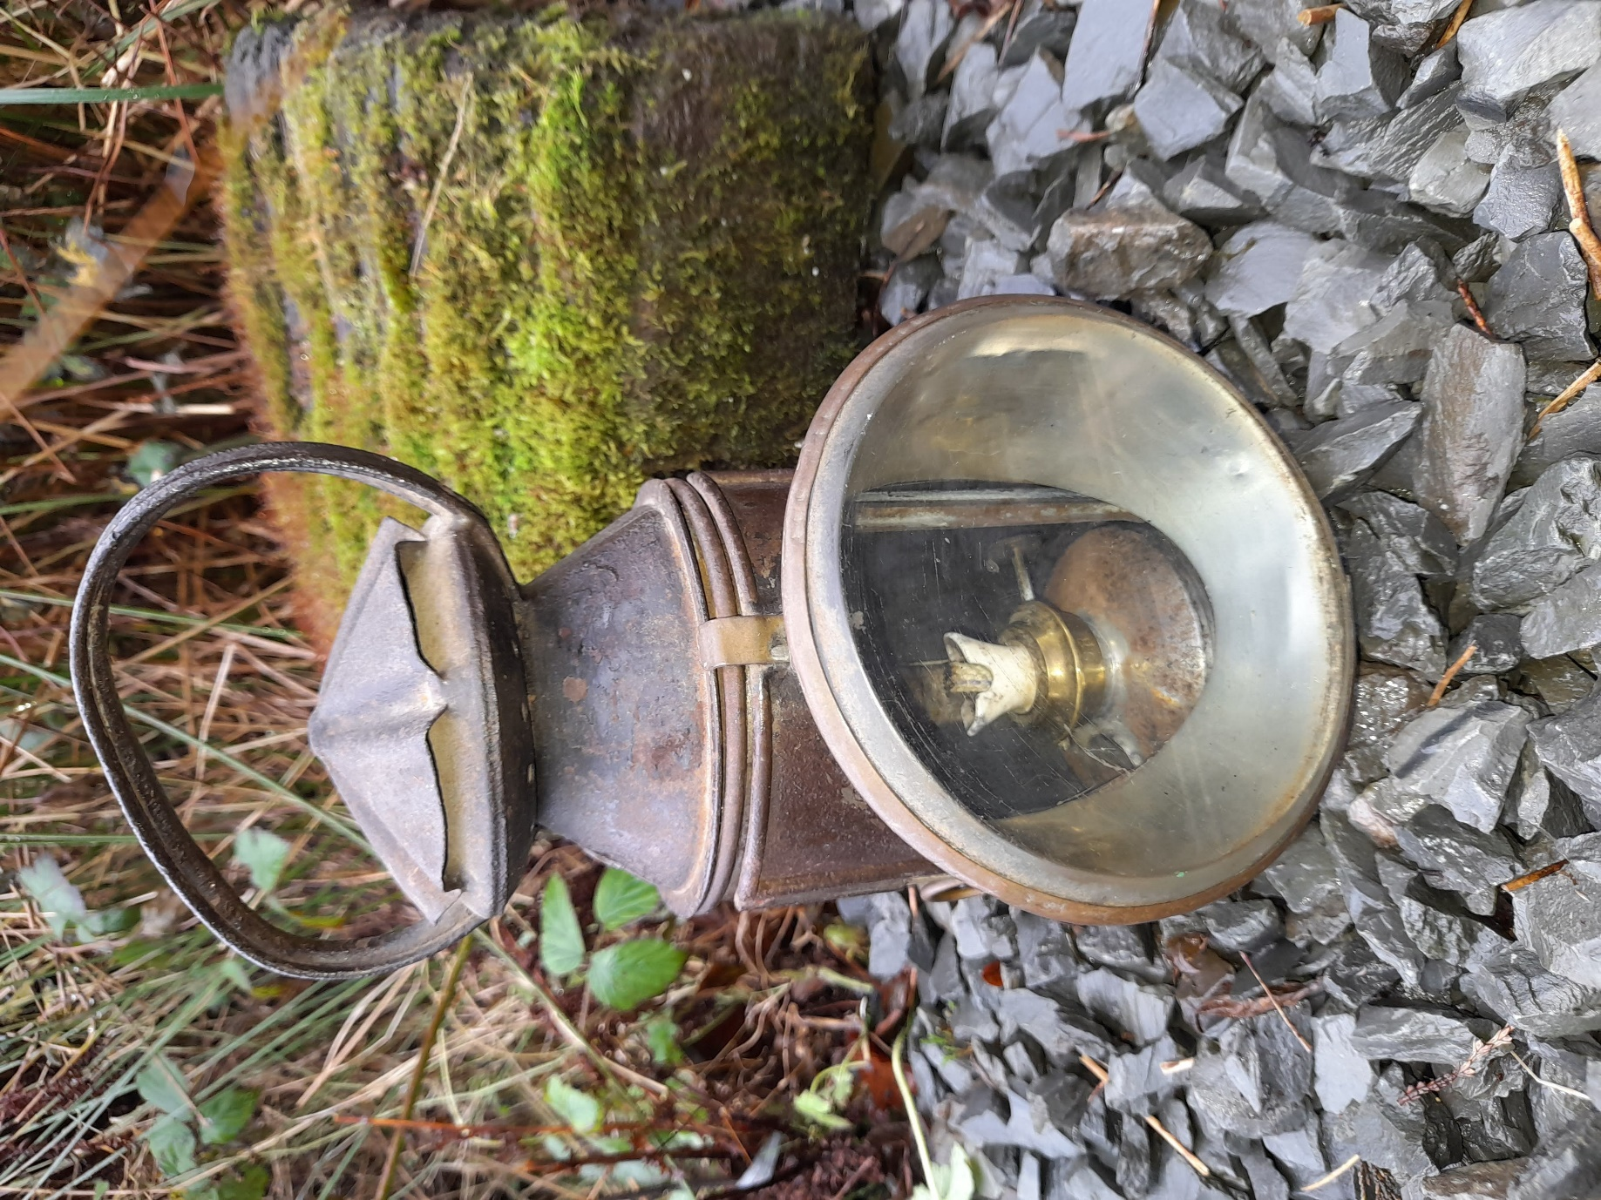
Victorian Railway Signal Lamp and railway sleeper. Picture by author 2021

DISPLAY
The lamp should be displayed as if in use, by the side of a railway sleeper. The gravel and sleeper give it scale; the outdoor rough conditions communicate the durability. The scene should be set on a waist high plinth to allow close inspection, without screens. The impression is of a small, everyday tool with hidden importance for safety. It could be lit with a red light.
SIGN.
A paraffin Railway Signal Lamp, used between 1833 until the battery Bardic lamp replaced it in 1962.This lamp is from the London and South West Railway and was manufactured between 1838 and 1922.
ADDITIONAL INFORMATION
- This lamp is 26cms high and 12cms wide, and weighs 1180g as it is.

- “The lamp will probably be made of brass or possibly copper and you can see that it has a soldered construction much as nearly all gas lanterns have.” says Chris Sugg, grandson of the inventor of the Sugg’s Lamp .

- L&SWR is engraved on the body of the oil reservoir. This company ran from 1838 until 1922, when the railway became Southern Railway after the Railways Act passed in 1921. This dates this lamp prior to 1922.
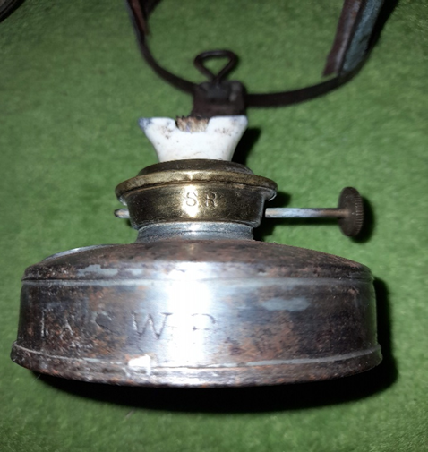
L&SWR. on oil reservoir. Picture by author 2021.
- The interior should have a mirror behind the lamp and have three curved glass lenses in the sleeve of red, green and clear glass. These are not present. It is designed to be carried, and the curved glass lenses could be rotated to show white, green or red light.

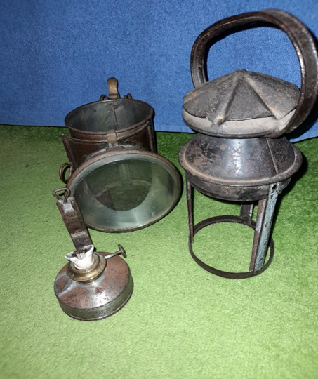
Interior parts of the lamp. Picture by author 2021.

MANUFACTURE.
- A similar lamp was made in London by William Suggs & Co, for the Great Western Railway, the main competitor to L&SWR. The two rail companies fought for supremacy in a battle that became known as the Gauge war, as they used different widths in the tracks. This battle continued until the Regulating the Gauge of Railways Act 1846 .
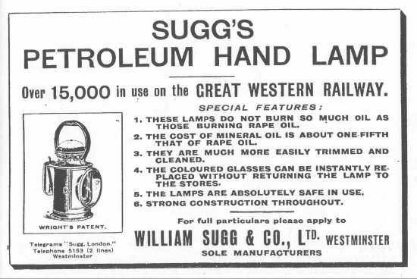
Picture courtesy of Chris Sugg.
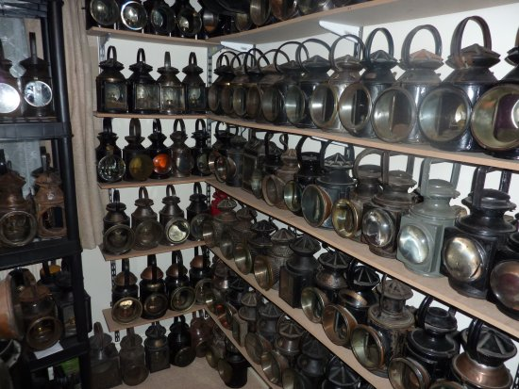
Collection of lamps by Kevin George. Picture courtesy of Chris Sugg.
- William Sugg was already making lamps for homes and streets and had experience with keeping a flame alight with ventilation. As his grandson Chris Sugg tells “… the company was paid for the design so that the railway had free use to have it made wherever they required” . This style of lamp was therefore popular as in their design the coloured lenses could be easily replaced by a railwayman. The flame was reliable, and the oil lasted a long time, not smoking up the glass as much as previous lamps . This style of lamp was manufactured by several companies, the basic pattern remaining the same and remained in use until the battery run Bardic Lamp became more popular in the 1960’s .
- The lamps were manufactured by hand, in workshops. An image below shows such a workshop that had adapted to manufacture components during the First World War.
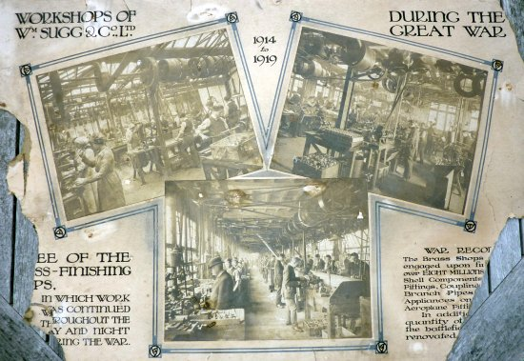
Picture courtesy of Chris Sugg.
- After posting information requests on social media, some personal stories of using these lamps have emerged. They were an everyday piece of equipment as Ray Hall, a railwayman on Southern Railway tells “…. all signals were lit by paraffin lamps, and guards and shunters used these handheld lamps to give instruction to drivers at night. They could burn continuously for a week, and only a very strong wind would blow them out. All signal boxes had one in case the main lamp on the signal went out” . He also remembers “ …. when I was on lamp filling duty, (I) was up a Home signal at Cowley Bridge Junction when a swarm of bees decided to congregate on the pole just below me, couldn’t go up or down, after an hour I managed to attract the attention of the driver of an incoming train, who reported my predicament to staff at St David’s. After about 2 hours stuck up there a beekeeper arrived and collected the swarm and I was able to climb down, that was a long working day as I had to catch up the rest of the days lamp maintenance”.
PERSONAL CONNECTION.
- This lamp was given to me by my grandad. I used to listen to his stories, when we visited, and sit in his shed with him. Everything was painted with thick Railway green paint, bought home from work, and it was an Aladdin’s cave. He gave me the lamp, along with other items from his many boxes. Some things were taken away, such as the long Turkish knife and the belt buckle cut off a dead soldier, but I did get to keep this lamp.
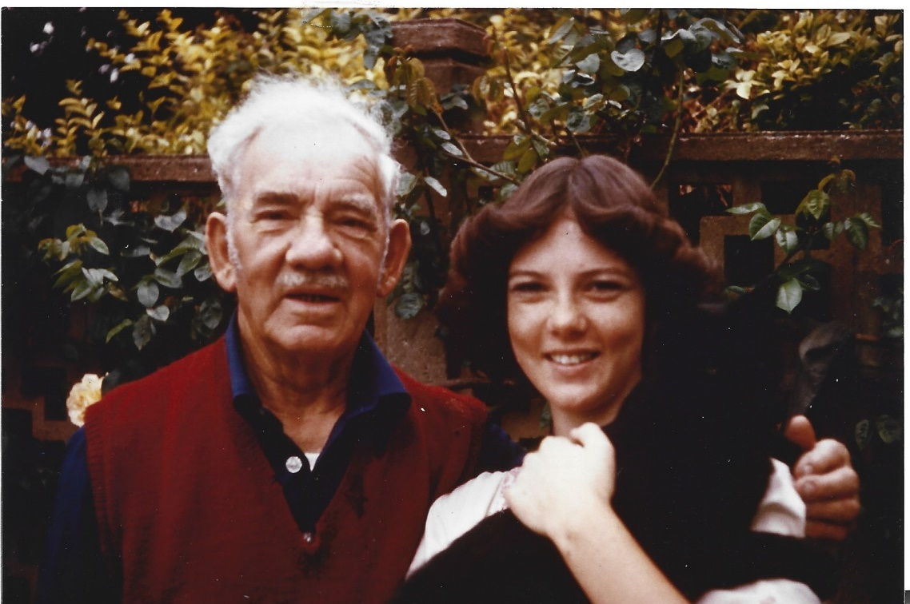
Sam Smith and author. 1977. Picture property of Smith family.
- After returning from the First World War, Granddad worked on the railway, initially shovelling coal into the engine, from London to the West Country and back. He worked on the railway all his life and retired after achieving Chief Inspector at Exmouth Junction.
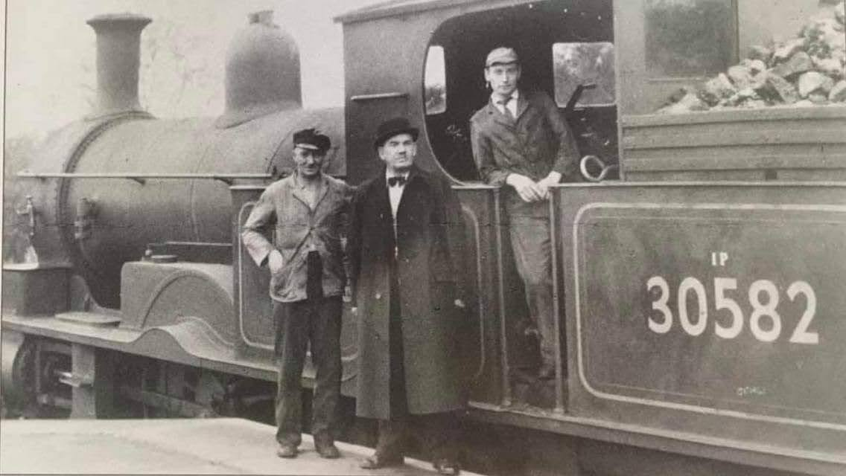
Picture the property of the Smith family. Pre 1961.
- The above engine 30582 was one of the two surviving steam engines used on the Southern Railway after 1930 due to electrification. The Adams 30582 was manufactured between 1882-1885, and these two engines remained in use until 1961 .
- He was known as a strong character, both inside the family and out.
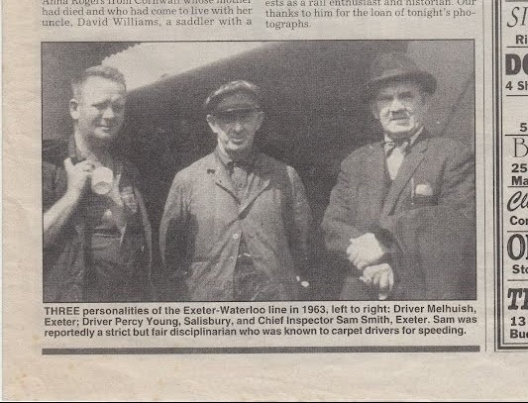
Picture property of Smith family. 1963.
- He would reminisce, sat in his chair and wearing his railway cap, sporting the badge from his war days, drinking his cloudy, strong, homemade Applejack, and tell me stories. I was one of the few family members he would do this with. To grow up as his child was hard, and many of the seven children had a difficult relationship with him. My father, as the eldest, was made responsible for the behaviour of the others, and often got the buckle end of the belt for their misdemeanours. But by the time I knew grandad and with an ability to sit and listen, he was a softie.
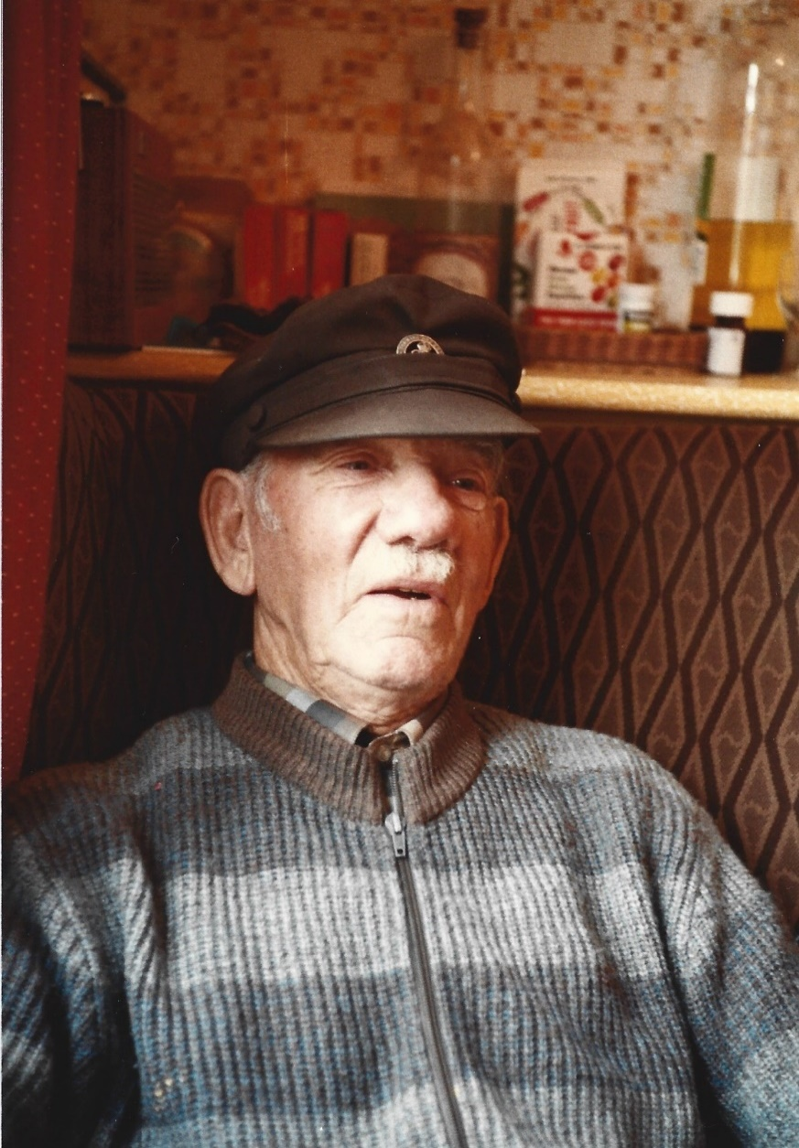
Sam Smith. Approx. 1980. Picture property of Smith family.
- Although the lamp has the mirror and coloured glass missing, it is a good example of solid manufacture of 100 years ago. Based on an ingenious invention by William Sugg it will have been in the hands of many men, communicating vital safety information from men on the ground to men driving enormous steam engines towing heavy loads at speed. A small piece of equipment with an important role in the safe running of a complex and huge scale transport system, treasured in fond memory of a very particular man.

Word count 1156.

Bibliography.
Hall, Ray. Exeter Memories Facebook Group. 2021. Available at: https://www.facebook.com/search/top?q=exeter%20memories Accessed on 17/12/21.
Jordan, Stuart. Gauge Wars. Right Lines. Available at: https://www.gaugemasterretail.com/magento/rightlines-article/gauge-wars.html Accessed on 16/12/21.
Preserved British Steam Locomotives. 0415 4-4-2T LSWR Adams 30582 – 30584 Available at: https://preservedbritishsteamlocomotives.com/0415-4-4-2t-lswr-adams-30582-30584/ Accessed on 14/12/21.
Sugg, William. 2021. William Sugg & Co. 1837-1969. Oil Hand Lamps. Available at: https://williamsugghistory.co.uk/lighting/oil-hand-lamps/ Accessed on 14/12/21.
Tales from the Supply Depot. 2017. Available at: https://talesfromthesupplydepot.blog/2017/07/06/bardic-lamp/ Accessed on 16/12/21.

Chris Sugg. Pers.comm. 16-12-21.
Stuart Jordan.Right Lines. Gaugemaster.com.
Chris Sugg. Pers comm. 16-12-21.
William Sugg & Co. 1837-1969.Oil Hand Lamps
Tales from the Supply Depot. 2017.
Ray Hall. Exeter Memories Facebook Group 2021.
Ibid.
Preserved British Steam Locomotives. 0415 4-4-2T LSWR Adams 30582 – 30584

