Tyrese Matthews
2609243
LCMN4002
DS 1 my digital life

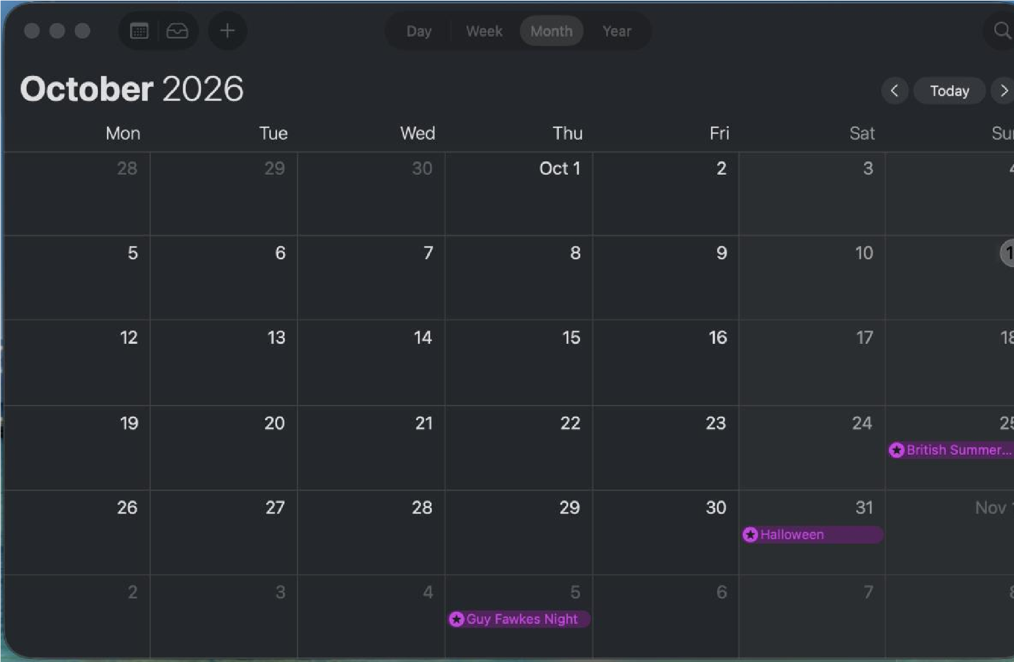
[
Insert Photo/Screenshot
below
]

This screenshot is showing my calendar. I use this everyday so I know what day it is and if I have anything I need to do that I might have forgotten about. This keeps me up to date with anything I need in my day-to-day life as well as a good way to note important dates like for example birthdays.

Screenshot/Photo

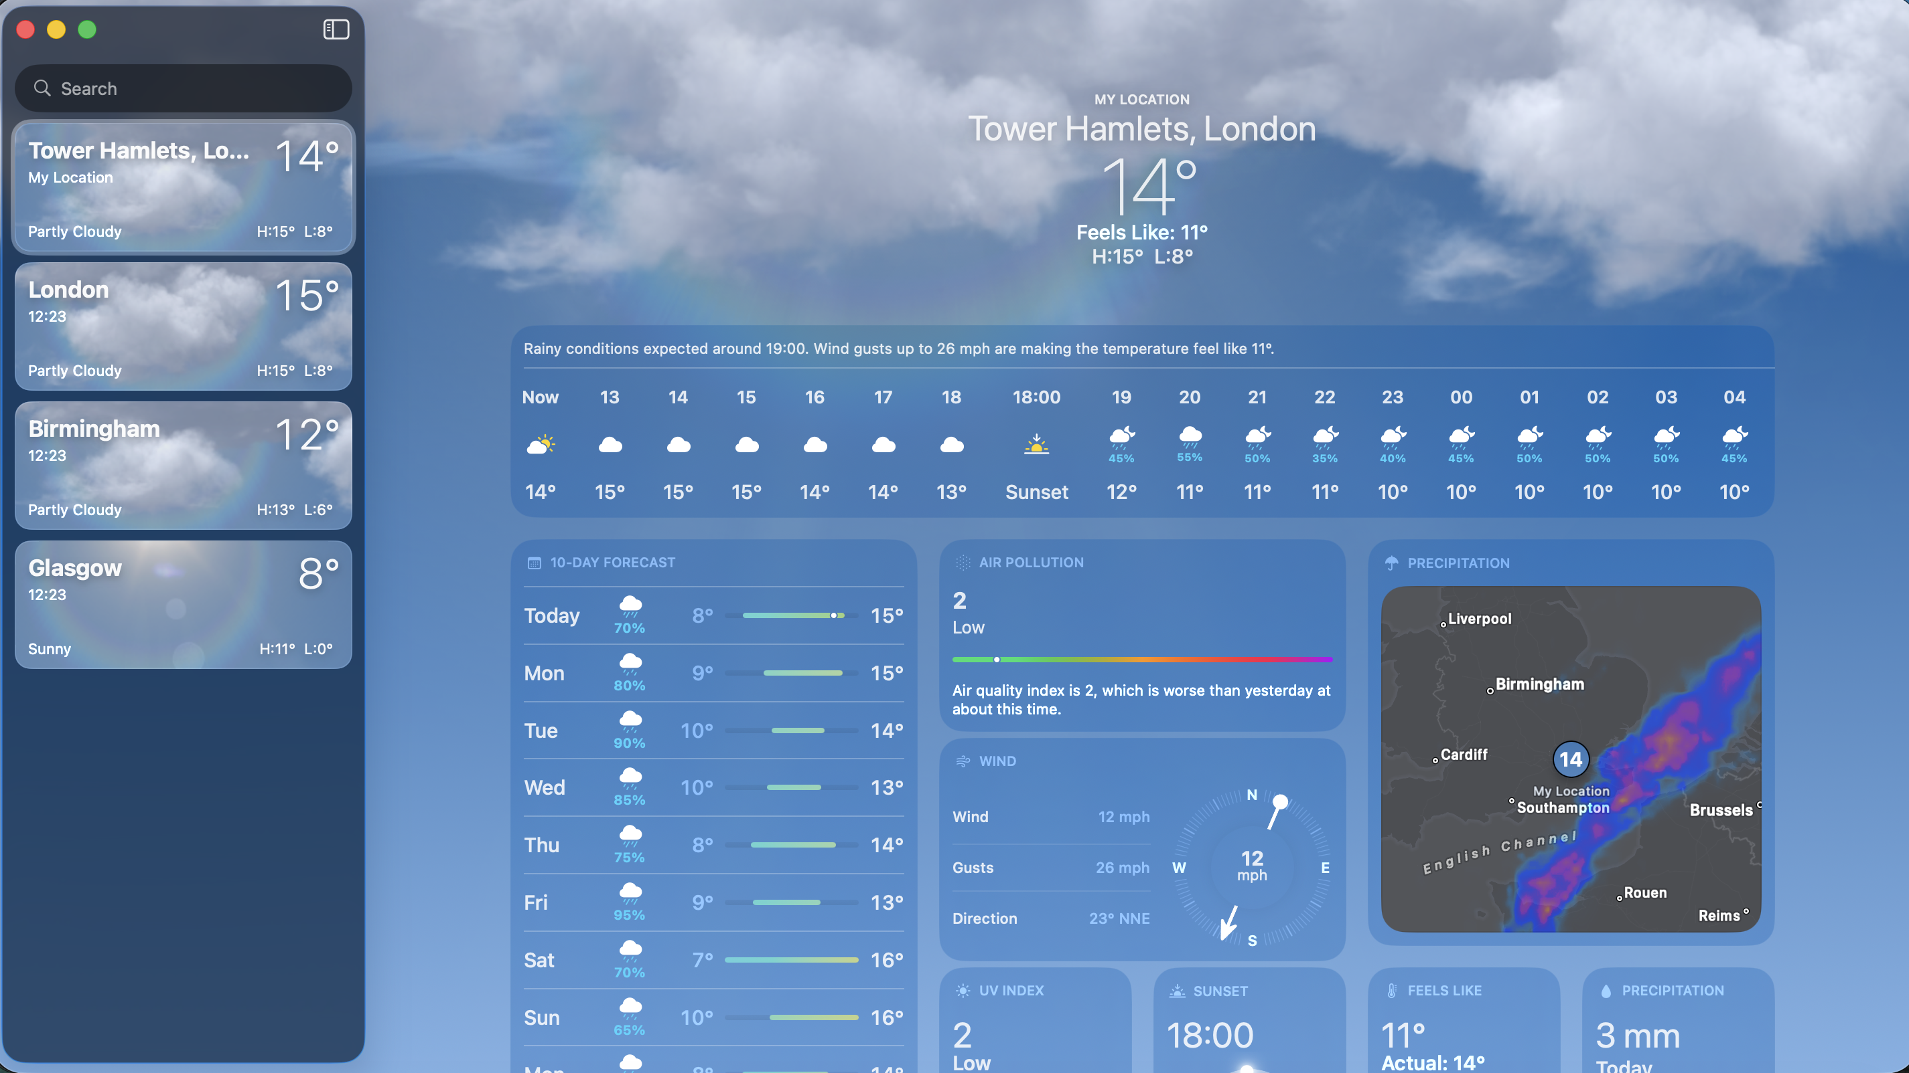

This is a screenshot of my weather app. I used this app everyday as its key to me. It helps me decide what appropriate clothes to wear all depending on the weather or whether I should even leave wherever I am

Screenshot/Photo 3
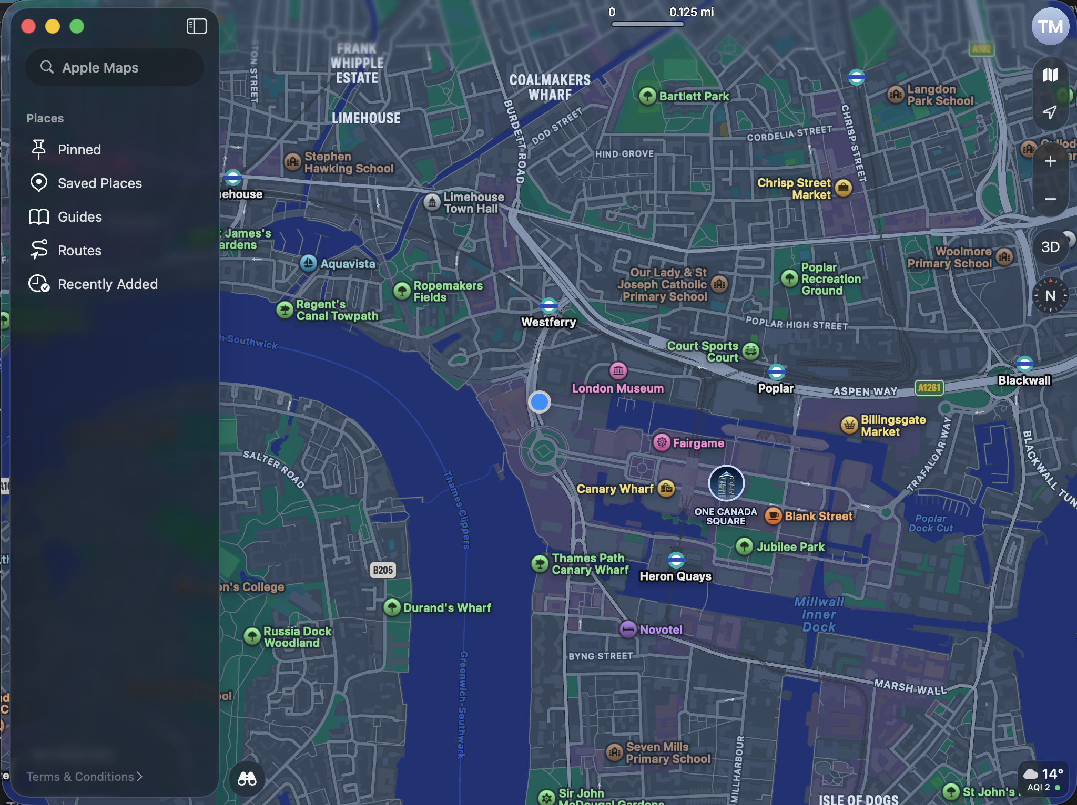
In this screenshot I am showing my maps app. I use this every day and is very key for me. It helps me plan my route Ahed so if there is any delays or something like a train line is not running that day, I will know before I leave my house, I can plan how to work around it. This also helps me when I get lost in certain places as it will show my multiple routes to get to my destination.

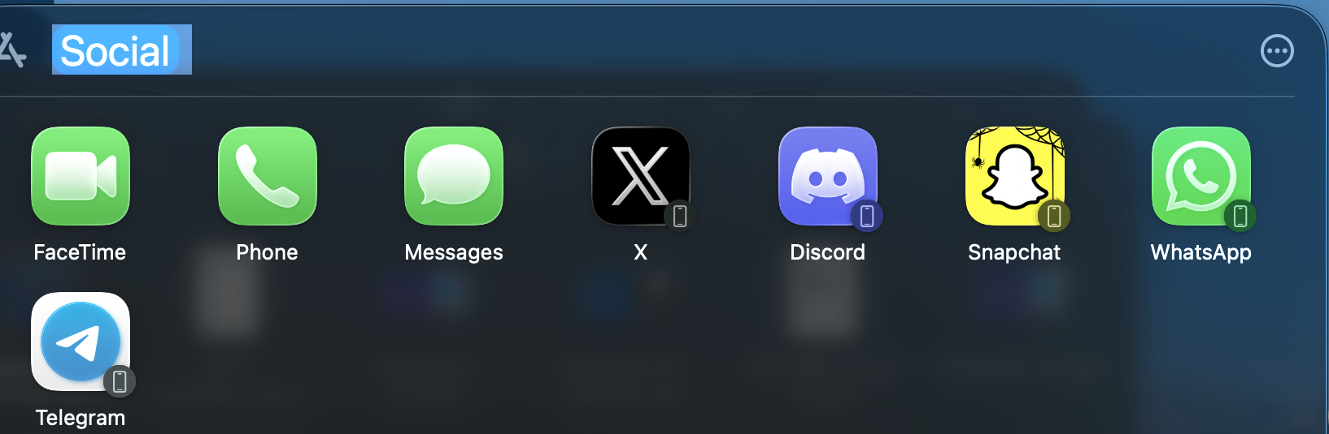
These are all my social media apps. These are all important to me as I use all these too communicate with everyone I know. With these apps I can keep up with all my family and loved ones in various ways like for example facetime where we can see each other on a video call or messaging where we are texting each other on these apps.

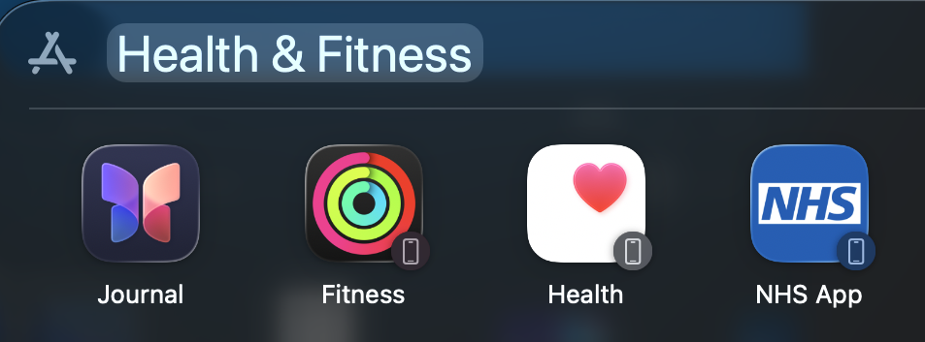

These are my health apps I use these every day. These are key to me because I use them every day to track different things that can help me with my health. These apps can track simple movement like for example the number of steps you take in a day and give you advice on your fitness. These are good for me because I am able. To track everything which makes me keeps up with any health problems.

Digital skills are important to me because it helps me make my day-to-day life easier. It helps me pre plan my day Ahed for example when I wake up in the morning if I check the weather app and it says there’s a high chance of it raining then I would wear a raincoat. I use digital tolls the most via social media. With apps like facetime iMessage snapchat X Instagram it makes me keep up with friends and family as well as the latest things going on around the world. I hope this module will teach me to have better knowledge about how digital skills really affect us on a day-to-day basis. Digital skills are important to me because I feel like I wouldn’t know how to really get around in life, for example I use google maps whenever I need to get a place, I have never been as I don’t have good memory so I wouldn’t image how I would try to get somewhere if I didn’t have map. Also, communication apps are essential to me as it’s the main way I communicate to everyone and without it, I would have never formed the relationships I did and every opportunity for me is online on the internet these days.

