A Case Study of Smol as an Example of The Circular Economy
Sally Hocking
UWTSD Carmarthen
Globally Responsible Business
(BMSP6001)
Jessica Shore
20th April, 2024

Executive Summary

This report looks at how businesses are transforming from linear economies to circular / sharing economies and the benefits economically and environmentally from this switch. Smol is the main focus of this report as an example of a circular business model that tackles plastic waste, recycling and designing cleaning products to be refilled not replaced. This is both more affordable and more sustainable for consumers. Unlike some other sustainable brands, smol aims to keep cost as low as possible, offering free trials to most of their cleaning products, so customers feel confident about the switch, that will remain affordable long term.

A Case Study of Smol as an Example of The Circular Economy

Introduction
This investigation will explore how circular economies and biomimicry can underpin businesses and become integral parts of future business models as we step away from our traditional linear business models. Linear business models produce a lot of waste and drains resources and so is not a sustainable way forward economically or environmentally. The report will look at Smol, a British based household cleaning brand, as a case study of circular economy in action, and how this is providing a valuable sustainable solution to a daily household cleaning waste problem. Below are some definitions of linear, circular/sharing economies and biomimicry, and their strengths/ limitations.

Linear Economy
The Linear economy is a business model we will all be familiar with, it is the traditional concept of input and output, waste from production ending in landfills, being burned, or otherwise discarded. Our planet cannot sustain this, and we are already experiencing the effects of global warming from factories pumping out toxic gasses and chemicals, and poor waste management poisoning our oceans and ecosystems. There is an enormous mass of plastic known as ‘The Great Pacific Garbage Patch’ that is estimated to be 100,000,000 kilograms of plastic. (The Ocean Cleanup, 2024) This is only one area of an entire ocean so heavily polluted plastic that leaches toxic chemicals and microplastics. This makes its way into the food chain, inevitably reaching us and we don’t yet truly know how harmful this is to the human body. (The Ocean Cleanup, 2024)

Circular Economy
The term ‘Circular Economy’ was first coined by German chemist Michael Braungart and American architect William McDonough (RTS - Recycle Track Systems, 2022). Circular economy refers to a business model in which there is no waste, and any by-products are recycled back into the supply chain or manufacturing. This is important as our planet's resources are limited and we are currently using up more than we are restoring. Circular Economy ensures that products are built with repairs and recycling in mind. This may mean the parts can all be separated and repurposed in future products, or that the product will eventually biodegrade. The main principle is that there are no wasted materials, which in turn cuts costs as new materials aren’t constantly being brought into the supply chain. Sharing economy is a concept of non-ownership, where products and services are shared amongst users, without transfer of ownership - for example, Airbnb, Uber. You don't gain ownership of the Airbnb when you rent it for a week, but for that week you have private access and use for a lower cost than if you were to purchase and own it. This way means more people have access to a shared resource for an affordable price.

Biomimicry
Biomimicry is when a product or business design is built to mimic patterns in nature. For example there is an innovative new way to ‘add colour’ to a product such as cars without actually adding any colour, by using nanostructures to bend and refract the incoming light. Wanlin Wang and his team at Shenzhen University, inspired by the way the Blue Morpho butterfly displays colour, developed a material that bounces back light to our eyes in a refraction of the desired colour appearing to be bright and vibrant. This colour will not experience fading with time or need re-application as there is no pigment, it is an optical illusion, or a bending of light that is permanent as long as the nano structures remain. The same effect can be observed by melting chocolate, and letting it cool against this type of film - diffraction grating film (Gerber, 2023). Once cooled, the film is removed and the imprinted pattern will display the same holographic appearance. An example is shown below.
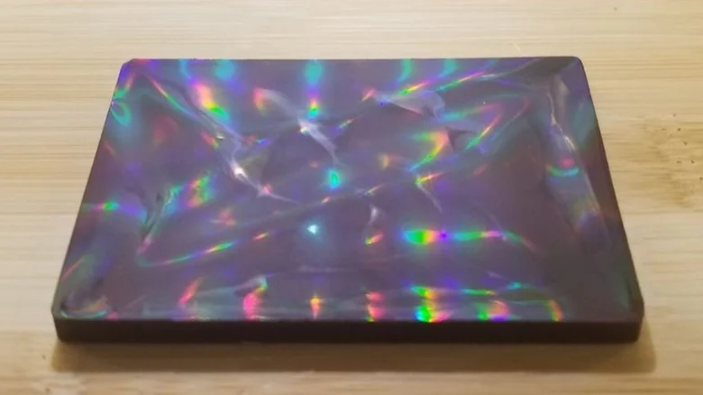
Chocolate with holographic effect (Gerber, 2023)
As an added design bonus, this light refracting film also has a cooling effect, so when used on cars, the vehicle won’t get as hot when left out in the scorching sun. (Riccio, 2023)

‘Smol change, Big impact’ - Smol Tagline n.d
Smol was founded in 2018 by Paula Quazi and Nick Green, two former employees of Unilever (Sophie, 2022). Smols business design is a great example of how circular economies can be delivered conveniently to their consumers who receive their orders through scheduled subscription deliveries, right through their letterbox. This demonstrates that circular economies don't have to be awkward or inconvenient, nor rely heavily on the consumer to do their part. The only role for the consumer is to recycle the carton. The company has received an incredible reputation, appearing in which?, the guardian, ok magazine, good housekeeping, financial times and metro.
Smol tackles the daily household issue of cleaning supplies being expensive, bulky, and often environmentally harmful with use of harsh chemicals. They achieve this by providing durable refillable ‘bottles for life’ for cleaning products and separately providing refills in sustainable and minimal packages straight to your door with a subscription based on your rate of usage (fortnightly, monthly, every 3 months etc). Smol offers a range of different products to cover all household cleaning jobs so customers can have a one stop shop for all of their necessary supplies, keeping regularly stocked up with their chosen regularity of deliveries.
For laundry they have detergent pods that come in a dissolvable film. You throw the pod into your wash cycle and the biofilm completely dissolves to release the liquid detergent inside. These come scented and scent free, bio and non-bio. They also offer a fabric softener and a bleach free stain remover gel. To refill these, you get a cardboard carton refill that can be poured into the bottle and recycled. Smol has a notice on their site to inform customers that if they are unable to recycle their refill cartons after use with their local council, to return the carton to Smol for free, for them to ensure all cartons are properly recycled. (Home Refills for Smol. Hooray!, 2023)
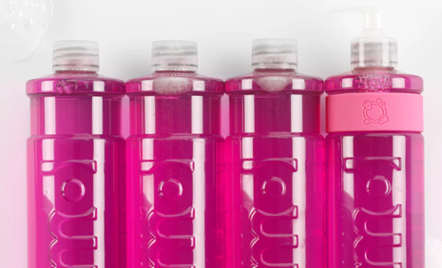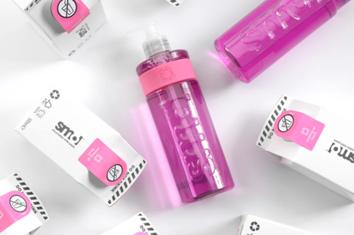
(Images from Smolproducts.com , 2024)
Previously, Smol encouraged a rinse and return for plastic bottle refills. Once refill bottles were empty, customers could send the empty bottles back to their factory in a prepaid delivery box. These empty bottles were then sterilized and refilled, then sent out to other customers. Having tried this, Smol explained the reason for the switch to cardboard carton refills. The new cartons are “made from 68% paper and 32% plastic” (Smol, n.d.) making them fully recyclable and more sustainable to produce. While the plastic bottles can be recycled, small claims plastic is far less likely to be recycled effectively and with cardboard being from a renewable resource, and the cartons being more carbon neutral to post, the switch makes sense for their business model. Having refill returnable bottles also required customers to actually return them in usable condition and would add another round of shipping for the same products (each bottle essentially being shipped twice). For these reasons, smol now provides a ‘bottle for life’ and carton refills in their subscriptions. Smol also provides a multipurpose cleaner that is delivered in tablet form that you dissolve in water in the refillable spray bottle they provide. This means customers aren't paying for the water in the product and the additional weight this would add to packaging. The highly concentrated formula can be delivered in a compact low carbon way and dissolved in water for use when needed, also meaning cupboards aren't filled with large watered down cleaning products. Their dishwasher tablets are delivered in the same way.
Smol are constantly innovating new products, more recently adding non plastic, biodegradable rubber cleaning gloves as well as dishcloths and sponges made from biodegradable cellulose. There is also a new range of refillable skincare and deodorant, and hair care and body wash as zero plastic soap bars.
While smol is certainly more focused on circular economy than biomimicry, the use of cellulose for cleaning sponges is developed through mimicking the way cellulose holds water and creates a sponge-like porous surface on plants. Cellulose is by nature antibacterial, porous and hydrophilic (holds water) (Qi et al., 2023) and so when adapted into a sponge material, it makes the perfect, antibacterial, biodegradable cleaning solution. This is great news as they feel very similar to the plastic sponges we are used to but without the environmental cost. On their website (smol.com, n.d) the company claims “400 million cleaning sponges are thrown into landfill in the UK each year and most are plastic and treated with harsh chemicals”. Smol sells these sponges in packs of 4 for £6. They are machine washable, can be sterilized where needed with boiling water, and can be home composted after final use. These sponges are designed to last longer than the plastic alternative and dry “4 times faster than their plastic counterparts which also means far less bacteria” as bacteria requires moisture to grow (Our Sponges and Scrubbers Have Had a Refresh, n.d.)
To summarize the key sustainability points of each product on smol.com, Smol has biodegradable packaging wherever possible and recyclable packaging or ‘bottles for life’ were not. Their cleaning products are vegan and cruelty free, with lower amounts of chemicals than their competitors. Plant powered ingredients are used where they can, such as their washing up liquid and plant cellulose dish sponges which are 100% biodegradable. Their formulas are all super concentrated to last for many uses and minimize waste. For all purpose cleaner and dishwasher tabs, they are compressed concentrated tablets that dissolve in water, when you purchase the all-purpose cleaner, you are getting 100% of the value without paying for the added water.
SWOT Analysis - Smol
Strengths - Smol has perfectly catered to the convenience of conscious consumers who are looking to make more sustainable switches. Smol is a strong competitor on price with laundry detergent priced at only £5.80 for 24 tablets (one per wash, 24p per wash). Due to popular demand, “Since July 2022 the bio and non-bio tablets have been available in Sainsbury's however,it's more expensive to buy from Sainsbury's at £7 a pack (similar in price to Ecover).” (Turner, 2023)
Smol offers a one-stop-shop solution to tackle most household cleaning jobs, all coming in refillable solutions that maximize value while maximizing cupboard space. No bulky packaging, highly concentrated solutions, and refills delivered on demand. For families, this is ideal and cost effective.
Weaknesses - Smol, while affordable and low cost, is still more expensive than some competitors, plastic dish sponges are readily available in corner shops, supermarkets and are cheaper. Some Smol products are available in sainsburys but they lack presence in shops, with an online and delivery model. Customers who are in need of a quick top up may be unwilling to schedule a delivery, and instead get what is cheaply available in store when they do their other shopping.
Opportunities - Smol should look to develop their in store presence. As they have ditched that bottle return scheme in place of cardboard cartons, there is no need to keep the business model online only. Visibility will draw more customers, and while having the Smol refill pump bottles is convenient, the carton liquid refills can be stored in any container, or used straight from the cartons,
Smol does not currently offer any reusable products such as makeup remover wipes, body wash cloths, loofah, bath sponges or natural exfoliators. They are branching into skincare with soap bars and deodorant but this would be an exciting avenue to explore.
Threats - Competitors are already available in supermarkets. Method Bathroom Cleaner Eucalyptus & Mint 828ML Can be found in Tesco along with Ecover fabric softener. However the products are still sold in non refillable packaging and so in this way smol would have a good USP (unique selling point) if they were to be sold in the same shops.

Conclusion
Smol has established a strong reputation, with average ratings of 4.1 / 5 on Trustpilot (2024) from 4,400 reviews, averaging 5 stars with 86%. They listen to customer feedback and develop new products, tweaking formulas, redesigning to address design flaws etc. An example of this is the switch to cellulose sponges from coconut fiber. Customers reported not linking the feel or durability, and the switch has since been much approved. The product design is already a huge strongpoint for Smol, they continue to innovate and introduce new ranges to cover a broader range of needs. The main drawback is lack of availability in stores and supermarkets. Once this is addressed, they will have covered all bases. Smol sources ethically and responsibly, uses non harmful ingredients, and reduces waste in a huge global industry of cleaning products. They have great customer service and reputation and are an affordable, accessible locally produced (if in britain) brand. Smol occasionally offers student discounts on TOTUM (2024) to gain further reach within the student market. They also ship worldwide, offering free shipping in the uk. As they expand their range, perhaps looking more into personal care items, there is still so much potential for growth for this company. I have personally used their home cleaning products with strong results and will continue to use and recommend this brand.

References
A plant-based washing up liquid that works? Oh YES! (2023, February 20). https://smolproducts.com/blogs/stories/washing-up-liquid

Gerber, S. (2023, August 28). Holographic chocolate is the dazzling dessert that’s easy to make. Tasting Table. https://www.tastingtable.com/1375723/holographic-chocolate-should-start-making/

Hodgson, C., & Evans, J. (2020, November 27). Green gold: how sustainability became big business for consumer brands. Financial Times. https://www.ft.com/content/ce523ca1-c8c2-43e7-86ad-ffa5d6605d2c

home refills for smol. hooray! (2023, October 6). https://smolproducts.com/blogs/stories/smol-cartons

Our sponges and scrubbers have had a refresh. (n.d.). https://smolproducts.com/blogs/stories/smol-sponges-and-scrubbers

Riccio, G. (2023, August 3). We will cool cars using “butterfly wings.” Futuro Prossimo. https://en.futuroprossimo.it/2023/08/raffredderemo-le-auto-usando-ali-di-farfalla/

RTS - Recycle Track Systems. (2022, January 26). What is Circular Economy & How Does It Work? : Complete Guide - RTS - Recycle Track Systems. Recycle Track Systems. https://www.rts.com/resources/guides/circular-economy/

sharing economy examples - Google Search. (n.d.). https://www.google.com/search?q=sharing+economy+examples&sca_esv=0e9d35a69ed69d23&sca_upv=1&sxsrf=ACQVn0_gjm-TtUzYE9Wt6yvu9toXeYxPkQ%3A1714169774406&ei=ricsZpC1GPurhbIPnt2kuAY&oq=sharing+economy+e&gs_lp=Egxnd3Mtd2l6LXNlcnAiEXNoYXJpbmcgZWNvbm9teSBlKgIIADILEAAYgAQYkQIYigUyBRAAGIAEMgUQABiABDIFEAAYgAQyBRAAGIAEMgUQABiABDIFEAAYgAQyBRAAGIAEMgUQABiABDIFEAAYgARIrCNQ5gJYphpwAngBkAEAmAFfoAHWBqoBAjEyuAEByAEA-AEBmAIGoALNAsICChAAGLADGNYEGEfCAg0QABiABBiwAxhDGIoFwgITEC4YgAQYsAMY0QMYQxjHARiKBcICChAAGIAEGEMYigXCAgYQABgWGB7CAggQABgWGB4YD8ICCxAAGIAEGIYDGIoFwgIIEAAYgAQYogSYAwCIBgGQBgqSBwE2oAenTQ&sclient=gws-wiz-serp

smol - The average household sends 25 plastic cleaning bottles to. . . (n.d.). https://www.facebook.com/smolproducts/photos/a.923061024537580/1787393714770969/?type=3&from_lookaside=1

the smol revolution of FREE TRIALS! (n.d.). https://smolproducts.com/blogs/stories/the-smol-revolution-of-free-trials

Smol Products. (n.d.). smol. https://smolproducts.com/

smol. (n.d.). https://smolproducts.com/pages/washing-up-liquid

smol. (n.d.). https://smolproducts.com/blogs/stories

Sophie. (2022, September 28). How Eco-Friendly is Green Cleaning Brand Smol? — Sustainably Lazy. Sustainably Lazy. https://www.sustainablylazy.com/eco-brand-list/is-smol-eco-friendly

Tesco. (n.d). ECover Softener Apple Blossom & Almond 50W 1.5L. Tesco Groceries. https://www.tesco.com/groceries/en-GB/products/297781639
Tesco. (n.d). Method Bathroom Cleaner Eucalyptus & Mint 828ML. Tesco Groceries. https://www.tesco.com/groceries/en-GB/products/259964781

The Ocean Cleanup. (2024, April 25). The ocean cleanup. https://theoceancleanup.com/?gad_source=1&gclid=CjwKCAjwoa2xBhACEiwA1sb1BIUJjTW31kc0pIaZh-5iHyklMrDrKTmTyPjtR8BtxPUuaCVZQq9P7xoC6REQAvD_BwE

TOTUM. (n.d.). smol Student Discounts, Offers & Vouchers | TOTUM. https://totum.com/discount/smol?offer-expired

Trustpilot. (2024, April 26). smol Reviews. https://uk.trustpilot.com/review/www.smolproducts.com

Turner, N. (2023, August 4). Smol and other laundry detergent subscriptions: are they worth trying? Which? https://www.which.co.uk/news/article/smol-and-other-laundry-detergent-subscriptions-are-they-worth-trying-aabyr4V4CZCU

Wanlin WANG | Professor (Assistant) | Doctor of Engineering | Shenzhen University | Institute of Optoelectronics | Research profile. (n.d.). ResearchGate. https://www.researchgate.net/profile/Wanlin-Wang-5/2

Qi, S., Kiratzis, I., Adoni, P., Tuekprakhon, A., Hill, H. J., Stamataki, Z., Nabi, A., Waugh, D., Rodrı́Guez, J. R., Clarke, S. M., Fryer, P., & Zhang, Z. J. (2023). Porous cellulose thin films as sustainable and effective antimicrobial surface coatings. ACS Applied Materials & Interfaces, 15(17), 20638–20648. https://doi.org/10.1021/acsami.2c23251

