Student Name: MIHAELA ALECU  Student ID: 2223648  Module Title:Foreign Languages & Cultural Awareness  Module Code: BMIH5003  Lecturer: LISA BASSLER  Date: 09.02.2024 | 
ASSIGNMENT 1: PORTFOLIO
(4 Components)

Component 1: Professional Reflection (500 words +/- 10%)

Weighting: 25%

While being subjected to Level 4 placement at Belton Woods Hotel Spa and Golf Resort, I was subjected to an unwanted situation of cultural misunderstanding which undermined my experience of serving dinner to a group of customers. The situation was that a Canadian couple arrived for dinner and the husband decided to order something spicy. In a short while, after they began eating, I approached them and asked them if the food tasted alright and the reply was, “It’s fine”. Immediately, I called the junior waiter and asked him to replace the food while apologising for the inconvenience caused by the lack of taste in the food. Both the husband and wife were perturbed and complained about the sudden removal of food. I told them that they did not like the food but they answered indeed the food was alright and I should not have unnecessarily disrupted their dinner. I responded by saying that “it’s fine” means there is space for improvement and they answered that it rather means everything is alright and there is nothing to worry.
The above situation clearly shows the difference between the Asian and European communication styles and is reflective of cultural differences in communication. According to Ho et al. (2020), Edward Hall’s Communication Theory necessitates high-context and low-context cultures wherein a high-context culture believes that people are aware of social codes and are able to understand the implicit meanings within a communication. In this regard, while the UK has a high-context culture, Canada has a low-context culture. Thus, Canadians express themselves plainly by what they say and do not use sub-text in communication (Mulbay, 2022). In this regard, I was mistaken because I thought the husband did not literally mean the food was good when he said, “It’s fine”. The mistake of mine led to unwanted harassment for the Canadian couple.
Therefore, according to the above-mentioned cultural misunderstanding situation, I feel that I need to enhance my communication skills to avoid similar misunderstandings in future. In this regard, I feel that I need to learn about ethical interpersonal communication. According to Solomon and Theiss (2022), ethical interpersonal communication necessitates being responsible for communication and recognising the impact of communication decisions on other people. Hence, this kind of communication will help me share my ideas first before I jump into action. In this way, I will be able to seek informed verbal consent from others before I undertake any action. This kind of consent will allow me to realise what customers really want or expect of me. As a result of transparency in communication and the absence of any hidden implied meanings, I will not commit any mistake in interpreting them and therefore, unwanted situations involving harassment for customers may be avoided in future. I also plan to practice intercultural communication skills. For example, I need to develop understanding skills by carefully listening to each and every word that others say. This will help me to interpret ideas from explicit meanings so that I do not overinterpret and act in a wrongful manner which risks the welfare of customers.
References
Ho, C.L.L., Whittle, C. and Eaves, M.H., 2020. Mixed methods research–nonverbal observations of cultural convergence in online and offline contexts: Testing Hall’s low-vs. high-context framework. Journal of Intercultural Communication Research, 49(4), pp.301-312.
Mulbay, B., 2022. Business Communication Etiquette in Canada. Available at: https://meeting.care/canada-business-communication-etiquette/# (Accessed 27 January 2024)
Solomon, D. and Theiss, J., 2022. Interpersonal communication: Putting theory into practice. Routledge.
Component 2: Training Plan (500 words +/- 10%)

Weighting: 25%

Identified cultural misunderstanding (in a few words):
Based on the reflection presented above, the identified cultural misunderstanding is associated with the wrong interpretation of communication. This is because the UK being a high-context culture, at times requires interpreting the possible hidden meanings in communications. This is because communication is often indirect and requires reading between the lines to interpret what Britons mean (Harzing, 2023). This feature is starkly in contrast to the low-context culture of nation’s people from nations like Canada who directly reveal their state of mind through simple and plain communication.
Training plan (Why/What//Who/Where/When):
Based on the intercultural interpretation problem that I faced, training is required for the employees of Belton Woods Hotel Spa and Golf Resort so that they may not face similar issues while dealing with customers in future. The training is necessary because it will help the employees to handle situations involving cultural differences. According to Braslauskas (2021), developing intercultural communication competency helps to move from an undesirable situation to a desirable situation. Hence, the training will help the employees learn how to handle situations involving a customer from a different culture and be involved in effective and useful communication outcomes. Hence, the training plan will involve trainers, supervisors and employees and will be offered in the presentation room. It will comprise of two parts namely theoretical and practical training. The theoretical training will run for a week on weekdays and the practical training will run for two weeks on weekdays. The theoretical training will be of 1 hour and will begin at the start of the work hours. However, the practical training will be conducted at the end of the day while replacing the end of the 30 minutes of the work hours with the training period.
The plan will begin with a theoretical understanding of intercultural communication. This will help the employees understand how cultures differ and impact communication. For example, besides Edward Hall’s Communication Theory, the employees will also be informed about Hofstede’s Cultural Dimensions Model. This model helps delineate the culture of a country based on the cultural values of the country (Hofstede-insights, 2024). Therefore, this kind of theoretical instruction will help employees learn how to comprehend cultural differences while making meaning of communication with customers which bears cultural differences. The training will be simulation-based as it will offer different scenarios of cultural communication problems and will require employees to resolve them. Problem-solving skills related to communication are important because they help an individual realise how to communicate with others while effectively managing problematic situations (Indeed, 2024). Hence, the simulated activities will help employees better learn how to avoid cross-cultural communication issues. According to Haataja et al. (2021), monitoring complex problem-solving brings forth greater success in solving a problem. Hence, the supervisor will be required to monitor the practice of the employees and will intervene in case the simulated practice proceeds in the wrong direction. Feedback will be offered at the end to help employees self-realise their learning and help them plan for future interventions to enhance intercultural communication skills and competencies.
References:
Braslauskas, J., 2021. Developing intercultural competences and creativity: The foundation for successful intercultural communication. Creativity studies, 14(1), pp.197-217.
Haataja, E., Malmberg, J., Dindar, M. and Järvelä, S., 2021. The pivotal role of monitoring for collaborative problem solving seen in interaction, performance, and interpersonal physiology. Metacognition and Learning, pp.1-28.
Harzing, 2023. British culture. Available at: https://harzing.com/resources/living-and-working-abroad/british-culture# (Accessed 26 January 2024)
Hofstede-insights, 2024. Intercultural Management. Available at: https://www.hofstede-insights.com/intercultural-management (Accessed 29 January 2024)
Indeed, 2024. Problem-Solving Skills: Definitions And Examples. Available at: https://in.indeed.com/career-advice/resumes-cover-letters/problem-solving-skills (Accessed 28 January 2024)
Component 3: Student Self-Reflection (500 words +/- 10%)

Weighting: 25%
Self-reflection is an essential element for an employee because it helps to ponder upon past incidents and practices to identify personal strengths and drawbacks and enhance self-capacity. Thus, self-reflection galvanises an individual’s willpower and empowers them with self-realisation to successfully achieve individual potential (HBR, 2022a). Hence, I feel that the incident of intercultural communication misunderstanding with the Canadian couple needs self-reflection so that I may avoid committing similar mistakes in future. Driscoll’s Model of Reflection facilitates an in-depth reflective analysis while using trigger questions like what, so what and now what (Ingham-Broomfield, 2021). Hence, this questions-based self-reflective approach will help me better evaluate the miscommunication situation and produce useful and effective outcomes.
What
The situation is about wrongly interpreting what was communicated. The Canadian couple while responding to my question about food quality simply meant that the food taste was acceptable to them as per their demand while they said, “It’s fine”. However, my familiarity with the high-context UK culture meant that the phrase should be considered to mean enhancement or development requirements. Therefore, I wrongly understood the situation and unknowingly harassed them by instantaneously removing the food and choosing to replace it with a better preparation. This act of mine dissatisfied them as they were interrupted while they had dinner which they felt to be disrespectful to them.
So what
The incident has revealed to me that the concept of intercultural communication is quite complex and not only depends on a single individual but also for the other parties associated with the communication procedure. As a result, intercultural communication is important because it helps understand the unique experiences of others so that the meaning and action are coordinated to achieve a common goal (Idrinstitute, 2018). Hence, from the experience, I have learnt that I need to start valuing what others say and must think from their perspective or point of view. In this way, I will be able to avoid overinterpretation and will not undertake any hasty and unnecessary action that may end up harming the welfare of customers. According to a survey by Deloitte, 70% of employees receiving language training feel more confident with their roles and interactions with clients (Business, 2023). Hence, I feel that this experience is critical for me as it reveals the need for developing language competency as a part of intercultural communication competency.
Now what
I have now realised that my intercultural communication competency is weak and one-sided. I majorly possess the ability to consider the high-context UK culture in communication but fail to effectively manage communication when a low-context communicator is involved as seen in the miscommunication incident. Hence, I plan to undertake simulation activities revolving around interpersonal and intercultural communication activities. An example is the Financial Fitness Simulator which involved 300 Managing Directors (MDs) of an agency where 88% of them reported a much better understanding and decision-making after the simulation training (HBR, 2022b). Similarly, I also plan to learn how to consider cultural implications through simulated practice so that I am able to consider the cultural practices of customers in future communication requirements and avoid acting rashly and impacting customer welfare due to overinterpreting the communicated ideas of customers.
References:
Business, 2023. How Can Intercultural Communications Support the Consumer Goods Industry?. Available at: https://business.busuu.com/resources/how-can-intercultural-communications-support-the-consumer-goods-industry (Accessed 29 January 2024)
HBR, 2022a. Don’t Underestimate the Power of Self-Reflection. Available at: https://hbr.org/2022/03/dont-underestimate-the-power-of-self-reflection (Accessed 25 January 2024)
HBR, 2022b. Using Simulations to Upskill Employees. Available at: https://hbr.org/2022/11/using-simulations-to-upskill-employees (Accessed 27 January 2024)
Idrinstitute, 2018. Intercultural Communication. Available at: https://www.idrinstitute.org/resources/intercultural-communication/ (Accessed 26 January 2024)
Ingham-Broomfield, B., 2021. A nurses' guide to using models of reflection. The Australian Journal of Advanced Nursing, 38(4), pp.62-67.
Component 4: Training Presentation (6 Slides)

Weighting: 25%
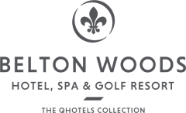
MULTILINGUAL TRAINING FOR EMPLOYEES OF BELTON WOODS HOTEL SPA AND GOLF RESORT
Student name:MIHAELA ALECU
Module code:BMIH5003
Date: 09.FEB.2024
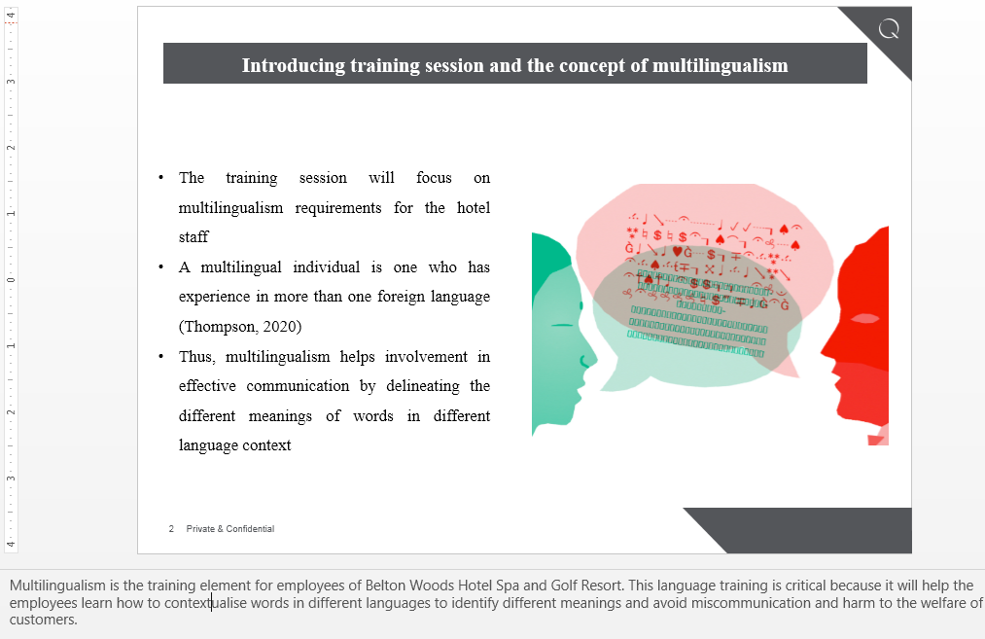
Slide 1: Introducing training session and the concept of multilingualism
- The training session will focus on multilingualism requirements for the hotel staff
- A multilingual individual is one who has experience in more than one foreign language (Thompson, 2020)
- Thus, multilingualism helps involvement in effective communication by delineating the different meanings of words in different language context
Multilingualism is the training element for employees of Belton Woods Hotel Spa and Golf Resort. This language training is critical because it will help the employees learn how to contextualise words in different languages to identify different meanings and avoid miscommunication and harm to the welfare of customers.
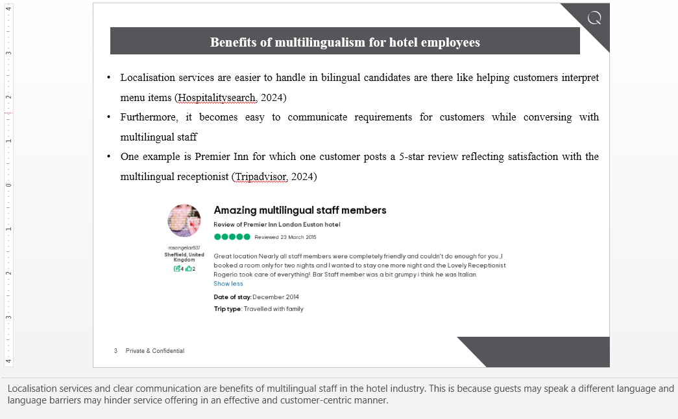
Slide 2: Benefits of multilingualism for hotel employees
- Localisation services are easier to handle in bilingual candidates are there like helping customers interpret menu items (Hospitalitysearch, 2024)
- Furthermore, it becomes easy to communicate requirements for customers while conversing with multilingual staff
- One example is Premier Inn for which one customer posts a 5-star review reflecting satisfaction with the multilingual receptionist (Tripadvisor, 2024)
Localisation services and clear communication are benefits of multilingual staff in the hotel industry. This is because guests may speak a different language and language barriers may hinder service offering in an effective and customer-centric manner.
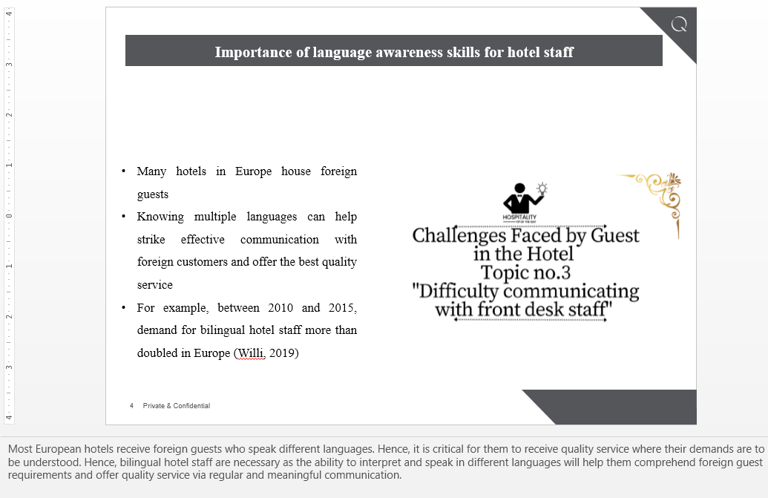
Slide 3: Importance of language awareness skills for hotel staff
- Many hotels in Europe house foreign guests
- Knowing multiple languages can help strike effective communication with foreign customers and offer the best quality service
- For example, between 2010 and 2015, demand for bilingual hotel staff more than doubled in Europe (Willi, 2019)
Most European hotels receive foreign guests who speak different languages. Hence, it is critical for them to receive quality service where their demands are to be understood. Hence, bilingual hotel staff are necessary as the ability to interpret and speak in different languages will help them comprehend foreign guest requirements and offer quality service via regular and meaningful communication.
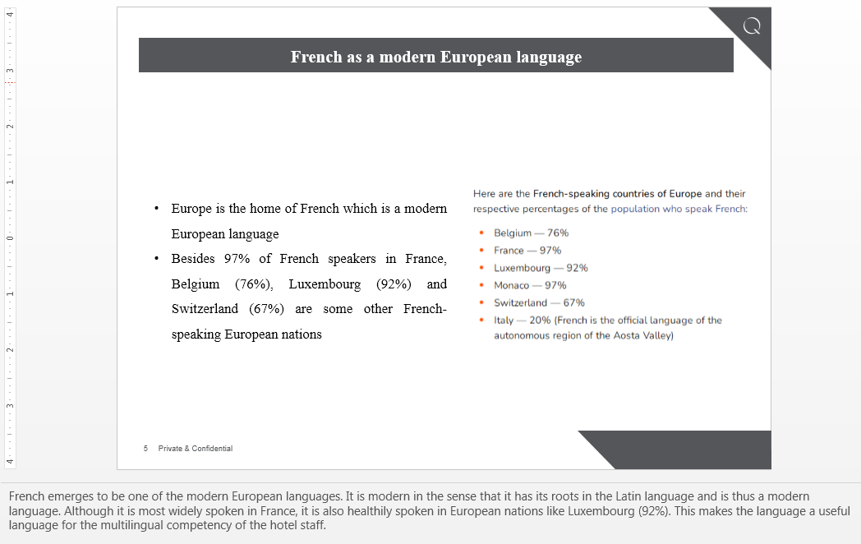
Slide 4: French as a modern European language
- Europe is the home of French which is a modern European language
- Besides 97% of French speakers in France, Belgium (76%), Luxembourg (92%) and Switzerland (67%) are some other French-speaking European nations
French emerges to be one of the modern European languages. It is modern in the sense that it has its roots in the Latin language and is thus a modern language. Although it is most widely spoken in France, it is also healthily spoken in European nations like Luxembourg (92%). This makes the language a useful language for the multilingual competency of the hotel staff.
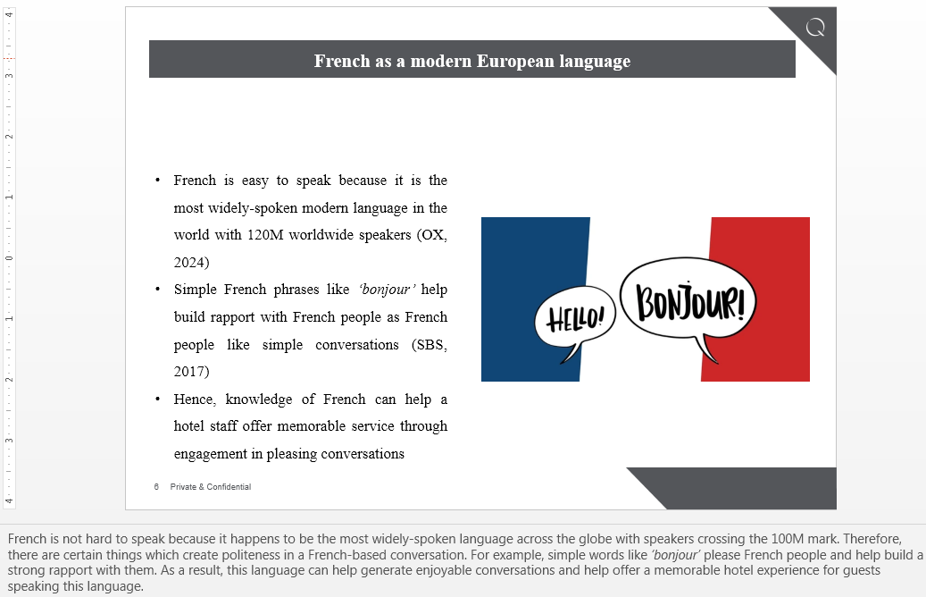
Slide 5: French as a modern European language
- French is easy to speak because it is the most widely-spoken modern language in the world with 120M worldwide speakers (OX, 2024)
- Simple French phrases like ‘bonjour’ help build rapport with French people as French people like simple conversations (SBS, 2017)
- Hence, knowledge of French can help a hotel staff offer memorable service through engagement in pleasing conversations
French is not hard to speak because it happens to be the most widely-spoken language across the globe with speakers crossing the 100M mark. Therefore, there are certain things which create politeness in a French-based conversation. For example, simple words like ‘bonjour’ please French people and help build a strong rapport with them. As a result, this language can help generate enjoyable conversations and help offer a memorable hotel experience for guests speaking this language.
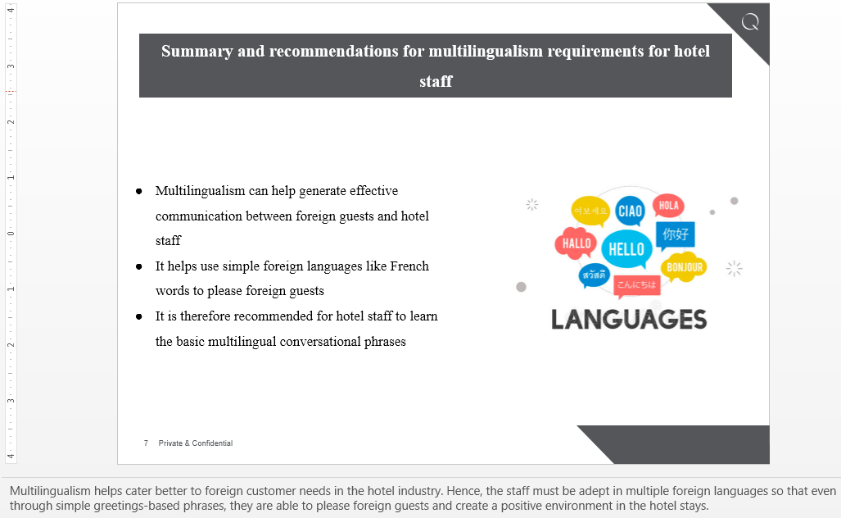
Slide 6: Summary and recommendations for multilingualism requirements for hotel staff
- Multilingualism can help generate effective communication between foreign guests and hotel staff
- It helps use simple foreign languages like French words to please foreign guests
- It is therefore recommended for hotel staff to learn the basic multilingual conversational phrases
Multilingualism helps cater better to foreign customer needs in the hotel industry. Hence, the staff must be adept in multiple foreign languages so that even through simple greetings-based phrases, they are able to please foreign guests and create a positive environment in the hotel stays.
References
Hospitalitysearch, 2024. Benefits of Being Multilingual. Available at: https://hospitalitysearch.co.uk/benefits-of-being-multilingual/ (Accessed 26 January 2024)
OX, 2024. Modern Languages: French and German. Available at: https://www.ox.ac.uk/admissions/undergraduate/courses/modern-languages/modern-languages%3A-french-and-german (Accessed 28 January 2024)
SBS, 2017. French Culture. Available at: https://culturalatlas.sbs.com.au/french-culture/french-culture-do-s-and-don-ts (Accessed 26 January 2024)
Thompson, A.S., 2020. My many selves are still me: Motivation and multilingualism. Studies in Second Language Learning and Teaching, 10(1), pp.159-176.
Tripadvisor, 2024. Premier Inn London Euston Hotel. Available at: https://www.tripadvisor.co.uk/ShowUserReviews-g186338-d215522-r261175222-Premier_Inn_London_Euston_hotel-London_England.html (Accessed 25 January 2024)
Willi, R., 2019. Language skills for an international hotel management career. Available at: https://hospitalityinsights.ehl.edu/key-language-skills-international-hotel-management-career (Accessed 30 January 2024)

