Chapter Three – Methodology
Upon the literature review that examined the arguments for and against raising the ACR and having investigated whether the media’s portrayal in the James Bugler case had an impact on the public’s perception of child offenders, the motivation for this section of the research is the comparative differences in which the media in the UK treated the offenders of James Bulger and the media in Norway responded to the murder of Silje Redergard. The two murders are comparable for a number of factors including the similarity in age of the offenders, the fact the murders occurred a year apart but were treated so differently within the media is intriguing. These cases in particular are the incentive for this research into whether the media vilifies child offenders in England and Wales.

This chapter will provide explanations and justifications to the chosen research methods that are to be used within this research study. This chapter will also evaluate the strengths, weaknesses and ethical aspects of the research study that need to be considered.

3.1 Research Onion
According to Saunders et al (2019) the research onion is a methodology framework is divided into sections, for researchers to select and justify their particular methods within a research project. See figure 3.1.1 (Saunders et al, 2019). This study will follow the research onion to ensure the chosen research methods and procedures are beneficial to the study and produce substantial comprehensive results.

3.2 Research Philosophy
According to Al-Ababneh (2020) the research philosophy is the perspective that corresponds with the selected research methods. This research follows the interpretivism research philosophy. According to Alharahsheh and Pius (2020) the interpretivism perspective considers that reality is distinct and unique to an individual that can differ due to different circumstances. When considering what type of responses will be gathered from the research survey, there may be external variables that will influence the participants’ feedback. The interpretivism approach is followed within this study due to such external variables that need to be considered when examining the results from the research. Lin (1998) argues that the advantage of adopting an interpretivist approach allows for strong and cogent conclusions to be drawn from research. According to Moon and Blackman (2014) the results from the research are examined and will consider the circumstantial variables, such as historical or cultural variables, which impact how the participant views and constructs their own perspective of their own world. Due to this study collecting data on the public’s perception of the ACR, it is vital to consider how circumstantial factors may influence participants responses.

3.3 Research Approach
Once establishing that the research philosophy follows the interpretivism perspective, it is believed that the inductive reasoning approach would be the most beneficial for this study. According to Steefkerk (2022) inductive reasoning develops a theory during the research. Steefkerk (2022) explains that inductive reasoning observes, recognises a pattern and then forms a theory or conclusion from the information gathered. Klauer and Phye (2008) also explains that when analysing data, the inductive reasoning compares and contrasts the evidence to form a generalising conclusion. With the combined interpretivism inductive approach, comparing and evaluating the public’s perceptions, taking into consideration all external variables and establishing an informed conclusion will produce a resourceful and compelling research study.

3.4 Methodological Choice
The methodological choice according to Meyer (2016) determines if the research will consist of quantitative or qualitative data. Bailey (2008) explains that qualitative data can be in a written format, audio or visual recordings and can consist of great detail. Qualitative data is beneficial for research that examines the why or how, such as studying human behaviour. Albers (2017) state that quantitative data is numerical, statistical data such as the mean age of participants. This research study aims to collect both quantitative and qualitative data. Doyle et al (2009) suggests that the advantage of using a mixed methods approach is that it allows for research to be conducted which cannot be discussed using simply just quantitative or just qualitative methods. Doyel et al (2009) also suggests that the use of mixed methods allows for research which is more complex to be explored intensely. This advantage can be applied to this research project. Due to the research project gathering the public’s opinion surrounding the ACR, using closed questions and gathering solely quantitative data would not produce a true outlook of the public’s perspective.

3.5 Research Strategy
According to Wedawatta et al (2011) the research strategy communicates the objective of the research and the technique in which the research is administered. This research strategy that has been determined for this study is a survey. Aldridge and Levine (2001) describe that when using a survey, the same information is collected from all participants within the sample, while analysing and examining each response individually and contextually. The advantage of using a quantitative and qualitative survey, according to Glik et al (2016) the data can offer the researcher further insight and provide a continual comparative method during analysis. The advantage of distributing an online survey for this research is, with the help of advancing modern technology, the online survey will develop more responses and is more easily accessible for participants than a paper survey. A study conducted by Woo et al (2014) found that online mobile phone surveys had a significant advantage over website survey’s concerning the quantity of feedback from participant. The Office for National Statistics (2016) also reported an estimate of 93% of adults within the UK own a mobile phone for their personal use.

3.6 Time Horizon
From the research onion provided by Saunders et al (2019) the inner circle suggests a time horizon to be selected. Saunders et al (2019) suggests that this determines if the research conducted will capture a compact level of results within a particular time or a larger series of data that has been taken periodically. A cross-sectional study collects relevant information over one phase of time such as a course of four weeks or four months (Kesmodel, 2018). Levin (2006) argues an advantage of a cross-sectional research study is the data is collected quickly and completion of the study is short-term meaning multiple outcomes and risk factors are easily assessable. Therefore, it is logical for this research to be conducted as a cross sectional study to adhere to the time constraints of academic research deadlines. The survey will collect data over the course of 2 weeks and will be accessible over this period. Once the 2 week period has concluded, the researcher will close the survey and will begin analysing the results.

3.7 Techniques for Data Collection, Processes and Analysis
For the primary data to be collected, the use of a survey as previously mentioned will be used to gather qualitative and quantitative data through open and closed questions. Open questions provide results with more detail whereas, closed questions receive a more direct response such as ‘yes’, ‘no’, ‘I am 19 years old’ etc. Google Forms will be utilised for the creation of the survey, this will also allow for the survey to be easily accessible and responsive. Coomber (2017) states that with the introduction of modern technology, the internet allows researchers to reach participants that would have been inaccessible when using a paper questionnaire. Once the data is collected, the data will be examined and analysed using thematic analysis. Thematic analysis assesses, investigates and details patterns that occur from the data collection (Scharp and Sanders, 2018).

3.7.1 Sampling
According to Turner (2020) the sample within a research study involves choosing participants to gather data from, as it is impractical to attempt to collect data from the whole population. This research will use the non-probability convenience sampling method. According to Stratton (2021) this method involves the researcher announcing the research and participants self-select themselves to engage in the study.

3.7.2 Reliability and Validity
Reliability according to Bermingham (2020) is the emphasis on how precise the research is described and evaluated in order for the study to be duplicated, such as the research methods, techniques, research design in order to reproduce similar results. To ensure the reliability of the study, it is important to be clear and exact in the explanation of research methods and also within the survey questions. Lee (2004) demonstrates that reliability can be strengthened when research is not easily misinterpreted or difficult to understand. Validity, according to Sullivan (2011), is how effectively the research can answer the research question. For example, within this study, if the participants gave false opinions the results of the research would not be valid. Cobern and Adams (2020) also explains that the survey research questions need to be constructed in a way that accumulates information that is important to the research. Cobern and Adams (2020) argues that if the survey generates invalid results, it is likely due to respondent error, which is the participant answering the survey question differently from what the researcher was anticipating. For example, simply asking “how should children be punished?” would not generate valid answers concerning children within the CJS.

3.7.3 Limitations
The limitations to a research study are the imperfections and drawbacks of the research that could impact the data collected. According to Greener (2018) recognising limitations and clarifying the impact they have onto the study, communicates to the reader that the researcher has been meticulous and allows the research to be developed and refined in the future.
One limitation to the study that could occur is sampling bias. As the survey will be published across the researcher’s social media, the sample is restricted to those who have access to the researcher’s social media platforms and those who have access to the internet when the survey is posted. Andrade (2020) also states that online surveys are more likely to be completed by individuals who have a particular interest in the subject, reducing the likelihood of an even and well-balanced data collection.

A further limitation to the research is due to the academic time constraints of the research this could result in a low response rate. As a result, this leads to an unrepresentative sample size that does not correctly reflect the current society. Baruch and Holton (2008) states this will also induce a higher probability of statistical bias.

Chapter 4 – Findings

4.1 “Evaluate public perceptions on the ACR in England and Wales.”

4.2 Introduction
The purpose of this chapter is to present the findings from the primary data that was collected within the survey. The survey was created using Google Forms to allow participants to easily access the survey which was posted across social media. The survey included 10 questions and accumulated 37 responses. Before the participants completed the survey, an introductory briefing statement was provided to ensure the participants possessed sufficient information to achieve informed consent. This included explaining to participants what the survey would involve, how their participation and data within the survey was going to be used, their anonymity and data was secure and assured and contact information was provided in the case that emotional harm was caused or to withdraw from the research. See figure 4.2.1 within the appendices for the survey in its entirety.

Within this chapter, the data from the survey will be analysed and examined to evaluate the public’s perceptions surrounding the ACR. This data will provide more insight into the thoughts and opinions of the public and will also be used in comparison to the secondary data that was evaluated within the literature review.

4.3 Findings: Description of Data Analysis and Results
The first question as part of the survey was used to achieve formal consent from the participants. This insured that the introduction brief was read, and participants were given the option to not take part within the research. This question was also included to avoid the survey from becoming unethical. According to the University of Surrey (2007) human participants have a right to privacy, and it could be considered that the public’s opinions are their own private information and to use this information as part of the research project without formal written consent would be a violation of the code of ethics. All 37 participants consented to the participation and the use of their data within the research.
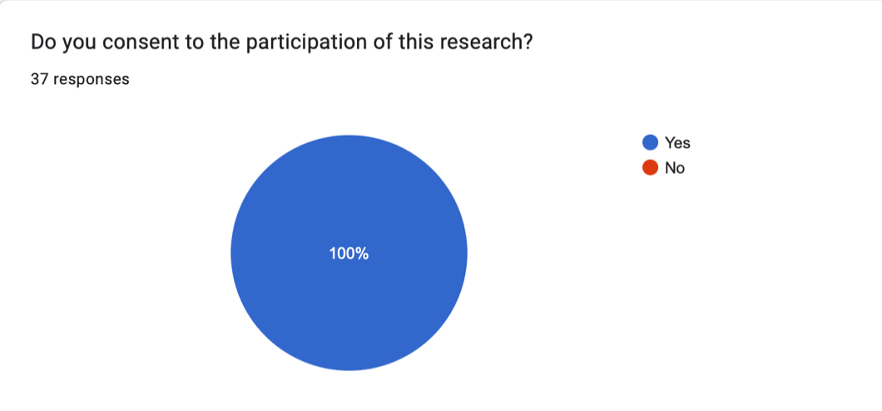
1.

Within the briefing information, to obtain the participants privacy and anonymity, if the participants wished to withdraw from the research, the participants were asked to provide a unique 4-digit code to include when emailing the contact information. This was asked as part of the second question of the survey to ensure that the participants data could easily be removed.

The third question of the survey asked what age category represented the participants to provide context to the qualitative open questions that would later be included within the survey. The age categories provided ranged from 18 to 60+, with the majority of participants aged 18 – 24 (51.4%).

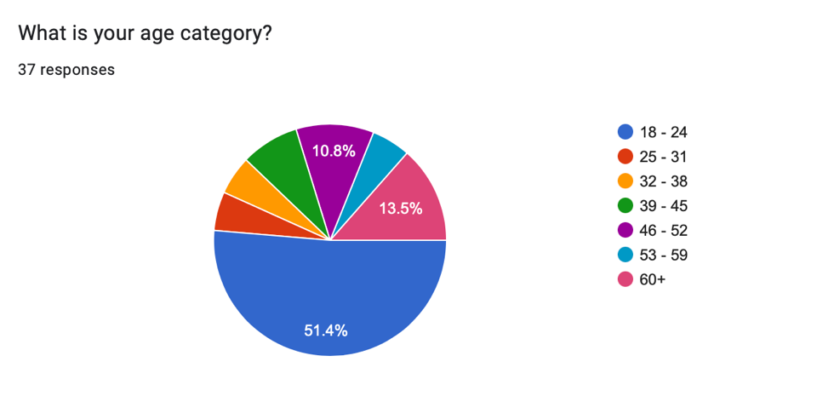
3.

The fourth question of the survey was to determine the gender of each participant. The purpose of this question was to analyse gender as a variable within qualitative open questions later included. Comparing the contents of the participants responses and if this had a relationship to the gender of the participant. 62.2% of participants (23 participants) identified as female, 35.1% of participants (13 participants) identified as male and 2.7% of participants (1 participant) identified as non-binary.
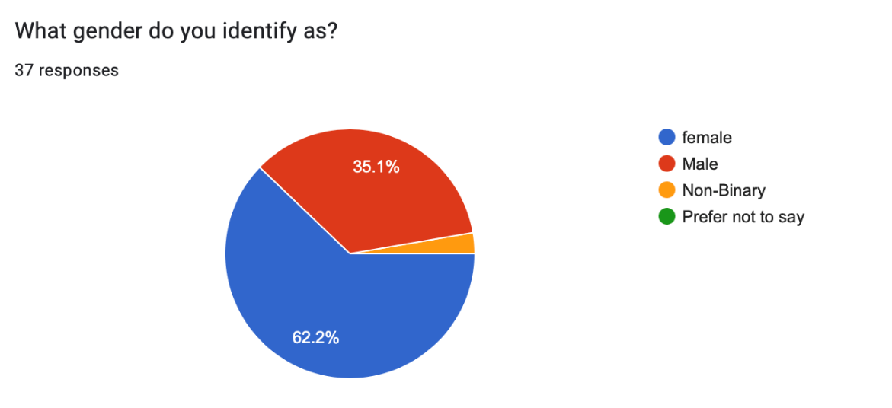
4.

The purpose of the fifth question of the survey was to determine if the participants were responsible for a child under 18. This was asked to compare and analyse the responses of participants with children and without children. 75.5% of participants responded ‘no’ to this question and 24.3% of participants responded ‘yes’ to this question.

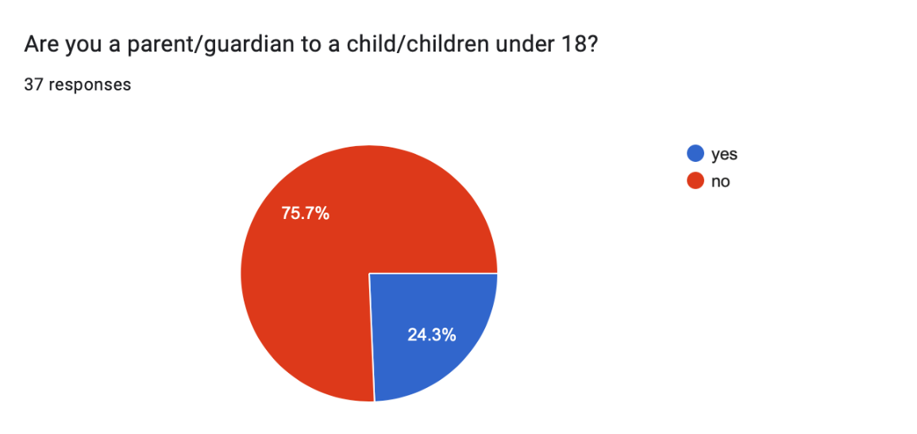
5.

The purpose of the sixth question of the survey was to understand if anyone from outside of the UK participated within the research. This was important to the research as the UK (Northern Ireland, England and Wales) has the lowest ACR in Europe (Queens University Belfast Research Portal, 2022). 100% of participants responded with ‘within the UK’.
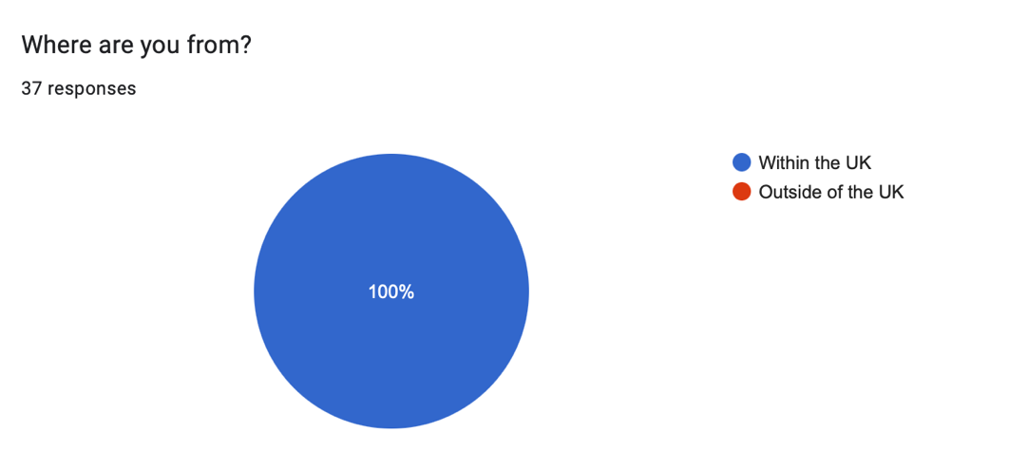
6.

The purpose of the seventh question of the survey was to reveal how much knowledge the public already had on the ACR. The results from the survey showed that 32.4% of participants responded that they did not know, whereas 67.2% of participants responded that they did know what the ACR is (see figure 7.1). However, when looking at the eighth question of the survey which asked, “Under the UK Government, the age of criminal responsibility is when a person can be criminally charged and sentenced at court. At what age do you think the UK Government deems a person to be criminally responsible and why?” out of the 25 respondents that claimed they knew what the ACR was, only 16 were correct. Through the combination of these questions, the more accurate representation shows that 56.8% of participants did not know what the ACR is and 43.2% of participants did know. See figure 7. 2.
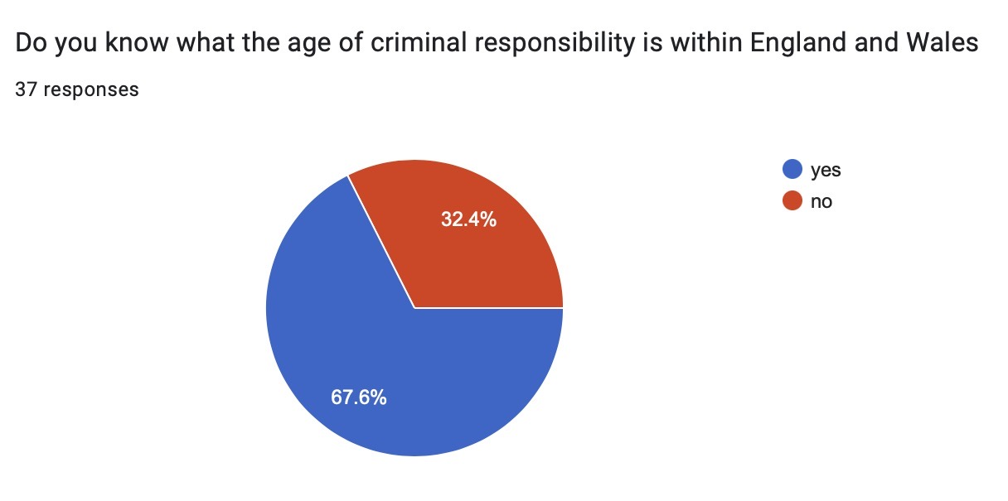
figure 7.1

Figure 7.2

Figure 7.3 also shows the responses in relation to the gender of the participants, of the 56.8% of participants that did not know what the ACR is, 66.7% of responses were female participants and 33.3% of responses were male participants.
From the findings, it is demonstrated that female participants had less knowledge surrounding the ACR, when compared to male participants. The findings representing the male participants showed that there was an even level of knowledge. Upon examining the findings, gender appears to make no impact on the public’s knowledge of the ACR.

Female. Figure 7.3
Male
Non-Binary

However, 68.6% of participants that knew what the ACR is, were aged 25 to 60+ (see figure 7.4). This shows that the younger generation, such as the 18 - 24 age category, are unaware of the legislation surrounding the ACR. This could be caused due to 25 to 60-year-olds predominately using mainstream news as their source of information and, with the rise of technology, younger generations are gathering their information from other sources. For example, a study conducted by Newman et al (2022) found that younger audiences are choosing to use social media as their source of news and distrust the mainstream news. With Newman et al (2022) reporting that particularly 18 to 34-year-olds are purposefully avoiding the news, due to feeling as though the reports negatively impacts their emotions.

Figure 7.4

In the context of participants who had children, 19.1% of participants who did not know what the ACR is, are responsible for a child or children under 18-years-old. Whereas 31.3% of participants who did know what the ACR is, are parents/guardians to 1 or more children under 18-years-old. Figure 7.5 represents the data for participants with and without children and their responses to question seven. The data may show that participants without children were more likely to be unaware of the ACR. Due to a only a small total of parents participating within the research, the data shows that having children made little to no impact on the participants’ knowledge of the ACR.

Figure 7.5
Yes

No

The eighth question of the survey asked:
“Under the UK Government, the age of criminal responsibility is when a person can be criminally charged and sentenced at court. At what age do you think the UK Government deems a person to be criminally responsible and why?”

A range of different answers were achieved however, only 51.4% of participants gave justifications for their answers. 42.2% of participants correctly answered that the ACR was 10 years old, with 6 participants including their reasoning for their answers and 1 of these participants was a parent/guardian to a child. The justifications for 5 of the participants (including the parent/guardian) justified their answers responding this is the age that children “should” or are “capable” of knowing right from wrong. The remaining participant responded that the ACR is “to reduce offending and prevent further criminal activity as an adult”.
Of the 56.8% of participants that did not know the ACR, the majority of participants (24.3%) had responded with 16 years old. 5 of the participants that thought the ACR was 16 justified their answer because it’s the “age of consent”, it’s “the legal age”, when “a child leaves school” and when “a child understands the depth of their actions”.
The participants that correctly recognised that the ACR is 10 years-old and justified their answers by stating children should know right from wrong, fail to acknowledge the premature and inexperienced mindset of a child of this age. Reiterating a viewpoint from the literature review, a child’s brain at 10 years old is at its initial stage of maturing, evolving and continues to do so for 14 years until 24 years old (Arian et al, 2013). Bateman (2013) supports the perspective of neuroscience and argues a child obtaining a moral grasp such as ‘knowing right from wrong’ is not a one-time achievement but rather a skill that is refined gradually with experience, time, and a progressing maturity. Therefore, the government and the public actively ignore a child’s vulnerabilities such as the inability to comprehend their actions, the impact their actions have and the influence of peer pressure and manipulation. This results in an undeniably harsh system that results in a criminal record, that can and will affect the trajectory of the child’s life.

The participants that expected the ACR to be 16, similar to other regulations such as the age of consent, identified that if the law allows 16-year-olds to, apply for housing (provided by the council) (UK Government, 2023), drive a moped (Driver and Vehicle Standards Agency, 2013) and work full time (NSPCC Learning, 2022) then it is logical to assume the ACR is also 16. With the evidence of neurological science and the contradictory of legislation, it is problematic to set the ACR considerably low, while civil responsibilities are much higher. Delmage (2013) acknowledges that within medicine, the age of consent to an extensive surgery is higher than the age of consent to a blood pressure check. The age threshold depends on the perceived weight of the decision. Delmage (2013) recommends that this structure of decision making could be transferred to the criminal setting whereby the ACR is higher for more serious crimes such as murder and rape.

The nineth question of the survey asked:
“The age of criminal responsibility for England and Wales is 10. Do you think this is an appropriate age for someone to be criminally responsible? Why?”

Of the 37 participants, 56.8% of participants responded that the age was unsuitable, 37.8% agreed with the legislation and responded that the age is suitable and 5.4% of participants gave responses that were deemed undetermined. See figure 8. Of the 56.8% of participants that deemed the ACR to be unsuitable many justifications included that children at 10 are “still mentally developing”, “still learning”, their “front cortex hasn’t fully developed” and they “don’t understand the consequences to their actions”. The consensus alluding to the idea that children at 10, lack the capacity to be held criminally responsible. The 37.8% of participants that consider the ACR to be suitable justified their responses by stating that children “should understand what they’re doing”, the legislation “is a preventative measure of continued offending in the future” and reaffirming that children “know right from wrong”. Thus, the public’s perspective represents the contemporary principles that are portrayed within the literature review.

The 5.4% of participants that were considered to be undetermined due to their responses represented a mixed opinion of both suitable and unsuitable, with the explanation for their answers being “it depends on the crime”. It could be argued that the public may have agreed with Delmage’s (2013) recommendation that the age threshold of the ACR, could be placed at separate ages for differentiating crimes.

Figure 8

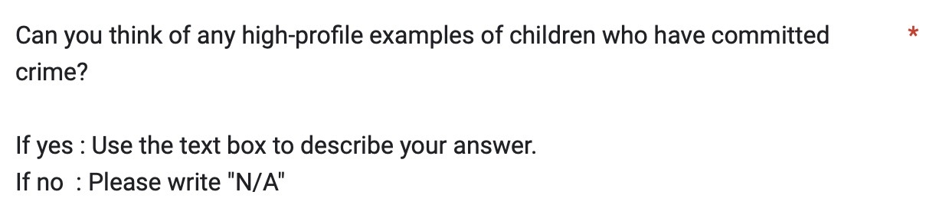
The tenth question asked:

73% of participants responded with “James Bulger”, 13.5% of participants responded with other cases of children committing acts of murder and 13.5% responded N/A. See figure 9. The ages of participants that responded James Bulger ranged between all age categories. However, 80% of participants that could not name a high-profile case or responded with a different case were under the age of 25. This could be supported by Newman et al (2022), as previously mentioned, many 18-24 year olds do not engage with mainstream news, therefore these participants are not engaging in the continued reports of the offenders that murdered James Bulger and have possibly not heard of this particular case. This data could also be explained that due to the James Bulger murder occurring 30 years ago, it is probable to interpret that these particular participants do not believe that this case can be considered high-profile within today’s society.
It was also noted that while 73% of participants acknowledged and recognised the James Bulger murder, the public still deemed the legislation to be unsuitable (56.8%) and also did not have previous knowledge of what the ACR was (56.8%). This shows that while public opinion and perspectives may have resulted in a change of legislation in 1998 through the abolishment of the Doli Incapax (Gibbon, 2016), the perspective of the public has changed and evolved in alliance to form today’s modern society, leading to the current ACR to be archaic.

Figure 9

The data from the survey indicates that the public do not have a sufficient extent of knowledge surrounding the ACR due to almost 60% of participants not knowing when a child is deemed criminally responsible within the UK. Upon learning what the ACR is and what age this begins a staggering 56.8% deemed this age was not suitable. One may believe, that if it is possible for the public’s opinions to have the authority to change the government’s policy then it is reasonable to deduce that if the public deem legislation to be unsuitable, it is possible for the ACR to be revised once more. With a multitude of research academic’s and the public supporting the reform of the ACR, it is evident that the ACR needs to be revised in today’s modern society. The Police Foundation (2020) also supports that when law organisations support and listen to the public’s opinions, this generates a perception of moral alignment resulting in the public having an improved attitude, feelings of trust and public confidence within police and the government.

