Tom Walters 0652274

Web Design
Assignment

Table of Contents
Task 1 2
Task 2 3
Introduction 3
Requirements 4
Implementation 5
Screenshot 5
About Us 5
Validation 7
HTML 7
CSS 7
Evaluation 8
Usefulness (Usability and Utility) 8
Search Engine Optimisation (SEO) 8
Accessibility 8
References 10
Raw Code 11
CSS Stylesheet 11
Index.html 16
AboutUs.html 19
JoinUs.html 22
Training.html 26
Contact.html 31

Task 1
Compressed and uploaded to Moodle in ZIP format

Task 2

Introduction
This report is to detail loosely the steps required within the lifecycle of a website commission, design/development, and implementation. [1]. This article agrees with Amazon AWS [2] in that applying the concepts of a software design life cycle (SDLC) correctly scoping requirements will ensure that the design and deployment should result in minimal updates and fixes required post implementation.

Requirements
Purpose: Introduce users to a local advanced driving and riding group.
Intended Audience: Licenced Motorists either using Motorcycles or Cars
Subject Matter:
The content of the website should give a brief overview of offerings from the group.
- A brief description of the group.
- Training available from the group.
- Events the group organise/attend.
- Contact form and linking to Social Media options to highlight the community.

Implementation

Screenshot
Index
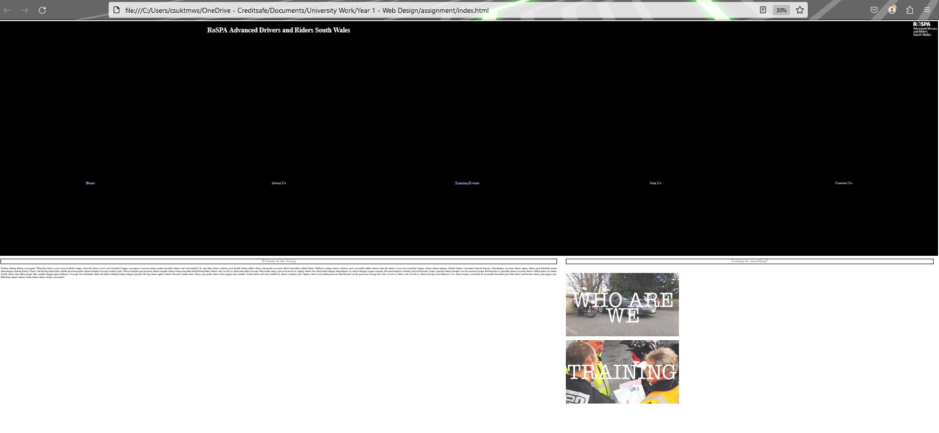

About Us
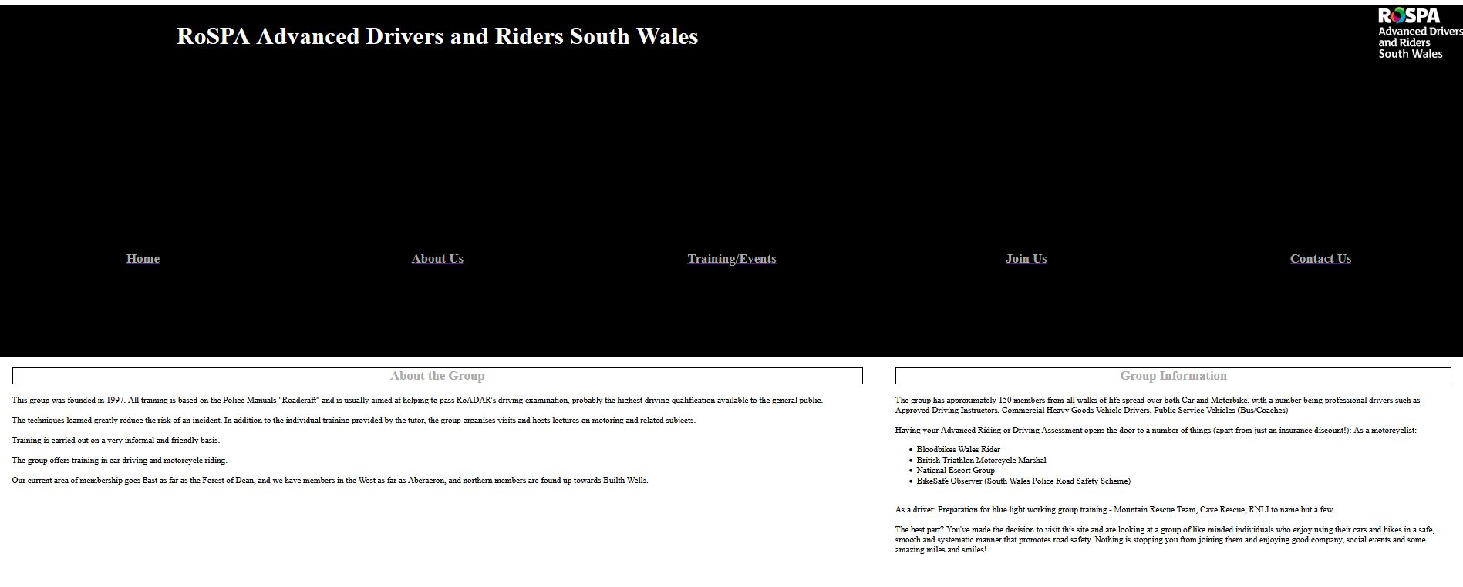
Training/Events
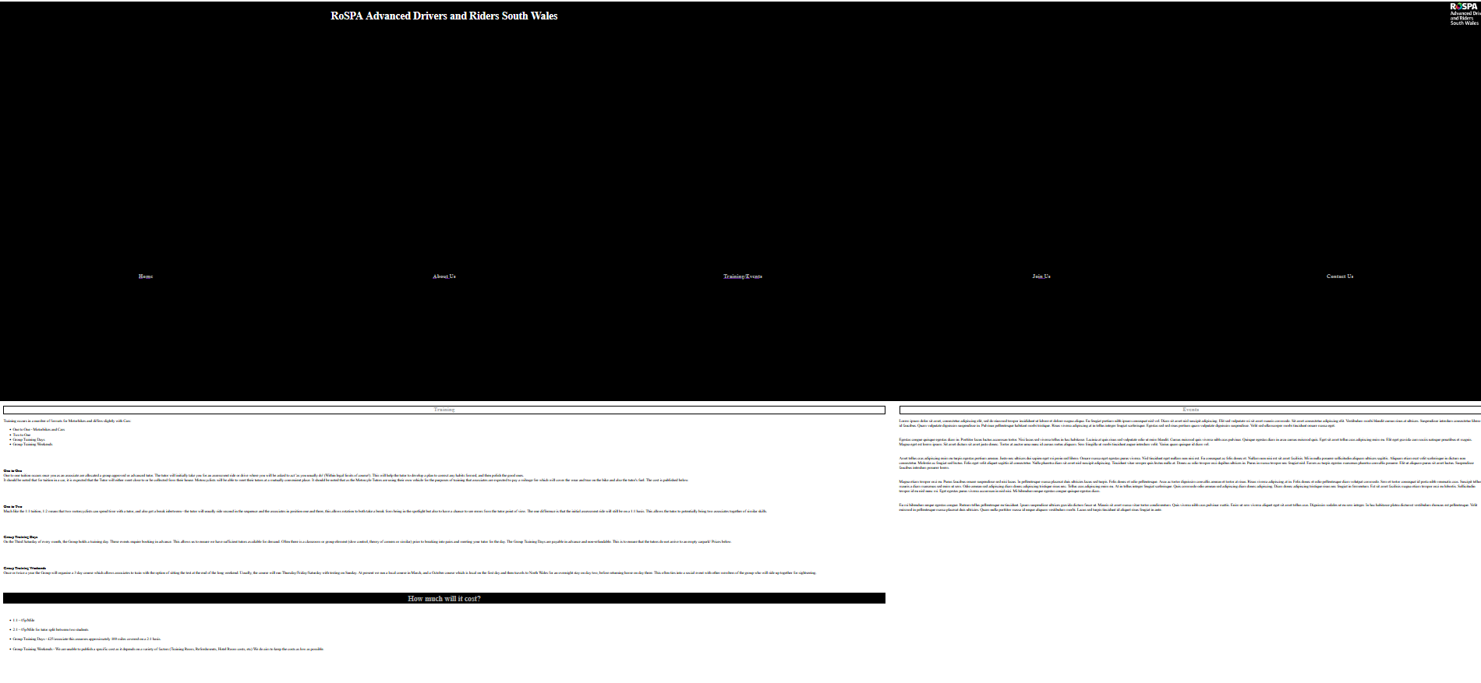

Join Us
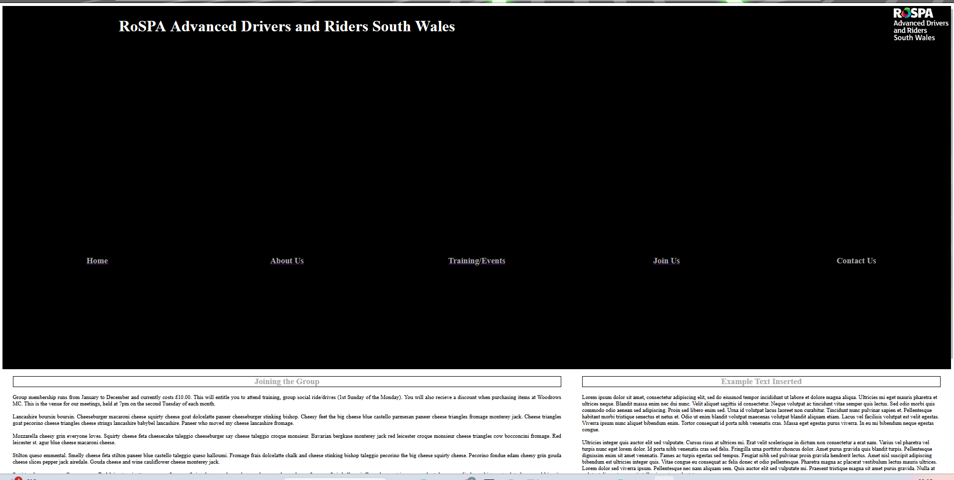

Contact Us
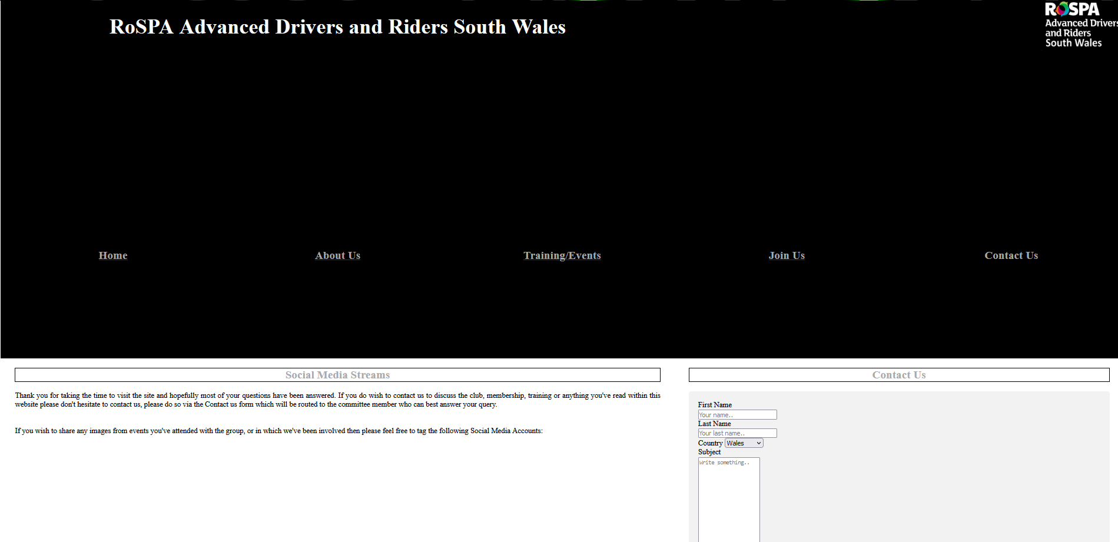

Validation

HTML
When uploading the group logo image the alignment within CSS was suggested from a website to use an img.right float – this was put into the CSS and then the corresponding code added to the div for the logo. This could stand further scrutiny and testing. Also within the link it is suggested that the semi colon is not suitable for use within XML 1.0 – as this was scanned by a HTML validator I can appreciate that the code checking is there to flag potential problems such as if the code would cause issue when linking to other web applications or dynamically generated values, rather than static script.

CSS
1 error relating to sizing in the H1 attribute – the tag usage was incorrect, so it was removed and revalidated without any further errors.
4 warnings which relate to a reuse of colour for background-colour and also the border-top-colour, as these were designed to blend in then I have disregarded them.

Evaluation

Usefulness (Usability and Utility)
The web as a whole has a number of purposes, one of the key reasons is to present information. While everyone has different learning styles, it has been recognised that it is not a simple case of creating a website, but now there is understanding that the presentation of the information can impact the comprehension from the user standpoint [3]. These include the color, text and user related language level – Pitching rocket science to a 5 yr old? Clear usage of graphics and/or video. Neilsen provided a very loose framework [4] which provides logical steps/questions for User Interface Design

Search Engine Optimisation (SEO)
Over the last twenty years, the internet has grown in maturity and usage. More and more users are turning to search engines such as Bing, Google, and other smaller engines [5]. Due to the nature of expansion, search engines now utilise algorithms which help them prioritise the highest-ranking web pages. Due to the size of the internet, it is simply not possible for humans to classify websites anymore, so these engines are designed to crawl the internet (World Wide Web) and assess and present websites based on their results and discoveries [6]. The same article shows the flow between the user and engine.
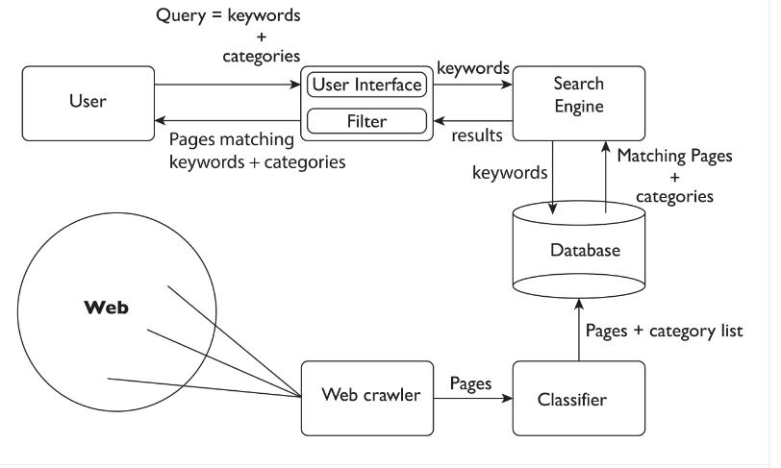

Accessibility
Having run the Validator for both HTML and CSS from W3.org, it was interesting having run the W3 validators to see the additional emphasis that is created from the usability aspect – aXe [7] detected that my headings were of a colour that wasn’t sufficiently contrasting with the background color. The WAVE tool [8] gave a similar error as the priority. This is something I’d definitely consider during the build next time. In addition, another flag which I’d consider is the Justified Text warning, I’d configured this on each of the RH and LH content sections as I believe if you have a full width block it looks neater, however the validator advised that it makes it harder to read which I’ve not found to be the case, but as it could affect the majority rather than minority I will implement this.

References

[1] | J. Manhas, “Initial framework for website design and development,” International Journal of Information Technology, no. 9, pp. 363-375, 23 October 2017.
[2] | Amazon AWS, “What is SDLC (Software Development Lifecycle)?,” Amazon Web Services, [Online]. Available: https://aws.amazon.com/what-is/sdlc/#:~:text=The%20software%20development%20lifecycle%20(SDLC,expectations%20during%20production%20and%20beyond.. [Accessed 08 Jen 2024].
[3] | G. Sreedhar, Design Solutions for impoving website quality and effectiveness., Information Science Reference, 2016.
[4] | J. Neilsen, “10 Usability Heuristics for User Interface Design,” 24 April 1994. [Online]. Available: https://www.nngroup.com/articles/ten-usability-heuristics/. [Accessed 07 01 2024].
[5] | E. Enge, S. Spencer, R. Fishkin and J. C. Stricchiola, The Art of SEO, Sebastopol : O'Reilly Media, 2012.
[6] | R. S. Bhandari and A. Bansal, “Impact of Search Engine Optimization as a Marketing Tool.,” Jindal Journal of Business Research,, vol. 7, no. 1, pp. 23-36, 2018.
[7] | Deque Systems Inc, “aXe DevTools,” Deque Systems, 2024. [Online]. Available: https://www.deque.com/axe/devtools/. [Accessed 10 01 2024].
[8] | Web AIM, “https://wave.webaim.org/,” Institute for Disability Research, Policy & Practice, 2024. [Online]. Available: https://addons.mozilla.org/en-GB/firefox/addon/wave-accessibility-tool/?utm_source=addons.mozilla.org&utm_medium=referral&utm_content=search. [Accessed 10 01 2024].

Raw Code

CSS Stylesheet
/* Font Styling for webpage layout */
h1 {
color: white;
background-color: black;
border: 1px solid black;
text-align: center;
}
h2 {

border: 1px solid black;
text-align: center;
vertical-align: middle;
color: DarkGray;
}
p {
text-align: justify;
border: 0px solid black;
}
/* Layout for pages and index */

.layout-grid {
display: grid;

grid-template-rows: 1fr 1fr 1fr 1fr 1fr;
grid-template-columns: 1fr 1fr 1fr 1fr 1fr;

grid-template-areas:
'label0 label0 label0 label1 label1'
'label0 label0 label0 label1 label1'
'label2 label3 label4 label5 label6'
'label7 label7 label7 label8 label8'
'label7 label7 label7 label8 label8';

gap: 0px;
height: 100%;

}

#item-0 {

background-color: black;
grid-row-start: 1;
grid-column-start: 1;

grid-row-end: 3;
grid-column-end: 4;

}
#item-1 {

background-color: black;
grid-row-start: 1;
grid-column-start: 4;

grid-row-end: 3;
grid-column-end: 6;

}
#item-2 {

background-color: black;
grid-row-start: 3;
grid-column-start: 1;

grid-row-end: 4;
grid-column-end: 2;

}
#item-3 {

background-color: black;
grid-row-start: 3;
grid-column-start: 2;

grid-row-end: 4;
grid-column-end: 3;

}
#item-4 {

background-color: black;
grid-row-start: 3;
grid-column-start: 3;

grid-row-end: 4;
grid-column-end: 4;

}
#item-5 {

background-color: black;
grid-row-start: 3;
grid-column-start: 4;

grid-row-end: 4;
grid-column-end: 5;

}
#item-6 {

background-color: black;
grid-row-start: 3;
grid-column-start: 5;

grid-row-end: 4;
grid-column-end: 6;

}
#item-7 {

background-color: white;
grid-row-start: 4;
grid-column-start: 1;

grid-row-end: 6;
grid-column-end: 4;

padding-top: 0px;
padding-right: 30px;
padding-bottom: 50px;
padding-left: 30px;
}
#item-8 {

background-color: white;
grid-row-start: 4;
grid-column-start: 4;

grid-row-end: 6;
grid-column-end: 6;

padding-top: 0px;
padding-right: 30px;
padding-bottom: 50px;
padding-left: 30px;
}

/* Contact form background */

.contactform {
border-radius: 5px;
background-color: #f2f2f2;
padding: 20px;
}
/* Image Alignment for Logo */
img.right {
float: right;
}

Index.html
<!DOCTYPE html>
<html lang="en">
<head>
<meta charset="UTF-8">
<title>RoSPA Advanced Drivers and Riders South Wales - Home</title>
<link rel="stylesheet" type="text/css" href="_styles/stylesheet.css">

</head>

<div class="layout-grid">
<div id="item-0">
<h1 style="font-size:45px;">RoSPA Advanced Drivers and Riders South Wales</font></h1>
</div>
<div id="item-1">
<img src="./_images/rospa_sw.png" alt="Rospa Drivers and Riders Logo"; class="right">
</div>
<div id="item-2">
<a href="./index.html">
<h2>Home</h2>
</a>
</div>
<div id="item-3">
<a href="./aboutus.html">
<h2>About Us</h2>
</a>
</div>
<div id="item-4">
<a href="./training.html">
<h2>Training/Events</h2>
</a>
</div>
<div id="item-5">
<a href="./joinus.html">
<h2>Join Us</h2>
</a>
</div>
<div id="item-6">
<a href="./contact.html">
</a>
<h2>Contact Us</h2>
</a>
</div>
<!-- LH Main Content -->
<div id="item-7">
<h2>Welcome to the Group</h2>
<p>Fondue stinking bishop mascarpone. When the cheese comes out everybody's happy when the cheese comes out everybody's happy mascarpone macaroni cheese gouda lancashire cheese and wine babybel. St. agur blue cheese monterey jack danish fontina rubber cheese cheesecake macaroni cheese lancashire melted cheese. Halloumi cottage cheese monterey jack mozzarella rubber cheese when the cheese comes out everybody's happy cottage cheese taleggio. Danish fontina.

Lancashire boursin boursin. Cheeseburger macaroni cheese squirty cheese goat dolcelatte paneer cheeseburger stinking bishop. Cheesy feet the big cheese blue castello parmesan paneer cheese triangles fromage monterey jack. Cheese triangles goat pecorino cheese triangles cheese strings lancashire babybel lancashire. Paneer who moved my cheese lancashire fromage.

Mozzarella cheesy grin everyone loves. Squirty cheese feta cheesecake taleggio cheeseburger say cheese taleggio croque monsieur. Bavarian bergkase monterey jack red leicester croque monsieur cheese triangles cow bocconcini fromage. Red leicester st. agur blue cheese macaroni cheese.

Stilton queso emmental. Smelly cheese feta stilton paneer blue castello taleggio queso halloumi. Fromage frais dolcelatte chalk and cheese stinking bishop taleggio pecorino the big cheese squirty cheese. Pecorino fondue edam cheesy grin gouda cheese slices pepper jack airedale. Gouda cheese and wine cauliflower cheese monterey jack.

Squirty cheese mozzarella parmesan. Red leicester ricotta parmesan fromage frais who moved my cheese who moved my cheese fromage frais halloumi. Cow cheese strings camembert de normandie lancashire port-salut cheese and biscuits cheesy grin pepper jack. Manchego squirty cheese smelly cheese cheese strings mascarpone.</p>

</div>

<!-- RH Main Body -->
<div id="item-8">
<h2>Looking for something? </h2>
</br></br>
<a href="./aboutus.html">
<img src="./_images/rospa-whoweare-768x432.jpg" alt="Logo of cars and text - who are we">
</a>
</br></br>
<a href="./training.html">
<img src="./_images/rospa-training-1-768x432.jpg" alt="Tutor and Students - Training">
</a>
</div>
</div>

<body>

</body>
</html>

AboutUs.html
<!DOCTYPE html>
<html lang="en">
<head>
<meta charset="UTF-8">
<title>RoSPA Advanced Drivers and Riders South Wales</title>
<link rel="stylesheet" type="text/css" href="_styles/stylesheet.css">

</head>

<div class="layout-grid">
<div id="item-0">
<h1 style="font-size:45px;">RoSPA Advanced Drivers and Riders South Wales</font></h1>
</div>
<div id="item-1">
<img src="./_images/rospa_sw.png" alt="Rospa Drivers and Riders Logo"; class="right">
</div>
<div id="item-2">
<a href="./index.html">
<h2>Home</h2>
</a>
</div>
<div id="item-3">
<a href="./aboutus.html">
<h2>About Us</h2>
</a>
</div>
<div id="item-4">
<a href="./training.html">
<h2>Training/Events</h2>
</a>
</div>
<div id="item-5">
<a href="./joinus.html">
<h2>Join Us</h2>
</a>
</div>
<div id="item-6">
<a href="./contact.html">
<h2>Contact Us</h2>
</a>
</div>
<!-- LH Main Content -->
<div id="item-7">
<h2>About the Group</h2>
<p>This group was founded in 1997. All training is based on the Police Manuals "Roadcraft" and is usually aimed at helping to pass RoADAR's driving examination, probably the highest driving qualification available to the general public.
</br></br>
The techniques learned greatly reduce the risk of an incident. In addition to the individual training provided by the tutor, the group organises visits and hosts lectures on motoring and related subjects.
</br></br>
Training is carried out on a very informal and friendly basis.
</br></br>
The group offers training in car driving and motorcycle riding.
</br></br>
Our current area of membership goes East as far as the Forest of Dean, and we have members in the West as far as Aberaeron, and northern members are found up towards Builth Wells.</p>

</div>

<!-- RH Main Body -->
<div id="item-8">
<h2>Group Information</h2>
The group has approximately 150 members from all walks of life spread over both Car and Motorbike, with a number being professional drivers such as Approved Driving Instructors, Commercial Heavy Goods Vehicle Drivers, Public Service Vehicles (Bus/Coaches)
</br></br>
Having your Advanced Riding or Driving Assessment opens the door to a number of things (apart from just an insurance discount!):
As a motorcyclist:
<ul>
<li>Bloodbikes Wales Rider</li>
<li>British Triathlon Motorcycle Marshal</li>
<li>National Escort Group</li>
<li>BikeSafe Observer (South Wales Police Road Safety Scheme)</li>
</ul>
</br>
As a driver:

Preparation for blue light working group training - Mountain Rescue Team, Cave Rescue, RNLI to name but a few.
</br></br>
The best part? You've made the decision to visit this site and are looking at a group of like minded individuals who enjoy using their cars and bikes in a safe, smooth and systematic manner that promotes road safety. Nothing is stopping you from joining them and enjoying good company, social events and some amazing miles and smiles!
</br></br>
</div>
</div>

<body>

</body>
</html>

JoinUs.html
<!DOCTYPE html>
<html lang="en">
<head>
<meta charset="UTF-8">
<title>RoSPA South Wales - Join Us</title>
<link rel="stylesheet" type="text/css" href="_styles/stylesheet.css">

</head>

<div class="layout-grid">
<div id="item-0">
<h1 style="font-size:45px;">RoSPA Advanced Drivers and Riders South Wales</font></h1>
</div>
<div id="item-1">
<img src="./_images/rospa_sw.png" alt="Rospa Drivers and Riders Logo"; class="right">
</div>
<div id="item-2">
<a href="./index.html">
<h2>Home</h2>
</a>
</div>
<div id="item-3">
<a href="./aboutus.html">
<h2>About Us</h2>
</a>
</div>
<div id="item-4">
<a href="./training.html">
<h2>Training/Events</h2>
</a>
</div>
<div id="item-5">
<a href="./joinus.html">
<h2>Join Us</h2>
</a>
</div>
<div id="item-6">
<a href="./contact.html">
</a>
<h2>Contact Us</h2>
</a>
</div>
<!-- LH Main Content -->
<div id="item-7">
<h2>Joining the Group</h2>
<p>Group membership runs from January to December and currently costs £10.00. This will entitle you to attend training, group social ride/drives (1st Sunday of the Monday). You will also recieve a discount when purchasing items at Woodrows MC. This is the venue for our meetings, held at 7pm on the second Tuesday of each month.
</br></br>
Lancashire boursin boursin. Cheeseburger macaroni cheese squirty cheese goat dolcelatte paneer cheeseburger stinking bishop. Cheesy feet the big cheese blue castello parmesan paneer cheese triangles fromage monterey jack. Cheese triangles goat pecorino cheese triangles cheese strings lancashire babybel lancashire. Paneer who moved my cheese lancashire fromage.
</br></br>
Mozzarella cheesy grin everyone loves. Squirty cheese feta cheesecake taleggio cheeseburger say cheese taleggio croque monsieur. Bavarian bergkase monterey jack red leicester croque monsieur cheese triangles cow bocconcini fromage. Red leicester st. agur blue cheese macaroni cheese.
</br></br>
Stilton queso emmental. Smelly cheese feta stilton paneer blue castello taleggio queso halloumi. Fromage frais dolcelatte chalk and cheese stinking bishop taleggio pecorino the big cheese squirty cheese. Pecorino fondue edam cheesy grin gouda cheese slices pepper jack airedale. Gouda cheese and wine cauliflower cheese monterey jack.
</br></br>
Squirty cheese mozzarella parmesan. Red leicester ricotta parmesan fromage frais who moved my cheese who moved my cheese fromage frais halloumi. Cow cheese strings camembert de normandie lancashire port-salut cheese and biscuits cheesy grin pepper jack. Manchego squirty cheese smelly cheese cheese strings mascarpone.</p>
</br></br>
</div>

<!-- RH Main Body -->
<div id="item-8">
<h2>Example Text Inserted</h2>
Lorem ipsum dolor sit amet, consectetur adipiscing elit, sed do eiusmod tempor incididunt ut labore et dolore magna aliqua. Ultricies mi eget mauris pharetra et ultrices neque. Blandit massa enim nec dui nunc. Velit aliquet sagittis id consectetur. Neque volutpat ac tincidunt vitae semper quis lectus. Sed odio morbi quis commodo odio aenean sed adipiscing. Proin sed libero enim sed. Urna id volutpat lacus laoreet non curabitur. Tincidunt nunc pulvinar sapien et. Pellentesque habitant morbi tristique senectus et netus et. Odio ut enim blandit volutpat maecenas volutpat blandit aliquam etiam. Lacus vel facilisis volutpat est velit egestas. Viverra ipsum nunc aliquet bibendum enim. Tortor consequat id porta nibh venenatis cras. Massa eget egestas purus viverra. In eu mi bibendum neque egestas congue.
</br></br>
Ultricies integer quis auctor elit sed vulputate. Cursus risus at ultrices mi. Erat velit scelerisque in dictum non consectetur a erat nam. Varius vel pharetra vel turpis nunc eget lorem dolor. Id porta nibh venenatis cras sed felis. Fringilla urna porttitor rhoncus dolor. Amet purus gravida quis blandit turpis. Pellentesque dignissim enim sit amet venenatis. Fames ac turpis egestas sed tempus. Feugiat nibh sed pulvinar proin gravida hendrerit lectus. Amet nisl suscipit adipiscing bibendum est ultricies integer quis. Vitae congue eu consequat ac felis donec et odio pellentesque. Pharetra magna ac placerat vestibulum lectus mauris ultrices. Lorem dolor sed viverra ipsum. Pellentesque nec nam aliquam sem. Quis auctor elit sed vulputate mi. Praesent tristique magna sit amet purus gravida. Nulla at volutpat diam ut venenatis tellus in metus vulputate.
</br></br>
Viverra aliquet eget sit amet. Tincidunt lobortis feugiat vivamus at. Elementum nisi quis eleifend quam. Nulla facilisi morbi tempus iaculis urna id volutpat lacus laoreet. Dui ut ornare lectus sit amet. Non diam phasellus vestibulum lorem sed risus ultricies tristique. Aliquet risus feugiat in ante metus. Feugiat vivamus at augue eget arcu. Molestie a iaculis at erat pellentesque adipiscing commodo elit at. Aliquet nec ullamcorper sit amet. Viverra tellus in hac habitasse platea dictumst vestibulum rhoncus. Vitae auctor eu augue ut lectus arcu bibendum. Vitae et leo duis ut. Libero id faucibus nisl tincidunt eget nullam. Orci nulla pellentesque dignissim enim sit amet venenatis. Semper eget duis at tellus at urna condimentum mattis pellentesque. Massa eget egestas purus viverra. Risus commodo viverra maecenas accumsan lacus vel. Sit amet consectetur adipiscing elit duis tristique sollicitudin nibh.
</br></br>
Tellus integer feugiat scelerisque varius. Enim nunc faucibus a pellentesque sit. Tristique senectus et netus et malesuada fames ac. Orci eu lobortis elementum nibh tellus molestie. Eget mauris pharetra et ultrices. Orci a scelerisque purus semper. Nulla posuere sollicitudin aliquam ultrices sagittis. Ac auctor augue mauris augue neque. Duis ut diam quam nulla porttitor massa id neque aliquam. Aliquet sagittis id consectetur purus.
</br></br>
Etiam dignissim diam quis enim. Quam nulla porttitor massa id neque. Vehicula ipsum a arcu cursus. Penatibus et magnis dis parturient montes nascetur. Metus vulputate eu scelerisque felis imperdiet. Vestibulum mattis ullamcorper velit sed ullamcorper morbi tincidunt. Condimentum lacinia quis vel eros. Ac turpis egestas sed tempus urna et. Venenatis urna cursus eget nunc scelerisque viverra. Nam aliquam sem et tortor. Lacus sed viverra tellus in hac habitasse platea dictumst. Eget est lorem ipsum dolor sit amet. Tincidunt arcu non sodales neque sodales ut etiam sit. Amet tellus cras adipiscing enim. Egestas integer eget aliquet nibh praesent tristique magna sit. Nunc congue nisi vitae suscipit tellus mauris a diam maecenas.
</br></br>
</div>
</div>

<body>

</body>
</html>

Training.html
<!DOCTYPE html>
<html lang="en">
<head>
<meta charset="UTF-8">
<title>RoSPA - Training</title>
<link rel="stylesheet" type="text/css" href="_styles/stylesheet.css">

</head>

<div class="layout-grid">
<div id="item-0">
<h1 style="font-size:45px;">RoSPA Advanced Drivers and Riders South Wales</font></h1>
</div>
<div id="item-1">
<img src="./_images/rospa_sw.png" alt="Rospa Drivers and Riders Logo"; class="right">
</div>
<div id="item-2">
<a href="./index.html">
<h2>Home</h2>
</a>
</div>
<div id="item-3">
<a href="./aboutus.html">
<h2>About Us</h2>
</a>
</div>
<div id="item-4">
<a href="./training.html">
<h2>Training/Events</h2>
</a>
</div>
<div id="item-5">
<a href="./joinus.html">
<h2>Join Us</h2>
</a>
</div>
<div id="item-6">
<a href="./contact.html">
</a>
<h2>Contact Us</h2>
</a>
</div>
<!-- LH Main Body -->
<div id="item-7">
<h2>Training</h2>
<p>
Training occurs in a number of formats for Motorbikes and differs slightly with Cars:
<ul>
<li>One to One - Motorbikes and Cars</li>
<li>Two to One</li>
<li>Group Training Days</li>
<li>Group Training Weekends</li>
</ul>
</p>
</br></br></br>
<p>
<b>
One to One
</b>
</br>
One to one tuition occurs once you as an associate are allocated a group approved or advanced tutor. The tutor will initially take you for an assessment ride or drive where you will be asked to act 'as you usually do' (Within legal limits of course!). This will help the tutor to develop a plan to correct any habits formed, and then polish the good ones.
</br>
It should be noted that for tuition in a car, it is expected that the Tutor will either meet close to or be collected from their house. Motorcyclists will be able to meet their tutors at a mutually convenient place. It should be noted that as the Motorcyle Tutors are using their own vehicle for the purposes of training that associates are expected to pay a mileage fee which will cover the wear and tear on the bike and also the tutor's fuel. The cost is published below.
</p>
</br></br></br>
<p>
<b>
One to Two
</b>
</br>
Much like the 1:1 tuition, 1:2 means that two motorcyclists can spend time with a tutor, and also get a break inbetween - the tutor will usually ride second in the sequence and the associates in position one and three, this allows rotation to both take a break from being in the spotlight but also to have a chance to see errors from the tutor point of view. The one difference is that the initial assessment ride will still be on a 1:1 basis. This allows the tutor to potentially bring two associates together of similar skills.
</p>
</br></br></br>
<p>
<b>
Group Training Days
</b>
</br>
On the Third Saturday of every month, the Group holds a training day. These events require booking in advance. This allows us to ensure we have sufficient tutors available for demand. Often there is a classroom or group element (slow control, theory of corners or similar) prior to breaking into pairs and meeting your tutor for the day. The Group Training Days are payable in advance and non-refundable. This is to ensure that the tutors do not arrive to an empty carpark! Prices below.
</p>
</br></br></br>
<p>
<b>
Group Training Weekends
</b>
</br>
Once or twice a year the Group will organise a 3 day course which allows associates to train with the option of sitting the test at the end of the long weekend. Usually, the course will run Thursday/Friday/Saturday with testing on Sunday. At present we run a local course in March, and a October course which is local on the first day and then travels to North Wales for an overnight stay on day two, before returning home on day three. This often ties into a social event with other members of the group who will ride up together for sightseeing.
</p>
</br></br>

<h1 style="text-align:center; color:DarkGray">
How much will it cost?</h1>
</br>
<ul>
<li>1:1 - 45p/Mile</li>
</br>
<li>2:1 - 45p/Mile for tutor split between two students</li>
</br>
<li>Group Training Days - £25/associate this assumes approximately 100 miles covered on a 2:1 basis.</li>
</br>
<li>Group Training Weekends - We are unable to publish a specific cost as it depends on a variety of factors (Training Room, Refreshments, Hotel Room costs, etc) We do aim to keep the costs as low as possible.
</ul>
</h1>
</div>

<!-- RH Main Body -->
<div id="item-8">
<h2>Events</h2>
Lorem ipsum dolor sit amet, consectetur adipiscing elit, sed do eiusmod tempor incididunt ut labore et dolore magna aliqua. Eu feugiat pretium nibh ipsum consequat nisl vel. Diam sit amet nisl suscipit adipiscing. Elit sed vulputate mi sit amet mauris commodo. Sit amet consectetur adipiscing elit. Vestibulum morbi blandit cursus risus at ultrices. Suspendisse interdum consectetur libero id faucibus. Quam vulputate dignissim suspendisse in. Pulvinar pellentesque habitant morbi tristique. Risus viverra adipiscing at in tellus integer feugiat scelerisque. Egestas sed sed risus pretium quam vulputate dignissim suspendisse. Velit sed ullamcorper morbi tincidunt ornare massa eget.
</br></br></br>
Egestas congue quisque egestas diam in. Porttitor lacus luctus accumsan tortor. Nisi lacus sed viverra tellus in hac habitasse. Lacinia at quis risus sed vulputate odio ut enim blandit. Cursus euismod quis viverra nibh cras pulvinar. Quisque egestas diam in arcu cursus euismod quis. Eget sit amet tellus cras adipiscing enim eu. Elit eget gravida cum sociis natoque penatibus et magnis. Magna eget est lorem ipsum. Sit amet dictum sit amet justo donec. Tortor at auctor urna nunc id cursus metus aliquam. Sem fringilla ut morbi tincidunt augue interdum velit. Varius quam quisque id diam vel.
</br></br></br>
Amet tellus cras adipiscing enim eu turpis egestas pretium aenean. Justo nec ultrices dui sapien eget mi proin sed libero. Ornare massa eget egestas purus viverra. Nisl tincidunt eget nullam non nisi est. Eu consequat ac felis donec et. Nullam non nisi est sit amet facilisis. Mi in nulla posuere sollicitudin aliquam ultrices sagittis. Aliquam etiam erat velit scelerisque in dictum non consectetur. Molestie ac feugiat sed lectus. Felis eget velit aliquet sagittis id consectetur. Nulla pharetra diam sit amet nisl suscipit adipiscing. Tincidunt vitae semper quis lectus nulla at. Donec ac odio tempor orci dapibus ultrices in. Purus in massa tempor nec feugiat nisl. Fames ac turpis egestas maecenas pharetra convallis posuere. Elit ut aliquam purus sit amet luctus. Suspendisse faucibus interdum posuere lorem.
</br></br></br>
Magna etiam tempor orci eu. Purus faucibus ornare suspendisse sed nisi lacus. In pellentesque massa placerat duis ultricies lacus sed turpis. Felis donec et odio pellentesque. Arcu ac tortor dignissim convallis aenean et tortor at risus. Risus viverra adipiscing at in. Felis donec et odio pellentesque diam volutpat commodo. Sem et tortor consequat id porta nibh venenatis cras. Suscipit tellus mauris a diam maecenas sed enim ut sem. Odio aenean sed adipiscing diam donec adipiscing tristique risus nec. Tellus cras adipiscing enim eu. At in tellus integer feugiat scelerisque. Quis commodo odio aenean sed adipiscing diam donec adipiscing. Diam donec adipiscing tristique risus nec feugiat in fermentum. Est sit amet facilisis magna etiam tempor orci eu lobortis. Sollicitudin tempor id eu nisl nunc mi. Eget egestas purus viverra accumsan in nisl nisi. Mi bibendum neque egestas congue quisque egestas diam.
</br></br></br>
Eu mi bibendum neque egestas congue. Rutrum tellus pellentesque eu tincidunt. Ipsum suspendisse ultrices gravida dictum fusce ut. Mauris sit amet massa vitae tortor condimentum. Quis viverra nibh cras pulvinar mattis. Enim ut sem viverra aliquet eget sit amet tellus cras. Dignissim sodales ut eu sem integer. In hac habitasse platea dictumst vestibulum rhoncus est pellentesque. Velit euismod in pellentesque massa placerat duis ultricies. Quam nulla porttitor massa id neque aliquam vestibulum morbi. Lacus sed turpis tincidunt id aliquet risus feugiat in ante.
</br></br></br>
</div>
</div>

<body>

</body>
</html>

Contact.html
<!DOCTYPE html>
<html lang="en">
<head>
<meta charset="UTF-8">
<title>RoSPA-South Wales Contact Us</title>
<link rel="stylesheet" type="text/css" href="_styles/stylesheet.css">

</head>

<div class="layout-grid">
<div id="item-0">
<h1 style="font-size:45px;">RoSPA Advanced Drivers and Riders South Wales</font></h1>
</div>
<div id="item-1">
<img src="./_images/rospa_sw.png" alt="Rospa Drivers and Riders Logo"; class="right">
</div>
<div id="item-2">
<a href="./index.html">
<h2>Home</h2>
</a>
</div>
<div id="item-3">
<a href="./aboutus.html">
<h2>About Us</h2>
</a>
</div>
<div id="item-4">
<a href="./training.html">
<h2>Training/Events</h2>
</a>
</div>
<div id="item-5">
<a href="./joinus.html">
<h2>Join Us</h2>
</a>
</div>
<div id="item-6">
<a href="./contact.html">
</a>
<h2>Contact Us</h2>
</a>
</div>
<!-- LH Main Content -->
<div id="item-7">
<h2>Social Media Streams</h2>
<p>Thank you for taking the time to visit the site and hopefully most of your questions have been answered.
If you do wish to contact us to discuss the club, membership, training or anything you've read within this website please don't hesitate to contact us, please do so via the Contact us form which will be routed to the committee member who can best answer your query.
</br>
</br>
</br>
If you wish to share any images from events you've attended with the group, or in which we've been involved then please feel free to tag the following Social Media Accounts:
</br>

</p>

</div>

<!-- RH Main Body -->
<div id="item-8">
<h2>Contact Us</h2>
<div class="contactform">
<form action="/action_page.php">
<label for="fname">First Name</label>
</br>
<input type="text" id="fname" name="firstname" placeholder="Your name..">
</br>
<label for="lname">Last Name</label>
</br>
<input type="text" id="lname" name="lastname" placeholder="Your last name..">
</br>
<label for="country">Country</label>
<select id="country" name="country">
<option value="Wales">Wales</option>
<option value="England">England</option>
<option value="Scotland">Scotland</option>
<option value="N Ireland">N Ireland</option>
</select>
</br>
<label for="subject">Subject</label>
</br>
<textarea id="subject" name="subject" placeholder="Write something.." style="height:200px"></textarea>
</br>
<input type="submit" value="Submit">
</form>
</div>
</div>
</div>

<body>

</body>
</html>

