

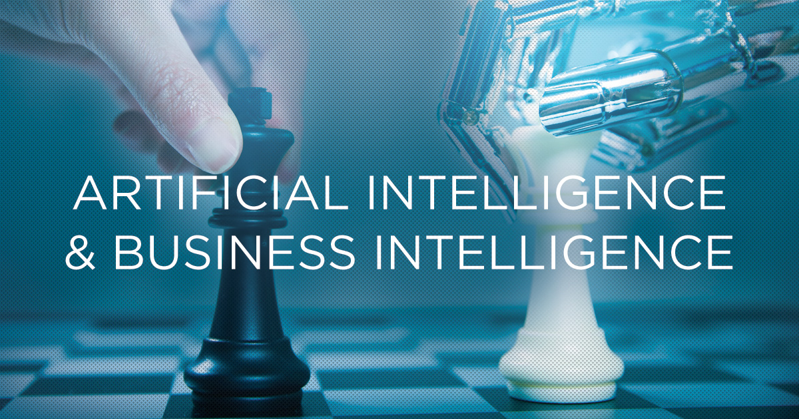

Programme: BA (HONS) Business Management
Module: Data Handling & Business Intelligence
Module code: LCBB5000
Lecturer: Dr Xavier Matieni
Student name: Vasilica Gherasim
Student ID: 2110943

Table of contents

1. Introduction …………………………………………………………. 3
2. What does Business Intelligence mean? ……. ………………………3
3. What does Artificial Intelligence explained …... …………………….3
4. Artificial Intelligence versus Business Intelligence ………………….4
5. Conclusion ……………………………………………………………5
6. References ……………………………………………………………6

1.Introduction

On this work I will try to explain the differences between Business Intelligence and Artificial Intelligence and how they will cooperate in the future. At all levels of any company, there is a greater need for information security professionals due to the ongoing battle against cyberattacks. Therefore, it becomes more crucial than ever to handle incoming data as information sets. It is crucial to incorporate subjectivity, and error into conventional decision-making procedures for these reasons. Business intelligence refers to the tools, techniques, and applications used by companies and organisations to gather, integrate, analyse, and present business data. Business data helps companies make better decisions. Artificial intelligence programmes can learn and make good decisions by mimicking human actions and reasoning.

2. What does Business Intelligence mean?

To provide historical, real-time, and predictive insights into company operations, business intelligence systems typically use data gathered in a data warehouse or data mart, but they may rarely use operational data. Applications can handle a variety of business data sources, such as sales, production, financials, and more, to manage tasks like business performance. Information about other companies in a given sector that compete with one another or produce goods that are produced or sold in similar markets is frequently gathered through a method called benchmarking. The administration of data and content should be seen as one integrated business strategy rather than as two distinct information management facets, as organisations are now starting to realise.
The process of turning data into information that can be used to influence strategic and tactical business decisions within a company is known as business intelligence. Business intelligence tools use datasets to access and analyse data, then present the findings in reports, summaries, dashboards, graphs, charts, and maps that provide users with a thorough understanding of the state of the business. OLAP (Online Analytical Processing), knowledge management, data mining, data visualization, value analysis, reporting, and teamwork platforms are just a few examples of the numerous components that make up business intelligence.
Business intelligence is frequently used to refer to a wide range of tools that offer fast and simple access to details about the current state of an organisation based on available data.

3. What does Artificial Intelligence explained

While Business Intelligence prioritises streamlining data gathering, reporting, and analysis processes, Artificial Intelligence adopts a different strategy. Businesses can use to improve the frequency and quality of their data gathering. As a result, we must comprehend artificial intelligence are functionality and capabilities, as well as how it is managing the enormous amounts of data thrown to us, to make decisions about our day-to-day operations as stakeholders in our company with confidence. To advance our understanding, we also require better information. Artificial intelligence systems can mimic human actions and mental processes to learn and make wise decisions. Artificial intelligence is capable of acting autonomously on orders in addition to just giving them to human operators. Business intelligence greatly simplifies data analysis while leaving decision-making to humans, whereas artificial intelligence enables computers to make business choices independently.
Chatbots, for instance, can respond to consumer inquiries devoid of human involvement, using chatbots and other artificial intelligence-based software can boost productivity and profitability. Artificial intelligence can both direct human workers' actions and perform those actions itself, so it is capable of more than just providing clarity in a confusing situation. You might be wondering, after reading what I've written about artificial intelligence, what precisely artificial intelligence is, and the basic principles involved. Artificial intelligence is the term used to describe a computer programme or a machine capacity to learn and reason similarly to a person. It is also an area of study with the goal of creating "smart" machines. However, there are crucial related truths that you should be aware of, including:
- It's crucial to understand the various varieties of artificial intelligence and the various phases of its development when developing application programmes.
- If the various forms of artificial intelligence and the variety of related uses are not understood, confusion may result, and expectations may differ greatly from reality.

4. Artificial Intelligence versus Business Intelligence

Differences and similarities business intelligence and artificial intelligence are tools that are becoming more crucial but frequently misunderstood in a company setting. These days, famous trends like artificial intelligence and business intelligence have extra features that give them a functional foundation. Artificial intelligence is built on the investigation and modelling of human cognition, and the underlying algorithm mimics the operations of the human brain. Contrarily, business intelligence is just technology that is used to enhance business solution selection. Companies are turning to artificial intelligence solutions to gather, process, analyse, and aggregate information from massive amounts of data, to help them deliver their data as a product. Artificial intelligence software is made to work long hours and finish jobs more quickly and effectively. Big data is also having the following effects on companies across all industries: Artificial intelligence has advanced in a number of fields, including government functions, education, banking, healthcare, manufacturing, retail, and the stock market. This input is typically acknowledged when the algorithm closely resembles the structure of the human brain. Even though the fields of study, artificial intelligence and business intelligence are used in research. The primary uses of artificial intelligence are in robotics, fuzzy logic, and artificial neural networks.
Artificial intelligence and business intelligence go together perfectly. Artificial intelligence-based alerts, from simple trigger alerts to advanced neural network alerts, keep an eye on artificial intelligence and business intelligence. By letting them know as soon as something occurs, these alerts assist a company in maintaining complete control over crucial success factors. These advancements in artificial intelligence will continue to alter how business data is used when coupled with new business displays. All of this relieves companies from the tiresome task of poring over data to spot trends and address pricey issues.

In essence, artificial intelligence is used to build expert systems that mimic human intellect, company analysis goal is to provide effective and efficient company solutions. The artificial intelligence of today will serve as the foundation for the intelligent robots of the future, which will be designed to carry out any duties given to them. Future computing agents may be based on these machines, which can handle data much more quickly than the human brain. To put it another way, selection can be reduced to a straightforward action that a physical entity can take.

5. Conclusion

For programmes and organisations whose fundamental functions rely on human intelligence, artificial intelligence is crucial. It is possible to deduce the symbolic operations and symbology that are primarily used in digital computers from human intelligence. Managing reports and using data mining and data storage techniques to assess data are at the heart of business intelligence. Business intelligence is used by the company to extract reliable information from data. This includes straightforward functional analysis and worksheet analysis. It is necessary to evaluate the variables to decide whether business intelligence, artificial intelligence, or a combination of the two should be used to build the applications. To sum up, artificial intelligence allows us to view our data in a way that will be advantageous to us rather than being overwhelmed by its volume. Finally, both business intelligence and artificial intelligence have a wide range of applications, some of which rarely overlap. The study of artificial intelligence examines how computer systems can imitate various aspects of human intelligence, such as problem-solving, learning, and reasoning. Business data collection and analysis using a variety of tools and platforms is known as business intelligence. The main objective of business intelligence is to give organisations valuable data and analytics to support decision-making. Businesses can now make choices nearly five times more quickly thanks to business intelligence. Business intelligence is viewed from one perspective, while artificial intelligence the ability of a computer programme or machine to reason and learn similarly to how people naturally do is viewed from another.

6. References

1. Leonardo dos Santos Pinheiro and Mark Dras, “Stock Market Prediction with Deep Learning: A Characterbased Neural Language Model for Event-based Trading.” https://www.aclweb.org/anthology/U17-1001

2. https://www.sas.com/en_us/insights/analytics/machinelearning.html

3. https://towardsdatascience.com/aifortrading2edd6fac689d#58e2

4. Zohuri, B. and Mossavar Rahmani, F., Artificial Intelligence Driven Resiliency with Machine Learning and Deep Learning Components”, Short Article, International Journal of Nanotechnology & Nanomedicine, Volume 4 | Issue 2 | 1 of 8.

5. Anthony Liew, Walden, Understanding Data, Information, Knowledge and Their Inter-Relationships, Journal of Knowledge Management Practice, Vol. 8, No. 2, June 2007.

6. Roman Stanek, Founder & CEO of Good Data Corporation with its post on internet dated October 26, 2018 under title of “Artificial Intelligence is the Future of Business Intelligence”.

