Matthew Satterthwaite
Student: 1910496

ACDA6009 – L6 Systems Engineering

Document: Design Book
Pen-Y-Scape Autonomous Gardening System

11 November 2022

Contents
Contents ii
1 Introduction 1
1.1 Document Scope 1
2 Systems Thinking 1
2.1 Quality Functional Deployment (QFD) 1
3 QFD 1 2
3.1 Inputs 2
3.2 Methodology 2
3.3 Stakeholder Management 3
3.4 Gathering Requirements 3
3.5 Validation of Requirements 7
3.6 Functionality 7
3.7 Output 8
4 QFD2 9
4.1 Inputs 9
4.2 Functional Means 9
4.3 Pugh Chart 10
4.4 Function Test Procedures 11
4.5 Relationships 11
4.6 Outputs 12
5 QFD 3 13
5.2 Methodology 13
5.3 P Diagram, What and Why? 13
5.4 Functional Means, Again 15
5.5 Manufacturing & Assembly 16
6 QFD4 19
6.1 Inputs 19
6.2 Process Focus 21
6.3 Output 22
7 Conclusion 22
8 References 23
List of Figures
Figure 2-1: QFD 1 to QFD 4 1
Figure 3-1: QFD 1 Construction 2
Figure 3-2: QFD1 Inputs and Output 2
Figure 3-3: Pen-Y-Scape Stakeholder Influence Map 3
Figure 3-4: Basic and Delighter requirements [5] 4
Figure 3-5: Affinity Diagram 4
Figure 3-6: Requirement Example 5
Figure 3-7: Requirement Levels 6
Figure 3-8: Design QFD1 7
Figure 3-9: Additional Functions 7
Figure 3-10: Full Functional Importance 8
Figure 4-1: QFD 2 Construction 9
Figure 4-2: Snippet of Function Means Analysis 9
Figure 4-3: System Pugh Diagram 10
Figure 4-4: Test Importance 11
Figure 4-5: QFD 2 Relationships 11
Figure 4-6: Feature Importance 12
Figure 5-1: QFD 3 Construction 13
Figure 5-2: What, Why Layout 14
Figure 5-3: What Why Output 14
Figure 5-4: Pugh Sub-System Chart 15
Figure 5-5: Manufacturing Functionality 16
Figure 5-6: Manufacturing Function Importance 16
Figure 5-7: Manufacturing Functional Means 17
Figure 5-8: Manufacturing Means Importance 17
Figure 5-9: QFD 3 Layout 18
Figure 6-1: QFD4 Layout 19
Figure 6-2: 1st QFD4 20
Figure 6-3: Process Importance 21

List of Tables
Table 5-1: Noise Factors 12

Introduction

Document Scope

An opportunity has been presented to develop a complete lawn care system that goes one further than autonomous lawn mowers by treating the turf and providing professional finishes.

This document details the steps taken to develop the idea from initial customer requirements through to process and manufacturing control measures.

Systems Thinking

Quality Functional Deployment (QFD)

QFD is a 4-step process that incorporates a specific set of tools used to effectively define customer requirements[1].

QFD focusses on understanding the requirements to develop a design that satisfies the consumers demands. These demands are transformed into design targets and quality assurance points so that potential errors, obstacles, or failure modes can be identified at the design stage, before it is too late [2]
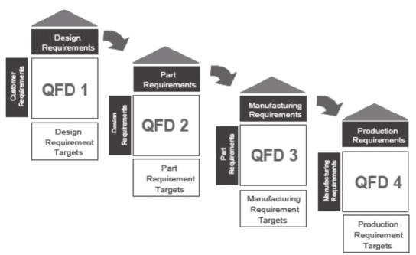
Figure 2-1: QFD 1 to QFD 4

QFD 1

Inputs

QFD1 was constructed using the following inputs.
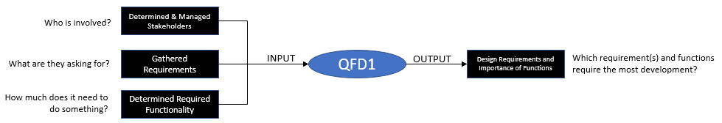
Figure 3-1: QFD 1 Construction

Methodology

This stage was all about translating what the customer wants into how it is going to be done. The “customer” at this point is defined broadly and is not necessarily the end user, but groups of stakeholders in the project [3].

Figure 3-2 demonstrated the layout of the QFD1 table with the bottom box – importance – being the output from this stage.
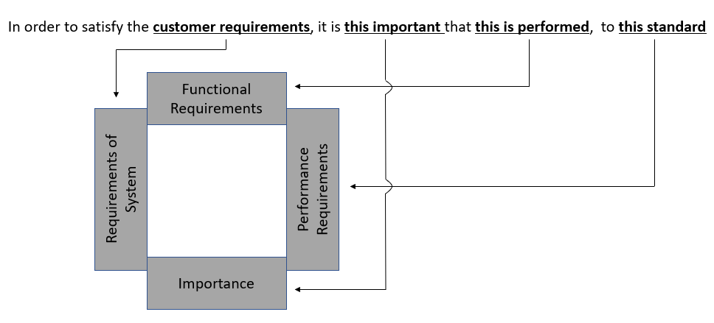
Figure 3-2: QFD1 Inputs and Output

Stakeholder Management

An influence stakeholder map was created for the Pen-Y-Scape system to capture the stakeholders and the interactions between them.

This was an important step in understanding the overall scope of the entire system. The end user only told of their personal requirements. For the system to satisfy those requirements a group of sub-systems will need to be involved.
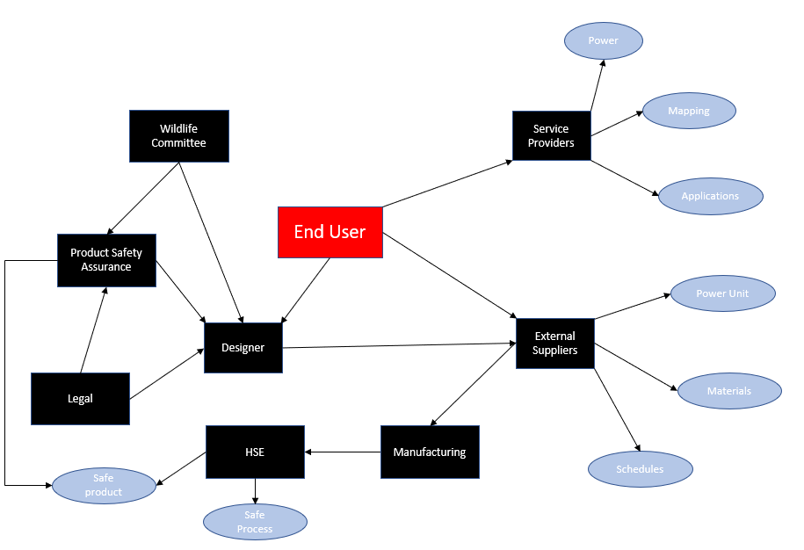
Figure 3-3: Pen-Y-Scape Stakeholder Influence Map

Each one of these stakeholders will have their owns sets of requirements. It was important to filter these into key stakeholders by levelling them by their relationships from the end user. Another method would be to group all of these stakeholders based on similar requirements i.e., manufacturing, external suppliers, and design.

Gathering Requirements

Once all stakeholders were identified, their requirements were gathered individually.

The most important step of this process was digging out the 3 types of unspoken requirements from the stakeholder. Stakeholders typically only ask for the requirements that they consider typically important to their part of the system, better known as the expressed requirements [4].

Creating a system that achieves all expressed requirements could still leave opportunity to miss any requirements that the stakeholders assumed the system could do. There is also the opportunity to provide something that the customer does not know they want yet, but if provided would delight.

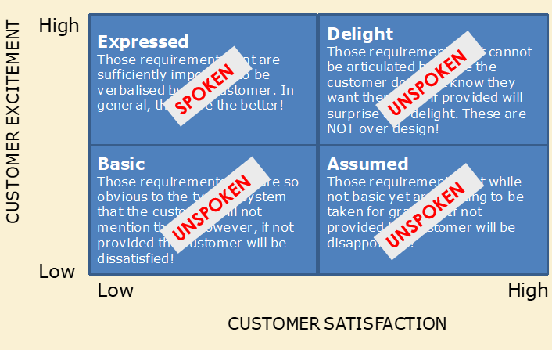
Figure 3-4: Basic and Delighter requirements [5]

Other methods where needed to extract these requirements from the stakeholders. A Gemba visit was conducted to observe current systems. It was important to observe without obstructing the system and interview the end users, running our suggestions by them soon after.

From the interview, the customer spoke of critical issues with their current system. These system complaints were captures so that we could understand the underlying issues. Measurable expectations were developed and reviewed before being agreed as additional requirements. This process is known as Voice of Customer translation (VoC) and converts complaints into requirements.

All requirements were then grouped using the Sixth Sigma Affinity Diagram process. This method allowed us to organize a large number of individual ideas into meaningful groups. The headings of the groups would later become our functionality requirements i.e. fuel system, signal system.
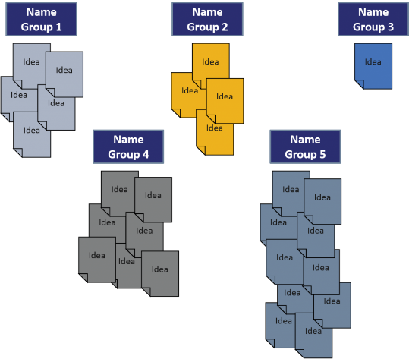
Figure 3-5: Affinity Diagram

The requirements under each heading then required re-writing to make them “good requirements”. They needed to be clear, concise, consistent, correct, confirmable and a complete sentence.

This also allowed several requirements to be covered under one, written requirement as explained below.

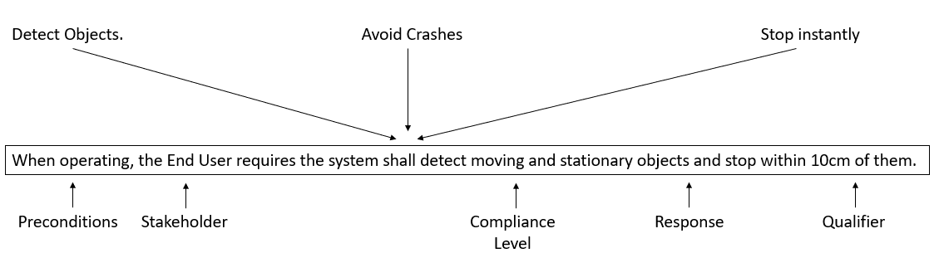
Figure 3-6: Requirement Example

These requirements were then organized and captured within a two-level system.

Figure 3-7: Requirement Levels

Validation of Requirements

Before inputting these requirements into the QFD1 matrix, we first had to validate them to ensure we are designing the correct system, by designing it to these requirements. It was important to do this to reduce the chances of system defects, design flaws or delivering the wrong system. In theory, if the requirements are correct, the system is design to meet these requirements, the system is built to meet that design and it works as expected – then the system can be delivered with confidence.

Functionality

The required functionality of the system is very rarely given by the customer and must be determined by the design authority.

These requirements have a Verb-Noun relationship and do not suggest a solution. Typical examples used within the Pen-Y-Scape are Power system, receive signal and detect objects.

The functions and then scored against the requirements to determine the importance of the functions, detailed below.
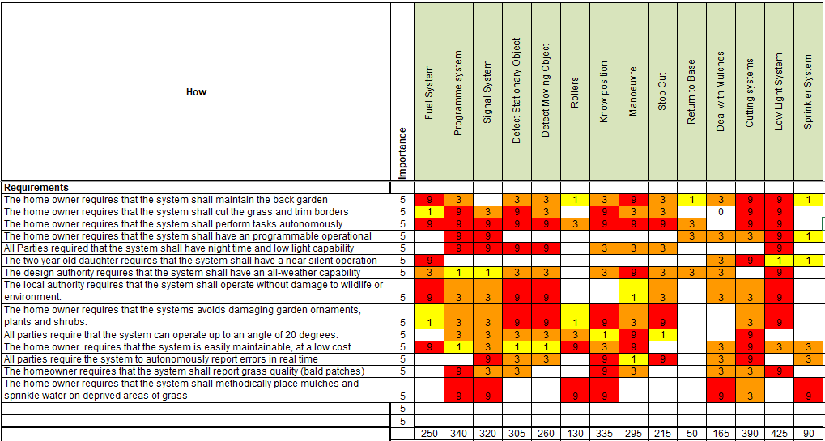
Figure 3-8: Design QFD1

Correctly written functions provide us as the manufacturers the opportunity to perform failure modes analysis at this very early stage for scenarios like not enough power, wrong signal or no objects detected.

This can lead to additional functions being added alongside the ones that were identified when grouping our requirements.
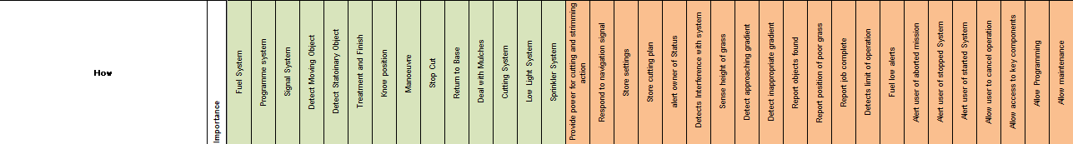
Figure 3-9: Additional Functions

Output

By scoring either a 1 for weak, 3 for medium or 9 for a strong relationship between the functions and the written requirements, the most important functions can now be identified. These are the requirements that have the strongest relationship with the most requirements, and therefore shall require the most attention.
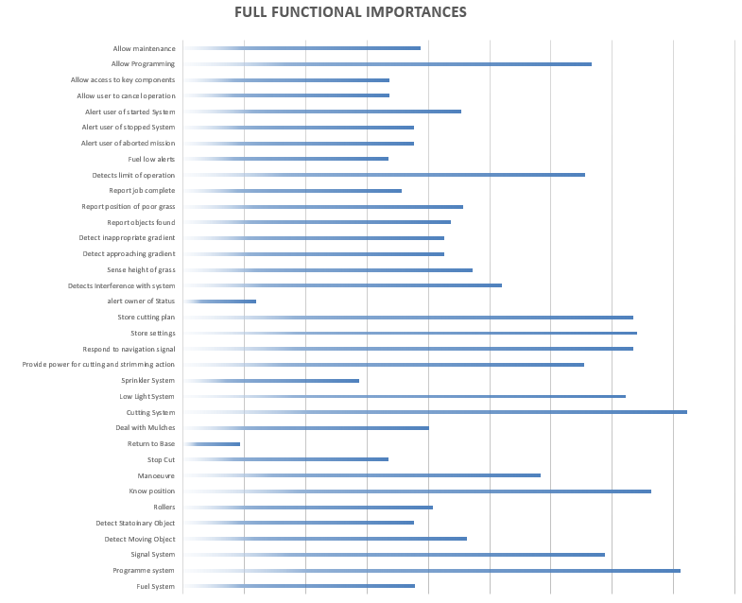Figure 3-10: Full Functional Importance

QFD1 is a live document that will grow continually throughout the systems life. Emergent functionalities like “whilst operational, the system shall cut the power and render safe if an overcurrent is detected” will be added and may slightly change the functional importance outlook.

Other requirements will be uncovered once the solutions have been selected and the way that the system is held together is determined.

QFD2

Inputs

QFD2 was constructed using the following inputs.
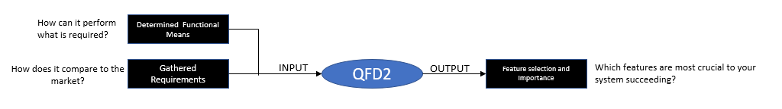
Figure 4-1: QFD 2 Construction

Functional Means

Now that the functions have been selected and the requirements of those functions have been identified, we then had to determine how those functions could be performed.

A functional means analysis was used to document all of the different methods that would allow our functions to achieve their requirements.

Several ideas were listed for each function, with the best two being carried forward to create Concept A (green) and Concept B (yellow). Reasons for selection and rejection were noted and can be found in the function means meeting minutes.

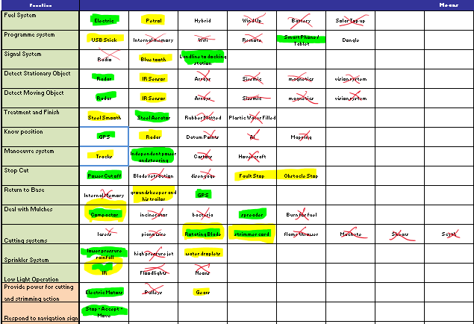
Figure 4-2: Snippet of Function Means Analysis

Pugh Chart

The next step was to evaluate the performance of these concepts based upon how the current market leading system performs against the customer requirements. This was done by using a Pugh Diagram with the John Deere Tango ES [6].

Figure 4-3: System Pugh Diagram

Both concepts were scored higher than the John Deere System, with Concept one beating it by 10 points and not scoring less than it at any stage. This told us that our system, if built correctly would be a great improvement on the current market leader – when assessed against the customer requirements.

With regards to Concept 2, is scored lower that both Concept A and the John Deere in only 2 areas due its internal combustion engine. But, due to the noise and environmental impact being such an important factor for the stakeholders it had quite a large impact on its final evaluation.

Function Test Procedures

Once the system configuration was decided, a concept was illustrated and sent to the customers for assessment.

A follow up meeting was conducted, where the integrated test and evaluation acceptance plan (ITEAP) was presented. This plan detailed how all of the functions will be tested. It was then agreed between how parties what the acceptable and not acceptable ranges of these tests will be.

All tests’ methods went through a relationship scoring procedure, or functional metrics, to determine how many functions will be tested during each individual test.

Figure 4-4: Test Importance

Relationships

Design QFD 2 was laid out in the following format to establish these relationships:

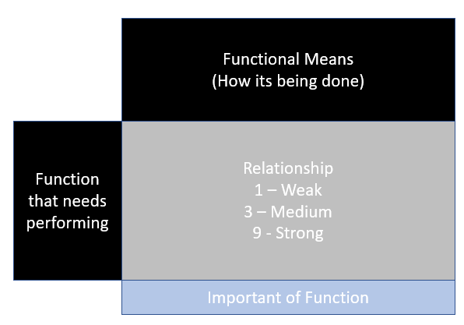
Figure 4-5: QFD 2 Relationships

Outputs

The major output from the QFD 2 process is that we determined out important features. These – more important – features are where most of the time and finances will be spent, whereas the less important features, like detachable ancillaries, will still require development but it can be done so more cheaply when compared to the smart phone application, or the cloud memory signal.
Figure 4-6: Feature Importance

QFD 3

QFD3 was constructed using the following inputs.

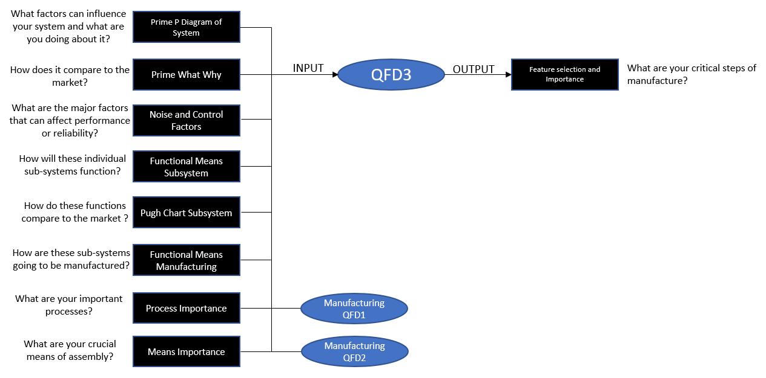
Figure 5-1: QFD 3 Construction

Methodology

QFD 3 includes repeating very similar steps to QFD 1 and QFD2 but considering how parts can be made and how these parts can be put together.

The system is evaluated as a whole before being broken down into subsystems to assess how they can be assembled, manufactured or whether they will be purchased and installed.

P Diagram, What and Why?

A Parameter diagram is a graphical tool used to identify key functions, requirements, and potential failure modes. The P diagram documents noise factors including Unit to Unit variation, Deterioration and Wear, Environmental or External Noise and Customer Interaction.
Table 5-1: Noise Factors
Noise Factor | Example
Unit to Unit Variation | Variation in Connection Quality
Deterioration and Wear | Tire Wear
External | Rain, Wind
Customer Interaction | Incorrect Programming

The system control factors are also included within the P diagram, as well as the undesired outputs or side effects. These parameters are input into a What, Why matrix to determine the importance of both the noise factors and of the control parameters. The layout of the What, Why matrix is detailed below.
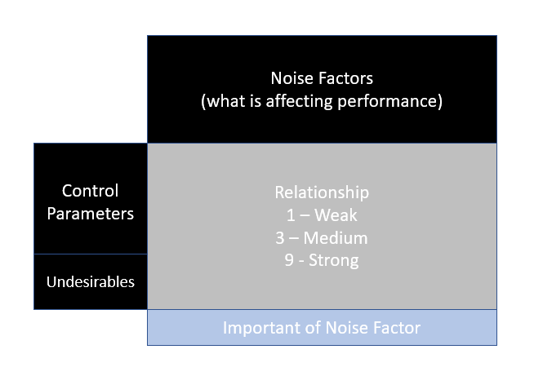
Figure 5-2: What, Why Layout

This is a vitally important step in the design stage as the tools tell you what the most important control parameters are, and whether they interact with the noise factors that will have the most effect on the systems performance. For the Pen-Y-Mow, this was the case.
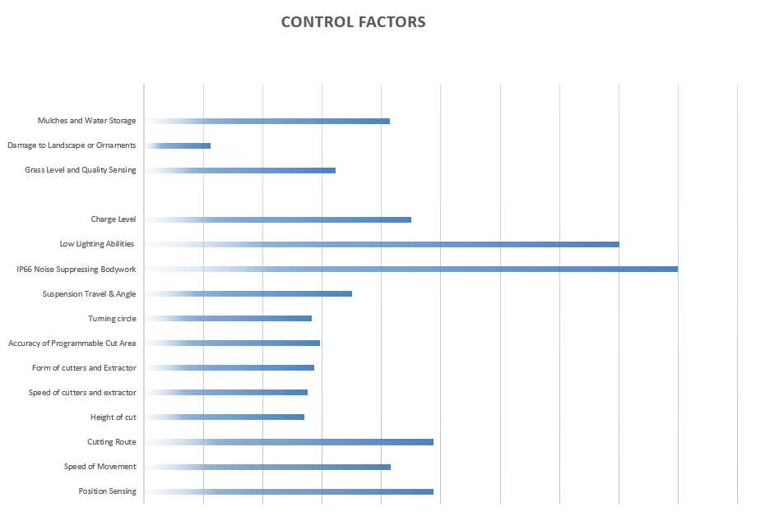
The most crucial control factor was the Weatherproof, Sound suppressing body panels. These will allow easy maintenance access as well as housing components. They will also protect all components against debris and harsh weather, which were all the highest scoring noise factors.
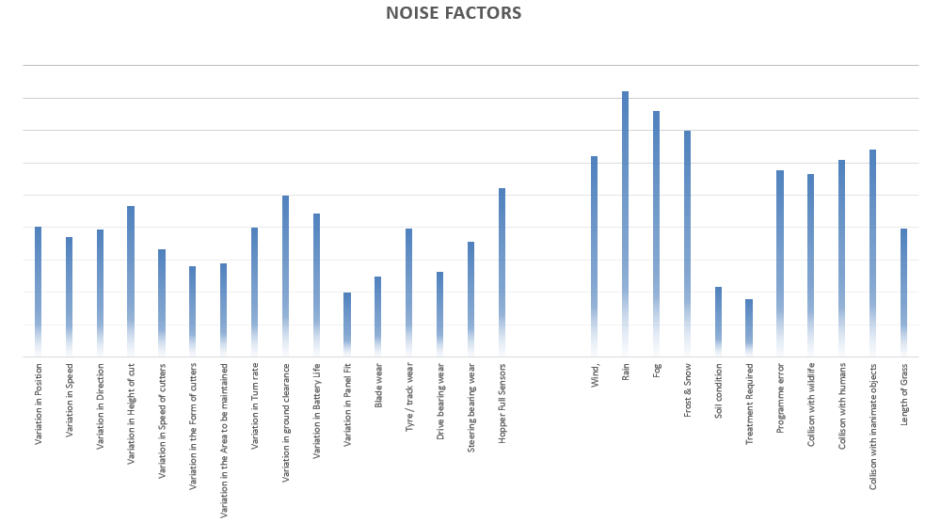
Figure 5-3: What Why Output

Functional Means, Again

The next step was to break the system down into sub systems, to analyze the best method of completing that function. Sub System functions included determining the method of housing the battery pack, providing drive to the cutting blade, and extracting mulches.

The functional means table was used alongside a Pugh chart like before, however in a slightly different order. All possible candidates were scored against each other before the best sub-system function was selected.

For this example, the subsystem to transmit cutting force to the central blade was used.

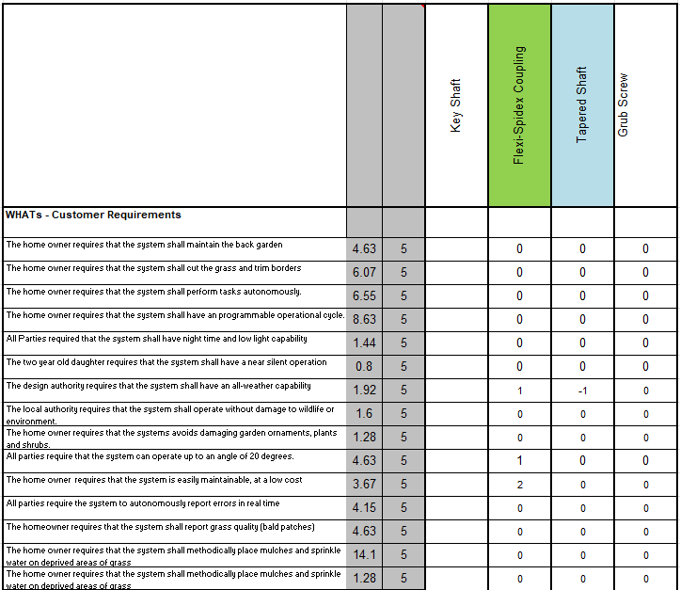
Figure 5-4: Pugh Sub-System Chart

This process was repeated for every sub-system until the functional means table had all of its methods selected. A P diagram and What, Why table was also created for each individual sub-system to ensure that all noise factors and control parameters were noted and relevant.

The benefit of this extra work at sub-system level is that it can identify what could affect the performance of that individual part and alert you to the most crucial sequence in that components manufacture and assembly.

Manufacturing & Assembly

Now that the method has been selected, the next step was to identify the most crucial steps of manufacture.

With the design being primarily dependent on several black box systems like the mobile application and the battery pack, the manufacturing QFD was focused mainly on integrating these purchased items with the system i.e., fitting the battery to the chassis.

These manufacturing requirements were process mapped and then used to create a manufacturing QFD 1, scoring the requirements against headings such as labour, safety, reliability, and quality.

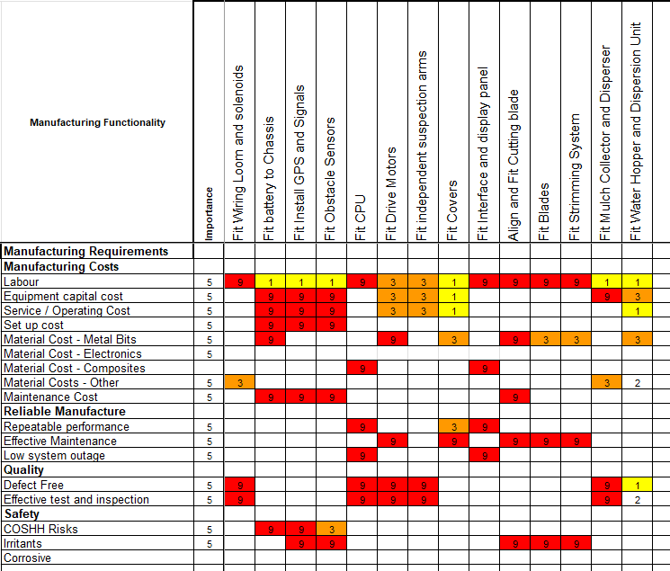
Figure 5-5: Manufacturing Functionality

The output of the Manufacturing QFD1 was the importance of our manufacturing functions.

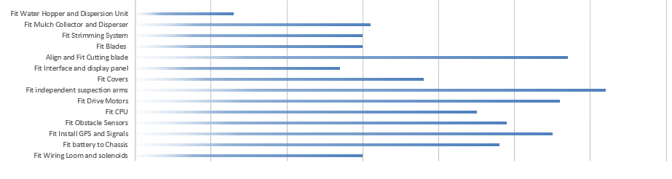
Figure 5-6: Manufacturing Function Importance

Now that the manufacturing functions have been determined, it is important to evaluate methods of completing that function. This requires an additional functional means matrix.

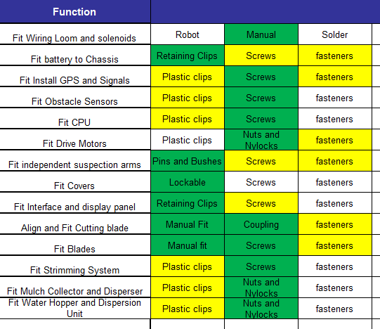
Figure 5-7: Manufacturing Functional Means

A hybrid assembly model was selected after comparing full manual or full robotic assembly in a Pugh diagram. Sub-Systems that are position critical will be robotically assembled.

These means were then compiled into the manufacturing QFD2. Using the same method as all previous QFD’s, this gave us our means importance.

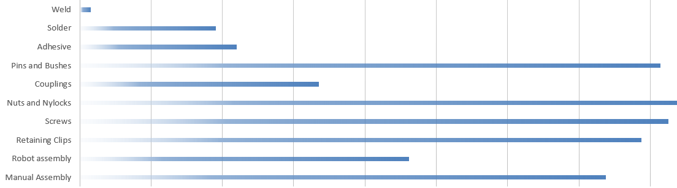
Figure 5-8: Manufacturing Means Importance

Figure 5-8 shows us that the assembly of the Pen-Y-Scape is a mainly manual process that relies heavily on the fixtures and fittings being used.

Output

The selected manufacturing means was then scored against the important design features in QFD3.
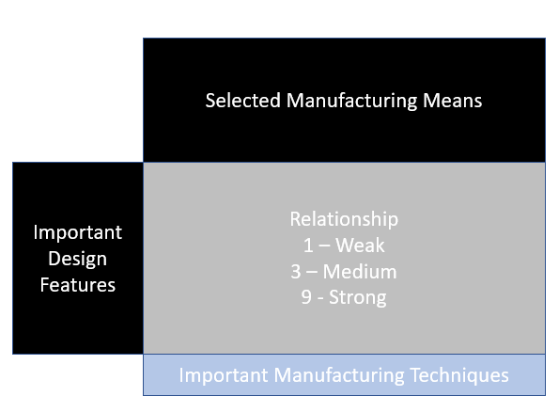
Figure 5-9: QFD 3 Layout

The output from QFD3 was a graphical representation of our important manufacturing techniques. Manual assembly was by far the most important technique, so several control measures will have to be implemented at QFD4.

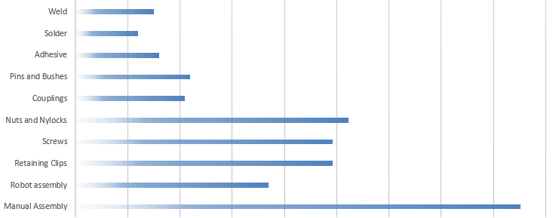

QFD4

Inputs

QFD4 starts off similarly to QFD3, with a P diagram of all the control and noise factors that could affect the manufacture of the system, or sub system.

Again, Unit to Unit variations in areas like hole positions, external factors like operator competence, deterioration factors like tool and fixture wear, were all scored again their relationship with design control parameters like Fastener materials, and fasteners hole sizes.

In return, our Key control measures and noise factors were presented.

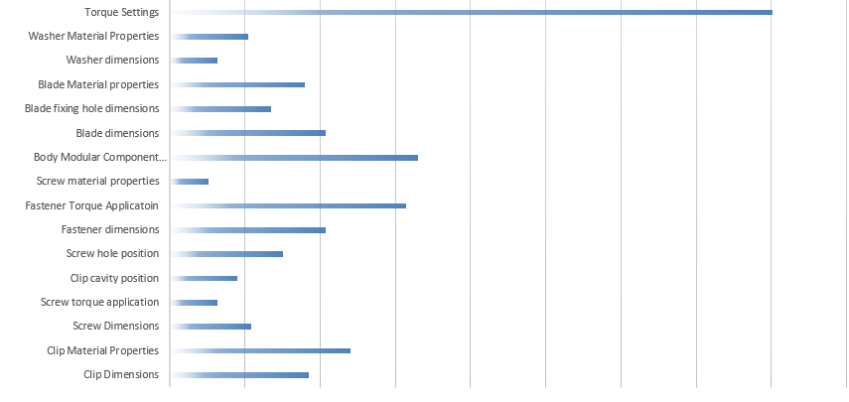
As with QFD 3, there is a coalition between the “tightness” of fixtures, with the biggest control measure being torque settings.
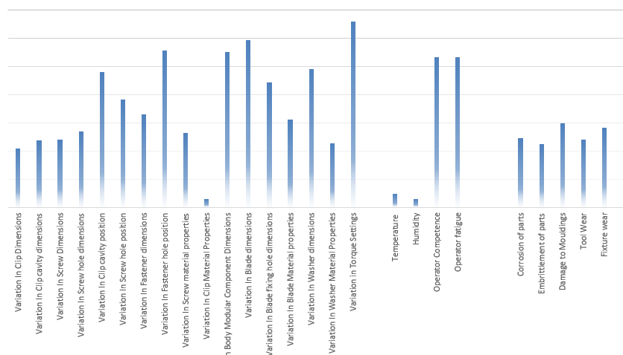

All noise factors were assessed to see if additional controls were required. These additional controls were added to the 1st QFD4 Matrix in the following format.

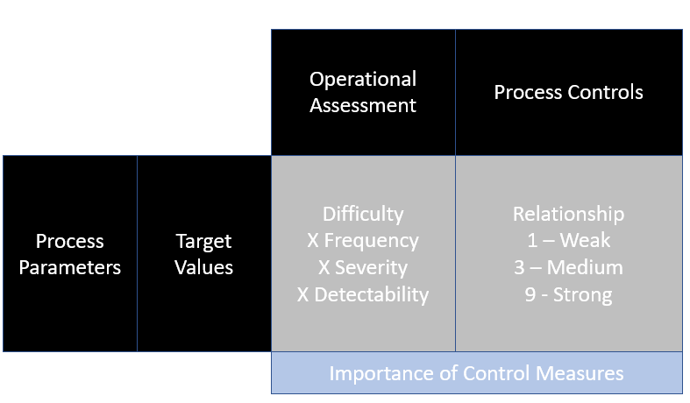
Figure 6-1: QFD4 Layout

Each individual subsystem will again be looked at individually to assess the specific noises effecting the components i.e., Heat treating the blade, Applying adhesive to the nuts and clipping components in.

With the majority of the in-house jobs on the Pen-Y-Scape being manual assembly of black box components, the major control measures that came out of all QFD4’s was operator training, regular breaks, and tool setting/maintenance.

Human factors assessments were conducted with swim lanes being utilized to ensure that the workload was evenly distributed between operators, with no single operator handling all the crucial steps. A workflow process was also conducted as well as an ergonomic factory lay out to reduce the risk of incorrect assembly and cross contamination.

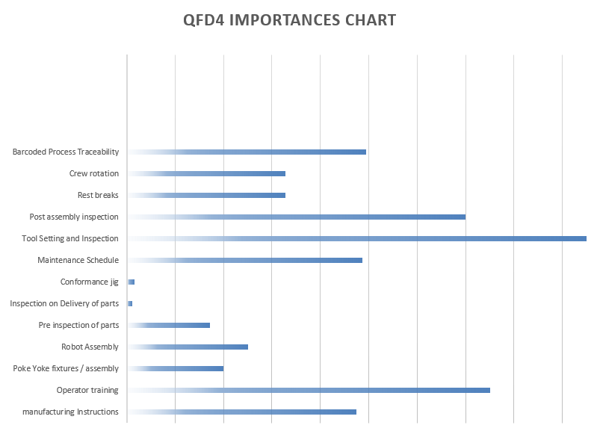

Figure 6-2: 1st QFD4

So far, the process has mainly focused on assembly of bought items, but the system was also used for manufactured items.

Component Manufacture

Any components not purchased from an external supplier and manufactured on site would be subjected to a manufacturing means analysis. As with a functional means analysis, this would involve selected the ideal means of manufacture for the component and comparing that means to other known methods. The selected processes were then scored in a QFD matrix to identify the most crucial steps in the manufacturing process.

The cutting blades were manufactured on site, the component process importance graph for this component is shown below.

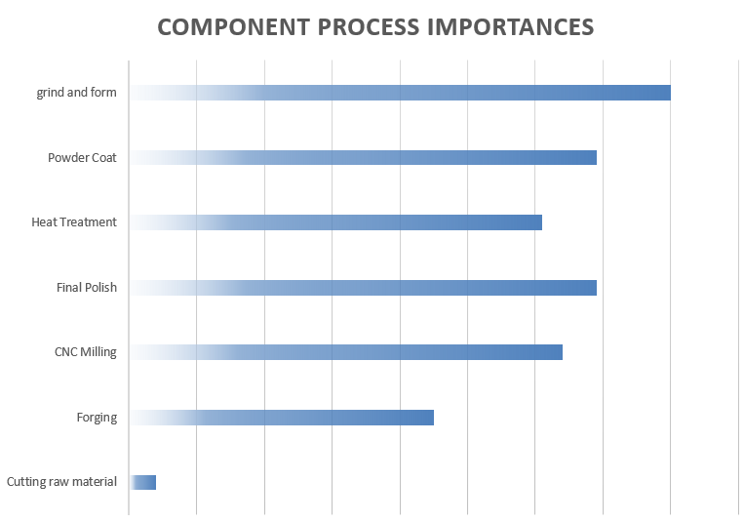
Figure 6-3: Process Importance

Process Focus

Continuing with the blades for this example, the next step was to conduct a “P” diagram for the most crucial step, in this case, the grinding and forming of the blade.

Potential noise factors like operator fatigue, variation of grinding pressure applied and degradation of grinding wheel were used and scored in another What, Why table to identify the crucial control factors for this process. Both operator competence and variations in application where among the highest scorers in this step.

These control factors were inputted into the 2nd QFD4 and were subjected to an operation assessment. During this step they scored 1,3 or 9 for difficulty, frequency, severity, and detectability. This gave them their multiplication score for the rest of the QFD where the process controls (crew rotation, regular breaks) were scored against the process parameters (operator fatigue).

Output

The output from this step was the importance of the process controls, shown below.

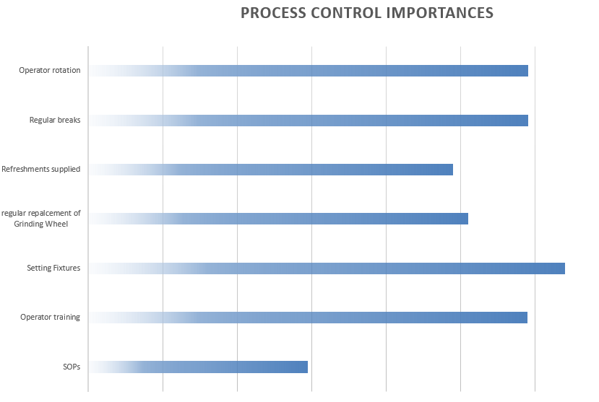

This identified the requirement for an effective setting fixture, as well as comfortable working conditions.

These control measures where then used within the failure modes and effects analysis (FMEA) to show how they can prevent or minimize the effect or likelihood of too much grinding, not enough grinding, incorrect grinding, no grinding or unintended process.

Conclusion

Entire Process

Following the entire QFD1-4 process allowed us as the manufacture and assembly team for the Pen-Y-Scape to plan out the entire design and manufacture process before ordering components or cutting materials.

This allowed us to identify any potential problems with the design, as well as highlighting any areas that require additional attention because of their importance to the products function and quality. If these steps had not been identified, then there would be a significant risk of a faulty or undesirable product being delivered.

Even if the potential issues had been spotted without the QFD process, the chances are it would have still caused significant delays and/or budgetary issues by having to re-design, pause development or at worst start again.

References

[1] | WebAuthor, "QFD," Quality One, [Online]. Available: https://quality-one.com/qfd/. [Accessed 09 11 2022].
[2] | R. K. Srivastava, "QFD," [Online]. Available: https://www.researchgate.net/figure/A-traditional-QFD-of-four-phases_fig2_264556030. [Accessed 11 11 2022].
[3] | R. Kent, "Quality Management in Plastics Processing," Science Direct, [Online]. Available: https://www.sciencedirect.com/topics/engineering/quality-function-deployment. [Accessed 11 11 2022].
[4] | D. Holley, Interviewee, Systems Engineering L6. [Interview]. 09 11 2022.
[5] | UWTSD, "Design Requirements - Lecture Notes," UWTSD, Moodle, Swansea, 2022.
[6] | K. Maquite, " John Deere Tango E5 Series II robotic mower review," gardeners World, 20 19 2019. [Online]. Available: https://www.gardenersworld.com/reviews/lawn-care/john-deere-tango-e5-series-ii-robotic-mower-review/.

