

AGE-RELATED HEALTH INEQUALITIES AND THE EPIDEMIOLOGICAL BURDEN OF OSTEOPOROSIS: A PUBLIC HEALTH ANALYSIS

Name: Krisha Jayesh Ahir
Student ID: 2515386
Module Name: Social Epidemiology and Public Health Development
Module Code: LCHS7000
Lecturer’s Name: Dr. Hamdi Hussain
Course Name: Master Of Science in Public Health and Social Care in practice
Date: 23 March 2026

Table of Contents
Task 1: Age and Health Inequality among Older Adults in the United Kingdom 3
Introduction 3
Higher Rates of Chronic Diseases 3
Mental Health Problems among Older Adults 3
Higher Mortality Risk among Older Adults 4
Social Isolation and Loneliness 4
Poverty and Financial Insecurity 4
Housing and Living Conditions 5
Conclusion 5
Task 2: Epidemiological Analysis – Osteoporosis 5
Introduction 5
Public Health Measures: Prevention, Protection and Promotion 6
Determinants and Risk Factors 6
Population at Risk 7
Monitoring and Surveillance Systems 7
Public Health Impact 8
Intervention Programme 8
Evaluation of Intervention 9
Strengths and Limitations of Epidemiological Approaches 9
References 10
Reference for Task 1 10
Reference for Task 2 11

Task 1: Age and Health Inequality among Older Adults in the United Kingdom
Introduction
Health inequalities is a term that is used to describe systematic and preventable disparities in the health outcomes among groups of people. Elderly people who are mostly persons who are 65 years and older are susceptible to these inequalities mainly because of biological ageing, socioeconomic inequalities and lack of healthcare services. Ageing population is on the rise in the United Kingdom due to the increasing life expectancy and this has presented fresh public health issues concerning chronic illness, social isolation and financial dependability. Later in life, the social determinants affect health outcomes to a significant degree due to factors like poverty, housing status and healthcare accessibility (UK Parliament POST, 2024). In the UK, the population aged 65 and over is expected to represent close to 25% by the year 2043, and this places new pressures on the health care systems (Office for National Statistics, 2023). Older people also feel lonely and socially isolated, and poor physical and mental health outcomes are associated with loneliness (Puyané et al., 2025).
In order to overcome these inequalities, the UK policies such as the NHS Long Term Plan target on improving the access of integrated care and preventive services for older adults (NHS England, 2019).
Higher Rates of Chronic Diseases
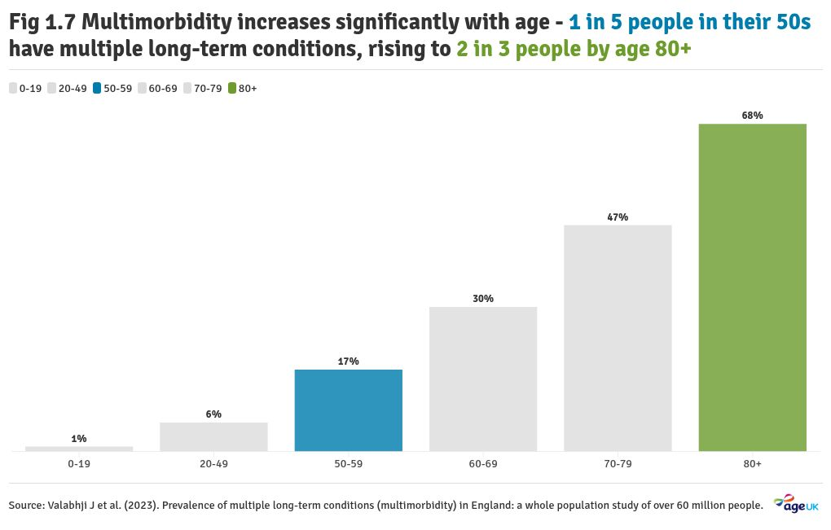
Figure 1: Multimorbidity increases significantly with age - 1 in 5 people in their 50s have multiple long-term conditions, rising to 2 in 3 people by age 80+
(Source: https://www.ageuk.org.uk/discover/2025/september/state-of-health-and-care-of-older-people-in-england-2025/)
Elderly people are exposed to chronic diseases more than the young. Biological ageing and chronic exposure to health risks lead to more prevalence of such conditions as cardiovascular disease, diabetes, arthritis and respiratory disorders with age. Older people tend to experience several chronic conditions at the same time, which is called multimorbidity, which is challenging to manage, which leads to healthcare demands and health disparities (UK Parliament POST, 2024). In the UK, two-thirds of the population above 65 years old (58%) are living with two or more chronic diseases (Age UK, 2023). The socioeconomic conditions also have an impact on the disease prevalence, with older and less wealthy adults being more susceptible to being impeded by the lack of affordability of getting healthcare and preventive care, which leads to worse disease control and late detection (Chi et al., 2024).
One of the main solutions is to develop and increase community-based healthcare and early screening programmes with the support of such organisations as Age UK that deliver health advice and support services to elderly patients (Age UK, 2023).
Mental Health Problems among Older Adults
Another major inequality among ageing groups is mental health issues. Older adults mostly experience depression, anxiety and cognitive decline, which might be caused by loneliness, bereavement and worsening body condition. Literature shows that loneliness has a close relationship with adverse mental health conditions and psychological distress among older adults (Araujo et al., 2025). The prevalence rate of depression among elderly people in the UK is estimated to be about 1 in 5, and many of them are not treated (NHS Digital, 2022). Emotional support is decreased in social isolation, which results in the risk of developing mental illness. It has also been indicated that loneliness among the older adults is an increasing population health issue on an international level (Bashar et al., 2025). To help overcome this, charities like Mind and Age UK have community engagement and befriending services to combat loneliness and help boost mental wellbeing (Mind, 2023).
Higher Mortality Risk among Older Adults
Older people are also at risk of mortality as compared to the young population. The chronic disease, lack of healthcare resources, and social factors like poverty and loneliness affect the motivation of later life mortality. Social isolation and dwelling alone are identified to have a major effect on older people by raising their risk of mortality (Nakou et al., 2025). Research shows that socially isolated older adults are 29% more likely to die (Holt-Lunstad et al., 2020). Ethnic disparities and socioeconomic disadvantages are other structural inequalities which may result to low health outcomes among the ageing populations (Cotterell et al., 2025).
Public health interventions such as targeted outreach programmes and improved access to primary care services can mitigate the risk of death in vulnerable elderly groups.
Social Isolation and Loneliness
One of the most prevalent social problems in older individuals is the social isolation and loneliness. Social interaction may also be curtailed by retirement, less mobility and loss of family members which is a contributory factor to loneliness. It has been indicated that around 25 percent of the elderly in the world are lonely and that the so-called health outcomes are rather adverse depression, cardiovascular disease and diminished life satisfaction (Salari et al., 2025). In the UK around 1.4 million older people say that they often feel lonely (Age UK, 2023).
Solutions include community-based organisations such as social clubs, digital inclusion programmes and government plans such as the UK Loneliness Strategy (Department for Digital, Culture, Media & Sport, 2018).
Poverty and Financial Insecurity
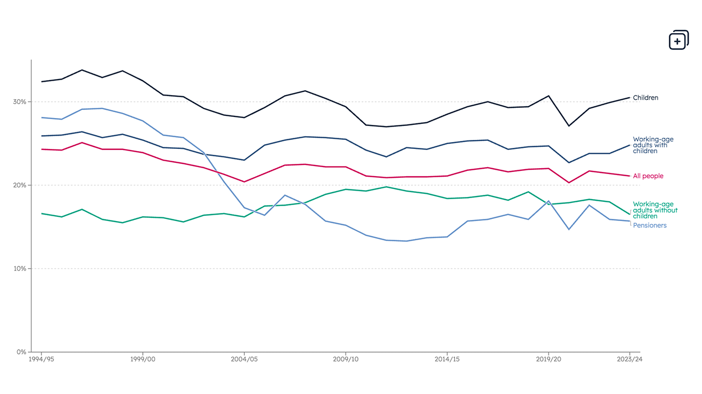
Figure 2: UK poverty statistics showing trends for pensioners
(Source: https://www.jrf.org.uk/uk-poverty-statistics)
Another important determinant of health inequality among the older adults is Poverty. Low income and financial insecurity might limit access to health services, healthy foodstuff and unhealthy living. People in older age, who are in poverty, also could have fuel poverty and a hard time using necessary costs of living. It has also been demonstrated that economic inequality can affect the healthcare utilisation because those who have less monetary means are less inclined to benefit with the preventive health services or even medical treatment (Chi et al., 2024). Around 18% of pensioners in the UK live relatively poorly (Joseph Rowntree Foundation, 2023).
To overcome this, government policies such as Pension Credit and Winter Fuel Payments to assist low-income elderly individuals to ensure financial barriers to health and wellbeing are reduced.
Housing and Living Conditions
The condition of housing is also relevant to the process of determining the health outcomes, among the older adults. The condition of housing, insecurity and inaccessibility can predispose accidents and health issues. The elderly in the substandard housing facilities could develop increased chances of falling, breathing diseases and poor autonomy. In England, poor housing conditions cause an estimated 10% of falls to older people (Public Health England, 2022). The policy on public health emphasises the need to offer age-friendly housing and supportive living to improve health and wellbeing in later life (UK Parliament POST, 2024).
Housing improvement schemes and support services delivered through local councils can help to create a safer living environment and reduce health risks.
Conclusion
The problem of age-related health inequalities is a significant social health issue globally which is highly problematic to older adults. Unequal health outcomes among ageing populations are caused by chronic diseases, mental health issues, mortality risks and social factors like loneliness and poverty. It has been established that structural factors such as socialeconomic disadvantage and lack of access to healthcare services have a major role in the causation of these disparities.
Dealing with these inequalities involves a multi-level process in terms of system and policy levels, community support, and health care systems, as seen with the examples of the NHS Long Term Plan and Age UK programmes in the UK. Age related health disparities would only be curtailed through a multi-tiered approach to the inclusion of communal health measures and better social policies, geared towards ensuring healthier ageing, and the enhancement of the quality of life among the elderly.

Reference for Task 1
Araújo, O., Sousa, L., Sampaio, F., Rodrigues, C., Santos, N.C., Sequeira, C. and Teixeira, L., 2025, June. Loneliness and Mental Health Disorders in Older Adults Living in Portugal During the COVID-19 Pandemic: A Cross-Sectional Study. In Healthcare (Vol. 13, No. 13, p. 1483). MDPI. https://www.mdpi.com/2227-9032/13/13/1483
Bashar, M.A., Begam, N., Gnansekaran, S. and Ahmed, M.Z., 2025. Elderly loneliness: a growing public health challenge.
https://www.intechopen.com/chapters/1225218
British Journal of Community Nursing, 2024. Loneliness in older adults.
https://www.magonlinelibrary.com/doi/10.12968/bjcn.2024.29.2.60
Byeon, H., 2026. The impact of social isolation and digital exclusion on mental and physical health in older adults: A meta-analysis. Medicine, 105(4), p.e46010.
https://journals.lww.com/md-journal/fulltext/2026/01230/the_impact_of_social_isolation_and_digital.8.aspx
Chi, Z., Lun, H., Ma, J. and Zhou, Y., 2024. Income inequality and healthcare utilization of the older adults-based on a study in three provinces and six cities in China. Frontiers in Public Health, 12, p.1435162. https://www.frontiersin.org/journals/public-health/articles/10.3389/fpubh.2024.1435162/full
Conduah, A.K. and Ofoe, S.H., 2025. Intersecting impacts of ageing, migration, and socioeconomic disparities on health equity: a post-pandemic policy review. International Journal for Equity in Health, 24(1), p.304. https://link.springer.com/article/10.1186/s12939-025-02683-0
Cotterell, N., Buffel, T., Nazroo, J. and Qualter, P., 2025. Loneliness among older ethnic minority people: Exploring the role of structural disadvantage and place using a co-research methodology. Ethnic and racial studies, 48(1), pp.206-228. https://www.tandfonline.com/doi/full/10.1080/01419870.2024.2311833
Kang, J.Y., Shin, O., Park, S., Baek, J. and Kwak, M., 2026. Material, Health, and Social Vulnerability and Loneliness Among Older Adults: From the Welfare Regime Perspective. Research on Aging, 48(2), pp.99-112.
https://journals.sagepub.com/doi/10.1177/01640275251330214
Monteiro, I.S., 2023. Health (dis) equalities and social isolation and loneliness in the older people: a qualitative study (Master's thesis, Instituto Politecnico do Porto (Portugal)). https://www.riagejournal.com/index.php/riage/article/view/237/234
Nakou, A., Dragioti, E., Bastas, N.S., Zagorianakou, N., Kakaidi, V., Tsartsalis, D., Mantzoukas, S., Tatsis, F., Veronese, N., Solmi, M. and Gouva, M., 2025. Loneliness, social isolation, and living alone: a comprehensive systematic review, meta-analysis, and meta-regression of mortality risks in older adults. Aging Clinical and Experimental Research, 37(1), p.29.
https://link.springer.com/article/10.1007/s40520-024-02925-1
Puyané, M., Chabrera, C., Camón, E. and Cabrera, E., 2025. Uncovering the impact of loneliness in ageing populations: a comprehensive scoping review. BMC geriatrics, 25(1), p.244. https://pmc.ncbi.nlm.nih.gov/articles/PMC11984289/
Salari, N., Najafi, H., Rasoulpoor, S., Canbary, Z., Heidarian, P. and Mohammadi, M., 2025. The global prevalence and associated factors of loneliness in older adults: a systematic review and meta-analysis. Humanities and Social Sciences Communications, 12(1), pp.1-24.
https://www.nature.com/articles/s41599-025-05304-x
UK Parliament POST, 2024. Healthy ageing and care for older populations.
https://post.parliament.uk/healthy-ageing-and-care-for-older-populations/
Wu, M., Xue, Y. and Ma, C., 2025. The association between the digital divide and health inequalities among older adults in China: nationally representative cross-sectional survey. Journal of Medical Internet Research, 27, p.e62645.
https://www.jmir.org/2025/1/e62645/

Task 2: Epidemiological Analysis – Osteoporosis
Introduction
Osteoporosis is a long term skeletal disorder that is associated with the decrease in bone density and weakness of the bones that causes the chances of getting a fracture. It is known to have been one of the greatest global health issues among the ageing groups with the women postmenopausal, and the elderly among others. Osteoporosis greatly enhances the risk of fragility fractures (on the hip, spine, and wrist) which might lead to disability, loss of independence as well as take away existence. It is estimated that over 200 million individuals are affected by osteoporosis worldwide, and the disease is getting more and more prevalent as the population is getting older (Salari et al., 2021). According to epidemiological research, it has been found that one in three women and one in every five men older than fifty years will suffer osteoporotic fractures in their lives (Clynes et al., 2020). In the UK alone, it is estimated that there are more than 3.5 million individuals living with osteoporosis and this results in an estimate of 500,000 and more fragility fractures in the UK each year (Royal Osteoporosis Society, 2023). The prevention of osteoporosis presents a massive proportion of weak fractures in the United Kingdom and renders a huge burden to the healthcare systems (Gregson et al., 2025). To mitigate this burden, UK policies in the domain of public health, including NHS Long Term Plan, focus on the early diagnosis and prevention of long-term conditions, including osteoporosis (NHS England, 2019).
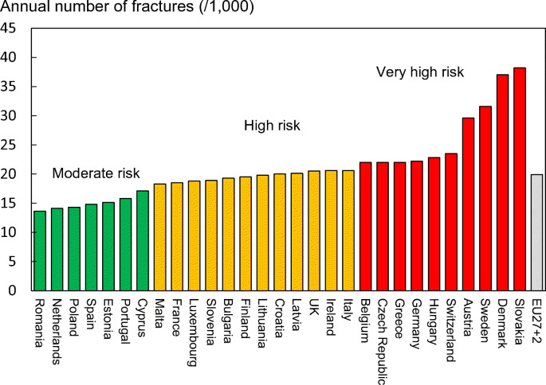
Figure 3: Annual number of fractures (1,000) across Europe including UK
(Source: https://link.springer.com/article/10.1007/s11657-020-00871-9)
Public Health Measures: Prevention, Protection and Promotion
Osteoporosis prevention, protection and health promotion are available as the public health strategies to minimize the number of the diseases and to eliminate the risk of fractures. Prevention measures are oriented at preserving bone integrity to be provided by proper nutrition and lifestyle changes. Preventive measures should include enough intake of calcium and vitamin D, weight-bearing exercises and weight, avoidance of smoking or excessive alcohol intake (Akbar et al., 2025). Research demonstrates that optimal calcium and vitamin D levels may minimize it by up to 15% (International Osteoporosis Foundation, 2022). The existence of bone mineral density screening tests called dual-energy X-ray absorptiometry (DXA) that are regularly conducted to determine the presence of frail individuals prior to them being able to fracture is one of the most widespread screening programmes (Yang et al., 2025).
The Royal Osteoporosis Society and other organisations in the UK are conducting awareness campaigns and screening to enhance early diagnosis. The main remedy is the extension of community-based screening and lifestyle education programmes which are targeted towards older adults.
Determinants and Risk Factors
There are a number of biological, behavioural, and environmental causes of osteoporosis. One of the greatest risks concerns age because bone mass decreases with age. This is especially risky to women who are menopausal since the bone loss is faster due to the shortage of oestrogen (Fan et al., 2024). The bone density and chances of fractures also depend on genetic predisposition. Some lifestyle choices, including the lack of calcium and sedentary behaviour, smoking and alcohol abuse, also add more likely to osteoporosis (Özmen et al., 2024). Hormonal changes have approximately caused osteoporosis in approximately 30 percent of postmenopausal women in the United Kingdom (NHS, 2023). Povery may reduce access to nutritious foods and health services, among the disadvantaged members of the population. To counter such risks, the strategies of the public health must aim at enhancing the nutrition access, encouraging physical activity and minimizing the health disparities.
Population at Risk
Epidemiological studies illustrate that osteoporosis is predominant among the elderly people especially postmenopausal women. On the global scales, it is analyzed that the bone mineral diminishes substantially in old age, thereby increasing the rate of fracturing in people who are above fifty years (Liang et al., 2025). Women have a higher burden of disease as compared to men due to hormonal changes related to menopause. It has been found out that osteoporosis is common in postmenopausal women and can lead to severe complication such as vertebral fractures and a lower mobility rate (Rao and Kavitha, 2024). Women in the UK are the osteoporotic group most affected (Royal Osteoporosis Society, 2023). More specific activities can be applied based on screening women older than 50 and old age and detect high risk groups at an early stage.
Monitoring and Surveillance Systems
Osteoporosis needs to be monitored through thorough surveillance mechanisms which have the potential to gather epidemiological data on prevalence of diseases, prevalence of fracture and treatment interventions. National databases and health information systems are significant in monitoring of the trends of osteoporosis and guiding health policies of people. There is helpful information in the global epidemiological studies such as the Global Burden of Disease Study that demonstrates the prevalence and any implications of osteoporosis on the global population (Liang et al., 2025). In the UK, hospital osteoporosis and fracture admissions receive tracking using the NHS data systems and fracture registries. The national healthcare organisations may also monitor the fragility fractures and evaluate the efficacy of treatment using the hospital records and fracture registries. Policy planning and early detection can be improved by improving the data collection and digital health systems.
Public Health Impact
Short-term impacts
Osteoporosis has direct health effects that are mostly manifested through fragility fractures mainly of the hip, spine and wrist. These fractures frequently involve hospitalisation, surgery and severe medical attention. Fracture patients often report severe pains, reduced mobility and prolonged recovery. Fractures of hips are particularly dangerous since they may significantly decrease the functional capacity and predispose to the development of various complications, including the risk of infections or low physical autonomy (Kenzhegazova et al., 2025). Hip fracture is a leading cause of hospital admission with more than 70,000 cases in the UK alone (NHS, 2023).
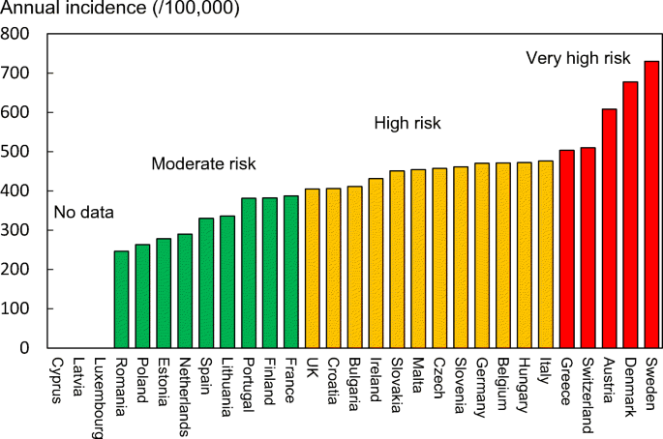
Figure 4: Annual incidence of hip fractures (1/100,000) across Europe including UK
(Source: https://link.springer.com/article/10.1007/s11657-020-00871-9)
Long-term impacts
The chronic disability, reduced quality of life and high risk of death are long-term outcomes of osteoporosis in old age. The disorder is also a significant financial burden on the healthcare systems because of the long-term care, rehabilitation services, and continuous medical treatment (Safiri et al., 2025). In the UK it is estimated that the annual cost of osteoporotic fractures is over the 4.4 billion mark (Royal Osteoporosis Society, 2023). Long-term burden can be prevented and quality of life can be enhanced through the use of preventive tools and rehabilitation services.
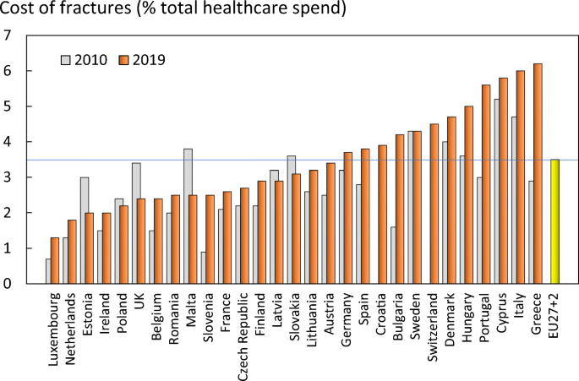
Figure 5: Cost of fractures (% total healthcare spend) across Europe including UK
(Source: https://link.springer.com/article/10.1007/s11657-020-00871-9)
Intervention Programme
Intervention methods of public health aimed at minimizing the effects of osteoporosis are usually based on screening, education and clinical management. Bone density screening programmes carried out in communities can be used in identifying people who are at high risks of fractures. After diagnosis, the affected patients can be given pharmacological therapy and lifestyle recommendations on how to enhance bone health (Gregson et al., 2025).
An example is the community-based intervention programme strategy when the local health centres may offer the service of bone density screening every year and provision of individualized diets, exercise, and fall-prevention training sessions to the community aged 50 and above. NHS clinics and local councils can be used to facilitate the use of this programme. This method focuses on prevention and early diagnosis and management of osteoporosis in the long run.
Evaluation of Intervention
The interventions of osteoporosis are also evaluated by measuring the fracture rate changes, bone density rates, and the rates of healthcare utilisation. Epidemiological research designs are capable of evaluation of whether screening programmes and preventive strategies can cut the incidences of fragility fracture with time. An example of this is by measuring the success of the proposed programme by the increase or decrease in the fracture rates, the density score of bones, and the number of people taking part in the screening programmes. The success of the intervention programmes can also be determined through tracking the outcomes of the patients and their compliance (Yang et al., 2025). Constant monitoring will keep the interventions effective and changeable to the needs of the population.
Strengths and Limitations of Epidemiological Approaches
Epidemiological methods are good in giving knowledge about prevalence of osteoporosis, risk and impact factors. Population studies can be carried out in large amount to reveal how diseases are distributed and to plan their strategies on popular health. Nevertheless, there are also some limitations such as differences in the diagnostic criteria and underdiagnosis in some groups.
In the case of osteoporosis, say a number of cases are still not diagnosed until the day they are fractured, therefore, restricting the effectiveness of early intervention. Along with the challenges, epidemiological research proves to be very important to provide information on preventive and curative strategies to reduce the global prevalence of osteoporosis (Clynes et al., 2020). These limitations can be overcome by ensuring better coverage and awareness of screening.

Reference for Task 2
Akbar, A., Zaheer, A., Kharal, M.M., Komel, A., Khan, M.H., Ahsan, A. and Singh, A.K., 2025. Evolving strategies for osteoporosis management in postmenopausal women: From tradition to innovation. Medicine, 104(7), p.e41605.
https://journals.lww.com/md-journal/fulltext/2025/02140/evolving_strategies_for_osteoporosis_management_in.2.aspx
Clynes, M.A., Harvey, N.C., Curtis, E.M., Fuggle, N.R., Dennison, E.M. and Cooper, C., 2020. The epidemiology of osteoporosis. British medical bulletin, 133(1), pp.105-117. https://pmc.ncbi.nlm.nih.gov/articles/PMC7115830/
Fan, Y., Li, Q., Liu, Y., Miao, J., Zhao, T., Cai, J., Liu, M., Cao, J., Xu, H., Wei, L. and Li, M., 2024. Sex-and age-specific prevalence of osteopenia and osteoporosis: sampling survey. JMIR public health and surveillance, 10(1), p.e48947. https://publichealth.jmir.org/2024/1/e48947/
Gregson, C.L., Armstrong, D.J., Avgerinou, C., Bowden, J., Cooper, C., Douglas, L., Edwards, J., Gittoes, N.J., Harvey, N.C., Kanis, J.A. and Leyland, S., 2025. The 2024 UK clinical guideline for the prevention and treatment of osteoporosis. Archives of Osteoporosis, 20(1), p.119.
https://link.springer.com/article/10.1007/s11657-025-01588-3
IJBCP, 2025. The rising global burden of osteoporosis.
https://www.ijbcp.com/index.php/ijbcp/article/download/5918/3863/25761
Kenzhegazova, G.K., Baspakova, A. and Umbetova, A.A., 2025. Osteoporosis: A Comprehensive Review of Epidemiology, Impact on Quality of Life, and Treatment Strategies. West Kazakhstan Medical Journal, 67(2), pp.177-187. https://www.researchgate.net/publication/392348639_Osteoporosis_A_Comprehensive_Review_of_Epidemiology_Impact_on_Quality_of_Life_and_Treatment_Strategies
Liang, H., Chen, S., Shi, M., Xu, J., Zhao, C., Yang, B., Zheng, S. and Tan, J., 2025. Global epidemiology and burden of osteoporosis among postmenopausal women: insights from the Global Burden of Disease Study 2021. npj Aging, 11(1), p.78. https://pmc.ncbi.nlm.nih.gov/articles/PMC12402057/
Liang, H., Chen, S., Shi, M., Xu, J., Zhao, C., Yang, B., Zheng, S. and Tan, J., 2025. Global epidemiology and burden of osteoporosis among postmenopausal women: insights from the Global Burden of Disease Study 2021. npj Aging, 11(1), p.78. https://www.nature.com/articles/s41514-025-00269-2
Liu, B., Chang, H., Li, P., Chang, H., Wang, X. and He, W., 2025. The critical role of inflammation in osteoporosis prediction unveiled by a machine learning framework integrating multi-source data. Frontiers in Physiology, 16, p.1729997.
https://www.frontiersin.org/journals/physiology/articles/10.3389/fphys.2025.1729997/full
Özmen, S., Kurt, S., Timur, H.T., Yavuz, O., Kula, H., Demir, A.Y. and Balcı, A., 2024. Prevalence and risk factors of osteoporosis: a cross-sectional study in a tertiary center. Medicina, 60(12), p.2109. https://www.mdpi.com/1648-9144/60/12/2109
Özmen, S., Kurt, S., Timur, H.T., Yavuz, O., Kula, H., Demir, A.Y. and Balcı, A., 2024. Prevalence and risk factors of osteoporosis: a cross-sectional study in a tertiary center. Medicina, 60(12), p.2109. https://pmc.ncbi.nlm.nih.gov/articles/PMC11677826/
Rao, A.A. and Kavitha, A., 2024. A Prospective Observational Study on the Impact of Osteoporosis in Postmenopausal Women Attending a Gynaecology Outpatient Department. European Journal of Cardiovascular Medicine, 14, pp.1418-1421.
https://healthcare-bulletin.co.uk/article/a-prospective-observational-study-on-the-impact-of-osteoporosis-in-postmenopausal-women-attending-a-gynaecology-outpatient-department-3825/
Safiri, S., Amiri, F., Karamzad, N., Sullman, M.J., Rahmanian, M., Aletaha, R., Mansournia, M.A., Collins, G.S., Şahin, F. and Kolahi, A.A., 2025. Global Health Effects of Osteopenia and Osteoporosis, 1990–2021. Health Science Reports, 8(10), p.e71378. https://pmc.ncbi.nlm.nih.gov/articles/PMC12546677/
Salari, N., Ghasemi, H., Mohammadi, L., Behzadi, M.H., Rabieenia, E., Shohaimi, S. and Mohammadi, M., 2021. The global prevalence of osteoporosis in the world: a comprehensive systematic review and meta-analysis. Journal of orthopaedic surgery and research, 16(1), p.609.
https://pmc.ncbi.nlm.nih.gov/articles/PMC8522202/

Yang, J., Zeng, Y. and Yu, W., 2025. Criteria for osteoporosis diagnosis: a systematic review and meta-analysis of osteoporosis diagnostic studies with DXA and QCT. EClinicalMedicine, 83.
https://www.sciencedirect.com/science/article/pii/S2589537025001762

