Leadership and Management Theory and Practice
LCBB6003
Anita Nan

Group Presentation

Elena Blagoeva 1913400
Lyuben Eftimov 1913402
Silviu Galusca 1915953
Nela Silitra 1912510

Assessment 2

BA Business Management
Level 6 Term 2
Group 2

Table of Contents
Elena Blagoeva 1913400 2
Introduction 2
Trait Theory of Leadership 3
Strengths 4
Limitations 4
Evaluating Jeff Bezos’ leadership style using Trait Theory 5
Conclusion 6
Lyuben Eftimov 1913402 7
Introduction 7
Contingency Theory of Leadership 8
Critical evaluation of effectiveness of Jeff Bezos’ leadership qualities 10
Conclusion 11
Silviu Galusca 1915953 12
TRANSFORMATIONAL VS TRANSACTIONAL LEADERSHIP 12
Effectiveness of Jeff Bezos’ leadership 13
Interpretation of the leadership theories 14
Reference List 15

Elena Blagoeva 1913400

Introduction

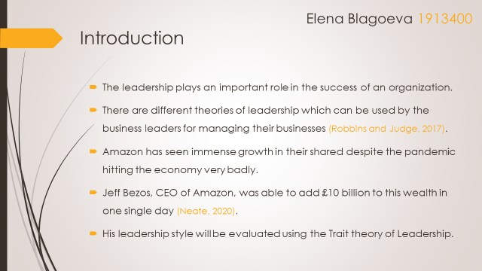

The leadership of an organization can play a very important role in the making the business successful and sustainable in the longer run. To have a better understanding of the leadership, there are different theories and models which can be of great help. The understanding of these leadership practices in real life situations is very important (Robbins and Judge, 2017). Amazon is a very successful organization which has seen immense success over the years. The company has been able to grow successfully even when the pandemic has negatively affected the environment. Jeff Bezos, the founder and CEO of Amazon was able to accumulate £10 billion in a single day. We will evaluate his leadership style using trait leadership theory (Neate, 2020).

Trait Theory of Leadership

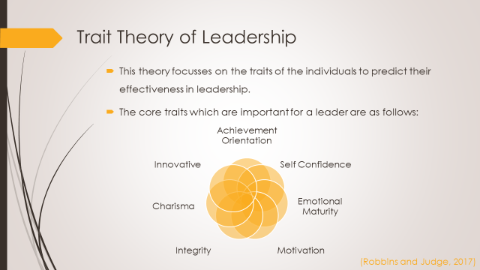

According to the trait theory of leadership, there are different traits that create an effective or ineffective leader. The people with the leadership traits have higher chances of becoming successful in their roles than others. There are many traits which have been associated with successful leaders. Some of the examples of key leadership traits are driven by achievement, confident on their abilities, high level of motivation, sound integrity, personal charisma, mature in emotions and innovative (Robbins and Judge, 2017).
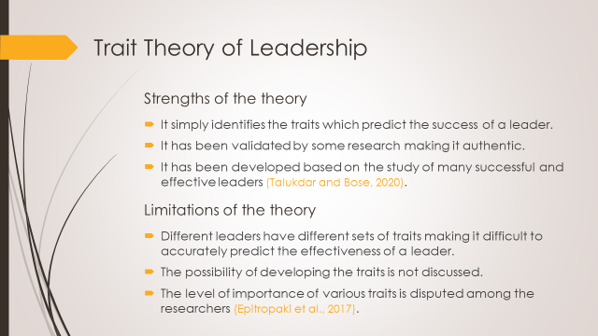

Strengths
There are different strengths of trait leadership theory. It is very simple and identifies traits which can be used as a yardstick to measure the effectiveness of a leader. There have been few researches which have shown that the successful leaders have traits which make them successful. These researches make this theory effective and applicable to work environment. The traits have been established after studying many successful and effective leaders (Talukdar and Bose, 2020).

Limitations
There are also some limitations of this theory. The effective leaders do not share common traits which make it difficult to predict success in an accurate manner in the real life. The possibility that an individual can develop certain traits to become a good leader is not discussed. The importance of traits is a matter on which there has been no consensus among the researchers (Epitropaki et al., 2017).

Evaluating Jeff Bezos’ leadership style using Trait Theory

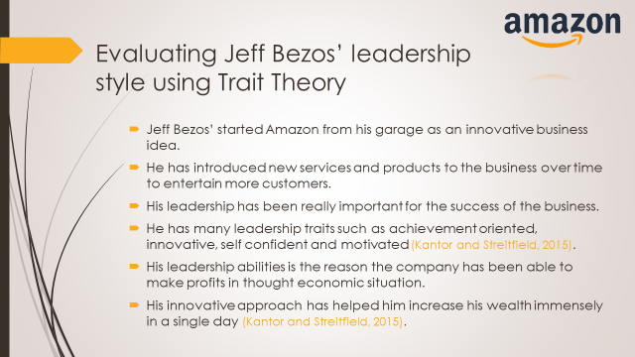
The Amazon was an innovative idea of Jeff Bezos. He launched the company from his garage and has been able to successfully expand it into a worldwide organization. The company now offers a huge range of products to their customers all around the world. The leadership of Jeff has been a great impact on the company (Kantor and Streitfield, 2015). There are many traits present in him that are an indicator of successful leader as per the traits theory of leadership. He is highly goal oriented, confident on this abilities, innovative thinker and motivated individual. His traits have enabled him to lead the company in such a manner that it showed growth when the market is slow. His ability to move forwards enabled him to gain wealth in such difficult times (Kantor and Streitfield, 2015).

Conclusion

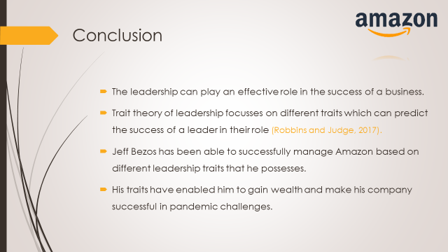
The leadership is important for the success of any business organization. There are different leadership approaches which can be adopted. As per the traits theory of leadership, there are certain traits which can predict the effectiveness of a leader (Robbins and Judge, 2017). Jeff Bezos is the CEO of Amazon and he has many traits of a good leader. This is the reason that he has increased his wealth as well as led the company successfully during the economic challenges of pandemic.

Lyuben Eftimov 1913402

Introduction

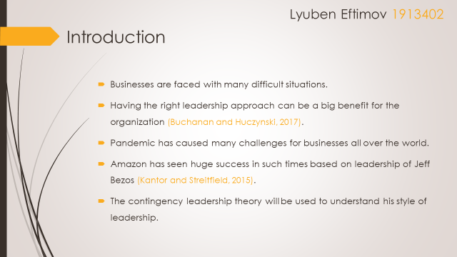
The business environment is very challenging and the organizations are often faced with different challenges. It is important that the right leadership style and approach is selected as it can have a strong impact on the business (Buchanan and Huczynski, 2017). The Covid-19 pandemic resulted in different challenges for the businesses all over the world. Many business organization were not able to continue profitably while many others had to shut down. In such difficult times, Amazon proved to be a successful business and showed growth (Kantor and Streitfield, 2015)... This can be associated to the leadership of Jeff Bezos, the founder and CEO of the company. His leadership style will be evaluated under the light of contingency theory.

Contingency Theory of Leadership

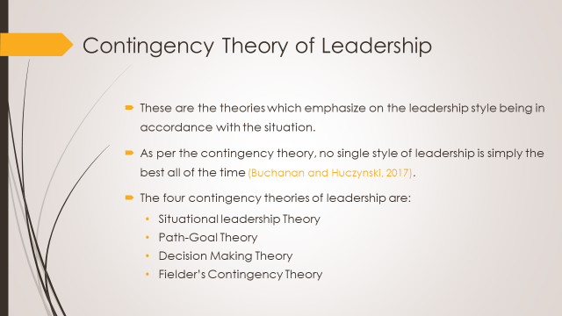
The contingency theories of leadership state that the true leadership means that the right style is adopted for the different situations faced by the business. As per these theories, the leaders do not have a single style which can be effective in all the different circumstances. The leadership style is a variable which depends on the situation faced by the leader or the business (Buchanan and Huczynski, 2017). The four different contingency theories are; situational leadership theory, path-goal theory, decision making theory and Fielder’s Contingency theory.
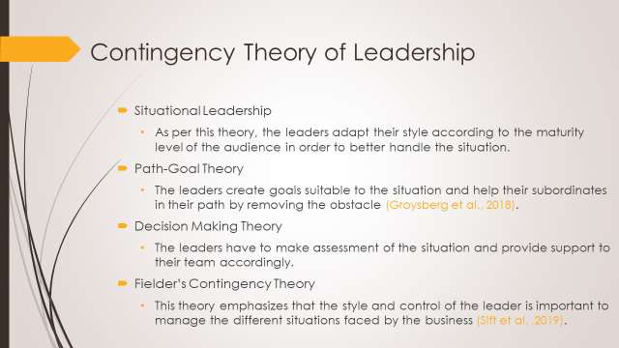
The situational leadership theory states that the leaders have to understand the maturity level of the audience. Based on this assessment, they have to adopt a leadership style which is most suitable for the situation which is being faced by the business at that time. The Path-Goal theory states that the leader sets the goals for the subordinates as per the situation of the business and at the same time provide complete support to them in their path towards achieving the goals by removing obstacles (Groysberg et al., 2018). The decision making theory states that the leaders have to make the assessment of the situation and their team in that situation. Then they have to make a decision of providing guidance and support to them in relation to the assessment. The Fielder’s contingency theory the style of leadership as well as the level of control are both important for managing a situating faced by the business (Sift et al. ,2019).

Critical evaluation of effectiveness of Jeff Bezos’ leadership qualities

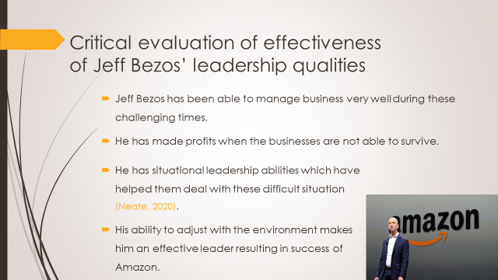
The business environment has been really challenging and Jeff Bezos has been able to manage Amazon in an excellent way. The company has shown growth and profitability while many businesses were not able to survive (Neate, 2020). The reason is that he has situational leadership abilities. He was able to manage the situation according to its requirements and lead the business towards success. The Amazon was able to successfully adjust to environmental changes based on his leadership style.

Conclusion

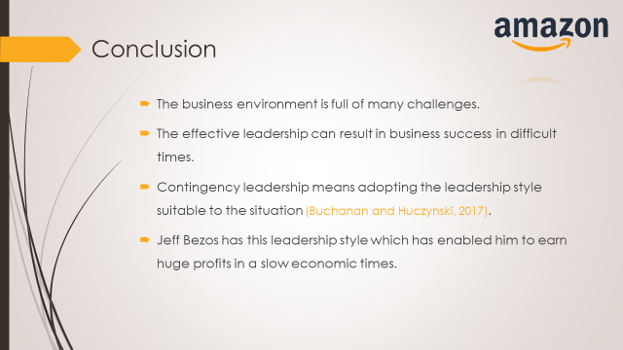
The business environment has many challenges and it is important for them to take care of these challenges in an effective manner. The leadership can play a big role in helping the business in such a scenario. The contingency leadership theory is focused on the way leaders are able to adjust their leadership styles to the different situations faced by the business (Buchanan and Huczynski, 2017). The CEO of Amazon, Jeff Bezos, has used his ability to adjust the leadership style to deal with the challenging business environment.

Silviu Galusca 1915953

TRANSFORMATIONAL VS TRANSACTIONAL LEADERSHIP

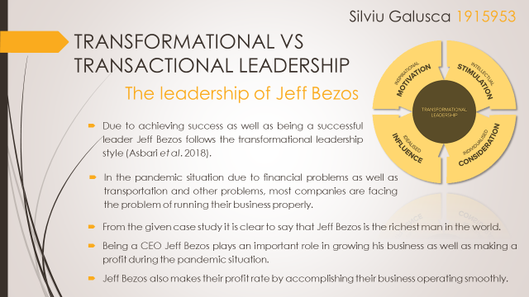
From the given case study it is clear to say that Jeff Bezos is the richest man in the world. In the other words, Jeff Bezos started Amazon in the year of 1994 as well as still owns eleven percent of the share of Amazon. From the given case study it is clear to understand that due to the pandemic situation for increasing the rate of patients affected by the Covid 19 virus, multiple companies face the problem to grow their business smoothly. On the other hand, at that time of the pandemic situation or during that crisis time, Jeff Bezos also makes a profit rate by accomplishing their business (Asbari et al. 2018). In a single sentence, it can be said that this type of making a profit as well as the success of that crisis time has been possible due to his leadership style and from analyzing the case study, it is clear to understand that his leadership style follows the transformational leadership style for creating more profit in the competitive market as well as getting success as being the richest man in the world. Therefore, by following the transformational leadership style Jeff Bezos has experienced success.

Effectiveness of Jeff Bezos’ leadership

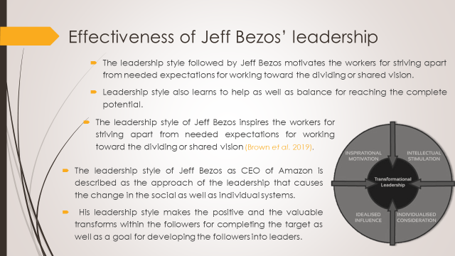
From the given case study it can be assumed that for getting success, Jeff Bezos follows the Transformational leadership style. This leadership style is described as the approach of the leadership that causes the change in the social as well as individual systems. On the other hand, the ideal form of this type of leadership style makes the positive and the valuable transforms within the followers with the finish of target and goal for improving the followers into the leaders (Brown et al. 2019). The leadership style that is followed by Jeff Bezos motivates the workers for striving apart from needed expectations for working toward the dividing or shared vision. On the other hand, the leadership style that is followed by Jeff Bezos as the CEO concentrates on extrinsic inspiration due to the performance of the particular task of the job. On the other hand, his leadership style also teaches balancing and helps to reach his complete potential.

Interpretation of the leadership theories

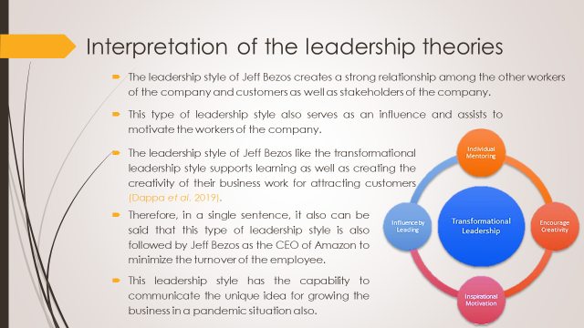
From the given case study, it can be understood that the reality or essentiality of the leadership style that is followed by Jeff Bezos as CEO of Amazon. On the other hand, different types of benefits of his leadership style are also understood from the given case study. For improving the business operation his leadership style is almost similar to the transformational leadership style. By following this type of leadership style, a strong relationship has been established among the other workers of the company and customers as well as stakeholders of the company. On the other hand, this type of leadership style also serves as an influence and assists to motivate the workers of the company (Dappa et al. 2019). In a single sentence, it is clear to say that a solid balance for the long-term goals with the vision for the short-term.

Reference List

Epitropaki, O., Kark, R., Mainemelis, C. and Lord, R., 2017. Leadership and followership identity processes: A multilevel review. The Leadership Quarterly, 28(1), pp.104-129.
Kantor, J. and Streitfield, S., 2015. Inside Amazon: Wrestling Big Ideas in a Bruising Workplace (Published 2015). [online] Nytimes.com. Available at: <https://www.nytimes.com/2015/08/16/technology/inside-amazon-wrestling-big-ideas-in-a-bruising-workplace.html?action=click&amp%3Bpgtype=Homepage&amp%3Bregion=CColumn&amp%3Bmodule=MostViewed&amp%3Bversion=Full&amp%3Bsrc=mv&amp%3BWT.nav=MostViewed> [Accessed 17 July 2022].
Neate, R., 2020. Jeff Bezos, the world's richest man, added £10bn to his fortune in just one day. [online] the Guardian. Available at: <https://www.theguardian.com/technology/2020/jul/21/jeff-bezos-the-worlds-richest-man-added-10bn-to-his-fortune-in-just-one-day> [Accessed 17 July 2022].
Robbins, S. and Judge, T., 2017. Organizational behavior. Harlow: Pearson Education Limited, pp.47-75.
Talukdar, S. and Bose, J., 2020. Business Management. La Vergne: New Central Book Agency.
Buchanan, D., & Huczynski, A., 2017. Organizational behaviour. 9th ed. Harlow: Pearson.
Groysberg, B., Lee, J., Price, J. and Cheng, J., 2018. The Leader’s Guide to Corporate Culture. Harvard Business Review, [online] (January-February), pp.4-15. Available at: <http://www.ritalka.com/secured_docs/Ritalka%20Training%20Tab/Learn%20-%20Educate%20-%20Lead%20%20Library/The%20Leader's%20Guide%20to%20Corporate%20Culture.pdf> [Accessed 17 July 2022].
Kantor, J. and Streitfield, S., 2015. Inside Amazon: Wrestling Big Ideas in a Bruising Workplace (Published 2015). [online] Nytimes.com. Available at: <https://www.nytimes.com/2015/08/16/technology/inside-amazon-wrestling-big-ideas-in-a-bruising-workplace.html?action=click&amp%3Bpgtype=Homepage&amp%3Bregion=CColumn&amp%3Bmodule=MostViewed&amp%3Bversion=Full&amp%3Bsrc=mv&amp%3BWT.nav=MostViewed> [Accessed 17 July 2022].
Neate, R., 2020. Jeff Bezos, the world's richest man, added £10bn to his fortune in just one day. [online] the Guardian. Available at: <https://www.theguardian.com/technology/2020/jul/21/jeff-bezos-the-worlds-richest-man-added-10bn-to-his-fortune-in-just-one-day> [Accessed 17 July 2022].
Sift, M., Qing, M., Hwang, J. and Shi, H., 2019. Ethical leadership, affective commitment, work engagement, and creativity: Testing a multiple mediation approach. Sustainability, 11(16), p.4489.
Asbari, M., Santoso, P.B. and Prasetya, A.B., 2020. Elitical And Antidemocratic Transformational Leadership Critics: Is It Still Relevant?(A Literature Study). INTERNATIONAL JOURNAL OF SOCIAL, POLICY AND LAW, 1(1), pp.12-16.
Brown, M., Brown, R.S. and Nandedkar, A., 2019. Transformational leadership theory and exploring the perceptions of diversity management in higher education. Journal of Higher Education Theory & Practice, 19(7).
Dappa, K., Bhatti, F. and Aljarah, A., 2019. A study on the effect of transformational leadership on job satisfaction: The role of gender, perceived organizational politics and perceived organizational commitment. Management Science Letters, 9(6), pp.823-834.

