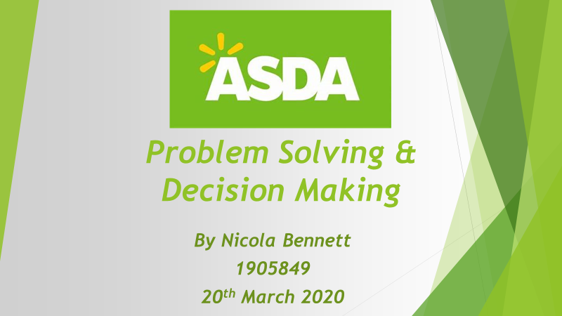

Executive Summary

Reverting to the problems in Nature, Scope and Impact has identified technological issues. After Analysing SWOT and delving into the Fishbone Model has shown how every aspect is vital for the business. To evaluate Asda’s structure of systems, productivity and staff training, they are in desperate need of a reliable team of Managers to lead the cause out of stormy situations. Technology will always remain a big part of the world and will keep on evolving every day. Asda will continue to have issues unless monitored correctly. Having failures and powering through tough times will be expensive and brutal and lessons will be learned. Asda has such amazing historic foundations and legacies and will always be remembered for their shopping experience. Having their major whirlwind of unsettlement will only make them stronger by putting their late experiences into new opportunities.

Contents
1.0 Introduction 3
2.0 Main Findings 4
2.1 Overview of Organisation 4
2.1.1 The History of Asda 4
2.1.2 What products does it offer? 5
2.2 Investigating Asda 4
2.2.1 Nature, Scope & Impact 4
2.2 SWOT Analysis 5
2.3 PESTLE Analysis 7
3.0 Conclusion 9
4.0 Options / Recommendations 10
5.0 Action Plan ( inc appendecies) 11
6.0 Appendices 13
7.0 Acknowledgements 18
8.0 Reference List 19

Introduction

This report has been requested by Laura James, Lecturer of University of Wales Trinity Saint David on the 12th February 2020. Nicola Bennett has compiled this report which will be submitted by 20th March 2020.
The purpose of this report is to provide an analysis of Asda’s current situation. There are many problems found throughout their organisation. However, one issue will be identified and critically analysed to why this has happened. There will be analytical tools such as SWOT, PESTLE, Fishbone and the Five Why methods including a timeline of Asda’s historical events used in this report. Whilst finding evidence of certain difficulties and challenges in Asda, Technology is one of their main customer complaints as of recent times. Drawing conclusions of recent challenging events, bringing on board suggestions and monitoring evaluations will have an impact for current and future needs.
In order to compile this report, some journals and websites were used for research, facts and guidance. Finding and documenting all factual evidence will show elements of objectivity and critically show how technology has areas of positive and negative use.

Main Findings

Overview of Organisation

Asda was UK’s first Supermarket to discounter, offering low prices and amazing products for every member of a family. Being creative in their retail background the Co- Founders learned that keeping costs low and having great value for money with a diversity of foods and goods has been their drive force. With 632 stores within the UK, Asda continuously reduces items to entice all customers young and old.
As Asda grew, they started to bring more food to their market, as well as their Meat, Poultry, Fruit, Vegetables and Dairy, they were offering a variety of tinned items and Bakery goods, desserts already made as well as frozen items all packed ready to pre heat and cook so foods would last longer. Whilst the economy in the 60’s started to excel, car sales were soaring, families were able to afford luxuries such as fridge and freezers at home resulting in bulk buys and using cars to transport their items for a weekly shop.
Asda invented wonderful catch phrases and adverts on the television so that they were branded and unique from competitors. Despite the years of Asda soaring and being one of the best competitors in retail, they have had their fair share of internal and external challenges. © Channel 5 Broadcasting Ltd (2020).

The History of Asda
Asda Timeline, See Appendices 6.1
In 1920’s The Asquith Family Butchers joined forces with Hindell’s Dairy Farmers Ltd known as the Stockdale Family. Through a process of diversification and working well together for many years they formed a new public company in 1949 known as Associated Dairies & Farm Stores Ltd. As they both linked their love and bond of retail, they passed their heritage onto their sons, where they opened their first UK supermarket superstore. © Asda (2020) Our History.

2.1.2 What products does it offer?

Offering many products and using their own Asda Brand of Tins and Groceries, International Procurement Limited (IPL) also provide and supply their products to Asda and Walmart, they help improve value and quality, and savings all around the world. Whilst Clothing, Home essentials (© George 2020) and Petrol are the longest sellers, Asda introduced Insurances for Travel (Travelex Currency Services Limited) Cars, Home, Pets and all vehicle and transportation (Introducer Appointed Representatives of Vast Visibility Limited). Whilst the UK economy had become stable, they also introduced Personal Loans and Credit cards (authorised and regulated by the Financial Conduct Authority). As the world grows and becoming faster paced, convenience has become a necessity for busy lifestyles, so whilst customers visit their local Asda they can also visit the opticians, relax in the café, collect there medicinal prescription, buy Travel money, Photography service and paying their bills using Pay Point at the customer service desks.

2.2 Investigating Asda

Critically looking into Asda and seeing how many beneficial services they provide only places alarm bells in the fact that too many products internally will incur higher monitoring, increased valuations, many more complaints and external problems. Using various network research sites into the company, Asda’s documentary (© Channel 5 Broadcasting Ltd (2020) Inside Asda: Bigger, Better, Cheaper?) shows problems occurred during periods of change.
Customer reviews show many complaints of similar issues, which has impacted many people around the world. Finding that Asda’s in-house technology and systems are causing more concern and contributing factors. However, Asda update and rectify situations at a timely and effective manner, but at a cost. The cost of reputation, convenience to customer and reputable service worldwide. Technology does everything in a systematic procedure, so not having this in place for any moment of time will have an effect for all organisational productivity.
In 2018, Asda started using Tyco Retail Solutions’ Sensormatic Shrink Management as a Service (SMaaS) which enables the business to centrally monitor Electronic Article Surveillance (EAS) and loss prevention systems across its 632 stores.
Inevitably, SMaas had been brought to life to show all roots of issues rapidly, however this deems untrue, due to the troubles they are receiving and the loss that is financially showing.
Sillitoe, B. (2020) News Writer Essential Retail

2.2.1 Nature, Scope and Impact

The Nature of Asda’s problem is their technology not working as effectively due to management not monitoring causes. They are currently facing strategic issues with their variety of systems and trying to control products and services in store and online. Looking into customer complaints as far back as 2016, reviews have mainly been on their online payments, their delivery service and self-service counters being unpredictable and unreliable. There are customers who take advantage of the Scan and Go system where stock is not being paid for. Face to face customer service experience has lacked and staff are unable to rectify issues at fort hand due to not having enough knowledge or training with technologies that are in place.
It is a renowned fact that the world has become an impossible place to stay without the use of technology. Having a scope into all technological equipment that Asda maintains, it is clear there is a knock-on effect if the systems malfunction or if staff or customers cannot use them.
It will influence:
- Customers
- Consumers
- In store staff
- Stock and warehouse staff
- Delivery drivers
- Office administrators
- CEO departments
- UK and Overseas suppliers
- Stakeholders
- Shareholders
- Investors
- Local economic areas
Not having communication between the management team and following protocol down the line of to all staff, in the UK and Overseas will create confusion, a disregarded outlook and uncertainty of what the company wants and needs, this will make them question their well- being and security of their job role which will then create a negative atmosphere and service to customers. Social media and online complaints that everyone can view will always escalate issues further, recommendations good or bad will allow people see or hear flaws in Asda which is affecting their reputation.

The impact of having varieties of technology systems and management unable to cope with the diversity and challenges they face, has influenced all staff:
- In-store
- Warehouse staff
- Office
- Financial Investors
- Shareholders
- Stakeholders
- Production staff
- All suppliers
Every person involved will start to lose faith, confidence and money, they will look to move elsewhere to a healthier, thriving company with better reputation, reasonable prices, great stock control and less technological complications. Low sales and productivity will leave Asda in major crisis. The impact has already seen many redundancies issued over the last two years, if management do not act quick enough to resolve their issues and start controlling the loss and damage caused, it may lead them into major financial consequences. Ookla, LLC, Downdetector.

2.3 SWOT Analysis
See Appendices 6.2
Strengths
Asda is known for their:
- Strength of Business culture and opportunities
- Reputation for advertisements
- Strong work force
- Rollback prices
- Being Third largest Supermarket in the UK.
- Selling multiple products online and instore
- Using own Brands and other high-class names,
- Charity and Brand awareness & Support
Asda continues to produce fresh and great quality items ranging from low, middle and higher costs, depending on Brand and supplier. Making sure all brands are suitable for families with different financial backgrounds. Being one of the largest stores makes it easy for customers to bring their belief and loyalty, it gives them a safe feeling knowing their products and necessities have been sold from a reputable organisation and with their performance in new markets clearly having a positive effect. Having many investors and trying to expand the production, working with Asda has brought in more employees to help the economy and local areas which helps create positive feedback to the Government and surrounding local businesses and customers.
Asda supports local communities and Charites by setting up an Asda Foundation programme and selling products in their stores. Asda let customers choose which charity they would like the store to contribute too, using The Green token scheme. Asda also use Match Funding Schemes where they encourage colleagues to raise money for local or national Charities and whatever amount is raised, Asda will match.
Asda Foundation: Transforming Communities & Saving lives: (2020)

Weakness
See Appendices Financial Loss Chart 6.3
There are many weaknesses gradually surfacing:
- Their lack of staff training for new software
- Unsure how to monitor or resolve their unreliable technology
- Their Management department are changing too frequently
- No true consistency, structure or stability
- No clear communication down the line of Staff
- Not enough or Too much money and time invested in Technology
- Low prices showing too much inflation
- Stock control system out of sync due to Scan & Go
With changes implemented and communication issues, there will be mixed signals of knowledge and misunderstandings.
With consistency being weak, shows not enough time or money invested to train their employees correctly or quickly enough for how fast their services are needed, this is causing friction between customers and staff due to them being frontline employees and too many complaints unresolved.
Whereas Asda used to keep their prices low, they are showing signs of delicacy in their company by keeping prices elevated. With not as many rollbacks and offers within the late, customers are finding their shopping immoderate and have started to seek lower prices and easier services in competitors.
In finding contradicting incidents with Asda’s Strengths and Weakness, shows that many loyal customers are wary of what the future brings especially with insurances or Credit they may hold. On one hand, Asda promotes they are the best supermarket with lowered prices, and that all staff members collaborate like one big family. They promote their systems to be easy, efficient and money saving, Eco-friendly gadgets.
On the other hand, reading customer complaints, online reviews, newspaper articles and feedback on their online and instore systems, this has not been more from the truth. With employees moral plummeting and with new contracts coming into place, losing wage or worse, being made redundant, is not gifting the business with the positivity it needs.
After analysing the technology, one system is letting the company down and losing millions a year. The Scan and Go system have no accountability for unscanned items. Most customers who use this system will abuse it intentionally and unintentionally and it is costing Asda everyday with messy stock control and financial loss.
Professional Academy Online: Albert Humphrey (1960)

PESTLE Analysis
See Fishbone & Five Whys 6.4 & 6.5
See PESTLE Analysis in Appendices 6.6
Investigating the complexed breakdown of PESTLE, helps discover new findings from a bird’s eye view. It benefits to see the adverse effects on the business and can help monitor and evaluate difficult situations if they were to arise. Despite the immense growth in value online and in store retail sales, Asda has its rivals and competition which has no limits and forever trying to better themselves.
Environmental - With the economic system constantly evolving and being very strict with recycling procedures, Asda need to make sure they keep up Green Economy.
By using
- Vehicles and Transport servicing and MOT and green eco tyres
- Organic Foods trade
- Eco-friendly products in stores
- Correct recycle waste bins
If Asda role models this type of behaviour, it will encourage others to follow. Asda has systems in place for advice and direction and correct recycling bins in their store and warehouse for all staff and customers to help with the economy.
Technological - Advancement in computer aided design is seen as vital for supermarkets. Having new and updated systems in store and online access including mobile applications will help the economy become less polluted, less paper and materials means less waste. It is beneficial to the economy and area’s surrounding the stores that communication resources between staff, departments and nearby trades are competent, using their procedures and regulations to keep areas as standards states.
Placing new security measures to the stores will decrease the theft percentage, items will be secure, and stock will be calculated more effectively to enhance the productivity online and at the warehouse. Having systems taking over and threatening redundancies in staff, Management need to have the best systems in place. It may be that technology may be more efficient and economically friendly, but that will not give emotional intelligence and a customer service experience that Asda have thrived on.
Copyright © My Theme Shop: (2019)
Sodry, D Dr Business and Environment Strategy: How and what (2017)

Conclusion

Bringing all theories together based on research, customer reviews and facts along the way, finds many superb traits that the store resumes from years ago. With their great work ethic and trade and with many of their items tailored to great causes and economical standards, Asda have created a whirlwind of a super store. They found ways to connect external firms and place them internally to extend their customers experience and conveniences and for social pleasures for millions of customers.
Whilst on the outside, Asda looks like it may be thriving due to their positive outlook, but they have hidden many problems that have now surfaced.
Ranging from Financial loss to technical issues and staff redundancies leads to unsecure relations to all involved in the company internally and externally. For such an immense corporation that holds over 130,000 employees, it is unfortunate that Management and CEO’s have let their monitoring evaluations slip and have such an effect on all departments, their products, staff and customers. If anything could help them claw back their finances and trust, is to reduce the redundancies as staff are vital for service and quality of care and staff not having to face a financial worry. Looking onto their competitors, Aldi and Lidl, they are simple and effective, they don’t use many self-service tills and Scan and Go systems and looking at their business to date it is working for them. Their staff provide a face to face service and scan every item, so theft is majorly reduced, and stock is controlled and organised efficiently. Asda need to get back to basics and fight for the amazing superstore prices and service they had the reputation and awards for. Additional security systems and guards would be beneficial due to the size of the stores and contracting Managers who are engaged with the floor staff for feedback and who will listen to what they have to say is imperative, communication throughout the vicinities will not only benefit staff and the business but customers too. Surely with simple and mindful tweaks Asda will get back to thriving and soaring in no time providing the correct management and the right technology.

Options / Recommendations

Communicating and listening to all members of staff and using feedback and making it effective is vital. Listening to customers and giving them what they want or what they don’t want will help with customer satisfaction and going forward will entice customers back. Monitoring and Evaluating more frequently.
4.1

After analysing all of Asda’s problems one major issue seems detrimental and all recommendations have been given to form a positive change.

To remove Scan and Go systems

To hire more security in the larger stores

To have consistency in Managerial departments

For Managers to monitor and evaluate systems closely and more frequently

5.0

Action Plan

Monitoring the decision:
Resources:
- CEO’s
- Managing Directors
- Managers in all departments and SMaaS Ltd are responsible for not monitoring effectively
Key Indicators:
- Customers experiences
- Staff feedback in all departments
- Online and paper reviews and complaints
- Stock control evaluations
- Warehouse productivity
Targets:
- To have financial gain
- To achieve better customer service care and experience in store and online both within 18 months
Data Sources:
- Online reviews
- Social Media
- Newspaper Articles
- Productivity readings
- Financial yearly reports
- Documentaries
Reviewing the decision:
(Write here how you will evaluate/review the problem. What questions will you ask? Etc)

- How do you feel the new systems have worked for the company?
- In which ways has it affected the financial side?
- How has the systems affected employees?
- How costly would it be to remove some systems?
- Is customer service care and experience / customer satisfaction a main priority for the business?
- Would you go back to basics, limiting in store technology and employing more staff?
How would I do It better next time?
Try not to get too far in advanced with technology in store, customers want lower prices and customer experiences, don’t try and be too competitive with gadgets, it’s the rollbacks and online shopping that customers enjoy. In store there is too much choice. Look at Aldi and Lidl they are both simplistic and thriving in sales.
Communicating the Decision:
Internal Stakeholders  - Communicate to all CEO’s and Managing Directors first, that changes will commence and decisions within 4 weeks face to face and emails and phone/ conference calls  - Feed down the Chain to all Managers the same information and the time scale of 4-5 weeks face to face, emails and handouts  - Managers to feed all the relevant information to staff within 5-6 weeks with emails and handouts | External Stakeholders  Information will be carried out externally via letter or private email and some face to face meetings to:  - Suppliers  - Governments  - Creditors  - Shareholders  Information will be sent out by TV news, Asda Website and newspaper articles for:  - Society  - Customers

6.0 Appendices

6.1 Our History Timeline

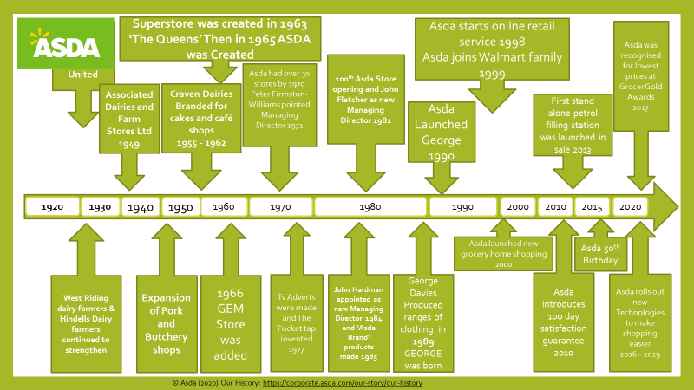

6.2
SWOT Analysis

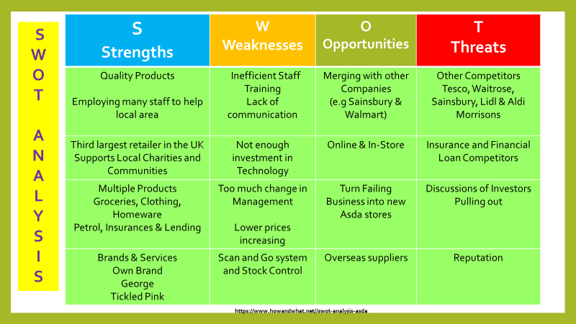

6.3
Financial Loss Chart

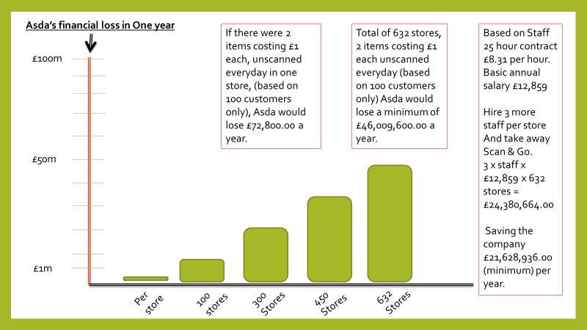

6.4
Fishbone (Ishikawa) Diagram Analysis

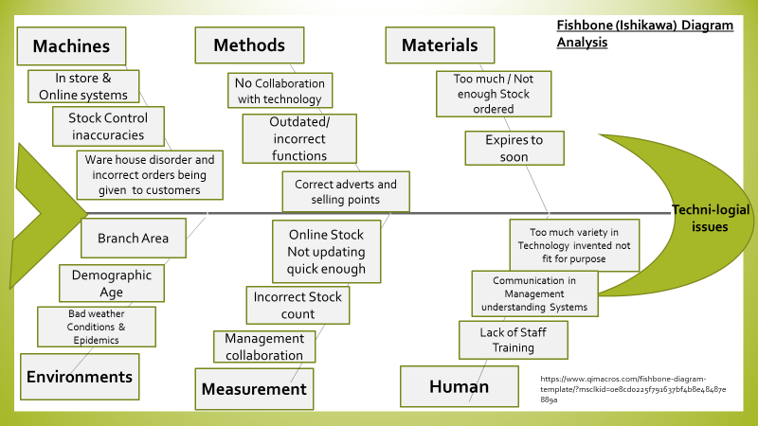

6.5
Five Whys Module

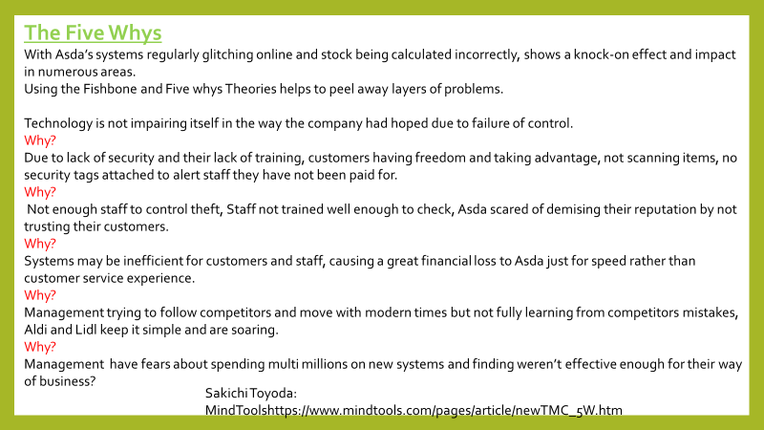

6.6
PESTEL Analysis

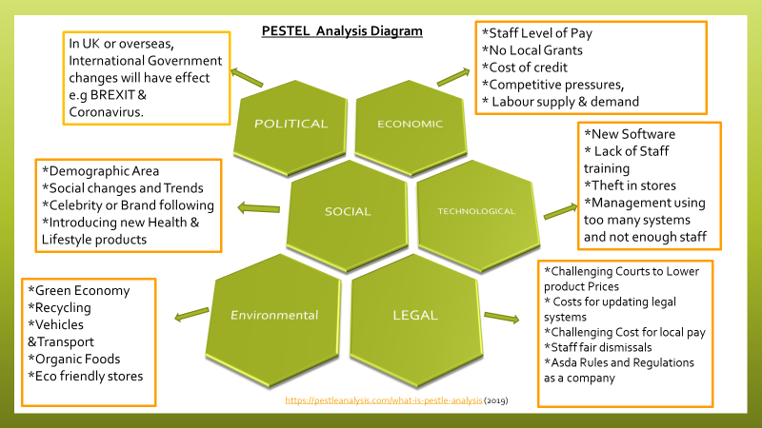

Acknowledgements

To bring all theories and reports together © Channel 5 Broadcasting Ltd (2020) have been very helpful, Thank you for the inspirational documentary.
Thank you to Laura James, without amazing lectures and support this report would not be satisfactory and to University of Wales St Davids Trinity for support and space for studying.
Thank you to Peers for their patience and time in the library and at home studies.
And lastly Thank you to Asda for all their information and research and factual detail they have provided for this report to be complete.

8.0

Reference List

© Asda (2020) About Asda [online]. Available at https://www.asda.com/about (Accessed 2nd March 2020)
© Asda (2020) Our History: [online]. Available at https://corporate.asda.com/our-story/our-history ( Accessed 2nd March 2020)

© Channel 5 Broadcasting Ltd (2020) Inside Asda: Bigger, Better, Cheaper? [Online]. Available at https://www.channel5.com/show/inside-asda-bigger-better-cheaper/ (Accessed 27th February 2020)

© Emerald Works Limited 2020 -Mind Tools: Essential skills of an excellent Career [online]. Available at https://www.mindtools.com/pages/article/newTMC_5W.htm (Accessed 8th March 2020)

©Asda (2020): (Images) [online]. Available at https://www.bing.com/images/search?view=detailV2&id=680F0B51AA294C3CC786C8BF423E568A39080543&thid=OIP.JvRliyx9pZJQ070lexeSSgHaFj&mediaurl=http%3A%2F%2Fwww.soultsretailview.co.uk%2Fwp-content%2Fuploads%2F2011%2F08%2Fasda_supermarket_old_fold_road_exterior_graham_soult4-300x225.jpg&exph=225&expw=300&q=Asda+UK&selectedindex=80&ajaxhist=0&vt=0&eim=2,6 (Accessed 2nd March 2020)

©Ookla, LLC, (2019) Downdetector: [online]. Available at https://downdetector.co.uk/status/asda/ (Accessed 26the February 2020)

Asda Foundation: Transforming Communities & Saving lives: (2020) [online]. Available at https://www.asdafoundation.org/foundation-grants (Accessed 8th March 2020)

Copyright © 2020 Reed Exhibitions Ltd - Sillitoe, B (2020) News Writer, Essential Retail [online]. Available at https://www.essentialretail.com/news/asda-loss-prevention/ (accessed 4th March 2020)

Copyright © My Theme Shop: (2019) [online]. Available at https://pestleanalysis.com/what-is-pestle-analysis/ (Accessed 9th March 2020)

MarketLine: Available at https://advantage-marketline-com.ezproxy.uwtsd.ac.uk/Analysis/ViewasPDF/united-kingdom-online-retail-94302 ( Accessed 28th February 2020)
Professional Academy Online: Albert Humphrey (1960) [online]. Available at https://www.professionalacademy.com/blogs-and-advice/marketing-theories---swot-analysis (Accessed 6th March 2020)

Sillitoe, B. (2020) News Writer Essential Retail: [online]. Available at https://www.essentialretail.com/news/asda-website-toyou/ (Accessed 29th February 2020)
Sodry, D Dr Business and Environment Strategy: How and what (2017) Asda PESTEL: [online]. Available at https://www.howandwhat.net/pestel-analysis-of-asda/ (Accessed 26th February 2020)

Sakichi Toyoda: (2020) Mindtools [Online]. Available at
https://www.mindtools.com/pages/article/newTMC_5W.htm (Accessed 9th March 2020)

