Network Operating Systems & Services:

cONFIGURE AND MANAGE a Type 2 Hypervisor based Virtualised network.

Joseph Evans

ACCA5023

University of Wales Trinity St David, Swansea, Wales

2216851@student.uwtsd.ac.uk

Introduction
This report is a continuation of a virtualized network deployment documented in NOSS assignment 1, now focusing on the configuration and management of the network environment. In the previous deployment stage, 2 domain controllers and 2 domains were deployed, hosted in Oracle VirtualBox. These machines were assigned IP addresses and were set up in a topology including three subnets – one LAN each for the London and Swansea domain controllers and associated clients, and a third existing to facilitate communication between the two domain controllers.

Scripts
Script 1: Name: Basic Configurations
Run at: London Server
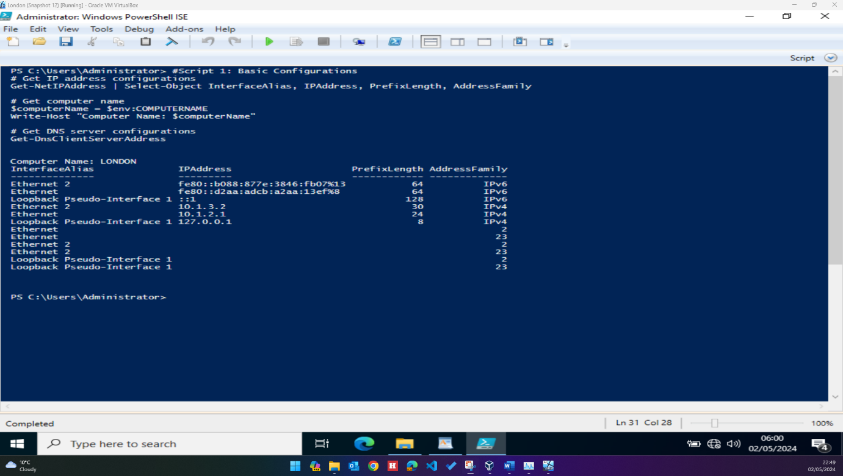

Script 1: Name: Basic Configurations
Run at: Swansea Server
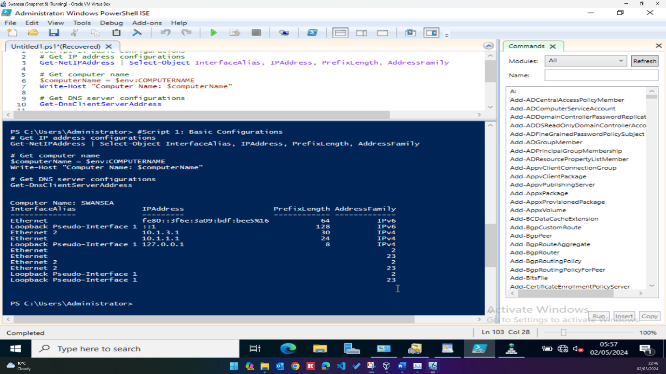

Script 1: Name: Basic Configurations
Run at: London PC
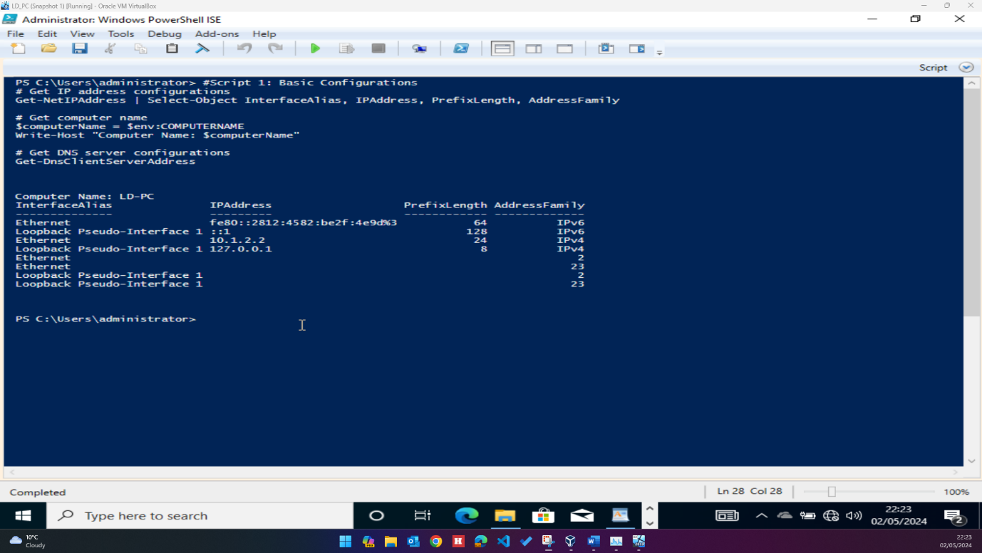

Script 1: Name: Basic Configurations
Run at: Swansea PC
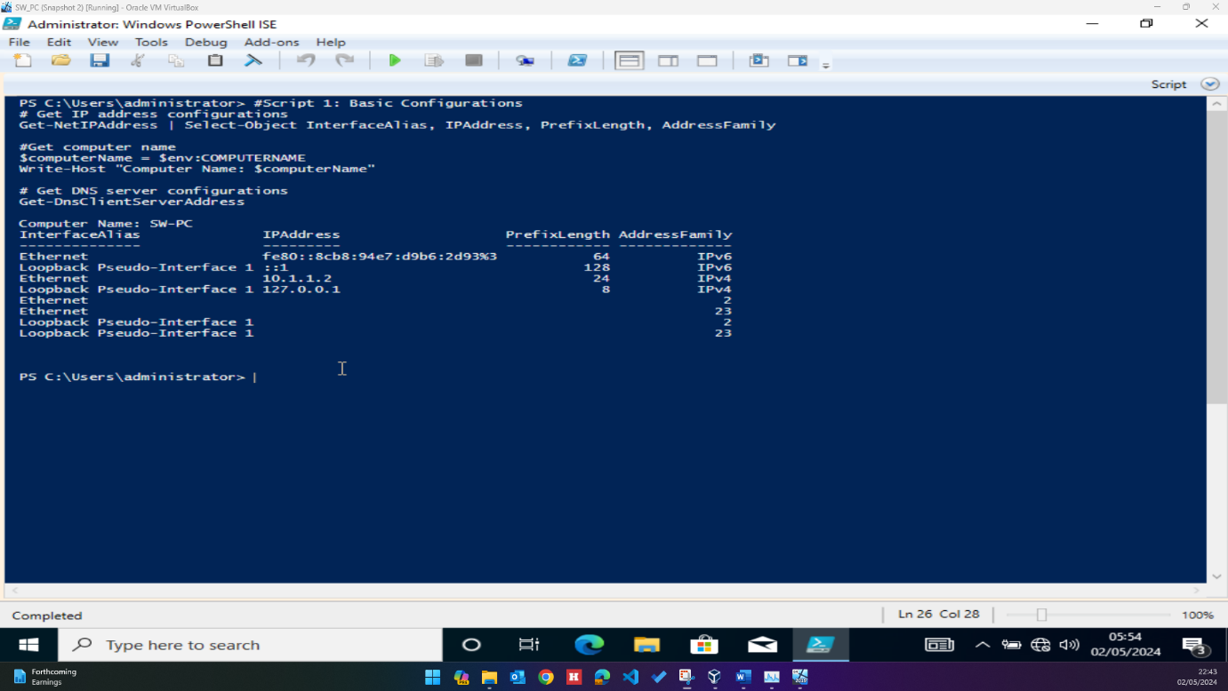

Script 2: Name: Firewall Rules
Run at: Swansea Server
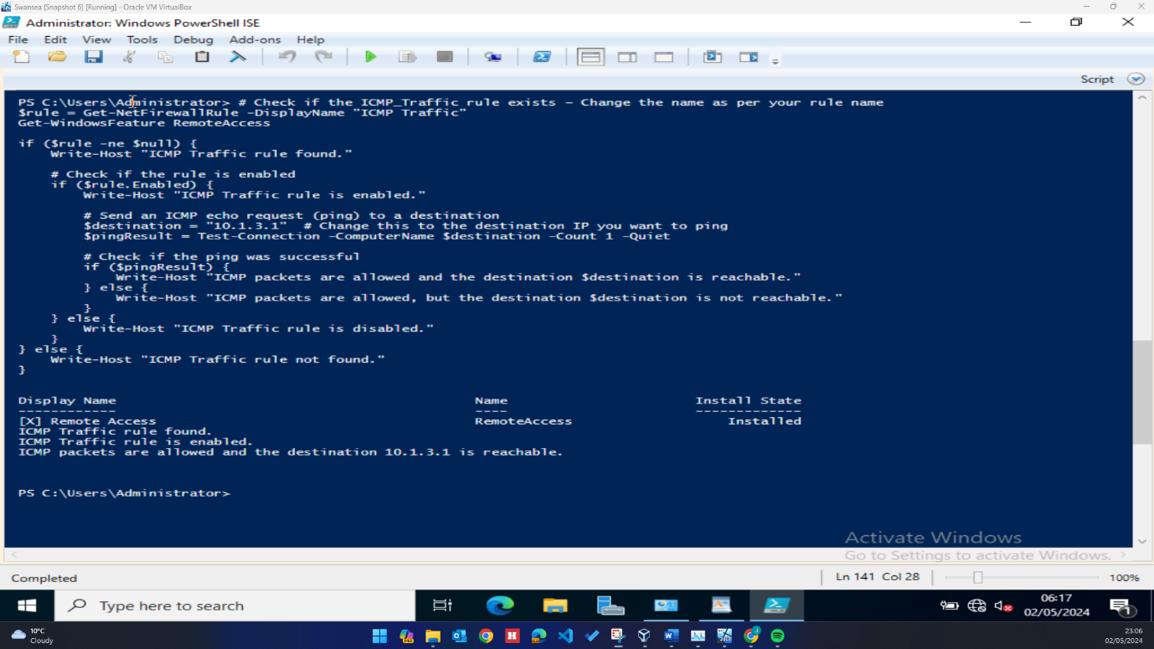

Script 2: Name: Firewall Rules
Run at: London Server
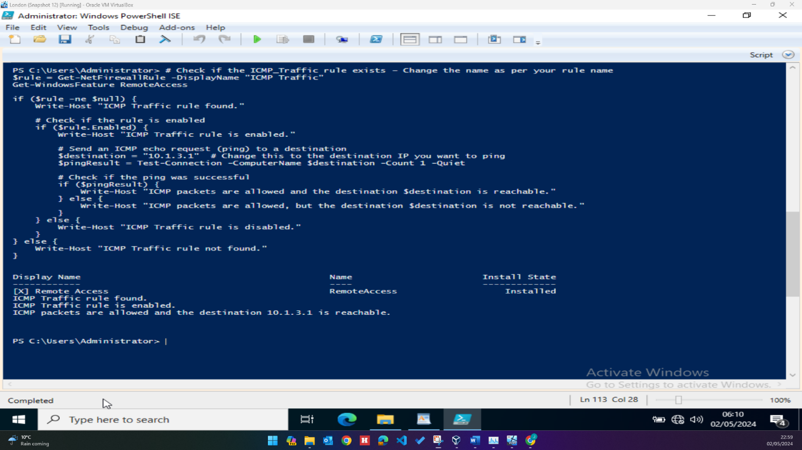

Script 3: Name: Appropriate Domain Controller Configuration in both Swansea and London Network
Run at: Swansea Server
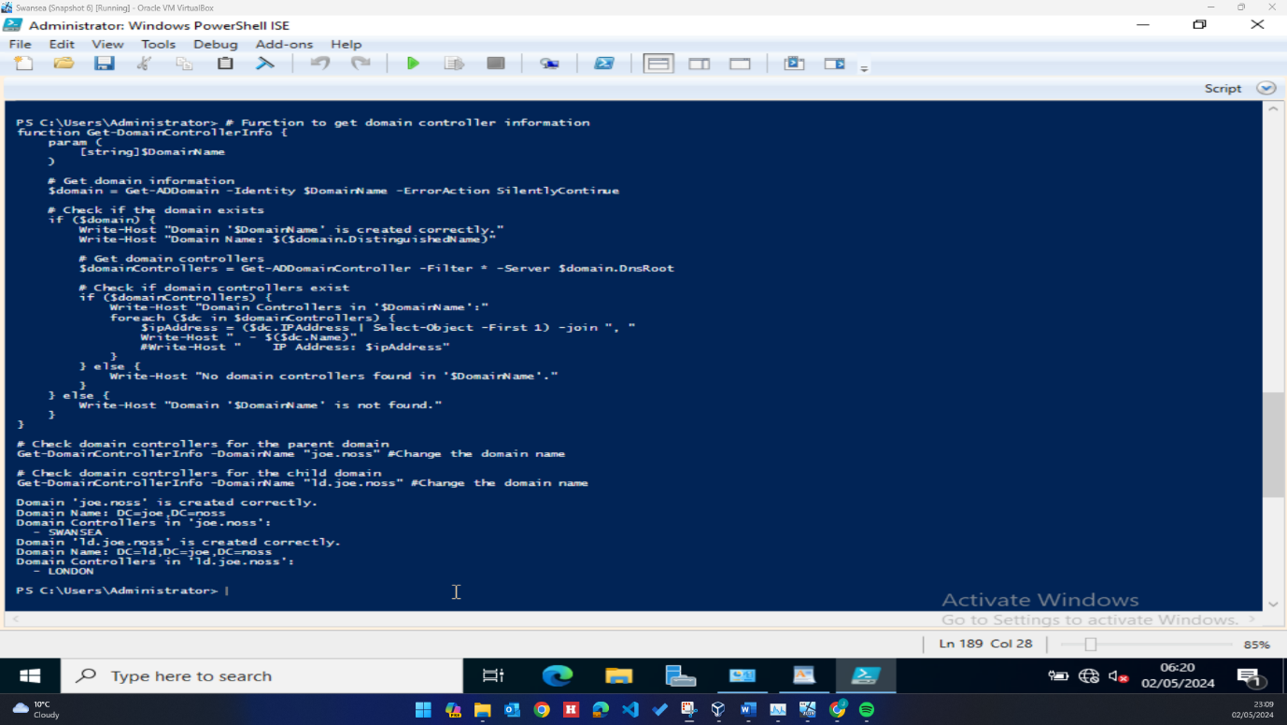
Script 3: Name: Appropriate Domain Controller Configuration in both Swansea and London Network
Run at: London Server
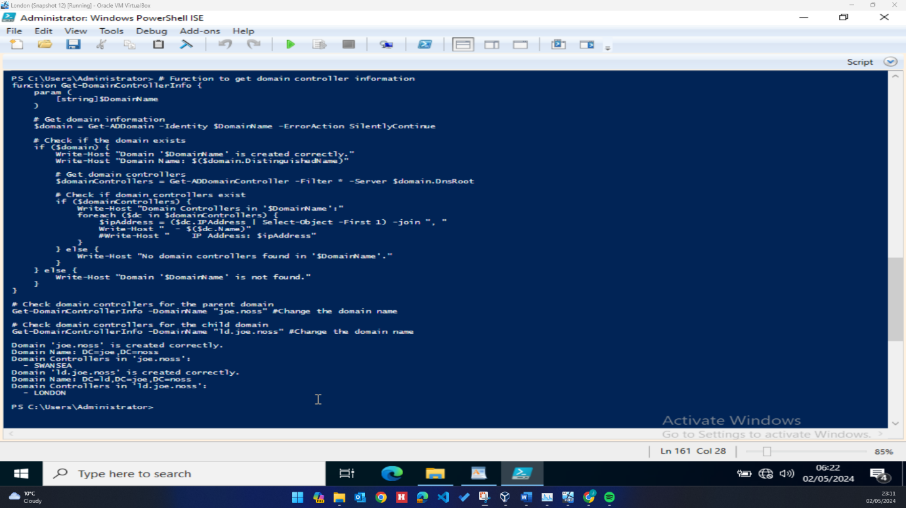

Script 4: Site to Site VPN with Persistent Connection between London & Swansea Network
Run at: Swansea Server
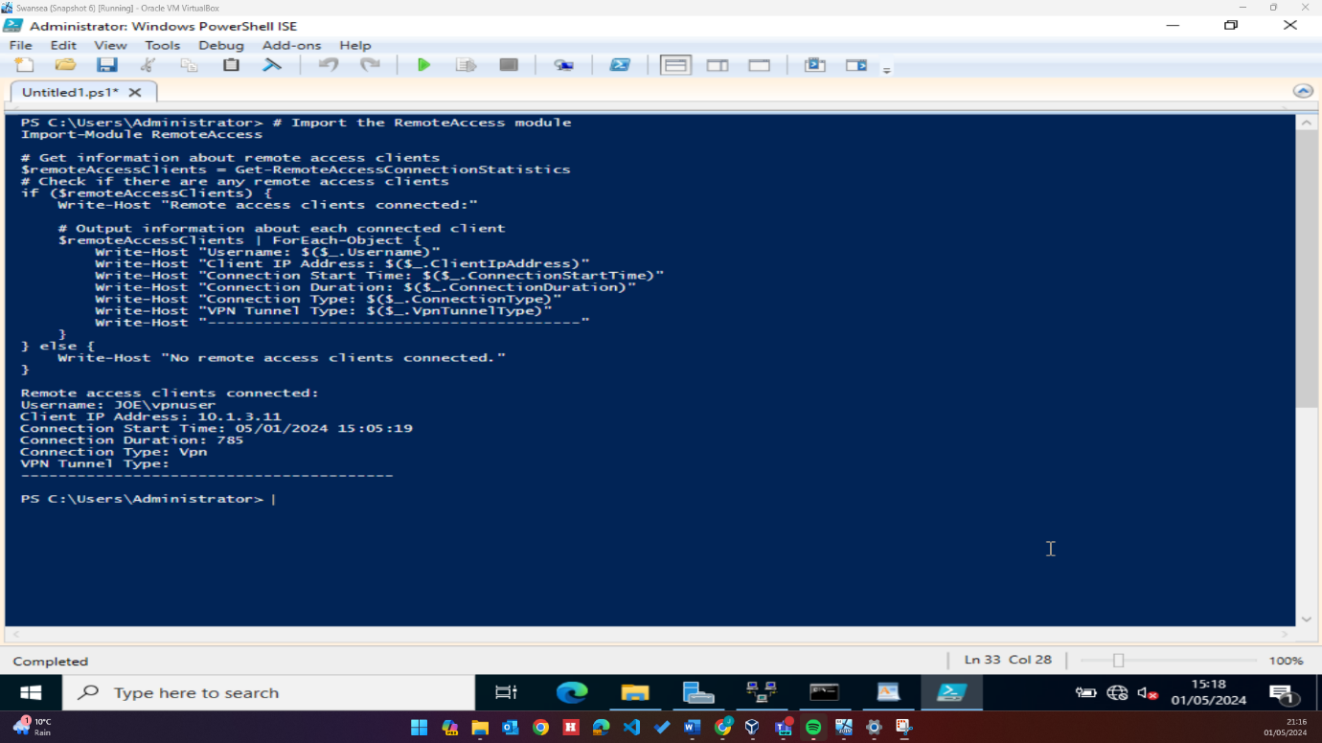
Script 4: Site to Site VPN with Persistent Connection between London & Swansea Network
Run at: London Server
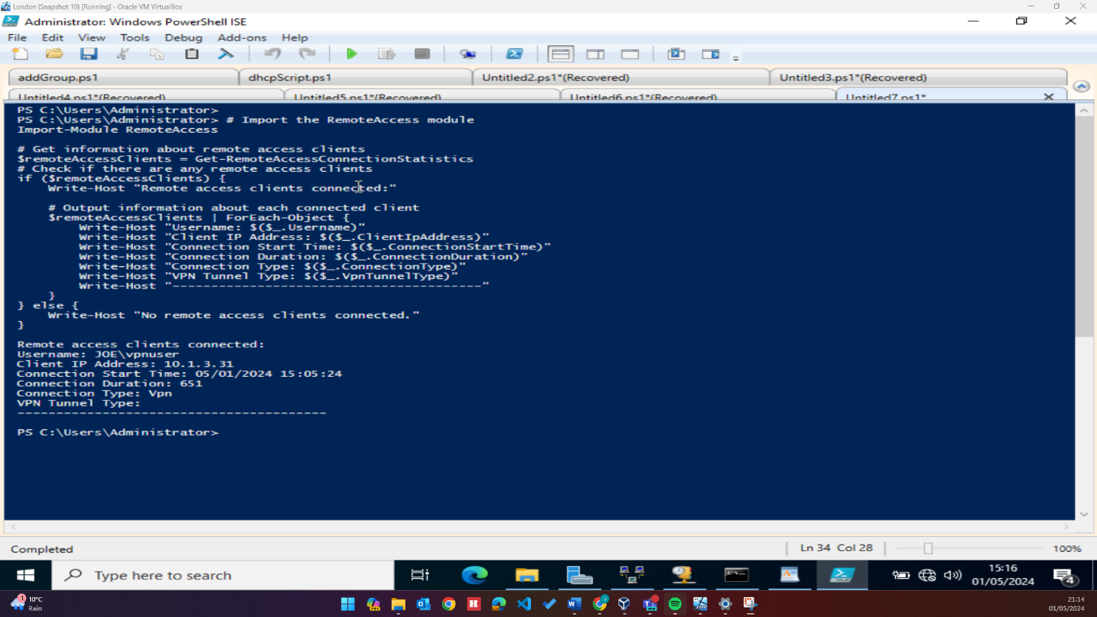

Script 5: DNS Records - Appropriate A Records and reverse lookup zones
Run at: Swansea Server
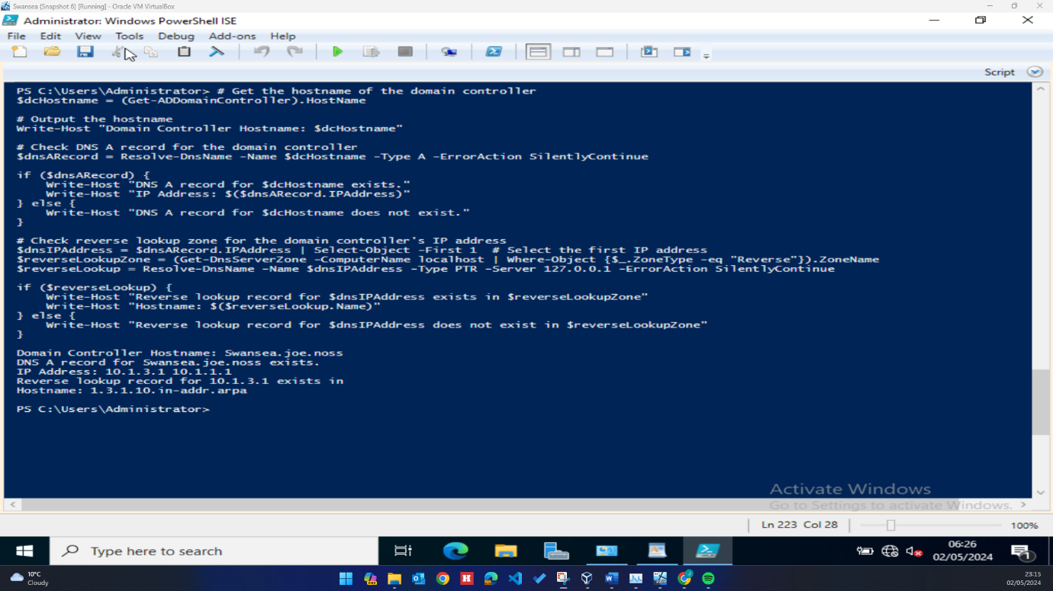

Script 5: DNS Records - Appropriate A Records and reverse lookup zones
Run at: London Server
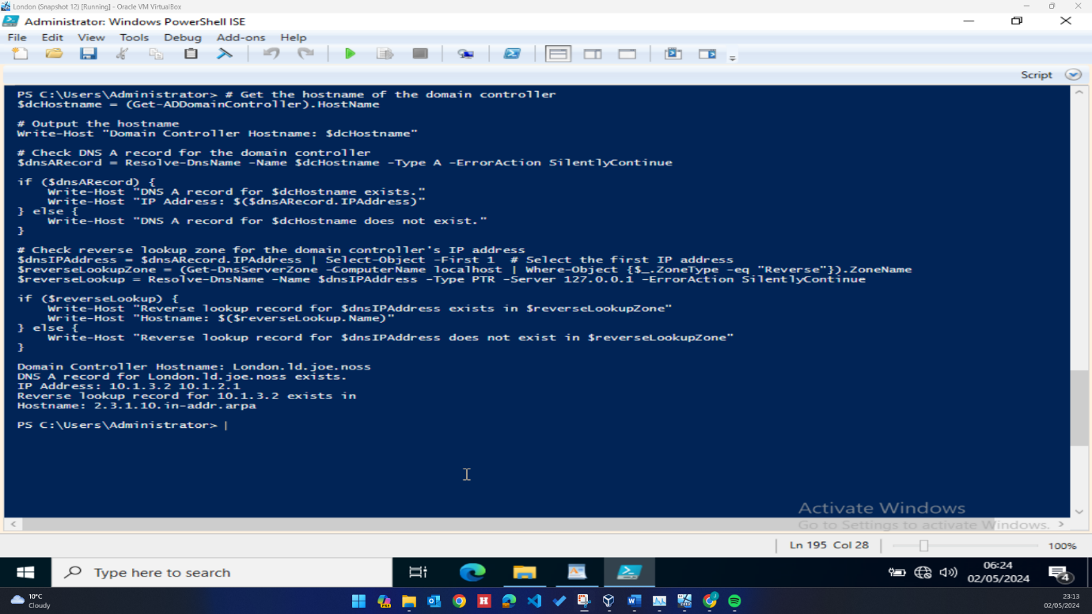

Script 6: Creating User Accounts based on users_list_updated.xlsx
Run at London Server:
Note: The script written to import the users from the CSV file added the naming convention to the UPN field rather than SAM, causing the below script to fail to find AD users. An amended script has been included below to look at the UPN username rather than SAM, and further explanation into the decision to configure user accounts in this manner will be provided later in the report.
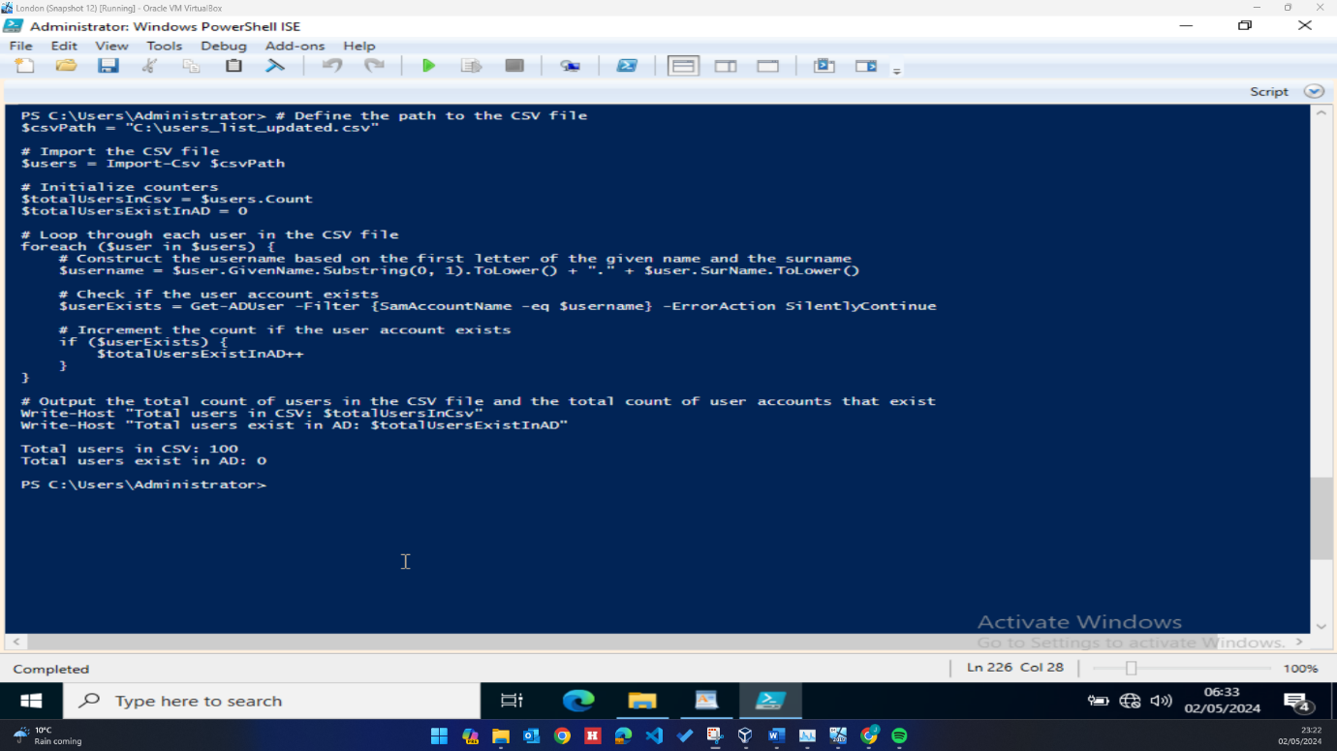

Modified script to find UPN users:
Run at: London Server
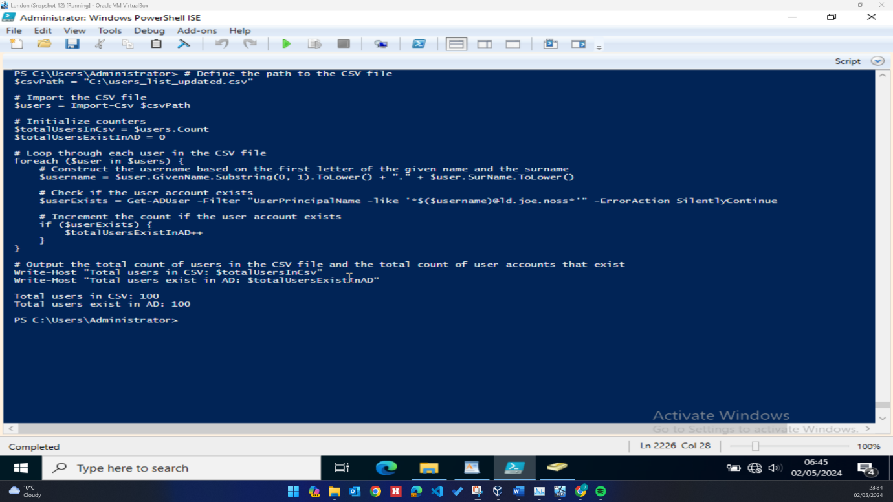
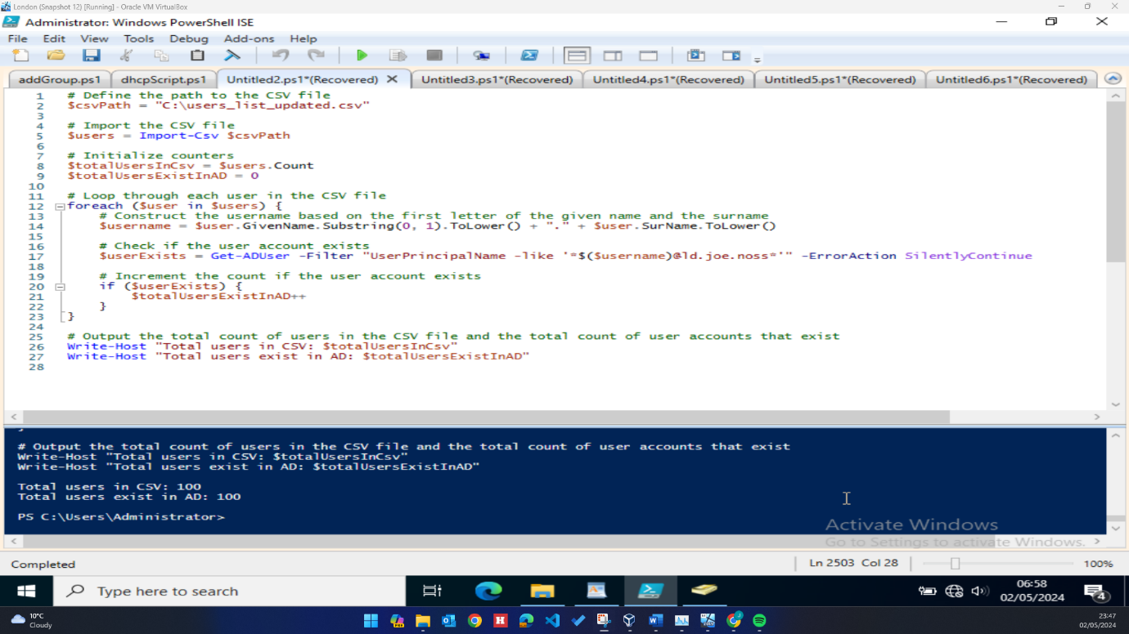

Script 7: User Accounts as per request - with first name with a dot and last name as SAM Account
Run at: London Server
Note: As with the previous script, this script also fails to retrieve users as it is looking for the naming convention being used in the SAM username rather than UPN. A modified script is provided below evidencing the existence of user accounts.
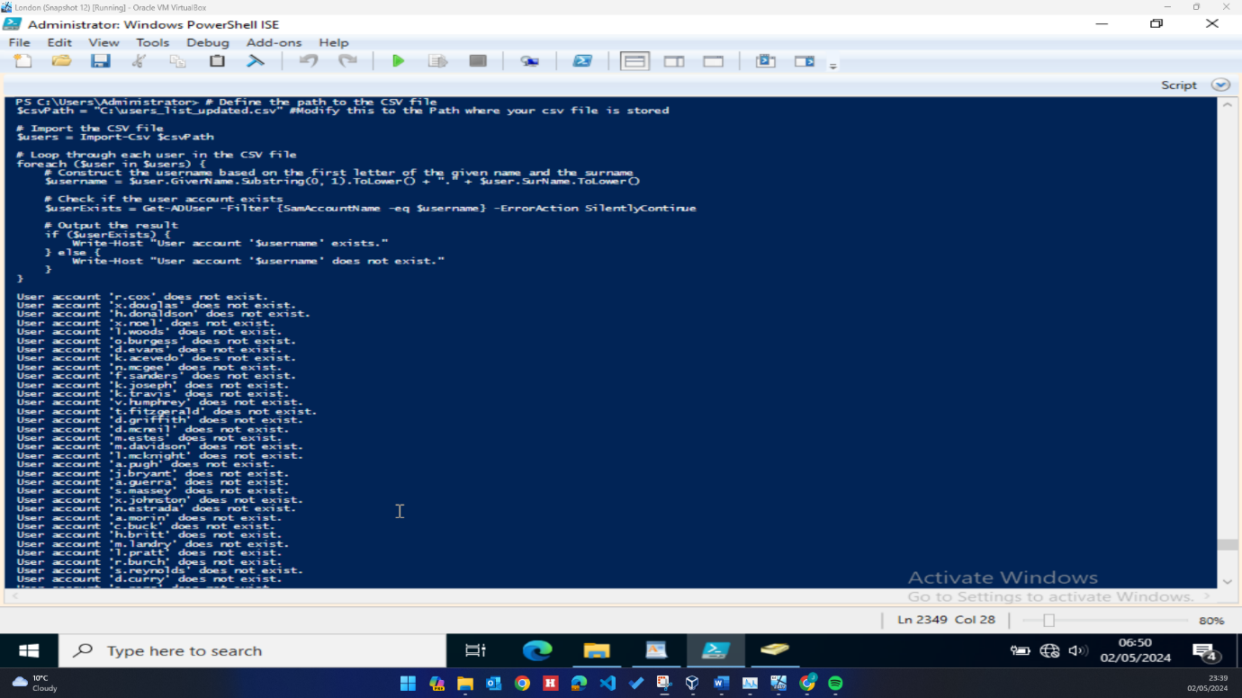

Modified script 7 substituting SAM for UPN:
Run at: London Server
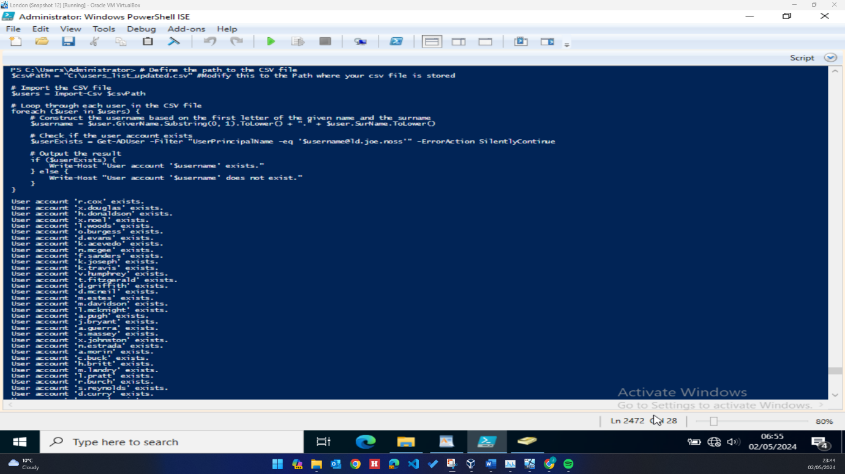
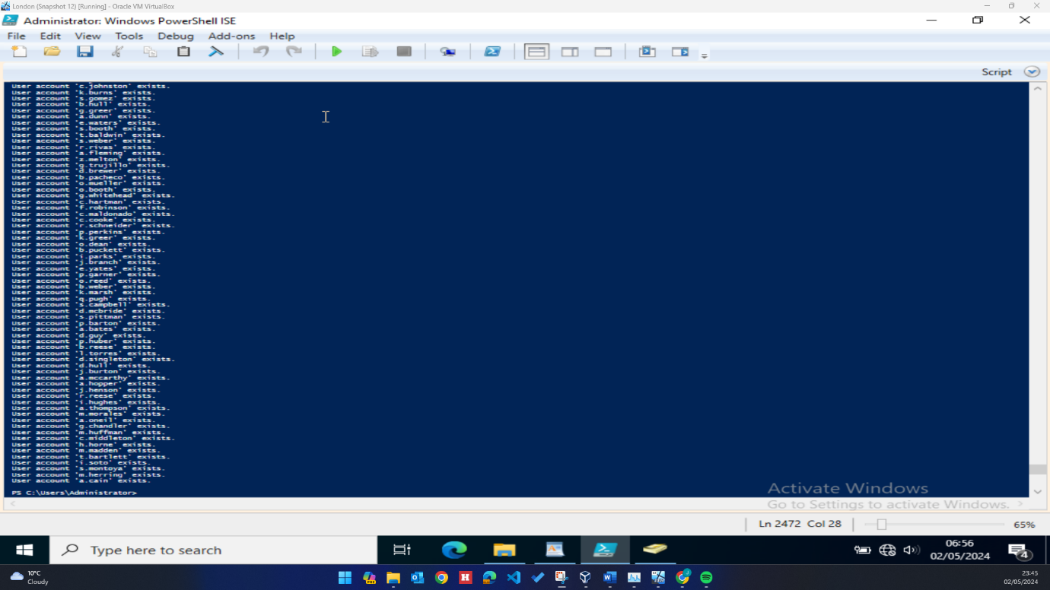
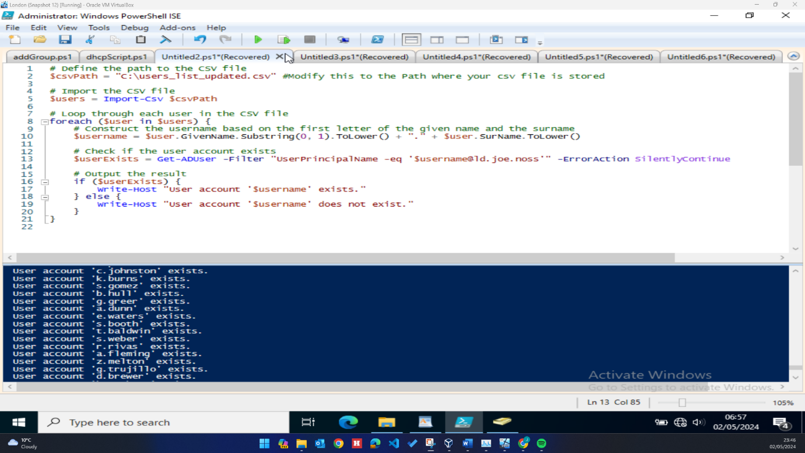

Script 8: Mount Second Disk Drive and Share Permissions (full permission for user list and READ only access for other users)
Run at: London Server
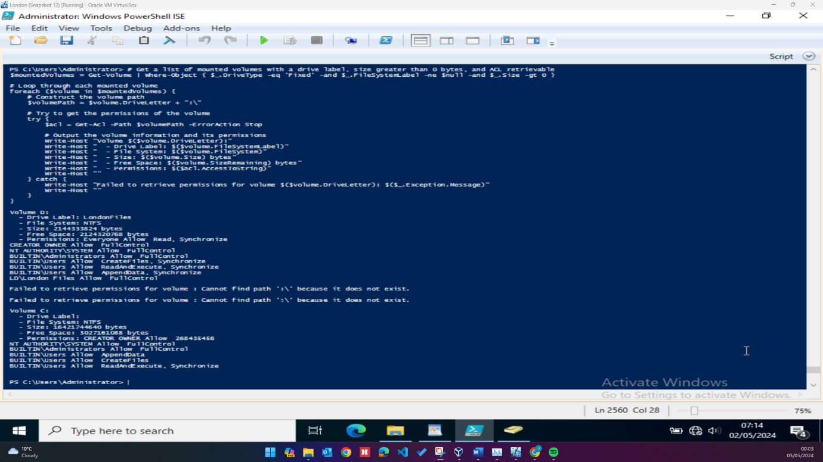

Script 8: Mount Second Disk Drive and Share Permissions (full permission for user list and READ only access for other users)
Run at: Swansea Server
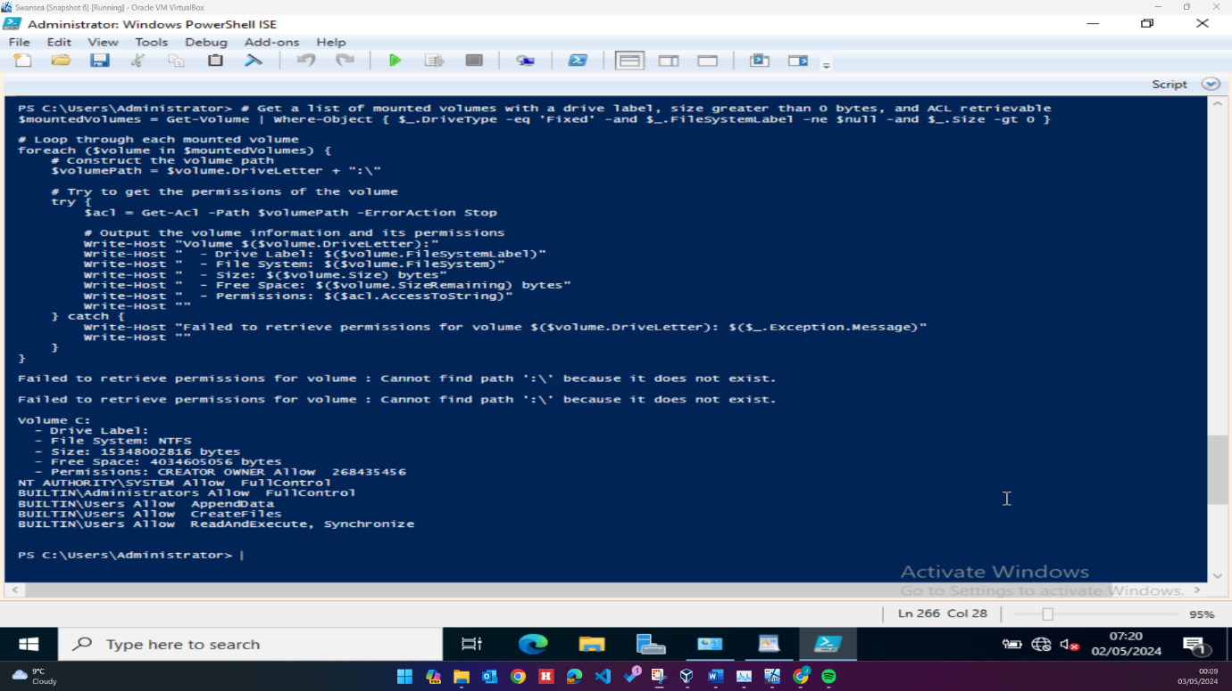

Script 9: DHCP
Run at: London Server
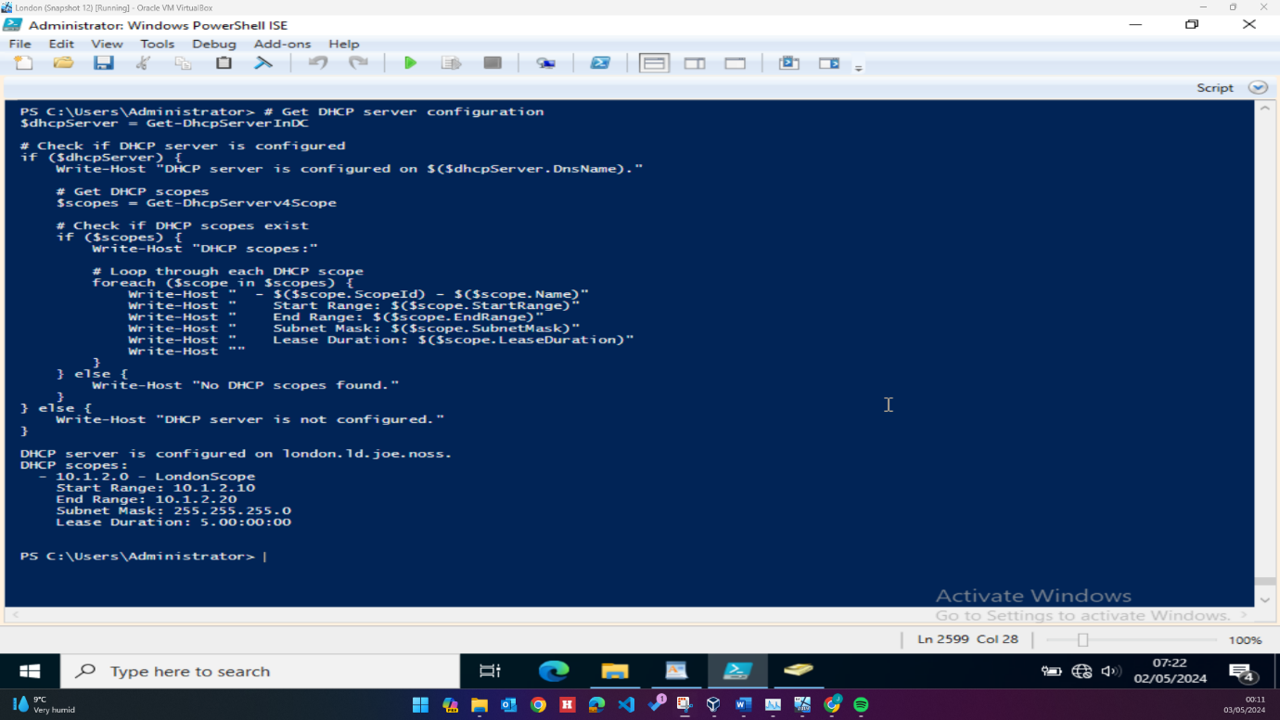
Script 10: test connection
Run at: Swansea server:
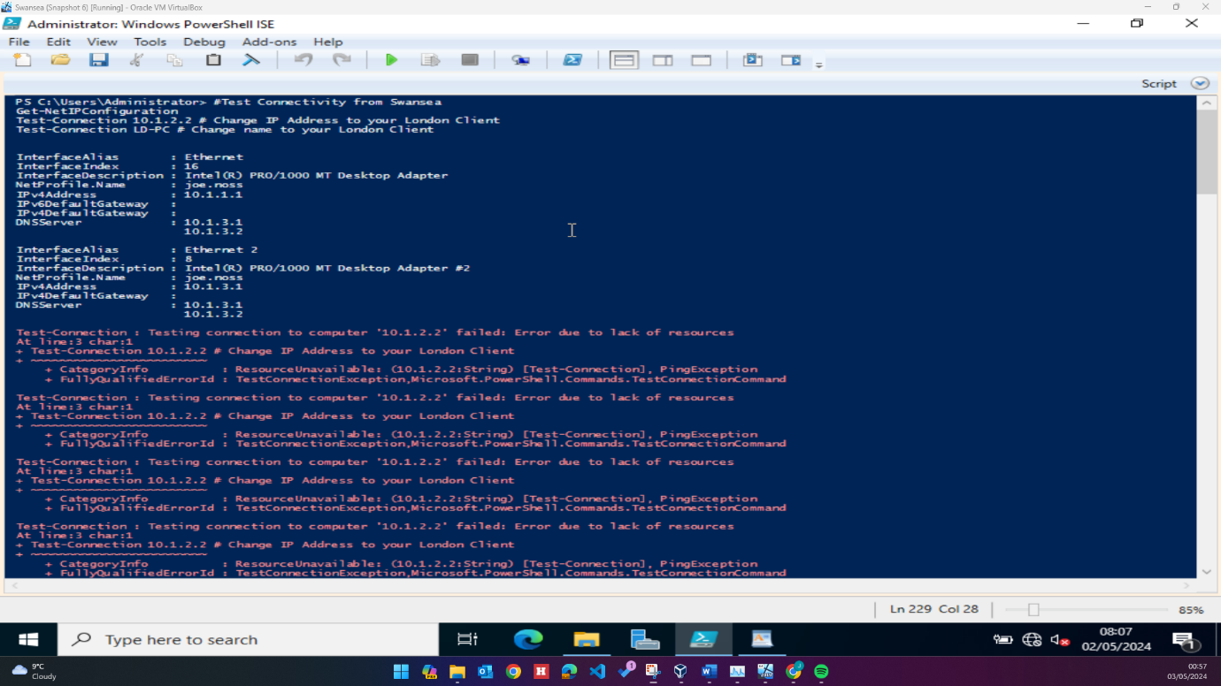

Script 11: Test connection
Run at: London Server
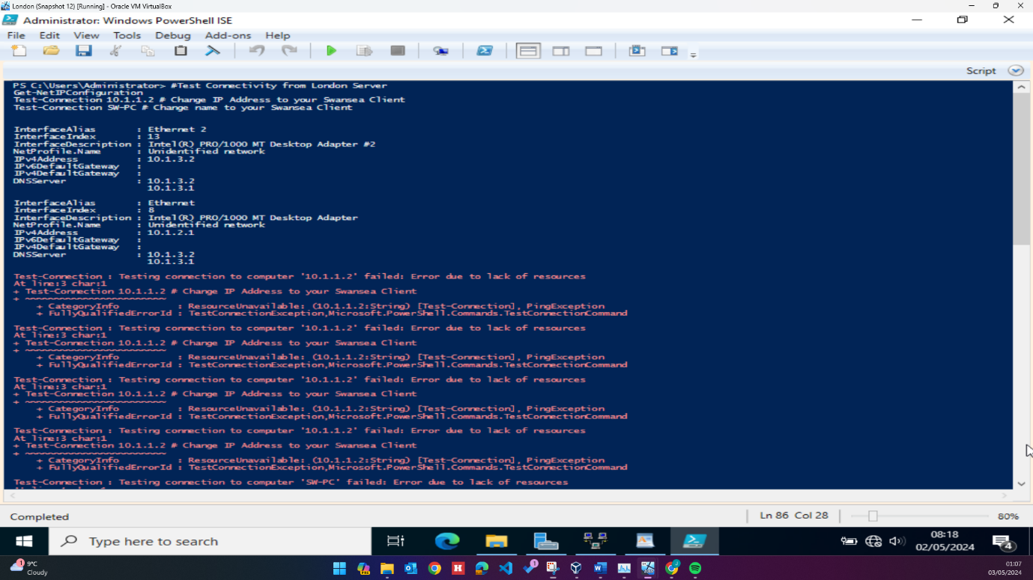

Configuration
Following the initial deployment of the VMs, firewall rules were amended on both domain controllers to allow ICMP traffic between machines for pings:
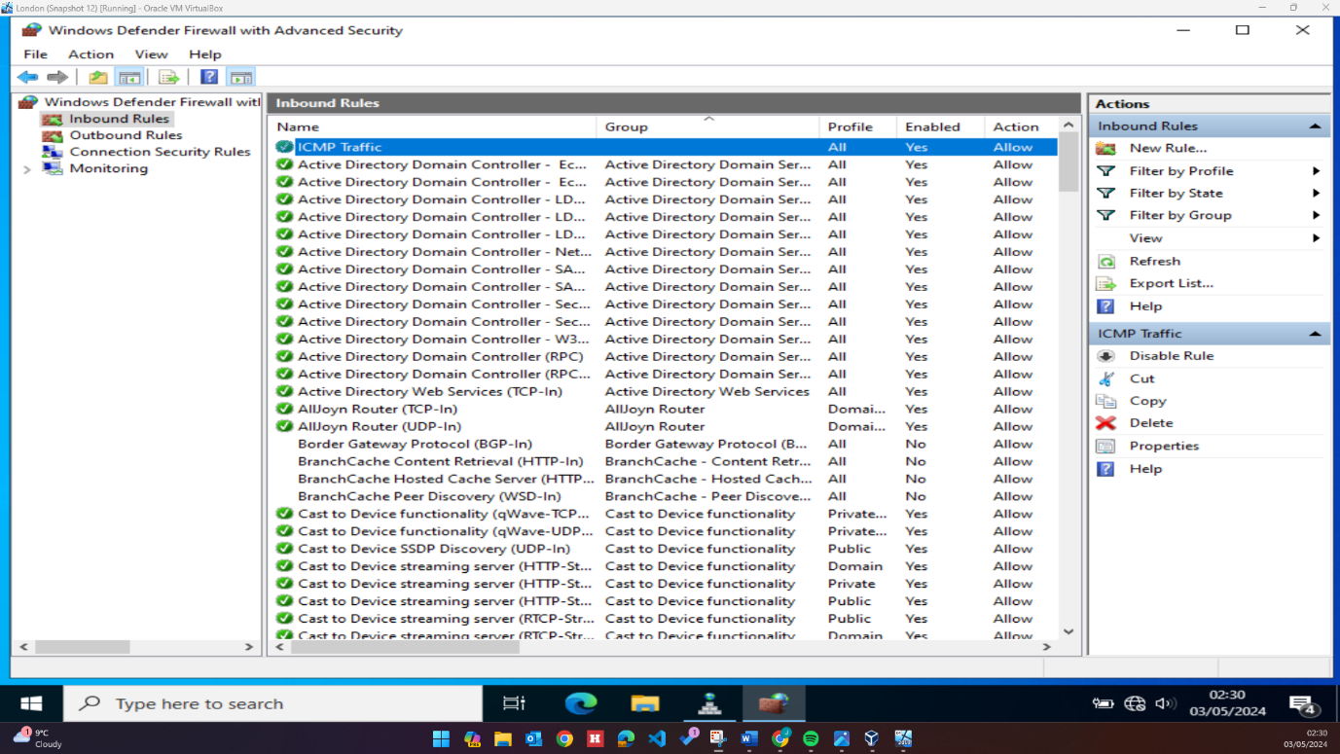

Following this, numerous roles were installed on both servers including Routing and Remote Access Services, Active Directory Domain Services and DNS. Swansea was promoted to a domain controller hosting the joe.noss forest:
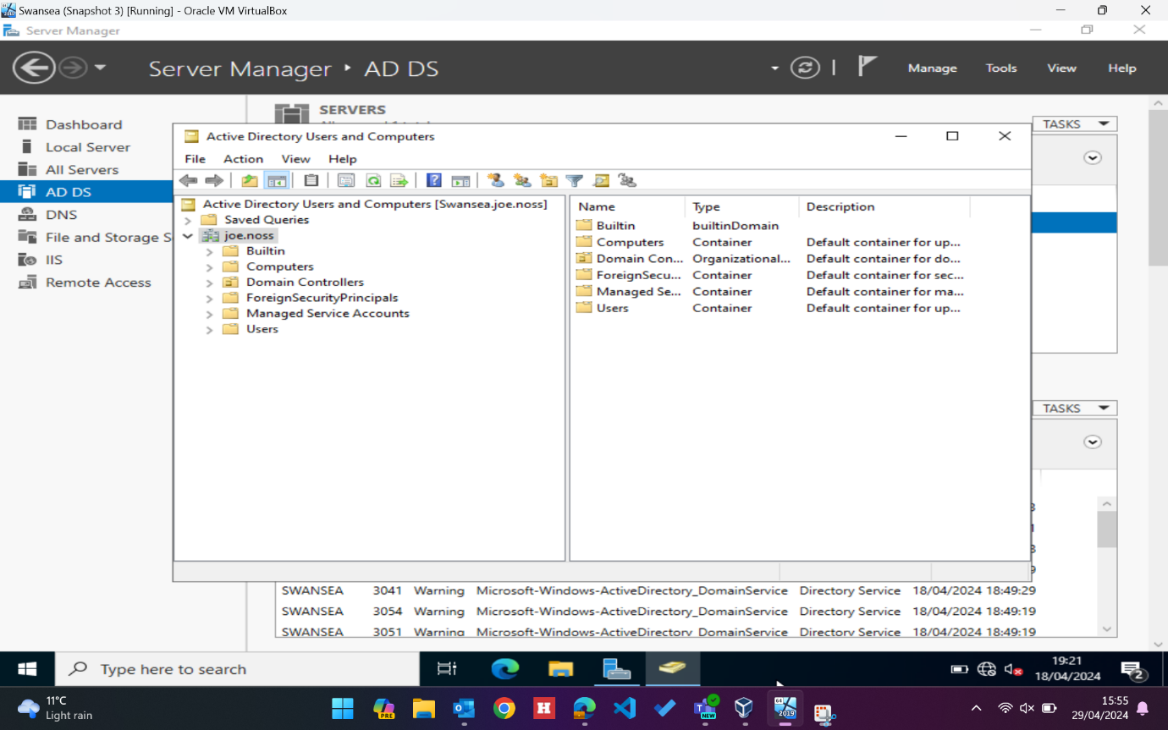
A child domain (ld.joe.noss) was then configured on the London server:

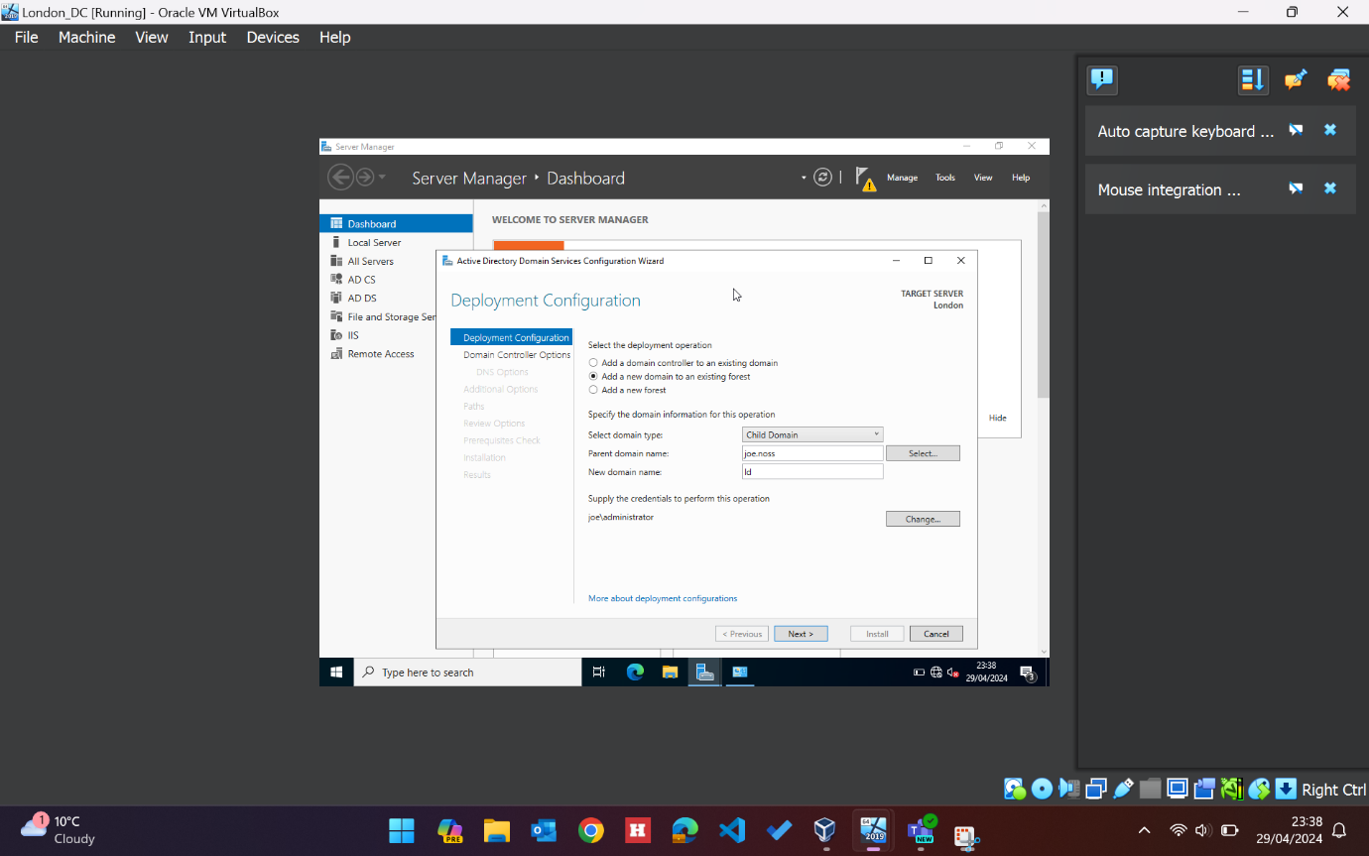
With both domain controllers configured, a site-to-site VPN was configured with persistent connection, facilitating communication between both sides of the network. This required two user accounts set up in each forest for dial-out credentials.
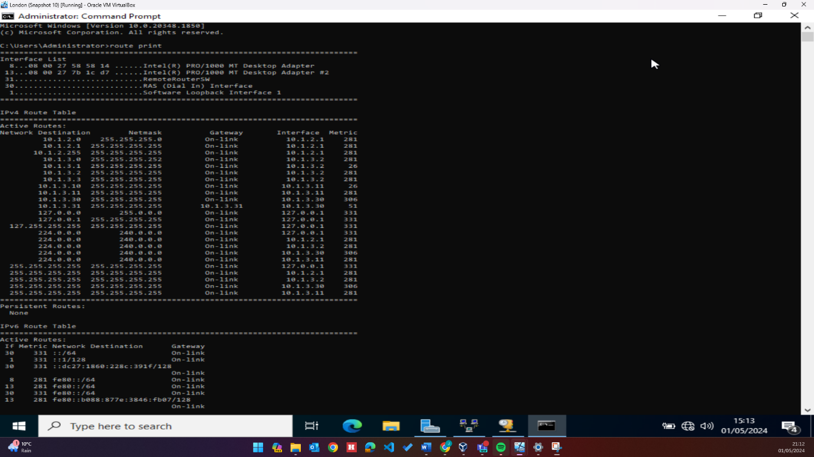

DNS
DNS was configured on both servers allowing machines to communicate via hostname, run nslookups, and navigate to fileshares hosted on the London server. A-records and reverse lookup pointer records were configured for all devices on the network. Both servers had a forward and reverse lookup zone configured for each s. The London server was configured to forward to the primary Swansea DNS server: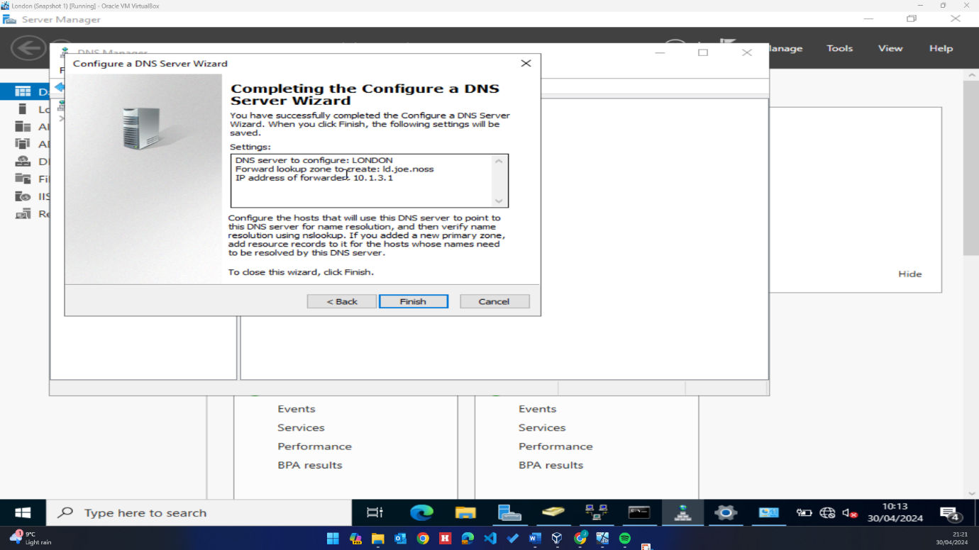

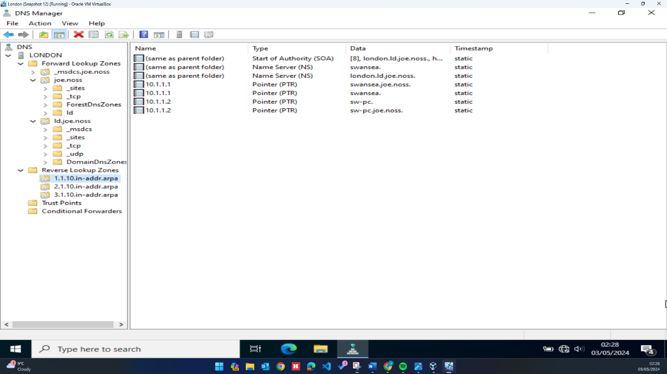
Nslookups were run from machines in the network to ensure DNS was correctly configured:
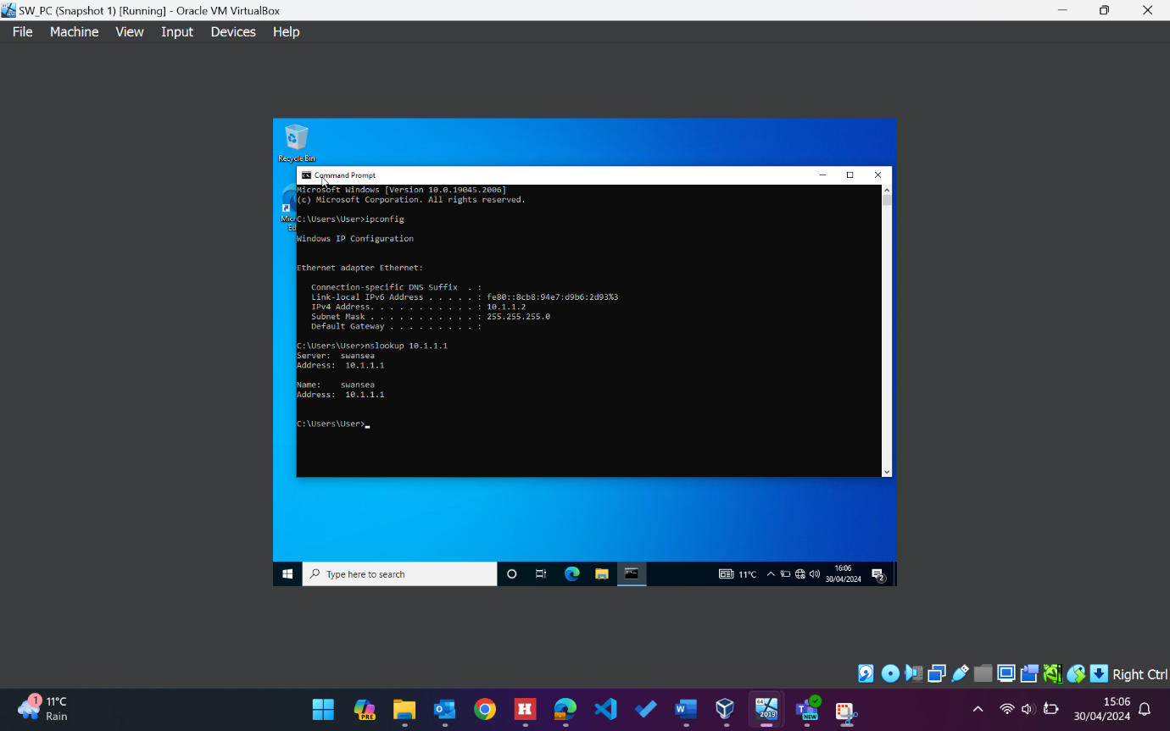

Adding user accounts
As part of this project, a list of users details in a .CSV file needed to be added as user accounts in the London child domain. To achieve this, a PowerShell script was written that loops through each user in the list, creating a new user account in AD and filling the fields with the relevant information contained in the .CSV file.
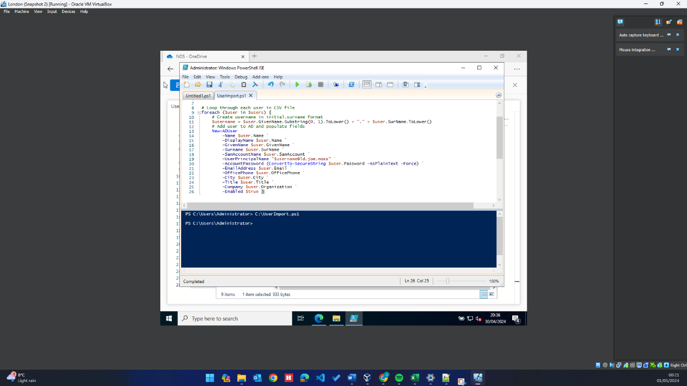
Whilst writing this script the decision was taken to add the initial.surname naming convention to the UserPrincipalName (UPN) username field, rather than the legacy SAM account field. The reasoning for this was twofold, firstly it is better practice to utilize UPN accounts over SAM in a modern domain environment, and secondly, data existed in the SAM account field of the CSV file that could have been legacy login names. The script ran successfully, and all users and their details were added to AD: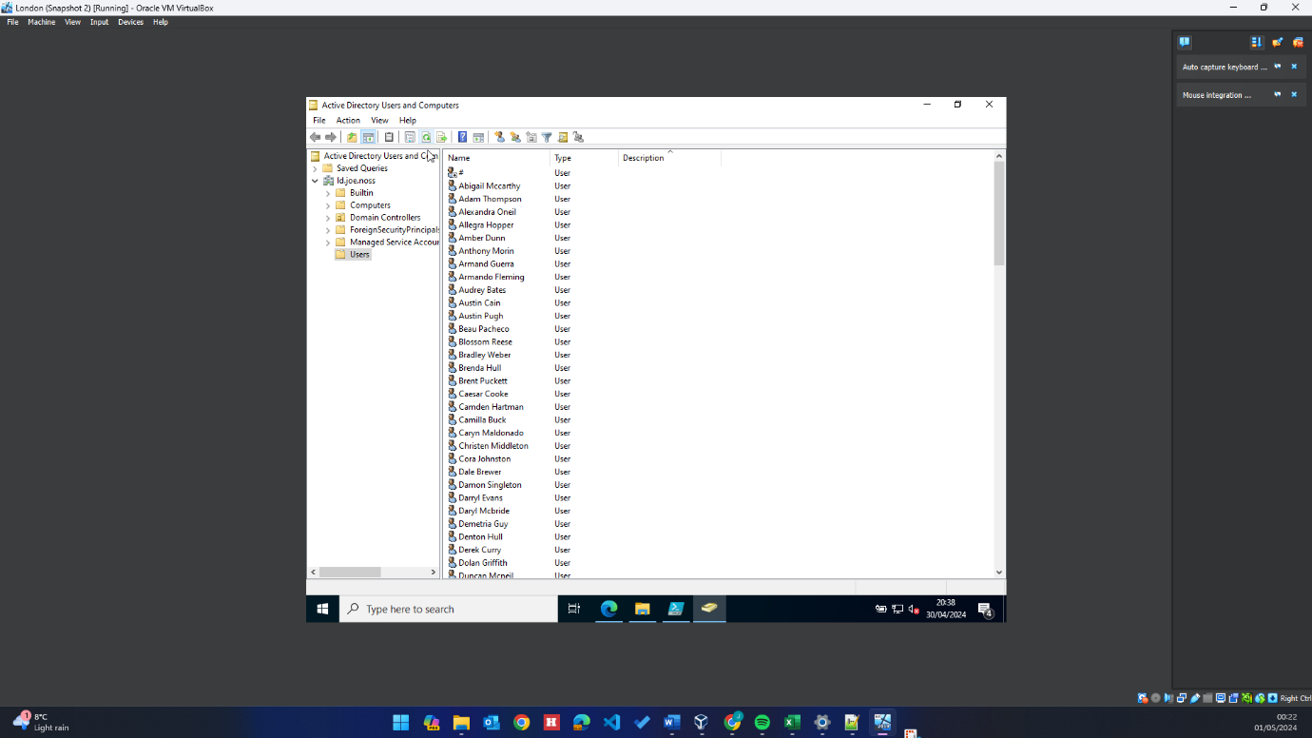
Mounting second drive and sharing
As this environment is within a hypervisor, the second drive needed to be added from the Oracle VirtualBox UI. An additional 2GB VDI was created and attached to the VirtualBox image: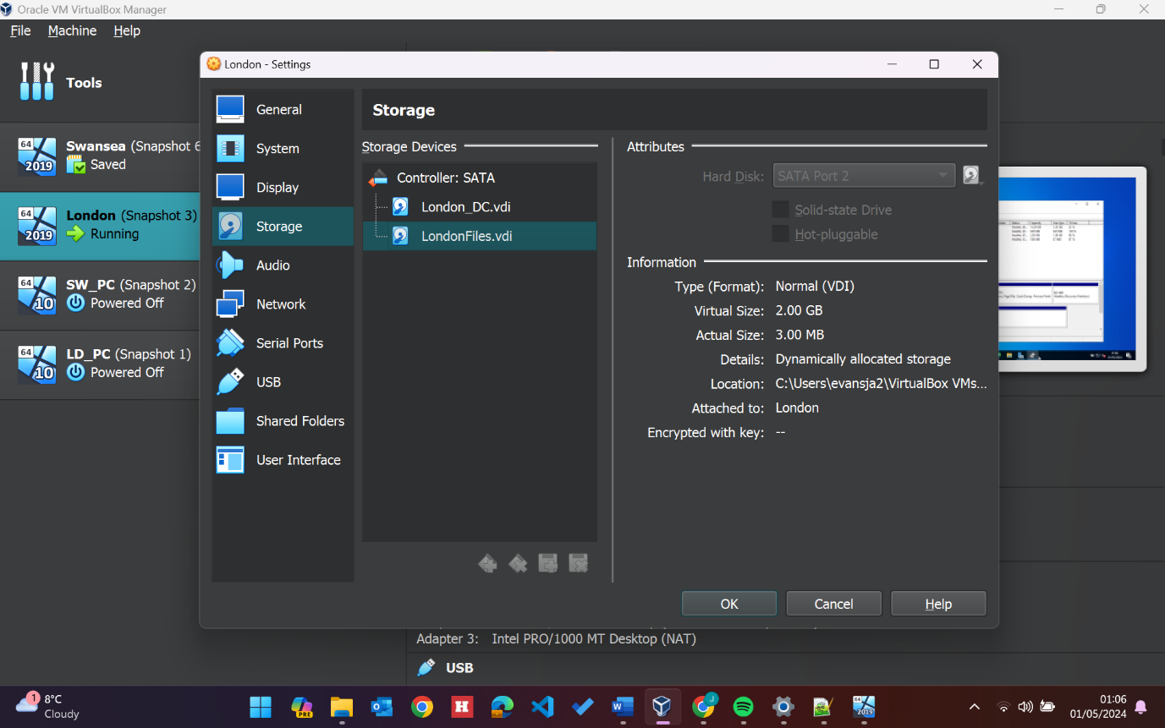
Once the London Server had been rebooted, the disk was formatted in disk management and allocated the D:/ label:
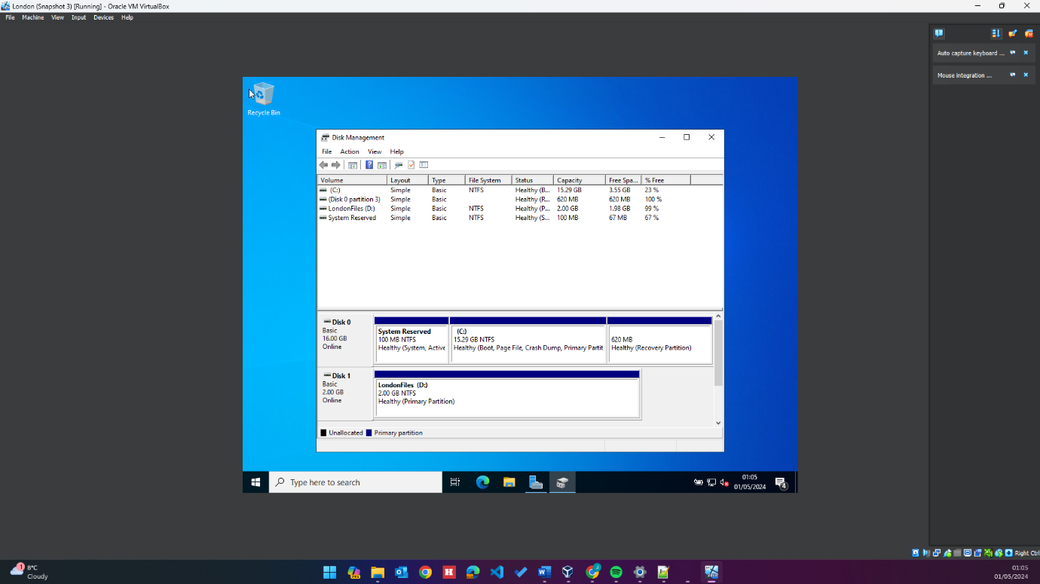
With the drive added and formatted, permissions needed to be set to allow users in the CSV file to have full access, whilst everyone else has read access only. To achieve this, a security group named ‘London Files’ was created in AD. A script was then written to loop through the users in the CSV file and add them to the security group: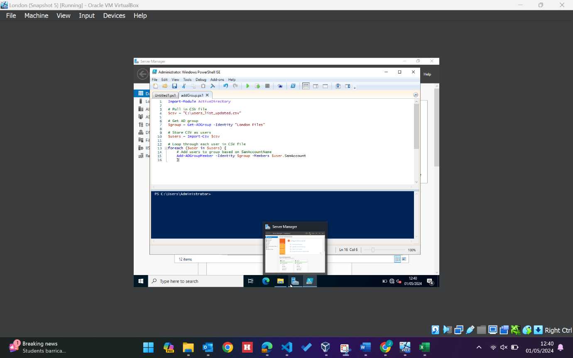
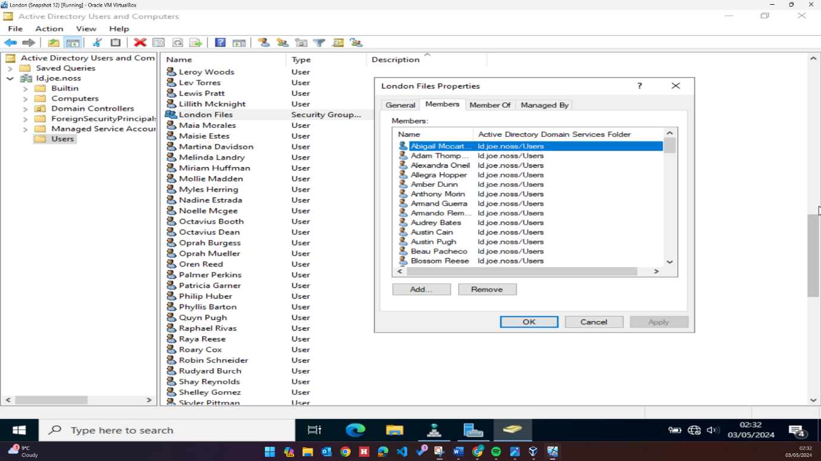
After creating both the second drive and the London Files security group, access permissions were set to allow members of the security group full access, and everyone else read only access:
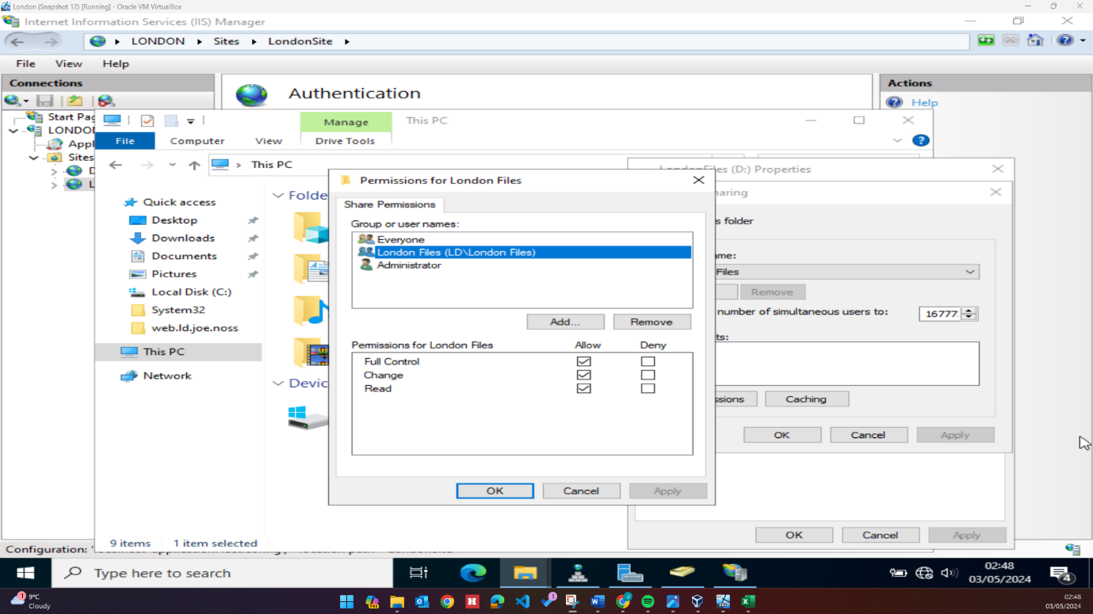
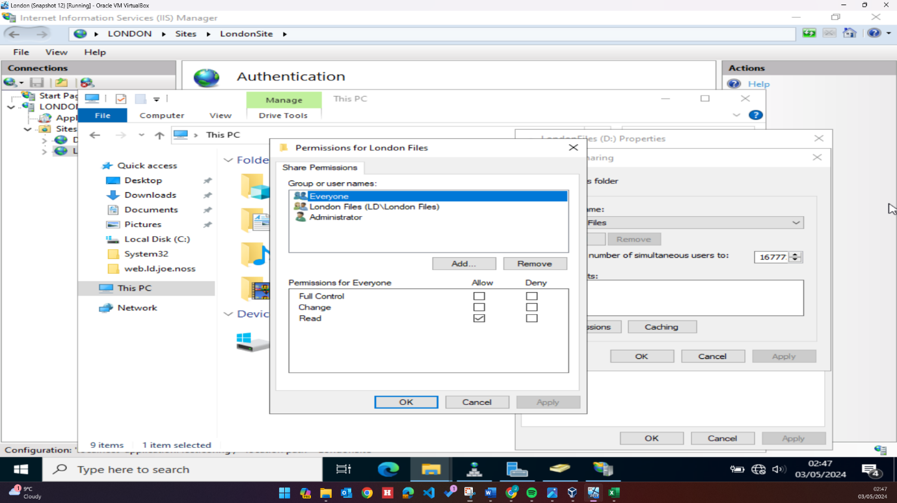

DHCP
The DHCP server role was installed and configured on the London server. The scope was configured to distribute IP addresses from the range 10.1.2.10 – 10.1.2.20 with a lease time of 5 days. No reservations were set for this scope.
In future, if a considerable number of devices are connecting to the range it may be prudent to extend the scope, which can run to the full length of the subnet. The lease time could also be adjusted depending on the circumstances of devices connecting – if the same devices are connected each day a long lease time like currently configured is suitable. However, if there are substantial visitor devices that are only connected for a short period of time, a shorter lease time of around 4hrs may be more suitable, keeping the available pool of addresses high.
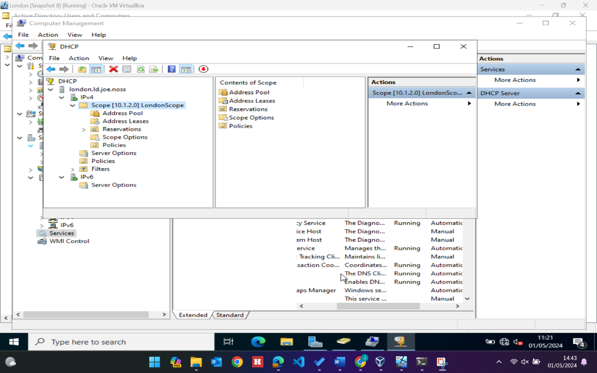

IIS
After all the prior configurations were implemented and tested, IIS and Remote Desktop Services roles were installed on the London server. A folder with the name of the site (web.ld.joe.noss) was created in the default folder location containing a file named default.htm – this file contained the text ‘Welcome to London Server.’ Default.htm was set as top priority in default files settings so that it would be the first file to open when browsing to the web page.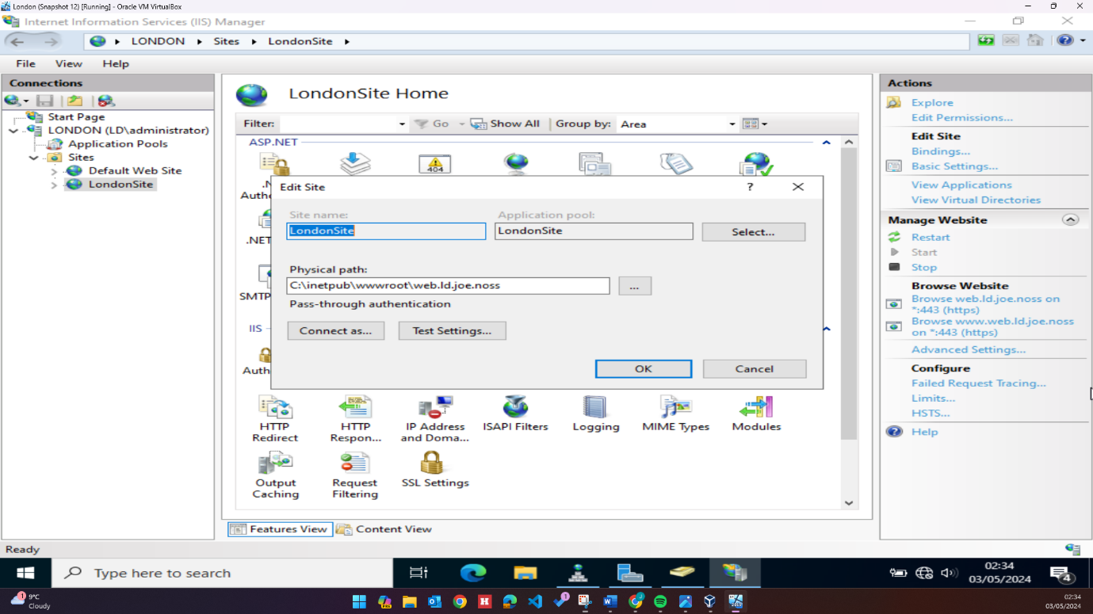

Anonymous authentication was disabled in the IIS managed, and windows authentication enabled, this prompts users connecting to the site to authenticate with ld.joe.noss credentials:
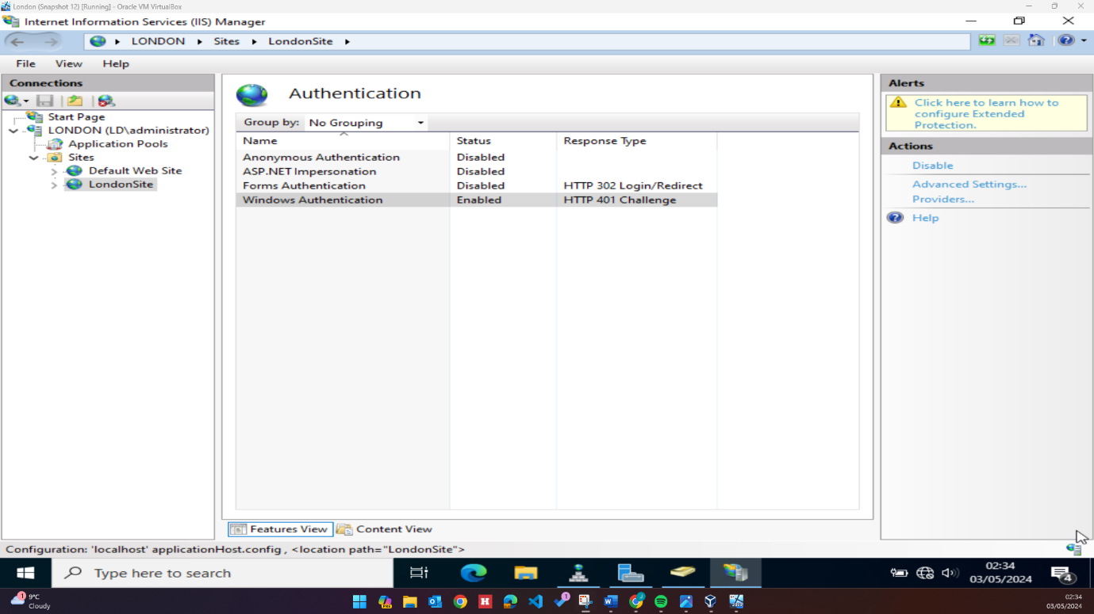
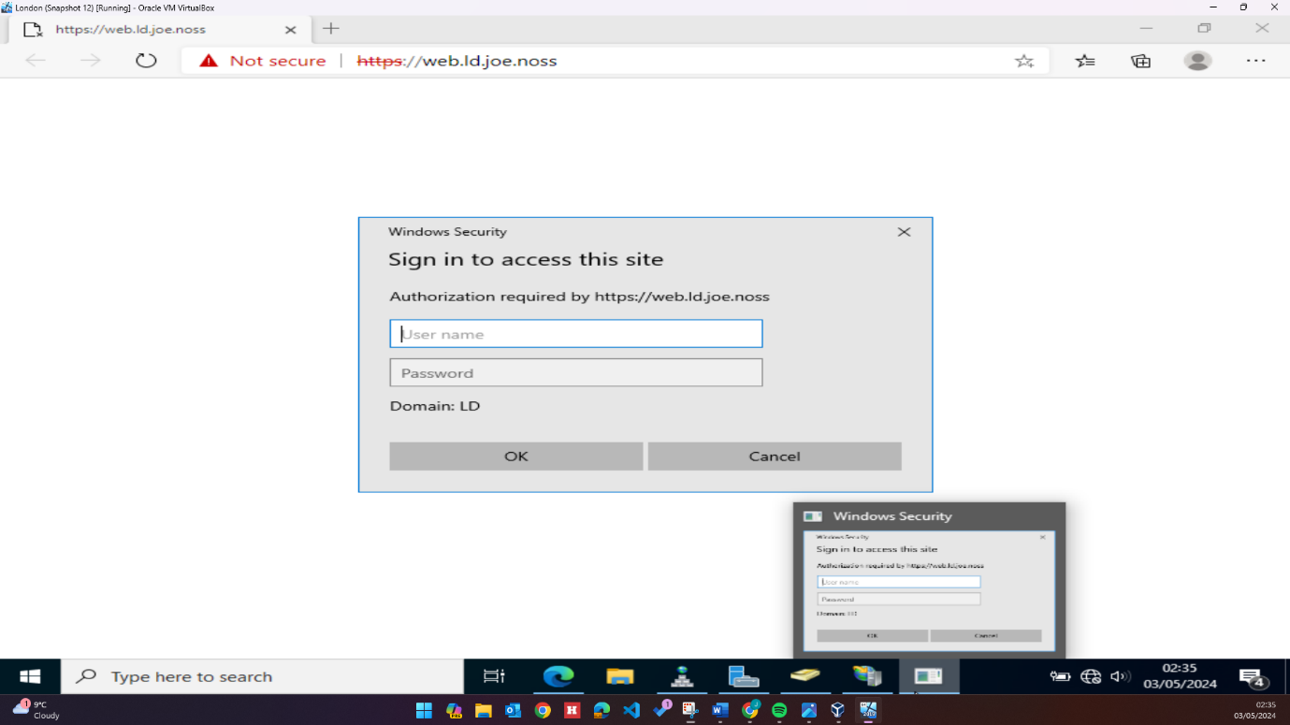

Once connected to the site, users see the ‘Welcome to London Server’ message contained in the Default.htm file configured earlier:
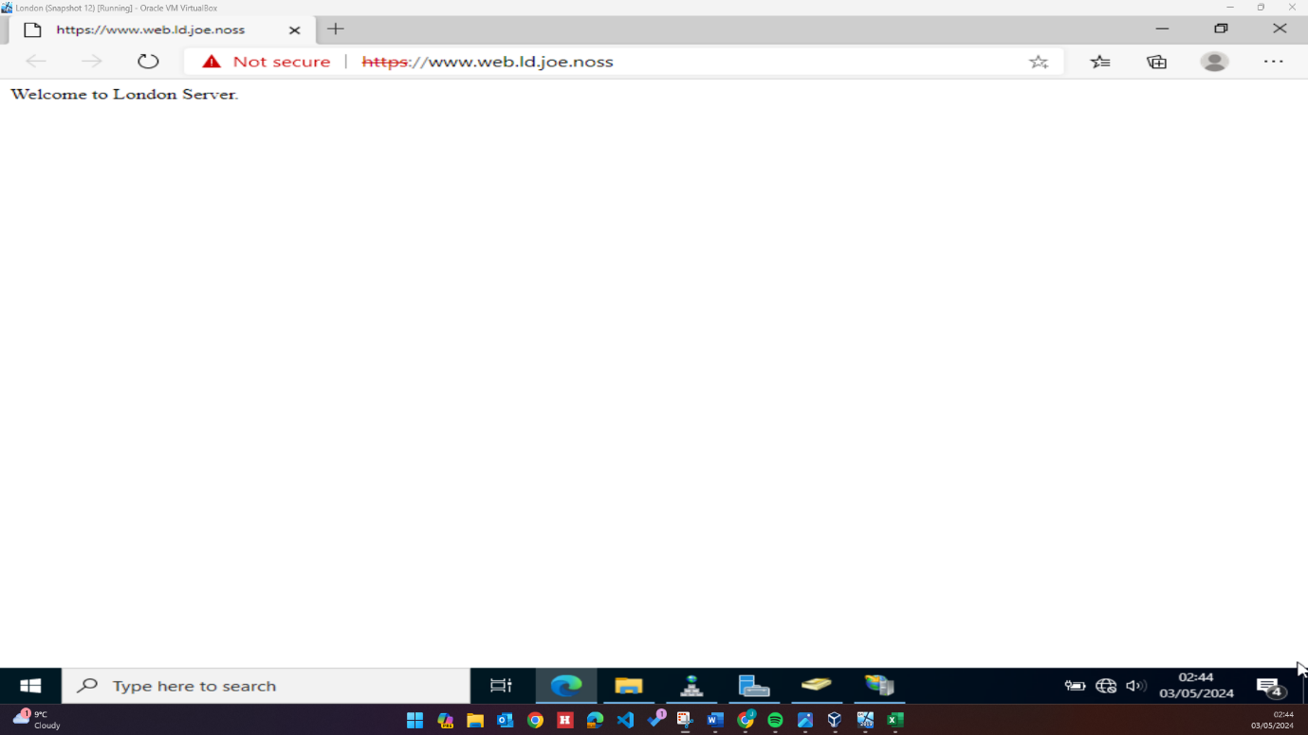

Reflection
The deployment and configuration of this virtual environment has been insightful and a good opportunity to explore areas of network operating systems and services. I feel that the areas that have been configured have been done so to specification, and for the most part the network functions as intended.
It is however disappointing that there were some areas that I was not able to attempt due to technical issues with the hypervisor. I encountered an increasing number of performance issues with the London server as the project progressed, from general slow responsiveness to crashing, making troubleshooting difficult and tedious.
After configuring IIS on the London server, both of my DCs crashed and were rendered inaccessible, with their instances irrecoverable. There were additional screenshots I would have liked to include in this report to cover areas that I had forgotten to capture during configuration, but this was not possible as the DCs no longer function, I could not even restore to an old snapshot of the VM as it had been corrupted. Were I to attempt a project like this again I would perhaps use a different hypervisor client like VMware, as it felt as if a large portion of the troubleshooting directly involved VirtualBox.

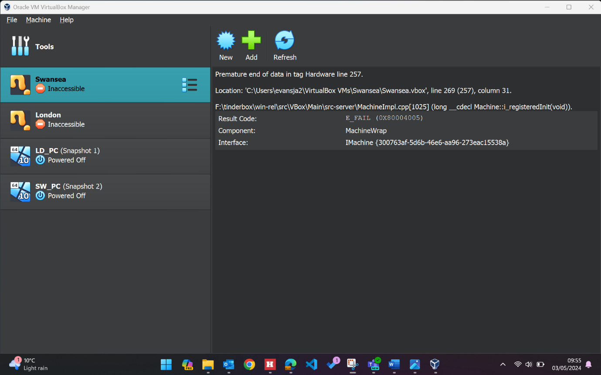
Technical issues aside I am pleased with how the configuration of this network turned out overall and feel that my knowledge of network operating systems and services has expanded. I feel comfortable deploying and building a network and would like to attempt a project like this again in the future.

