Report for Digital Intelligence & Analytics
Data Mining Software



Name: Kacey Mills
ID: 1808911

TABLE OF CONTENTS

- EXECUTIVE SUMMARY........................................................................... 1
- INTRODUCTION..................................................................................... 2
2.1 WHAT IS DATA MINING ….....................................................................
3. DATA MINING APPROACHES …............................................................ 3
3.1 PREDICTION ANALYSIS ..........................................................................
3. 2 ASSOCIATION ANALYSIS ………………………………………………..
3.3 CLUSTERING ANALYSIS …………………………………………………
4. DATA MINING SOFTWARE ………………………………………………… 4
4.1 DATA MINING JUSTIFIED …..........................................................

LIST OF FIGURES
FIGURE 2-1 - Association Analysis by: Chih-Ling Hsu (2017)
FIGURE 2-2 - Weka Data Mining Tool

- EXECUTIVE SUMMARY

It was found that data mining techniques are useful in the marketing profession. The report demonstrates how the three main approaches have been adapted into the marketing world, these include Prediction, Association and the Clustering analysis. Prediction was found to be a good source in predicting future sales and profit for the business. To support this was an example of leading UK retailers who have adapted this approach to predict buying behaviours. Market based analysis is a common association technique used in the marketing field. This was found to be a useful source for sales promotion, Adidas demonstrating the outcome of this technique by an increase in sales and profit. The report found that the Clustering analysis is a beneficial technique for marketing professionals, this approach identifies common features for businesses to gain an insight in buyer behaviour. The report goes on to evaluate the data mining software that is available to the public. A comparison between open source software Weka to award winning Microsoft’s Windows Excel illustrates how different businesses need access to different types of software. A main factor in the marketing profession is dealing with large sets of data, research found that Excel was the best software in dealing with large amounts. The report concludes with a statement on how the workforce must adapt to these changes in order to achieve business aims and objectives.

- INTRODUCTION

The following report will identify and evaluate the current trends in data mining, warehousing and business intelligence. It will focus on the marketing profession and how data mining software interprets trends and patterns in this discipline. The approaches of data mining include the prediction, association and clustering analysis. The report will demonstrate how these approaches are important in the evolving workforce. Illustrating the importance of adapting to these changes in order to survive and succeed in the profession. It will show how the marketing profession relies on business intelligence and data mining software in order to predict consumer behaviour and create new product opportunities. The key advancements in data mining software has had a huge impact on businesses around the globe, especially in the marketing field. ‘Data mining is the extraction of implicit, previously unknown, and potentially useful information from data’ (Witten and Frank, n.d) Data mining is used to discover patters and relationships which help assist companies in making vital business decisions. Marketing as a discipline involves researching and developing a product or service before distributing it to the general public. As a marketer, data mining is beneficial when spotting trends in the market, predicting customer loyalty and developing effective marketing campaigns. Due to advancement in technology, the working environment has rapidly changed. This technology is popular with marketers as it enables them to gain an insight in what consumers want and need. ‘Data mining depends on effective data collection, warehousing, and computer processing’ (Twin, 2019). The report will demonstrate the ways in which data is collected, including the main approaches of prediction, clustering and association. Along with comparing the various types of software available from proprietary software to open source.

2.1 What is Data Mining
‘Data mining is the exploration and analysis of large quantities of data in order to discover meaningful patterns and rules. (Berry & Linoff, 2008). The main aim of data mining is to extract knowledge from existing data and develop it into a straight-forward structure for businesses to use in the future. In a marketing workforce, the data mining process enables them to make better business decisions and create a structured marketing strategy to achieve the business’ overall aim.
The key factors of data mining include:
- Prediction based outcomes and decision-oriented information
- Automatic predictions based on social trends and behaviour
- Focusing on large sets of data
- Clustering based on findings
Many companies around the UK follow these key features of data mining to use to their advantage. Amazon being a prime example who have developed a ‘Price Check Mobile App’ which enables customers to gain quick access to find the lowest prices. The 7 Billon company use data mining to collect pricing and intelligence information from their competitors. Data mining enables companies to be a step closer to their main objective. It includes a collection of various data from both qualitative and quantitative to warehousing and computer processing.

3.Data Mining Approaches
3.1 Prediction Analysis
Data Mining is considered "a blend of statistics, AI (artificial intelligence), and data base research" (Pregibon, 1997, p. 8) The most common type of data mining amongst business’ is prediction, this is a technique that discovers the relationship between an independent and dependant variable. According to Kantardzic, (2019) ‘Prediction involves using some variables or fields in the data set to predict unknown or future values of other variables of interest’. Predictive analysis is the use of artificial intelligence, data and statistics to identify outcomes for the future of marketing. There are three main stages that takes place through the process which includes, Initial Exploration, Pattern Identification and Deployment. As a marketer, predictive analytics is essential to achieve a successful outcome, for example it can be used in the business to predict future sales and profit. According to Martin (2019) there are various ways that marketers use prediction analysis, these include:
- Personalising Content
- Optimising Campaigns
- Accurate Results Reporting
- Predicting Consumer Behaviour

‘Many UK retailers are increasingly using big data, predictive analytics and machine learning to gain insight into customer shopping and buying behaviour.’ (Rossi, 2017). For example, market leader Tesco have adapted to the technique in order to improve their use of data to deal with the ever-changing working environment and customer buying patterns.
3.2 Association Analysis
Association is another key feature of data mining that many companies interpret into their business strategies. ‘Association analysis is useful for discovering interesting relationships hidden in large data sets. The uncovered relationships can be represented in the form of association rules or sets of frequent items’ HSU (2019) The author implies these rules are set up due to various issues that come from adapting to the association technique, this is displayed in the following graph:
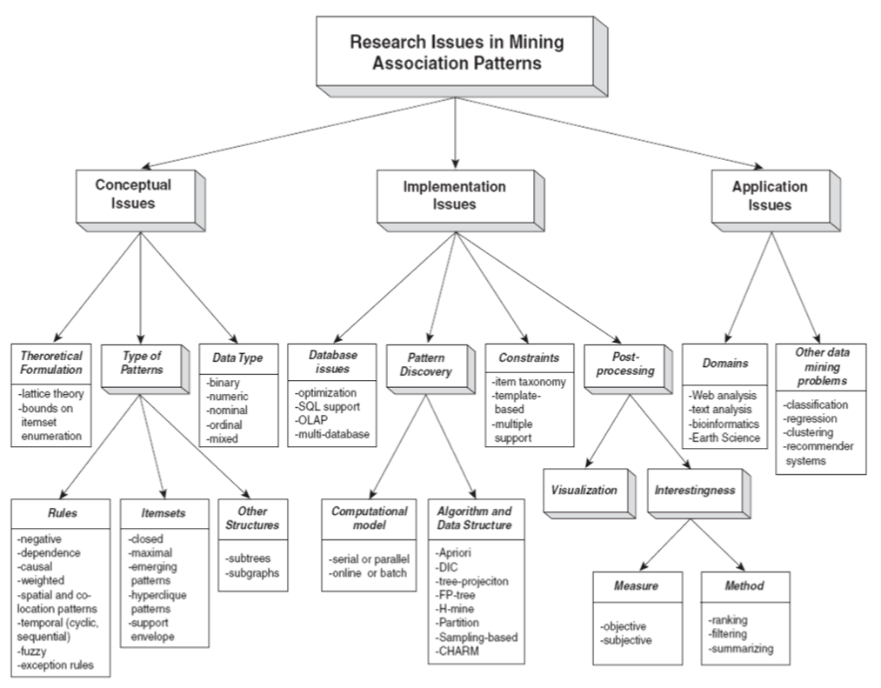Figure 2-1 Association Analysis by: Chih-Ling Hsu (2017)
The main aim of the association rule is to analyse sale and transactions to determine what products customers buy together. The application of association is also known as Market Based Analysis, this is the most common type of data used in the marketing profession. It is a useful source for direct marketing, this includes exploring business patterns and sales promotion. Association can help marketers build their brand and create a positive image for the company, this is done through partnerships. The London 2012 Olympic Games made use of the association marketing technique, ‘Last year saw Adidas ramping up its sponsorship efforts, which alongside sponsorship of the European Championships and Champions League, contributed to a 15% increase in sale' (Knight, 2013) The data mining process enables business’ to discover trends and analyse data.
3.3 Clustering Analysis
A practical form of data mining is Clustering, this module is used to identify certain groups based on common features, these include, demographics, attitudes and buying behaviours. According to Berkin, (2016) ‘Clustering is the division of data into groups of similar objects’ Implying that a collection of data is found that is similar or dissimilar to one another. In the marketing profession, the cluster analysis assists marketers in identifying their target market. As it is a form of segmentation it can help businesses understand buyer behaviours and create new product or service opportunities. The application of clustering has been used in many sectors, including the entertainment industry. Data provider WiseWindow analysed over 25 million comments on major artists such as Lady Gaga. ‘The cluster analysis shows the rise and fall of intensity with respect to 84 aspects of the artists such as stage presence and music’ (Woods, 2010)
4. Data Mining Software
The workplace is continuously changing in every sector, this is due to the evolution of technology. Data mining has enabled companies to understand and adapt to the patterns and trends in society. These data mining techniques are used through software such as Weka and Excel.
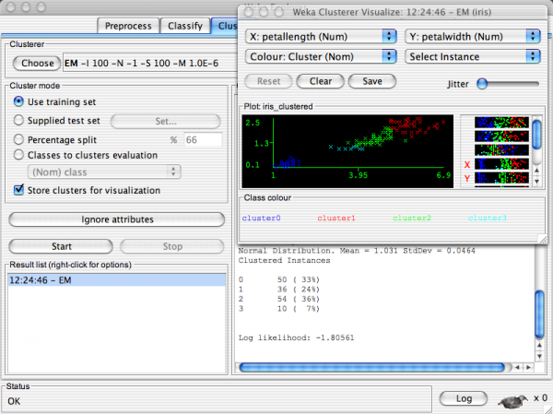
Figure 2.2 Weka Data Mining Tool | Cluster Analysis (2015)
Weka is an open source software that uses a collection of machine learning algorithms, this data set is known as a collection tool for the clustering analysis. According to Shah (2017) ‘Weka contains tools for data pre-processing, classification, regression, clustering, association rules, and visualisation’ Weka is an easy and accessible source for businesses to use, this is due to it being open source. The software has three different interfaces and is written in Java which enables the software to run on any platform. However, this open source software does not support new techniques, due to the limited training algorithm. Despite the software being open source there are very limited tutorials and documentation on how to use it, this can make it hard for businesses to follow and interpret. Data Mining (2000) by I. H. Witten and E. Frank. gives a tutorial on how to use the software effectively, however as the software is rapidly growing it is not fully up to date. Conflicting with Excel, which is a spreadsheet application developed by Microsoft. ‘Excel has become one of the most-used software programs in the business world since its launch in 1985’ (Deskbright.com, 2019). Microsoft excel is a spreadsheet organising data into columns and rows, it is a limited data mining application that allows marketers to preform common data mining tasks from cleansing, predicting to model building. In the marketing profession it is a useful tool to prepare data, it contains wizards that clean and cleanse old data on file in order to prepare for future tasks. However, this software is not an open source, as it is a part of the Microsoft package certain tablets and PC’s may need to purchase and install the application. This does not make the software as accessible as other software available such as Weka. Despite this, Microsoft Excel can organise large amounts of data and transfer it into an orderly spreadsheet, gaining an advantage over Weka which has shown to struggle with large amounts of data. Due to Microsoft being a market leader there is a broad range of information and tutorials available for individuals to follow a step-by-step guide. In the marketing field, excel is a valuable software tool to overcome marketing tasks. The most imperative use for Excel is researching, for example having an insight into the needs and wants of your target audience. Other uses that benefit a marketer include reporting and anaylsing information. According to Walsh (2017) ‘Excel is used by an estimated 750 million people worldwide’.
4.1 Data Mining Justified
The evolution of automation and technology has created advancements in data mining software. The data mining process has many approaches such as prediction, application and the cluster analysis. These approaches have been adapted in the working environment, especially in the marketing profession. It has been proven that marketers have used these data mining techniques to assist them in predicting consumer behaviours, analysing social trends and pesonalising contents. The association analysis has helped organisations build brand rapport and loyalty with the use of social influencers and creating partnerships throughout the UK and rest of the world. Data mining has improved the way businesses and organisations think by identifying certain groups based on common features, this has changed the way organisations think and produce their product or service.

References:

Berkhin, p. (2016). Data Mining and Constraint Programming. Cham: Springer International Publishing.

Deskbright.com. (2019). What Is Excel? A Beginner's Overview | Deskbright. [online]
Available at: https://www.deskbright.com/excel/what-is-excel/
[Accessed 5 Dec. 2019].

Ebecken, N., Brebbia, C. and Zanasi, A. (2004). Data mining IV. Southampton: WIT.

Hsu, C. (2019). Data Mining - Association Analysis. [online] An Explorer of Things.
Available at: https://chih-ling-hsu.github.io/2017/03/25/Data-Mining-Association-Analysis
[Accessed 3 Dec. 2019].

Knight, s. (2019). How association marketing can help build a brand. [online] the Guardian.
Available at: https://www.theguardian.com/media-network/media-network-blog/2013/jul/04/association-marketing-build-brand
[Accessed 5 Dec. 2019].

martin, n. (2019). How AI and Predictive Analytics Drive Marketing Success. [online] Forbes.com.
Available at: https://www.forbes.com/sites/nicolemartin1/2019/01/16/how-ai-and-predictive-analytics-drive-marketing-success/#2f421f4e7b78
[Accessed 3 Dec. 2019].

Witten, I. and Frank, E. (n.d) Data Mining, 2nd edition

Woods, d. (2019). [online] Forbes.com.
Available at: https://www.forbes.com/2010/07/26/cluster-analysis-predictions-technology-social-media.html#4b32447b2234
[Accessed 5 Dec. 2019]

