Report

Effective Teamworking for team success.

Name: Wael Abdelrehim Mohamed Hussein
Student ID: 2123453
Programme: Certificate of Higher Education Health & Social Care
Module: Effective Team Working and Communication
Module code: BMSW4002
Lecturer’s name: Obinna Nkwocha

Executive Summary
A team is constituted when a number of individuals having same goals come together to work towards meeting those goals. Team work refers to as the collaboration between all the members of the team who jointly work together for the accomplishment of the project or task. This report will provide the importance of teamwork and how it helps in achieving the success of the business with the help of various teamwork.

Table of Contents
1 Executive Summary 2
2 Introduction 4
3 Overview of team work 5
4 Models of teamwork 6
4.1 Model 1: Tuckman model 6
4.2 Model 2: GRPI model 7
5 Types of roles needed to create effective team 7
6 Impact of effective team work on success of team 9
7 Conclusion 11
8 References 12

Introduction
Team work is an essential professional skill that is required by the businesses as it helps to maintain coordination among the employees within the organization. An effective team always strive to attain the goals set by the firm. A good team leader is someone who knows how to manage and handle the team so that no conflicts happen at the workplace. Team work helps in better sharing of ideas which further helps in bringing innovation in the business that is essential element for the success and sustainability of any organization. The report aims to analyze the way in which an effective team can be build and will use team work models to justify the importance of team work. It also aims to understand the impact of effective team working in an organization. Further, it will also discuss the types of roles that are needed to develop an efficient and cohesive team. The ultimate goal of a business is to meet the objectives that are set to run that business. Every employee of the establishment has the responsibility to work towards achieving those objectives and this can only be done when there is some coordination and collaboration among the employees otherwise conflicts can hamper the productivity and growth of the business.

Overview of team work
A team is a group of number of independent individuals coming and working together towards a common goal. Whereas, Team work refers to the collaboration between all the members of the team who jointly work together for the effective and efficient accomplishment of the project or task. A team is handled and managed by a team leader who is responsible and accountable for the work and conduct of its team. The leader always tries to maintain harmony within the team so that no conflicts arise among the members. Therefore, the leader should be impartial and capable of dealing in conflicting situations (McDaniel and Salas, 2018).
Characteristics of teamwork:
- A good team will help in creating a positive work culture within the organization
- With teamwork, the management can utilize the skills of every individual as per the need of the task.
- Team work gives the opportunity to brainstorm and sharing of multiple views which help in bringing creativity and innovativeness that is very much required in growth and development of a business.
- Everyone has some strengths. In a team, the strengths of all individuals can be utilized in an effective way to fulfill the task.
- Team work avoids the scope of laxity as all the members are dependent on each other’s work to complete the task so, everyone is accountable for their work and efforts.
- Team work gives opportunity to learn new things and enhance the knowledge base.
- It can also develop healthy competition within the organization (Tripathy, 2018).

Thus, it can be said that team work has many advantages but there are some demerits as well. If not handled properly, it can lead to conflicts and unhealthy competition that can prove detrimental for the performance and growth of business. Therefore, there should be a good mechanism in place that helps in avoiding any such situation and team leader should be capable enough to manage its team in the best possible way.

Models of teamwork

Model 1: Tuckman model
The Tuckman theory, put out by Bruce Tuckman, is one of the well-known theories of team development. It operates according to the principle that a team completes a task from beginning to end. The phases of this theory, which is particularly pertinent for team-building exercises, are as follows:
Forming: The team is firstly assembled during this phase, and responsibilities are distributed. Although they work together, the team members behave independently. They don't know one another well enough to develop a relationship or trust. It takes time to develop a strategy, gather information, and establish ties.
Storming: The team starts working on the tasks by making ideas during this phase. To avoid misunderstanding and team conflicts, it is important to efficiently manage the competition between the numerous ideas to identify which is better. During this time, relationships within the workforce could develop or disintegrate. The problem also surfaces if the group comes to a decision rapidly because this could lead to shoddy judgement. Thus, productive brainstorming is necessary.
Norming: The team then moves on to the norming phase, when a member guides the discourse and gives proposals for the conclusion they have reached, after the aforementioned discussion phase. These are different people from those who first put up the notion, to give a more accurate opinion.
Performing and adjourning: At the performance and adjourning stages, the team operates in a smooth flow. Here, team members are aware of one another's abilities and limitations. They are comfortable enough with one another. At this moment, everyone on the team is motivated and confident. They are not subject to many limitations when working here. Not all teams advance to this round; only those with the highest coordination and collaboration do (Teambuilding, 2022).

Model 2: GRPI model
GRPI stands for Goals, Roles, Processes and Inter-personal relationships. Proposed by Rubin, Plovnick and Fry, this mode is comparatively simple in its approach which works on four stages that are required for a team development. These stages include clearly defining of goals, specifying and allocating roles to all members, transparent workflow and well defined procedures, trustful interpersonal relationships in the team. As per this theory, these four stages are required where every member of the team in assigned specific roles and they work in harmony to successful accomplishment of the common goals (Chapman, 2018).

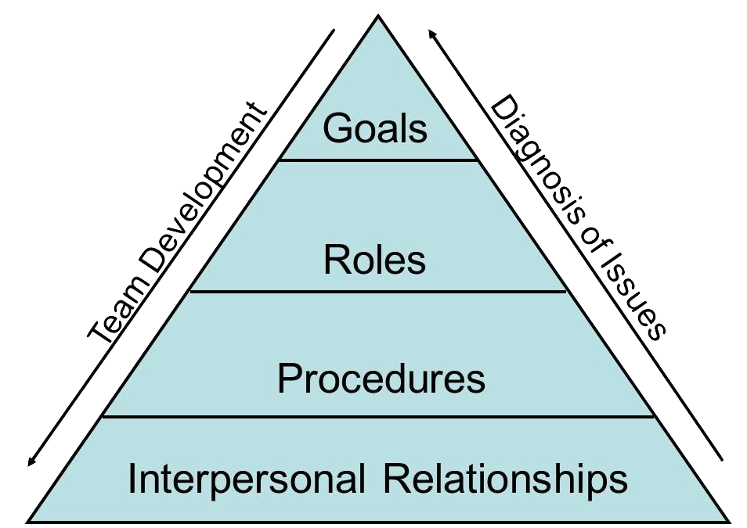

(Source: Medium, 2018)

Types of roles needed to create effective team
Team roles are the behavioral attributes that are required to make effective and efficient contribution to the performance of the team. According to Belbin, the teams which are most successful are the ones that are composed of diversity of behaviours. Proposed by Meredith Belbin, the nine team roles are mentioned below (Ruch, et. al., 2018).

(Self-made, 2022)
The monitor evaluator: Monitor evaluator takes the decisions rationally rather than emotionally. These are the people who have strong critical thinking and reasoning skills. They think of all the possible ways before arising at the final solution.
The specialist: This is member who is expert in a specific area or subject. They have in-depth knowledge of their work but being specialists they are needed at the time when some task requires expertise.
The Plant: They are the creative thinkers who come up with new and innovative ideas of doing the tasks. These people usually tend to work alone but as they are important for the growth and development of the business, they are permitted to do so.
The Shaper: These people are extroverts in nature and they try to push everyone to achieve the targets. They are dynamic personalities who encourage the team in reaching the goals. They are good at handling the challenges and remain calm despite of the pressure and also keep the spirit of the team high in every situation.
The Implementer: They are the rational people who organise the work structure and make a robust plan form the rough ideas. They are much disciplined people and give priority to team interest rather than self-interests.
The Finisher: These are the introverts who are responsible for the quality checks in the team. They are usually perfectionists who look for fine details or mistakes and check the completed tasks.
The Coordinator: These are the people with good and effective communication skills. They usually perform management duties and create an environment of open communication for better coordination.
The Team Worker: These people are extroverts and good listeners and assist the other team members wherever they get stuck in fulfillment of the task. They are very important persons as they maintain the harmony within the team.
The resource Investigator: These people are also extroverts and possess the skill of networking. They are good at exploring new opportunities and developments. These people are also responsible for making new contracts for the business thus help in growth and expansion of the organization (Indeed Career Guide, 2019).

Impact of effective team work on success of team
Working in teams and promoting team work at workplace can help the organization in having a competitive edge over others as it impacts the growth and performance of the organization in many positive ways such as:
- Making of a positive work culture: A good team will help in creating a positive work culture within the organization. With teamwork, the management can utilize the skills of every individual as per the need of the task.
- Promotes innovations: Team work gives the opportunity to brainstorm and sharing of multiple views which help in bringing creativity and innovativeness that is very much required in growth and development of a business.
- Effectively utilizing the workforce strengths: Each employee has some unique capabilities. In a team, the strengths of all individuals can be utilized in an effective way to fulfill the task. Team work avoids the scope of laxity as all the members are dependent on each other’s work to complete the task so, everyone is accountable for their work and efforts which is good for the growth of the company.
- Opportunity to learn and implement: Team work gives opportunity to learn new things and enhance the knowledge base. It also develops healthy competition within the organization. A good learning environment fosters improvement and thus helps the organization to improve its performance (Lacerenza, et. al., 2018).
- Improved Problem solving: In a tea, there is a lot of diversity as people come from different backgrounds, they think differently and this helps in easy and quick finding of the solutions. This helps the business to tackle any difficulties that come its way.
- Meeting the deadlines: In a team, everyone is allocated specific roles as per their skill and capabilities. This helps in ensuring that the target is achieved within the stipulated time frame. Since, all the team members in a well-organized team coordinate and collaborate with each other, this helps in timely delivery of the tasks which further helps the business to meet their targets.
- Support and strong relationship: In an effective team, all the members support each other and thus there is a trust building with in the team. The weakness of one person can be the strength of the other person. Therefore, there is a sense of belongingness where everyone develops interpersonal relationship over the time and support each other in times of need.
- Boost morale: When everyone in a team support each other and there is an environment of growth and learning, this encourages the team members and boost their morale to work towards achieving the common goal of the team and business as a whole (Sanyal and Hisam, 2018).
Thus, there are a lot of benefits of an effective and coercive team but at the same time it is not an easy to task to develop such a team as it is quite difficult to get together a diversity of personalities. Here, the role of a good leader is essential which guides and controls the team in a better manner so that productivity can be increased and conflicts can be avoided.

Conclusion
It has been learnt in this report that teamwork is a crucial professional ability that businesses demand because it keeps employee coordination inside the company in check. A productive team works tirelessly to meet the company's objectives. A good team leader is someone who knows how to lead and control the group so that there are no problems at work. Working as a team promotes greater idea exchange, which in turn fosters creativity in the workplace, a vital component for the success and long-term viability of any organisation. The report provided an understanding about the way in which an effective team can be build and discussed about team work models to justify the importance of team work. It also provided an overview of the impact of effective team working in an organization. Additionally, it discussed the types of roles that are needed to develop an efficient team.

References
Chapman, A., 2018. The GRPI Model. [Online] Businessballs.com. Available at: <https://www.businessballs.com/leading-teams/the-grpi-model/> [Accessed 28 June 2022].
Indeed Career Guide. 2019. The 9 Belbin Team Roles (With Examples) | Indeed.com. [Online] Available at: <https://www.indeed.com/career-advice/career-development/belbin-team-roles> [Accessed 28 June 2022].
Lacerenza, C.N., Marlow, S.L., Tannenbaum, S.I. and Salas, E., 2018. Team development interventions: Evidence-based approaches for improving teamwork. American psychologist, 73(4), p.517.
Medium. 2018. 8 Models of Team Effectiveness. [Online] Available at: <https://medium.com/@RiterApp/8-models-of-team-effectiveness-3a3b84efb3ae> [Accessed 28 June 2022].
McDaniel, S.H. and Salas, E., 2018. The science of teamwork: Introduction to the special issue. American Psychologist, 73(4), p.305.
Ruch, W., Gander, F., Platt, T. and Hofmann, J., 2018. Team roles: Their relationships to character strengths and job satisfaction. The Journal of Positive Psychology, 13(2), pp.190-199.
Sanyal, S. and Hisam, M.W., 2018. The impact of teamwork on work performance of employees: A study of faculty members in Dhofar University. IOSR Journal of Business and Management, 20(3), pp.15-22.
Teambuilding.co.uk. 2022. Tuckman; Forming - Storming - Norming - Perfoming. [Online] Available at: <https://www.teambuilding.co.uk/theory/Forming-Storming-Norming-Performing.html> [Accessed 28 June 2022].
Tripathy, M., 2018. Building quality teamwork to achieve excellence in business organizations. International research journal of management, IT and social sciences, 5(3), pp.1-7.

