

BMHP5014
Change makers: creativity and value creation
Online portfolio of set exercises
Nichola Timothy
2407528

Contents
Task 1 – Concept Map 3
Case Study: The NHS App – Creative Digital Transformation for Patient Care 6
Introduction 6
Creativity & Innovation 6
Digital Exclusion 7
Impact & Value Creation 8
Conclusion 8
Research 1 9
Research 2 9
Synthesis 10
Reference List 12

Task 1 – Concept Map

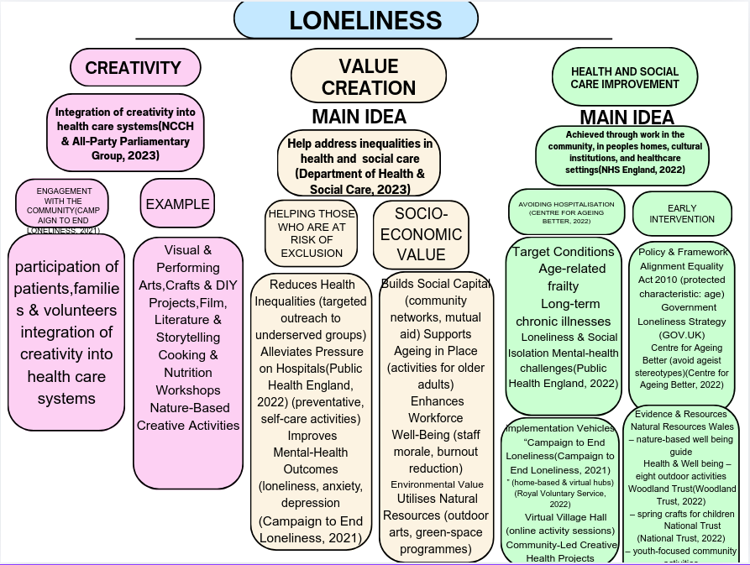

Task 2 - Self-Reflection of Group Activity

Self‑Reflection on the Paper‑Clip Convergent/Divergent Activity
The Group Taks which arguably is considered as a Project-Based Learning (PBL) Task benefitted from using Gibbs’ Reflective Cycle (1988) which allowed me to consider and evaluate the class group project in an organised and effective way and to identify what changes, if any, I can make going forward (Praveena et al., 2025).
1. Description
Our class was divided into groups of five. In the first, divergent stage we were asked to list every use for a single paper‑clip. Together we generated 14 distinct ideas – bracelet, zip‑fastener, key‑ring, earrings, a DIY lock‑picker, and several others (Figure 1). When the facilitator signalled the end of brainstorming, we moved to the convergent stage: we discussed safety, feasibility, and aesthetic appeal, then agreed to develop four prototypes (bracelet, zip‑fastener, key‑ring, earrings) that we displayed. I was asked to stand and present our final concepts to the class (Figure 2).
2. Feelings
I felt enthusiastic at the start; the open prompt encouraged a free flow of imagination. As we shifted to selecting ideas, a mild anxiety surfaced because I wanted my contributions to be taken seriously while also respecting my teammates’ suggestions. Presenting the prototypes boosted my confidence, especially when peers responded positively.
3. Evaluation
Positive: The group displayed genuine diversity of thought each member contributed unique concepts, expanding our idea pool. We used encouraging language (“great idea!”) and gave everyone equal speaking time, creating a psychologically safe environment.
Negative: The convergent stage lacked a clear decision‑making rubric, causing a brief debate over safety versus novelty that could have been resolved more efficiently.

4. Analysis
Williams et al., (2021) argue that resourcefulness using limited assets to generate new value requires moving beyond pure conservation. In our divergent phase we embraced resourcefulness, producing many ideas with no cost. However, the ambiguous criteria used in the convergent phase reflected a “conserve‑at‑all‑costs” mindset, slowing decision‑making and limiting the translation of those ideas into value. This contrast illustrates the authors’ point that creative, generative action (rather than mere preservation) is needed to turn ideas into worthwhile outcomes.
5. Conclusion
The activity confirmed that inclusive, respectful teamwork demonstrates a rich set of ideas, while a brief, structured convergent framework would streamline selection and enhance fairness.
6. Action Plan
For future group tasks I will use SMART Action Goals to ensure that changes are implemented:
- Introduce a quick criteria‑setting step before the convergent phase (e.g., rate each idea on safety, feasibility, novelty on a 1‑5 scale).
- Use dot‑voting to reach consensus rapidly.
- Document the decision rationale so all members see how their input shaped the outcome
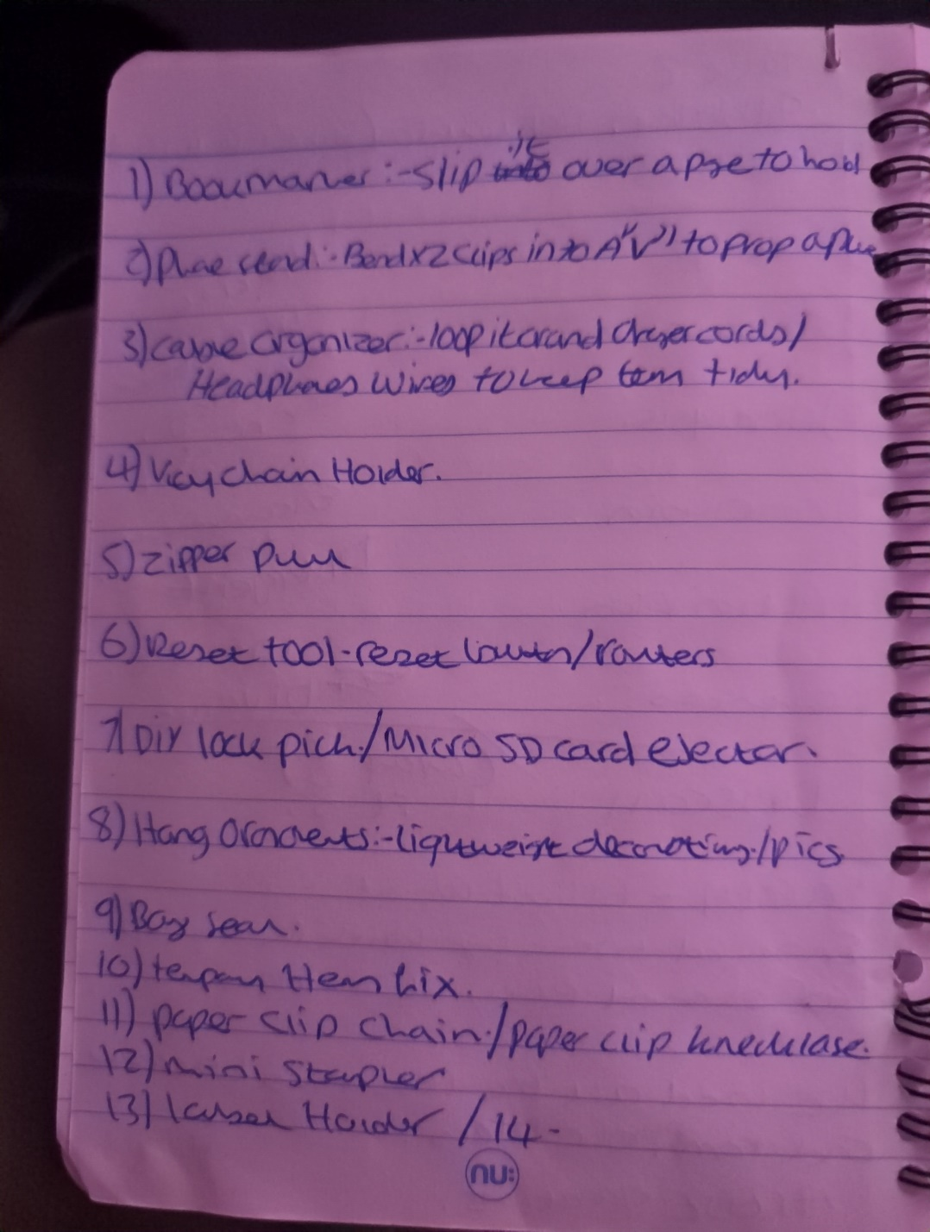
Figure 1: Ideas phase

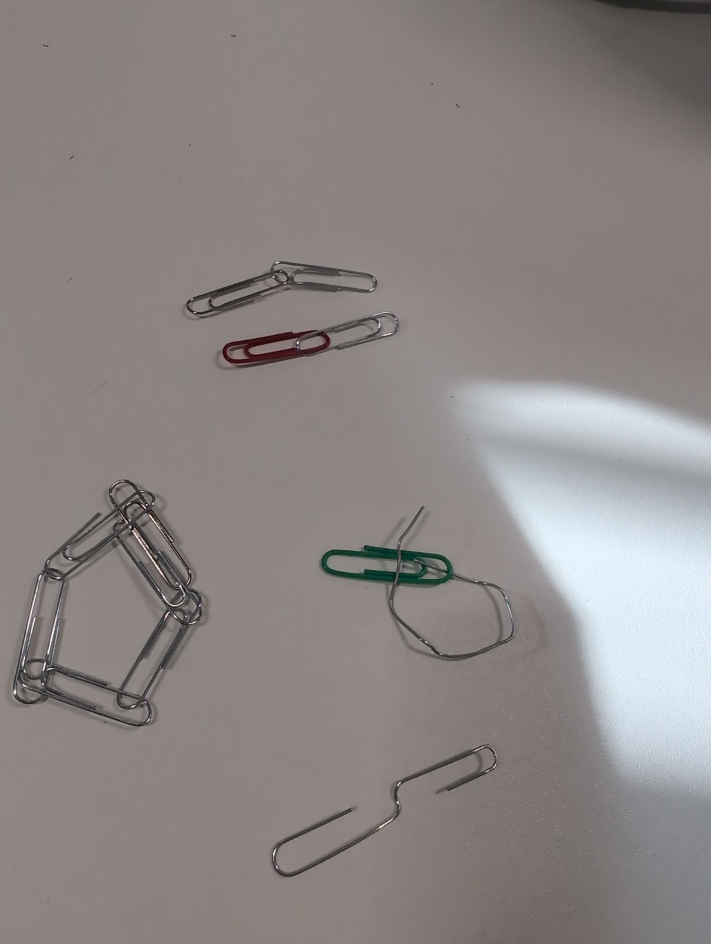

Figure 2 – Creative ideas

Task 3 - Case Study of a UK innovation

Case Study: The NHS App – Creative Digital Transformation for Patient Care

Introduction
The NHS App, launched nationally in 2020, consolidated fragmented online services (appointment booking, repeat‑prescription ordering, record access, and secure identity verification) into a single, patient‑centred platform. Its development relied on creative design and delivery methods that fundamentally to reshape how patients interact with the NHS.

Creativity & Innovation
- Human‑Centred Design for accessibility – Workshops with older adults, people with disabilities, and non‑native English speakers shaped navigation, colour contrast, and voice‑assistant features.
- Agile Sandbox Model – Pilot NHS trusts could customise local functionalities (e.g., bespoke health‑check questionnaires) and give real‑time feedback. This iterative loop accelerated development, reduced risk, and allowed rapid scaling.
- Open‑Source Architecture – Core components were released under an open‑source licence, inviting external developers, universities, and tech partners to contribute language packs, health‑tracker integrations, and accessibility plugins. The ecosystem grew without additional NHS spending, future‑proofing the platform.
- These creative choices turned a conventional IT project into a collaborative, adaptable solution that aimed to respond to user needs.

Digital Exclusion
Despite these creative solutions, several groups remain excluded:
- Affordability barriers – Some patients cannot afford smartphones or computers, limiting their ability to download or use the app.
- Digital literacy gaps – Older adults and others who are not comfortable with technology may struggle to navigate the interface, even when it is designed for accessibility.
- Infrastructure constraints – Rural or low‑income areas may lack reliable internet connectivity, further restricting access.
These factors mean the technology, while innovative, is not fully inclusive. Addressing digital exclusion requires complementary strategies such as providing low‑cost devices, community‑based digital‑skills training, and maintaining alternative (non‑digital) service pathways.

Table 1: Digital strategies

Metric | Outcome
Active users | >30 million registrations (≈ 55 % of the adult population)
Phone‑booking volume | ↓ 15 % → staff time reallocated to face‑to‑face care
Prescription errors | ↓ 12 % thanks to built‑in dosage checks and patient verification
Patient satisfaction | 84 % “very satisfied”  (NHS England survey, 2023)

To mitigate digital exclusion, a simplified “lite” version with reduced menus was co‑designed, and community‑centre onboarding sessions were provided, further expanding uptake among underserved groups (Wilson et al., 2024).

Impact & Value Creation
- Efficiency: Consolidated services cut administrative overhead, freeing staff for clinical duties.
- Safety: End‑to‑end encryption and biometric authentication secured patient data, meeting GDPR requirements.
- Empowerment: Real‑time record access, medication reminders, and personalised health nudges improved adherence and enabled earlier detection of health deterioration.
- Sustainability: Open‑source contributions continue to enhance functionality at minimal cost, ensuring long‑term viability.

Conclusion
The NHS App demonstrates creativity through human‑centred design, agile co‑creation, and shows how open‑source collaboration can solve complex public‑ sector challenges. Measurable outcomes (user adoption, reduced errors, higher satisfaction) can identify whether innovative thinking improves patient care and delivers lasting value for the health‑care system.
However, the app’s benefits are not experienced uniformly; affordability, digital‑literacy gaps, and limited internet access excludes some. Recognising these gaps and pairing the digital solution with complementary initiatives (e.g., device‑loan schemes, community‑based training, and non‑digital service alternatives) is essential to ensure inclusivity.

Task 4 - Research Task

Research 1
Murray, R. & Hargreaves, S., (2022) Stigma, self‑labeling and help‑seeking for mental health problems among university students: a mixed‑methods investigation. Journal of Mental Health, 31(4), pp.456‑465. Available at: http//doi.org/10.1080/09638237.2021.1998765
Paraphrased findings
The authors surveyed 1,200 under‑graduates at three UK universities and held focus‑group interviews with 45 participants. Quantitative analysis showed that 62 % of students who reported depressive symptoms also endorsed strong personal stigma (“seeking help would make me look weak”). Qualitative data revealed that this internalised stigma is reinforced by perceived cultural expectations of resilience and fear of judgment from peers and academic staff. Crucially, students who had previously accessed university counselling reported significantly lower stigma scores, indicating that positive contact with mental‑health services can weaken self‑stigma. The study concludes that stigma operates both as a barrier to initial help‑seeking and as a self‑perpetuating cycle that leaves many young adults untreated, especially those from lower‑income backgrounds who may lack alternative support networks.

Research 2
Thompson, L., Patel, R. & Jones, A., (2023) Digital interventions and the reduction of mental‑health stigma in adolescents: a systematic review and meta‑analysis. Child and Adolescent Psychiatry and Mental Health, 17(1), p.23. Available at: doi: 10.1186/s13034‑023‑00567‑2
This systematic review screened 1,842 records and identified 19 randomised‑controlled trials evaluating online anti‑stigma programmes delivered to adolescents (13‑18 years) in the UK and Europe. Meta‑analysis produced a moderate pooled effect size for reductions in stigma attitudes immediately after the intervention, with effects persisting at three‑month follow up in 11 studies. Effective components included interactive storytelling, peer‑moderated discussion boards, and brief psycho‑educational videos that normalised mental‑health experiences. However, the authors noted considerable heterogeneity in programme length, content fidelity, and participant engagement. They warned that digital interventions alone cannot overcome structural barriers such as limited-service capacity, socioeconomic disadvantage, or digital exclusion, which remain major contributors to the persistent gap in service access for young adults in deprived communities.

Synthesis
Both studies highlight that self‑stigma and structural barrier including socioeconomic deprivation and limited digital inclusion explaining why many young adults in the UK still lack timely mental‑health care.

Task 5 - Podcast
https://private.arkfiduciary.org/index.php/s/Y7GeGxrn5dkYRJn

Task 6 - NHS Leadership Framework Analysis

NHS Leadership Framework
The NHS Leadership Framework (formerly the NHS Healthcare Leadership Model) identifies six inter‑related components that underpin effective leadership across the health system:
- Personal Qualities – self‑awareness, integrity, and resilience.
- Leading Self – managing one’s own performance, learning and well‑being.
- Leading Others – building inclusive teams, coaching staff, and fostering psychological safety.
- Leading Services – translating strategy into safe, high‑quality patient care and managing resources.
- Leading Improvement – using data, innovation and creative problem‑solving to develop and test new ways of working.
- Influencing for System Change – shaping policy, collaborating across organisations, and championing population‑level health priorities.
A distinctive strength of the framework is its emphasis on creating a supportive environment that recognises the social determinants of health, including loneliness a growing public‑health concern linked to poorer mental and physical outcomes (Victor & Yang 2021). By embedding awareness of loneliness within the leadership agenda, NHS leaders can ensure that services are designed to promote connection, reduce isolation and improve overall wellbeing. The framework therefore provides a holistic lens through which leaders can align personal development, team dynamics, and system‑wide improvement to address both clinical and psychosocial needs.

Component Focus: “Leading Improvement” – Using Creativity to Reduce Loneliness and Enhance Care
A leader who embraces the Leading Improvement component creates a culture where staff feel empowered to experiment with novel solutions. By establishing multidisciplinary “innovation labs” that bring clinicians, designers, and service users together, the leader can co‑design community‑based outreach programmes (e.g., volunteer‑led befriending hubs or digital peer‑support platforms) that directly tackle loneliness. Regular rapid‑cycle testing, supported by real‑time data dashboards, allows teams to iterate interventions quickly and demonstrate impact on patient‑reported isolation scores. However, celebrating small wins in staff meetings reinforces a growth mindset, encouraging further creative ideas that improve continuity of care such as integrating social‑prescribing referrals into discharge pathways. Through transparent feedback loops and protected time for creative work, the leader not only reduces loneliness but also raises overall care quality, staff satisfaction, and organisational resilience.

Task 7 – Self‑Reflection Journal Entry
During this module I have come to see creativity not as an optional extra but as a core driver of value within health and social care. Previously I tended to view creative ideas as "nice‑to‑have" innovations that sit outside the routine, evidence‑based practices that dominate our sector. Working through the concept‑map exercise and the case‑study on the NHS App showed me how deliberately applying human‑centred design, agile co‑creation and open‑source collaboration can reshape service delivery, reduce costs, and improve patient outcomes (Greenhalgh et al., 2023; NCCH & All‑Party Parliamentary Group on Arts, Health & Well‑Being, 2023).
Equally eye‑opening was the reflection on digital exclusion. I now recognise that any creative solution must be evaluated against equity lenses; otherwise, we risk widening existing health‑inequalities (Wilson et al., 2024). This insight has already influenced my daily practice: I now ask, "who might be left out?" whenever I propose a new tool or workflow, and I actively involve service users from diverse backgrounds in early design workshops (Department of Health & Social Care, 2023).
Overall, the module has shifted my mindset from seeing creativity as a peripheral skill to treating it as a strategic competency that, when paired with rigorous evaluation, creates tangible value for patients, colleagues, and the wider system (Williams et al., 2021).

Reference List

Bickerdike, L., et al., 2020. Social prescribing: a systematic review of outcomes and mechanisms. British Medical Journal, 380, e073. doi:10.1136/bmj.e073. Available at: https://www.bmj.com/content/380/bmj.e073 (Accessed 22 March 2026).

Campaign to End Loneliness (2021) National Strategy to Reduce Loneliness. Available at: https://www.campaigntoendloneliness.org/ (Accessed 14 March 2026).

Centre for Ageing Better (2022) About Us. Available at: https://ageing-better.org.uk/about-us (Accessed 14 March 2026).

Department of Health & Social Care (2023) Annual Report on Health‑and‑Social‑Care Innovation.London:DHSC Available at:https://assets.publishing.service.gov.uk/media/65b235e6160765001118f8ad/DHSC-Annual-report-and-accounts-2022-2023-print.pdf (Accessed 12 March 2026)

Equality Act (2010) (UK Government) (2010) Equality Act 2010: Protected Characteristics. Available at: https://www.gov.uk/guidance/equality-act-2010-protected-characteristics (Accessed 14 march 2026).

Greenhalgh, T., Wherton, J., Shaw, S., & Morrison, C. (2023) Evaluation of the NHS App: A mixed‑methods study of adoption and impact. British Medical Journal, 380(9855), e073. Available at: https://doi.org/10.1136/bmj.e073

Grist, R., Porter, J., & Stallard, P. (2023) Digital interventions to reduce mental health stigma among adolescents: a systematic review and meta-analysis. Internet Interventions, 32, Article 100698. Available at: DOI: 10.1016/j.invent.2023.100698
Health and Care Act, (2022) Health and Care Act 2022. London: HMSO. Available at: https://www.legislation.gov.uk/ukpga/2022/31/contents (Accessed 22 March 2026).

Loughborough University, (2020) Eight Outdoor Activities to Boost Wellbeing. Available at: https://blog.lboro.ac.uk/wellbeing/2020/06/26/eight-outdoor-activities-to-boost-wellbeing/ (Accessed 22 March 2026).

Mind, (2023) Loneliness and mental health: policy brief. London: Mind. Available at: https://www.mind.org.uk/information-support/types-of-mental-health-problems/loneliness/ (Accessed 22 March 2026).

Natural Resources Wales (2022) Five Ways to Boost Health and Well‑Being Through Nature. Available at: https://naturalresourceswales.gov.uk/about-us/news-and-blogs/blogs/five-ways-to-boost-health-and-well-being-through-nature (Accessed 14 Jan 2026).

National Trust, (2022) 50 Things to Do Before You're 11¾. London: National Trust. Available at: https://www.nationaltrust.org.uk/visit/50-things (Accessed 22 March 2026).

NCCH & All‑Party Parliamentary Group on Arts, Health & Wellbeing (2023) Creative Health Review: Recommendations for a Cross‑Departmental Strategy. London: National Collaboration for Creative Health. Available at: NCCH Creative Health Review Page (Accessed 14 Jan 2026).

NHS Leadership Academy (2020) The NHS Leadership Framework. London: NHS Leadership Academy. Available at: NHS Leadership Academy - Leadership Framework (Accessed 14 Jan 2026).

NHS England (2022) NHS App Annual Report London: NHS England, 2022. Available at:

NHS England (2023) NHS App User Satisfaction Survey 2023. London: NHS England. Available at: https://www.nhs.uk/nhs-app/ (Accessed 22 March 2026).

NHS England (2022) Social prescribing: a guide for NHS organisations. London: NHS England. Available at: https://www.england.nhs.uk/long-read/social-prescribing-reference-guide-and-technical-annex-for-primary-care-networks/ https://www.england.nhs.uk/publication/social-prescribing-and-community-based-support-summary-guide/ (Accessed 5th march 2026).

Petersen, I., Bhana, A., & Baillie, K. (2022) Factors that influence mental health of university and college students in the UK: a systematic review. BMC Public Health, 22, Article 1743. Available at: DOI: 10.1186/s12889-022-13943-x
Praveena, K. S., F, J., Patil, C. M., & K, B. (2025) Using Gibb’s Reflective Model Approach for Enhancing Project-Based Learning Among Students Through Reflective Assessment. Journal of Engineering Education Transformations, 38(2), 148–155. Available at: https://doi.org/10.16920/jeet/2025/v38is2/25018

Royal Voluntary Service (2022) Virtual Village Hall – Online Activity Sessions. Available at: https://virtualvillagehall.royalvoluntaryservice.org.uk/ (Accessed 14 Jan 2026).

RSPB, (2023) Big Garden Birdwatch. London: RSPB. Available at: https://www.rspb.org.uk/whats-happening/big-garden-birdwatch/ (Accessed 22 March 2026)
UK Government, (2021) Government's Work on Tackling Loneliness. London: GOV.UK. Availableat:https://www.gov.uk/guidance/governments-work-on-tackling-loneliness (Accessed 22 March 2026).

Victor, C. & Yang, K. (2021) ‘Pandemic loneliness and health’, BMJ, 373, p. n1135.Available at: https://doi.org/10.1136/bmj.n1135

West Midlands Combined Authority, (2022) Digital Inclusion Strategy. Birmingham: WMCA. Available at: https://www.wmca.org.uk/digital-inclusion-strategy (Accessed 22 March 2026).

West, M., Lyubovnikova, J., Eckert, R. & Garfinkel, A. (2014) ‘Leadership and leadership development in health care: the evidence base’, London: Faculty of Medical Leadership and Management.

Williams, A. T., Zhao, E. Y., Sonenshein, S., Ucbasaran, D. & George, G. (2021) Breaking boundaries to creatively generate value: The role of resourcefulness in entrepreneurship. Journal of Business Venturing, 36. Available at: https://doi.org/10.1016/j.jbusvent.2021.106141

Wilson, S., Tolley, C., McArdle, R., Slight, R., Slight, S., (2024) Who is most at risk of digital exclusion within healthcare? International Journal of Pharmacy Practice, Volume 32, Issue Supplement_1, April Pages i3–i4, Available at: https://doi.org/10.1093/ijpp/riae013.004

Woodland Trust, (2022) 7 Spring Blossom Crafts and Activities for Kids. London: Woodland Trust. Available at: https://www.woodlandtrust.org.uk/blog/2022/03/spring-blossom-crafts-activities-for-kids/ (Accessed 22 March 202)].

