27/03/2026

Module NaMe: Network Operating Systems and Services
Module Code: ACCA 5023
Student NAME: Adriano Antonio Donda
Student ID: 2428051
Lecturer: Dr. Nitheesh Kaliyamurthy
Trinity saint david University of Wales (London Campus)

Assessment 1

Page of contents
Page of contents 1
Task 1: Research Report 2
Hypervisor research and evaluation 2
IP addressing research and reflection. 2
Routing research and reflection 3
Network services research and reflection 4
Task 2: Technical Documentation 5
Hypervisor choice and justification 5
Resource acquisition and setup evidence 6
Virtual machine installation and deployment 8
IP addressing design and configuration 12
Testing and troubleshooting 18
Task 3: Reflection 20
Technical reflection 20
Personal reflection 20
References 21

Task 1: Research Report

Hypervisor research and evaluation
Hypervisors enable multiple virtual machines that are hosted on the same physical host to be shared, acting as the abstraction layer. However, Type 1 and Type 2 are not merely a theoretical split but also a practical one. Type 1 hypervisor is installed straight on the hardware and is purported to be much more highly isolated, with its performance being more predictable; it can also be scaled up more effectively in server settings. Based on a Microsoft statement, Hyper-V is a type 1 hypervisor, which entails that it follows a parent-child partition approach; the management stack that regulates the hypervisor capabilities is operating in the root partition since the child partitions are isolated and used by the guest workloads. This enterprise-oriented design is aimed at security, stability, and resource control (Microsoft, 2025; Microsoft, 2026; Chandramouli, 2018).
A Type 2 hypervisor, on the other hand, is based on a host operating system. It incurs a certain overhead, though it can be more conveniently installed on a student’s laptop, and is easier to use when testing in the laboratory (Barker et al., 2020). Whereas Oracle Virtual Box also demands a host OS, it allows a large variety of Windows and Linux combinations of host and guest operating systems, supports snapshots to roll back, and provides a variety of flexible networking setups, including NAT, bridged, inside and host-only networking, which are handy during the repeated creation and testing of a multi-VM configuration (Oracle, 2025).
In this topology, Type 1 is the superior architectural Version in Birmingham. ACCA domain and subsequent service growth, whereas the Type 2 platform is a more probable implementation choice in the situation where hardware is constrained. Hyper-V is better suited to enterprises, and VirtualBox is more suited to the coursework.

IP addressing research and reflection.
IP addressing plays a major role in identifying devices to each other and determining where the data should be directed within a network. Practically, the IP address and subnet mask define whether the communication remains on the same local segment or it has to be forwarded to a gateway that will send it to a different location. The addressing in IPv4 is based on a 32-bit format with network and host components, whereas in IPv6, the addressing is based on a 128-bit format and was implemented to address the long-term limitations of the availability of addresses in IPv4. Switches within a network like this coursework context are used to facilitate communication within the local network, and routers or Layer 3 interfaces are used to set out the path between individual subnets (Ashraf et al., 2023). This elevates the planning of addresses to a significant design choice and not a mere configuration undertaking. In this topology, subnetting is required since Birmingham and London environments are different network segments that have different hosts and functions. An organised plan of addressing enhances organisation, minimises waste, and eases troubleshooting. The scheme based on VLSM is particularly effective since it enables the allocation of addresses in accordance with the real hosts’ needs rather than allocating the same subnet size across the board (Silhavy, 2019). This creates a more efficient and scaled-down design of the current network and subsequent expansion.

Routing research and reflection
When the packets leave the local network, the routing process determines the path to send the packets from one network to another. Routers or hosts with routing capability look at destination addresses, match them to the entries in the routing table and forward the traffic to the next hop that is the best one. The reason is that static routing is based on manually designed routes and is simple to utilise, predictable, and can be used in small topology systems that are stable. Dynamic routing, on the other hand, is the routing protocol that utilises routing information to exchange information and recalculate routes as the network changes. This allows it to be more scalable; however, it adds additional control traffic, complexity in configurations, and resource overhead (Huawei Technologies Co., Ltd., 2023; Li and Bai, 2025). The principles of this coursework topology are a somewhat more appropriate choice of a static approach since the network is small, easily partitioned, and is not yet in need of the flexibility of e.g. RIP or OSPF. The same judgment applies to the brief, which anticipates successful communication across the network but not connectivity across networks, which is not provided in the case of the three networks at the current stage. That is, routing is to be learnt and designed, but not to be fully operational in offering inter-network communication in Coursework 1. It would not be of interest to the dynamic routing until improved topology is introduced in the future and the network is increased or complicated (Thorenoor, 2018).

Network services research and reflection
VPN, DHCP, AD DS, and Certificate Authorities are more useful in an enterprise network when they are viewed as interconnected. VPN is most useful when traversal is made over less trusted links since IPsec can offer confidentiality, integration and setting up of a secure tunnel among hosts or destinations; but its usefulness lies in the good setup of IKE and security parameter settings in addition to the fact that enabling a tunnel. DHCP enhances operational stability as it has automated address allocation and configuration delivery, a very helpful feature, particularly in a segmented network where manual configuration would be tedious and prone to mistakes. It further utilises the standard to provide support to relay behaviour where the clients and servers are not within the same subnet (Okoh et al., 2024). The importance of AD DS is that it brings together several isolated machines into a domain structure that can be managed, where the users, devices and other objects are centrally managed using domains and forests beneath domain controllers. Practically, this allows administration to become more scalable and more appropriate in the brief to the Birmingham domain environment (Cheon, Jin, and Kim, 2016).
The Certificate Authorities enforce that environment with the help of issuing certificates, revocation, and validating the path. The services that would be most useful together in the enhanced topology of Coursework 2 would be DHCP to control the configuration of a client, AD DS to provide a central administration point, CA to provide trust, and VPN to provide secure communication across sites.

Task 2: Technical Documentation

Hypervisor choice and justification
The Type 2 hypervisor has been chosen in terms of this implementation due to the fact that the network was not constructed on the basis of the specific enterprise server hardware, but on the personal workstation. Even though Type 1 hypervisors are typically better suited to the production environment, the brief makes it obvious that the decision of the virtualisation is based on the available resources and that the topology is going to be carried out in Coursework 2, so practicality, compatibility and repeatability were critical in the case. UTM was selected as it offered a viable condition to create and administer various virtual machines on the existing host system, in addition to enabling a separate virtual networking to be built to various regions of the topology. It was a decision that was validated by the technicalities of the coursework. It had to be implemented to support a Windows Server 2022 Standard Desktop machine, Windows 10 client, Debian CLI server, and Debian GUI client, and must remain flexible to enable separate LAN and WAN-like connections to be constructed and tested. The choice of a hypervisor provided an opportunity to assign more than one adapter, isolate hosts into different virtual networks and repeat installation and configuration steps in a managed manner. This served both the purpose of deployment of Coursework 1, and because the same environment may be extended in the future when new services are added in Coursework 2. That is why the chosen hypervisor was not merely the simplest, but the most appropriate combination of compatibility, the availability of resources, and scalability in the future (O’Leary, 2019).

Resource acquisition and setup evidence
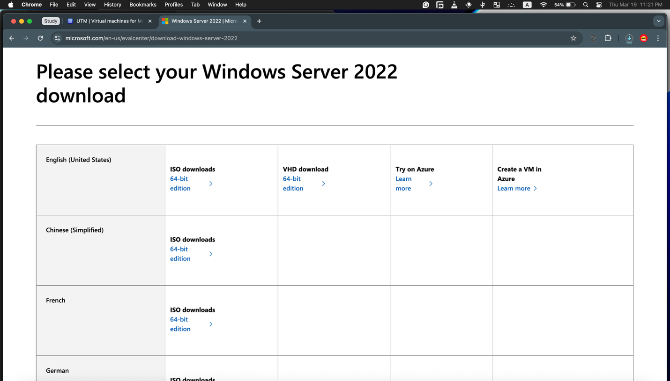
Figure 1: Windows Server 2022 download evidence
This screenshot can testify that the operating system resources needed were obtained and ready before they were deployed. It aids the short-term requirement to download the selected hypervisor and operating systems through the appropriate sources and to record the process of setting them up through time stamped evidences.
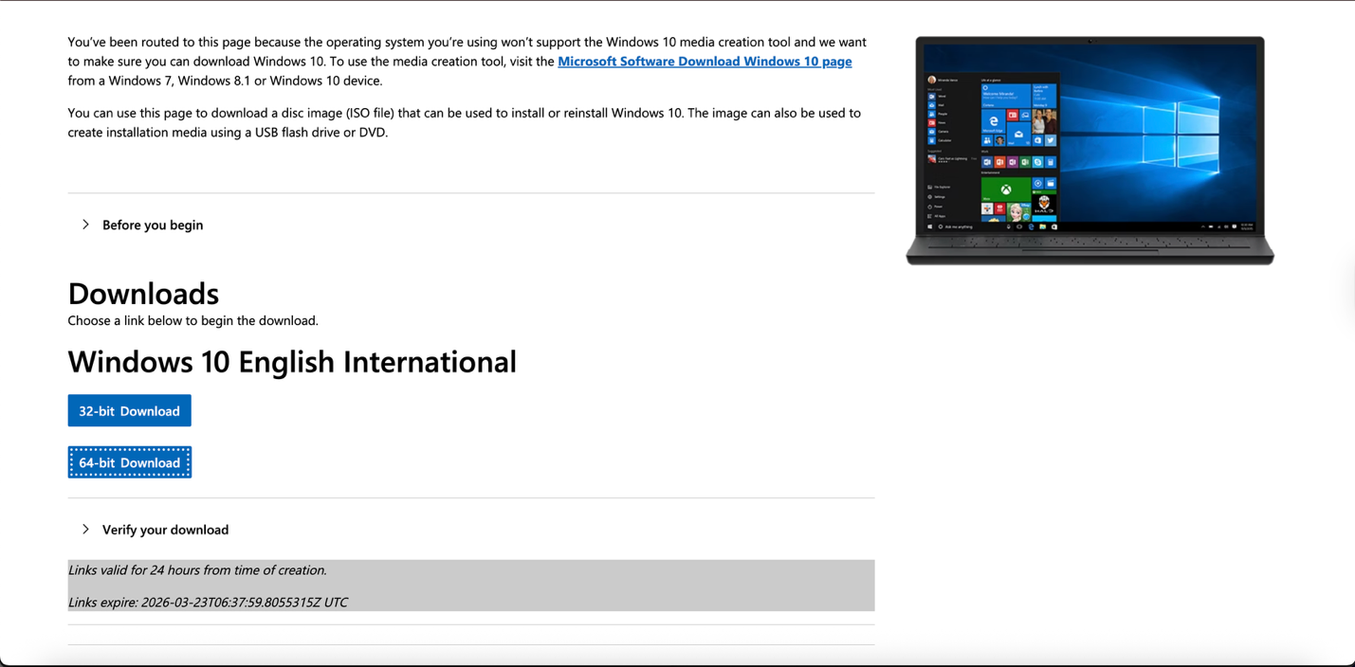
Figure 2: Windows 10 client download evidence
This screenshot is a piece of evidence that the Windows 10 client installation media was acquired from a proper source at the stage of resource acquisition. This is compliant with Task 2.2.1, which involves downloading the selected hypervisor and server/client operating systems by using the download sites of concerned resources, and states that the signs of downloading the resources by using appropriate download sites can be deemed as exceptional work.
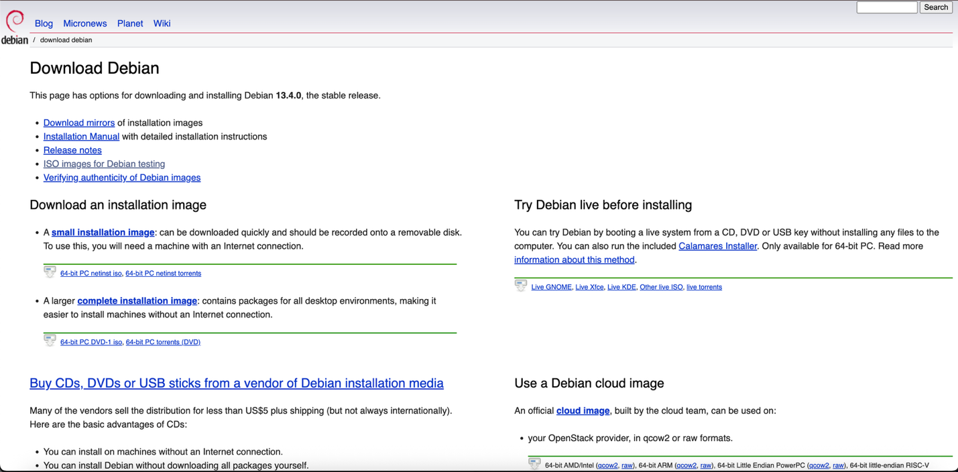
Figure 3: Debian 13.4.0 download evidence
This screenshot is also evidence that the Debian operating system installation media was acquired through the official Debian source to be deployed later in the virtual network. This facilitates Task 2.2.1, indicating that the server/client operating system resources were procured through the relevant and appropriate sources and then installed.

Virtual machine installation and deployment
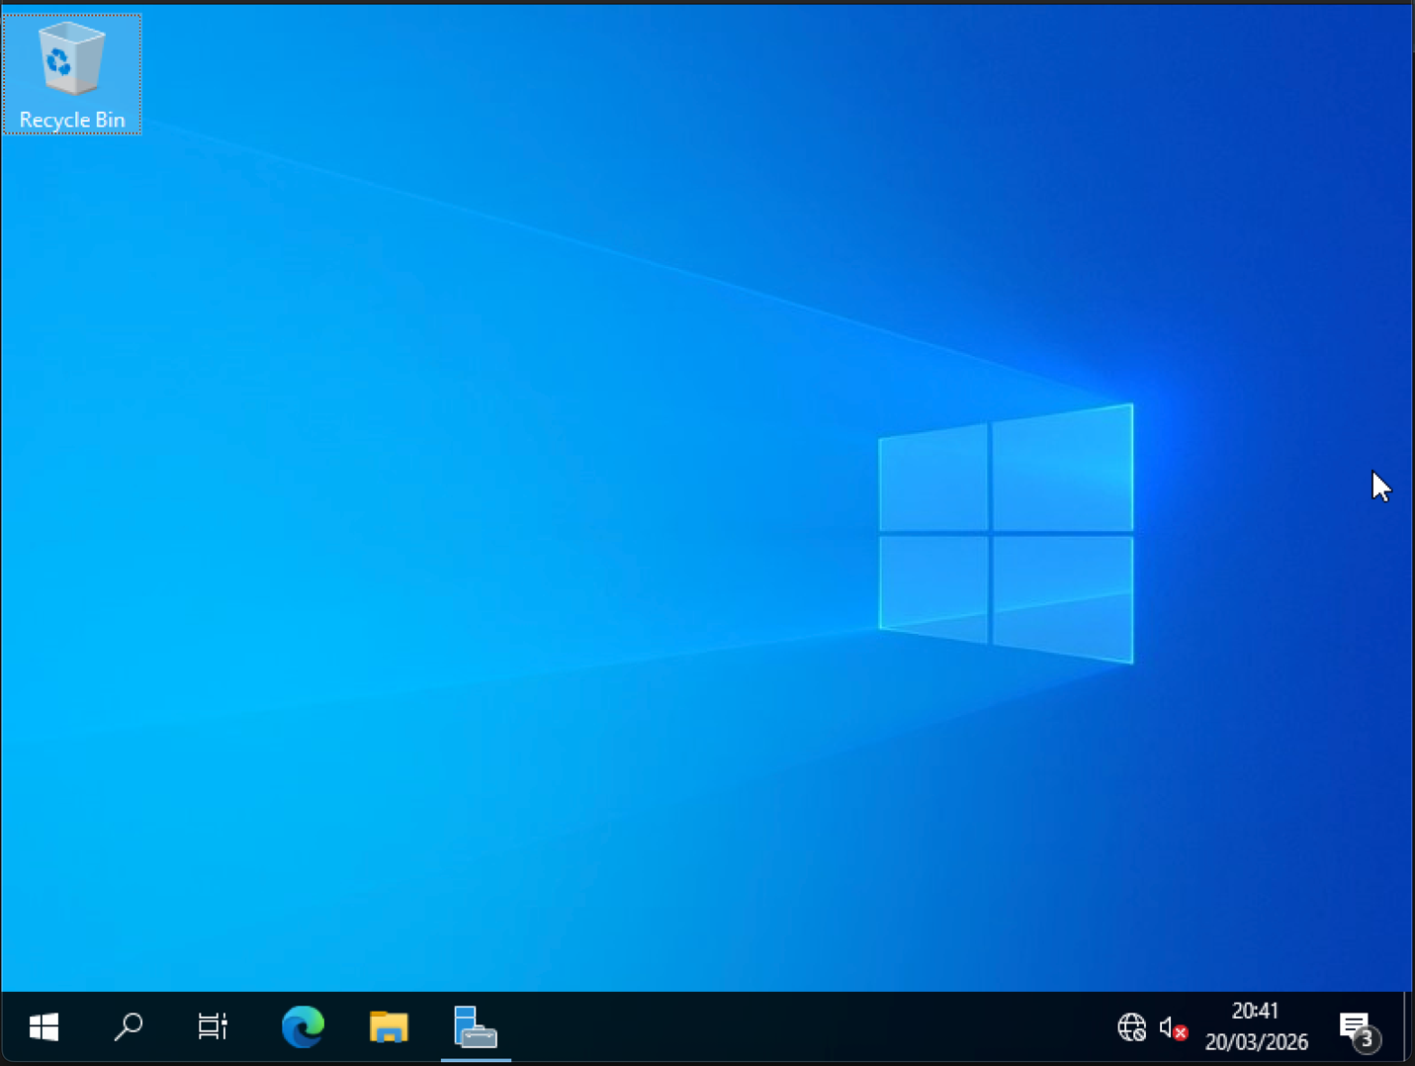
Figure 4: Windows Server 2022 desktop after successful installation
This screenshot proves that the Windows Server 2022 virtual machine was successfully installed in the Standard Desktop mode, as per the most important details of the brief. The successful desktop boot indicates that the server VM had been prepared to be named regarding the adapter later, to be tested in terms of IP configuration and connectivity.
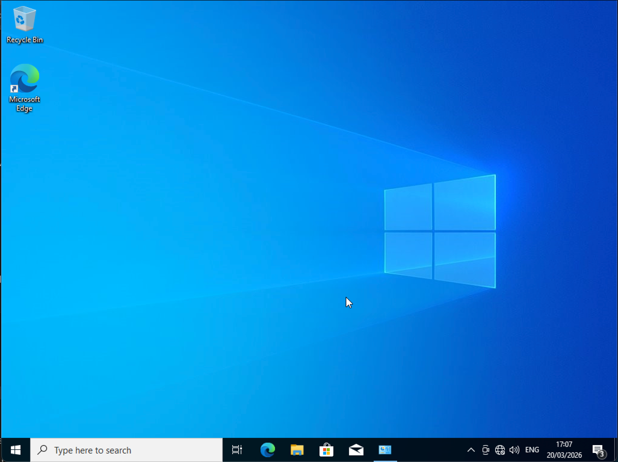
Figure 5: Windows 10 client desktop after installation.
This screenshot proves that the installation of the Windows 10 client virtual machine of the Birmingham LAN was successful. The time date shows that the deployment activity was conducted in a gradual manner and recorded as necessary in Task 2.2.
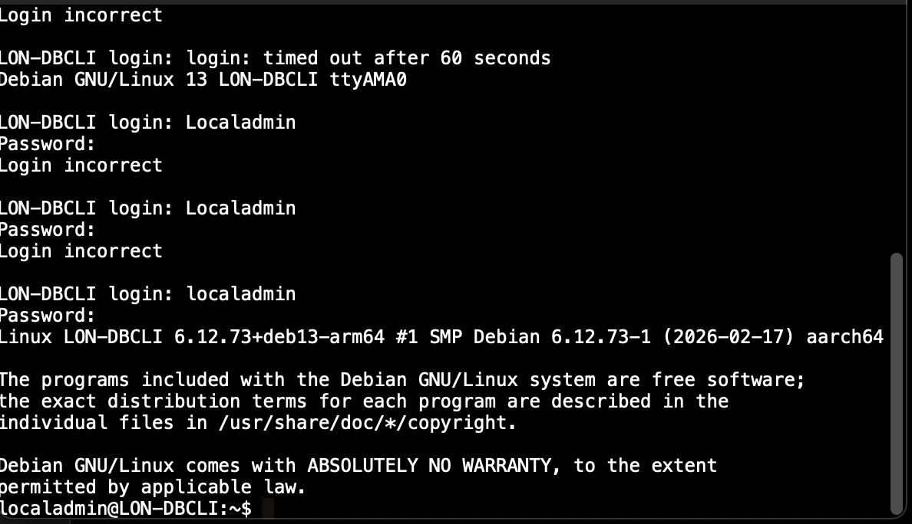
Figure 6: Debian CLI server login after installation
This screenshot proves that the Debian server was installed successfully in command-line mode, and it was able to be accessed using the shell and the login prompt. This suits the short-term need that the Debian server must be installed as a CLI server, as opposed to a GUI system.
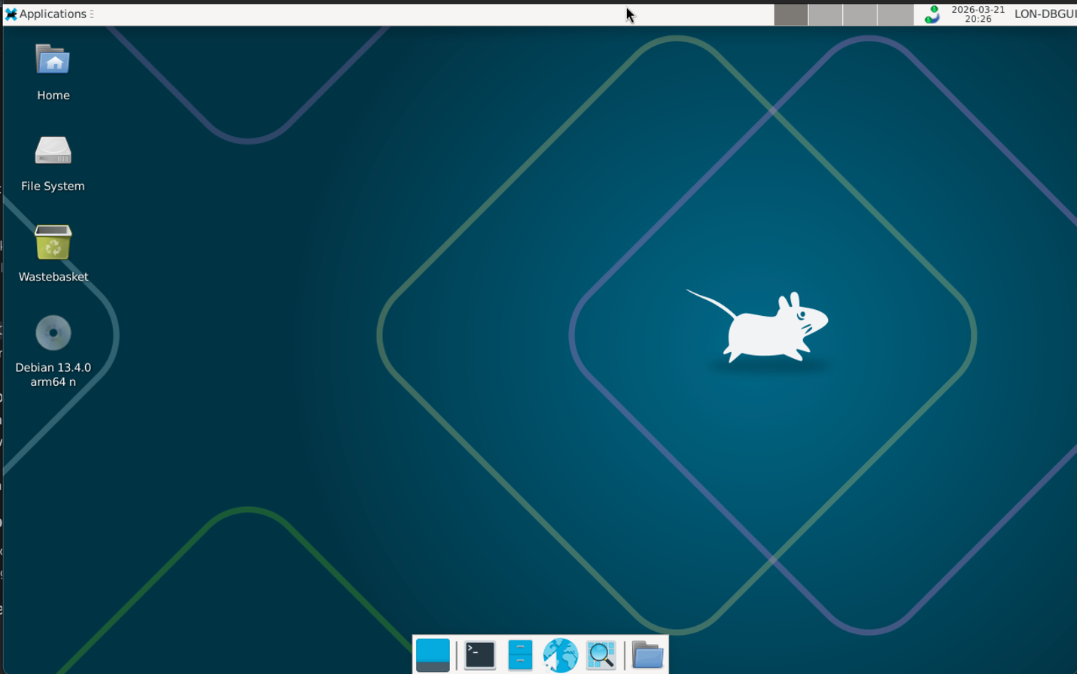
Figure 7: Debian GUI client desktop after installation.
This screenshot proves the effective implementation of the Debian GUI client on the London side of the topology. The system successfully reached the graphical desktop environment, which demonstrates that the client VM was ready to be configured and tested in final terms in connection with the network.

IP addressing design and configuration
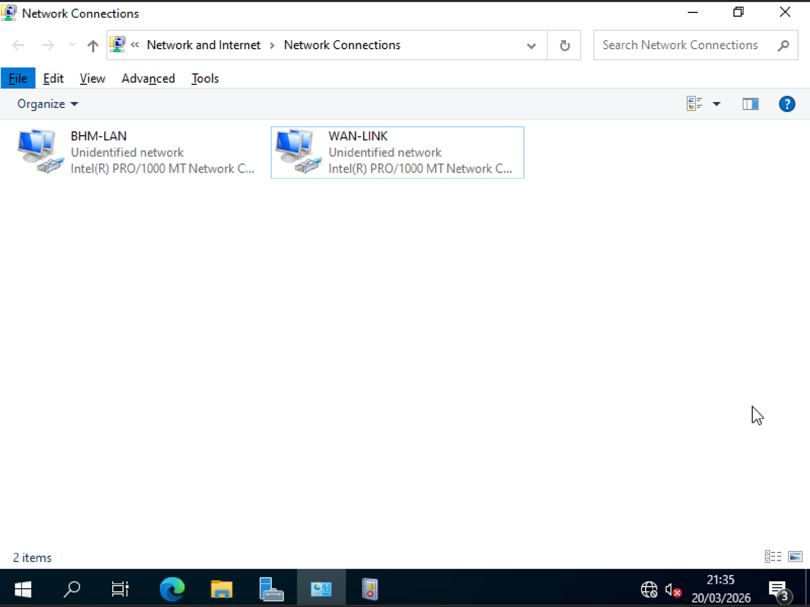
Figure 8: Windows Server network adapters renamed to BHM-LAN and WAN-LINK.
In this screenshot, one can see that the two Windows server network adapters were renamed in accordance with the logical role in the topology. By renaming the interfaces to BHM-LAN and WAN-LINK, the interface was clearer when being configured and minimised the possibility of a wrong interface being assigned an address. This serves directly to satisfy the short-term task of recording configuration information in the technical setup.
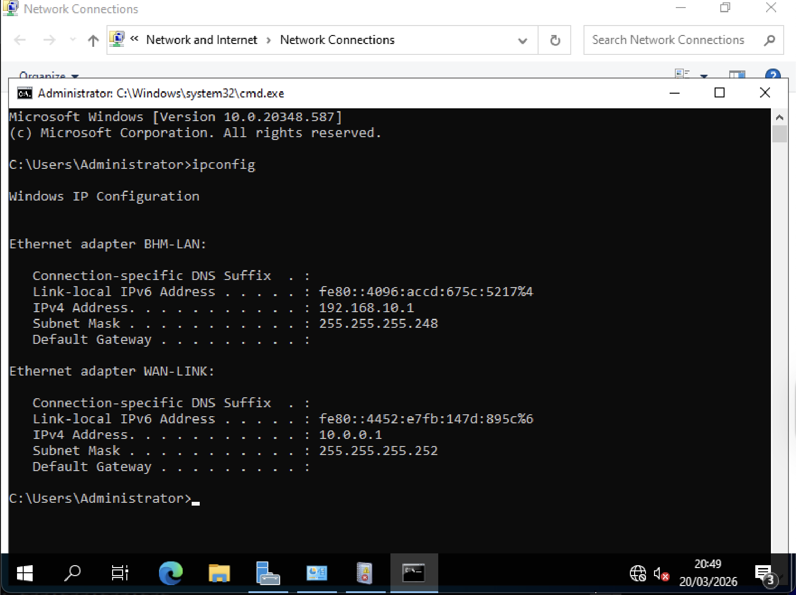
Figure 9: Windows Server IP configuration
The screenshot shows the final IP configuration for the Windows server. The BHM-LAN adapter has 192.168.10.1 with subnet mask 255.255.255.248, and the WAN-LINK adapter has 10.0.0.1 with subnet mask 255.255.255.252 – this sets the host on the LAN side of the gateway in Birmingham and the endpoint on the WAN side of the Windows machine.
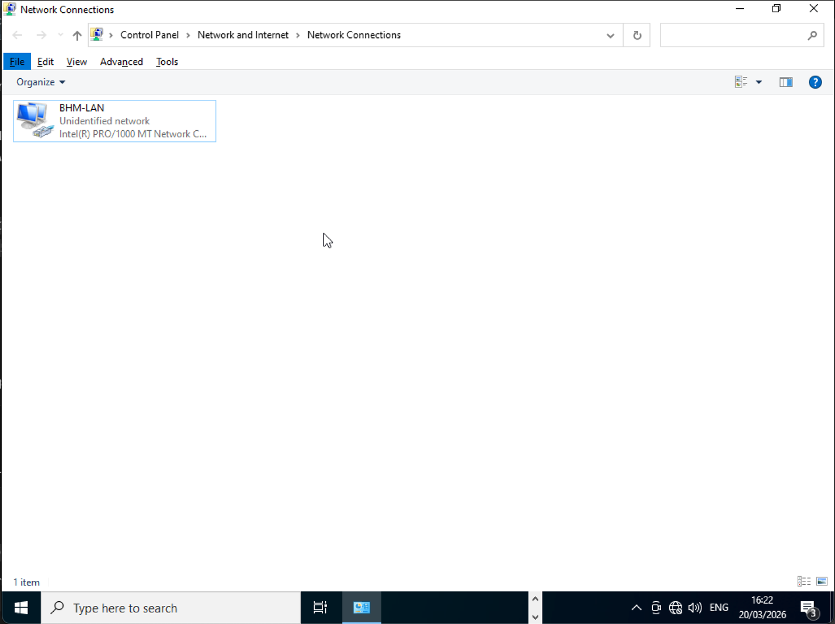
Figure 10: Windows 10 client network adapter configured as BHM-LAN.
This screenshot demonstrates that in the Windows 10 client, there was a single network connection to the Birmingham LAN segment only. This is in favour of the topology design as it makes sure that the client was a LAN host and not a multi-homed device.
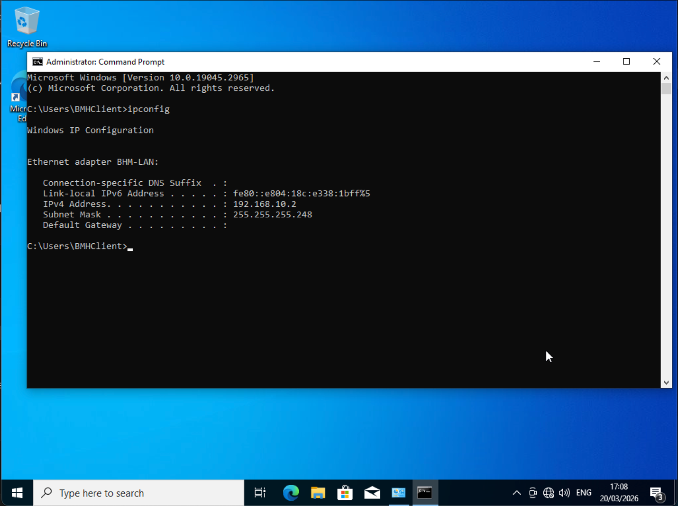
Figure 11: Windows 10 client IP configuration
This screenshot proves the end static IPv4 setup of the Windows 10 client as 192.168.10.2 with a subnet mask of 255.255.255.248. This positioned the client in the right subnet of Birmingham and allowed it to be connected to the Windows server locally.
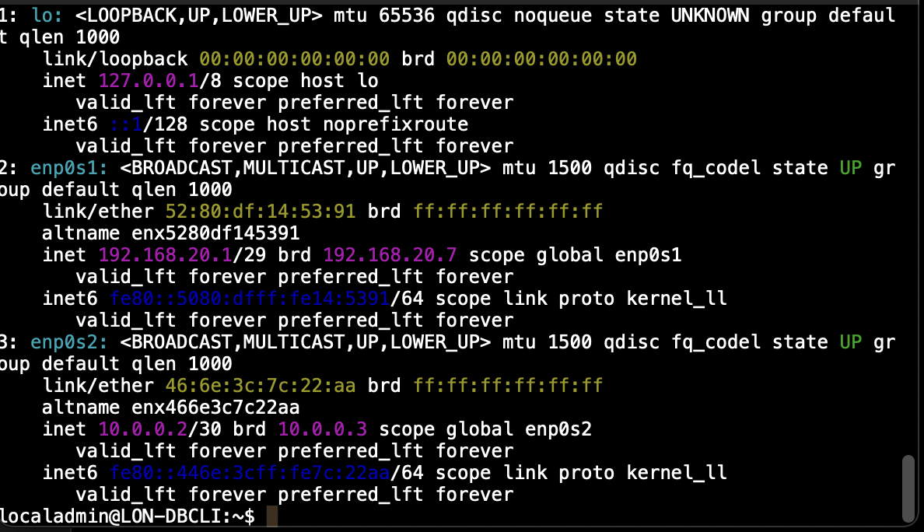
Figure 12: Debian CLI server final IP configuration
The screenshot shows the Debian CLI server applying its final settings with the ip a command. Plus, the London LAN interface received 192.168.20.1/29, and the WAN interface was set to 10.0.0.2/30. That places the server inside the London LAN and between network sites. The thing is, proper IP assignment is vital, and this image clearly proves it.
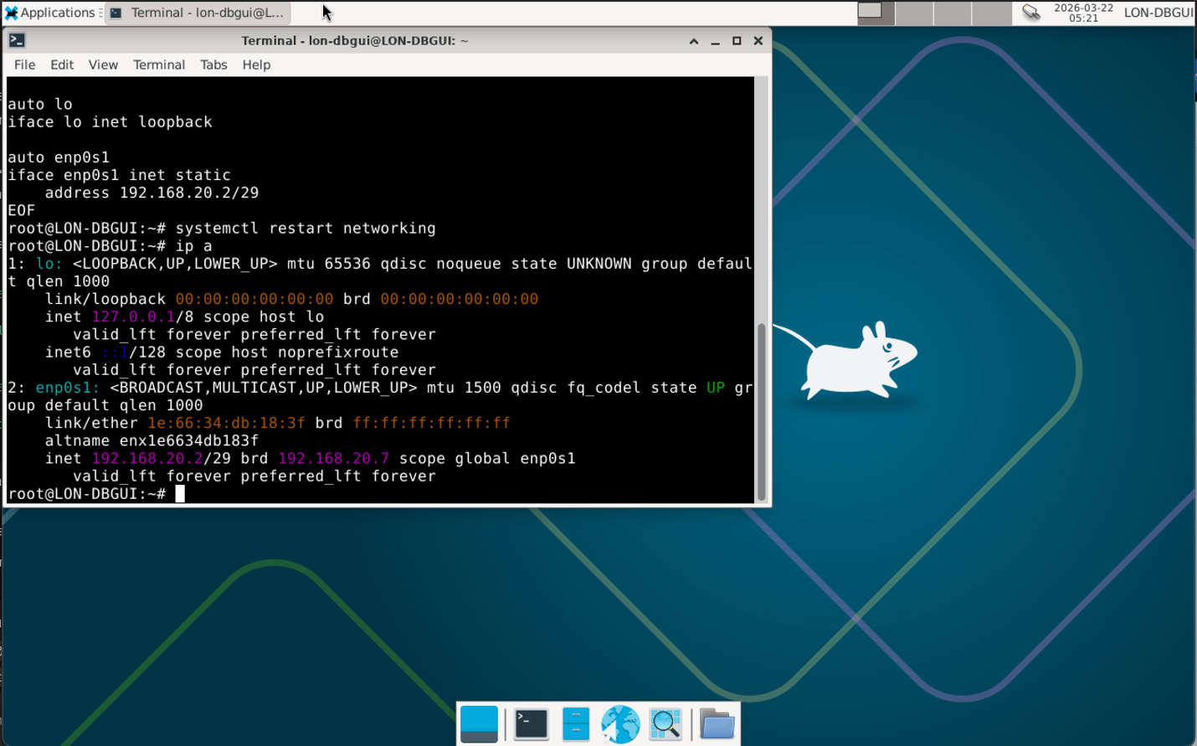
Figure 13: Debian GUI client final IP configuration
This screenshot verifies the ultimate IP address range of the Debian GUI client as 192.168.20.2/29 on the London LAN. The setup indicates that the client was put into the right subnet to test the local connection with the Debian CLI server.

Testing and troubleshooting
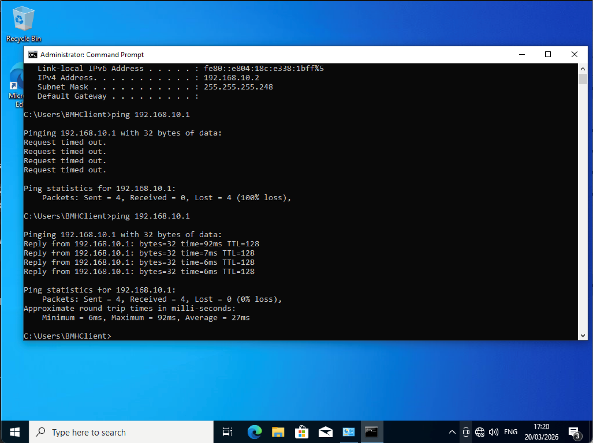
Figure 14: Windows testing: initial failure, then successful same-network ping
This screenshot records the troubleshooting of the Birmingham side. The early failed ping to 192.168.10.1 meant there was a problem in the configuration of the local client path. But the repeated test was successful after the correction. It proves that the activity of troubleshooting and successful connectivity within the same network has been achieved, which is one of the must-have outcomes in Task 2.
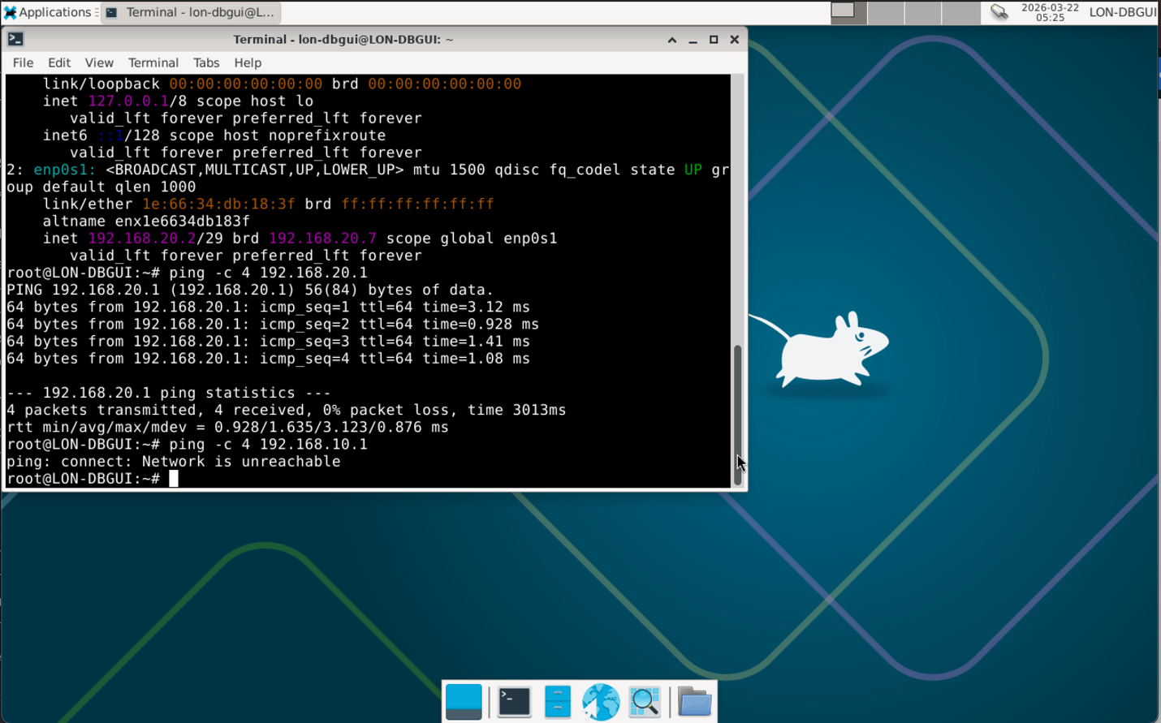
Figure 15: Debian testing: successful same-network ping and failed different-network ping
This screenshot gives the best concluding support to Task 2.4. The Debian GUI client was able to ping 192.168.20.1, which was a good sign of correct connectivity in the London LAN and failed to ping 192.168.10.1, which was a failure of correct communication between the different networks by this point. This is precisely the short results.

Task 3: Reflection

Technical reflection
The deployment and test process demonstrated that the implementation of a virtual network relies more on thorough verification than on initial configuration. Installation of the virtual machines was not the main issue, as the problem was to have each adapter connected to the respective virtual network and each of the hosts to the appropriate fixed IP address. On the Debian side, the network autoconfiguration did not work at all during installation, as the network did not provide DHCP on the host-only network, and therefore the interfaces had to be configured manually (Prilla, 2015). This involved determining the status of interfaces by checking their positions via ip a and ascertaining which interface was part of the London LAN segment and which part was in the WAN segment, and then tweaking the configuration until both addresses were put in place. One of the connectivity tests did not succeed on the client side, but the failure was identified as the network configuration, and it was fixed by repeatedly checking it. Test findings on the final test were in line with the topology design: communication in same subnet was made, but between the networks was not successful since route-setting was yet to be made. This process demonstrated the importance of methodical troubleshooting, in which every problem was uniquely removed, tested, fixed and retested instead of being modified at random.

Personal reflection
This exercise enhanced my confidence in developing a virtual network at the start-up level and capturing it in a well-organised manner. I have also learned that it is necessary to plan, use the right evidence of a screenshot, and go step by step, particularly when a number of operating systems, as well as network segments, are in question (Oportus-Torres et al., 2024). I was also more attentive to the accuracy of commands, allocation of IP and identification of interfaces. The experience in general has helped in enhancing my technical knowledge as well as patience when solving practical networking issues.

References
Ashraf, Z., Sohail, A., Latif, S., Hameed, A. and Yousaf, M. (2023). Challenges and Mitigation Strategies for Transition from IPv4 Network to Virtualised Next-Generation IPv6 Network. International Arab Journal of Information Technology (IAJIT), 20(1). https://doi.org/10.34028/iajit/20/1/9.
Barker, E.B., Dang, Q.H., Frankel, S.E., Scarfone, K. and Wouters, P. (2020). Guide to IPsec VPNs. https://doi.org/10.6028/nist.sp.800-77r1.
Chandramouli, R. (2018). Security recommendations for server-based hypervisor platforms. https://doi.org/10.6028/nist.sp.800-125ar1.
Cheon, S., Jin, D. and Kim, C. (2016) 'A VLSM address management method for variable IP subnetting,' in Lecture notes in computer science, pp. 73–83. https://doi.org/10.1007/11751595_9.
Huawei Technologies Co., Ltd. (2022). Dynamic routing,' in Dynamic Routing’, in Data Communications and Network Technologies, pp. 193–220. https://doi.org/10.1007/978-981-19-3029-4_6.
Li, H. and Bai, H. (2025) 'Addressing and routing,' in Addressing and Routing’, in Principle of Architecture, Protocol, and Algorithms for CoG-MIN, pp. 55–87. https://doi.org/10.1007/978-981-96-3596-2_5.
Microsoft (2025) Hyper-V virtualisation in Windows Server and Windows. https://learn.microsoft.com/en-us/windows-server/virtualization/hyper-v/overview (Accessed: March 22, 2026).
Microsoft (2026) Hyper-V architecture. Microsoft Learn. Available at: https://learn.microsoft.com/en-us/windows-server/virtualization/hyper-v/architecture (Accessed: 22 March 2026).
O’Leary, M. (2019) 'Active Directory,' in Apress eBooks, pp. 235–275. https://doi.org/10.1007/978-1-4842-4294-0_6.
Okoh, C., Theophilus, W.N., Dawkins, P. and Paheerathan, S. (2024). Enhancing Data Security Through VLSM Subnetting and TCP/IP Model in an ENT. Applied Sciences, 14(23), p.10968. https://doi.org/10.3390/app142310968.
Oportus-Torres, R., Contreras-Soto, Y., Sanhueza-Campos, C., Maluenda-Albornoz, J., Pérez-Villalobos, C. and Quintanilla-Espinoza, A. (2024), July. Self-regulated learning and engagement through emergency remote teaching in EFL undergraduate students. In Frontiers in Education (Vol. 9, p. 1416507). Frontiers Media SA. doi: 10.3389/feduc.2024.1416507
Oracle (2025) Oracle VirtualBox User Guide for Release 7.1. Oracle. November 2025. Available at: https://docs.oracle.com/en/virtualization/virtualbox/7.1/user/EN-VBOX-7-1-USER.pdf (Accessed: 22 March 2026).
Prilla, M. (2015) 'Supporting Collaborative Reflection at Work: A Socio-Technical Analysis,' AIS Transactions on Human-Computer Interaction, 7(1), pp. 1–17. https://doi.org/10.17705/1thci.00063.
Silhavy, R. (2019). Software engineering methods in intelligent algorithms: Proceedings of 8th Computer Science Online Conference 2019, Vol. 1. Springer.
Thorenoor, S.G. (2018) 'Dynamic Routing Protocol Implementation Decision between EIGRP, OSPF and RIP Based on Technical Background Using OPNET Modeller,' Second International Conference on Computer and Network Technology, pp. 191–195. https://doi.org/10.1109/iccnt.2010.66.

